CS 255 System Design Document

UML Diagrams

UML Use Case Diagram
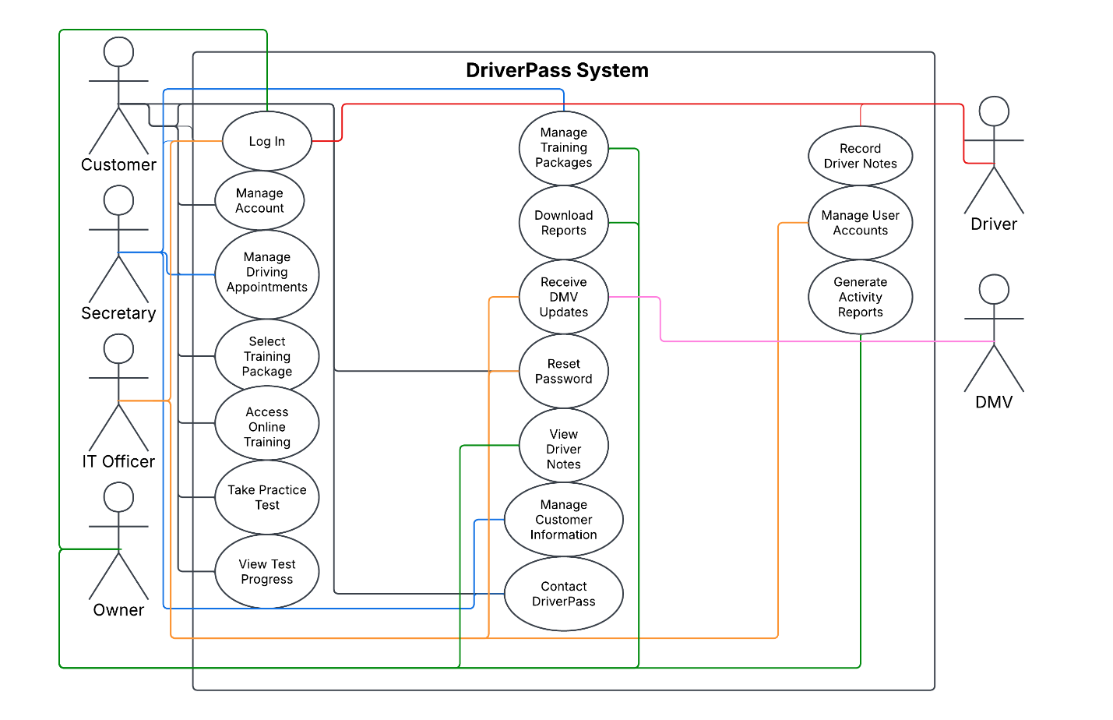

UML Activity Diagrams
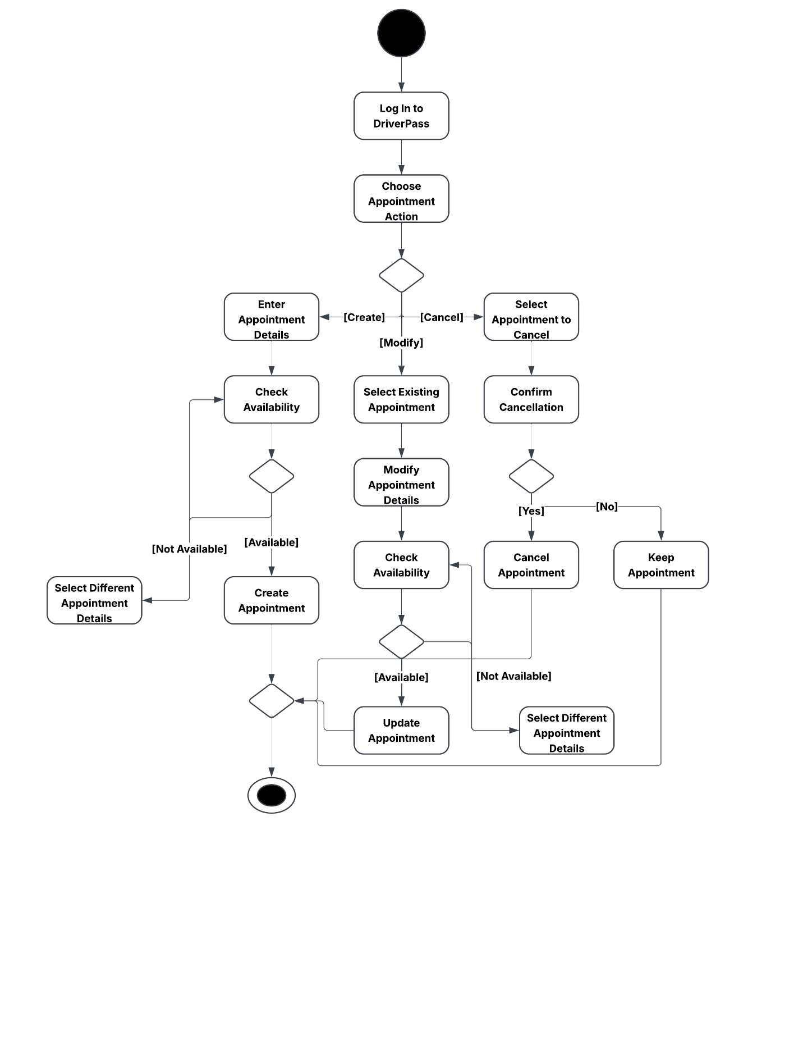

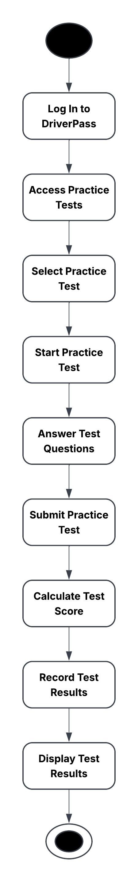

UML Sequence Diagram

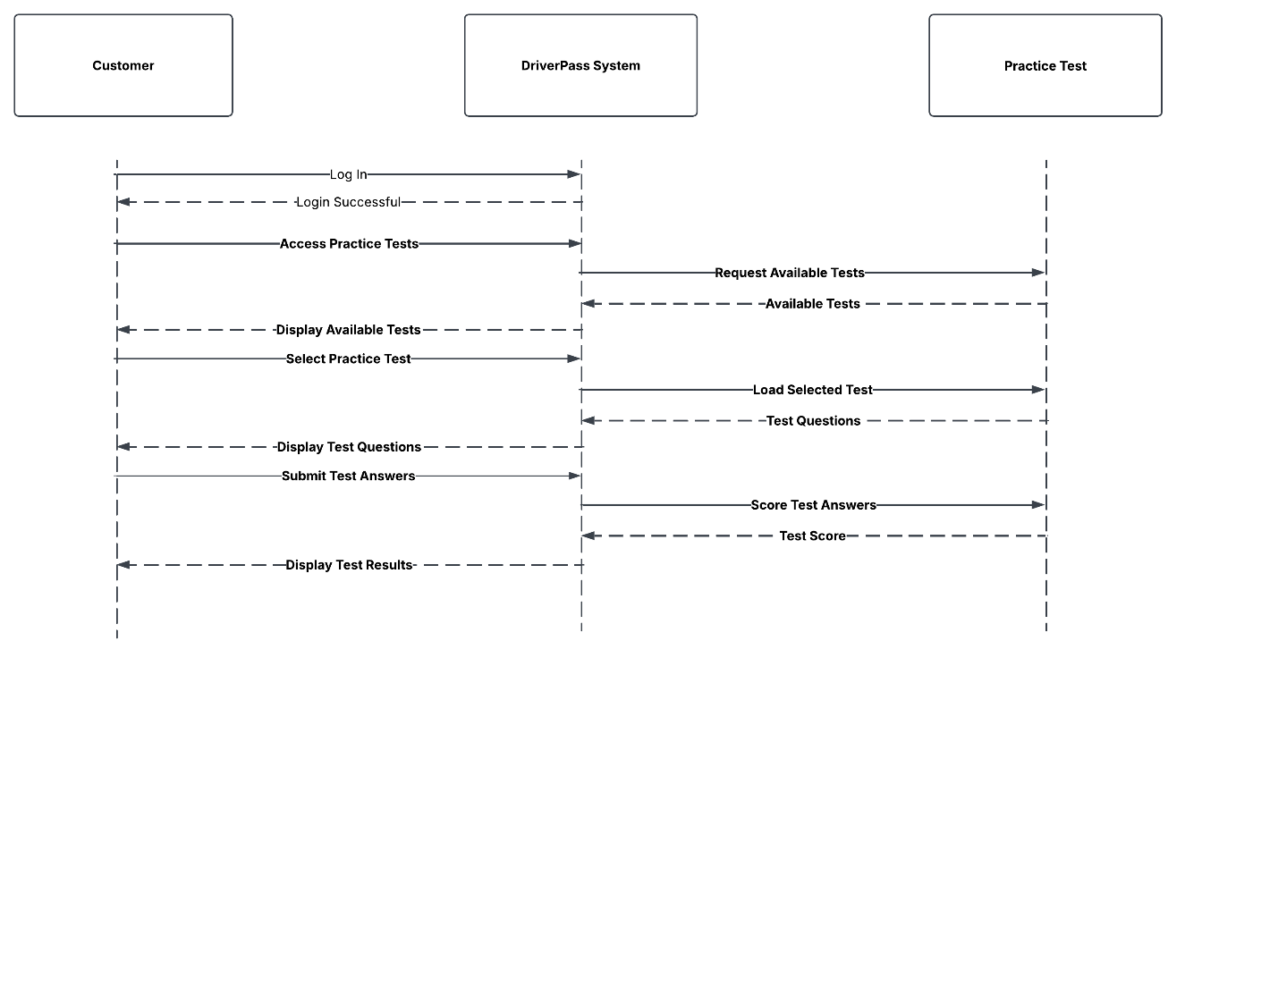

UML Class Diagram
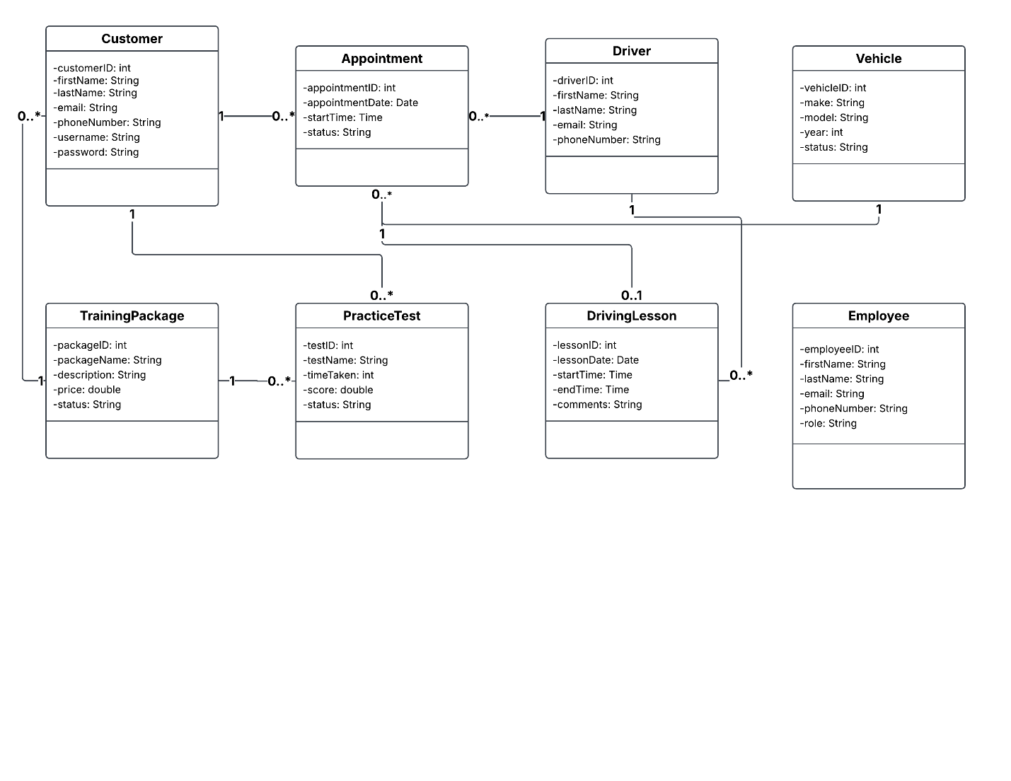

Technical Requirements
Hardware
The DriverPass system will require computers or mobile devices with reliable internet access so customers and employees can access the web-based system. DriverPass employees will need desktop or laptop computers to manage customer information, appointments, training packages, reports, and other administrative functions. Customers will be able to use computers, tablets, or smartphones to access online training, take practice tests, manage appointments, and review their progress. DriverPass will also require reliable network equipment, such as routers and wireless access points, to provide employees with consistent access to the system.

Software
The DriverPass system will require a web-based software application that allows customers and employees to access features according to their assigned roles. The application will include customer account management, appointment scheduling, training package management, online training, practice tests, driver notes, progress tracking, and reporting capabilities. The system will also require database software to securely store customer accounts, appointments, test results, training information, and employee data. The application should support current web browsers on desktop and mobile devices and allow authorized users to download report data for use in spreadsheet software such as Microsoft Excel.

Tools
Development and maintenance of the DriverPass system will require software development and design tools. UML modeling tools such as Lucidchart can be used to create and maintain system diagrams, while an integrated development environment (IDE) can be used to develop and update the application. Database management tools will be needed to create, maintain, and monitor the system database. Version control tools should also be used to track changes to the application source code and support future system updates.

Infrastructure
The DriverPass system should use a cloud-based infrastructure to host the web application and database. The cloud environment should provide secure remote access, data backup, system recovery, and the ability to scale as the number of users increases. Secure internet connections using HTTPS should protect data transmitted between users and the system. Role-based access controls should limit users to the functions and information appropriate for their roles. The infrastructure should also support the connection to DMV information so DriverPass can receive updated rules, policies, and practice test information.

