Avantika Shailesh Deshmukh
2021BIT153

Q.Get minimum element from stack :

#include <stdio.h>
#define size 10
int top = -1;
int arr[size];

void push(int x);
void pop();
void show();
void getmin()
{
int Q = arr[0];
for (int i = 0; i <= top; i++)
{

if (Q > arr[i])
{
Q = arr[i];
}
}
printf("%d is Min number from Stack\n", Q);
}
int main()
{
push(37);
push(32);
push(20);
show();
printf("\t\t");
pop();

push(30);
push(40);

show();
printf("\t\t");
pop();
push(1);
push(11);
push(7);

push(6);

printf("\n");

show();

printf("\n");

getmin();
}
void push(int x)
{

if (x != -1)
{

++top;
arr[top] = x;
}
else if (top == -1)
{
printf("Stack is empty\n");
return;
}
else if (top == size - 1)
{
printf("Overflow\n");
}
else
return;
}
void pop()
{
if (top != -1)
{
printf("%d is popped\n", arr[top]);
top = top - 1;
}
else if (top == -1)
{
printf("Underflow\n");
}
}
void show()
{
for (int i = 0; i <= top; i++)
{
printf("%d\n", arr[i]);
}
}

Output:
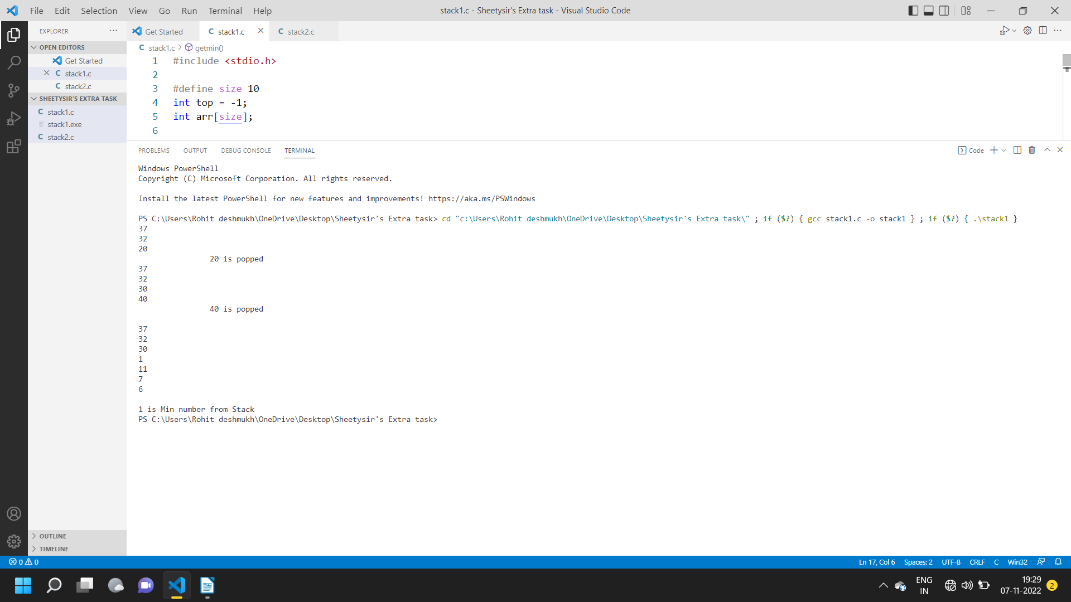

Q.Delete middle element of stack:

#include <stdio.h>
#define size 10
int top = -1;
int arr[size];

void push(int x);
void pop();
void show();

int main()
{
push(37);
push(58);
push(20);
show();
printf("\t\t");
pop();
show();
printf("\n\n");
push(30);
push(1);

show();
pop();
show();
printf("\n\n");
}
void push(int x)
{

if (x != -1)
{

++top;
arr[top] = x;
}
else if (top == -1)
{
printf("Stack is empty\n");
return;
}
else if (top == size - 1)
{
printf("Overflow\n");
}
else
return;
}
void pop()
{
if (top != -1)
{
printf("\n\t\t->->%d is popped\n", arr[top / 2]);
arr[top / 2] = arr[(top / 2) + 1];

for (int i = ((top / 2) + 1); i < top; i++)
{
arr[i] = arr[top];
}
top = top - 1;
}
else if (top == -1)
{
printf("Underflow\n");
}
}
void show()
{
for (int i = 0; i <= top; i++)
{
printf("%d\t", arr[i]);
}
}
Output:

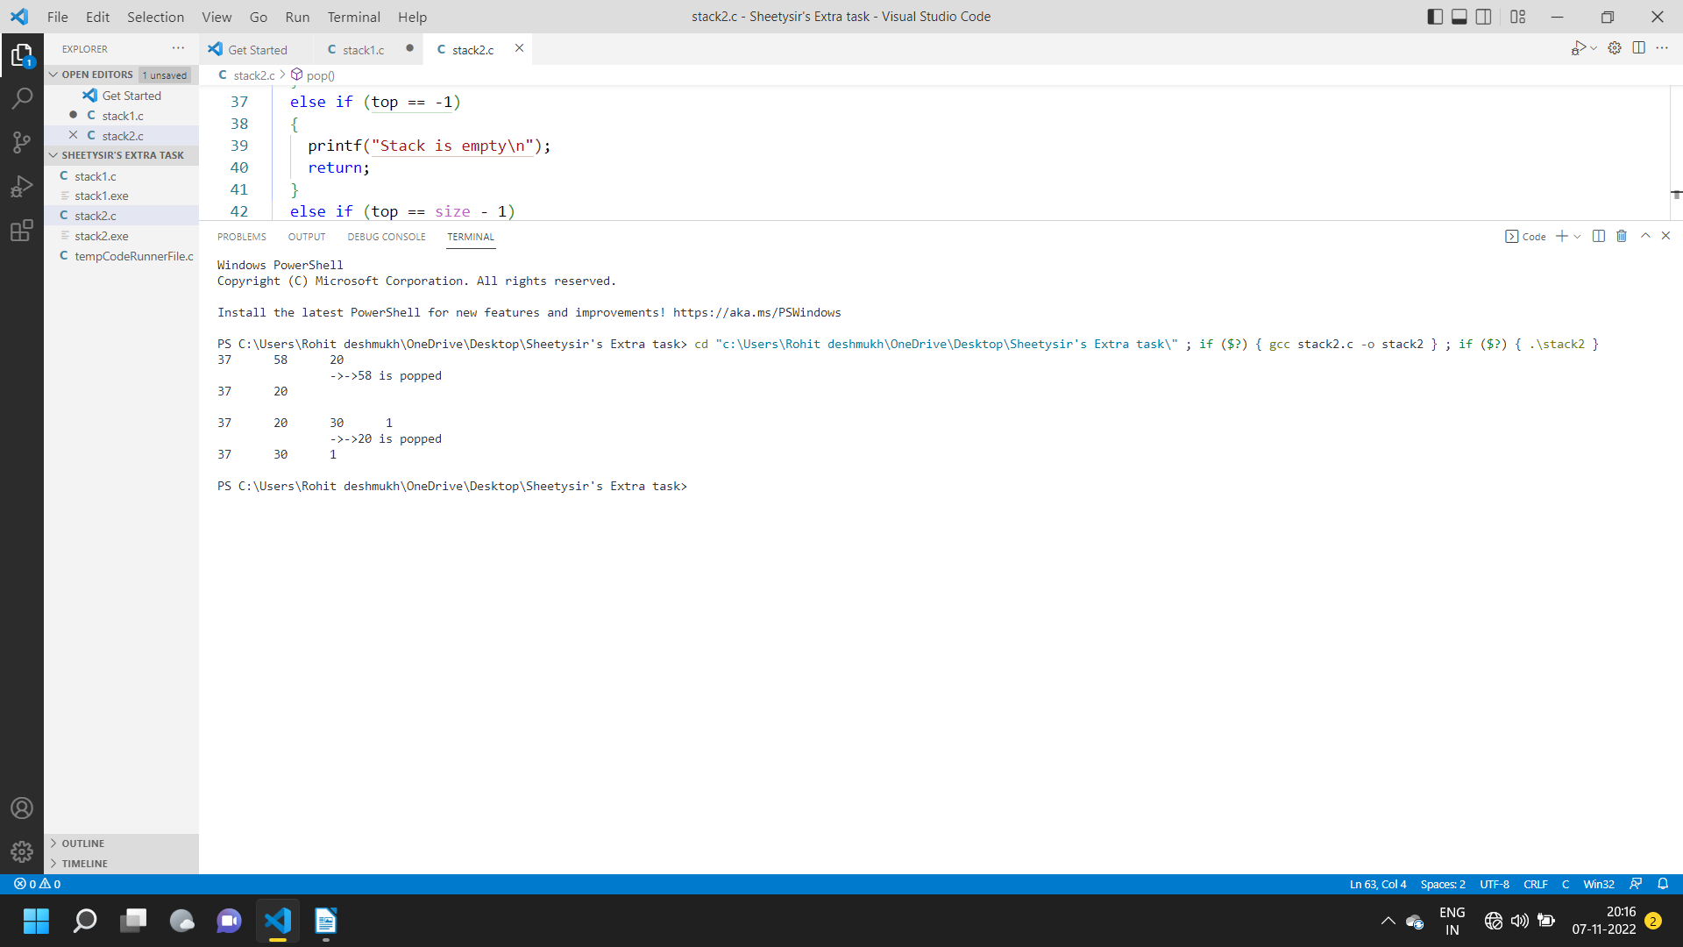
Q. Enqueue Dequeue using stack:

#include <stdio.h>
#include <stdlib.h>
void push1(int);
void push2(int);
int pop1();
int pop2();
void enqueue();
void dequeue();
void display();
void create();

int s1[50], s2[50];
int top1 = -1, top2 = -1;
int count = 0;
void main()
{
int ch;
printf("\n1]Enqueue element into queue");
printf("\n2]dequeue element from queue");
printf("\n3]Display from queue");
printf("\n4]Exit");
create();
while (1)
{
printf("\n Enter choice :");
scanf("%d", &ch);
switch (ch)
{
case 1:
enqueue();
break;
case 2:
dequeue();
break;
case 3:
display();
break;
case 4:
exit(0);
default:
printf("Enter valid choice\n");
}
}
}
void create()
{
top1 = top2 = -1;
}
void push1(int data)
{
s1[++top1] = data;
}
int pop1()
{
return (s1[top1--]);
}
void push2(int data)
{
s2[++top2] = data;
}
int pop2()
{
return (s2[top2--]);
}

void enqueue()
{
int data, i;
printf("Enter data into queue:");
scanf("%d", &data);
push1(data);
count++;
}
void dequeue()
{

for (int i = 0; i <= count; i++)
{
push2(pop1());
}
pop2();
count--;
for (int i = 0; i <= count; i++)
{
push1(pop2());
}
}
void display()
{
for (int i = 0; i <= top1; i++)
{
printf("%d\t", s1[i]);
}
}
Output:

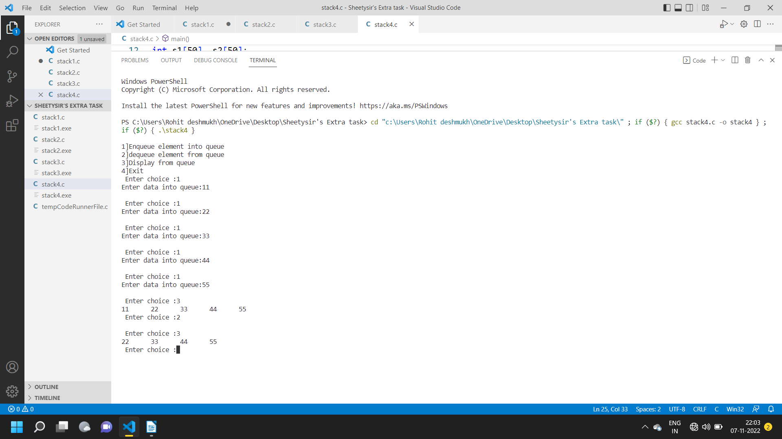

Q.Stack operation using array:
#include <stdio.h>

#define size 10
int top = -1;
int arr[size];

void push(int x);
void pop();
void show();
int main()
{
push(37);
push(32);
push(20);
show();
printf("\t\t");
pop();

push(30);
push(40);

show();
printf("\t\t");
pop();
push(1);
push(11);
push(7);

push(6);

printf("\n");

show();

printf("\n");
}
void push(int x)
{

if (x != -1)
{

++top;
arr[top] = x;
}
else if (top == -1)
{
printf("Stack is empty\n");
return;
}
else if (top == size - 1)
{
printf("Overflow\n");
}
else
return;
}
void pop()
{
if (top != -1)
{
printf("%d is popped\n", arr[top]);
top = top - 1;
}
else if (top == -1)
{
printf("Underflow\n");
}
}
void show()
{
for (int i = 0; i <= top; i++)
{
printf("%d\n", arr[i]);
}
}
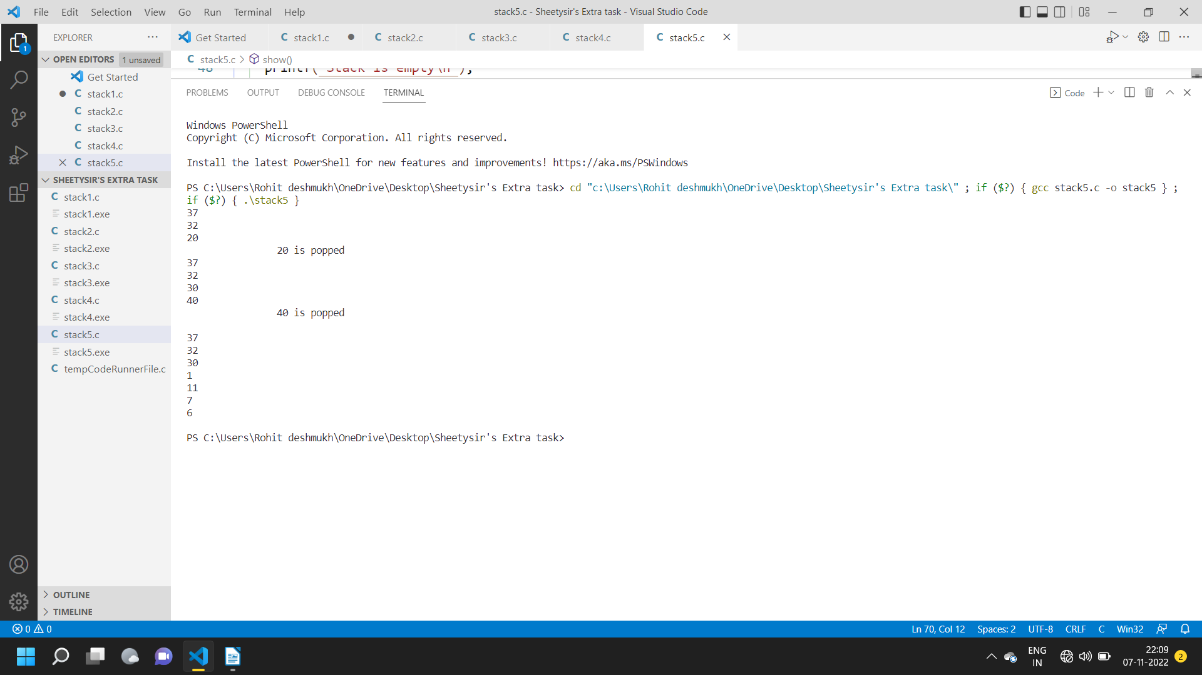
Output:

Q.Stack using Linked List

#include <stdio.h>
#include <conio.h>
#include <stdlib.h>

struct node
{
int data;
struct node *next;

} *top = NULL;

void push(int);
void pop();
void Display();
void main()
{
int choice, value;
printf("Stack Using Linked List:");
while (1)
{
printf("\n1.push \n2.pop \n3.Display \n4.exit");
printf("\nEnter choice:");
scanf("%d", &choice);
switch (choice)
{
case 1:
printf("Enter value to insert:");
scanf("%d", &value);
push(value);
break;
case 2:
pop();
break;
case 3:
Display();
break;
case 4:
exit(0);
break;

default:
printf("Enter valid ");
}
}
}
void push(int value)
{
struct node *newnode;
newnode = (struct node *)malloc(sizeof(struct node*));
newnode->data = value;
if (top == NULL)
{
newnode->next = NULL;
}
else
newnode->next = top;
top = newnode;
printf("\nInsertion Done\n");
}
void pop()
{
if (top == NULL)
printf("\nStack Is empty ");
else
{
struct node *temp = top;
printf("\n Delete Element :%d", temp->data);
top = temp->next;
free(temp);
}
}
void Display()
{
if (top == NULL)
printf("\n Stack is Empty");
else
{
struct node *temp = top;
while (temp->next != NULL)
{
printf("%d->", temp->data);
temp = temp->next;
}
printf("%d->NULL", temp->data);
}
}

Output:

