Real–Time Big Data Analytics for IoT Driven Public Safety Systems

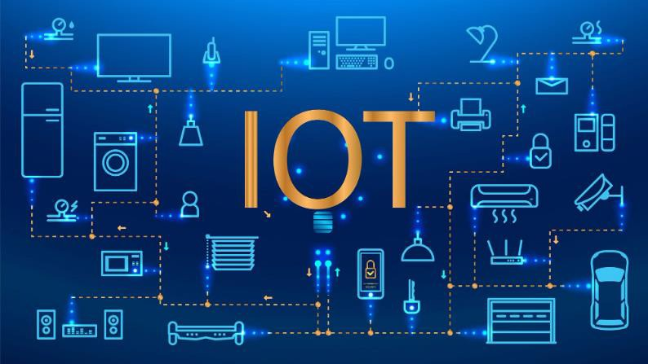
Real-time big data analytics for IoT-driven public safety systems involves the immediate processing, analysis, and interpretation of data from IoT devices to provide actionable insights and facilitate informed decision-making in public safety applications.

BY

21BCS2402 – Harsh Choudhary 21BCS2567 – Ranit Tatrial 21BCS3039 – Aavesh Tanwar 21BCS3003 – Dushant Chaudhary
21BCS7883 - Akshat





INTRODUCTION
In an era where urban safety is paramount, integrating real-time big data analytics with IoT-driven public safety systems has become a transformative approach. This technology empowers authorities to monitor, analyze, and respond to threats and emergencies with unprecedented speed and precision.

By leveraging vast streams of sensor data, emergency services can enhance situational awareness, anticipate incidents, and deploy resources effectively to protect communities and infrastructure.



Core Components of IoT- Enabled Public Safety Analytics

Data Acquisition
High-density IoT devices collect diverse data types including video feeds, environmental sensors, and social feeds.

Real-Time Processing

Stream processing platforms analyze incoming data instantly, enabling immediate insights and alerts.

Advanced Analytics
Machine learning algorithms detect anomalies, predict risks, and support decision-making in dynamic environments.
Visualization & Response
Integrated dashboards and automated triggers allow rapid response coordination and public communication.

Challenges in Implementing Real- Time Big Data Analytics

Data Volume & Velocity

Managing massive continuous data streams requires scalable infrastructure and optimized processing techniques.
Balancing storage costs with retrieval speed is critical for
operational effectiveness.

Data Integration & Quality

Diverse sensor types and inconsistent formats pose challenges for accurate data fusion and cleansing.
Poor data quality impacts the reliability of analytics output
and decision-making.



Real-World Applications Enhancing Public Safety


Disaster Detection & Response
Immediate identification of natural disasters like floods or fires through sensor data accelerates evacuation and aid deployment.

Crowd and Traffic Management
Real-time monitoring of crowd density and traffic flows helps prevent incidents and optimizes emergency vehicle routing.

Crime Prediction and Prevention
Predictive analytics on crime hotspots and patterns enables proactive policing and resource allocation.



Key Takeaways and Future Directions

Integration is Essential
Success depends on seamlessly combining IoT, analytics, and operational
workflows for timely interventions.

Investment in Infrastructure
Scalable and robust computing architectures are vital to support continuous real- time processing demands.

Emphasis on Data Security
Protecting sensitive public safety data is mandatory with strong encryption and strict access controls.

Future Innovations
Advances in edge computing, AI, and 5G connectivity will further empower real- time analytics capabilities.

