Boat Inspection Form

|  |  |
| --- | --- |
| Make/Model | **2019 Bentley 240 Cruise** |
| HIN | **BAG01883L819** |
| Registration # | **GA5287CH** |
| Date/Time |  |

# Before-Rental Inspection

Prior to the start of the rental, the lessee needs to inspect the vessel and denote in the below drawing, any pre-existing damage. This includes, but is not limited to the pontoons, upholstery, engine, propeller or any other equipment.

**Notes:**

________________________________________________________________________________________________________________________________________________________________________________________________________________________________________________________________________________________________________________________________________________________________________________________________________________________________________________________________________________________________________________________________________________________________________________________________________________________________________________________________________________________________________________________________________________________________________________________________________________________________________________________________________________________________________________________

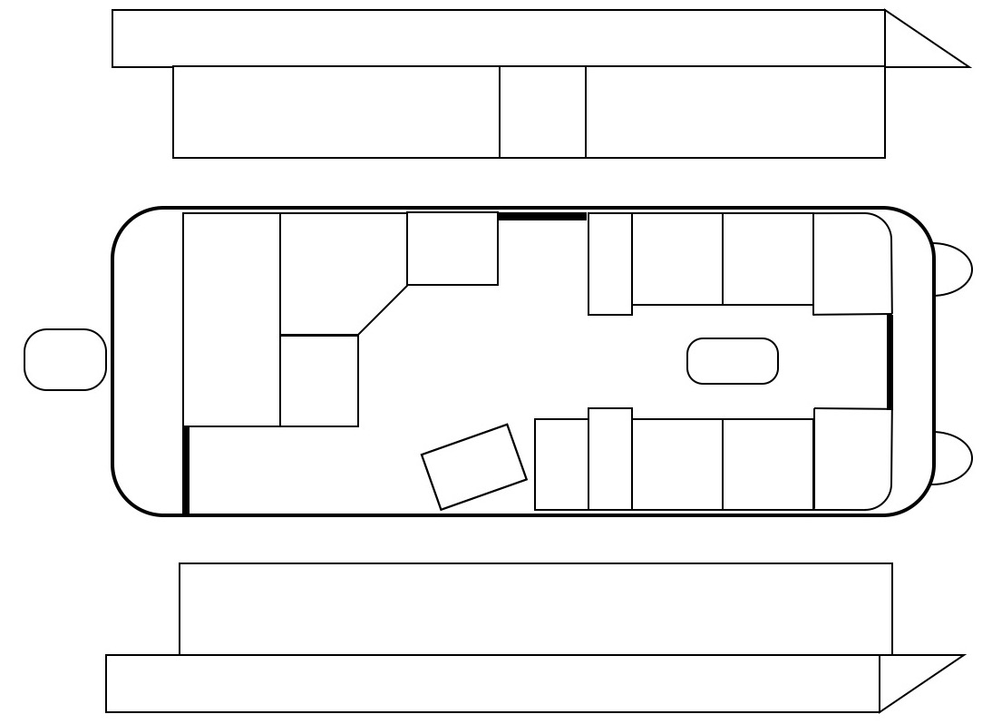

|  |  |
| --- | --- |
| LEESEE:_________________________________ ____________ | PizBoats: ________________ |
| (name) (sign) | (sign) |

# After-Rental Inspection

This section is filled only if there are any new damages to the boat found after completion of the rental period.

|  |  |
| --- | --- |
| Date/Time |  |

**Notes:**

______________________________________________________________________________________________________________________________________________________________________________________________________________________________________________________________________________________________________________________________________________________________________________________________________________________________________________________________________________________________________________________________________________________________________________________________________________________________________________________________________________________________________________________________________________________________________________________________________________________________________________**__________________________________________________________________________**



|  |  |
| --- | --- |
| LEESEE:_________________________________ ____________ | PizBoats: ________________ |
| (name) (sign) | (sign) |