CES — Compliance Evidence System
User guide, screen by screen · Architecture · New-joiner training
Aavya Engineering for Blue Heron Defense · platform state: master, 12 November 2026 · demo data only (Contoso Defense, simulator tenant)
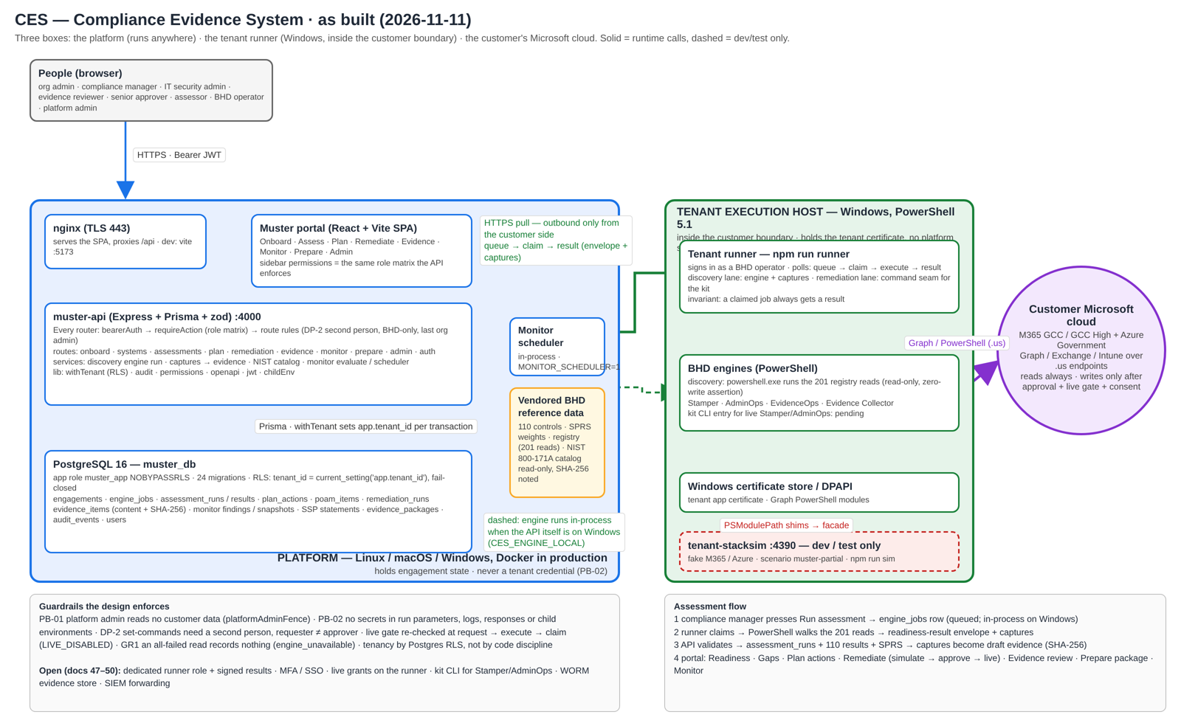
Figure 1 — the as-built platform. Editable source: docs/architecture/ces-platform.drawio (draw.io).

Contents

If the table is empty, right-click it and choose Update Field (Word builds it on open).

1. What CES is, in one page
A US defence contractor that handles Controlled Unclassified Information (CUI) has to meet the 110 security requirements of NIST SP 800-171 and prove it to a CMMC Level 2 assessor. CES walks a contractor through that, end to end, in seven steps that are also the seven sections of the portal:
- Onboard — who the customer is, which tenants and systems are in scope, where the CUI boundary sits
- Assess — read the Microsoft 365 / Azure tenant against the requirements and score it (SPRS)
- Plan — turn gaps into owned, dated actions and a POA&M
- Remediate — fix configuration and admin settings with approvals, simulate first, live only behind a gate
- Collect Evidence — gather and review the artefacts an assessor will ask for
- Monitor — keep it fixed: evaluate, raise findings, track drift
- Prepare — SSP statements, signed evidence packages, and a read-only assessor workspace
Blue Heron Defense built the engines that touch a tenant (PowerShell, Microsoft Graph). Aavya built the platform around them: the portal, the API, the database, the roles and approvals, and the runner that carries work to the Windows machine where the engines live. One sentence explains most of the design: the engines need Windows, the rest does not.

Words you will hear
Term | Meaning
Requirement | One of the 110 NIST SP 800-171 requirements, e.g. AC.L2-3.1.1
Objective | One of the 320 assessment objectives under them (NIST 800-171A)
SPRS | The score reported to DoD, from −203 to 110; only met requirements count
Engagement | One customer’s assessment cycle
Tenant | The customer’s Microsoft 365 / Azure (GCC or GCC High)
Simulator | tenant-stacksim — a fake tenant used for demos and tests
Runner | The Windows process that executes engine work for the platform
Stamper / AdminOps | BHD’s engines: configuration changes / governed admin operations
DP-2 | Two-person rule: the person who requests a change cannot approve it
PB-01 / PB-02 | Platform admin sees no customer data / no secrets in run parameters, logs or responses

2. How it is built
Three boxes. A platform that runs anywhere Node and Postgres run — the portal people click, the API behind it, the database — and holds the state of every engagement. A tenant runner that must run on Windows next to the customer’s tenant, because the engines are PowerShell; it has no state of its own, it pulls work from the platform and pushes results back. And the customer’s Microsoft cloud, which only the runner ever touches, and only in read mode unless a person has approved a change.
Figure 2 — as-built architecture (docs/architecture/ces-platform.drawio).

Why it is shaped this way
The engines need Windows and the portal does not. BHD’s registry of 201 read commands and the Stamper/AdminOps engines spawn powershell.exe and read the Windows certificate store; their kit says Linux is unsupported. So the platform is OS-neutral and the Windows part is as thin as possible.
The runner pulls; the platform never calls in. A customer’s Windows host is behind their firewall. Queue → claim → result over HTTPS needs no inbound port and no platform credential that can reach a tenant. If the runner is off, work queues; nothing is lost.
Postgres enforces tenancy. Every query runs in a transaction that sets the tenant id; row-level security compares it; the app role cannot bypass RLS and the API refuses to start as a superuser. A bug in a route gets zero rows, not another tenant’s rows.
One role table, used twice. The sidebar and the API read the same matrix (section × role → view / edit / approve / execute). A test fails if they drift. Route rules add what a matrix cannot say: second person, BHD-only, last org admin.
Simulate first, live behind a gate. Live mode is refused unless the engagement has live access on and a consent exists, re-checked at request, execute and claim. The portal only shows what the API will allow.

What flows where
- A compliance manager presses Run assessment. The API writes an engine job. On Windows it runs the engine in-process; elsewhere the job waits for a runner.
- The runner claims it; PowerShell walks the 201 reads against the tenant (or simulator) and produces a readiness-result envelope — 110 requirements, 320 objectives, met / not met / unknown — plus the raw captures that justify each read.
- The API validates the envelope, writes the run and results, computes SPRS, and files each capture as draft evidence with its SHA-256. If every command failed on the host, nothing is recorded: an empty read is not evidence.
- From there the portal: gaps → plan actions → remediation (simulate, approve, live) → evidence review → SSP and packages → monitoring.
Detail: HLD v2 (doc 04 v2) and LLD v2 (doc 05 v2) in the Aavya project — routes, tables, state machines, runner protocol, error codes.

3. Roles and what each can do
The table is the permission matrix the sidebar and the API both use (V = view, E = edit, A = approve, X = execute). Blank means the section is not shown. Route rules apply on top: the requester never approves their own change; Stamper is BHD-only; the last org admin cannot be removed.
Section | BHD operator | Org admin | Compliance mgr | IT security admin | Evidence reviewer | Senior approver | Assessor
Onboard | V E | V E A | V E | V E | V | V
Assess | V E X | V | V E X A | V E X | V | V
Plan | V E X | V A | V E A | V E | V | V A
Remediate · Stamper | V E A X
Remediate · AdminOps | V A X | V | V | V E X |  | V A
Remediate · tracking | V E | V | V E | V E | V | V
Collect Evidence | V E | V | V E | V E | V A | V
Monitor | V E | V | V E | V E X | V | V A
Prepare | V E | V | V E A | V | V | V | V
Administration | V | V E
Platform admin (BHD’s system owner) administers platform users and the audit log and is fenced off customer data (PB-01).

Demo accounts (local development only)
Password for every account: Ces!Local2026. Created by npm run seed:dev (Mac/Linux) or npm run seed:dev:win (Windows). Never run the seed against a shared database.
Account | Tenant | Role
admin@bhd.local | Blue Heron Defense | platform admin
operator@bhd.local | Blue Heron Defense | BHD operator
bhd-ops1@contoso.local · bhd-ops2@contoso.local | Contoso Defense (demo) | BHD operator (two, for the second-person rule)
runner@contoso.local | Contoso Defense (demo) | BHD operator — the account the Windows runner polls with
orgadmin@contoso.local | Contoso Defense (demo) | org admin
compliance@contoso.local | Contoso Defense (demo) | compliance manager
itsec@contoso.local | Contoso Defense (demo) | IT security admin
reviewer@contoso.local | Contoso Defense (demo) | evidence reviewer
approver@contoso.local | Contoso Defense (demo) | senior approver
assessor@c3pao.local | Contoso Defense (demo) | assessor (read-only)

4. The portal, screen by screen
Screens appear in the order a customer meets them. The role line says who sees the actions; if you do not see a button, your role does not have it — that is not a bug. Screenshots are from the demo tenant on 11–12 November 2026.

Getting in

1. Sign in
Who: everyone Where: /
Email and password. A temporary password forces a change on first sign-in; 'remember me' keeps the session on this browser. Five wrong passwords in 15 minutes pauses the account.
- Reset link goes to e-mail (demo build: printed in the API log)
- Theme switch (light/dark) top right
- Account menu after sign-in: change password, sign out
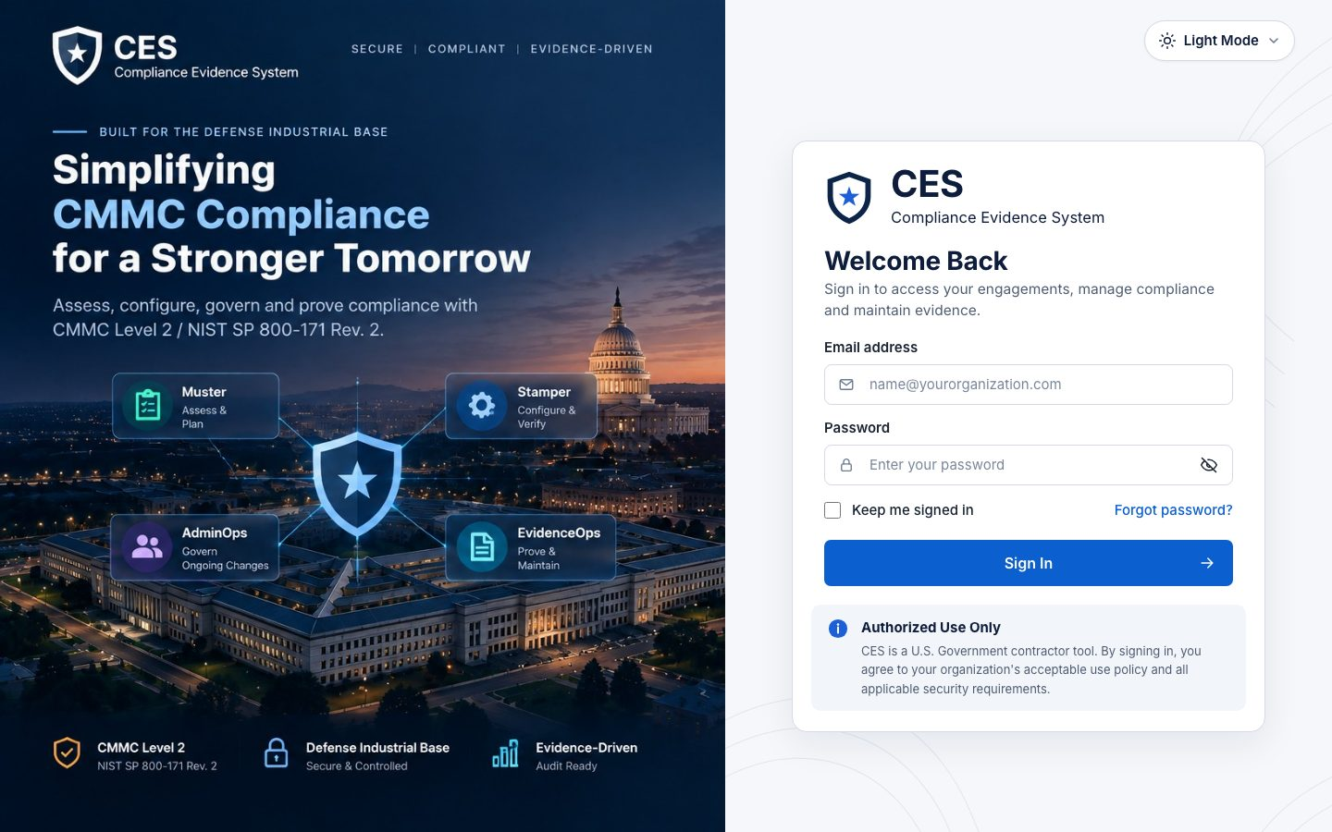
Figure 3 — Sign in (everyone).

Onboard

2. Organizations
Who: org admin Where: #/onboard/organizations
The customer's legal entities. Everything else in the engagement hangs off one of these.
- Create organization: legal name and basics
- Table lists what exists; open a row to edit
- Deleting is a soft close, history stays
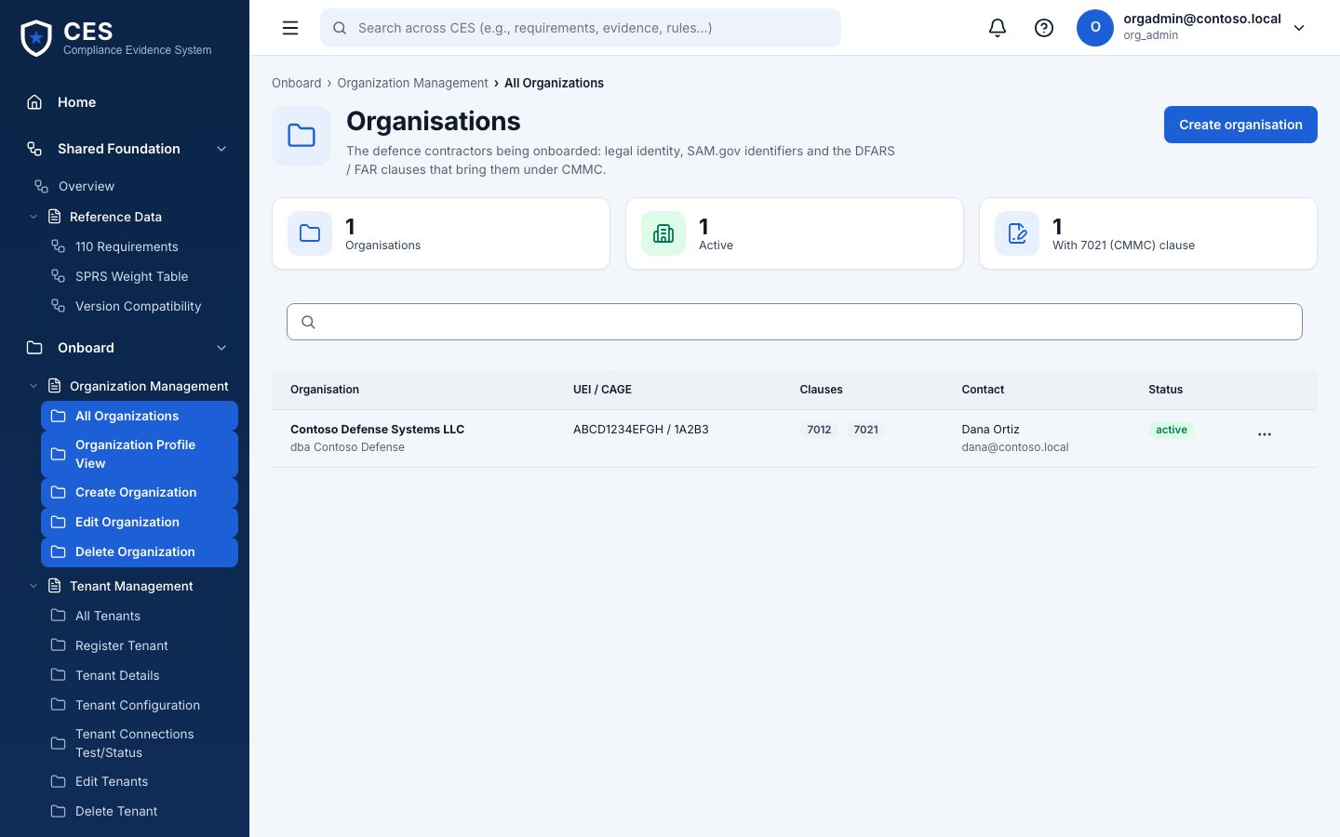
Figure 4 — Organizations (org admin).

3. Tenants
Who: org admin Where: #/onboard/tenants
The Microsoft 365 / Azure tenants in scope (GCC or GCC High). In the demo the tenant points at the simulator.
- Register tenant: name, cloud, identifiers
- Connection checks show whether the platform can reach it
- No credentials are stored here — the runner holds the certificate
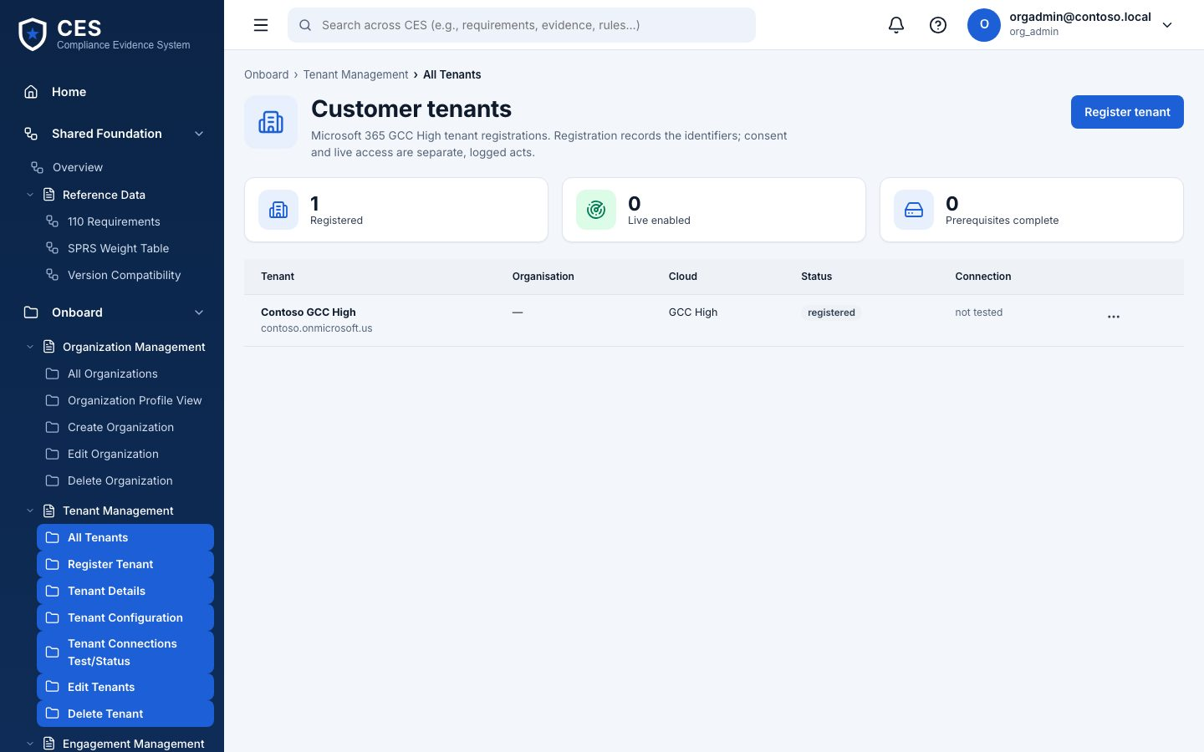
Figure 5 — Tenants (org admin).

4. Scope — CUI boundary
Who: compliance manager drafts · org admin confirms Where: #/onboard/scope
Which systems and assets handle CUI. Confirming a boundary version is a formal act: it is what the assessor sees as 'what you said was in scope'.
- Assets by category: CUI, SPA, CRMA, Specialized, Out of scope
- Draft → Confirm (org admin only); every version kept
- Narrative and data flows attached to the boundary
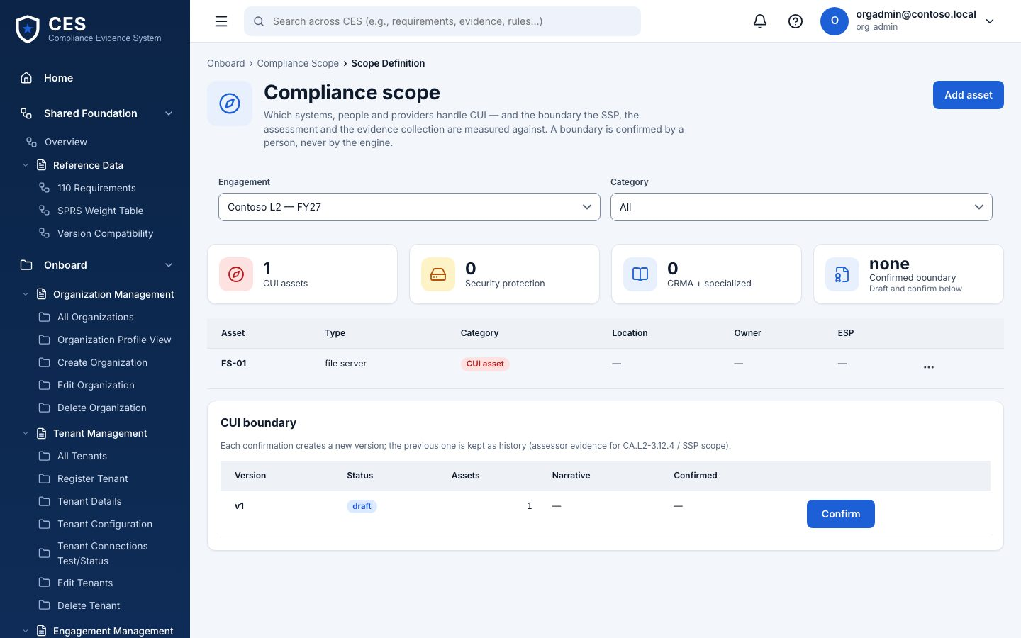
Figure 6 — Scope — CUI boundary (compliance manager drafts · org admin confirms).

5. Systems inventory
Who: compliance manager · org admin Where: #/onboard/systems
The systems and environments registry: name, environment, owner. Feeds the SSP system description later.
- Add a system with its environment and owner
- Everyone reads; compliance manager and org admin edit
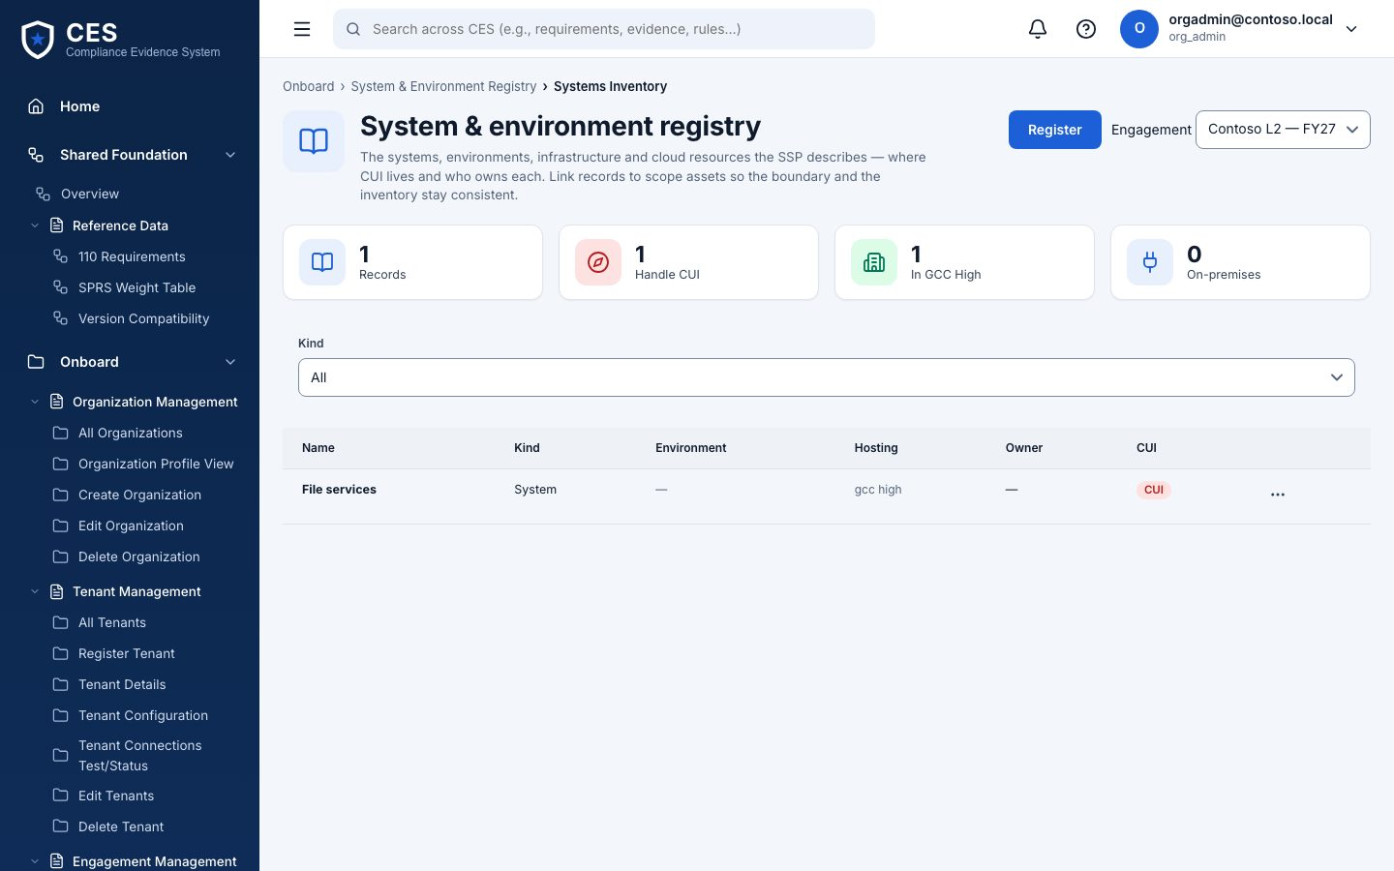
Figure 7 — Systems inventory (compliance manager · org admin).

6. Onboarding checklist
Who: everyone Where: #/onboard/checklist
What is done and what is still missing before an assessment makes sense. No actions here — it tells you where to go.
- Organization, tenant, boundary, systems, first run
- Each item links to the page that completes it
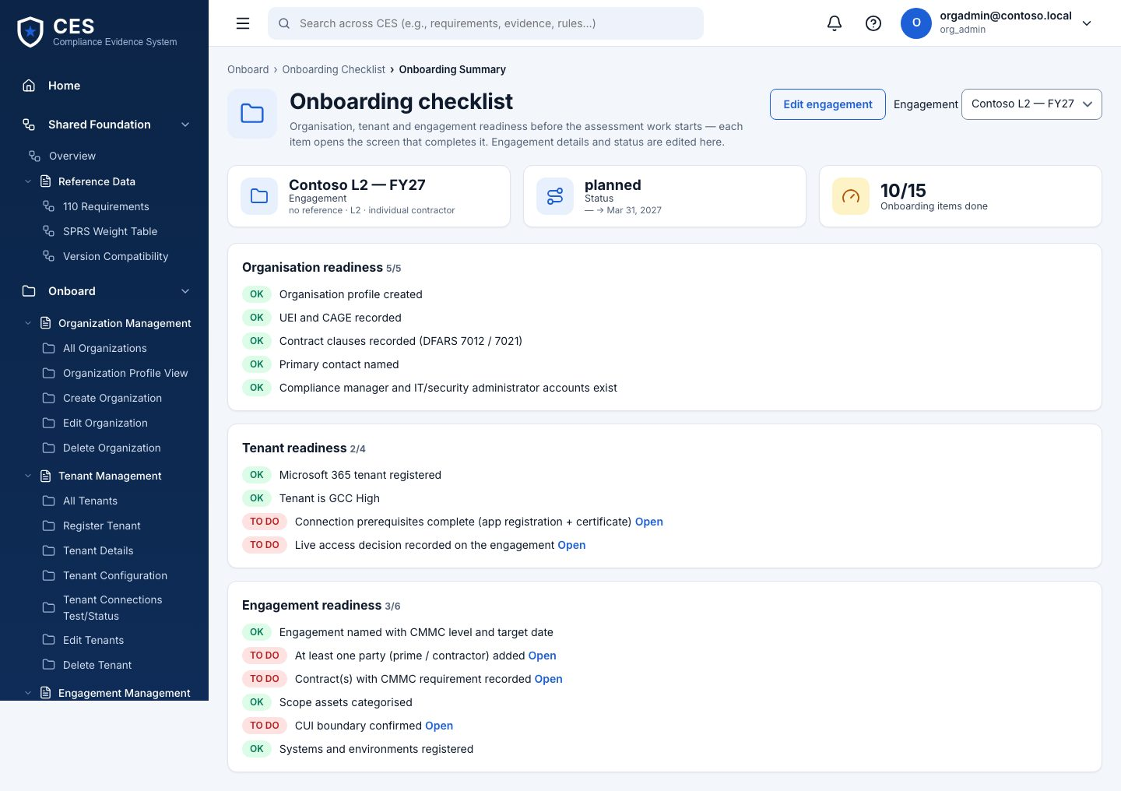
Figure 8 — Onboarding checklist (everyone).

Assess

7. Readiness assessment
Who: compliance manager · IT security admin · BHD operator Where: #/assess/readiness
The main screen. Pick the engagement and a run; the family table shows met / partial / not met / unknown per control family and the SPRS score. Run assessment reads the tenant (simulator or live) — never writes.
- Run assessment: 'Engine running…' on Windows, 'Queued…' until a runner picks it up elsewhere
- Unknown is honest: ~150 of 320 objectives need a document or a person
- Import readiness result: load a result file produced elsewhere (BHD)
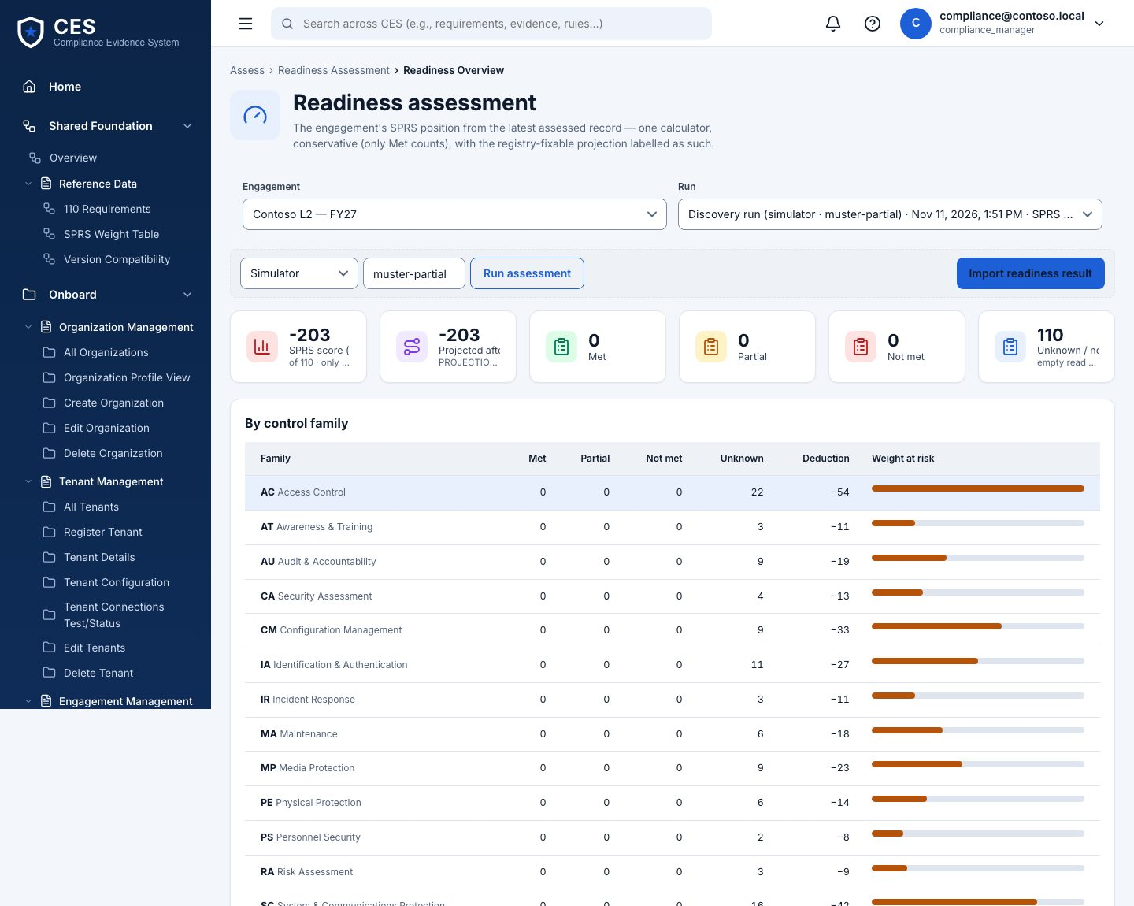
Figure 9 — Readiness assessment (compliance manager · IT security admin · BHD operator).

8. Gap analysis
Who: compliance manager · BHD operator (override) Where: #/assess/gaps
Every requirement that is not met or unknown, heaviest first (SPRS weights 1/3/5). Open a gap for its objectives; Override sets a status by hand with a reason, recorded under your name.
- Export CSV for the working session with the customer
- Override needs a reason of at least ten characters and is audited
- Fixable gaps point at Stamper registry entries
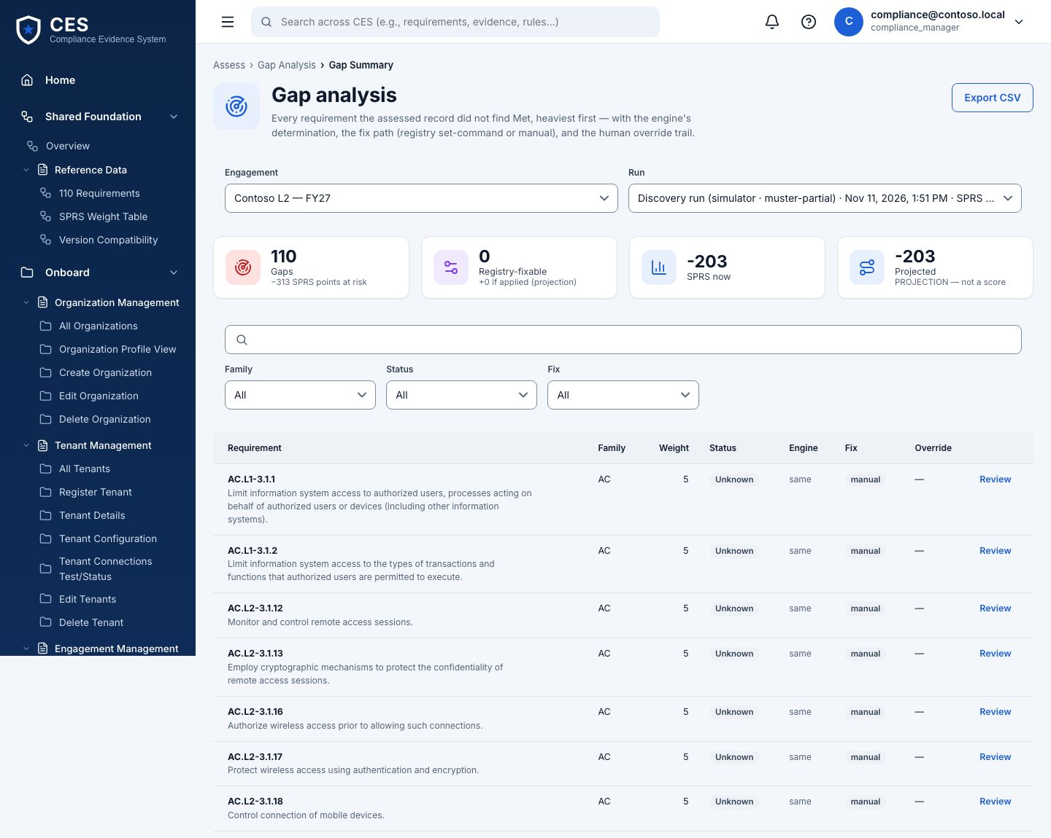
Figure 10 — Gap analysis (compliance manager · BHD operator (override)).

Plan

9. Planning overview
Who: everyone Where: #/plan/overview
Counts by priority and status across actions and POA&M items.
- Open vs in progress vs done
- Which gaps have no action yet
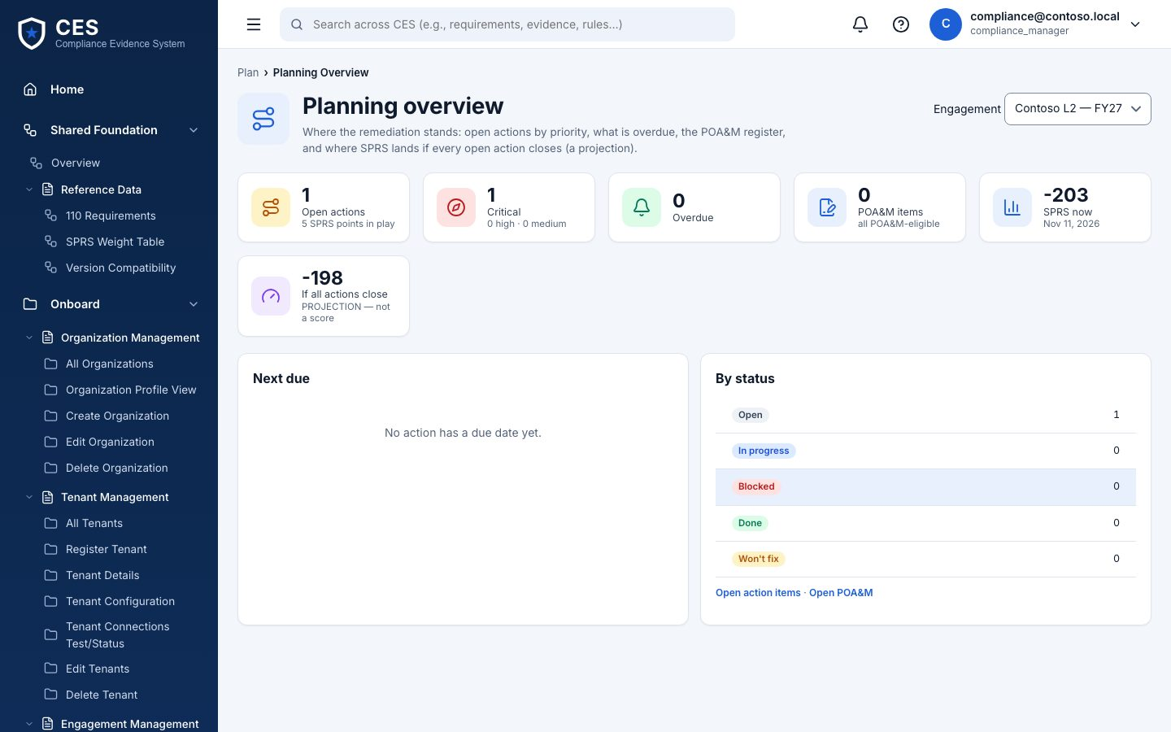
Figure 11 — Planning overview (everyone).

10. Action items
Who: compliance manager Where: #/plan/actions
One row per thing to do: requirement, owner, priority, due date, fix kind. 'Registry' fix kind means Stamper can do it automatically.
- Generate from gaps, or add by hand
- open → in progress → done / won't fix
- Export CSV
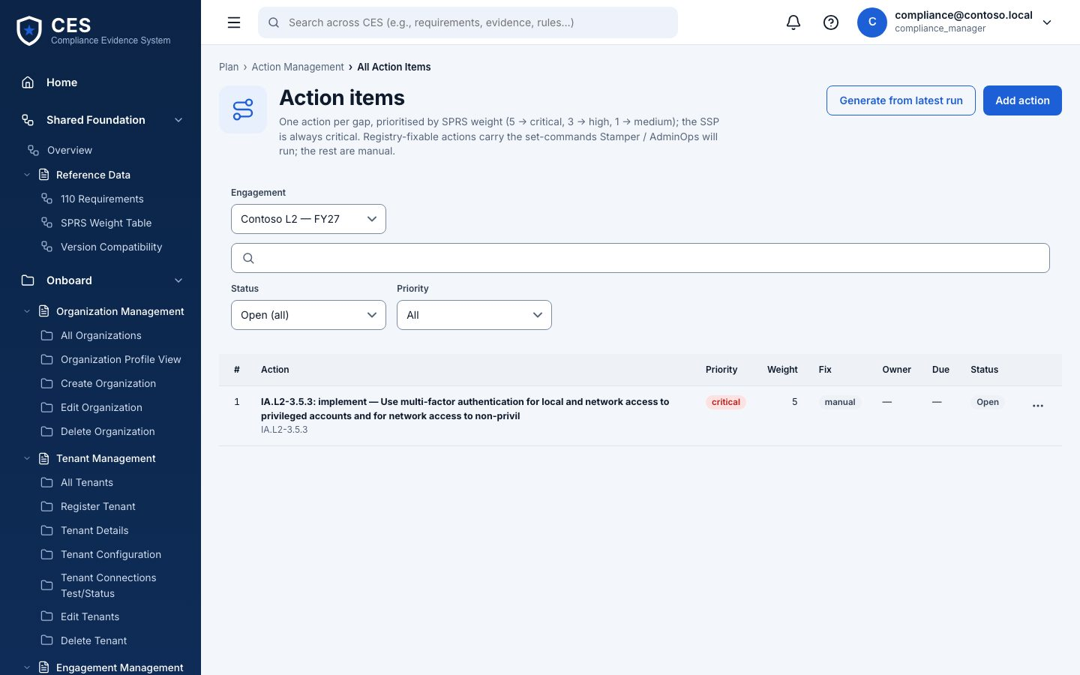
Figure 12 — Action items (compliance manager).

11. POA&M
Who: compliance manager edits · senior approver approves Where: #/plan/poam
The Plan of Action & Milestones an assessor expects: weakness, mitigation, milestones with dates, and whether a POA&M is even allowed for that requirement.
- Build from actions in one click
- Rows marked NO cannot be deferred — they must be met
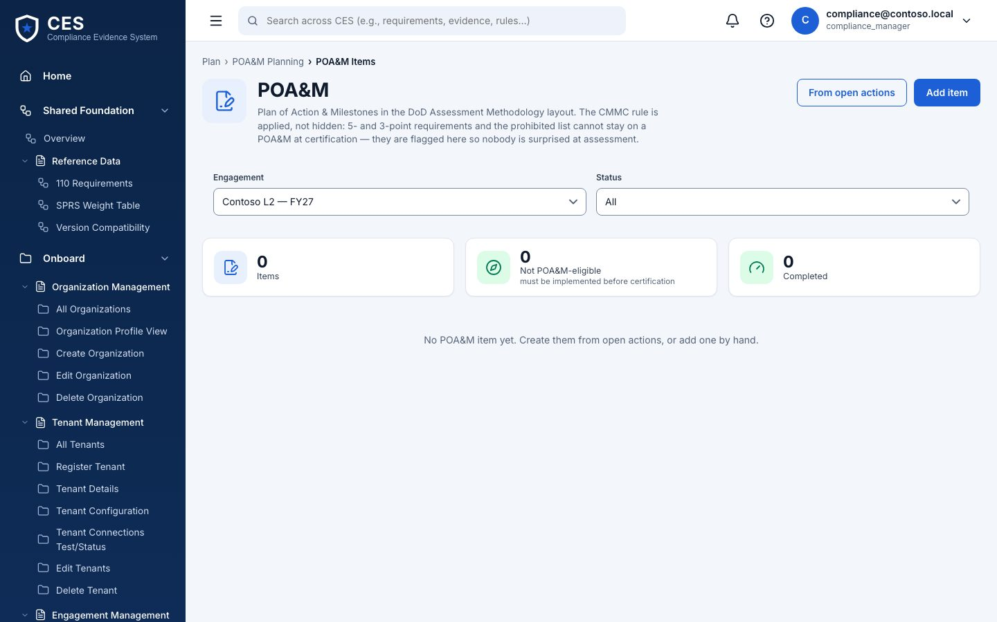
Figure 13 — POA&M (compliance manager edits · senior approver approves).

Remediate

12. Remediation overview
Who: everyone (Stamper runs: BHD only) Where: #/remediate/overview
Every run across both engines: who requested, module, mode (simulate / live), cost, gates, status. Open a run for its drawer: gates, result, and the actions your role has.
- Awaiting approval → Approved → (Queued → Running) → Finished · verify → Verified
- Rejected, Blocked by gate, Cancelled are terminal
- Simulate never touches the tenant
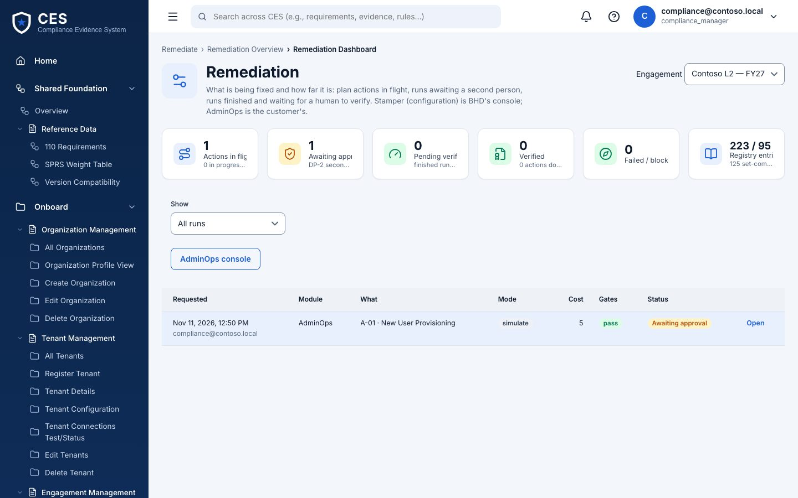
Figure 14 — Remediation overview (everyone (Stamper runs: BHD only)).

13. Stamper — configuration management
Who: BHD operator only Where: #/remediate/stamper
Configuration changes from BHD's registry. Pick entries (get = read-only check, set = changes something, HELD = manual), choose simulate or live, justify, request.
- A get-only run is approved on request; any set entry needs a second BHD operator (DP-2)
- Live needs the engagement's live-access flag and consent, re-checked at every hop
- Execute records the plan (simulate) or queues it for the Windows runner (live)
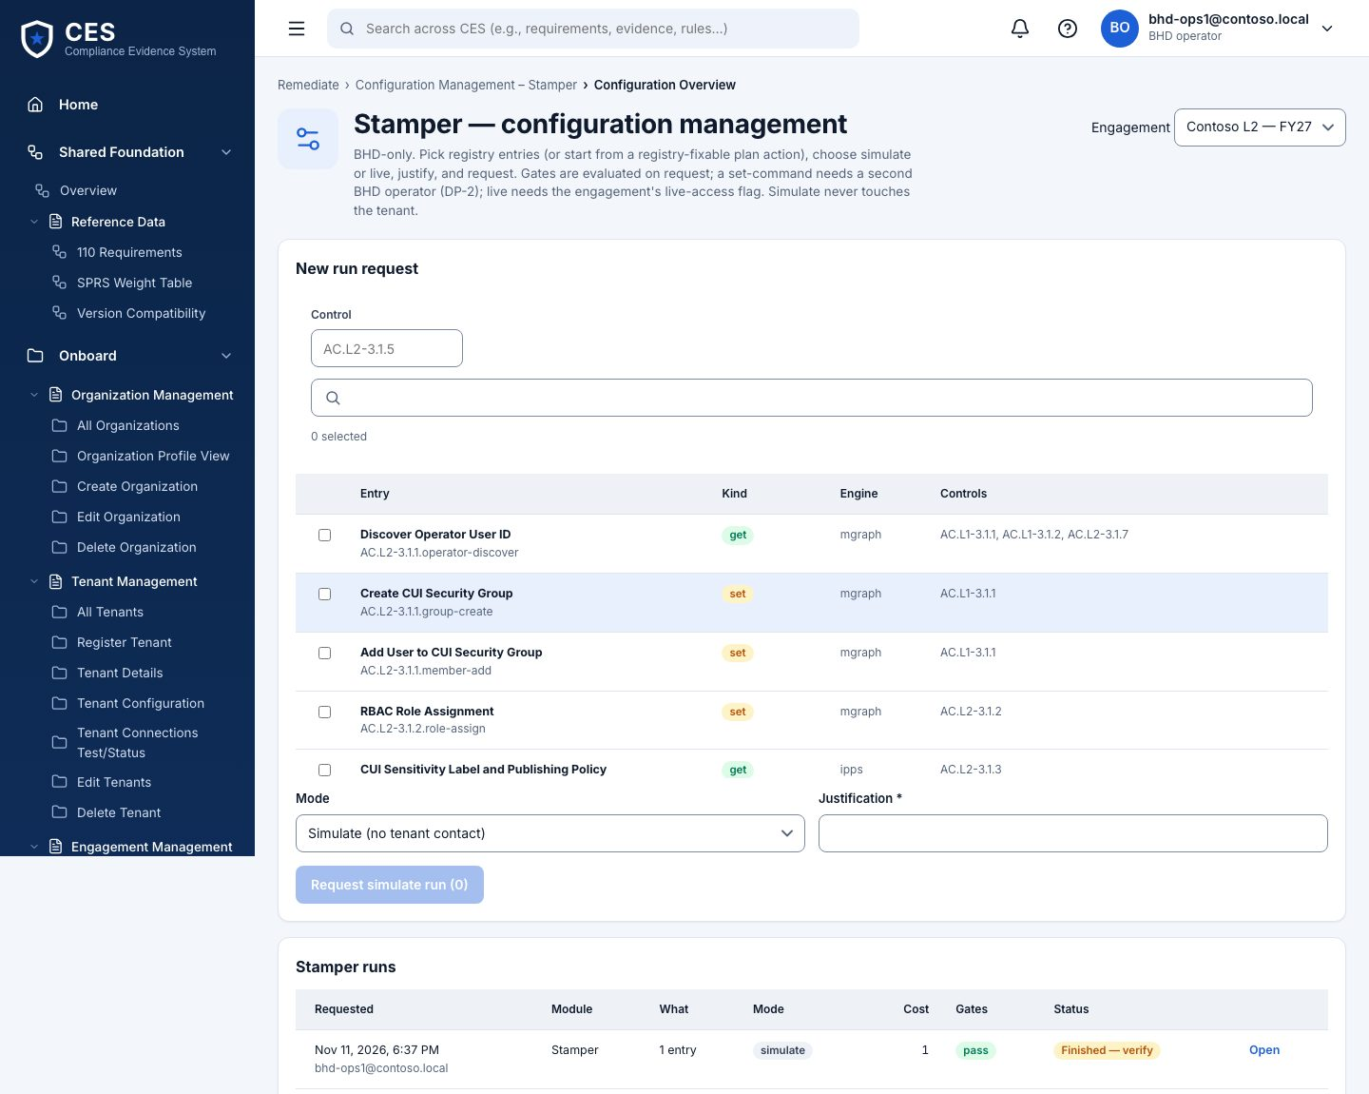
Figure 15 — Stamper — configuration management (BHD operator only).

14. AdminOps — governed admin operations
Who: IT security admin requests · senior approver or BHD approves Where: #/remediate/adminops
Day-2 admin operations by domain (Identity & Access, Devices, Credentials, Data Protection, Audit…). Pick an operation, fill its parameters, justify, request.
- Parameters never hold secrets — the platform refuses them (PB-02)
- Same approval and execute flow as Stamper
- Other customer roles see the queue, cannot request
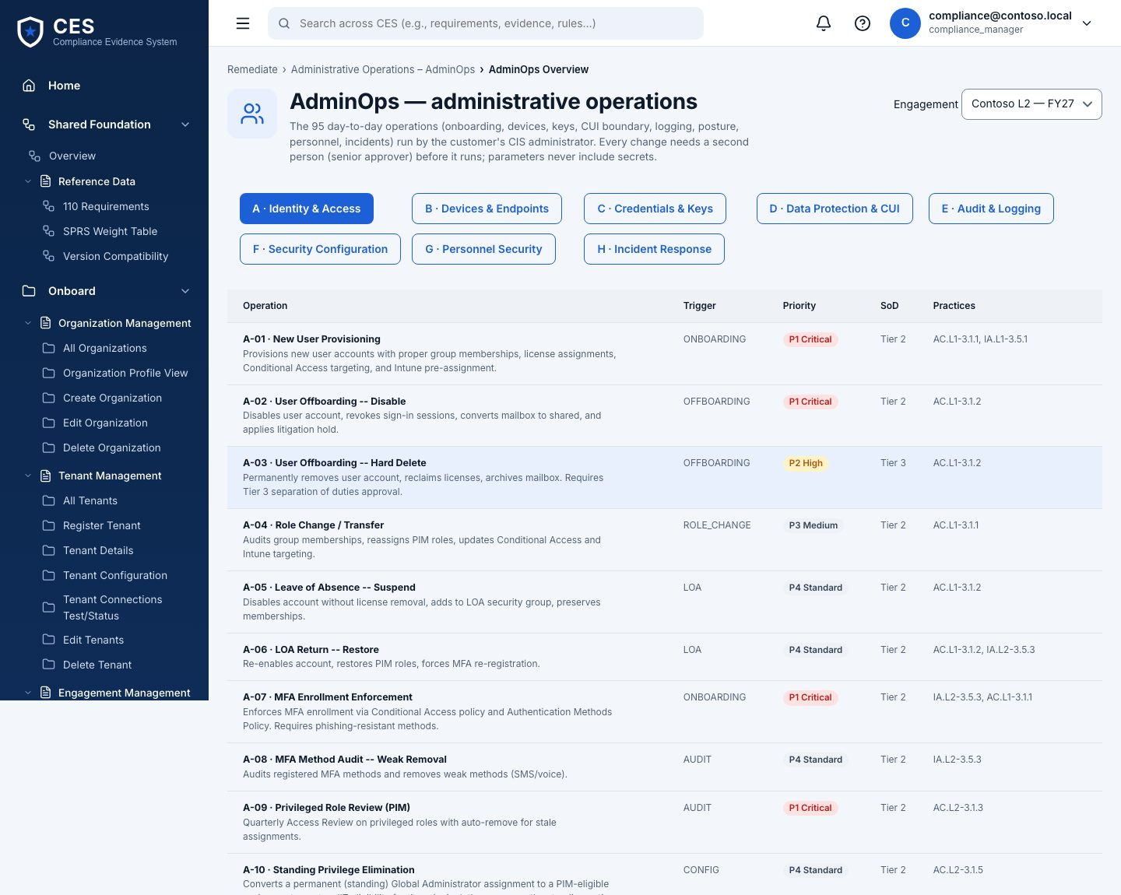
Figure 16 — AdminOps — governed admin operations (IT security admin requests · senior approver or BHD approves).

Collect Evidence

15. Evidence overview
Who: everyone Where: #/evidence/overview
Counts by status (draft, submitted, validated, rejected) and by source (discovery, stamper, adminops, manual).
- Coverage: which requirements have evidence, which do not
- Evidence requests outstanding
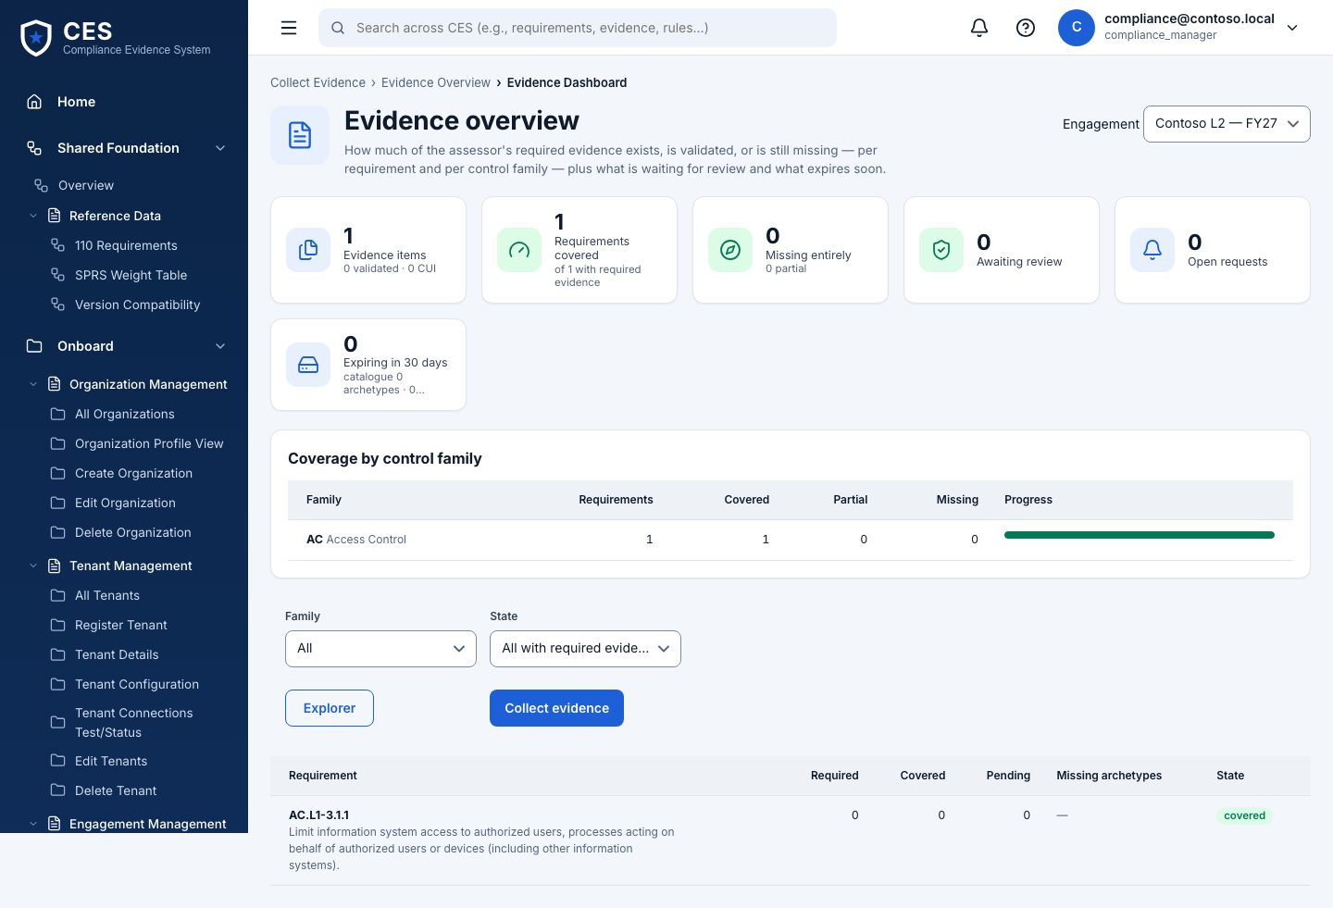
Figure 17 — Evidence overview (everyone).

16. Evidence explorer
Who: everyone Where: #/evidence/explorer
Every item: title, requirement(s), objective(s), source, SHA-256, size, status. Open one for the content preview, who created and reviewed it, and the run it came from.
- Lists never load content — open the item
- Captures from assessment runs arrive here as drafts automatically
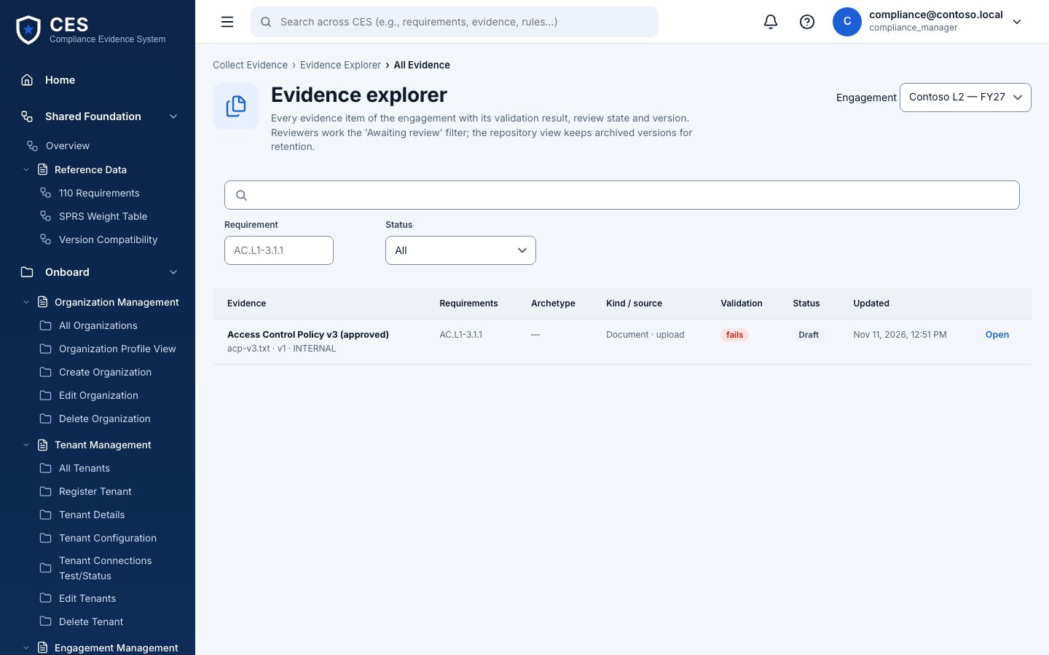
Figure 18 — Evidence explorer (everyone).

17. Collect evidence
Who: compliance manager · IT security admin · BHD operator Where: #/evidence/collect
Upload a file or paste text; choose requirement and objectives; optionally pick a catalog definition — what the assessor expects for that requirement. Submit for review.
- Inline evidence up to 10 MB; hash computed on save
- Pre-set definition from the catalog page lands here
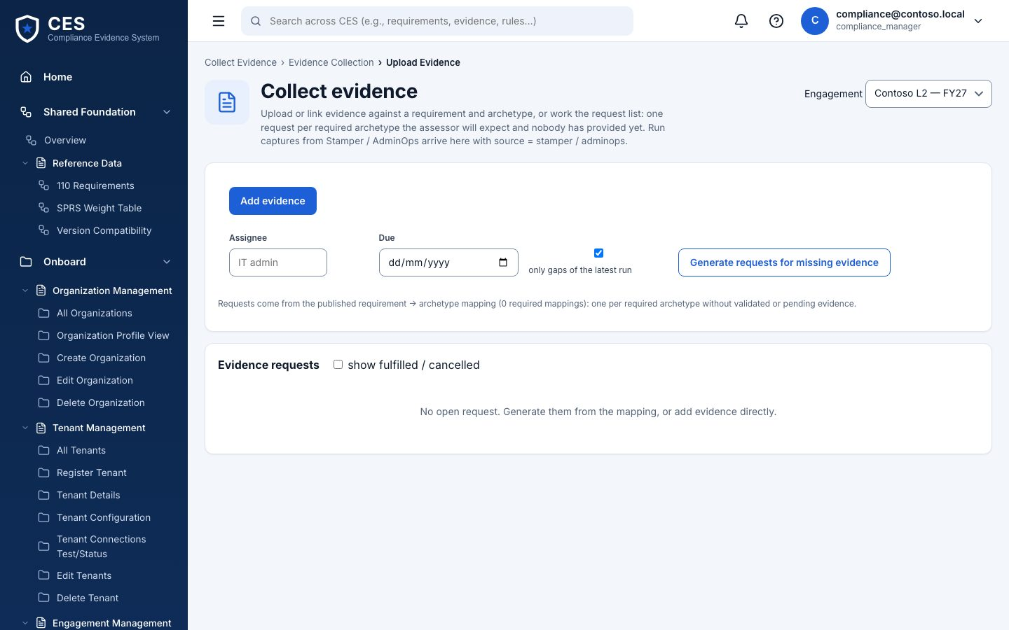
Figure 19 — Collect evidence (compliance manager · IT security admin · BHD operator).

18. NIST evidence catalog
Who: everyone Where: #/evidence/catalog
Per requirement, the NIST 800-171A examine items and the evidence definitions (form ids, what to collect, which objectives it satisfies). Release 0 covers AC.L2-3.1.1; BHD delivers the rest in batches.
- Click a definition → pre-filled Collect form
- Batch validator checks new releases before they are vendored
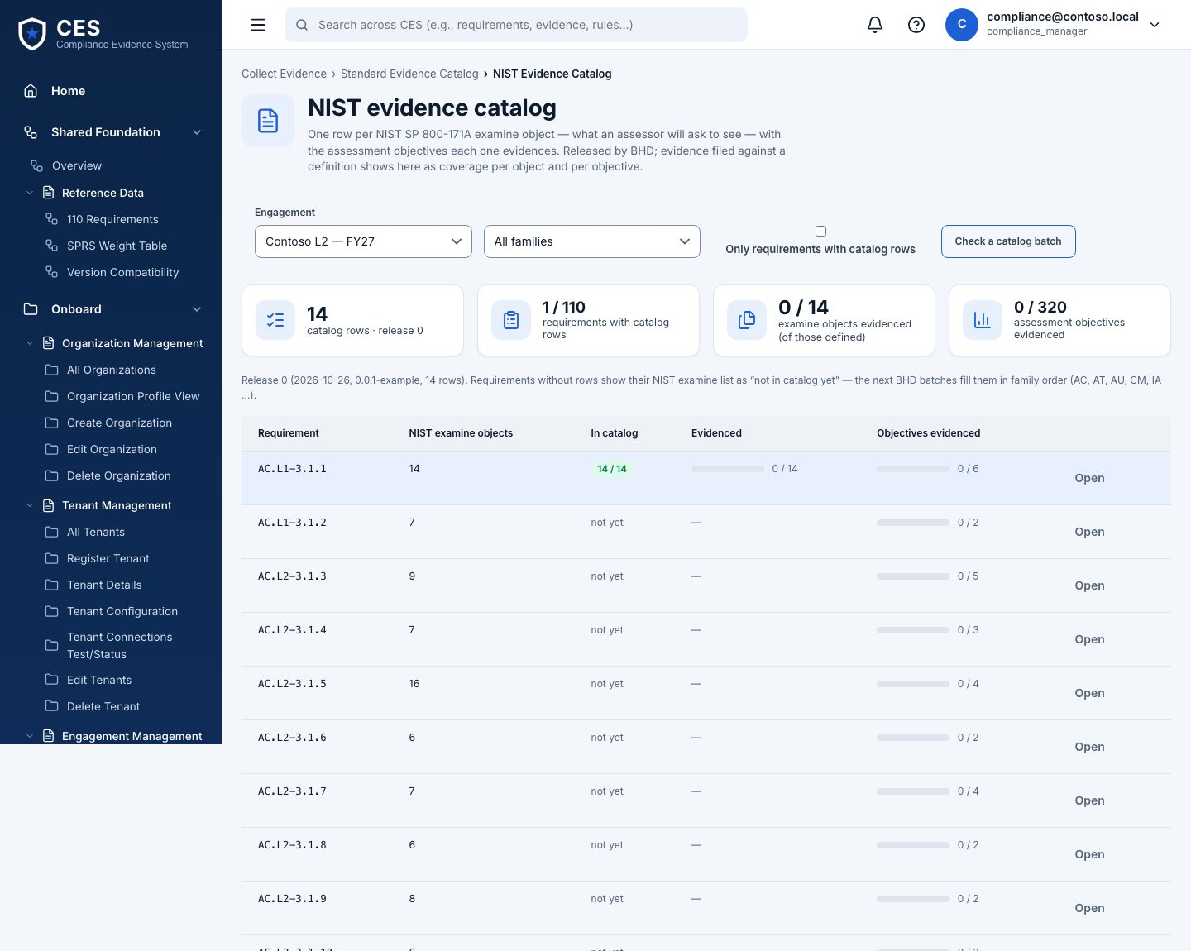
Figure 20 — NIST evidence catalog (everyone).

19. Review (as evidence reviewer)
Who: evidence reviewer Where: #/evidence/explorer
The same explorer seen by the reviewer: submitted items can be approved or rejected with a note. You cannot review what you submitted yourself — the page says so.
- Separation of duties enforced by the API, hinted by the UI
- New version supersedes, keeps the chain
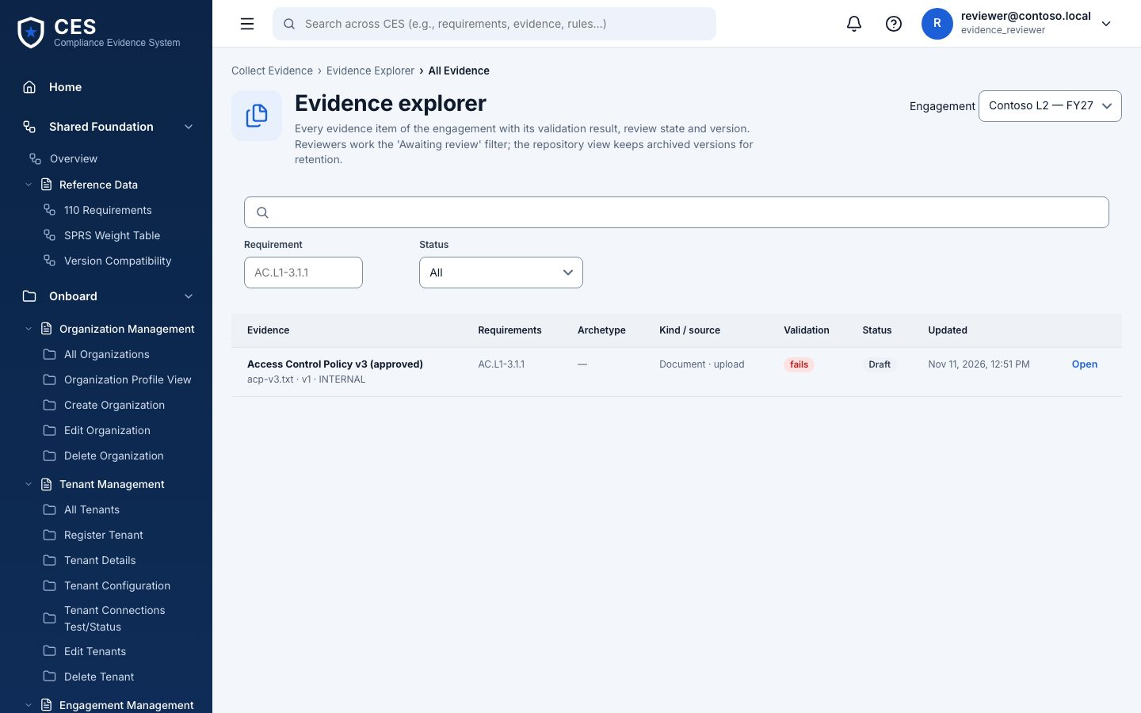
Figure 21 — Review (as evidence reviewer) (evidence reviewer).

Monitor

20. Monitoring overview
Who: IT security admin runs · everyone reads Where: #/monitor/overview
Compliance posture over time: findings open / acknowledged / resolved, last evaluation, drift since the last assessment. Evaluate now re-reads what it can; the scheduler does it on the engagement's cadence when switched on.
- Snapshots per evaluation
- Drift = requirements that were met and no longer are
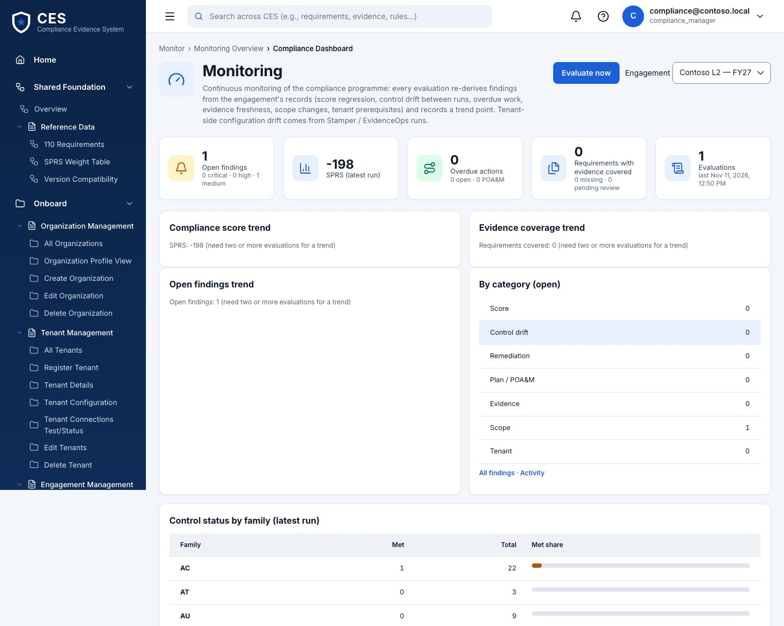
Figure 22 — Monitoring overview (IT security admin runs · everyone reads).

21. Alerts
Who: anyone with edit acknowledges · senior approver resolves / escalates Where: #/monitor/findings
Findings by family and status. Open one to acknowledge with notes, resolve, or escalate.
- open → acknowledged → resolved; escalated from either
- Every change lands in Activity
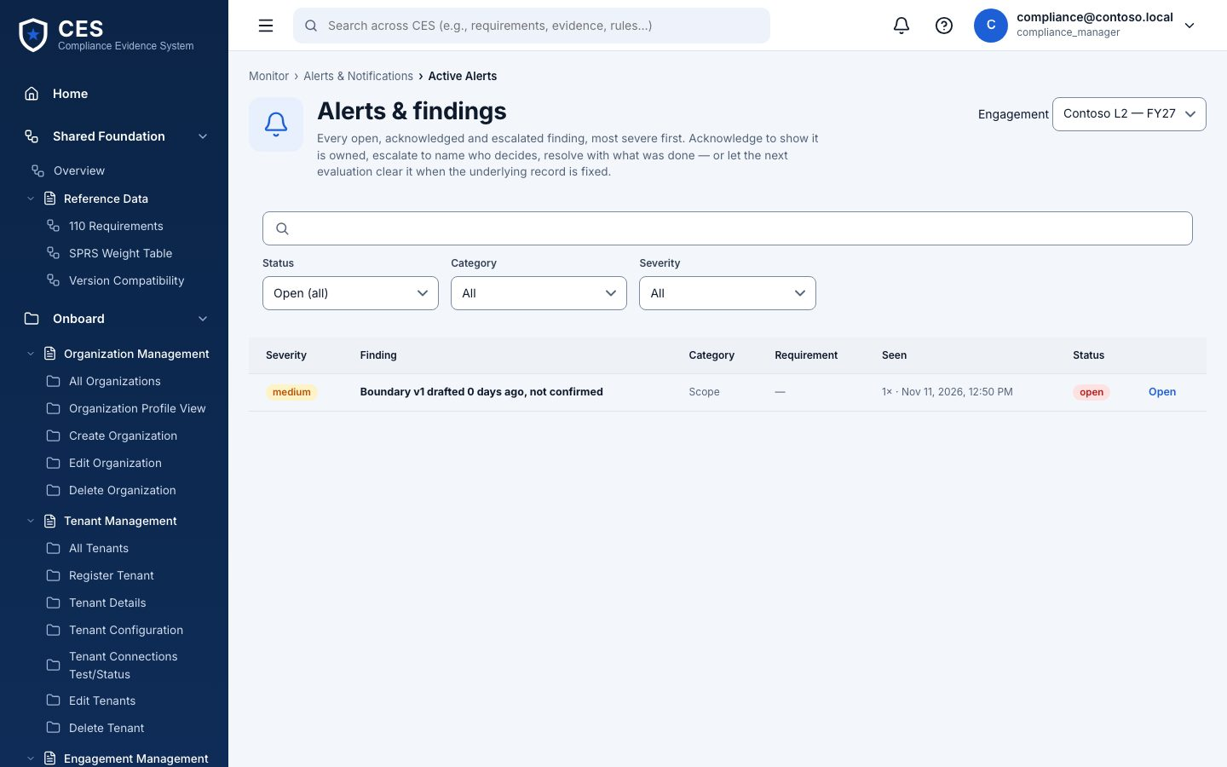
Figure 23 — Alerts (anyone with edit acknowledges · senior approver resolves / escalates).

22. Audit & activity
Who: everyone Where: #/monitor/activity
The audit trail for this engagement: who did what, when, filterable by text. This is the answer to 'who changed that'.
- Actor, action, target, time
- Approvals, executions, claims, results, overrides all appear here
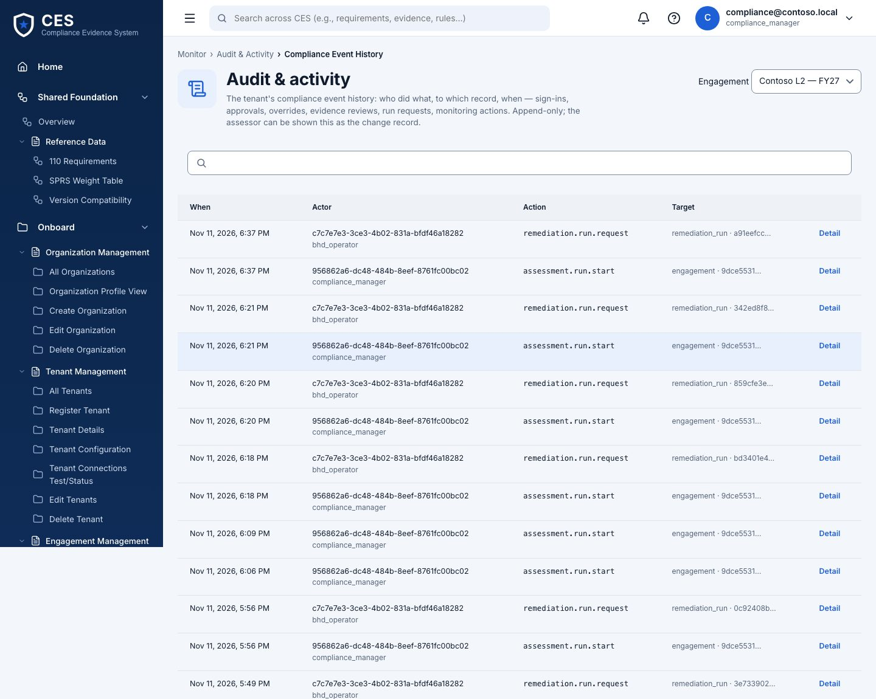
Figure 24 — Audit & activity (everyone).

Prepare

23. Assessment readiness
Who: everyone Where: #/prepare/overview
The checklist for the package: boundary confirmed, assessment run exists, POA&M present, evidence coverage, SSP statements, sign-offs.
- Each line says what is missing and where to fix it
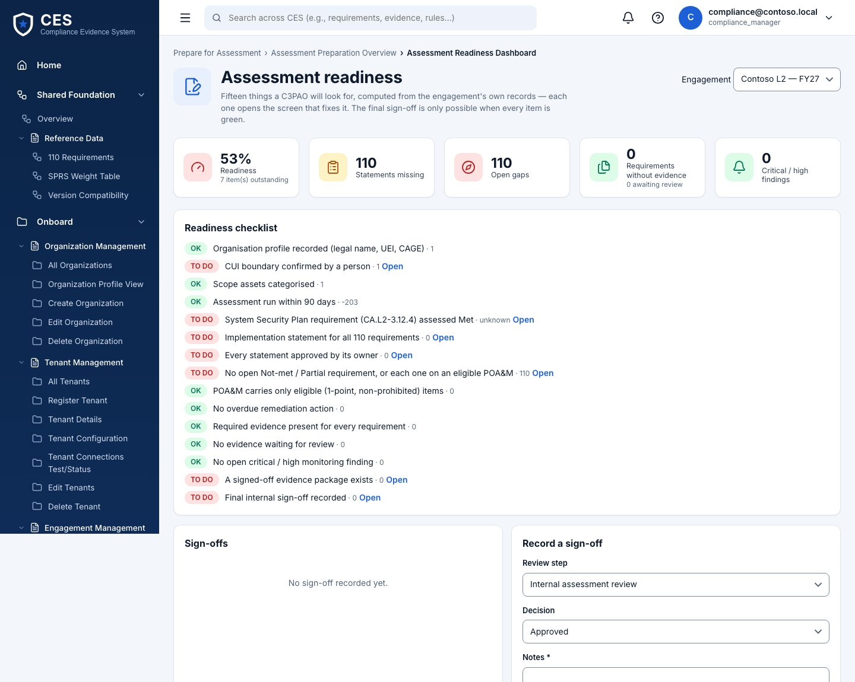
Figure 25 — Assessment readiness (everyone).

24. System Security Plan (SSP)
Who: compliance manager edits and approves Where: #/prepare/ssp
One row per requirement: implementation statement (draft → approved), implementation status, linked evidence. Generate drafts from the assessment and evidence; export as Markdown.
- Status: implemented · partially · planned · alternative · not applicable
- Approving a statement is a separate, audited click
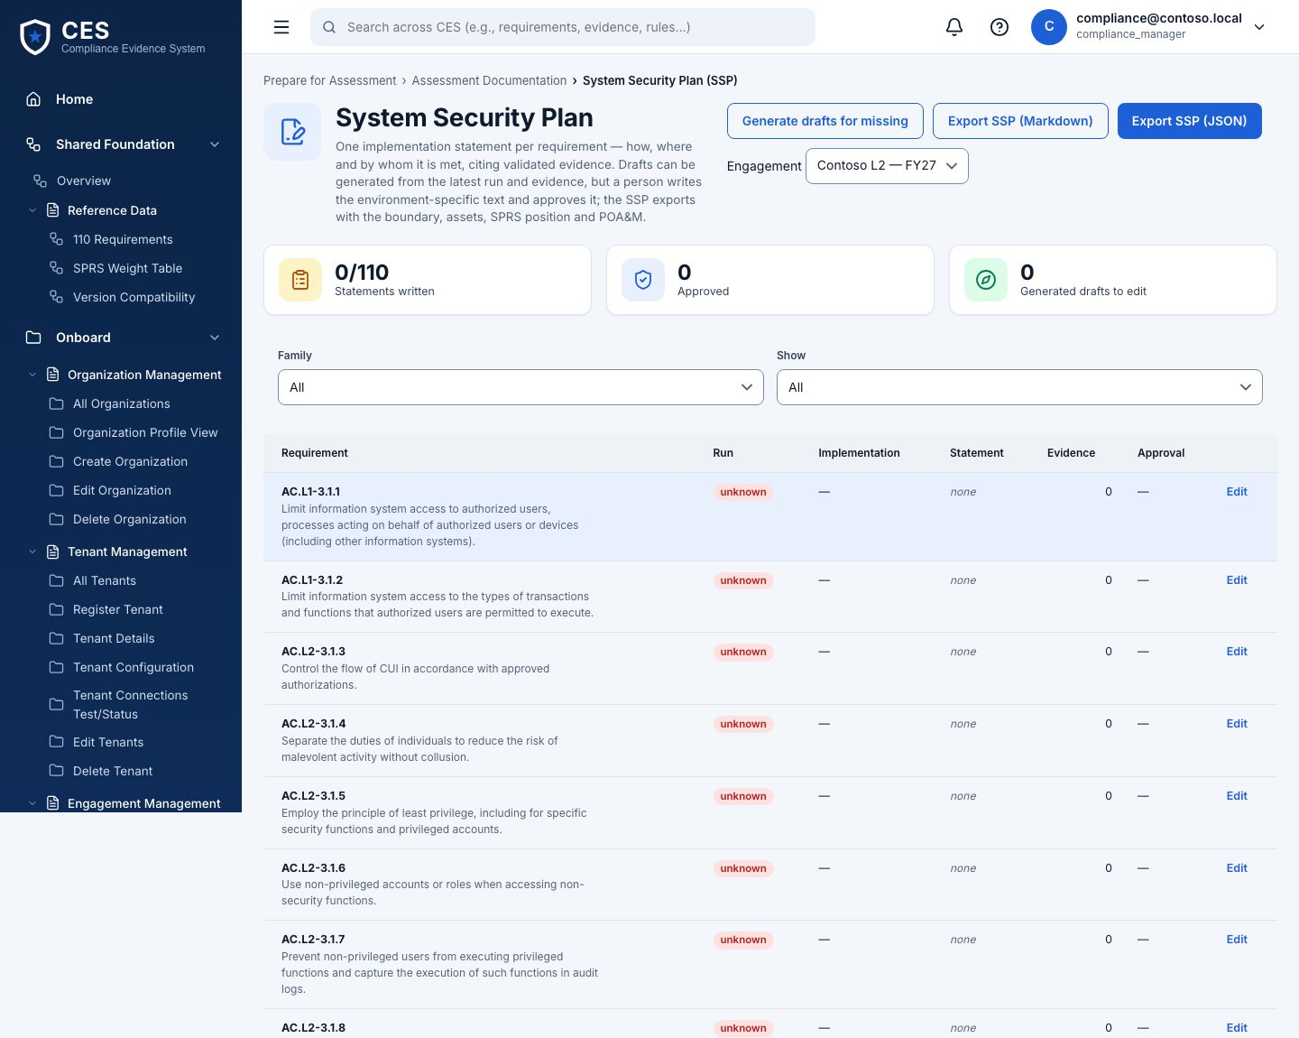
Figure 26 — System Security Plan (SSP) (compliance manager edits and approves).

25. Evidence packages
Who: compliance manager builds and signs (not the same person) Where: #/prepare/packages
Build an evidence package for a scope (all, a family, a requirement list): Build → Validate → Sign off. Versions are kept; a signed package is immutable.
- The builder cannot sign their own package
- Export the manifest for the assessor
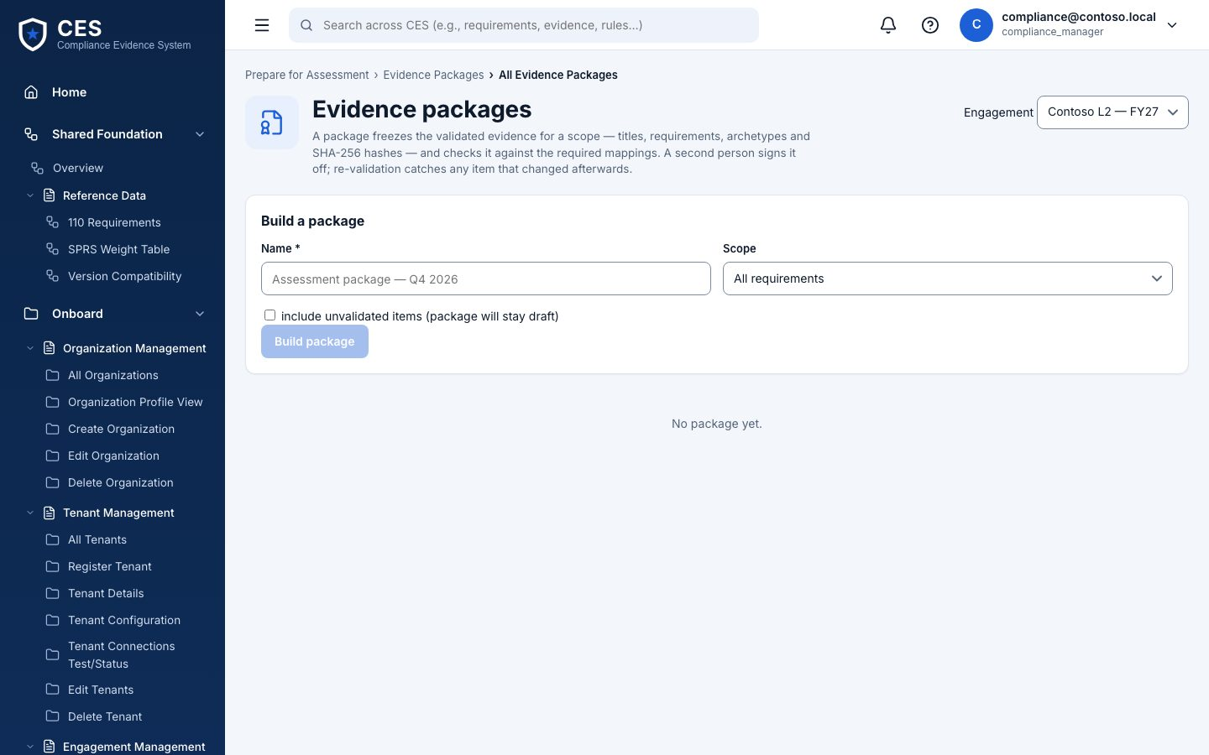
Figure 27 — Evidence packages (compliance manager builds and signs (not the same person)).

26. Assessor workspace (read-only)
Who: assessor Where: #/prepare/assessor
What the C3PAO assessor sees: the package, read-only, and a request list. They ask for an item; the compliance manager answers with evidence or a note.
- Nothing in this view can change the engagement
- Requests: open → answered → closed
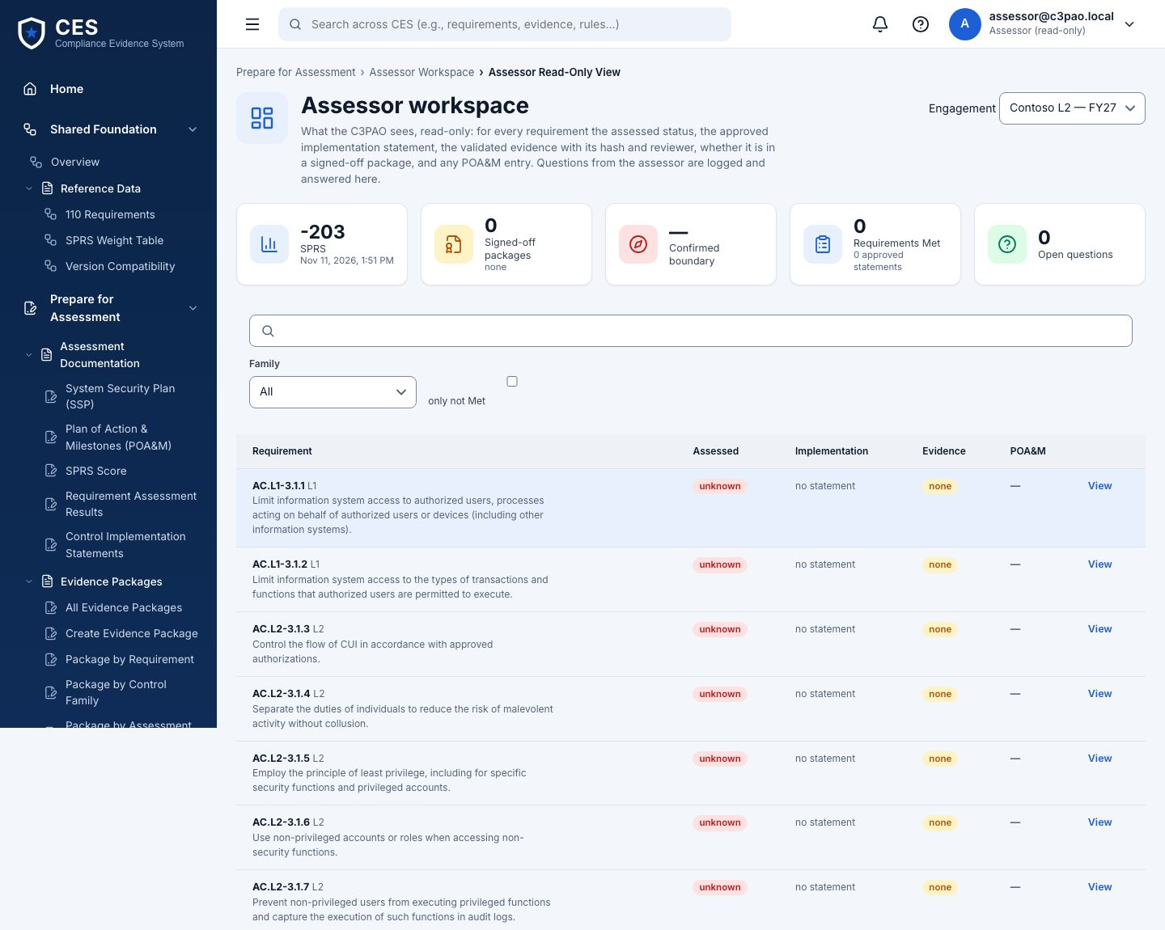
Figure 28 — Assessor workspace (read-only) (assessor).

27. Reports & exports
Who: everyone Where: #/prepare/reports
Readiness, coverage, gaps, SPRS, POA&M and evidence inventory as JSON, Markdown or CSV.
- CSV cells are formula-safe
- Same numbers as the screens — one calculator
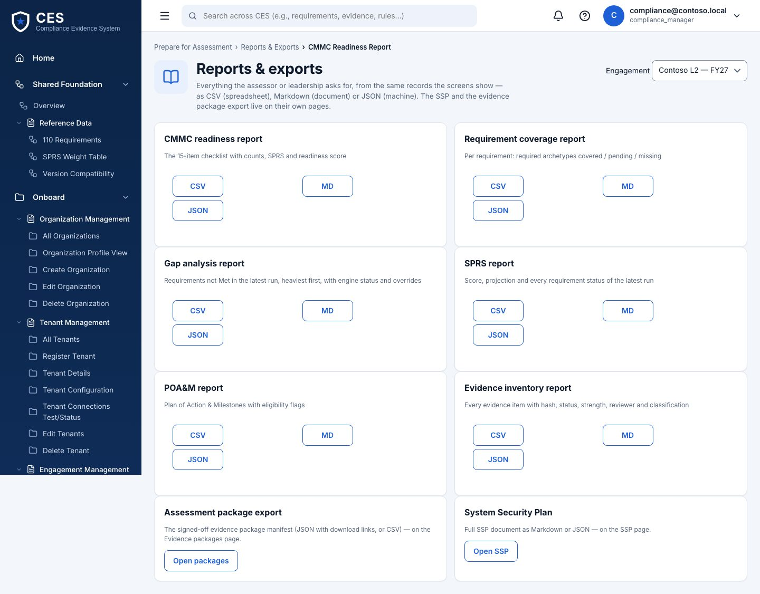
Figure 29 — Reports & exports (everyone).

Administration

28. Settings
Who: org admin edits · others view Where: #/admin/settings
Engagement details (name, reference, CMMC level, status, dates), monitoring cadence, notification settings, and the Modules tab: hide lifecycle sections for everyone in this organisation — a phased roll-out or a demo. Hidden is not disallowed; the API keeps enforcing the role matrix.
- Some settings are recorded but not yet enforced — the tab says which (open with BHD)
- Modules: Administration cannot be hidden; takes effect at the next sign-in or reload
- Every save is versioned and audited
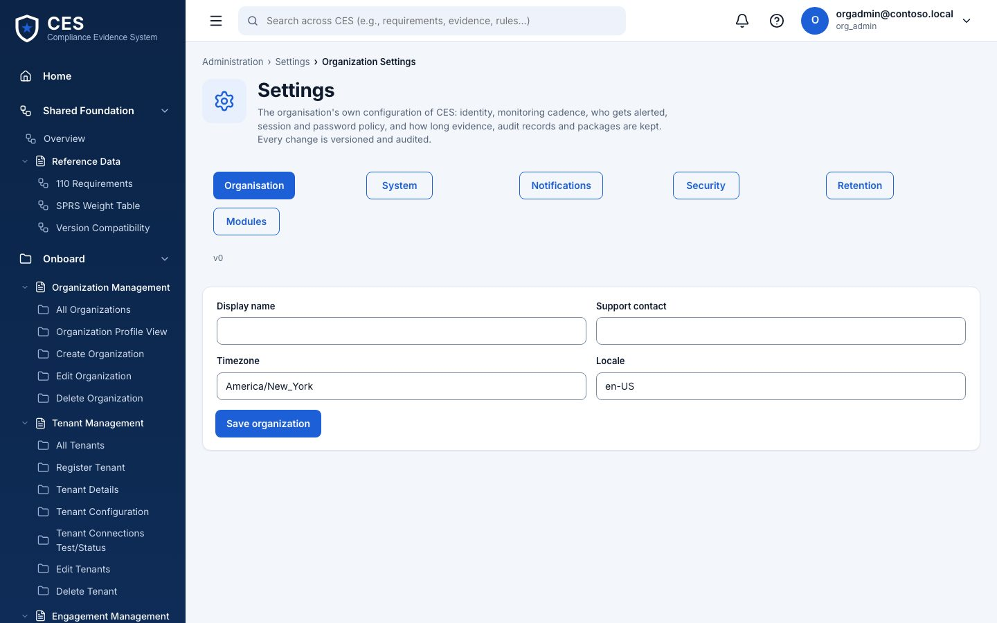
Figure 30 — Settings (org admin edits · others view).

29. Access management
Who: org admin Where: #/admin/access
Requests (anyone asks for a role, org admin decides), periodic access reviews (completion attested by a different admin), and Users: org-scoped user admin with customer roles only.
- Never grants platform or BHD roles
- Temporary password shown once; last org admin cannot be removed
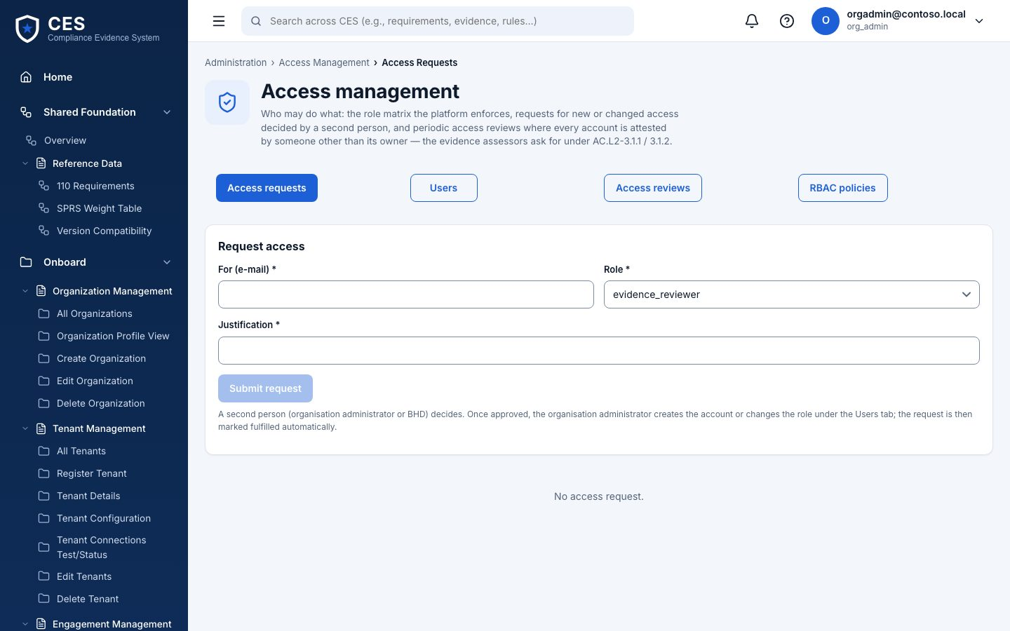
Figure 31 — Access management (org admin).

30. System health
Who: BHD operator Where: #/admin/health
Database, integrations (simulator / Graph reachability), the scheduler (on/off, last tick), and when a runner last claimed work. If Run assessment sits in Queued…, look here.
- Platform admin is fenced from tenant health (PB-01) — decision pending with BHD
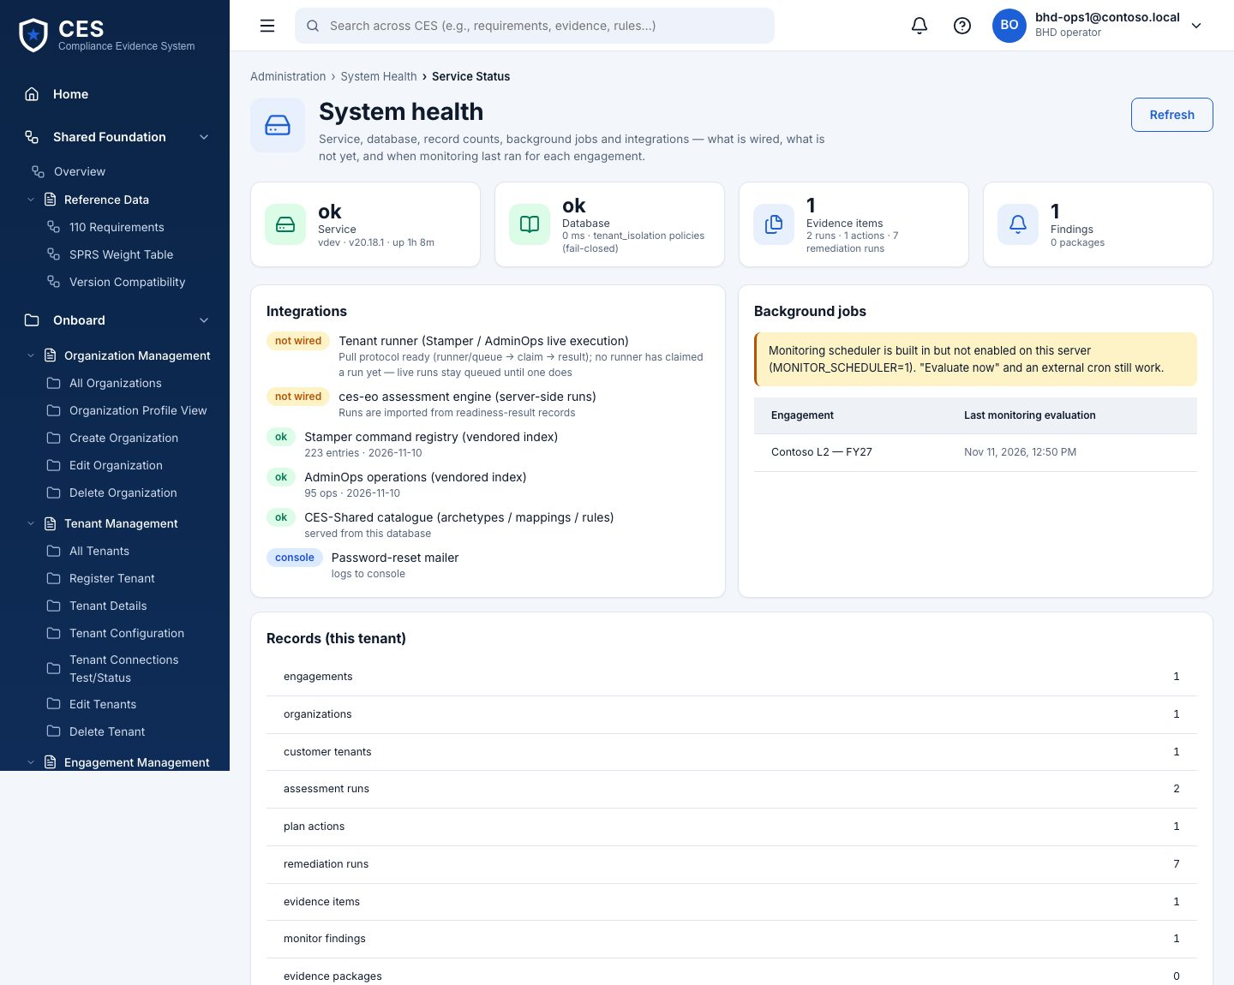
Figure 32 — System health (BHD operator).

31. Settings — Modules (show / hide sections)
Who: org admin Where: #/admin/settings
Untick a lifecycle section to hide it from every role in this organisation — for a demo, or to switch sections on as the engagement progresses. Save, then sign in again (or reload) to see the sidebar change.
- Hidden ≠ disallowed: the API still enforces the role matrix
- Administration and Shared Foundation cannot be hidden
- Audited like every settings change; the BHD operator sees it in Activity
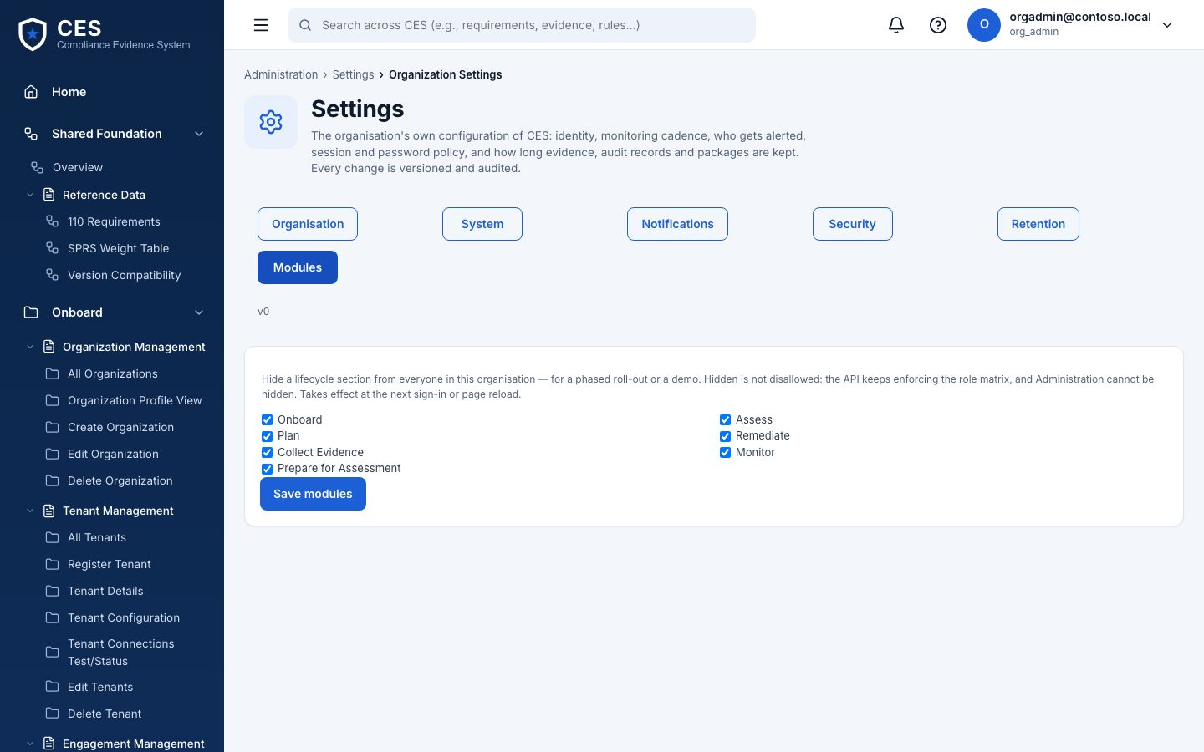
Figure 33 — Settings — Modules (show / hide sections) (org admin).

5. Run it yourself
The full developer setup is docs/DEV-SETUP-WINDOWS.md in the repository (Windows 10/11; the same steps work on macOS with the .sh scripts). In short:
Clone: git clone -c core.autocrlf=false https://github.com/aavya-engineering/CES.git C:\ces
Install (four trees): npm ci at the root, in ces-muster, in ces-muster\muster-api and in tenant-stacksim
Database: Postgres 16 (Docker: postgres:16); migrate as postgres, then scripts\bootstrap-app-role.sql creates the least-privilege app role
Configure: copy muster-api\.env.example to .env: DATABASE_URL (app role), JWT_SECRET
Seed: npm run seed:dev:win — the demo accounts above
Run: API: npm run dev (:4000) · portal: npm run dev (:5173) · simulator: npm run sim at the root (:4390) · optional runner: npm run runner
Verify: npm run smoke:postgres (every lifecycle slice against the real database) · CES_E2E_LIVE=1 npm run test:e2e:live (the browser walk)
Only one thing cannot work on macOS or Linux: Run assessment. The registry’s read commands are Windows PowerShell, so on those hosts the job queues for a Windows runner instead.

6. New-joiner training — five days
For an engineer joining the CES work. Each day ends with something you can show. The long form, with exercises and file-by-file traces, is docs/NEW-JOINER-TRAINING.md.

Day 1 — Run it and click through
Set up from section 5 until the smoke passes and you can sign in. Then sign in as org admin, compliance manager, BHD operator 1 and BHD operator 2 and do one thing each: look at the boundary and, in Settings › Modules, hide Monitor and watch it leave the sidebar (then put it back); press Run assessment and open the NIST catalog; request a get-only Stamper simulate run; execute it as the second operator. Write down three things that confused you.

Day 2 — The user journeys
J1 Where do we stand (Onboard → Assess → Gaps). J2 Fix it (Plan → Remediate; try live mode and read the refusal). J3 Prove it (Collect → review as reviewer → SSP → package → sign-off by a second compliance manager → assessor view). J4 Keep it that way (Monitor: evaluate as IT security admin, alerts, activity). J5 Run the shop (Settings, Access, System health as BHD). By the end, draw the sidebar from memory and name who can do what — then check against lifecycle/rbac.ts.

Day 3 — Read the code the way it runs
Trace one request: AssessPages.tsx → assessApi.ts → vite proxy → app.ts (bearerAuth → requireAction → router) → routes/assessments.ts POST /run → services/simDiscoveryRun.ts → liveSimSession.ts (powershell.exe) → landEnvelope → runCaptures.ts → lib/prisma.ts withTenant. Then trace Stamper request → approve → execute on your own and write the chain down. Exercise: pick any route in app.ts, say who can call it, what it writes, what it audits, and prove the first with a one-line denial probe in tests/roleMatrix.test.ts.

Day 4 — The engine, the runner and Windows
Read ADR-02. Start the runner with --once against a queued job on a Mac (it ends failed engine_unavailable — correct) and on Windows (it ends done with a run and evidence). Start the API with CES_ENGINE_LOCAL=0 to force the queue on Windows and watch the runner pick jobs up. Read src/runner/poll.ts (100 lines; every branch has a test). Exercise: run the lifecycle walk on Windows and add one assertion.

Day 5 — Ship a change the way we ship
Small branch from master; test first (mockDb for API, smoke for RLS, Playwright for UI); open it in the browser against the real API before calling it done; commit messages say why; PR; read the CI yourself; update the doc that describes the behaviour in the same PR. Graduation: add the role-matrix guard to one legacy router (/api/plan) with a denial probe, and open the PR.

Things we never do without an explicit yes
- Push to master directly or deploy to the demo server
- Touch a real tenant
- Add dependencies with native builds; run npm install instead of npm ci
- Put a credential anywhere the platform stores run parameters, logs or responses

7. When something looks wrong
What you see | What it means | What to do
"Your role cannot do this" on a page you can see | Sidebar and API share one matrix, but one page shows for a role the API fences (System health for platform admin) | Use the role the page is for; decision pending with BHD
Run assessment stays Queued… | The platform is not on Windows (or CES_ENGINE_LOCAL=0) and no runner is polling | Start the runner on the Windows host; check System health → last runner claim
Run assessment fails: engine_unavailable | All registry commands failed on that host — PowerShell missing | Run on Windows; nothing was recorded, by design
Run assessment fails: sim_unreachable | The simulator is not serving muster-partial on :4390 | npm run sim at the repo root
Approve button missing on a run you requested | Second-person rule (DP-2) | A different BHD operator / approver approves
Evidence content empty in a list | Lists never load content | Open the item
403 ROLE_MATRIX in the API log | The role matrix said no — scope and action are in the response | Check lifecycle/rbac.ts for who can
Zero rows where you expect data | A query outside withTenant, or signed in to another tenant | Both are correct behaviour; fix the code or the account
Five wrong passwords | Account paused for 15 minutes | Wait; the message says how long

Where things are
Thing | Place
Developer setup | docs/DEV-SETUP-WINDOWS.md
This guide (Markdown) | docs/USER-GUIDE.md
Training (long form) | docs/NEW-JOINER-TRAINING.md
Architecture diagram (editable) | docs/architecture/ces-platform.drawio
Permission matrix | ces-muster/src/features/portal/lifecycle/rbac.ts = muster-api/src/lib/permissions.ts
API reference | GET /api/docs on a running API (OpenAPI)
Runner | ces-muster/muster-api/src/runner (npm run runner)
SDLC set (PRD, FRS, SRS, HLD v2, LLD v2, tests, threat model, security review, ADRs) | Aavya Claude project "CES-BlueHeron", claude/ces-sdlc/

