Wireshark
Shows a packet diargams of DataLink, IP, TCP-IP (UDP) layers.
edit-perferences-appereance-layout->pane3->PacketDiagram
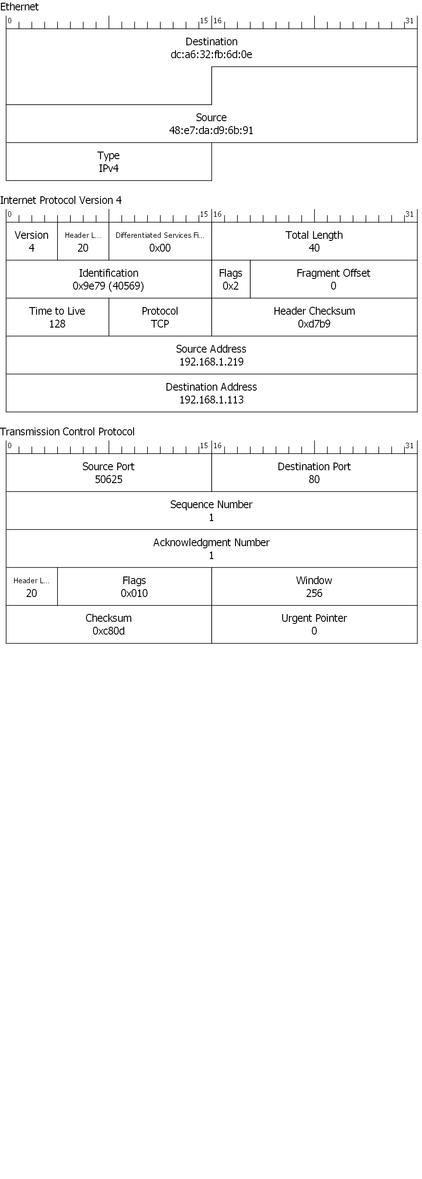

☼To add Time column (or an another column): Perferences-Appearance-Columns

☼To change time format: use a menu View>Time Display Format->.....

☼To change color of traffic (HTTP, TCP, lost packets,..): View->Coloring Rules. You can also add here a NEW rule + filter for the one.

☼DISPLAY FILTERS. Please see also **1 belove. If you needs to display ONLY (and, or) for example a packets with SYN flag – you click in the lower window (transmission control protocol->flags).Find the SYN flag and right clicking on the mouse.THere will be a menu: Apply as filter->Selected.This filters working with packets , which has been already captured. Examples: (tcp.srcport == 50548 or tcp.srcport == 80) && (ip.src == 192.168.1.219) || (ip.src == 192.168.1.113)
not (arp or ipv6)
tcp.port in {80 443 8080}
string filtering: frame contains google

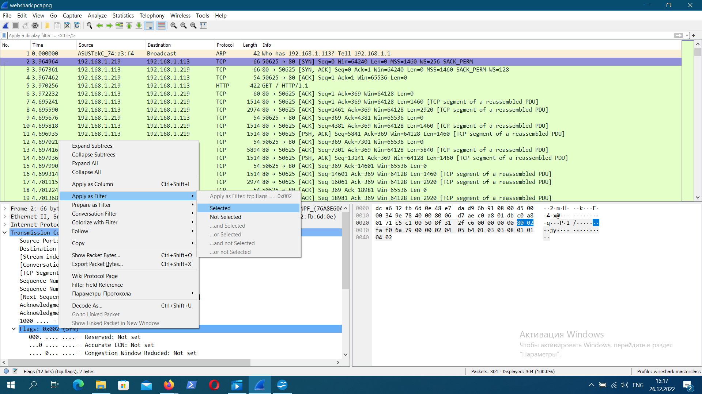
After this option there will be only SYN packets, another packets will be hiding.
To remove or change this filter – please click a red button that is on the right of the green strip with a filter rule (top side of the program's window below the program menu).The same order you can use to filtering IP addresses (two addresses separate with || ).

☼To manage a capturing process: Capture->Options .”Snaplen” - an amount of data to capture.Then push a button “manage interfaces” - you can turn on/off an inactive/active interfaces.

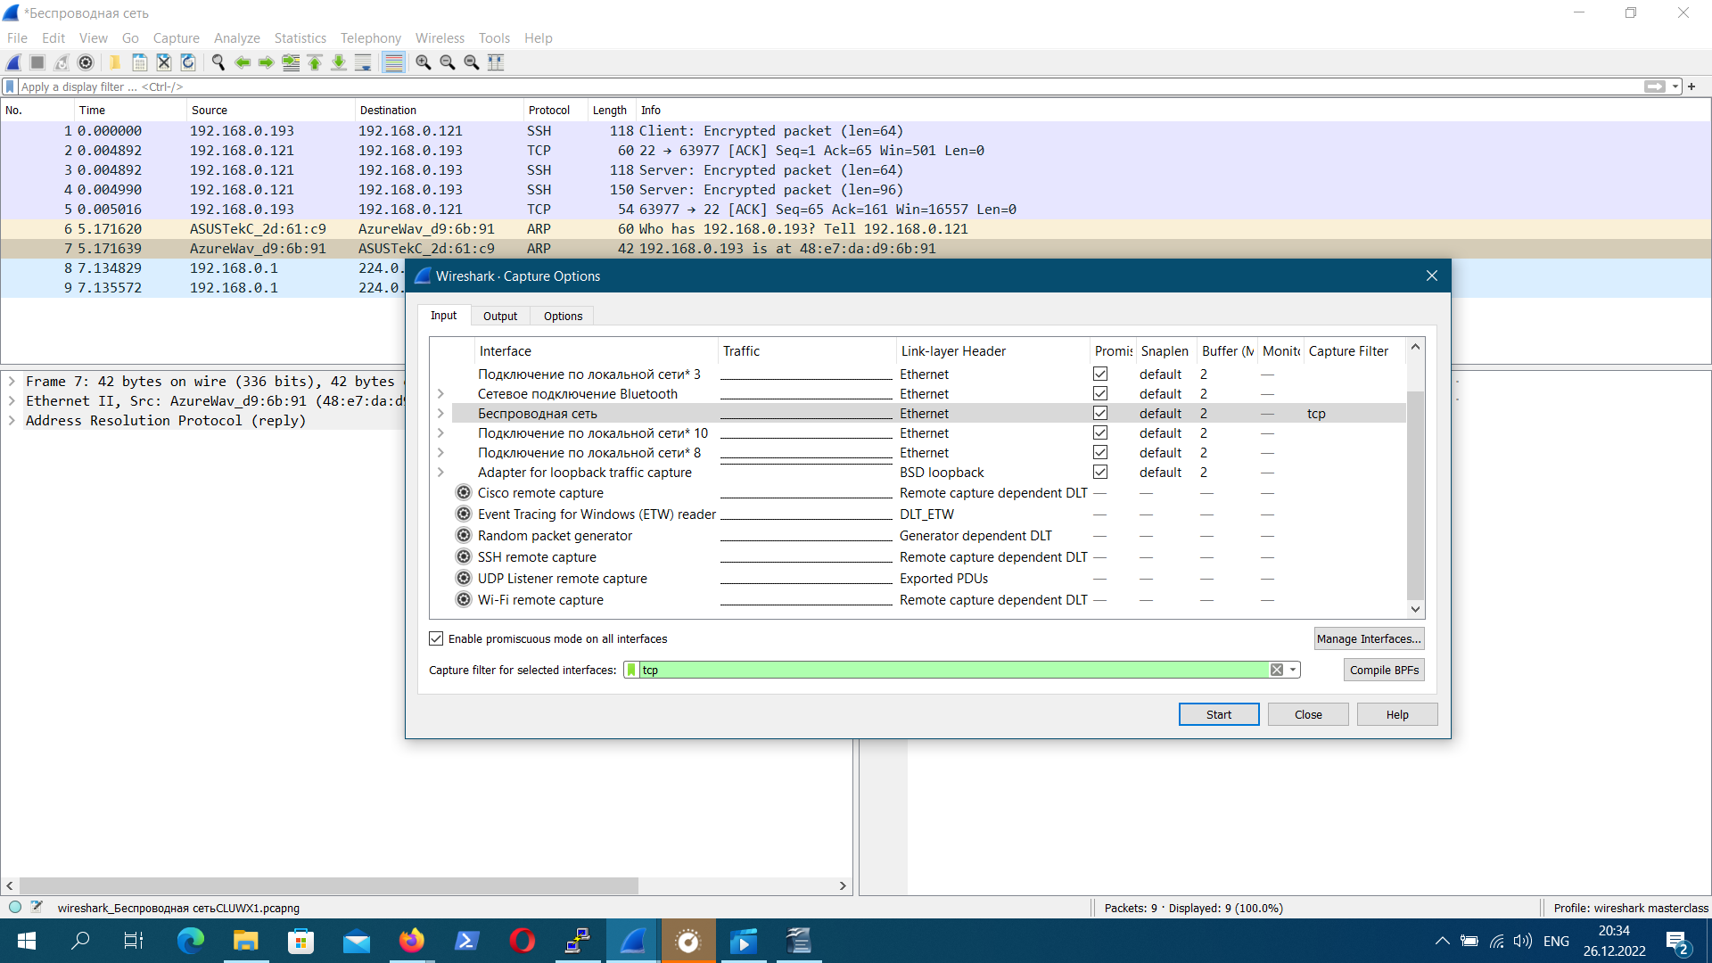
CAPTURE FILTERS. To filter packets during capture process – select Capture->Options.In this window select the interface (which you needs) and there are belove a text input: “capture filter for selected interfaces”.Type in the one the equation and run “Capture”.

FILTER EXAMPLES: port 53 ip.addr==192.168.0.1 tcp udp dns. They can be using together:
for example : ip.addr=10.2.15.11 || ip.addr==192.168.0.1 || port 80.

☼NAME RESOLUTION Menu Edit->Preferences->Name resolution. You can resolve MAC addresses , transport names, network IP addresses.You can see for example network host`s names instead of IP addresses.

ADD your own custom resolved name. Right click on the IP address.There appears a context menu.Select “ Edit Resolved Name”.

THE TIME COLUMN. Top Menu: View->Time DisplayFormat->... there are several variants: seconds since a first packet has been captured, UTC date/time, mSec, μSec, and other time formats.

TIME REFERENCE. When you want to see a time since certain packet (start a time counting since this packet) – select a packet and right click on the one. There will be a context menu. Select “Set/Unset Time Reference”

☼ **1 STATISTIC. Create auto display filters. Use a menu “Statistics->Conversations”.In this window you can select any conversation and right-clicking on the one. Then appears a context menu and you can select “Apply As Filter->Selected->”. This option allows to filter for example TCP communication between a server A and client B. It created a display filter. Use it to see ALL THE COMMUNICATION between a server and a client.

