NAT protocol
When you you have private network which has a private IP addresses – you must to convert you IPs into public address area.It works Network Translation Protocol. When we have one router and one IP from the internet service provider – the protocol uses ports number for translating and distinguish to which host a packet belong to :
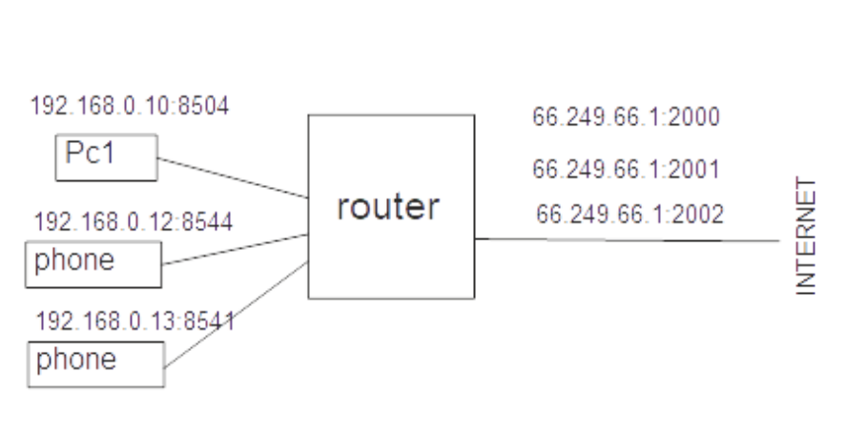
When we have a group of hosts (PC`s laptops, phones , IoT) with private IP`s and an another network - the NAT translating IP addresses from private to public.

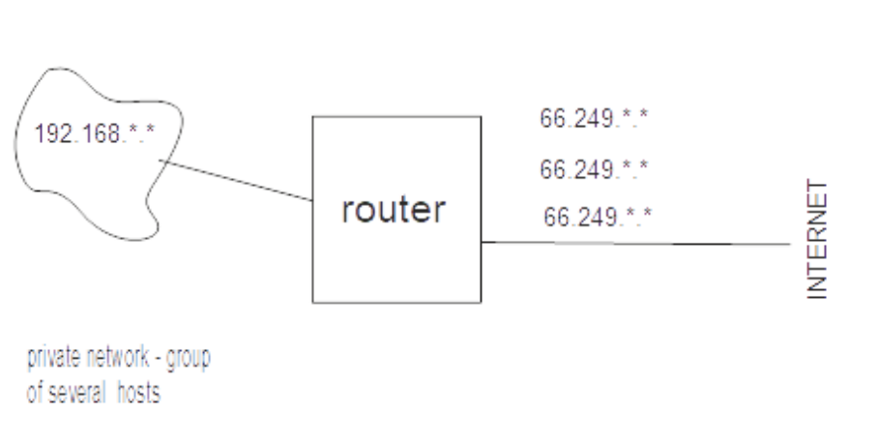
Static NAT: each private IP assigned to a specific routable IP address.
Dynamic NAT: The protocol enabled router dynamically assigns IP address to devices from a pool o an avaliable public IP addresses

ARP Address Resolution Protocol
The ARP protocol working on the data link layer and on the network layer.
The ARP responsive to resolve MAC address when we know IP address.
A host A (192.168.0.64, MAC:1ab) wants to send an info to an another host B (192.168.0.80,
MAC:?).
1)The protocol ARP on host A looks up in it`s own table MAC of host B.

2)When it hasn`t been found – ARP sends a broadcast ARP request to all the hosts in the local network.

3)The host which IP has been matched – returns a MAC to the protocol.

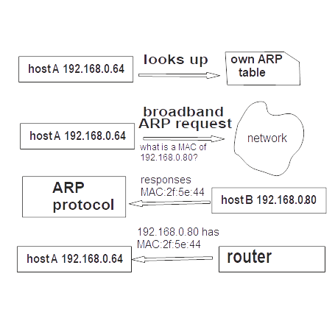
4)The router returns MAC of host B to host A.

When we want to send a request in an another network – a host A sending the
ARP to the gatway. The ARP on the gatway responses with the MAC of this gateway.

DHCP Dynamic Host Configuration Protocol

This protocol allows a host to have own IP, a default DNS server's IP, Subnet mask automatically -
because a static configuration of IP is inconvenience and difficult to support and service: (sys administrator MUST each time reconfiguring IP of the host when a new device appears in the local network.
When a host wants to get an own IP address – it sends a request(using UDP port 67): is there a DHCP server?
The server response on MAC address of the host (UDP port 68)
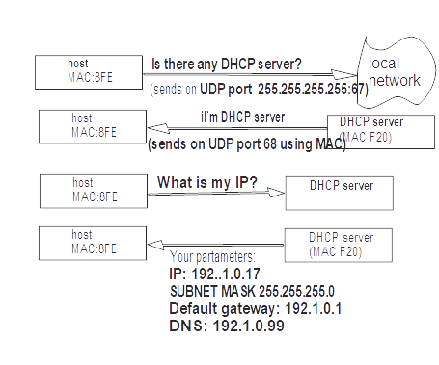
A DHCP offer (response from the DHCP server to a host) has usualy lifetime - 3600sec

OSI levels

2 Data Link layer
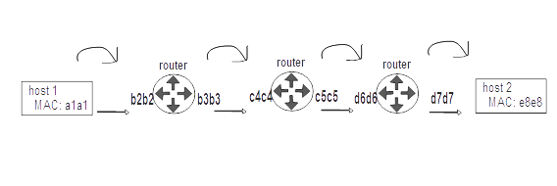
This layer using from translating data hop-to-hop. Each network device (card) has own MAC address: 48bits 94:65:9c:3b:8a. Every NIC (network interface card) has own unique Mac address.
WHERE : network interface cards, switches. Datagrams have a source and a destination MAC. When a datagram goes through networks – these fields changing.
Addressing scheme -MAC addresses

3 Network layer
End-to-end delivery. The layer responsive on delivery a data from one host to an another.
Where: routers, hosts.
Addressing scheme – IP addresses.
When a data goes through nodes (routers) the source and destination MAC addresses is changing
The ARP protocol working between the data link layer and the network layer.

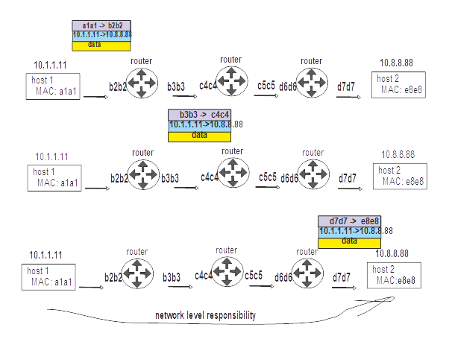
4 Transport Layer

This layer distinguish data streams. Address scheme -ports. There are 2 protocols – TCP and UDP.

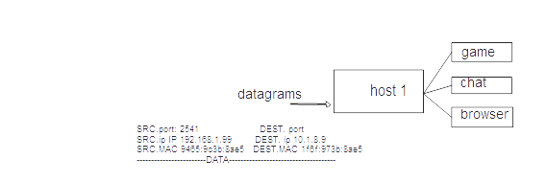

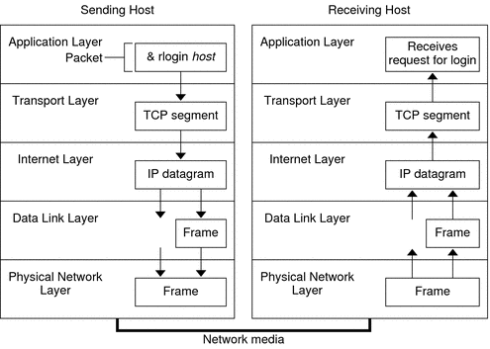
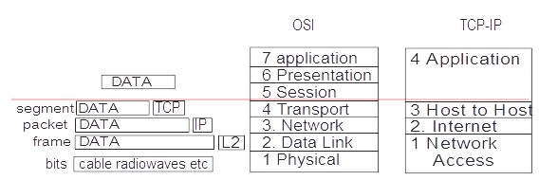

TCP protocol
The transmission control protocol provides relaible delivery data between sides. The connection starting from three-way TCP handshake.
C L I E N T :
0) flags: SYN, source , destination numbers of ports,
1)Window size – a length of the TCP buffer,.
- Sequence number of the client – a random number for syncronization 2402365382
- Acknowledge number – 0
- additional option: maximum segment size (1460bytes for example), TCP
window multiplier when window size more that 16bits, e. t. c.
S E R V E R
0) flags: SYN, ACK
  - server`s window size – a length of the TCP buffer.
2) Sequence number of the cserver – a random number for syncronization 2917281596
3) acknowledge number 2402365383

4)additional option: maximum segment size (1460bytes for example), TCP
window multiplier when window size more that 16bits, e. t. c.
C L I E N T
0)flags: ACK
    - sequence number 2402365383
    - acknowledge number 2917281597

When the three-way handshake has been successful – it means tht the conection has been established. The server and the client starting to communicate each to other.The sequence nunbers using for syncronization between sizes and detection lost segments.The diagram below has been showing the handshake:

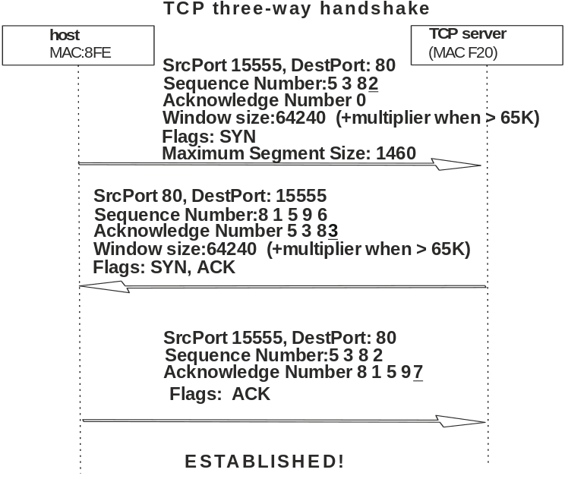

When data transmitted from sender to reciever - a reciever get a SEQ of sender, adds a datalength
and response to the sender an acknowledge empty segment witout data with
ACK=(SEQof_sender + dataLength):

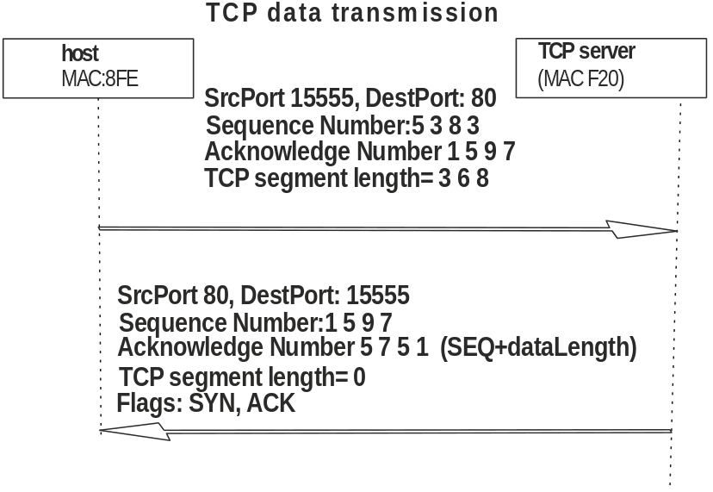
It means that a reciever side has been recived a TCP segment. When a sender starting sends a TCP segment – it turn on an internal sender`s timer. If a sender recive an acknowledge from a reciver – the timer clear. When there was a time-out of the timer (and the segment has been lost), the sender retransmitt the same packet – it provides reliable data transmitting.
TCP congestion control.
When a sender wants to transmit a big amount of data – there was a problem. A TCP protocol has a window (like a buffer). This window usually has a small size (from kilobytes in MCU to Megabytes in servers). When a sender starting sends for example 10MByte of data, after short time there will be overflow of this window (because a TCP protocol unable to process incoming data). The same situation will be when we flow a water from a big pool to a small glass.
To solve this problem – there is an algorithm - “slow start”.
A sender transmit for example 10 packets to receiver and waiting for acknowledgment. When
a sender receive an ACK successfully - the sender increase amount of data – for example 15 packets and so on. It will be the situation soon – the receiver can't sends an acknowledgment in time (because there is a network speed limitation or calculation on receiver CPU isn't enough).When it has been happened – the sender DECREASE amounts of TCP segments. This technique helps avoid congestion of TCP window.
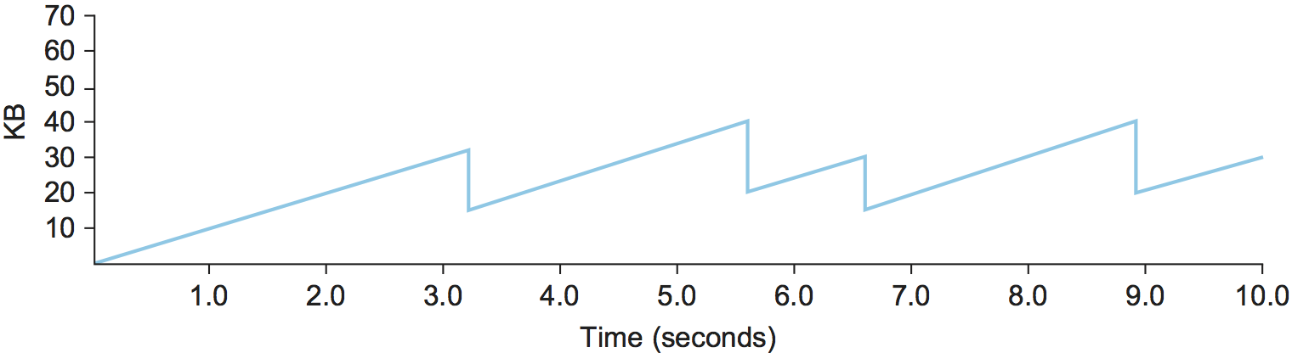
Keep-Alive.
A client has an internal timer.When this timer has been out – the client send to a server TCP Keep-Alive segment.This segment is small – 60bytes.The server responses to a client with Keep-Alive
ACK .This technique using to provide hold TCP connection in active state.

UDP

UDP uses IP to get a datagram from one computer to another. UDP works by gathering data in a UDP packet and adding its own header information to the packet. This data consists of the source and destination ports on which to communicate, the packet length and a checksum. After UDP packets are encapsulated in an IP packet, they're sent off to their destinations. UDP uses a simple transmission model that doesn't include handshaking dialogs to provide reliability, ordering or data integrity. Consequently, UDP's service is unreliable.
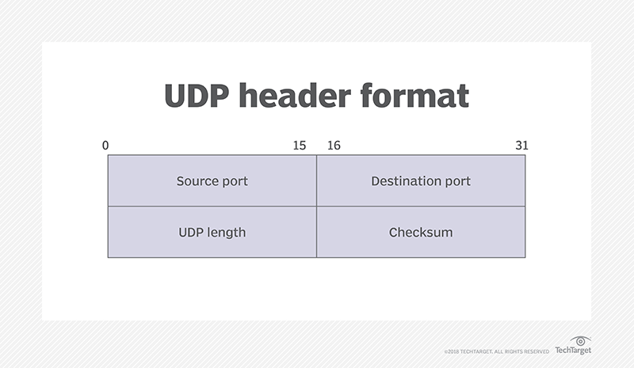
The User Datagram Protocol header has four fields, each of which is 2 bytes.

NETWORKS
a bit about routers
Network -layer functions:
forwarding:move packets from a router`s input link to appropriate router output link.
Routing: dtermine route taken by packets from a source to destination (maybe through several networks).
Data plane – per-rouer function how to datagram arrivung from an input router`s port to a router`s output port.
Control plane- network-wide logic: how to datagram routed among routers from a source host to destination host.There are two aproaches:
traditional routing algorythm – implemented in routers.
Software defined networking - implemented in remite servers.
Indidvidual routing algorithm components n each every router interact in the control table

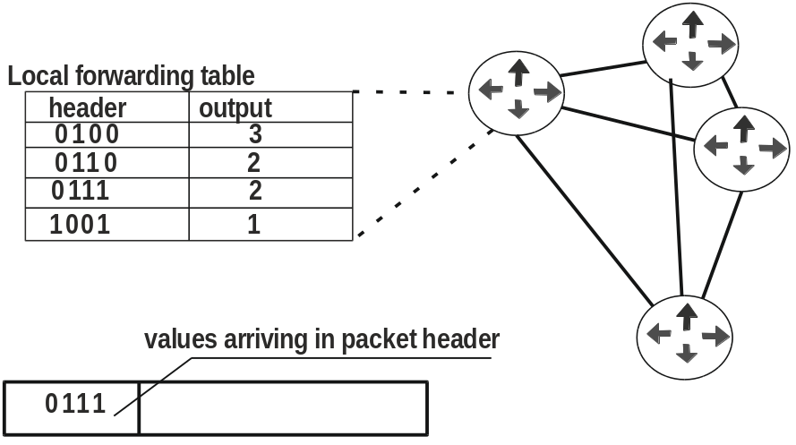

SDN control plane – remore control computers installs forwarding tables in routers.

ROUTER input port functions: destination based forwarding – forward only on destination IP address (traditional).Generalized: forward based on any set of header field values.

IP PROTOCOL

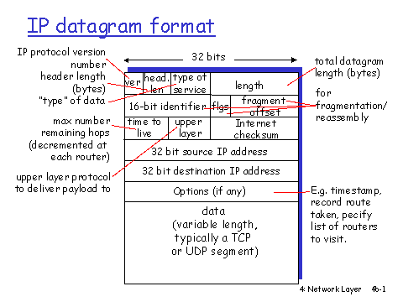
Maximum length 64KBytes. Typical – 1500 Bytes or less. UpperLayer field – means TCP or UDP

WHEN a host wants to connect to a network – it gets it`s own IP address using the DHCP protocol:
by request to a DHCP server (DHCP runninig usually on the router).
IP protocol responsive for fragmentation/reassembling of datagrams (upper layer TCP/UDP e.t.c.)

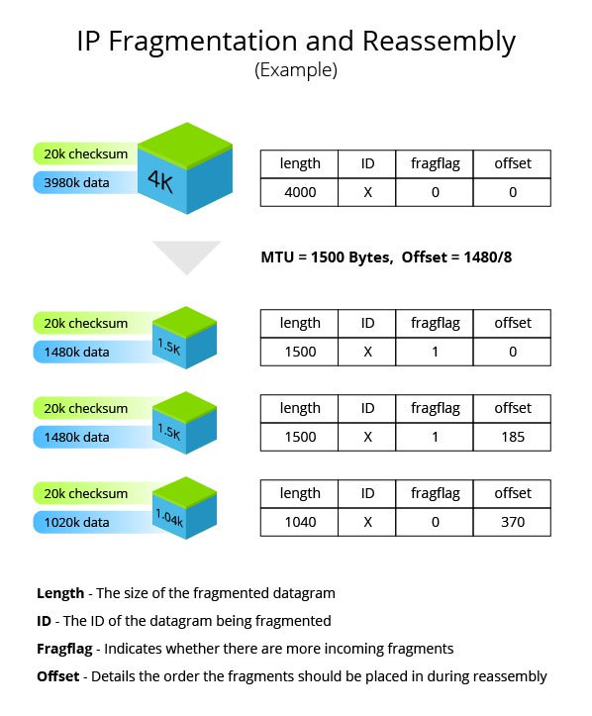

When a SUBNET wants to get a subnet part of IP address – the subnet gets it from ISP `s address space.

ISP gets blocks of addresses from ICANN - Internet Corporation for Assigned Names And Numbers. https://icann.org

