An Integrated Web-Based Sales and Order Management System with Predictive Machine Learning Intelligence: A Case Study of Kenya Airways' Water Bottling Plant

Oyieri Jermaine Obed

166588 – ICS 4D

Supervisor: Julliet Kirui

An Informatics and Computer Science Project Proposal Submitted to the School of Computing and Engineering Sciences in partial fulfillment of the requirements for the award of a Degree in Bachelor of Science in Informatics and Computer Science

School of Computing and Engineering Sciences Strathmore University
Nairobi, Kenya

June 2026

Declaration and Approval
I declare that this project proposal has not been submitted to Strathmore University or any other University for the award of a Degree in Bachelor of Science in Informatics and Computer Science or any other Degree. To the best of my knowledge and belief, the research proposal contains no material previously published or written by another person except where due reference is made in the research proposal itself.

Student Name: Oyieri Jermaine Obed

Student Admission Number: 166588 – ICS 4D Sign:

Date: 12/06/2026

Supervisor’s Approval

Supervisor Name: Julliet Kirui Sign:
Date: 12/06/2026

Acknowledgement
I would like to extend my sincere gratitude to all those who supported and guided me throughout the development of this project proposal. First and foremost, I am deeply grateful to my supervisor, whose expert guidance, constructive feedback, and consistent availability were instrumental in shaping the direction and rigour of this work. Their patience and commitment to my academic development have been invaluable.
I am also grateful to the faculty and staff of the School of Computing and Engineering Sciences at Strathmore University for providing the academic environment and resources that have supported my learning throughout this programme. My appreciation also goes to the staff at Kenya Airways who offered their time and operational insights during the requirements gathering phase of this project, without whose cooperation the contextual grounding of this proposal would not have been possible.
Finally, I wish to acknowledge my family and friends for their unwavering moral support, encouragement, and understanding during the demanding periods of this project. Their belief in my abilities provided the motivation to see this work through to completion.

Abstract
Kenya Airways (KQ), the national flag carrier of Kenya, launched an expansion of its onboard
Water Bottling Plant in October 2024 under Project Kifaru, its strategic recovery plan, to reduce
reliance on external water suppliers and generate additional internal revenue. Despite this growing
operational function, KQ's water production and sales unit currently manages its sales and order
lifecycle through a combination of paper-based ledgers, standalone spreadsheets, and manual stock
count sheets, creating a fragmented information environment in which data must be reconciled
manually at the end of each operational cycle. This disconnected approach is consistent with a
well-documented challenge in production and distribution operations, whereby the absence of
integrated management systems generates data silos, inventory inaccuracies, revenue leakage from
uninvoiced orders, and the unavailability of real-time operational reporting for management
decision-making. More critically, KQ currently has no capability to forecast demand, detect
irregular orders, or analyse customer purchasing trends from its water sales data, leaving
management decisions reactive rather than proactive.
The specific problem addressed by this project is the absence of a centralised, data-driven system
for managing the sales and order lifecycle within KQ's water production and sales unit, and the
absence of any predictive intelligence capability operating on that data. Sales agents lack a unified
platform to capture and track customer orders, stock deductions following order fulfilment are not
automatically reflected in inventory records, invoice generation is performed manually and
inconsistently, and there is no real-time sales dashboard or predictive insight available to
management.
This project proposes the development of a data-driven, web-based Sales and Order Intelligence
System for KQ's water production unit, integrating order capture, inventory tracking, automated
invoice generation, payment recording, and real-time sales reporting, and augmented by machine
learning models for sales demand forecasting, order anomaly detection, and customer sales trend
analysis built directly on the system's own order and customer data. The system will be developed
using Python with the Django web framework for the back-end, scikit-learn for the machine
learning pipeline, Bootstrap for the responsive front-end interface, and MySQL as the relational
database management system. Development will follow an Agile, iterative approach adapted for
solo development, with periodic stakeholder feedback, and the system will be deployed on a cloud
platform-as-a-service environment to enable multi-user access across the water plant, distribution
points, and management offices.

Table of Contents
Declaration and Approval ii
Acknowledgement iii
Abstract iv
Table of Contents v
List of Figures viii
List of Abbreviations ix
Chapter One: Introduction 1
  - Background 1
  - Problem Statement 2
  - General Objective / Aim 2
    - Specific Objectives 3
    - Research Questions 3
  - Justification(s) 4
  - Scope and Limitations 5
    - Scope of the Project 5
    - Limitation(s) in the Project 5
    - Delimitations in the Project 6
Chapter Two: Literature Review 7
  - Introduction 7
  - Information Systems Integration and Sales Order Management 7
  - Machine Learning in Sales Intelligence 8
    - Demand Forecasting 8
    - Anomaly Detection 9
    - Customer Sales Trend Analysis 9
  - Review of Related Systems 10
    - Zoho Inventory 10
    - Odoo Sales and Inventory Module 11
    - QuickBooks Online 11
    - Salesforce Sales Cloud with Einstein Analytics 11
  - Research Gaps 13
  - Conceptual Framework 13
Chapter Three: Development Methodology 17
  - Introduction 17
  - Research Paradigm 17
    - Data Acquisition 17
    - Data Preprocessing 18
    - Model Training 18
    - Model Validation and Testing 19
  - Software Development Methodology / Approach 19
    - Requirements Elicitation 20
    - System Design 20
    - Sprint Planning and Execution 20
    - Testing and Quality Assurance 20
    - User Acceptance Testing 21
    - Coding and Development 21
    - Testing and Deployment 21
  - System Analysis and Design 21
    - System Analysis 21
    - System Design 22
      - Use Case Diagram 22
      - Class Diagram 22
      - Entity Relationship Diagram (ERD) 23
      - Database Schema 23
      - System Architecture 23
  - System Development Tools and Techniques 24
    - Python and Django 24
    - MySQL 24
    - Bootstrap 24
    - Git and GitHub 25
    - Railway / PythonAnywhere 25
    - Draw.io / Lucidchart 25
    - Machine Learning Libraries 25
  - System Deliverables 26
    - System Documentation 26
    - Authentication Module 26
    - Order Management Module 26
    - Inventory and Fulfilment Module 27
    - Invoicing and Reporting Module 27
    - Customer and Account Management Module 27
REFERENCES 29
APPENDIX 31

List of Figures
Figure 2.1 Conceptual Framework 16

List of Abbreviations
API Application Programming Interface CRM Customer Relationship Management CSS Cascading Style Sheets
ERD Entity Relationship Diagram ERP Enterprise Resource Planning HTTP Hypertext Transfer Protocol
ICS Informatics and Computer Science KQ Kenya Airways (IATA code) MVC Model-View-Controller
MySQL My Structured Query Language
ORM Object-Relational Mapping
PaaS Platform as a Service
DDWSOMS Data-Driven Water Sales and Order Management System Using Machine Learning
SQL Structured Query Language UAT User Acceptance Testing UI User Interface
UML Unified Modelling Language
URL Uniform Resource Locator
WPSMS Water Production and Sales Management System

Chapter One: Introduction

Background

Kenya Airways (KQ), the flag carrier of Kenya, is one of Africa's leading airlines, operating a vast
network of domestic, regional, and intercontinental routes from its hub at Jomo Kenyatta
International Airport in Nairobi. Founded in 1977, the airline has grown to serve destinations
across Africa, Europe, Asia, and the Americas, carrying millions of passengers annually. Beyond
passenger travel, Kenya Airways manages a portfolio of ancillary and support functions, including
an onboard water production and distribution capability that supports the safe and compliant
delivery of catering and cabin services on its flights (Kenya Airways, 2024).

On 1 October 2024, Kenya Airways launched the expansion of its Water Bottling Plant at Jomo
Kenyatta International Airport as one of three strategic initiatives under Project Kifaru, the
airline's sustainability and strategic recovery plan (Kenya Airways, 2024). According to Kenya
Airways Chief Operating Officer George Kamal, the plant, with a production capacity of
approximately 4,500 litres per day, was established specifically to reduce the airline's reliance on
external water suppliers, significantly lower water procurement costs, and generate additional
revenue through internal water sales (Kenya Airways, 2024). The plant's launch followed a period
of financial recovery for the airline, which reported its first profit in eleven years in the first half
of 2024, a turnaround attributed to Project Kifaru's broader cost-discipline and operational-
efficiency initiatives (Capital Business, 2024). The water bottling plant is therefore positioned
within the airline as both a cost-saving and revenue-generating unit, making the accuracy and
efficiency of its internal sales and order operations directly material to KQ's wider financial
recovery objectives, rather than a peripheral concern.

Despite this operational and financial significance, Kenya Airways's water production and sales
operations are currently managed through a combination of disconnected tools including paper-
based ledgers, standalone spreadsheets, and manual stock count sheets. Sales agents and production
staff lack a unified digital platform through which they can capture water orders, monitor stock
distribution across departments and catering units, and generate invoices or revenue reports in real
time. Each of these activities is handled in isolation by different teams, leading to a fragmented
information environment where data must be reconciled manually at the end of each operational
cycle. Furthermore, no capability currently exists within the unit to forecast future demand, detect
irregular or anomalous orders, or analyse customer purchasing trends from the sales and order data
generated by day-to-day operations, meaning that management decisions are made reactively rather
than proactively.

The consequences of this fragmented approach are significant. Stock discrepancies arise when
physical production records do not match distribution logs, resulting in inaccurate inventory
figures. Revenue leakage occurs when orders are fulfilled but not formally invoiced. Compliance
gaps emerge when production volumes cannot be accurately reported. Management is left without
timely, reliable data, and without any predictive or analytical capability, on which to base
operational decisions, and the burden of manual reconciliation consumes time that could otherwise
be spent on value-adding activities.

This project proposes a Machine Learning-Driven Sales and Order Intelligence System that
addresses both dimensions of this gap: it provides KQ's water production and sales unit with a
centralised, web-based platform for order capture, stock management, fulfilment tracking, invoice
generation, and real-time sales reporting, and it introduces machine learning models trained on the
system's own order and customer data to generate demand forecasts, flag anomalous orders, and
surface customer purchasing trends — a predictive intelligence capability the unit does not
currently possess in any form.

Problem Statement
Kenya Airways currently lacks a centralised and integrated system for managing the sales and order lifecycle within its water production operations. Sales agents operate without a unified platform to capture and track customer orders, resulting in orders being recorded across multiple disconnected channels including physical forms and unstructured spreadsheets. Stock deductions following order fulfilment are not automatically reflected in inventory records, creating persistent discrepancies between actual and reported stock levels. Invoice generation is performed manually and inconsistently, leading to delayed billing cycles and revenue leakage. Furthermore, there is no real-time sales dashboard available to management, meaning that operational decisions are made on the basis of outdated or incomplete information. These interconnected failures directly cause the inefficiencies and inaccurate revenue tracking that the broader Water Production and Sales Management System project has been commissioned to resolve.
The proposed project sought to address these gaps through the development of a Machine Learning-Driven
Sales and Order Intelligence System for KQ's water production and sales unit. The system will
provide a centralised platform for order capture, inventory tracking, invoice generation, and
payment recording, eliminating the manual reconciliation currently required across disconnected
tools. In addition, the system will introduce a machine learning intelligence layer, trained on the
unit's own order and customer data, to generate sales demand forecasts, detect anomalous or
irregular orders, and surface customer purchasing trends — providing management with a
predictive and analytical capability that does not currently exist within the unit.

General Objective / Aim
To develop a data-driven, web-based Water Sales and Order Management System that integrates order capture, inventory tracking, invoice generation, and real-time sales reporting with machine learning capabilities for sales demand forecasting, order anomaly detection, and customer sales trend analysis within Kenya Airways's water sales and order management operations.

Specific Objectives
      - To investigate the challenges in Kenya Airways’ water sales and order management.
      - To design a centralised, data-driven web-based system for capturing, tracking, and managing water sales orders and fulfilment workflows, incorporating a machine learning intelligence layer for sales demand forecasting, order anomaly detection and customer sales trend analysis on the system’s order and customer data.
      - To develop and integrate machine learning models for sales demand forecasting, order anomaly detection, and customer sales trend analysis into the proposed system, using historical order and customer data from Kenya Airways’ water production and sales operations.
      - To implement a web-based Sales and Order Management Sub-System incorporating order capture, inventory tracking, automated invoice generation, payment recording, and a real-time sales dashboard for Kenya Airways’ water production and sales operations.
      - To test and validate the developed web-based system against defined functional and performance requirements, and to validate the machine learning models against defined accuracy and performance metrics, within the operational context of Kenya Airways’ water production and sales unit.

Research Questions
      - What are the existing challenges in Kenya Airways’ current water sales and order management processes?
      - How can a centralised web-based system be designed to effectively capture, track, and manage water sales orders and fulfilment workflows at Kenya Airways?
      - How can machine learning models for sales demand forecasting, order anomaly detection, and customer sales trend analysis be developed and integrated into the proposed system using historical order and customer data?
      - How can a web-based Sales and Order Management Sub-System incorporating order capture, inventory tracking, automated invoice generation, payment recording, and a
real-time sales dashboard be implemented for Kenya Airways’ water production and sales operations?
      - How can the developed web-based system be tested and validated to confirm that it meets the defined functional and performance requirements within the operational context of Kenya Airways’ water production and sales environment?

Justification(s)
The development of a bespoke, data-driven Water Sales and Order Management System incorporating machine learning intelligence is the most appropriate solution to the challenges identified in Kenya Airways’ water sales and order management operations. Commercial off-the-shelf enterprise resource planning systems such as SAP or Oracle, while feature-rich, present significant drawbacks in this context. Their high licensing and customisation costs make them disproportionate to the specific and bounded scope of this sub-system. Furthermore, generic ERP platforms are designed for broad organisational deployment rather than the targeted workflows of a water production and sales unit, and configuring them to match Kenya Airways’ exact operational structure would require extensive and expensive specialist engagement.
A third-party point-of-sale system integrated with a standalone accounting tool represents another alternative. However, this approach reintroduces the very problem the proposed solution seeks to eliminate, namely the fragmentation of data across multiple systems. Integrating disparate tools raises concerns around data consistency, synchronisation delays, and the technical overhead of maintaining inter-system compatibility over time.
The proposed bespoke web-based sub-system, by contrast, can be purpose-built to mirror the precise operational workflows of Kenya Airways’ water production and sales function. It eliminates licensing costs, enables tight integration between order capture, stock management, and financial recording, and can be deployed on accessible cloud infrastructure requiring no client-side software installation. The use of an Agile development methodology ensures that the system can be iteratively refined based on direct stakeholder feedback throughout the development process, resulting in a solution that genuinely meets operational needs. The system's web-based nature also supports concurrent multi-user access across locations including the water plant, distribution points, and management offices, which is critical in an airline operational environment where activities span multiple physical sites.
The urgency of this solution is further underscored by the fact that the Water Bottling Plant was officially expanded in October 2024 as a revenue-generating initiative under Project Kifaru (Kenya Airways, 2024), meaning that the absence of a centralised sales and order management system represents an active and growing operational gap rather than a hypothetical one.

Scope and Limitations

Scope of the Project
The proposed Data-Driven Water Sales and Order Management System is scoped to the sales and order management domain within Kenya Airways’ water operations. Specifically, the system will cover customer and account management, order capture and tracking, stock deduction and fulfillment workflow management, invoice generation and payment recording, a real-time sales dashboard accessible to authorised management users, and machine learning modules for sales demand forecasting, order anomaly detection, and customer sales trend analysis. The system does not cover water production planning, raw material procurement, or manufacturing output management, which fall under separate modules within the broader Water Production and Sales Management System. The system will be web-based, accessible via any standard desktop or mobile browser, and will interface with a cloud-hosted MySQL database. The proposed sub-system is designed to operate as a standalone module that can be integrated into the broader Water Production and Sales Management System at a later stage. The development will cover the full software development lifecycle from requirements analysis through to testing and deployment on a cloud platform.
The proposed system will not cover the production planning or raw material procurement sub-systems, which fall under separate slots within the wider Water Production and Sales Management System project. Integration with Kenya Airways’ existing enterprise systems such as the airline's passenger service system or financial ERP is also outside the scope of this proposal and would be considered a future enhancement.

Limitation(s) in the Project
A key limitation of this project is the restricted access to Kenya Airways’ internal operational data and system documentation. As a student project, full access to proprietary business processes, live databases, and internal transaction records may not be granted, which could limit the degree to which the system can be tested against real production data. The proposed system will therefore be developed and validated using simulated or anonymised datasets that approximate real operational conditions.
Additionally, the timeline of the academic project constrains the depth to which advanced features such as automated compliance reporting or multi-currency billing can be developed and tested within the submission period. These features, while desirable, are identified as future enhancements beyond the immediate scope of this proposal.

Delimitations in the Project
This study is delimited to the sales and order management function within Kenya Airways's water production operations. The target users of the proposed system are Kenya Airways sales agents, warehouse staff, and operations managers directly involved in the water production and distribution workflow. The proposed system will be developed and tested within the academic timeframe of the 2026 project cycle. Only web-based technologies will be considered for implementation; native mobile applications and desktop clients are excluded from this study. The system will be evaluated against functional requirements derived from the identified problem statement and specific objectives, rather than through a full-scale production deployment.

Chapter Two: Literature Review

Introduction

This chapter reviews scholarly literature and related systems relevant to the research problem addressed by this project. The chapter is organised around the three core subject areas that underpin the proposed system: the management of sales and order processes in operational environments, the application of machine learning to sales intelligence and anomaly detection, and the evaluation of existing software solutions that address aspects of these problems. The chapter begins by examining theoretical frameworks and empirical studies on integrated information systems and sales order management. It then reviews literature on machine learning techniques applied to demand forecasting, anomaly detection, and sales trend analysis. The third section analyses four existing related applications against the identified research problem. The chapter concludes by identifying gaps in existing literature and solutions, and presents a conceptual framework grounding the design of the proposed Data-Driven Water Sales and Order Management System.

Information Systems Integration and Sales Order Management

The challenge of managing sales and order processes through fragmented, non-integrated systems is well documented in information systems literature. Laudon and Laudon (2020) define an integrated information system as one in which data captured at any point in a business process is automatically propagated to all dependent processes without manual re-entry, eliminating redundancy and reducing the risk of transcription error. In contrast, organisations relying on disconnected tools such as paper ledgers, standalone spreadsheets, and separate billing software must reconcile data manually across systems, a process that introduces latency, inconsistency, and significant error risk. O'Brien and Marakas (2011) identify data fragmentation as one of the primary causes of operational inefficiency in sales environments, noting that when order capture, stock management, and invoicing are handled by separate systems, data discrepancies accumulate across the workflow and are often only detected during periodic reconciliation rather than in real time.
Enterprise Resource Planning systems emerged as the dominant theoretical and practical response to data fragmentation. Davenport (1998), in a foundational study on enterprise systems, argues that the central value proposition of integrated business software is the replacement of multiple disconnected applications with a single unified data model through which all organisational functions operate. Subsequent empirical work by Dillon, Wu, and Chang (2010) on cloud-based enterprise systems demonstrated that organisations adopting integrated order management platforms achieved measurable reductions in order processing time, invoicing errors, and stock discrepancy rates compared to those relying on manual or semi-manual processes. These findings are consistent with the operational challenges identified in the problem statement of this project.
The concept of real-time operational visibility is a recurring theme in information systems research on sales management. Turban, Volonino, and Wood (2015) argue that the availability of real-time transactional data is a prerequisite for effective operational decision-making, as management decisions based on retrospective reports are inherently reactive rather than proactive. This distinction between reactive and proactive management is particularly relevant in high-throughput operational environments where delays in identifying discrepancies or shortfalls translate directly into financial loss. The proposed system addresses this gap by providing a real-time sales dashboard that surfaces order status, stock levels, and revenue metrics as transactions occur rather than at the end of an operational cycle.
These fragmentation and reconciliation challenges documented in the information systems
literature directly inform the first specific objective of this project, which is to investigate the
challenges present in Kenya Airways's water sales and order management processes. Rather than
assuming that KQ's operational environment mirrors the generic cases described above, this project
treats the literature as a framework of expected symptoms — data silos, manual reconciliation
delays, and reactive rather than proactive decision-making — against which the specific challenges
identified through stakeholder engagement at KQ will be examined and confirmed.

Machine Learning in Sales Intelligence

The application of machine learning to sales and order management has been an active area of research since the mid-2010s, driven by the increasing availability of transactional data and advances in predictive modelling techniques. Kuhn and Johnson (2013) provide a foundational treatment of predictive modelling for business applications, establishing the theoretical basis for applying supervised and unsupervised learning algorithms to operational datasets. Within the domain of sales intelligence, three specific applications are directly relevant to the proposed system: demand forecasting, anomaly detection, and customer behaviour analysis.

Demand Forecasting
Demand forecasting using machine learning has been extensively studied as an alternative to traditional statistical approaches such as ARIMA and exponential smoothing. Makridakis, Spiliotis, and Assimakopoulos (2018) conducted a large-scale empirical comparison of forecasting methods and found that machine learning models, particularly gradient boosting and long short-term memory neural networks, consistently outperformed classical statistical methods on datasets with complex seasonal and trend patterns. In the context of sales order management, Zhang (2003) demonstrated that artificial neural networks applied to historical order data could produce demand forecasts with significantly lower mean absolute error than regression-based approaches, particularly when the order data contained non-linear patterns. More recently, Fildes et al. (2022) reviewed machine learning forecasting in operational contexts and concluded that time-series regression models trained on transactional order histories provide reliable short-term demand predictions suitable for operational planning purposes, even when the training dataset is of modest size. These findings support the inclusion of a demand forecasting model in the proposed system, trained on the historical order records captured within the sales and order management workflow.

Anomaly Detection
Anomaly detection in transactional data has been studied extensively in the context of fraud detection, quality assurance, and operational monitoring. Chandola, Banerjee, and Kumar (2009), in a widely cited survey of anomaly detection techniques, classify transactional anomalies into point anomalies, contextual anomalies, and collective anomalies, and review the relative performance of distance-based, density-based, and model-based detection approaches. The isolation forest algorithm, proposed by Liu, Ting, and Zhou (2008), is identified in subsequent literature as particularly well suited to high-dimensional transactional datasets because it isolates anomalies by randomly partitioning the feature space rather than building a profile of normal behaviour, making it both computationally efficient and robust to datasets with complex distributional characteristics. Phua et al. (2010) applied anomaly detection to sales order datasets and found that isolation forest models reliably flagged orders that deviated significantly from established customer purchasing patterns, including unusual quantities, unexpected ordering frequencies, and orders from dormant accounts, with low false positive rates when trained on sufficient order history. These properties make isolation forest an appropriate algorithm for the order anomaly detection component of the proposed system.

Customer Sales Trend Analysis
The analysis of customer purchasing behaviour using machine learning has been applied in retail, distribution, and service environments to support targeted sales activity and churn prevention. Ngai et al. (2009) reviewed data mining applications in customer relationship management and found that clustering algorithms, particularly k-means and hierarchical clustering applied to purchase frequency, recency, and monetary value data, provide reliable segmentation of customers by purchasing behaviour without requiring labelled training data. This recency-frequency-monetary (RFM) framework, originally described by Hughes (1994) and subsequently extended by Fader, Hardie, and Lee (2005), is widely used in the sales intelligence literature as the basis for identifying high-value customers, declining accounts, and dormant relationships from transactional order data. Stone (2020) applied RFM-based clustering to operational sales datasets in logistics environments and demonstrated that the resulting customer segments provided actionable intelligence for sales agents, enabling prioritisation of follow-up activities based on predicted customer lifetime value. The proposed system will implement a simplified RFM-based trend analysis model using the order history data captured within the system to provide management and sales agents with customer-level purchasing behaviour insights.
Collectively, the demand forecasting, anomaly detection, and customer trend analysis literature reviewed in this section establishes the specific machine learning intelligence layer referenced in Objective ii (designing a system incorporating ML for these three functions) and developed in Objective iii (building and integrating those models). Each of the three techniques selected for this project — time-series regression for demand forecasting, isolation forest for anomaly detection, and RFM-based k-means clustering for customer trend analysis — is grounded in empirical evidence of its suitability for transactional order data of the kind KQ's water sales and order management unit will generate, rather than being adopted as a generic or default choice.

Review of Related Systems

Zoho Inventory
Zoho Inventory is a cloud-based inventory and order management application designed for small to medium enterprises engaged in product sales and distribution. The application enables users to create and manage sales orders, track stock levels, generate invoices, and produce sales reports. Its integration with Zoho Books and Zoho CRM positions it as a relatively comprehensive solution for organisations seeking to consolidate sales and inventory workflows within a single vendor ecosystem. The application supports multi-currency transactions, barcode scanning, and automated reorder alerts, features that align with the functional requirements identified in the literature on integrated sales systems (Zoho Corporation, 2023).
However, Zoho Inventory does not provide any of the three machine learning capabilities central to this project. It offers no demand forecasting model — inventory reorder alerts are threshold-based rather than predictive — and no anomaly detection mechanism capable of flagging orders that deviate from a customer's established purchasing pattern. Its reporting functionality is limited to retrospective sales summaries rather than the kind of RFM-based customer segmentation proposed in this project, meaning it cannot surface which customers are high-value, declining, or dormant without manual analysis of exported reports. Furthermore, its pricing model, based on order volumes and user counts, introduces ongoing licensing costs that are inconsistent with a purpose-built solution. From a research perspective, the system represents an adequate implementation of integrated order and inventory management but leaves the specific forecasting, anomaly detection, and customer trend analysis gap identified in this project's research questions entirely unaddressed (Laudon and Laudon, 2020).

Odoo Sales and Inventory Module
Odoo is an open-source enterprise resource planning platform with dedicated Sales and Inventory modules. The Sales module manages customer quotations, sales orders, delivery orders, and invoicing within a unified platform, while the Inventory module provides real-time stock tracking and fulfilment workflow automation. Odoo's modular, open-source architecture makes it a cost-effective alternative to proprietary ERP systems and has been studied in the information systems literature as a viable platform for small and medium enterprise digitalisation (Johansson and Ruivo, 2013).
In the context of this research, Odoo's primary limitation is its configuration complexity. Deploying Odoo to reflect the specific workflow of a bounded operational unit requires substantial technical expertise and time investment that is disproportionate to the scope of this project. More critically, Odoo does not provide machine learning-driven sales intelligence as a native capability. While third-party extensions exist, they require additional configuration and integration effort and do not address the specific combination of demand forecasting, anomaly detection, and customer trend analysis identified as requirements in this project. Odoo therefore addresses the integration dimension of the research problem but not the intelligence dimension.

QuickBooks Online
QuickBooks Online is a widely adopted cloud-based accounting platform that includes basic sales order and invoicing functionality. It enables organisations to create customer records, generate invoices, and track payments. The platform has been evaluated in the small business information systems literature as an effective tool for financial record-keeping and basic sales administration (Collier and Hoeffler, 2012). However, QuickBooks Online is fundamentally an accounting application rather than an operational sales and order management system. It lacks workflow automation for order status tracking, stock deduction triggers, and fulfilment confirmation, and its reporting capabilities do not extend to real-time operational dashboards or predictive analytics. QuickBooks Online therefore addresses only the financial recording dimension of the research problem and provides no basis for the machine learning intelligence layer proposed in this project.

Salesforce Sales Cloud with Einstein Analytics
Of the related systems reviewed, Salesforce Sales Cloud, augmented by its Einstein Analytics and Einstein Discovery modules, is the only commercially available application that explicitly integrates machine learning capabilities within a sales order management workflow and therefore represents the closest existing precedent to the intelligence dimension of the proposed system. Salesforce Sales Cloud provides centralised customer relationship management, opportunity tracking, order management, and invoicing functionality. Salesforce Sales Cloud provides centralised customer relationship management, opportunity tracking, order management, and invoicing functionality. Einstein Analytics applies machine learning to the data held within the Salesforce platform to generate predictive sales forecasts, lead scoring models, and opportunity win-probability predictions, while Einstein Discovery surfaces automated data insights and outcome predictions directly within the Sales Cloud dashboard (Salesforce, 2023). These capabilities are broadly aligned with the demand forecasting and trend analysis dimensions of the machine learning intelligence layer proposed in the current project.
However, Salesforce Sales Cloud presents several critical limitations in the context of this project. Its licensing model, based on per-user monthly subscriptions with additional charges for Einstein Analytics and Einstein Discovery, places it well beyond the cost parameters appropriate for an internal operational sub-system within a single production unit. More fundamentally, the machine learning models within Einstein are trained on Salesforce's own aggregated customer relationship management data and general sales pipeline patterns, rather than on the domain-specific transactional order data generated within a bounded water production and sales environment. The platform's anomaly detection capabilities are oriented towards sales pipeline irregularities rather than order-level transactional anomalies of the kind addressed by the isolation forest model proposed in this project. Furthermore, Salesforce Sales Cloud is designed for enterprise-wide CRM deployment across large sales teams and is not configurable as a purpose-built operational sub-system for a water production unit without substantial and expensive customisation. The absence of inventory and stock deduction workflow automation — a feature essential to the proposed system's integration between order management and real-time stock control — represents an additional gap between Salesforce's capabilities and the functional requirements of this project. Salesforce Sales Cloud therefore provides the closest approximation to the intelligence dimension of the research problem but fails to address the operational integration, cost, and domain specificity requirements that collectively define the gap this project seeks to fill.

Research Gaps

The review of scholarly literature and related systems reveals two interconnected gaps that collectively justify the proposed system. First, while integrated information systems literature establishes the operational value of unified sales and order management platforms, existing commercial solutions do not provide purpose-built implementations for bounded, internal operational environments such as the one addressed by this project. Generic ERP platforms such as Odoo impose disproportionate configuration complexity, cloud-based solutions such as Zoho Inventory introduce ongoing licensing costs, accounting-oriented tools such as QuickBooks Online provide only partial coverage of the order management workflow, and enterprise CRM platforms such as Salesforce Sales Cloud with Einstein Analytics, while incorporating machine learning, are prohibitively expensive, trained on generalised CRM data rather than domain-specific order transactional data, and lack the operational inventory integration required by this project. No existing solution provides an integrated, bespoke platform suited to the specific operational context addressed by this research.
Second, while machine learning literature demonstrates the effectiveness of demand forecasting, anomaly detection, and customer behaviour analysis as applied to sales transactional data, these capabilities are absent from the existing related systems reviewed. The integration of machine learning intelligence directly into the sales and order management workflow, operating on the system's own order and customer data without reference to external datasets or production processes, represents a contribution that neither the existing literature on sales management systems nor the reviewed commercial applications has addressed in this specific operational context. These two gaps collectively justify the development of the proposed Data-Driven Water Sales and Order Management System.

Conceptual Framework

The conceptual framework for the proposed system, named DDWSOMS (Data-Driven Water Sales and Order Management System), is structured around six interconnected layers derived from the literature reviewed in this chapter. The first layer defines the four actor types that interact with the system: the Sales Agent, Warehouse Officer, Operations Manager, and System Administrator. The second layer is an Authentication and Access Control gateway implementing role-based
access control, session management, and an audit log through which all actor interactions are mediated. The third layer comprises the four core functional modules: Order Management, Inventory Management, Financial Management, and Customer and Account Management. The fourth layer is a cloud-hosted MySQL database that persists all transactional records, including orders, customers, stock, invoices, users, and ML outputs. The fifth layer is the Machine Learning Intelligence pipeline, grounded in the demand forecasting literature of Fildes et al. (2022), the anomaly detection framework of Chandola et al. (2009), and the customer behaviour analysis approach of Ngai et al. (2009). The sixth layer is the Outputs layer, which surfaces the intelligence generated by the ML pipeline alongside operational dashboards and financial reports. The first four domains reflect the integrated information systems model described by Laudon and Laudon (2020), in which data flows automatically between order capture, stock management, financial recording, and reporting without manual re-entry. The fifth domain, Machine Learning Intelligence, is grounded in the demand forecasting literature of Fildes et al. (2022), the anomaly detection framework of Chandola et al. (2009), and the customer behaviour analysis approach of Ngai et al. (2009).
In the Order Management domain, sales agents will capture and track customer orders through a centralised interface. The Inventory Management domain will receive automatic stock deduction triggers from the Order Management domain upon order fulfilment, maintaining real-time accuracy without manual reconciliation. The Financial Management domain will generate invoices automatically upon fulfilment and record payment receipts. The Outputs layer will aggregate data across the four operational modules to surface five categories of system output: a Real-time Dashboard reflecting live order, stock, and revenue data; Invoices and Reports providing auto-generated billing documents and exportable period summaries; Demand Forecasts presenting predicted order volumes by customer and period; Anomaly Alerts flagging suspicious or irregular orders in real time; and Customer Trend Insights presenting RFM segment profiles and purchasing behaviour patterns. The Machine Learning Intelligence layer will ingest historical order and customer data from the MySQL database — where all transactional records are persisted by the operational modules — to train and serve three models: a sales demand forecasting model, an order anomaly detection model, and a customer sales trend analysis model. The outputs of the ML Intelligence layer are surfaced within this Outputs layer, providing management and sales agents with predictive intelligence derived entirely from within the sales and order management workflow. The five domains will interact bidirectionally, with operational data continuously enriching the machine learning models and model outputs informing decisions that feed back into the order management process.

2.6.1 Machine Learning Model Specifications

Model | Algorithm | Input Features | Output
Demand Forecasting | Time-series regression | Order date, product type, order quantity, customer identifier, aggregated historical order volume by period | Predicted order volume by customer, product, and future period
Anomaly Detection | Isolation Forest | Order quantity, order frequency relative to customer average, time elapsed since last order, deviation from customer's historical mean order size | Anomaly flag/score per order
Customer Sales Trend Analysis | K-Means clustering (RFM-based) | Recency (time since last order), Frequency (order count within period), Monetary value (total/average order value within period) | Customer segment label (e.g. high-value, at-risk, dormant)

As summarised in Table 2.1, all three models are trained exclusively on order and customer data
generated within the system, without reference to production or manufacturing data. Consistent
with the feedback loop depicted in Figure 2.1, model outputs — forecast values, anomaly flags, and
segment labels — will be written back to the MySQL database and incorporated into subsequent
retraining cycles as new order data accumulates, allowing predictive accuracy to improve over
time.

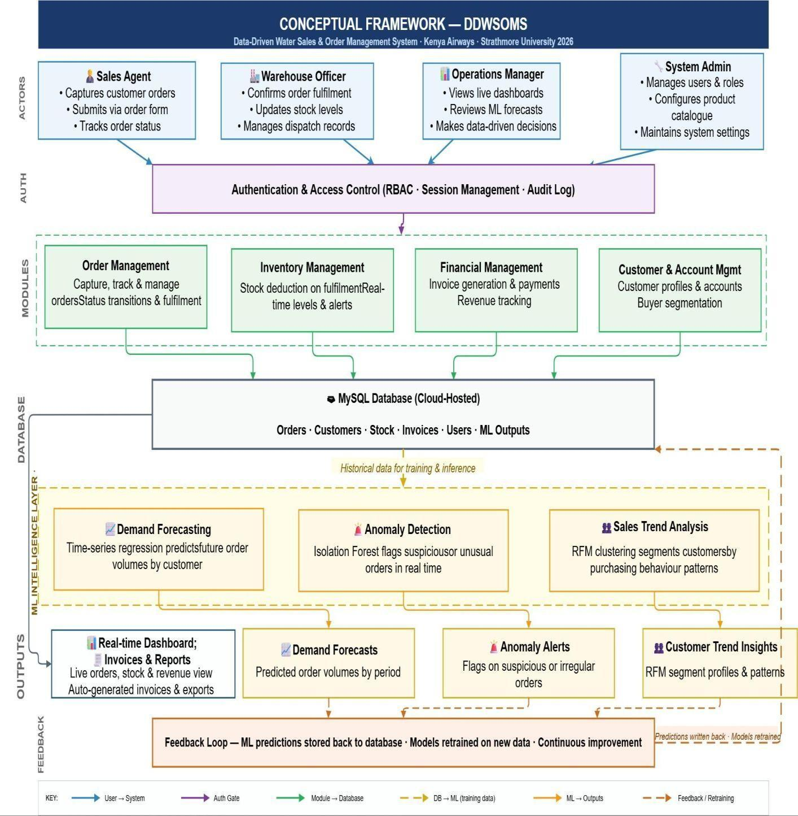

Figure 2.1 Conceptual Framework

Chapter Three: Development Methodology

Introduction
This chapter discusses the software development methodology, machine learning pipeline, and the different aspects of the system analysis and design that will guide the development of the proposed Data-Driven Water Sales and Order Management System. The chapter presents the research paradigm adopted for this project, the software development methodology selected and the justification for its selection, the system analysis and design artefacts including use case, class, and entity relationship diagrams, the development tools and techniques to be employed, and the deliverables expected at the conclusion of the development process.

Research Paradigm
This project adopts a pragmatic research paradigm, which prioritises practical outcomes and the selection of methods best suited to addressing the defined problem rather than adherence to a single philosophical tradition. The pragmatic approach is appropriate for applied software development projects because it allows the researcher to draw on both qualitative methods, such as stakeholder interviews and requirements workshops, and quantitative methods, such as system performance testing and data accuracy measurement, in service of the overarching goal of delivering a functional, validated software solution.
The research is applied and developmental in nature, as its primary output is a working software system rather than a theoretical contribution. The development process will be guided by empirical feedback gathered iteratively from stakeholders throughout the project lifecycle, consistent with the Agile methodology described in the following section.

Data Acquisition
Data for the requirements analysis phase of this project will be acquired through structured interviews with Kenya Airways sales agents, warehouse supervisors, and operations managers directly involved in the water production and sales workflow. Semi-structured questionnaires will
be used to elicit information about current processes, pain points, data flows, and desired system capabilities. Document analysis of existing process documentation, order forms, and sales records will supplement the interview data to provide a comprehensive picture of the current operational environment. Where access to live operational data is restricted, representative sample datasets will be constructed in consultation with stakeholders to enable realistic system testing.

Data Preprocessing
The data collected during the requirements analysis phase will be organised and analysed using thematic analysis to identify recurring challenges, user requirements, and functional priorities. This analysis will inform the functional and non-functional requirements specification that will drive the system design phase. Sample datasets used for testing will be validated against operational parameters provided by stakeholders to ensure that they adequately represent real-world conditions, including order volumes, customer categories, stock levels, and fulfilment timelines.

Model Training
The machine learning components of the proposed system will be trained entirely on sales and order data captured within the system, ensuring the ML layer remains within the scope of the sales and order management domain. Three models will be developed. First, a sales demand forecasting model using time-series regression will analyse historical order records to predict future order volumes by customer, product type, and time period, enabling sales agents and managers to anticipate demand without reference to production processes. Second, an order anomaly detection model using isolation forest algorithms will monitor incoming orders in real time and flag transactions that deviate significantly from a customer's established ordering pattern, such as unusually large quantities, unexpected order frequencies, or orders from dormant accounts, supporting fraud prevention and data quality assurance within the order management workflow. Third, a customer sales trend analysis model will apply clustering and trend analysis to order history data to segment customers by purchasing behaviour and identify accounts with declining or growing order volumes, enabling targeted sales follow-up directly from within the system's dashboard. All three models operate exclusively on order and customer data generated by the system itself and do not interface with production, manufacturing, or procurement data. To support continuous improvement, the outputs of each model will be written back to the MySQL database upon generation, storing forecast values, anomaly flags, and customer segment assignments as structured records alongside the transactional order data. The models will be periodically retrained on this enriched dataset — incorporating both original order history and stored prediction outcomes — ensuring that predictive accuracy improves as the volume and recency of system data increases over time. This feedback loop between the operational database and the machine learning pipeline is represented explicitly in the system's conceptual framework.

Model Validation and Testing
The proposed system will be validated through a combination of unit testing, integration testing, and user acceptance testing. Unit testing will verify that individual system components, including the order capture module, stock management logic, invoice generation engine, and reporting dashboard, perform correctly in isolation. Integration testing will confirm that data flows correctly between components, for example that an order marked as fulfilled triggers the expected stock deduction and invoice generation events. User acceptance testing will involve representative end users, including sales agents and operations managers at Kenya Airways, who will evaluate the system against defined acceptance criteria derived from the specific objectives and research questions established in Chapter One.

Software Development Methodology
The proposed system will be developed using an Agile, iterative development methodology adapted for a single developer. Conventional Scrum assumes a dedicated team occupying distinct roles — a Scrum Master, a Product Owner, and a development team — coordinated through daily stand-up meetings and formal sprint ceremonies. As this project will be developed by a sole student developer, a full Scrum implementation is not applicable. Instead, this project adopts the core Agile principles underlying Scrum — iterative development in fixed-length cycles, working software delivered at the end of each cycle, and requirements refined based on stakeholder feedback — while consolidating the Product Owner, Scrum Master, and developer roles into a single individual. Development will be organised into two-week iterations, at the end of which a working increment will be reviewed against the current requirements and, where possible, shared with the project supervisor or Kenya Airways stakeholders for feedback in place of formal sprint ceremonies. This adapted approach retains Agile's core benefit — the ability to refine requirements iteratively as stakeholders interact with working software — while remaining realistic about the resourcing constraints of a solo academic project.The selection of Agile Scrum over alternative methodologies such as the Waterfall model is justified by several factors specific to this project. The Waterfall model, which progresses linearly through requirements, design, implementation, testing, and deployment phases, is ill-suited to a project where requirements may be refined iteratively as Kenya Airways stakeholders engage with working prototypes. The risk of investing significant development effort in a system design that does not ultimately meet operational needs is substantially higher under a Waterfall approach. Agile Scrum mitigates this risk by delivering working software at the end of each sprint and incorporating stakeholder feedback into each subsequent iteration.
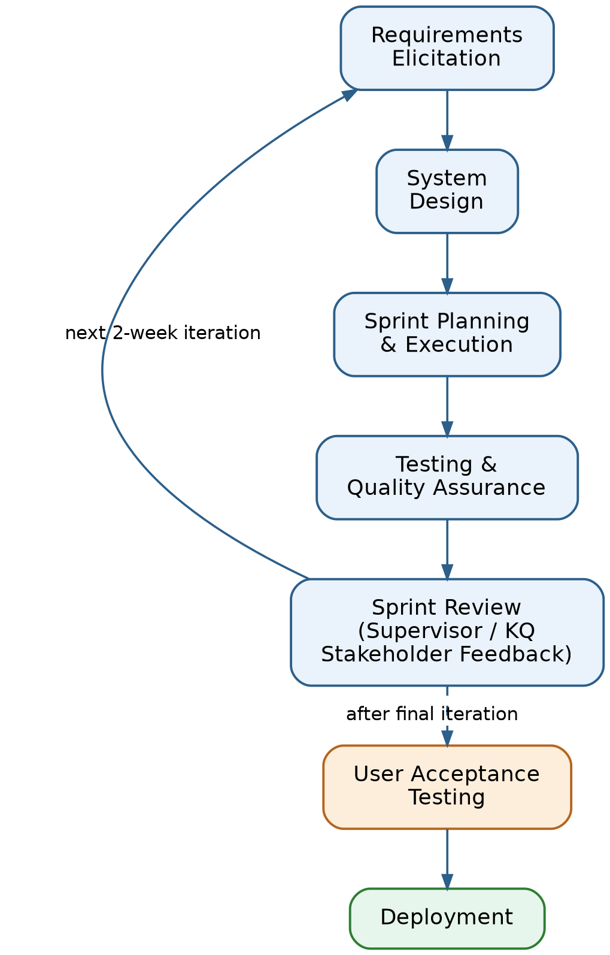
Figure 3.1: Adapted Agile Development Methodology

Requirements Elicitation
In this phase, requirements will be gathered through stakeholder interviews, process observation, and document analysis as described in Section 3.2.1. The outputs of this phase will include a prioritised product backlog containing all functional and non-functional requirements expressed as user stories, which will guide the subsequent sprint planning and development activities.

System Design
The system design phase will translate the prioritised requirements into architectural and detailed design artefacts, including the use case diagram, class diagram, entity relationship diagram, database schema, and system architecture diagram described in Section 3.4. These artefacts will define the structure, behaviour, and data model of the proposed system prior to implementation.

Sprint Planning and Execution
Development will be organised into a series of two-week iterations. At the start of each iteration, a set of prioritised user stories will be selected from the product backlog for delivery within that period. In place of team stand-up meetings, progress and blockers will be tracked through a personal development log maintained throughout each iteration. At the end of each iteration, the working increment will be reviewed against the iteration's goals and, where feasible, shared with the supervisor or KQ stakeholders to gather feedback before the next iteration is planned.

Testing and Quality Assurance
Testing will be conducted continuously throughout the development process rather than as a single phase at the end of the project. Unit tests will be written for each system component prior to or alongside implementation, consistent with test-driven development principles. Integration tests will be executed at the end of each sprint to verify that new components interact correctly with the existing system. Defects identified during testing will be logged in the product backlog and prioritised for resolution in subsequent sprints.

User Acceptance Testing
Following the completion of all planned development sprints, a dedicated user acceptance testing phase will be conducted with representative Kenya Airways end users. Acceptance criteria derived from the specific objectives and research questions will be used to evaluate whether the system meets the defined requirements. Any defects or shortfalls identified during this phase will be addressed before the system is prepared for deployment.

Coding and Development
The back-end of the proposed system will be developed using Python with the Django web framework, which provides built-in authentication, object-relational mapping, URL routing, and an auto-generated administrative interface, significantly accelerating development. The front-end will be built using Bootstrap to deliver a responsive, browser-based interface accessible on both desktop and mobile devices. MySQL will serve as the relational database management system, chosen for its reliability with structured transactional data and its seamless compatibility with Django's ORM.

Testing and Deployment
The completed system will be deployed on a cloud platform, either Railway or PythonAnywhere, with a cloud-managed MySQL database instance. This deployment approach makes the system accessible via a public URL, enabling live stakeholder access during the demonstration and evaluation phase and simulating a real-world production environment consistent with the web-based nature of the proposed solution.

System Analysis and Design

System Analysis
System analysis for the proposed DDWSOMS was conducted using an Object-Oriented Analysis and Design (OOAD) approach. OOAD was selected because the system's core entities — customers, orders, products, stock, invoices, and users — are naturally modelled as objects with defined attributes and behaviours, and because the Django framework used for development follows an object-oriented paradigm. All diagrams produced for this project, including the use case diagram, class diagram, and entity relationship diagram, follow UML (Unified Modelling Language) notation consistent with the OOAD methodology. The structured systems analysis and design method (SSAD) was not adopted as the system's requirements are better expressed through object interactions and class relationships than through data flow and process decomposition.

System Design
System design translates the functional and machine learning requirements of the proposed Data-Driven Water Sales and Order Management System into structured artefacts that define the system's architecture, behaviour, data model, and user interactions. The machine learning components are treated as an integrated intelligence layer within the sales and order management workflow rather than as a separate system. The following sub-sections present the key design artefacts for the proposed system, each of which is illustrated with the corresponding figure below.

Use Case Diagram
The use case diagram for the proposed system identifies three primary actor types: the Sales Agent, the Warehouse Officer, and the Operations Manager. The Sales Agent interacts with the system to create and track customer orders, view customer records, and generate invoices. The Warehouse Officer uses the system to confirm order fulfilment and update stock levels following dispatch. The Operations Manager accesses the real-time sales dashboard, generates period-based reports, and manages user accounts. A system administrator actor is also identified, responsible for system configuration and user management. The use case diagram is presented as Figure 3.2.
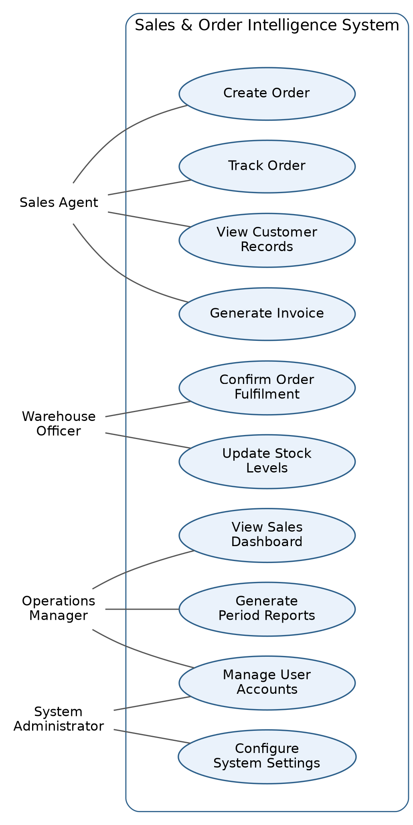
Figure 3.2: Use Case Diagram

Class Diagram
The class diagram defines the object-oriented structure of the proposed system. The primary classes identified are Customer, Order, OrderItem, Product, Stock, Invoice, Payment, User, and Report. The Customer class holds customer account information and is associated with zero or many Orders. Each Order is associated with one Customer and one or many OrderItems, each of which references a Product. The Stock class maintains the current inventory level for each Product and is updated automatically whenever an Order transitions to a fulfilled status. The Invoice class is generated from a fulfilled Order and is associated with zero or many Payments. The User class represents authenticated system users and is associated with a Role that determines their access permissions. The class diagram is presented as Figure 3.3.
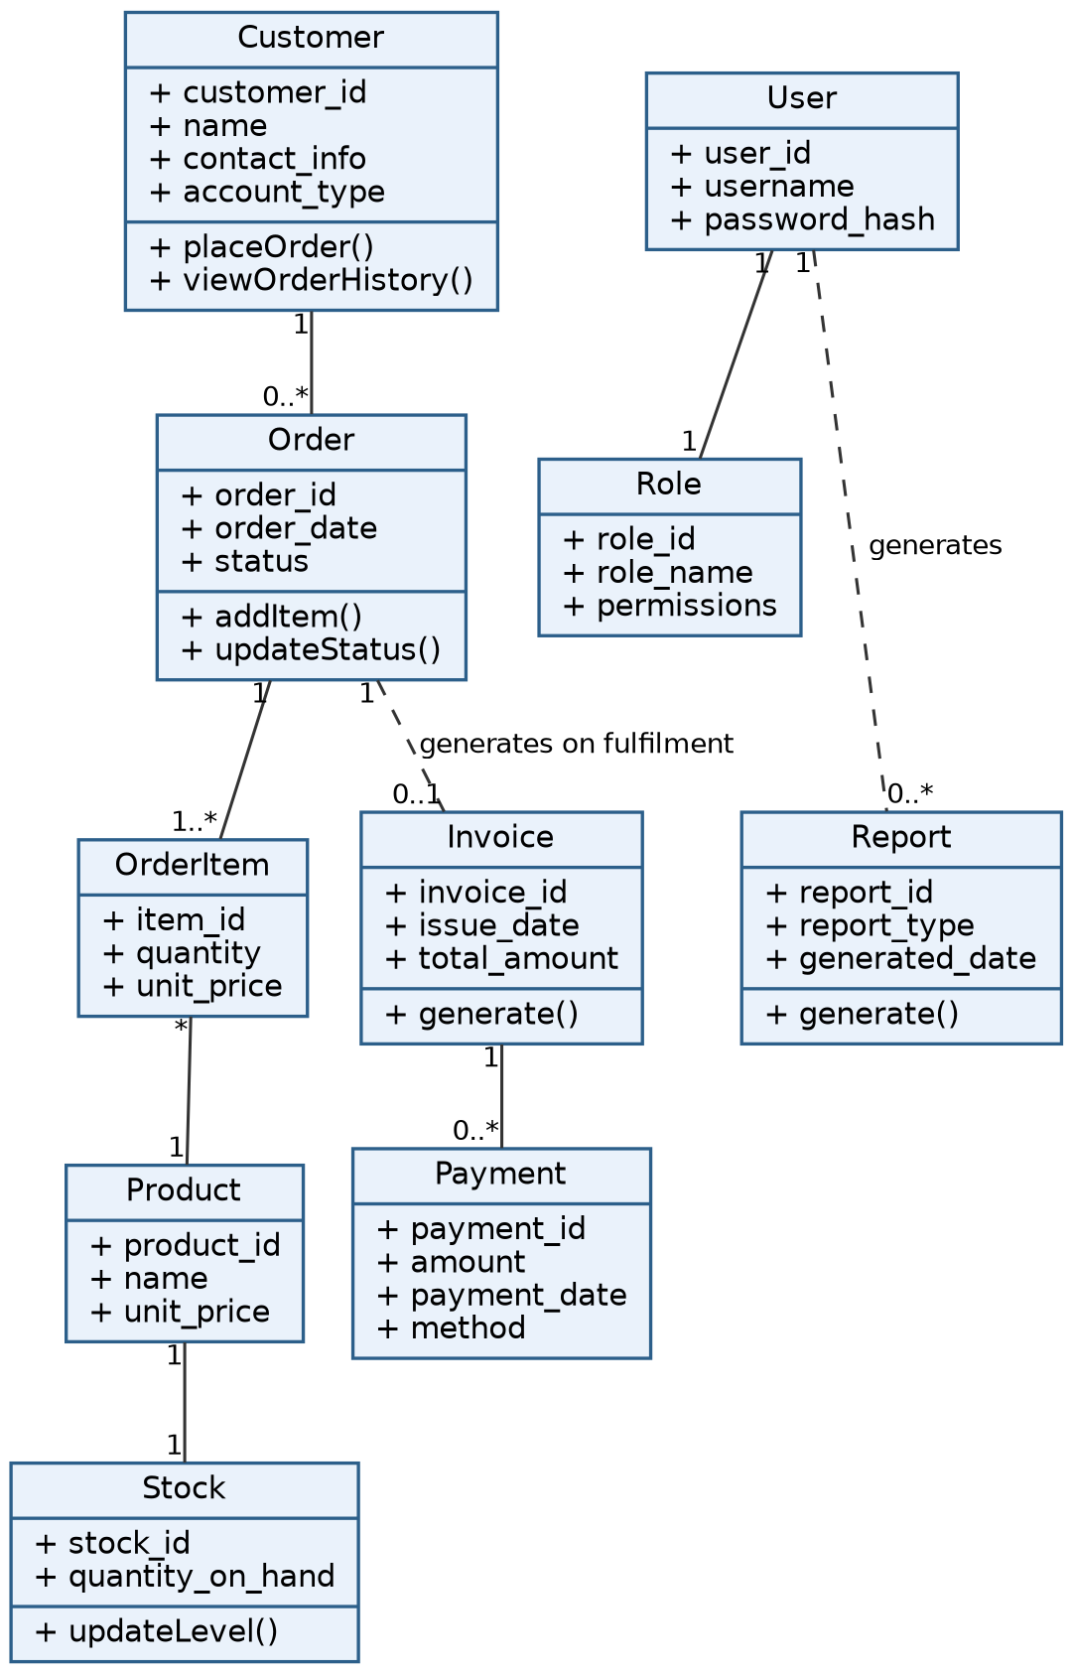
Figure 3.3: Class Diagram

Entity Relationship Diagram (ERD)
The entity relationship diagram maps the data entities and their relationships within the proposed system's database. The primary entities are CUSTOMER, ORDER, ORDER_ITEM, PRODUCT, STOCK, INVOICE, PAYMENT, and USER. A CUSTOMER may place many ORDERS, but each ORDER belongs to one CUSTOMER. An ORDER contains one or many ORDER_ITEMS, each of which references one PRODUCT. A PRODUCT has one STOCK record that tracks its current quantity. An ORDER generates one INVOICE upon fulfilment, and an INVOICE may be associated with one or many PAYMENT records. The ERD is presented as Figure 3.4.
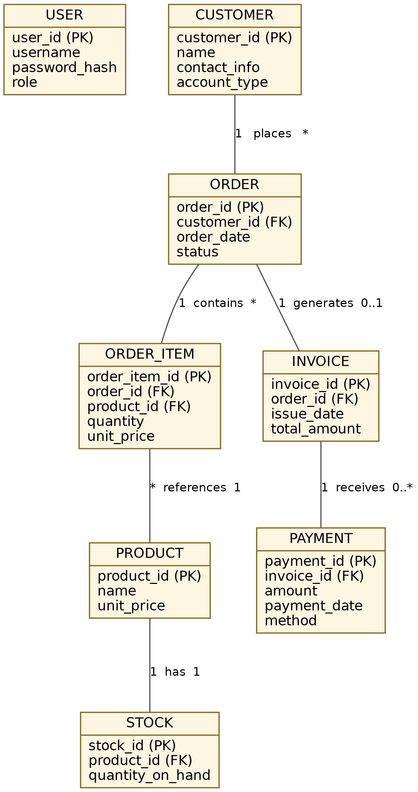
Figure 3.4: Entity Relationship Diagram (ERD)

Database Schema
The database schema will implement the entities and relationships defined in the ERD using MySQL. Primary keys will be defined for each table using auto-incrementing integer identifiers. Foreign key constraints will enforce referential integrity between related tables. The Orders table will include a status field with enumerated values corresponding to the stages of the order lifecycle, specifically Pending, Confirmed, Fulfilled, and Invoiced. All monetary values will be stored as decimal fields with two decimal places to ensure financial precision. Timestamps recording the creation and last modification date of each record will be included across all tables to support audit trail requirements. The database schema, including column data types and key constraints, is presented as Figure 3.6.
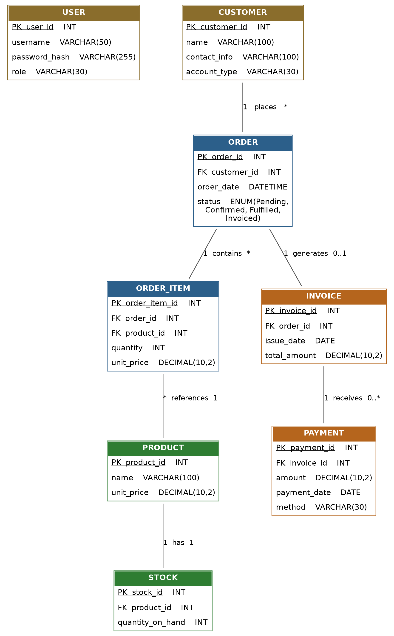
Figure 3.6: Database Schema

System Architecture
The proposed system will adopt a three-tier web application architecture comprising a presentation tier, an application tier, and a data tier. The presentation tier consists of the browser-based user interface built with Bootstrap, which communicates with the application tier via HTTP requests. The application tier is implemented in Django and handles business logic, request routing, authentication and authorisation, and data processing. The data tier consists of the MySQL database, hosted on a cloud-managed database service, which stores all persistent application data. This architecture supports concurrent multi-user access, enables horizontal scaling if required, and ensures a clear separation of concerns between the user interface, business logic, and data storage layers.
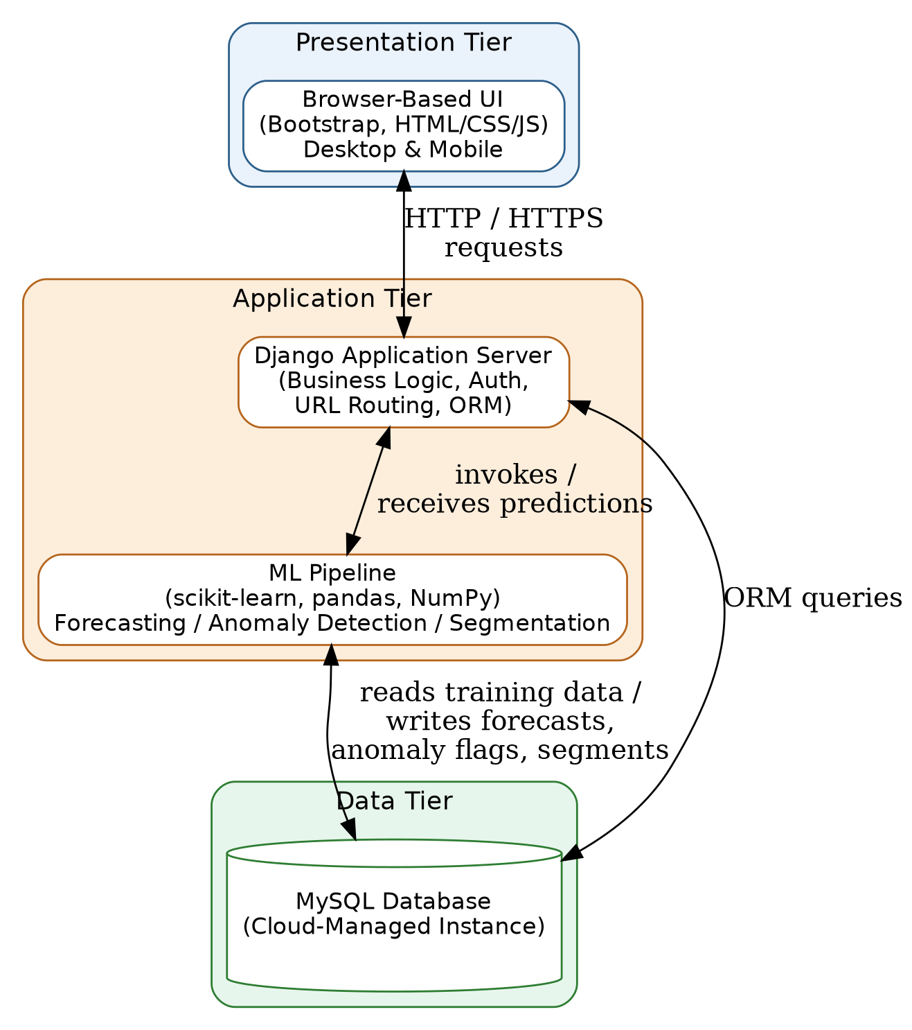
Figure 3.5: System Architecture Diagram

Wireframes
To translate the system design artefacts above into a concrete user interface, wireframes were developed for each of the primary screens identified in the use case diagram (Figure 3.2). The wireframes are organised by user role — Sales Agent, Warehouse Officer, Operations Manager, and System Administrator — and illustrate the intended layout, navigation structure, and key interactive elements of the Django and Bootstrap-based interface prior to full implementation.
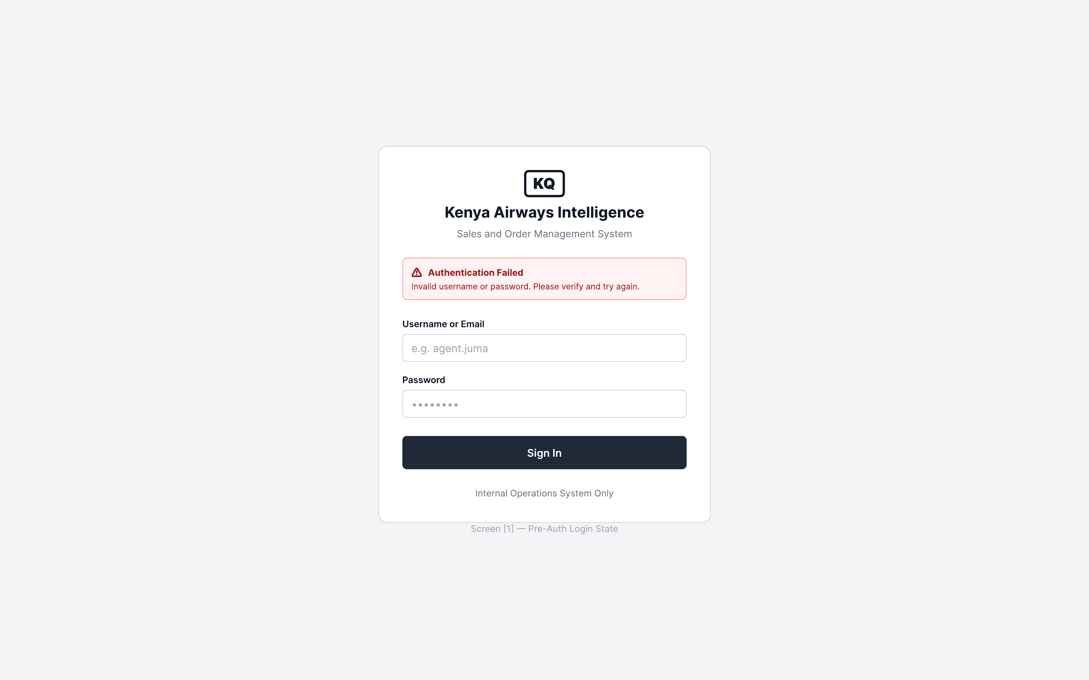
Figure 3.7a: Login Screen
The login screen (Figure 3.7a) authenticates all system users regardless of role. It displays an error state for invalid credentials, consistent with the User entity's authentication attributes defined in the class diagram and database schema.
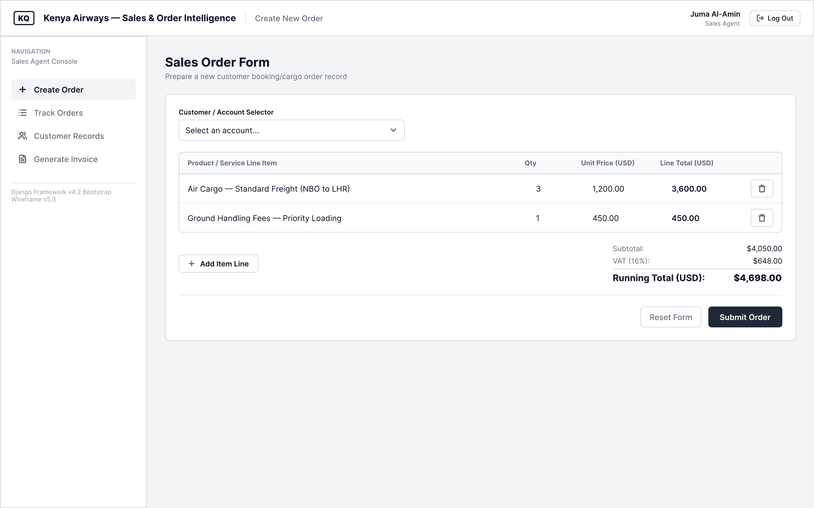
Figure 3.7b: Sales Agent — Create Order
The Create Order screen (Figure 3.7b) allows the Sales Agent to select a customer account, add product or service line items, and view a running subtotal, VAT, and total, directly supporting the Create Order use case and the Order/OrderItem relationship in the class diagram.
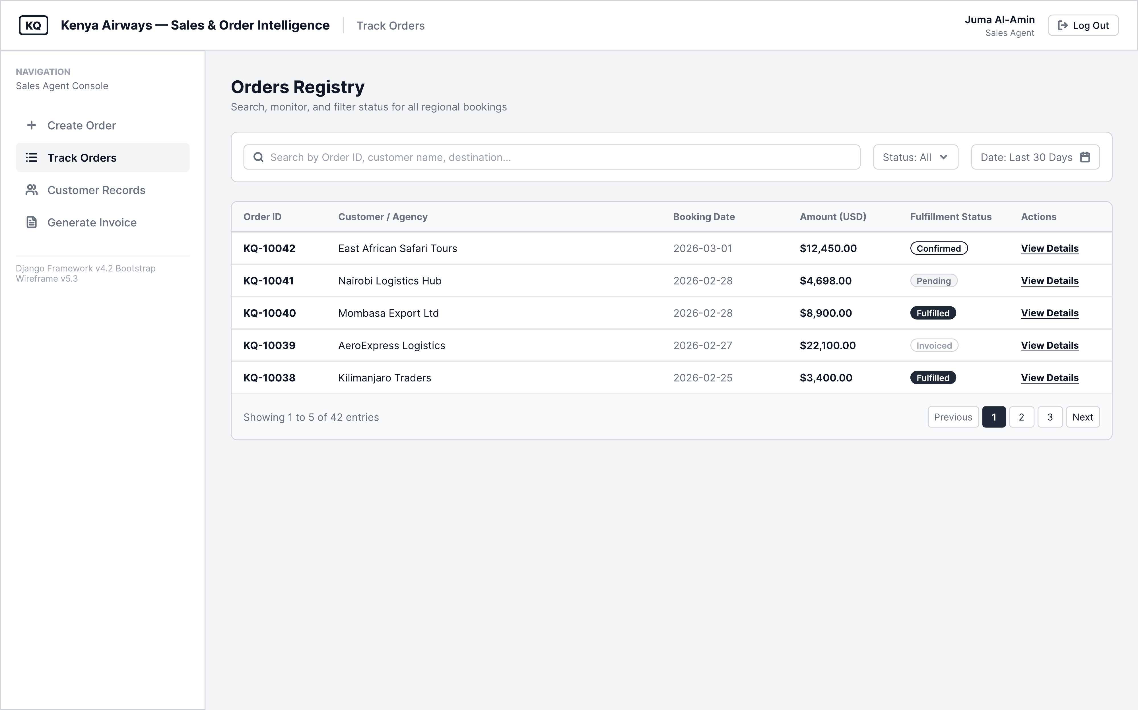
Figure 3.7c: Sales Agent — Track Orders
The Track Orders screen (Figure 3.7c) presents a searchable and filterable registry of all orders with their fulfilment status, corresponding to the order status lifecycle (Pending, Confirmed, Fulfilled, Invoiced) defined in the database schema.
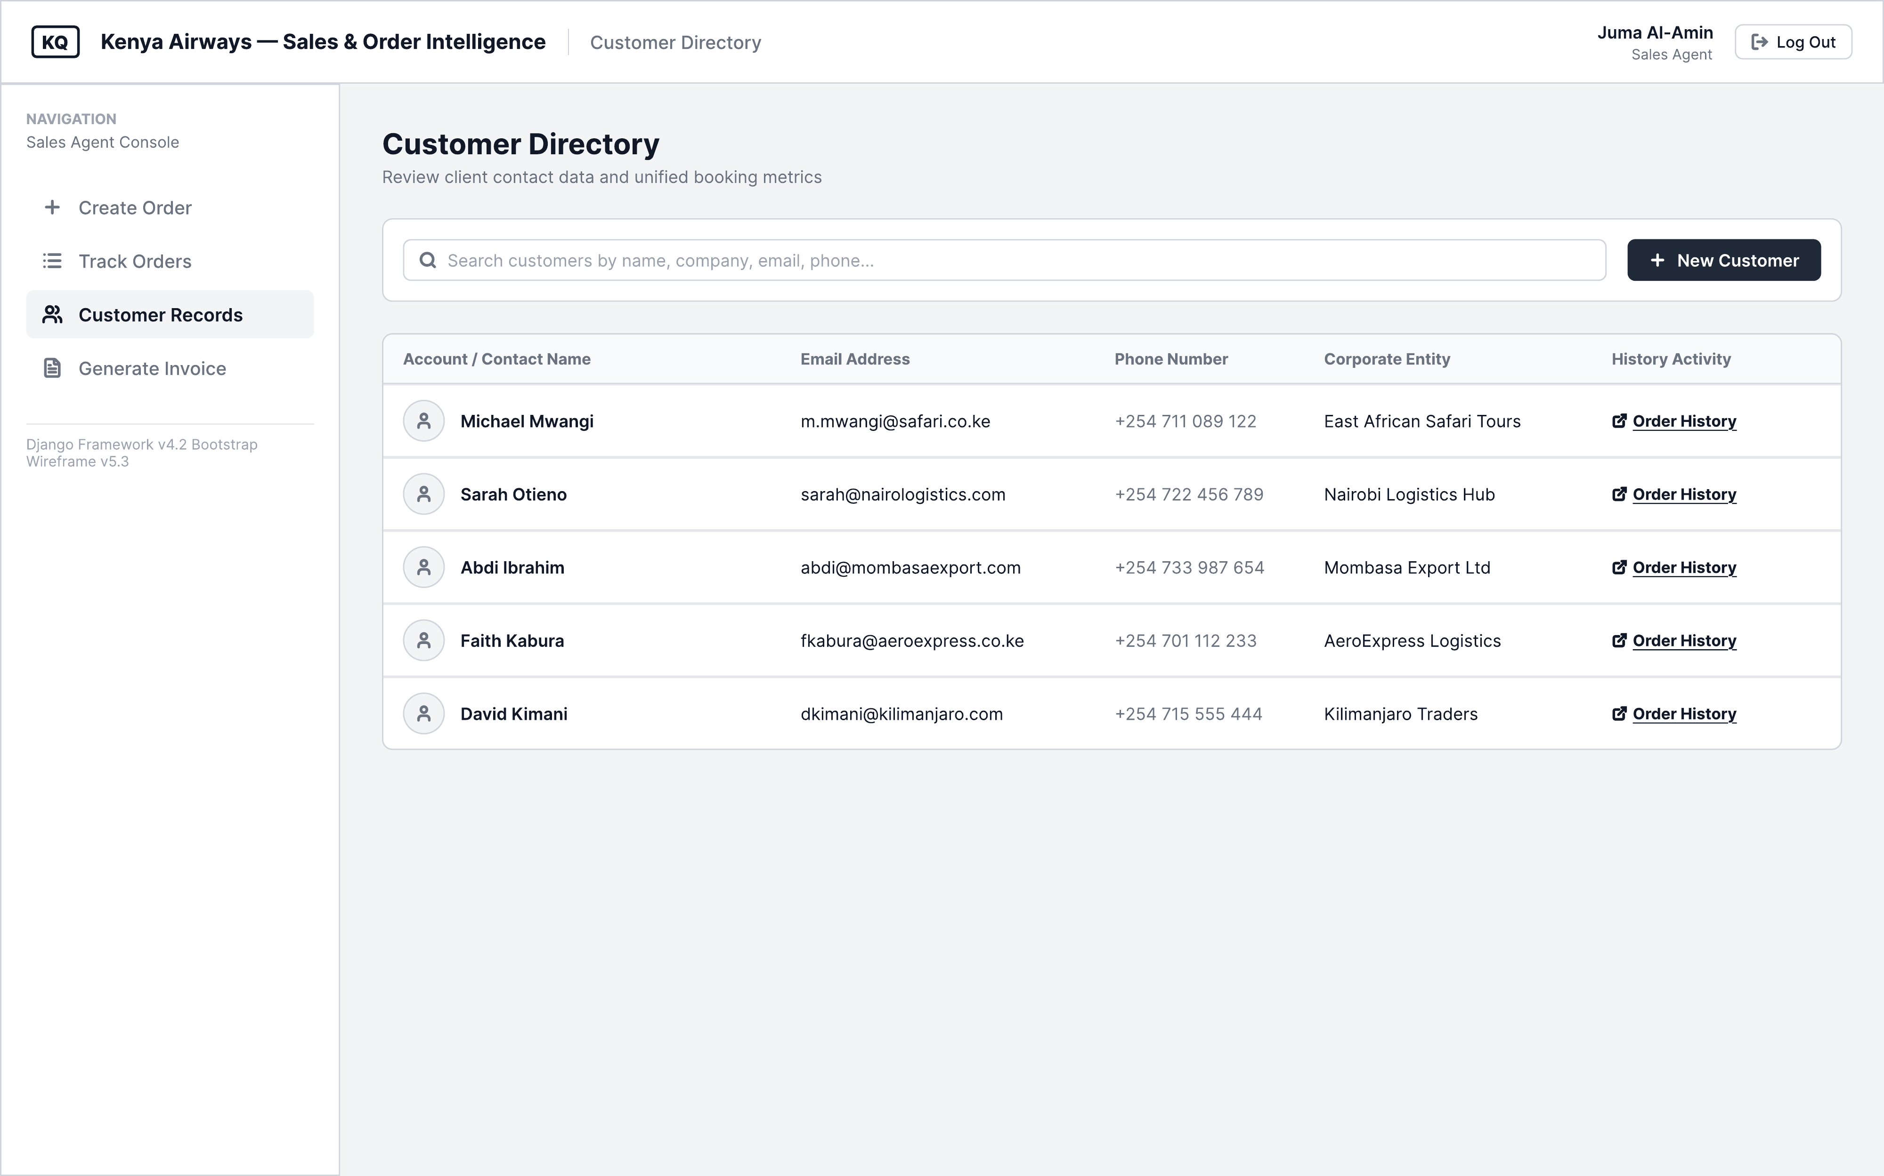
Figure 3.7d: Sales Agent — Customer Records
The Customer Records screen (Figure 3.7d) lists customer accounts and their contact details, with a link to each customer's order history, supporting the View Customer Records use case.
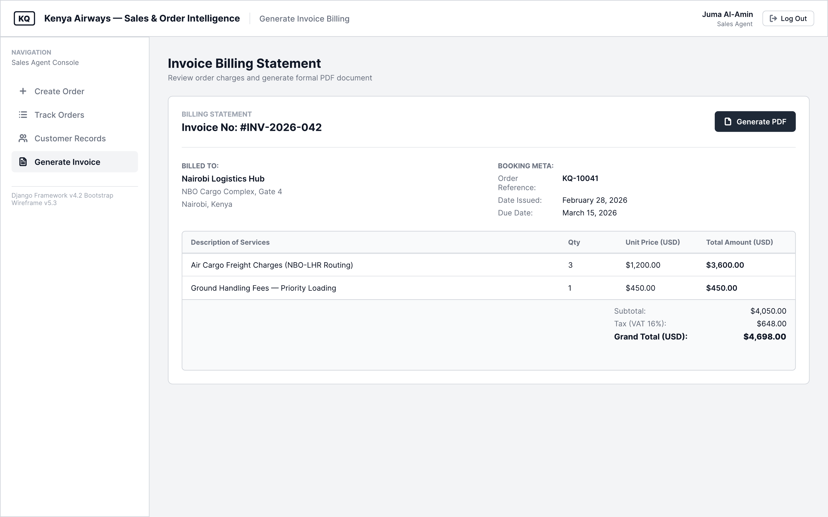
Figure 3.7e: Sales Agent — Generate Invoice
The Generate Invoice screen (Figure 3.7e) compiles the billed items, subtotal, VAT, and grand total for a fulfilled order and provides an option to export the invoice as a PDF document, corresponding to the Invoice class and its generate() operation.
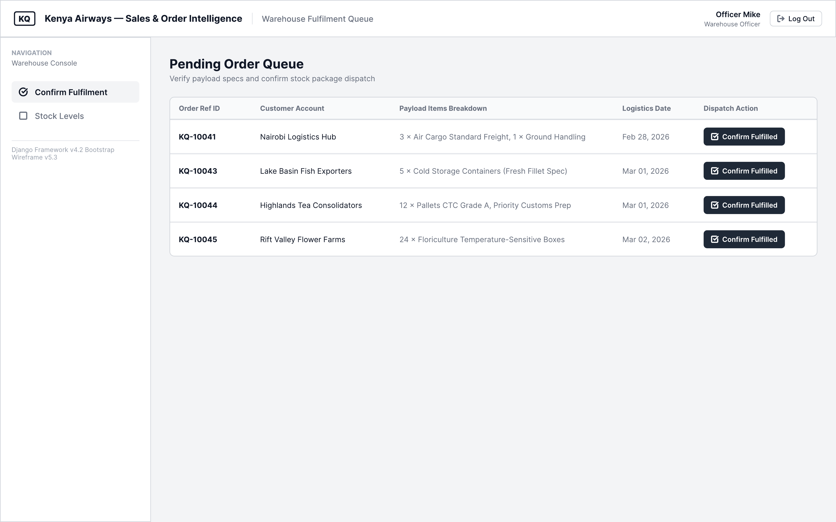
Figure 3.7f: Warehouse Officer — Confirm Fulfilment
The Confirm Fulfilment screen (Figure 3.7f) lists pending orders awaiting dispatch and allows the Warehouse Officer to mark each as fulfilled, triggering the generation of an invoice.
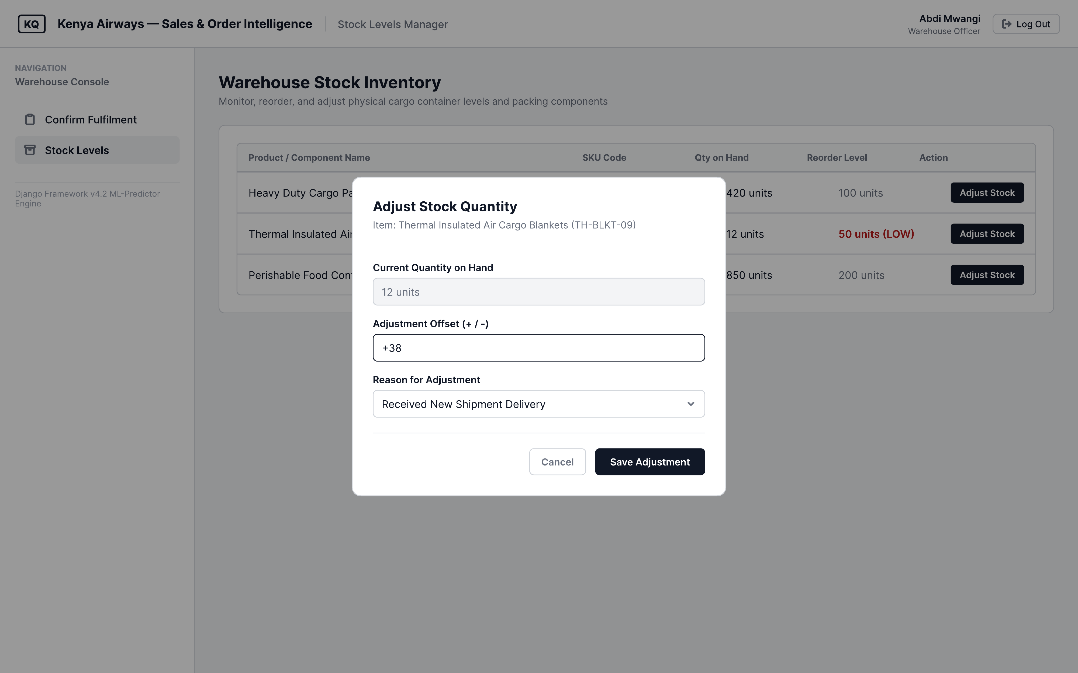
Figure 3.7g: Warehouse Officer — Stock Levels
The Stock Levels screen (Figure 3.7g) displays current stock quantities against reorder thresholds and provides an adjustment modal for updating stock following new deliveries, corresponding to the Stock class and its updateLevel() operation.
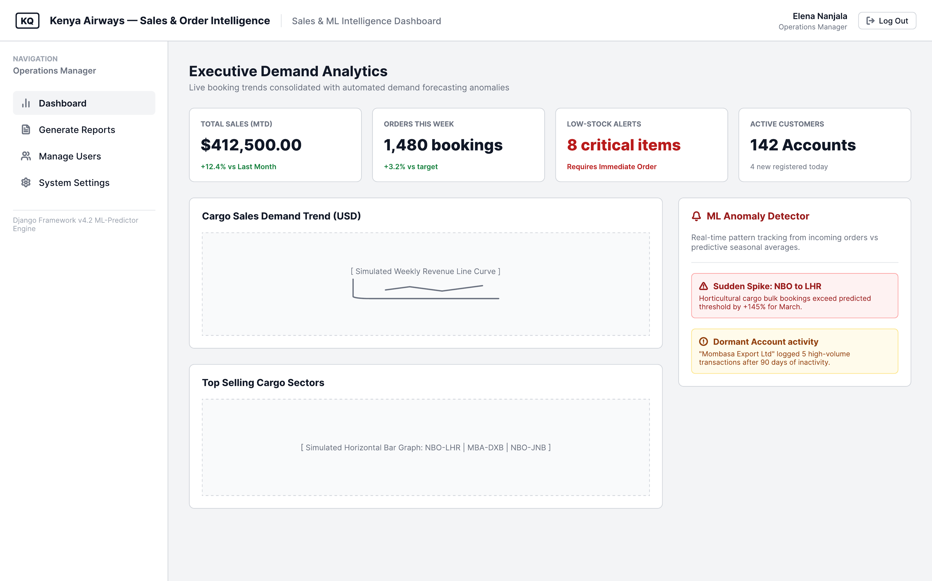
Figure 3.7h: Operations Manager — Sales Dashboard
The Sales Dashboard (Figure 3.7h) presents key performance indicators, a sales trend chart, and an ML Anomaly Detector panel that surfaces demand spikes and dormant account activity, reflecting the anomaly detection and forecasting components of the machine learning pipeline.
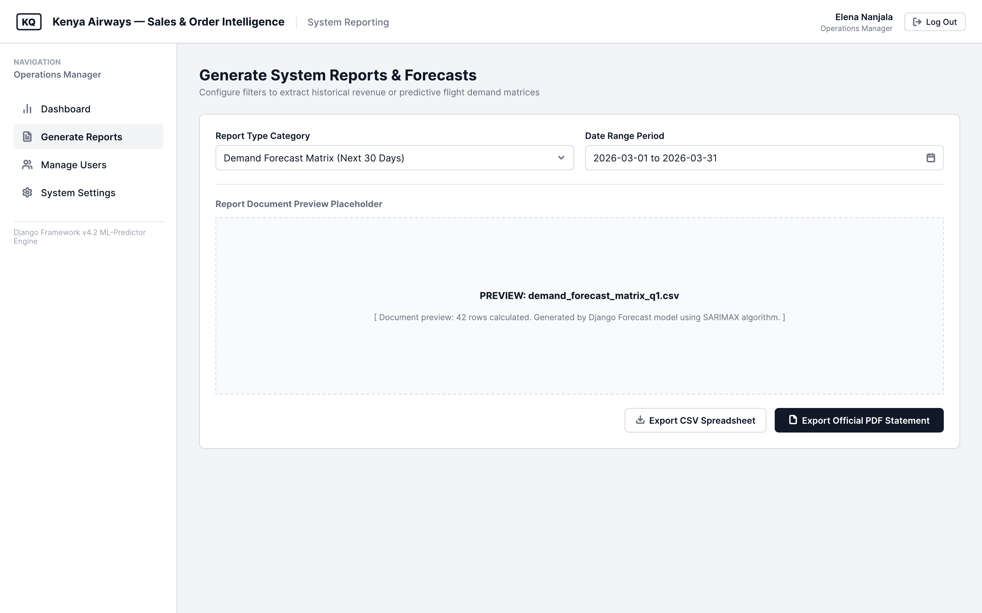
Figure 3.7i: Operations Manager — Generate Reports
The Generate Reports screen (Figure 3.7i) allows the Operations Manager to select a report type and date range, preview the underlying data, and export the result as CSV or PDF, supporting the Generate Period Reports use case and the Report class.
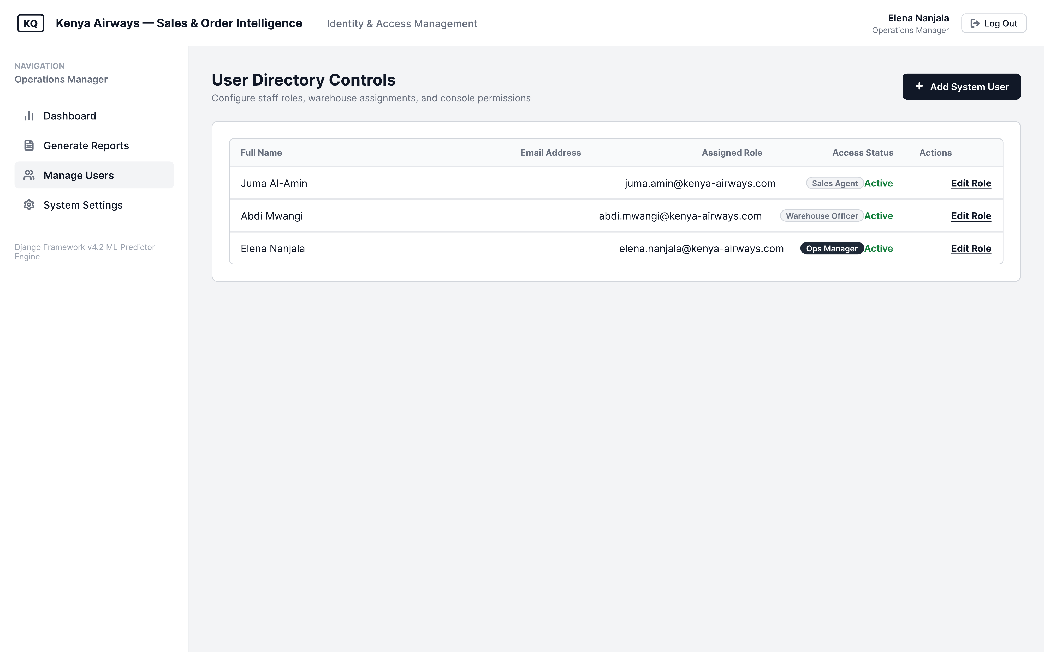
Figure 3.7j: Operations Manager — Manage User Accounts
The Manage User Accounts screen (Figure 3.7j) lists system users with their assigned roles and access status, supporting the Manage User Accounts use case shared between the Operations Manager and System Administrator.
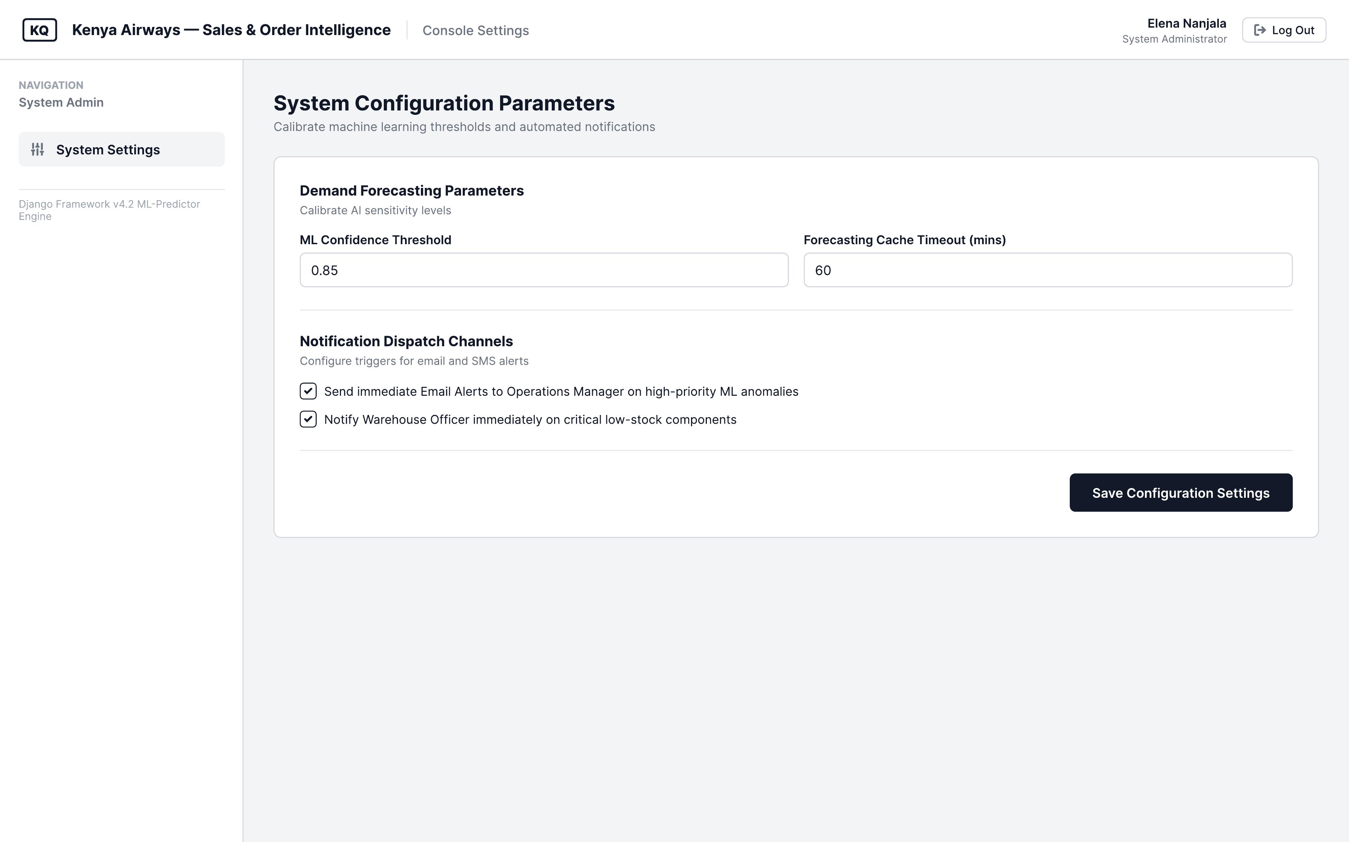
Figure 3.7k: System Administrator — System Settings
The System Settings screen (Figure 3.7k) exposes configurable machine learning thresholds and notification preferences, supporting the Configure System Settings use case.

System Development Tools and Techniques

Python and Django
Python, with the Django web framework, will serve as the primary back-end development technology for the proposed system. Django is selected for its batteries-included philosophy, which provides built-in modules for user authentication, database object-relational mapping, form validation, URL routing, and an auto-generated administrative interface. These built-in capabilities significantly reduce development time and allow the project to focus engineering effort on the domain-specific features of the proposed system. Python also serves as the language for the machine learning pipeline, with scikit-learn providing the core modelling library for demand forecasting and anomaly detection, and pandas and NumPy supporting data manipulation and preprocessing.

MySQL
MySQL will be used as the relational database management system for the proposed system. MySQL is selected for its proven reliability in handling structured, transactional data, its wide industry adoption, and its seamless compatibility with Django's ORM layer. The use of a relational database is appropriate for this project given the highly structured and relational nature of the data entities involved, including customers, orders, products, stock, invoices, and payments, and the need to enforce referential integrity constraints across these entities.

Bootstrap
Bootstrap will be used to implement the front-end user interface of the proposed system. Bootstrap is a widely used open-source CSS framework that provides a comprehensive library of responsive UI components, including navigation bars, forms, tables, buttons, and modal dialogues, which can be assembled to create professional, accessible, and mobile-responsive web interfaces. Its use eliminates the need to write custom CSS from scratch and ensures that the system's interface is consistent and accessible across different browsers and device sizes.

Git and GitHub
Git will be used as the version control system for the project, with GitHub serving as the remote repository hosting platform. Version control is essential for managing code changes across the iterative development sprints of the Agile process, enabling the developer to track changes, revert to previous states, and maintain a complete history of the system's development. GitHub also provides project management features including issue tracking and milestone management that will support the organisation of the Agile sprint process.

Railway / PythonAnywhere
The proposed system will be deployed on either Railway or PythonAnywhere, both of which are cloud platform-as-a-service providers that support Python and Django deployments with managed database instances. Cloud deployment ensures that the system is accessible via a public URL without requiring the configuration and maintenance of dedicated server infrastructure, making it practical for demonstration and evaluation purposes within the project timeline.

Draw.io / Lucidchart
Draw.io or Lucidchart will be used to produce the system design diagrams required for this proposal, including the use case diagram, class diagram, entity relationship diagram, and system architecture diagram. Both tools provide comprehensive libraries of UML and database diagram components and support the export of diagrams in formats suitable for inclusion in the project documentation.

Machine Learning Libraries
The machine learning pipeline for the proposed system will be implemented using the following Python libraries. scikit-learn will serve as the primary modelling library, providing implementations of the time-series regression model for demand forecasting, the Isolation Forest algorithm for anomaly detection, and the K-Means clustering algorithm for RFM-based customer segmentation. pandas will be used for data manipulation, including the loading, cleaning, and transformation of historical order and customer data extracted from the MySQL database prior to
model training. NumPy will support numerical array operations underlying the preprocessing and feature engineering steps of the pipeline. Matplotlib or Seaborn will be used to visualise model outputs such as forecast trend lines and anomaly flag distributions within the management dashboard and project documentation. All libraries are open-source and compatible with the Python and Django environment described in Section 3.5.1

System Deliverables

System Documentation
The project will produce comprehensive system documentation covering the requirements specification, system design artefacts, user manual, and technical deployment guide. The requirements specification will document the functional and non-functional requirements of the system as derived from the stakeholder engagement activities described in Section 3.2.1. The user manual will provide step-by-step guidance for each category of end user, including sales agents, warehouse officers, and operations managers. The technical deployment guide will document the steps required to configure, deploy, and maintain the system in a production environment.

Authentication Module
The authentication module will provide secure, role-based access control for the proposed system. Users will be required to authenticate using a username and password, and their access to system features will be governed by their assigned role, specifically Sales Agent, Warehouse Officer, Operations Manager, or System Administrator. The module will implement session management, password hashing, and login attempt limiting to protect against unauthorised access. An audit log will record all user actions within the system, including order creation and modification events, stock updates, and login activity, providing a traceable activity history for compliance and administrative review purposes.

Order Management Module
The order management module is the core functional component of the proposed system. It will enable sales agents to create new customer orders, specify order items and quantities, assign fulfilment priorities, and track the status of each order through the fulfilment workflow. The
module will display a real-time order list view with filtering and search capabilities, and will provide detailed order history for each customer account. Order status transitions will automatically trigger downstream actions in the inventory and financial management modules.

Inventory and Fulfilment Module
The inventory and fulfilment module will maintain real-time stock level records for all water products managed within the system. Stock levels will be automatically decremented when an order is confirmed as fulfilled by the warehouse officer, eliminating the need for manual stock reconciliation. The module will provide stock level dashboards accessible to both warehouse staff and operations management, and will generate automated alerts when stock levels fall below configurable reorder thresholds.

Invoicing and Reporting Module
The invoicing and reporting module will automatically generate invoices upon order fulfilment and record payment receipts against the corresponding invoice records. The module will maintain an accounts receivable dashboard showing outstanding and settled invoices. It will provide management with a real-time sales dashboard displaying key operational metrics including total orders, revenue, fulfilment rates, and stock consumption. Period-based reports covering daily, weekly, and monthly performance will be available for export in standard formats. This module will also surface the four output types generated by the machine learning intelligence layer: Demand Forecasts presenting predicted order volumes by customer and period; Anomaly Alerts flagging suspicious or irregular orders identified by the isolation forest model in real time; Customer Trend Insights providing RFM segment profiles and purchasing behaviour patterns; and a Real-time Dashboard consolidating live order status, stock levels, and revenue metrics alongside auto-generated invoices and exportable reports. These outputs will be presented directly within the management dashboard, enabling sales agents and managers to act on predictive intelligence derived from the system's own order and customer data.

Customer and Account Management Module
The customer and account management module will maintain a centralised registry of all customer accounts within the system. Sales agents will be able to create and update customer profiles, including contact details, account status, and assigned product categories. The module will support buyer segmentation, enabling customers to be grouped by account type or purchasing profile for targeted order management and reporting purposes. Customer records will be linked to the order and invoicing modules, ensuring that the full transaction history for each account is accessible from a single view. This module corresponds directly to the Customer and Account Management component of the system's conceptual framework.

REFERENCES

Chandola, V., Banerjee, A., & Kumar, V. (2009). Anomaly detection: A survey. ACM Computing Surveys, 41(3), Article 15. https://doi.org/10.1145/1541880.1541882
Collier, P., & Hoeffler, A. (2012). Business accounting and financial management. Oxford University Press.
Davenport, T. H. (1998). Putting the enterprise into the enterprise system. Harvard Business Review, 76(4), 121–131.
Dillon, S., Wu, C., & Chang, E. (2010). Cloud computing: Issues and challenges. Proceedings of the 24th IEEE International Conference on Advanced Information Networking and Applications, 27–33.
Fader, P. S., Hardie, B. G. S., & Lee, K. L. (2005). RFM and CLV: Using iso-value curves for customer base analysis. Journal of Marketing Research, 42(4), 415–430.
Fildes, R., Ma, S., & Kolassa, S. (2022). Retail forecasting: Research and practice. International Journal of Forecasting, 38(4), 1283–1318. https://doi.org/10.1016/j.ijforecast.2019.06.004
Hughes, A. M. (1994). Strategic database marketing. Probus Publishing.
Johansson, B., & Ruivo, P. (2013). Exploring factors for adopting ERP as SaaS. Procedia Technology, 9, 94–99.
Kenya Airways. (2024). Kenya Airways annual report and financial statements 2024. Kenya Airways PLC.
Laudon, K. C., & Laudon, J. P. (2020). Management information systems: Managing the digital firm (16th ed.). Pearson.
Liu, F. T., Ting, K. M., & Zhou, Z.-H. (2008). Isolation forest. Proceedings of the 8th IEEE International Conference on Data Mining (ICDM), 413–422. https://doi.org/10.1109/ICDM.2008.17
Makridakis, S., Spiliotis, E., & Assimakopoulos, V. (2018). Statistical and machine learning forecasting methods: Concerns and ways forward. PLOS ONE, 13(3), e0194889. https://doi.org/10.1371/journal.pone.0194889
Ngai, E. W. T., Xiu, L., & Chau, D. C. K. (2009). Application of data mining techniques in customer relationship management: A literature review and classification. Expert Systems with Applications, 36(2), 2592–2602.
O'Brien, J. A., & Marakas, G. M. (2011). Management information systems (10th ed.). McGraw-Hill.
Phua, C., Lee, V., Smith, K., & Gayler, R. (2010). A comprehensive survey of data mining-based fraud detection research. arXiv preprint arXiv:1009.6119.
Salesforce. (2023). Einstein analytics and discovery: Product overview. Salesforce Inc. https://www.salesforce.com/products/einstein/overview/
Stone, M. (2020). Customer relationship management: Concepts and tools (3rd ed.). Macmillan Publishers.
Turban, E., Volonino, L., & Wood, G. R. (2015). Information technology for management: Digital strategies for insight, action, and sustainable performance (10th ed.). Wiley.
Zhang, G. P. (2003). Time series forecasting using a hybrid ARIMA and neural network model.
Neurocomputing, 50, 159–175.
Zoho Corporation. (2023). Zoho Inventory: Product overview. Zoho Corporation Pvt. Ltd. https://www.zoho.com/inventory/

APPENDIX

