Proposal on

Worker Advisory System

**Module:** Computing Project



**Submitted by:                        Submitted to:**

**Name:** Akshay Kumar Das Kiran Rana

**Student Id:** 160483

**Batch:** 21 ‘A’

**NCC Id:** 00168754

**Date:** 4-Jan-2019

**SOFTWARICA COLLEGE OF IT AND E-COMMERCE**

Table of Contents

1) Overview 4

1.1 Introduction 4

1.2 Justification for The Project 4

1.2.1 Background of the project 4

1.2.2 Problem Statement 4

1.3 Description of The Proposed System 4

1.3.1 Features of The Project 4

2) Project Scope 5

2.1 Scope and Limitation of project 5

2.2 Aim 5

2.2 Objective 6

3) Development Methodology 6

3.1 Methodology used 6

3.2 Design Pattern 7

3.3 System Architecture 8

4) Project Plan 9

4.1 Work Breakdown Structure 9

4.2 Milestones 11

4.3 Scheduling/ Gantt Chart 12

5) Risk management 14

6) Configuration Management 15

7) Conclusion 17

8) Reference 18

Table of Figures

Figure 1 Waterfall Model 7

Figure 2: Model View Controller 8

Figure 4: WBS Diagram 10

Figure 6 Gantt chart 14

Figure 6 Project local directory 16

Figure 7: Git Directory 17

# 1) Overview

## 1.1 Introduction

Repairing and refurbishing tasks on household like repairing kitchen sinks, clogged bathrooms, electronic goods, furniture, or installation of solar panels, water heaters, etc. in a building may require skilled manpower. Such manpower may be not available conveniently everywhere and every time. Such lack of manpower may cause trouble to people. This project aims to tackle problems associated with such tasks.

## 1.2 Justification for The Project

### 1.2.1 Background of the project

With the lack of skilled manpower to do household repairing tasks, people may find it difficult to find such manpower by their own. Also, the average person has to go through different sources to get to the required skilled person. Such task could be time consuming and also inconvenient. Also, it is never guaranteed that the required task may finish in given time and money. The worker may charge more money and also can consume more time and the quality of the work couldn’t also be guaranteed. The prerequisites of the project are that the workers should be eager to be listed into the website and employers should be eager to hire workers from the website.

The primary focus of the project is to allow people to view and hire workers for their household and office works like carpenters, masons, plumbers, etc.

### 1.2.2 Problem Statement

A third part could be introduced as a mediator between the two parties i.e. the employer and the employee. This website will charge some commission to work as an intermediator. Employers could choose between workers on the website by viewing their ratings and descriptions.

## 1.3 Description of The Proposed System

In a nutshell, this website will allow workers to be listed in the website. Through the website, employers can browse different categories of workers according to needs and choose the appropriate worker. The employer can information obtain skills of the worker through ratings and reviews by other employers. The employers can select workers for their household or office. The workers could be hired throughout the day from 7 A.M. to 5 P.M. in a selected urban area.

## 1.3.1 Features of The Project

Altogether, the finished website will have the following features.

1. Verified workers

A KYC will be will be necessary in order to be listed as a worker in the website and all necessary details about the worker will be available to be viewed by the employer.

1. Basic verification for employers

The employers should sign up for the servicer to use. The employers will have to enter certain details and some identification details.

1. Reviewing by verified employers

The employers who did hire a worker will be able to review and rate the quality of work of the worker.

1. Service charge of workers will vary

The service charge of the workers will vary according to their ratings and reviews.

1. Confidentiality will be maintained

Only limited amount of personal data about employee and employer will be displayed.

1. Log In data will be stored securely

Hashing algorithms will be used to store the password securely in the database.

# 2) Project Scope

## 2.1 Scope and Limitation of project

Scope is an arrangement of limits that defines the degree of a project. It defines what group and where the project could be used. It can mark its importance from resource perspective to economic viewpoint.

This phase project is limited to serve in a limited geographical area with limited number of individual workers available only. This project couldn’t function in the remote areas where there is lack of transportation. This is one of the limitations of the project.

## 2.2 Aim

To provide customers with easy access to skilled manpower like carpenters, masons, plumbers, electricians, etc. for their household and official repairing and refurbishing works. These small works on houses can cause a lot of problem if not fixed in time. The finding of skilled manpower for these takes can be a tough work. So, to solve this problem, this project will list all the workers who want to be listed in the website and their services could be provided to the employers who want these services. Different categories of workers will be listed in the website and employers can choose from different workers in the website

## 2.2 Objective

1. Setting up a functional website.
2. Configuring the server and setting secure database for the website.
3. Finding and encouraging skilled workers to be listed in the website.
4. Finding employers and encouraging them to hire workers and review their works in the website.
5. Keeping the website secure and functional.

# 3) Development Methodology

## 3.1 Methodology used

As this project will have a single person who will be in charge of analyzing, designing, development, implementation and testing, there will be no involvement of other team mates, so waterfall methodology will be the best to use in this project. The size of the project is also small so requirements of the project is unlikely to change.

Waterfall methodology has some of these advantages over other methodology like Agile.

1. Project planning is easier as the stages are non-repetitive unlike agile
2. With no customer present, stakeholder interaction and people oriented doesn’t have to be implemented
3. Other stage is only begun when the previous stage is completed
4. Tasks of the stages can be completed within the given time frame

While it may have many advantages over other methodologies, it also the following shortcomings

1. The rollback of the project is not possible to the previous stages
2. There is a risk as the requirements may change at any point
3. Customer satisfaction is not guaranteed as the stakeholder involvement is not present

Below is the diagram illustrating the steps for the waterfall model

#### Figure 1 Waterfall Model

## 3.2 Design Pattern

For an efficient and much better design architecture, design pattern will be used. Design pattern makes the code easy to debug and decreases the necessity for refactoring. The design pattern that will be used in the project will be MVC or Model View Controller. In this design pattern, if one of the parts gets affect, it doesn’t affect the other part. As an example, if model has an error, it is independent of view and controller. MVC will be used over other design patterns as the code is reusable in the other sections and classes. The MVC consists of three parts.

1. **Model**: Model represents the shape of the data and business logic. It maintains the data of the application. Model objects retrieve and store model state in the database.
2. **View**: View is the user interface. View display data using model to the user and also enables them to modify the data.
3. **Controller**: Controller handles the user request. Typically, user interact with view, which in turn raises an appropriate URL request, this request will be handled by a controller. The controller renders the appropriate view with the model data as a response.

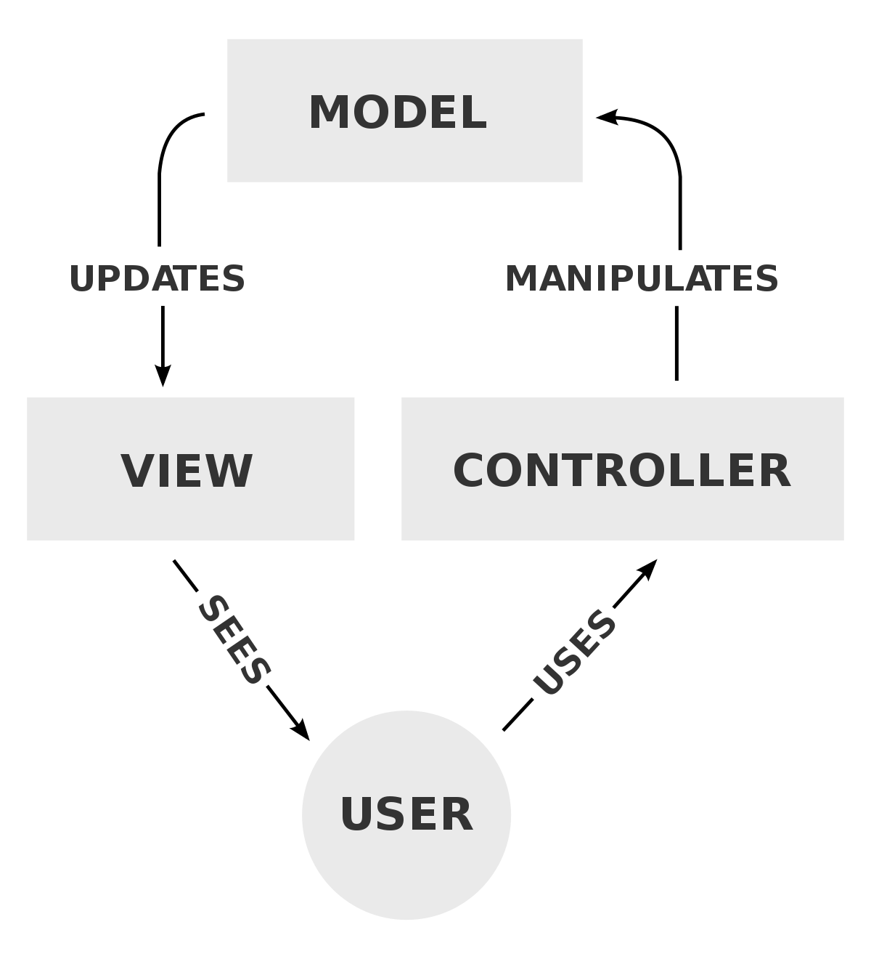

#### Figure 2: Model View Controller

## 3.3 System Architecture

The system architecture tier that will be used for this project will be the 3-tier as the user does not need to control the database of the system. Also, 3-tier architecture is more flexible and the application is faster. The three tiers are explained below:

1. **Presentation Tier**: Occupies the top level and displays information related services available on a website. This tier communicates with other tiers by sending results to the and other tiers in the network.
2. **Application Tier**: Also called the middle tier, logic tier, this tier is pulled from the presentation tier. It controls application functionality by performing detailed processing.
3. **Data Tier**: Houses database servers where information is stored and retrieved. Data in this tier is kept independent of application servers or business logic.

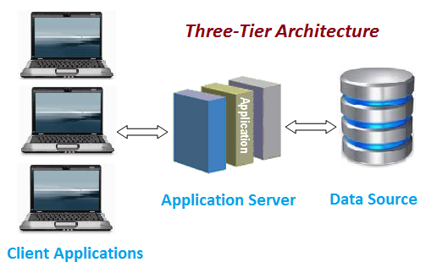

Figure 3: 3-tier architecture model

# 4) Project Plan

## 4.1 Work Breakdown Structure

A WBS in project management is a deliverable-oriented breakdown of a project into smaller components. Dividing the work helps for a better planning and organization of the work. Work break down structure has a hierarchical decomposition of the work. The project is divided into smaller chunks for detailed information.

#### Figure 4: WBS Diagram

The name and the diagram are rather self-explanatory. The project is broken down into smaller, more manageable pieces which can be reasonable to evaluate and work into it. In the figure above, I have divided my work into 6 major phases which is again granulated into other sub phases for being able to understand clearly.

## 4.2 Milestones

|  |  |
| --- | --- |
| **Milestones** | **Date** |
| **Project Management**  Risk Management  WBS  Configuration Management  Proposal Submission | 12/23/2018 to 1/5/2019  12/23/2018 to 12/26/2018  12/27/2018 to 12/29/2018  12/30/2018 to 1/1/2019  1/2/2019 to 1/5/2019 |
| **Analysis**  Requirement analysis  Use Case  Architecture (Initial Class Diagram)  Analysis Specification | 1/6/2019 to 1/30/2019  1/6/2019 to 1/12/2019  1/13/2019 to 1/18/2019  1/19/2019 to 1/23/2019  1/24/2019 to 1/30/2019 |
| **Design**  Structural Diagram  Behavioral Diagram  UI Design  Database Design (ER, Data Dictionary) | 1/31/2019 to 3/1/2019  1/31/2019 to 2/7/2019  2/8/2019 to 2/15/2019  2/16/2019 to 2/21/2019  2/22/2019 to 3/1/2019 |
| **Implementation**  Building Database  Coding | 3/2/2019 to 3/1/2019  3/2/2019 to 3/11/2019  3/12/2019 to 4/2/2019 |
| **Testing**  Unit Testing  Integration Testing  Blackbox Testing  Whitebox Testing | 4/3/2019 to 4/12/2019  4/3/2019 to 4/5/2019  4/6/2019 to 4/8/2019  4/9/2019 to 4/10/2019  4/11/2019 to 4/12/2019 |
| **Deployment**  User Training  Final Report | 4/13/2019 to 4/22/2019  4/13/2019 to 4/17/2019  4/18/2019 to 4/22/2019 |

Table: Time Estimation of the Project

In this stage, all the project stages are allocated a time frame within which it is hoped to be achieved. Allocation milestone helps in a better time management and ultimately deliverance of project on time.

**Description of Milestones:**

* **Project Management (14 days)**
* Risk Management (4 days)
* WBS (3 days)
* Configuration Management (3 days)
* Proposal Submission (4 days)
* **Analysis (30 days)**
* Requirement Analysis (7 days)
* Use case Diagram (6 days)
* Architecture (5 days)
* Analysis Specification (7 days)
* **Design (32 days)**
* Structural Model (8 days)
* Behavioral Model (8 days)
* UI Design (6 days)
* Database Design (8 days)
* **Implementation (32 days)**
* Database Coding (10 days)
* GUI Coding (22 days)
* **Testing (10 days)**
* Unit testing (3 days)
* Integration testing (3 days)
* Black box (2 days)
* White box (2 days)

## 4.3 Scheduling/ Gantt Chart

Gantt charts convey this information visually. They outline all of the tasks involved in a project, and their order, shown against a timescale. This gives an instant overview of a project, its associated tasks, and when these need to be finished.

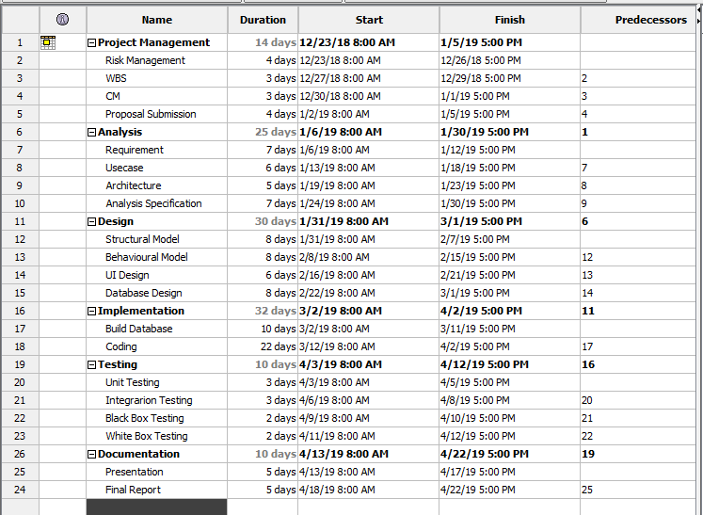Figure 5: Scheduling

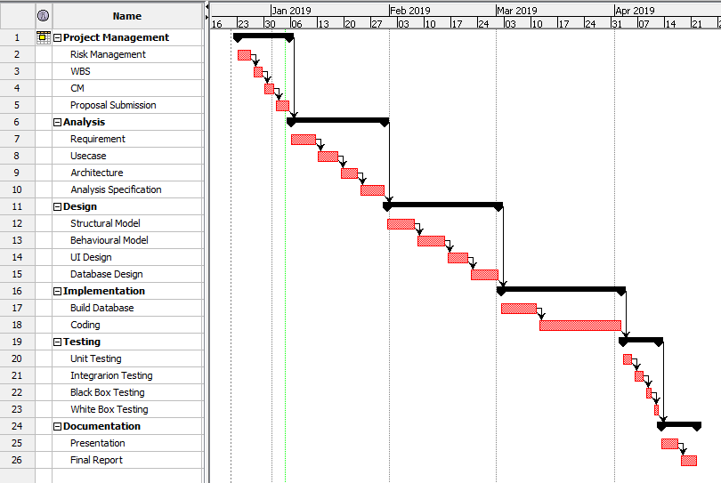

#### Figure 6 Gantt chart

# 5) Risk management

Risk management is the identification, evaluation, and prioritization of risks followed by coordinated and economical application of resources to minimize, monitor, and control the probability or impact of unfortunate events or to maximize the realization of opportunities. These threats or risks, could steam from wide variety of sources, including financial uncertainty, legal liabilities, strategic management errors, accidents and natural disasters. Following are the risks and their management for this project.

**Impact = Likelihood * Consequence**

Risk Likelihood values are shown as follows

|  |  |
| --- | --- |
| **Likelihood** | **Value** |
| Low | 1 |
| Medium | 2 |
| High | 3 |

Table: Likelihood

Risk Consequence values are shown below

|  |  |
| --- | --- |
| **Consequence** | **Value** |
| Very Low | 1 |
| Low | 2 |
| Medium | 3 |
| High | 4 |
| Very High | 5 |

Table: Consequences

|  |  |  |  |  |  |
| --- | --- | --- | --- | --- | --- |
| Risk No | Risk | Likelihood | Consequence | Impact | Action |
| 1 | Shortage in time and budget | 2 | 5 | 5 | Proper time and budget allocation |
| 2 | Failure of hardware e.g. hard disk | 2 | 4 | 4 | Data should be frequently backed up in the cloud and locally. |
| 3 | Misdirection of project | 1 | 4 | 3 | Proper analysis should be done |
| 4 | Conflict between implementation and design | 2 | 4 | 3 | Proper design should be made |
| 5 | Project resources not met | 1 | 3 | 2 | Proper analysis should be done |

Table: Risk Management

# Configuration Management

It is a mechanism to deal with different technical difficulties of a project plan. In a software organization, effective implementation of software configuration management can improve productivity by increased coordination among the programmers in a team. The Software configuration management system controls the basic components such as software objects, program code, test data, test output, design documents, and user manuals.

Software configuration management has the following reasons behind why it should be used

* Same work needn’t be done repeatedly which reduces redundancy
* Any updates that happen in the team are transparent
* Helps in building management; managing tools used in builds.
* It substantially helps on a team coordination

For software configuration management, I have created backup in different places such as local PC and git-hub.

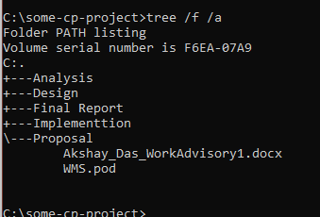

#### Figure 6 Project local directory

For a local back up, I have created a folder within which there are sub folders for each stages of the project. As an online backup, I have created an account with account name ‘aaxee33’ on GitHub where all the folders in the same way are stored. Any code necessary that has been used previously can be reused through here.

Below is the GitHub backup of the project

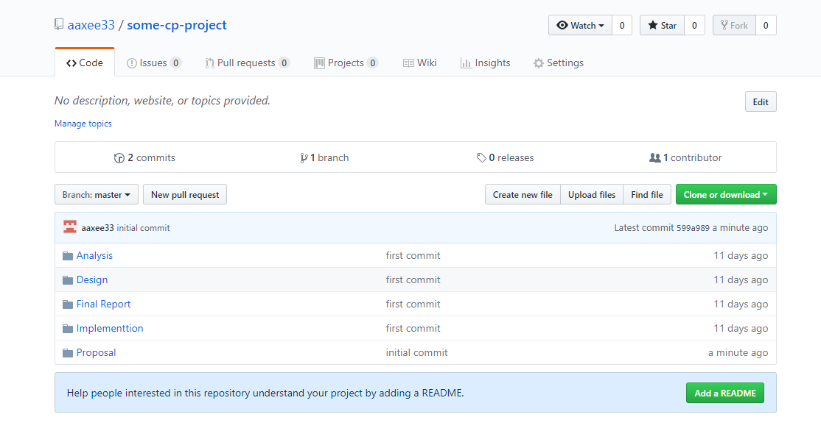

#### Figure 7: Git Directory

# 7) Conclusion

Therefore, overview of the project entitled ‘Work Advisory System’ has been shown. The scope, limitations and the methodology used to complete this project has been defined. With the help of WBS diagram, the project decomposition has been done and to show the time allocated for the decomposed parts, a Gantt chart has been made. The potential risks that can occur has been listed with proper solutions for it. For a better software efficiency software configuration management has been set up.

# 8) Reference

Project Management Guide. 2019. What is Scope in Project Management? - Project Management Guide. [ONLINE] Available at: <https://www.wrike.com/project-management-guide/faq/what-is-scope-in-project-management/>.

Difference Between 2-tier and 3-tier Architecture. Difference Between 2-tier and 3-tier Architecture. [ONLINE] Available at: <https://www.softwaretestingclass.com/what-is-difference-between-two-tier-and-three-tier-architecture/>

Waterfall model - Wikipedia. 2019. Waterfall model - Wikipedia. [ONLINE] Available at: <https://en.wikipedia.org/wiki/Waterfall_model>.

Waterfall model - Wikipedia. 2019. Waterfall model - Wikipedia. [ONLINE] Available at: <https://en.wikipedia.org/wiki/Waterfall_model>.

MVC Architecture – TutorialsTeacher 2019. MVC Architecture – TutorialsTeacher 2019 [ONLINE] Available at: www.tutorialsteacher.com/mvc/mvc-architecture