CURRICULUM VITAE

PERSONAL DETAILS - Aayaan Gautam
Residential Address: Kadaghari, Kathamndu, Nepal
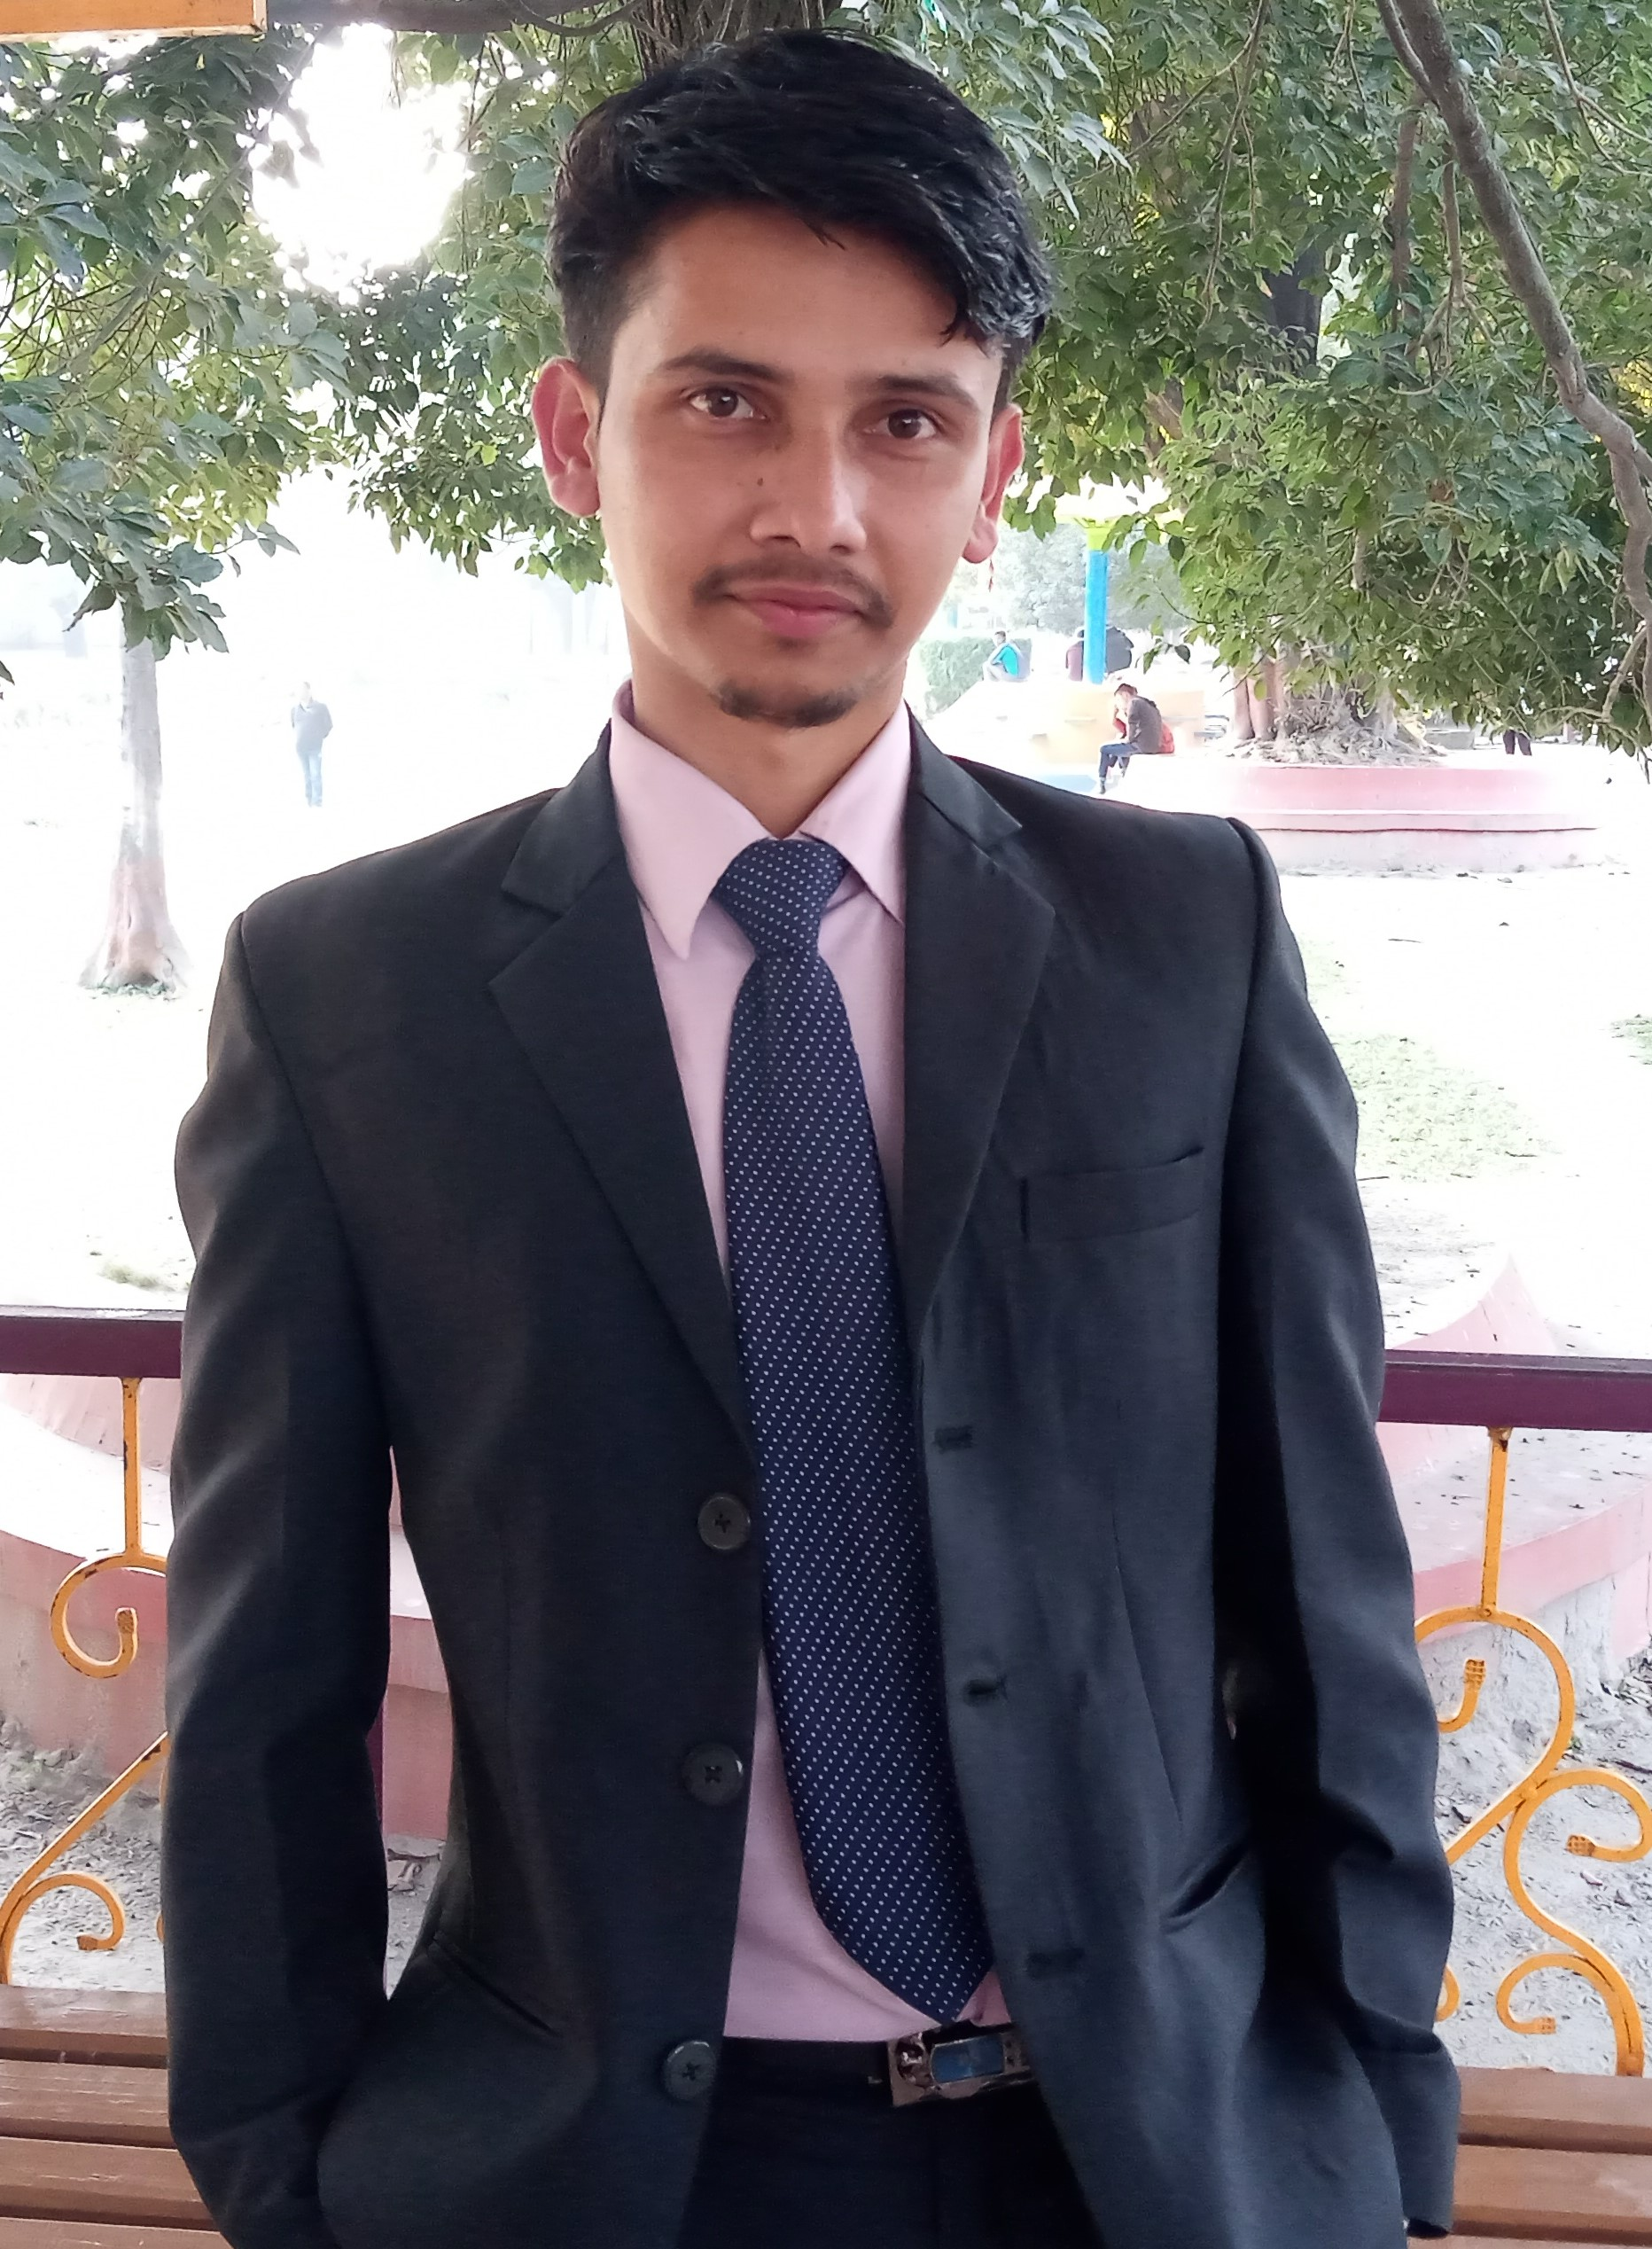
Permanent Address: Chautara,Sindhupalchok, Nepal

Mobile: 9861941779

Email: aayaan.gautam1999@gmail.com

Date of Birth: 23rd June, 1999

Nationality: Nepali

CAREER OBJECTIVE
Self-motivated and hardworking fresher seeking for an opportunity to work in a challenging environment to prove my skill and utilize my knowledge and intelligence in the growth of organisation.

EDUCATION HISTORY

S.N. | Qualification | Institute Name | University / Board | Percentage/Grade | Year of Graduation
1. | BscCsit | Bhaktapur Multiple Campus  (dudhpati,Bhaktapur) | Tribhuvan University  (Nepal)
2. | Intermediate (Science) | Himalayan Whitehouse international college  (subidhanagar, Kathmandu) | HSEB | 73% | 2074  (2017 AD)
3. | S.L.C | Ekta Boarding High School  (Chautara, Sindhupalchok) | Nepal Government | 76.50% | 2072 B.S.  (2015 AD)

SKILLS AND CERTIFICATES

TRAININGS
- Basic Trainings of python and machine learning from coursera,Kaggle,udemy.
- Attended different seminars, Exhibition.

PROGRAMMING AND COMPUTER SKILLS:

- C and C++ (Basic programming concepts according to the course of Tribhuvan University).
- Basic on Python, ML(machine learning),HTML,css,javascript.
- Microsoft Office applications (Word, Excel, PowerPoint) – Advanced

LANGUAGE SKILLS:

- Nepali
- English
- Hindi

PERSONAL COMPETENCIES

- Ability to work in a fast-paced environment.
- Enthusiastic self-starter who contributes well to the team
- Dedicated
- Honest and responsible
- Eagerness to learn new things

DECLARATION
I hereby declare that the above written particulars are true to the best of my knowledge and belief.

------------------------------------------ (AAYAAN GAUTAM)

