

**A Project**

**On**

**Man walking in rain with umbrella**

**Submitted By**

Aayaan Gautam

CSIT

**Roll No. :** 1

**Submitted To**

CSIT Department

Bhaktapur Multiple Campus

**ACKNOWLEDGEMENTS**

I would like to express my gratitude toward our respected Computer Graphics Sir Mr. Ramesh Kharbuja for his kind co-operation and encouragement which helps in the completion of this project. He provide us an opportunity to grow our interest in computer graphics and animation and by giving us a chance to learn more about this broad topic and make an eye catching graphics via this beautiful project. I would like to express mine special gratitude and thanks to my friend for giving me precious attention and time. Similarly, I would like to acknowledge Bhaktapur Multiple Campus for providing an innovative way to learn about graphics and programing language to make our projects look attractive and detailed as possible.

Table of contents

Introduction 4

Background 4

C Language 4

Statements of Problems 4

Objectives of the Study 4

Literature Review 5

Header files Description 5

Functions Description 7

Research Methodology 10

Results and Discussion 11

Overview 11

Implementation 19

Conclusion and Recommendation 21

Conclusion 21

Limitation of the study 21

Future Enhancements 22

Reference 22

## 

# Introduction

## Background

“Man walking in rain with Umbrella” is an animation created with the help of C language coded in Dev C++. The animation is of man waking in rain by hanging the umbrella with his hand. The major objects in thisanimation are: Man, Rain,Ground and Umbrella. This animation depicts the interaction betweenthese components. The demonstration of the motion of the man can be observed in the animation along with the motion of the umbrella and motion of the Rain. Using random variable for raining in all the direction and provide an umbrella to a man to get the secure from the heavy rain while walking on the ground. These are the major highlight of these project.

## C Language

C is a procedural programming language. It was initially developed by Dennis Ritchie in the year 1972. It was mainly developed as a system programming language to write an operating system. The main features of C language include low-level access to memory, a simple set of keywords, and clean style, these features make C language suitable for system programming like an operating system or compiler development.

## Statements of Problems

This report discusses the Computer Graphics project “Man walking in the rain with Umbrella”. It also dealswith the different functions used in the program to make the program executesuccessfully. It attempts to highlight different functions like rand() for generating random variables and also user defined function is being used. This report tries to showcase the mathematics regarding the motion of theman, rain, umbrella and also has the source code of the project. This report lists the limitations inthe project. One of the limitation of this project is that the demonstration of the motion of the umbrella can’t be observed in theanimation along with circular motion and rains in the man legs.It also tries to deal with the improvements that can be made in thisproject to make its graphics more detailed and finer.

## Objectives of the Study

Objective of the project is to thank my respected teacher by putting in all the knowledge that I have gained from him throughout the Third Semester of my journey to complete BSc.CSIT regarding the subject Computer Graphics and also grow the skills in the graphics field.

# Literature Review

## Header files Description

A header file is a file with extension .h which contains C function declarations and macro definitions to be shared between several source files. There are two types of header files: the files that the programmer writes and the files that come with our compiler.

We request to use a header file in our program by including it with the C preprocessing directive **#**include, like we have seen inclusion of stdio.h header file, which comes along with our compiler.

**#include<stdio.h>**

stdio.h is the header file for standard input and output. This is useful for getting the input from the user and output result text to the monitor. Without this header file, one cannot display the results to the users on the screen or cannot input the values through the keyboard. The stdio.h header defines three variable types, several macros, and various functions for performing input and output.

The three variable types defined by stdio.h are: size_t, FILE and fpos_t.

Some macros defined in the header file stdio.h are: NULL, BUFFSIZ, EOF, etc.

Some functions defined in the header file stdio.h are: int fclose, void clearer, int feof, etc.

**#include<conio.h>**

The conio.h header file used in C programming language contains functions for console input/output.

There are five different inbuilt C functions declared in header file conio.h.

They are: clrscr( ), getch( ), getche( ), textcolor( ) and textbackground( ).

**#include<graphics.h>**

The graphics.h header file provides access to a simple graphics library that makes it possible to draw lines, rectangles, ovals, arcs, polygons, images, and strings on a graphical window.

**#include<stdlib.h>**

The **stdlib.h** header defines four variable types, several macros, and various functions for performing general functions.

## Library Variables

Following are the variable types defined in the header stdlib.h −

|  |  |
| --- | --- |
| **Sr.No.** | **Variable & Description** |
| 1 | **size_t**  This is the unsigned integral type and is the result of the **sizeof** keyword. |
| 2 | **wchar_t**  This is an integer type of the size of a **wide** character constant. |
| 3 | **div_t**  This is the structure returned by the **div** function. |
| 4 | **ldiv_t**  This is the structure returned by the **ldiv** function. |

## Library Macros

Following are the macros defined in the header stdlib.h −

|  |  |
| --- | --- |
| **Sr.No.** | **Macro & Description** |
| 1 | **NULL**  This macro is the value of a null pointer constant. |
| 2 | **EXIT_FAILURE**  This is the value for the exit function to return in case of failure. |
| 3 | **EXIT_SUCCESS**  This is the value for the exit function to return in case of success. |
| 4 | **RAND_MAX**  This macro is the maximum value returned by the rand function. |
| 5 | **MB_CUR_MAX**  This macro is the maximum number of bytes in a multi-byte character set which cannot be larger than MB_LEN_MAX. |

**#include<dos.h>**

dos. h header file of C language contains functions for handling interrupts, producing sound, date and time functions etc. It is Borland specific and works in Turbo C compiler.

## Functions Description

**#define**

#define is a C preprocessor directiveused to define macros.

A preprocessor directive is a program statement which is invoked before the program compilation takes place. Actually, any line followed by a **#** character is a preprocessor. This includes the includedrective as well. The preprocessor directives are used to provide general instruction or required data which is used inside a program.

A macro is a block of code which has been given a name. Any occurance of that name is replaced by the value of the macro. Say, I defined macro named AMOUNT who's value is 200. Now every time the word AMOUNT is used in the program it is replaced by the number 200 before compilation. In contrast to variables, where data is actually stored inside of them, macros act rather like alias names.

Syntax of #define directive is as follows:

#define MACRONAME value

OR

#define MACRONAME (expression)

**Line Function**

Linefunction is used to draw a line from a point(x1,y1) to point(x2,y2) i.e. (x1,y1) and (x2,y2) are end points of the line.

Syntax: void line(int x1, int y1, int x2, int y2);

**Setcolor Function**

In Graphics, each color is assigned a number. Total number of colors available is 16. Number of available colors depends on current graphics mode and driver. For example, setcolor(RED) or setcolor(4) changes the current drawing color to RED. The default drawing color is WHITE. The Colors table is given below:

|  |  |
| --- | --- |
| **COLORS** | **INT VALUES** |
| BLACK | 0 |
| BLUE | 1 |
| GREEN | 2 |
| CYAN | 3 |
| RED | 4 |
| MAGNETA | 5 |
| BROWN | 6 |
| LIGHTGRAY | 7 |
| DARKGRAY | 8 |
| LIGHTBLUE | 9 |
| LIGHTGREEN | 10 |
| LIGHTCYAN | 11 |
| LIGHTRED | 12 |
| LIGHTMAGNETA | 13 |
| YELLOW | 14 |
| WHITE | 15 |

**setfillstyleFunction**

* + setfillstyle() function contains two arguments pattern and color. Various fill patterns are already enumerated in graphics.h header file as given below:

enum fill_styles

{

EMPTY_FILL,

SOLID_FILL,

LINE_FILL,

LTSLASH_FILL,

SLASH_FILL,

BKSLASH_FILL,

LTBKSLASH_FILL,

HATCH_FILL,

XHATCH_FILL,

INTERLEAVE_FILL,

WIDE_DOT_FILL,

CLOSE_DOT_FILL,

USER_FILL

};

**rand Function**

rand() function is used in C to generate random numbers. If we generate a sequence of random number with rand() function, it will create the same sequence again and again every time program runs. Say if we are generating 5 random numbers in C with the help of rand() in a loop, then every time we compile and run the program our output must be the same sequence of numbers.

**Syntax:**

**int rand(void):**

returns a pseudo-random number in the range of 0 to RAND_MAX.

**RAND_MAX:** is a constant whose default value may vary

between implementations but it is granted to be at least 32767.

# Research Methodology

**Introduction**

I was able to create a man with umbrella and the man is walking on the ground. So to make it more creative I thought that if I was able to add the rain then it would be more realistic. Also , I want the movement of the umbrella in the hand of man for more realistic.To get the movement of the umbrella and the rain in the project, I used different method and that method are mention below:

1. **Notes:** I review the notes that I have written in previous semesters to return knowledge about different functions within programing language c and c++.
2. **Peers:** I discussed about the project with my friends and the problem I was having to complete it.we had a through view ever my project and they were able to enlighten me with several ideas that I thought I would be able to implement within my project.
3. **Web Surfing:** After the reaserch over several articles over the internet, I was config that the materials over there would surely help me in my project. I went through some videos where the tutor explained about the position of cursor as desired by the user.

After gathering information by using above mentioned methods, I come up with some ways to move the umbrella and the rain in overall in the screen.I use built-in function of C i.e rand function to randomize the position of the rain over the screen.i would also be able to move the umbrella using for loop as well as pieslice function for the movement of the umbrella.

# Results and Discussion

## Overview

Source Code

#include<stdio.h>

#include<graphics.h>

#include<stdlib.h>

#include<dos.h>

#include<conio.h>

#define ScreenWidth getmaxx()

#define ScreenHeight getmaxy()

#define GroundY ScreenHeight*0.75

int ldisp=5;

void DrawManAndUmbrella(int x,int ldisp)

{

//head

circle(x,GroundY-90,10);

circle(x+6,GroundY-92,1.5);

line(x,GroundY-80,x,GroundY-30);

//hand

line(x,GroundY-70,x+10,GroundY-60);

line(x,GroundY-65,x+10,GroundY-55);

line(x+10,GroundY-60,x+30,GroundY-70);

line(x+10,GroundY-55,x+30,GroundY-70);

//legs

line(x,GroundY-30,x+ldisp,GroundY);

line(x,GroundY-30,x-ldisp,GroundY);

//umbrella

setfillstyle(SOLID_FILL,8);

setcolor(5);

pieslice(x+30-ldisp,GroundY-120,ldisp,180+ldisp,40);

//floodfill(x+30-ldisp,GroundY-120,5);

line(x+30-ldisp,GroundY-120,x+30,GroundY-70);

}

void Rain2(int x)

{

int i,rx,ry;

for(i=0;i<800;i++)

{

rx=rand() % ScreenWidth;

ry=rand() % ScreenHeight;

if(ry>GroundY && ry<GroundY+20)

line(rx,ry,rx+4,ry+0.5);

}

}

void Rain1(int x)

{

int i,rx,ry;

for(i=0;i<400;i++)

{

rx=rand() % ScreenWidth;

ry=rand() % ScreenHeight;

if(ry<GroundY)

{

if(ry<GroundY-165 || (ry>GroundY-165 && (rx<x-30 || rx>x+60)))

line(rx,ry,rx+0.2,ry+4);

}

}

}

int main()

{

int gd=DETECT,gm,x=0;

initgraph(&gd,&gm,"C:\\TurboC3\\BGI");

while(!kbhit())

{

rectangle(-1,GroundY,ScreenWidth+1,GroundY+20);

Rain1(x);

Rain2(x);

ldisp=(ldisp+2)%35;

DrawManAndUmbrella(x,ldisp);

delay(30);

cleardevice();

x=(x+2)%ScreenWidth;

}

getch();

closegraph();

return 0;

}

## Implementation

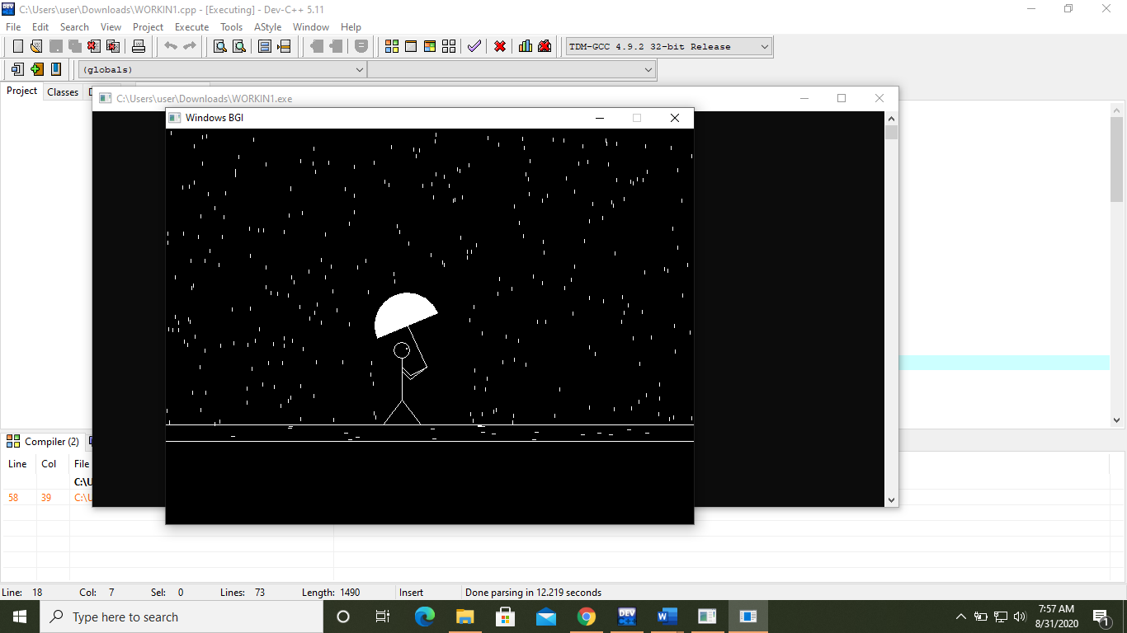

# Conclusion and Recommendation

## Conclusion

This project is an animation created with the help of C language coded in Dev C++. This project report also deals with the motion of ball along with the motion of striker and goalkeeper. Out of many features available this project uses some popular and commonly used features and functions like line, circle, srand, etc.

In a nutshell, this project is a simple execution of motion of the man with umbrella in graphics simulation and demonstrates the use of C language and various concepts of generatingrandom variable so that it can create variation in raining and movement of man along with movement of the umbrella.

## Limitation of the study

* It falls short in setting the resolution and making an app full-screen i.e.

making its window take up the entire screen.

* Demonstration of the motion of the umbrella in a cirular way is not seen in the proiect as well as rains in the feet of the man also not seen in this project.

## Future Enhancements

In future, we can use OpenGL and GLUT on Code Blocks platform and use sphere, cylinder and quadrilaterals to make our environment more realistic i.e. With the help of various OpenGL functions, we can also create a motion of the umbrella in a circular way using the hemisphere function and ground using rectangle and rain in the feet of the man and so on.

OpenGL by itself is not familiar with the concept of a camera, but we can also try to simulate one by moving all objects in the scene in the prefer direction, giving the illusion that we are moving by changing the vertex and co-ordinates as seen from the camera’s prospective in real time.

# Reference

1. www.pintrest.com
2. https://github.com/CodAffection/CG-Program-For-A-Man-Walking-In-Rain/blob/master/A%20Man%20Walking%20In%20The%20Rain.C
3. <https://www.google.com/>