Reconciliation & Verification Tool
Application flow, screen by screen, with screenshots
What this document is. A walk through every tab and screen of the tool in the order a CA firm uses them during the filing season, from the first start of the tool to the decision on each finding. Every picture is a real screenshot of the current build, taken on 2 November 2026.
Data used. All screenshots use Test Pack A, the fictional company "Nimbus Logic Systems Private Limited" (testdata/testpack_nimbus). Its PAN, figures and names are made up. The user names (A. Partner, B. Staff) are invented too. No real client data appears anywhere in this document.
How the screenshots were taken. A fresh copy of the tool was started on the office machine with an empty database, the first Partner was set up, the Test Pack A client was added, its files were uploaded and checked, and every tab was then opened in turn.

1. The flow at a glance
The tool reads what the accounting software (Tally), the tax suite, the GST portal and TRACES produce, compares the same figure wherever it appears, and lists every place where two documents disagree, to the rupee. It never says what a figure should be and never prepares a filing. The working day follows these steps:
Step | Screen / tab | Who does it | What comes out
1 | Set up the first Partner, then Sign in | Partner (once); then every user | A signed-in session with the user's role
2 | Season board (tab 1) | Everyone | The list of the firm's clients for the tax year, with their status
3 | Add client | Partner, Manager, Staff | A client with PAN, constitution, GSTINs and address
4 | Client file → Upload and run | Partner, Manager, Staff | Files recognised by their contents; every runnable rule is run
5 | Teach this layout (only if a file is not recognised) | Partner, Manager, Staff | A new layout saved once; later files in that layout are read by themselves
6 | Client file → Findings | Everyone can view | Findings grouped by the document to fix, each with both figures, the difference and both sources
7 | Decide a finding (Fix / Not an issue / Ask client) | Partner, Manager, Staff | A decision with a note, kept in the audit trail
8 | Client file → Documents and Run history | Everyone | What was read from each file, and every earlier run kept as it was
9 | Worklist (tab 2) | Partner, Manager, Staff | New, vanished and changed ledger heads, classified by staff
10 | Rules (tab 3) and the Rule Builder | View: all; edit: Staff and above; approve: Partner | The firm's rule book, rule status and versions
11 | Admin (tab 4) | Partner only | Users and roles, lockout settings, the audit log

Moving around. The left menu holds the four tabs: Season board (key 1), Worklist (key 2), Rules (key 3) and Admin (key 4, Partner only). The Client file opens from the Season board. Esc goes back to the Season board. The bottom of the menu shows that the screens are connected to the engine, who is signed in, Sign out, the keyboard shortcuts and the light/dark theme switch.
Roles. Partner: everything, including approving rules and the Admin tab. Manager: view, upload and run, decide and delete findings, draft rules, export. Staff: view, upload and run, decide findings and classify the Worklist, draft rules. Read-only: view only.

2. First start and sign-in

2.1 Set up the first Partner
The very first time the tool is opened on the office machine, no one has used it yet, so it asks for the first Partner: a login name, a display name and a password of at least 10 characters. This screen appears only once. After that, every other user is added by the Partner on the Admin tab.
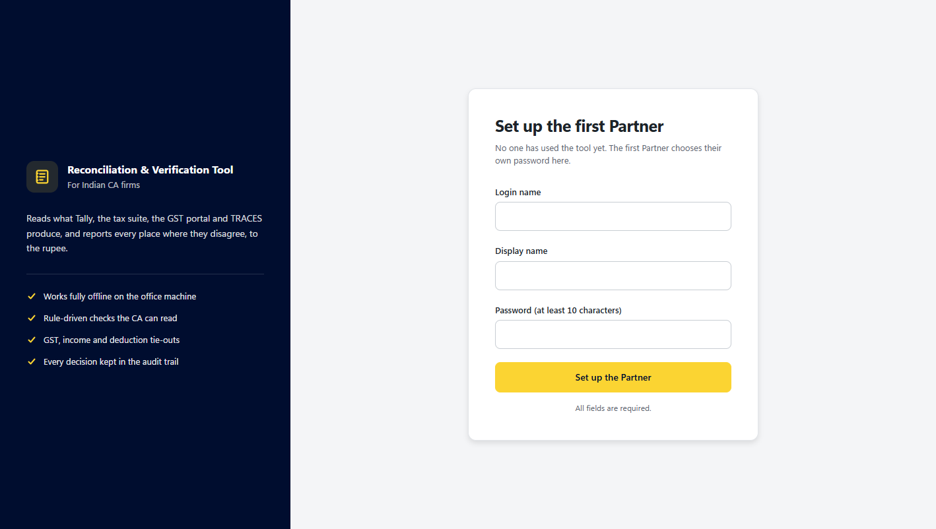
Figure 1. Set up the first Partner (shown only on the first start).

2.2 Sign in
From then on the tool opens on the sign-in screen. The left panel says what the tool does: it works fully offline on the office machine, its checks are rules the CA can read, and every decision is kept in the audit trail. A user added by the Partner signs in with a starting password and must choose their own at the first sign-in. After too many wrong passwords the account is locked for a while (set on the Admin tab).
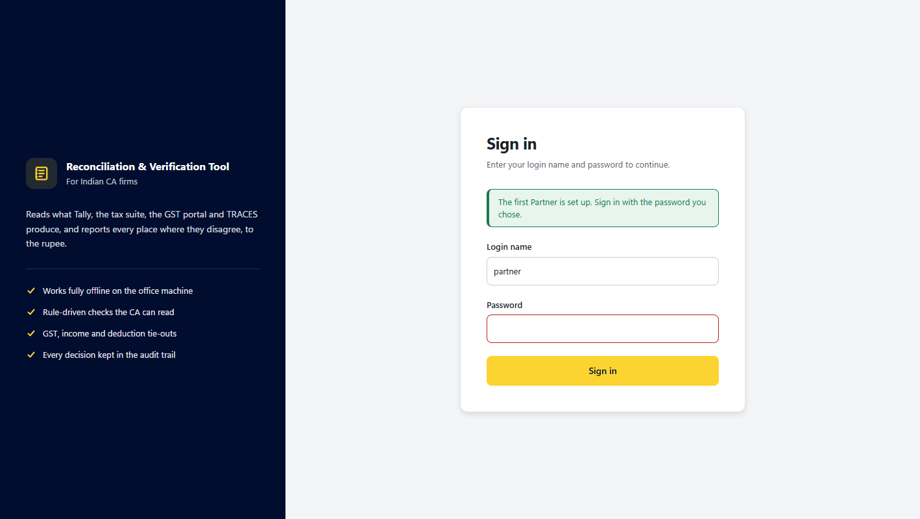
Figure 2. Sign in.

3. Season board (tab 1)
The Season board is the home screen. It lists every client of the firm for the chosen tax year and shows, for the whole season: how many clients there are, how many checks have been run, how many clients have findings, the total number of findings, how many checks could not be done ("Cannot check") and how many clients have no run yet.

3.1 An empty board
On a new database the board is empty and points to "+ Add client".
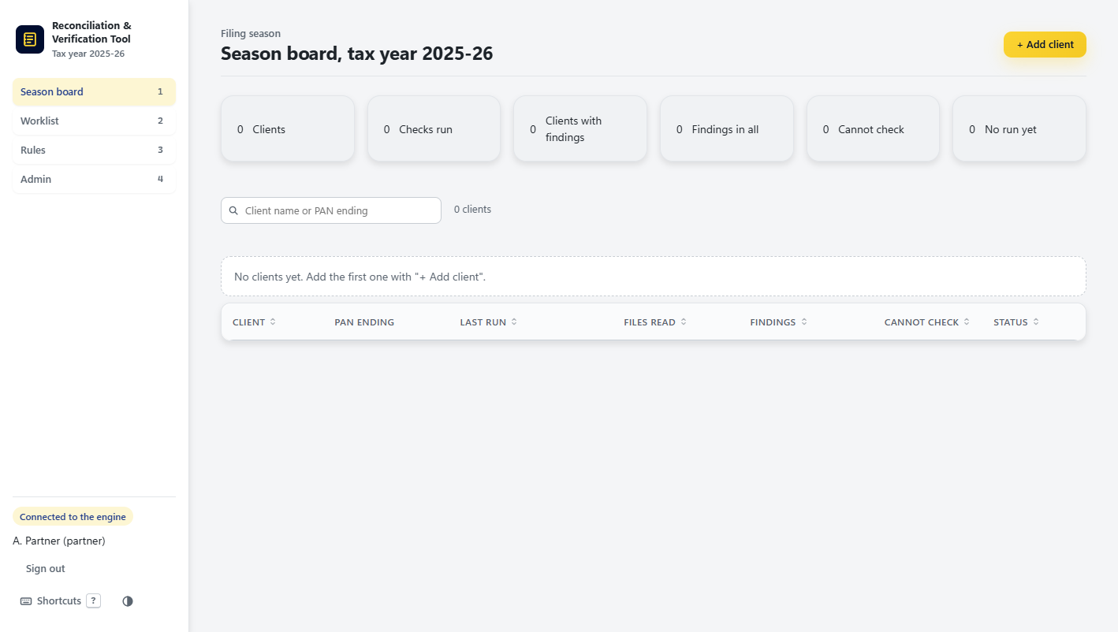
Figure 3. Season board before any client is added.

3.2 Add a client
"+ Add client" (or the key n) opens the client form in three parts. Identity: legal name, trade name, PAN, constitution (company, LLP, firm, individual, HUF, trust and so on), date of incorporation, CIN or LLPIN, TAN and the tax year. GST registrations: one or more GSTINs. Registered address, contact and software: address, contact person, email, phone, the accounting software and notes. The full PAN is not shown again after saving; only its last four characters are.
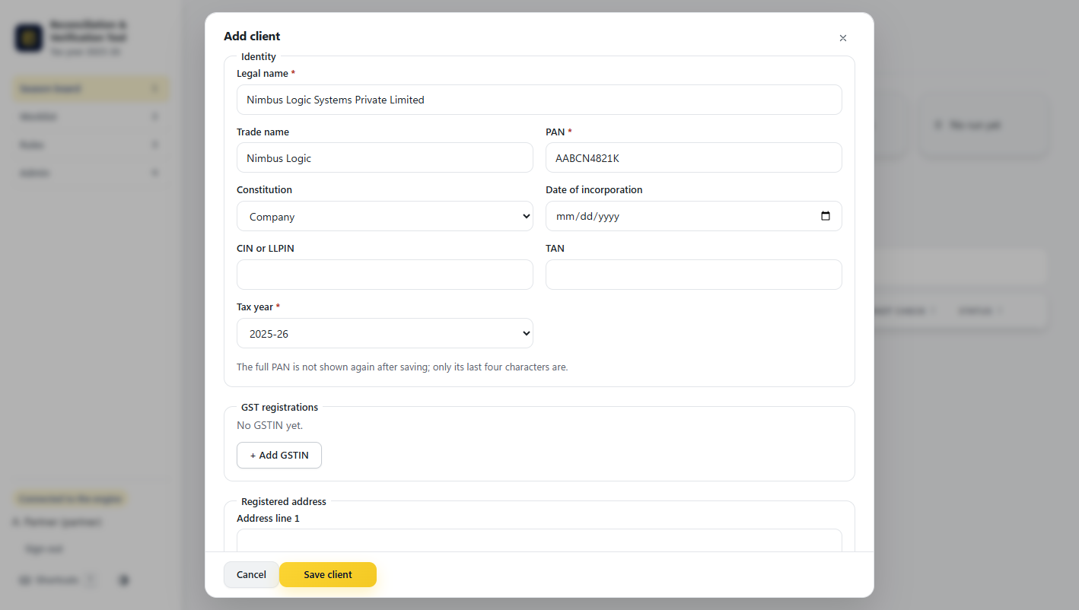
Figure 4. The Add client form, filled in for the fictional Test Pack A company.

3.3 The board during the season
Once clients have been checked, each row shows the PAN ending, the date of the last run, how many files were read, the number of findings, the number of checks that could not be done and a status such as "Findings to review". The columns can be sorted and the list searched (key /). Clicking a row, or pressing Enter on it, opens the Client file.
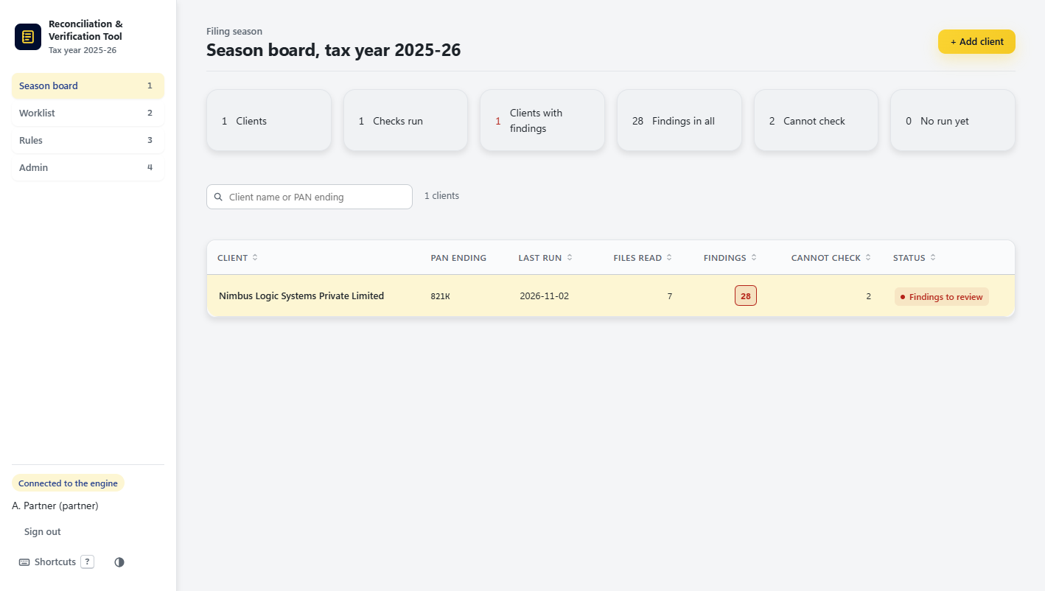
Figure 5. Season board after the Test Pack A client was checked: 1 client, 28 findings, 2 checks that could not be done.

4. Client file: upload and run

4.1 A new client
The Client file is the page for one client. Its header shows the client's name, PAN ending, constitution and city, with "Edit client" and "Export Excel" on the right. Before any run it explains the next step: upload the client's files and run the checks.
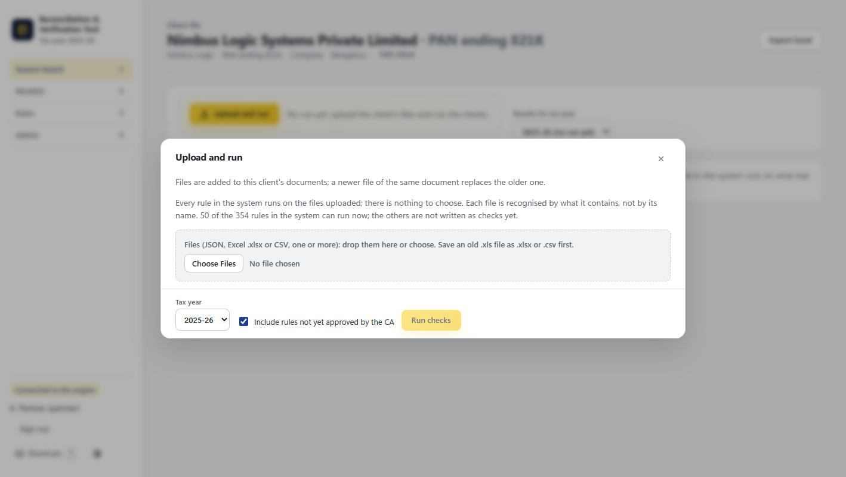
Figure 6. The Client file of a new client, before any run.

4.2 Upload and run
"Upload and run" opens a panel where one or more files are dropped or chosen. JSON, Excel (.xlsx) and CSV are read; an old .xls file has to be saved as .xlsx or .csv first. There is nothing to choose about which checks to run: every rule in the system runs on what was uploaded, and each file is recognised by what it contains, not by its file name. The panel says how many of the rules can run today.
The tool also works out the tax year from the files. In the example, the files are for 2024-25 and 2025-26, so the run is for 2025-26 and the 2024-25 expense ledger is kept as last year's ledger for the Worklist. "Include rules not yet approved by the CA" also runs the rules that are still in testing; results from such a run are marked as such. "Run checks" starts the run.
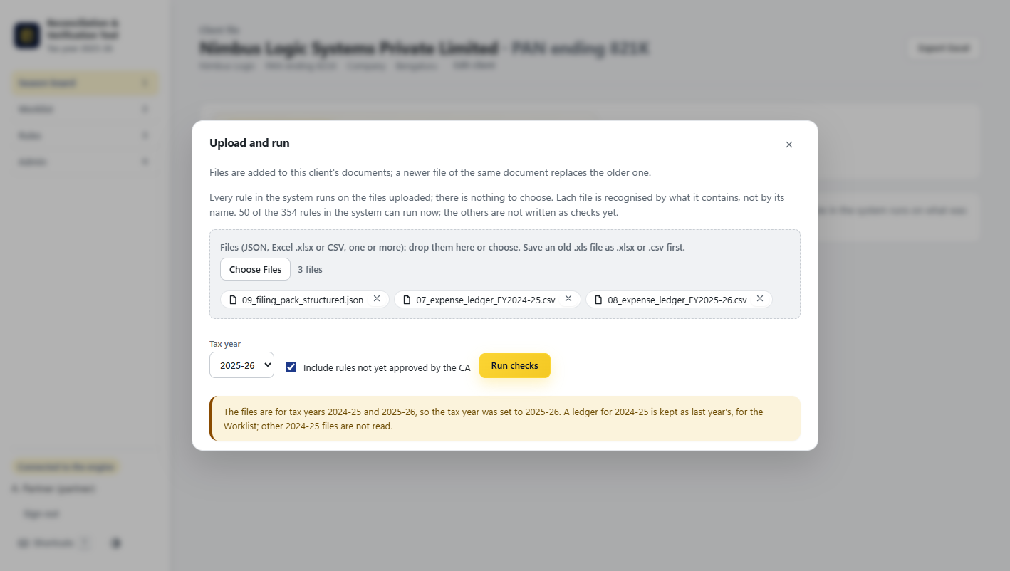
Figure 7. Upload and run with the Test Pack A filing pack (JSON) and two expense ledgers (CSV).

4.3 A file the tool does not know: Teach this layout
If a file comes from software or a version the tool has not seen, the run stops for that file with a plain message ("the file matches no known format") and offers "Teach this layout". This is the mapping screen. Nobody writes code: the user says once which field is which, and from then on every file in that layout is read by itself.
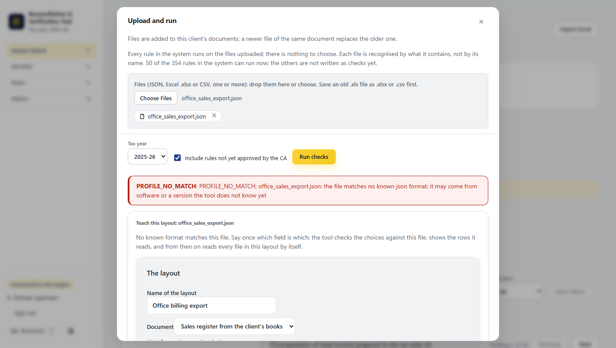
Figure 8. An unknown file (a made-up office billing export) and the start of the mapping screen.
The mapping asks for: a name for the layout, which document it is (for example the sales register from the client's books), where the list of rows is (one per invoice), whether amounts are in rupees or paise, and then which field holds each column: invoice number (needed, because rows are matched on it), customer GSTIN, invoice date, place of supply, GST rate, taxable value, IGST, CGST, SGST/UTGST, cess and invoice value. Each choice shows an example value from the file. The period comes either from a field in the file or is the same for every file.
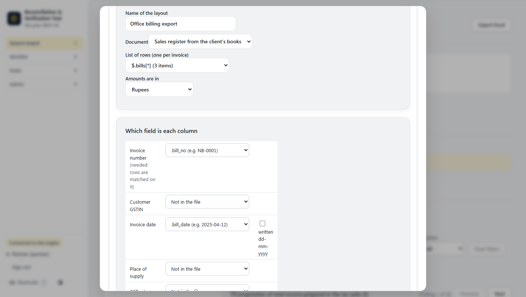
Figure 9. Saying which field is each column.
"Preview rows" checks the choices against the file and shows the rows exactly as they will be read, with the place each value came from. The layout can be saved only once the rows read correctly. A wrong choice gives a clear error instead of a wrong figure.
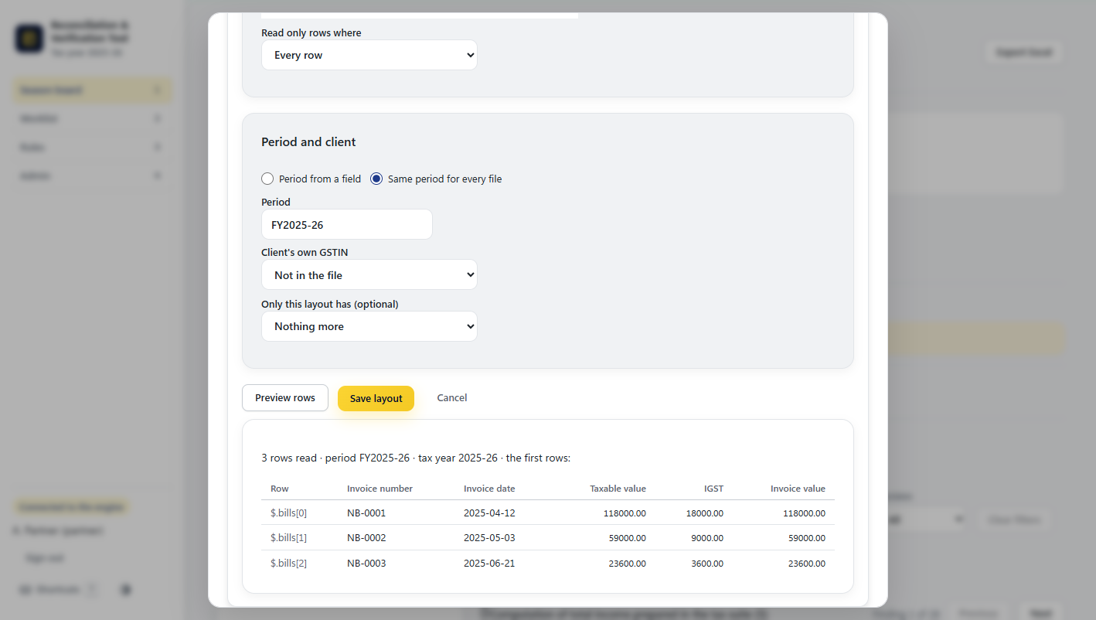
Figure 10. Preview of the rows read before the layout is saved.

5. Client file: the result

5.1 Result summary
After the run the Client file shows the result for the chosen tax year, with three views: Findings, Documents and Run history. The summary line counts the checks run, how many passed, how many failed (findings), how many could not be checked because a figure was not in the files, and how many findings are still open with no decision. A yellow note says when the run included rules not yet approved by the CA.
In the example: 69 checks, 39 pass, 28 findings, 2 cannot check, 28 open.
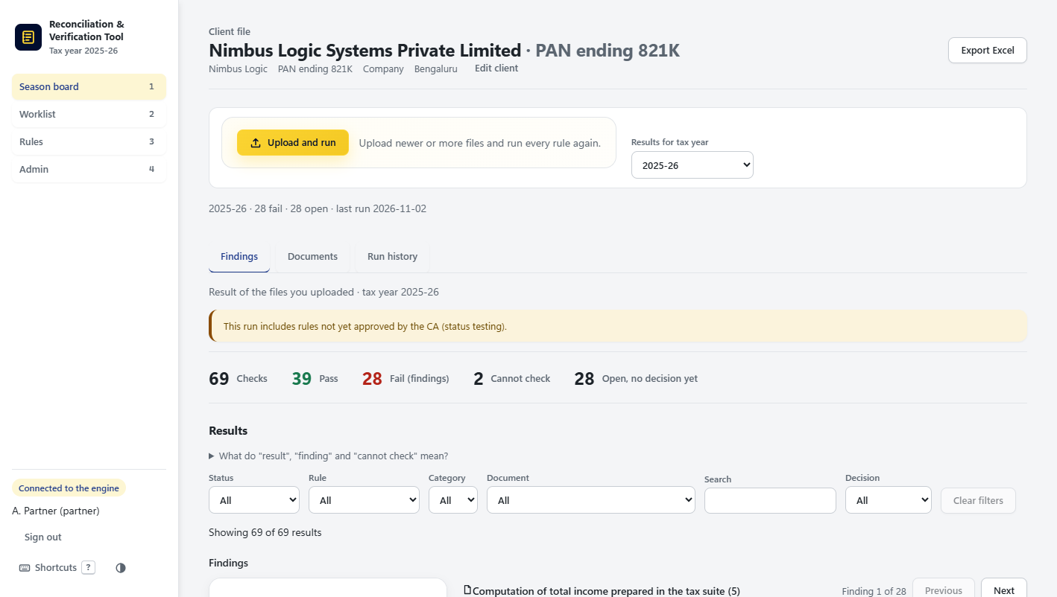
Figure 11. The result of the Test Pack A run.

5.2 Findings, grouped by the document to fix
Findings are listed under the document that needs fixing (for example the computation of total income, Form 26AS, Form 67 or the tax audit report), not under the rule category, because that is how the work is handed out. Each line shows the rule ID, its name and the difference in rupees. Filters narrow the list by status, rule, category, document, decision or free text, and "Previous" / "Next" (or j and k) move between findings.
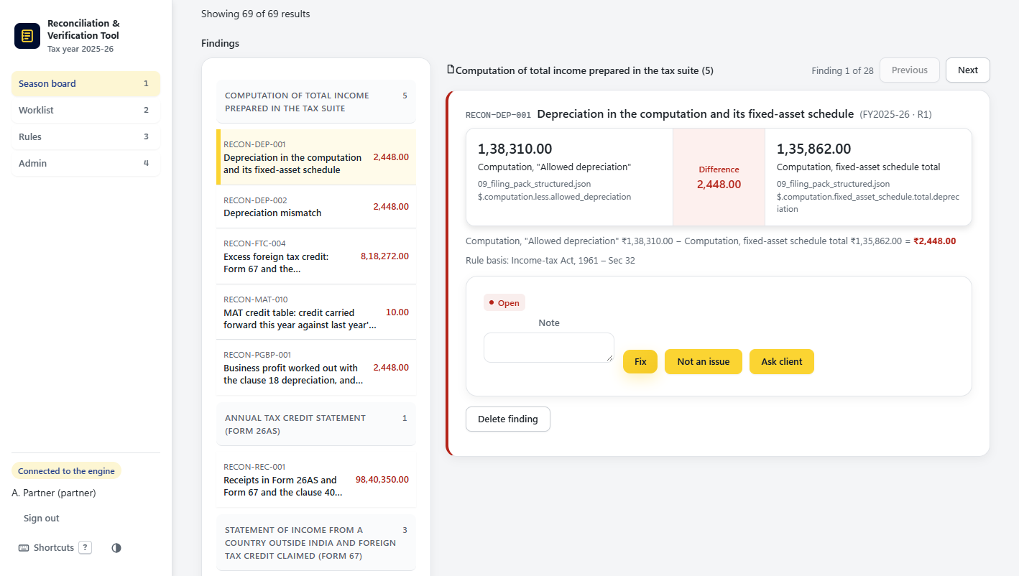
Figure 12. Findings grouped by document, with filters above.

5.3 One finding: both figures, the difference and both sources
Opening a finding shows the arithmetic in full. On the left is the first figure with its label and its exact source (file name and location inside the file); on the right the second figure and its source; in the middle the difference. Below it the sum is written out in words and figures, followed by the rule basis (the law section behind the check).
In the example: the computation's "Allowed depreciation" is ₹1,38,310.00, the computation's fixed-asset schedule total is ₹1,35,862.00, and the difference is ₹2,448.00, under section 32 of the Income-tax Act. The tool states only what it can compute. It never says which figure is right.
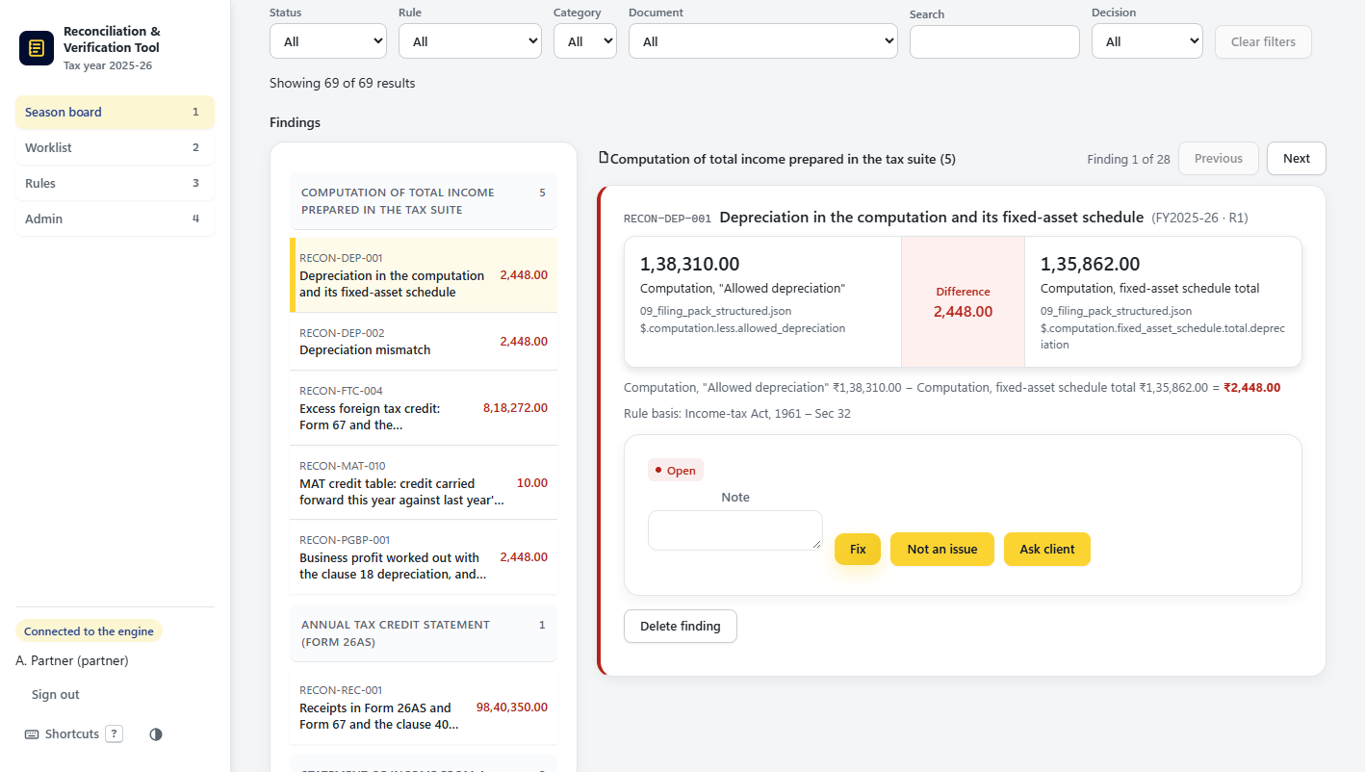
Figure 13. A finding with both values, the difference and both source locators.

5.4 Deciding a finding
Below the figures, the reviewer writes an optional note and chooses Fix (the document will be corrected), Not an issue (the difference is explained) or Ask client (information is needed from the client). The decision is recorded with who made it, when, and the note, and it is never overwritten: a later decision is added on top, so the history stays complete. Decisions follow the finding into later runs. In the example, after a second run, 27 findings were open because one had already been decided. A Partner or Manager can also delete a finding, with a reason that is kept.
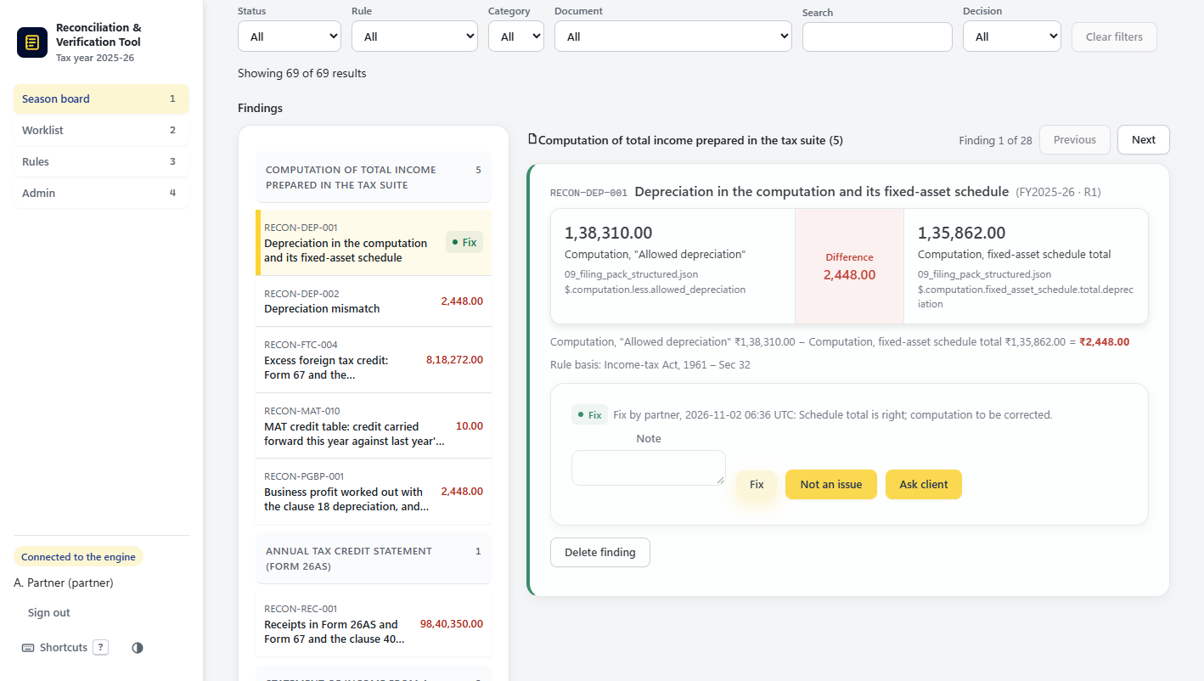
Figure 14. The finding after "Fix" was chosen, with the note and who decided it.

5.5 Documents: what was read from each file
The Documents view lists every file read and what it was recognised as. One upload can hold several documents: the Test Pack A filing pack holds the computation, the financial statements, Form 26AS, Form 67, the MAT report (Form 29B) and the tax audit report (Form 3CD), and each is read by its own format. For each document the table shows the tax year, how many figures or rows were read, how many values no check uses ("Not read") and any problems. Opening a row shows exactly what was read from the file, what was not, and why.
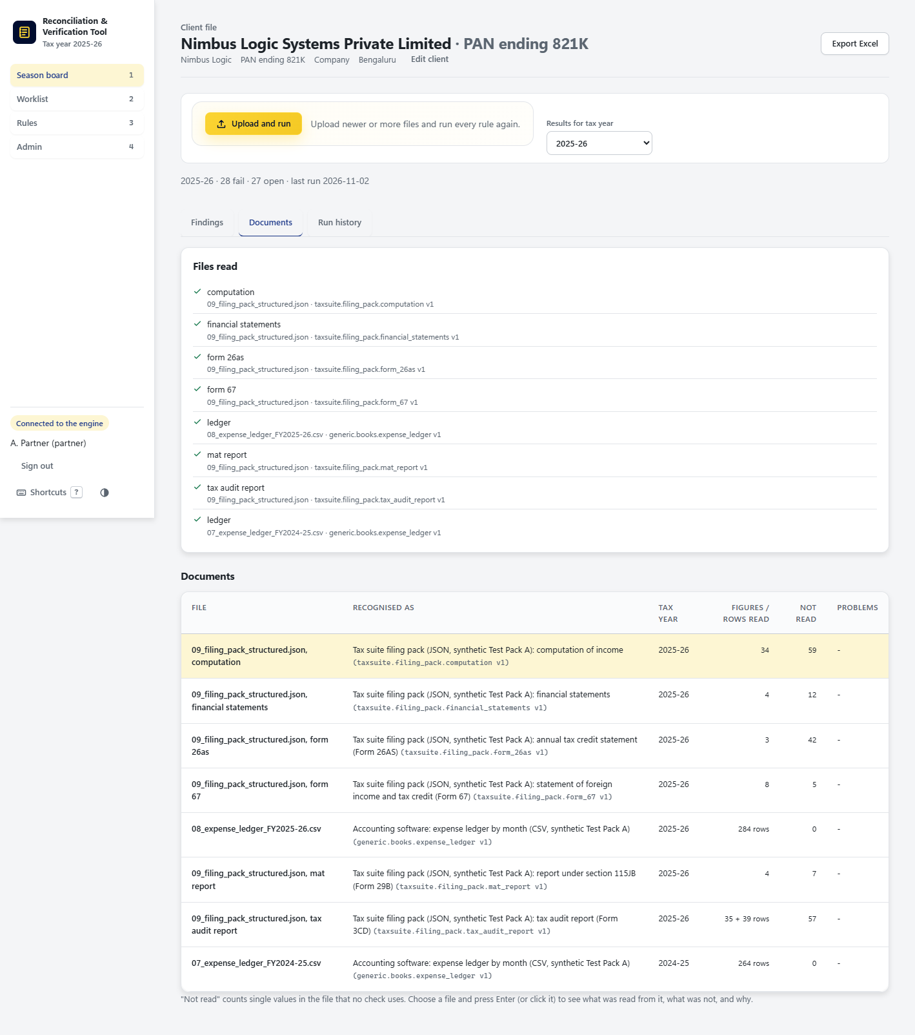
Figure 15. The Documents view of the Test Pack A run.

5.6 Run history
Every run of the checks is kept as Run 1, Run 2, and so on, with its date and time, its pass, fail and cannot-check counts, and the drafts of the documents it read. An earlier run opens read only, exactly as it was reported, so the firm can always show what the tool said on a given day. "Results for tax year" at the top switches to another tax year of the same client. "Export Excel" writes the result to a workbook.
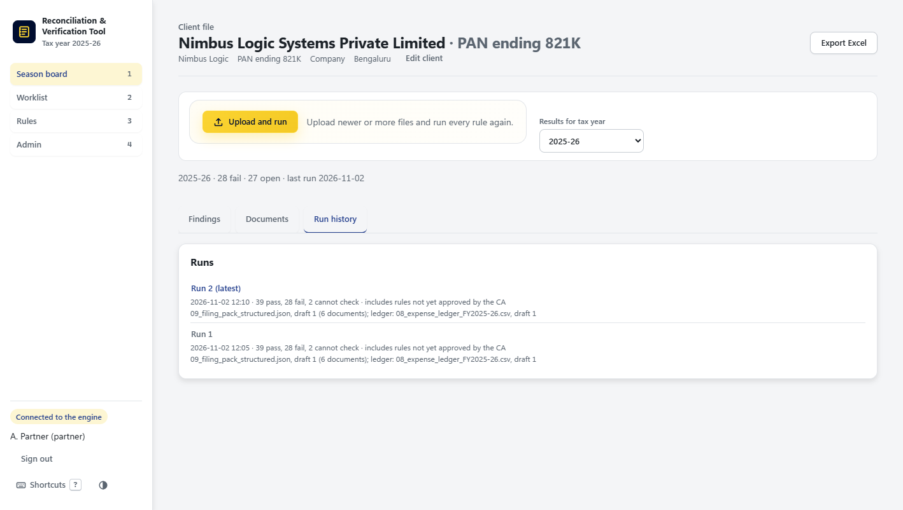
Figure 16. Run history with two runs of the same client.

6. Worklist (tab 2)
The Worklist compares this year's expense ledger with last year's and lists the ledger heads that are new, that have vanished, that are missing months or that show a step change in amount. These are not findings. They are items a person has to classify (for example the tax audit clause, GST status, TDS section or section 43B category). The tool never fills in the classification itself.
Each row shows the client, the ledger head, what changed, last year's and this year's amounts, and how many months were counted. In the example, 12 items came from the Test Pack A ledgers, such as "Cloud hosting - overseas" (new head, ₹11,53,216.00 over 12 months) and "Courier and postage" (vanished).
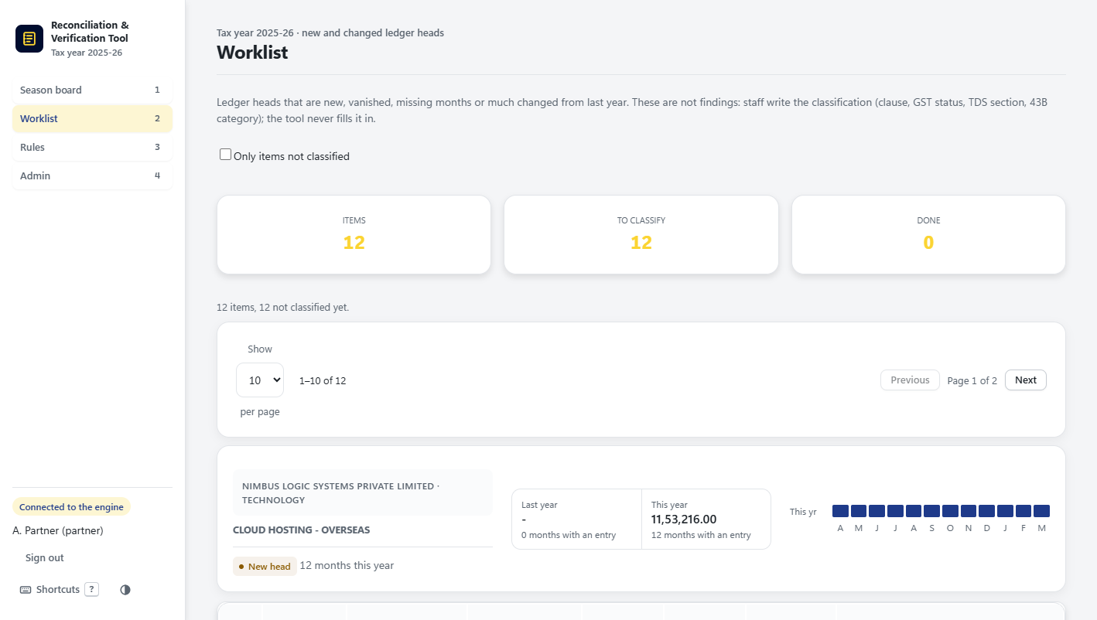
Figure 17. The Worklist: 12 items to classify.
Staff type the classification in the row and press Save, or tick several rows and classify them together. The counters at the top move from "To classify" to "Done", and "Only items not classified" hides the finished ones. A save can be undone.
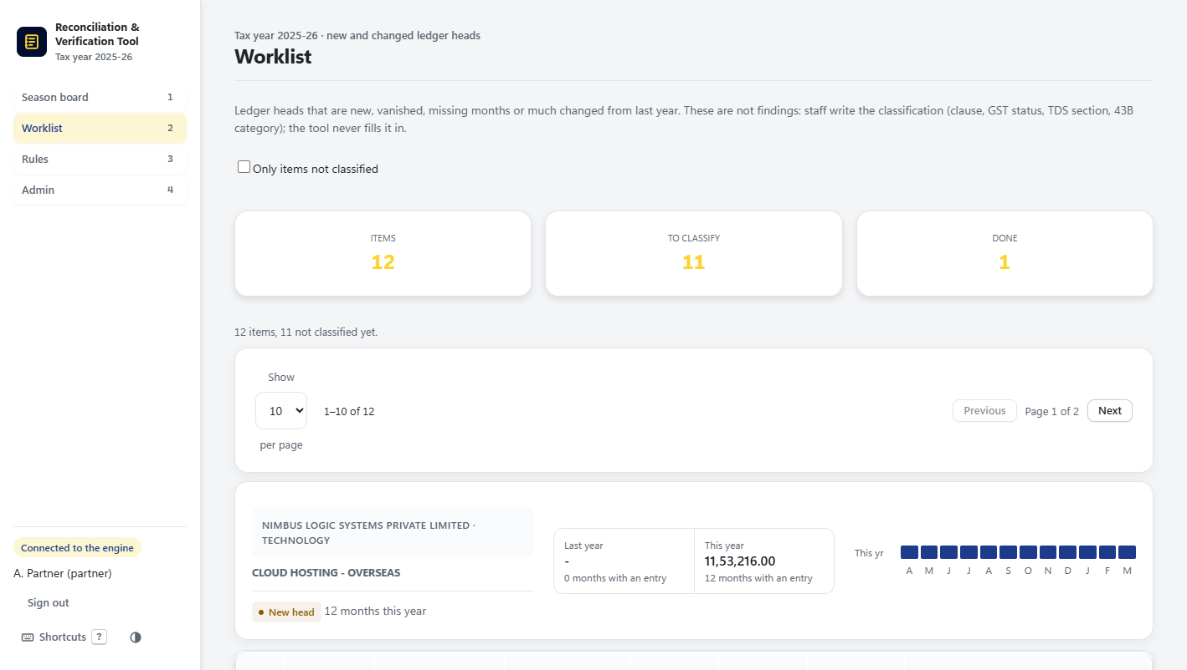
Figure 18. One item classified; 11 still to classify.

7. Rules (tab 3)

7.1 The rule book
The Rules tab shows the firm's whole rule book: 354 rules made from the CA-approved rule book and the engine rules. Each row shows the rule ID, its name, type, subject, category, the tax years it applies to, its status and its source. Rules that are only described and cannot run yet say so ("Described only, not run yet"). Filters narrow the list by tax year, type, subject, category, status and source, and the search box finds a rule by ID, name or category. "Add rule" opens the Rule Builder for a new rule.
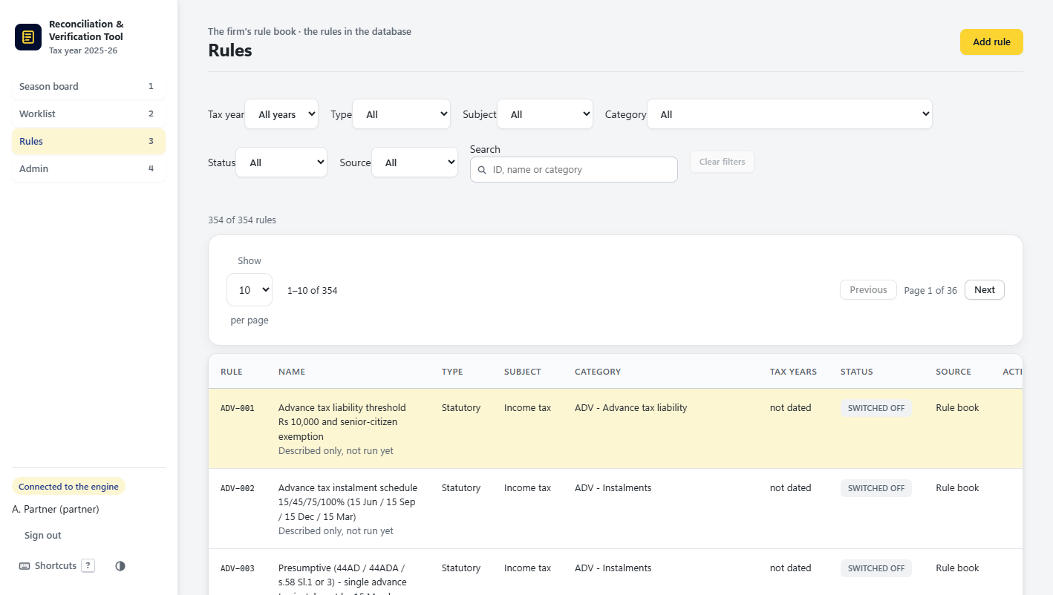
Figure 19. The Rules tab.

7.2 One rule
Opening a rule shows its status (for example Testing, waiting for approval), why it is or is not ready to approve, its type, category, tax years, version and the file it comes from, and every version with who made it and which one is in use. A rule is approved by a Partner only after it has run on a client with testing rules included. A rule that fires wrongly can be disabled, and an office change can be reset to the standard rule.
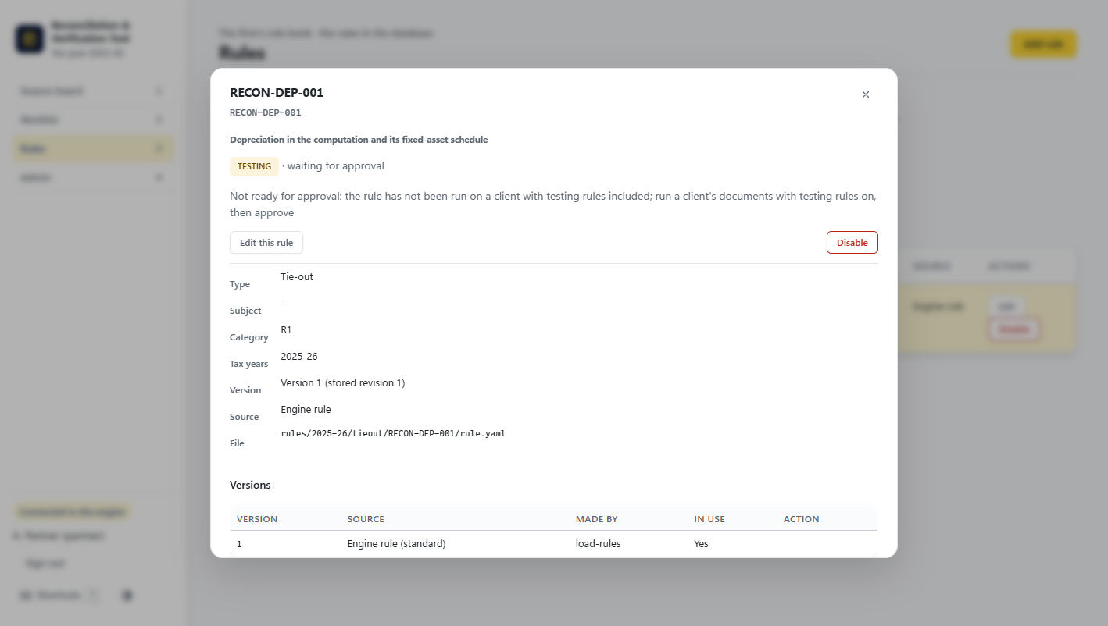
Figure 20. The detail of rule RECON-DEP-001.

7.3 The Rule Builder
"Edit this rule" (or "Add rule") opens the Rule Builder, a form a CA can fill without writing code: who and what (ID, title, the rule text in plain English, notes), where it applies (module, category R1 to R10 or GST, tax years, valid from and to), the figures and rows the rule reads (picked from the fact vocabulary and record types), and the check itself. Each rule needs a passing and a failing example before it can be used.
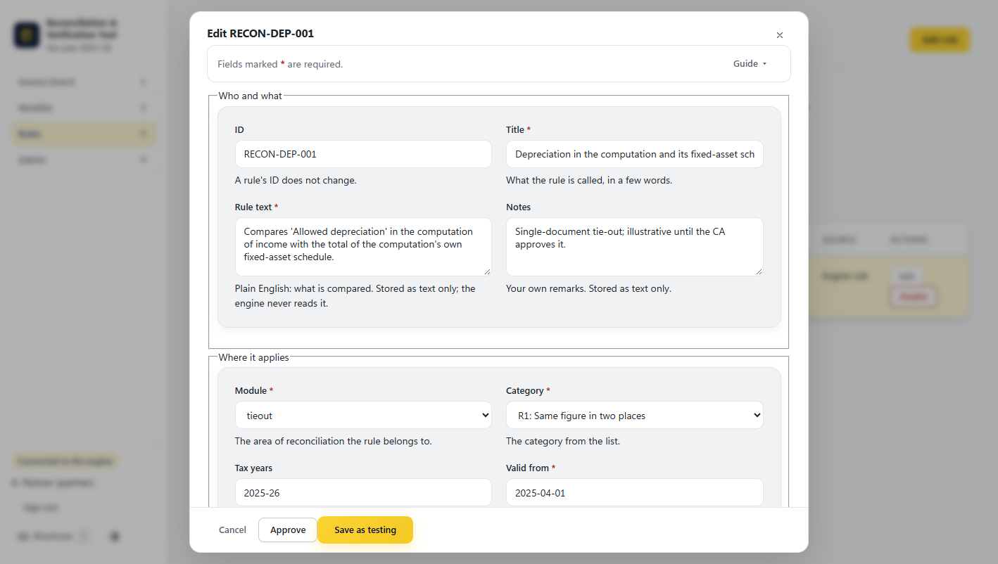
Figure 21. The Rule Builder.

8. Admin (tab 4, Partner only)
The Admin tab belongs to the Partner. Users lists every user with their role, status and last sign-in; "Manage" changes a user's role, resets a password, disables or unlocks an account. Add a user creates a user with a role (Partner, Manager, Staff or Read-only) and a starting password, which the user must change at the first sign-in. Lockout sets how many wrong passwords lock an account and for how many minutes.
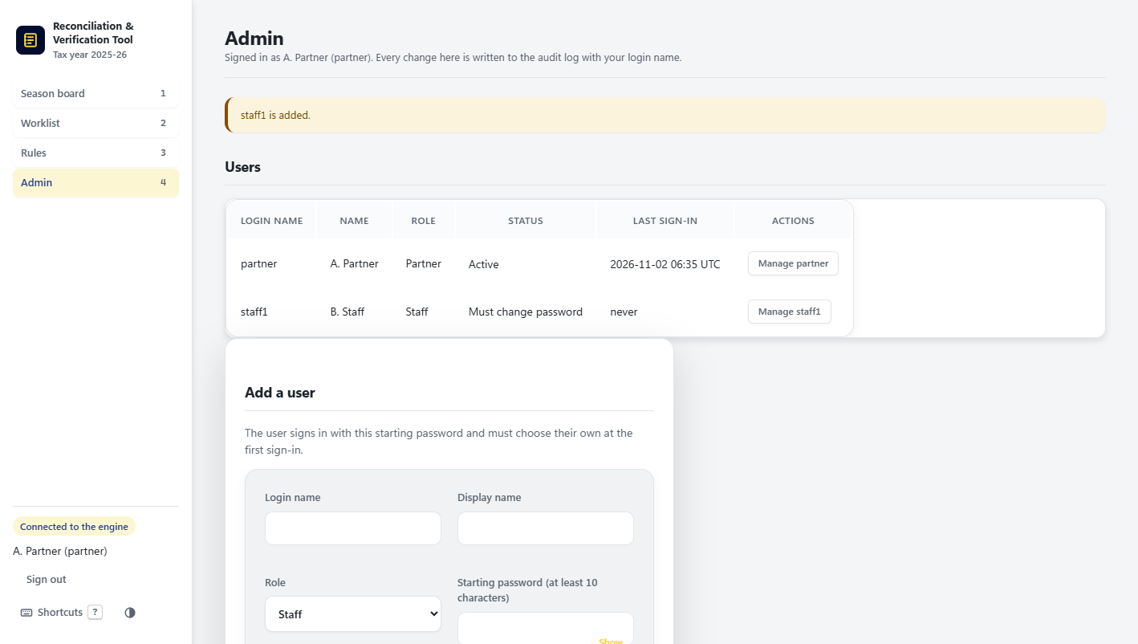
Figure 22. Admin: users (a Staff user has just been added) and Add a user.
Audit log lists every action with when, who, what and on which object: sign-ins, opening a client, runs, decisions and user changes. The log is chained, and the screen confirms that the chain is intact, so a changed or removed entry would be noticed.
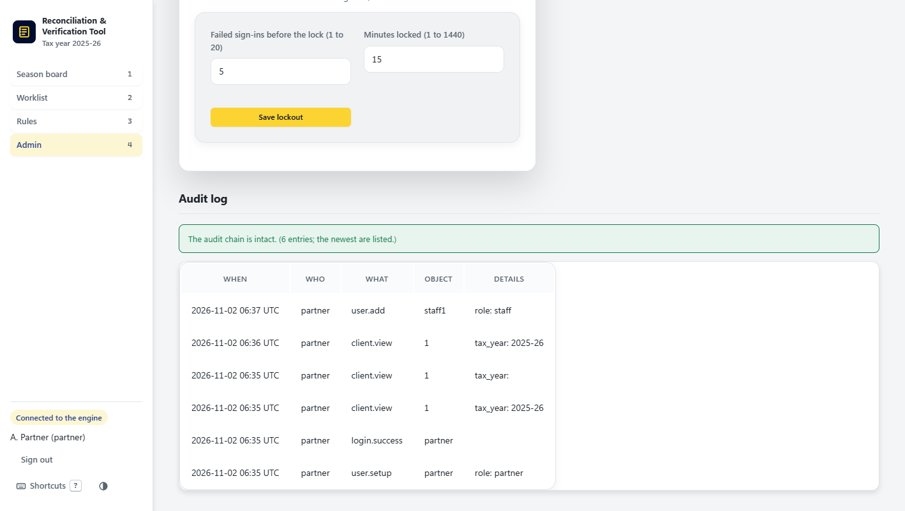
Figure 23. Lockout settings and the audit log.

9. Keyboard shortcuts
The tool is built to be used from the keyboard. "Shortcuts" in the menu, or the ? key, shows the full sheet: 1 to 4 for the tabs, / to search, Esc to close a panel or go back, the arrow keys (or j and k) to move between rows, Enter to open a row, n to add a client, and the left and right arrows to move between views in the Client file.
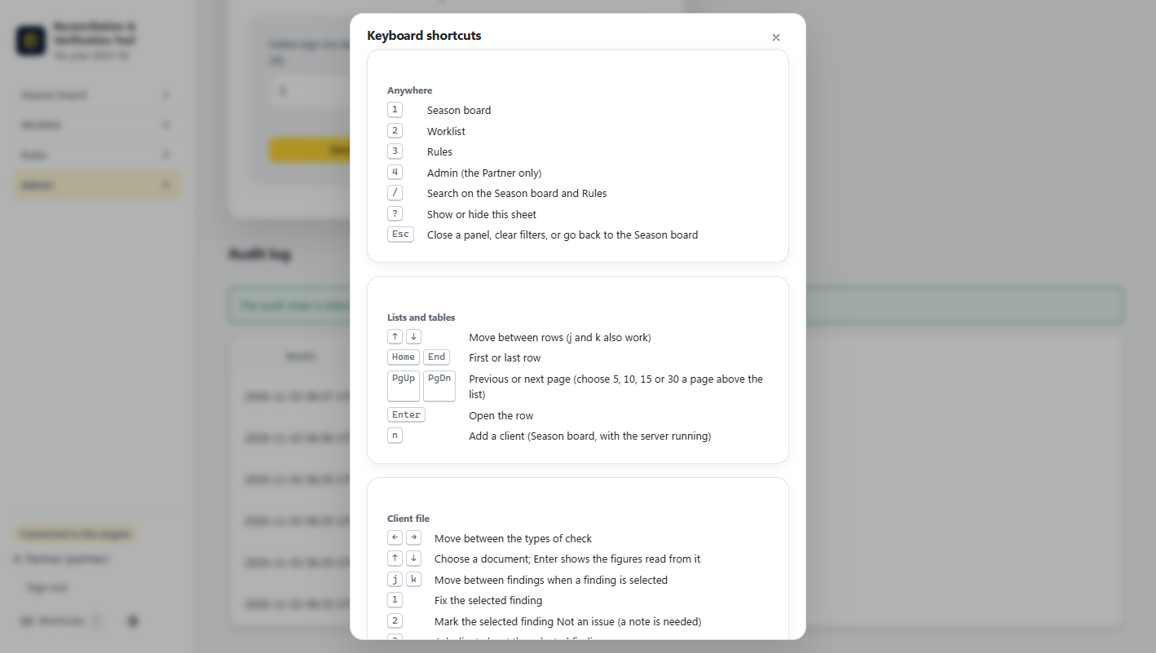
Figure 24. The keyboard shortcuts sheet.

10. The rules the screens keep
• Only what can be computed. A finding always shows both figures, the difference and where each figure came from. The tool never says what a figure should be, and never gives a judgment or tax advice.
• Fixed rules, same answer. Findings come only from the rules, never from AI. The same files always give the same result.
• Money to the paisa. Every amount is kept as a whole number of paise, so there are no rounding surprises.
• Offline, on one office machine. The tool runs on one computer in the office and staff use it from a browser on the office network. Nothing is sent to the internet.
• Every action is kept. Decisions, classifications, runs and user changes are kept in the audit trail, and earlier runs stay as they were reported.

