SLE-3: Architectural Design (Full C4 Model)
Course: 02AML204 – Introduction to Artificial Intelligence
PRN: 25UAM016
Name: Aayaan kalawant
Division: A
Date: 29 September 2026

1. System Title & Short Description
8-Puzzle BFS vs DFS Search System. This is a Python console program that solves the classic 8-puzzle (a 3×3 sliding-tile board) using two uninformed search strategies, Breadth-First Search and Depth-First Search. Given the same fixed start and goal state, both algorithms search the space of reachable board configurations until the goal is found. The system also measures and compares how the two strategies perform on the same problem: execution time, number of states expanded, and whether the returned solution is the shortest possible. This continues directly from SLE-1 (the search code) and SLE-2 (the profiling / comparison report on this same system).

2. Context Diagram (Level 1)
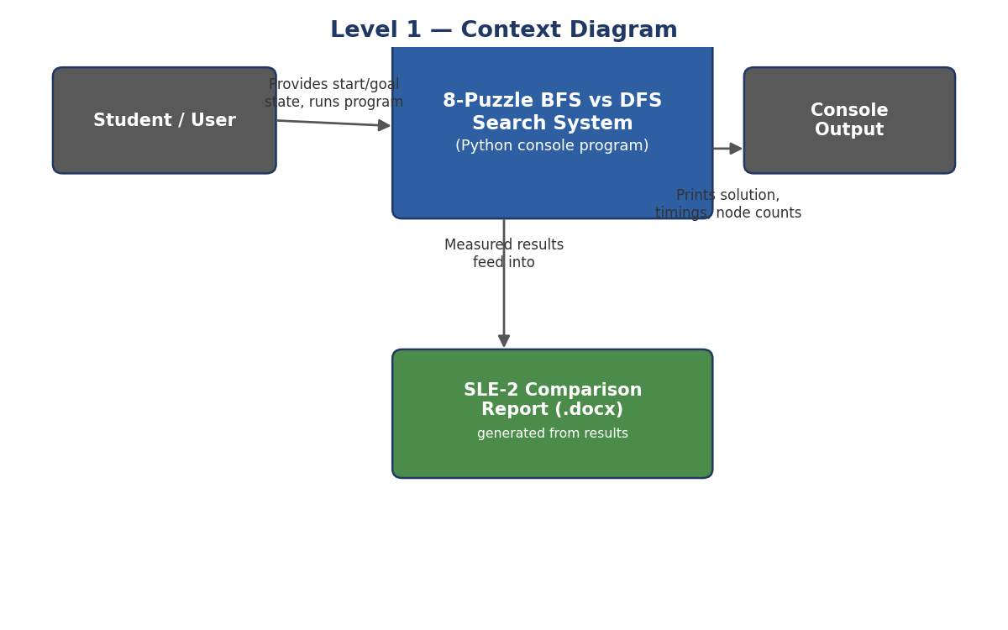
Fig. 1 — Context Diagram: the system sits between the user and the console/report output
The Student / User supplies the start and goal states (hard-coded for this experiment) and runs the program. The 8-Puzzle BFS vs DFS Search System runs both algorithms and prints the solution path, timings, and node counts to the Console. Those measured results also feed into the SLE-2 Comparison Report, which documents the same numbers in document form.

3. Container Diagram (Level 2)
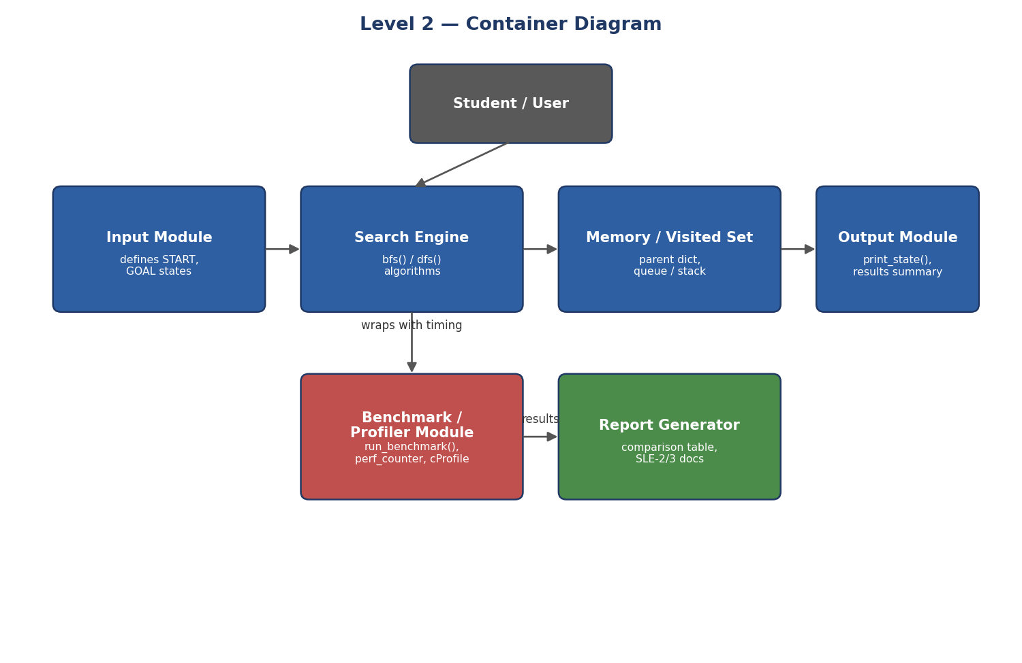
Fig. 2 — Container Diagram: the 6 main building blocks inside the system
- Input Module: holds the fixed START and GOAL board states used by both algorithms.
- Search Engine: runs bfs() and dfs(), the two search algorithms being compared.
- Memory / Visited Set: the parent dictionary and frontier (deque for BFS, list-as-stack for DFS) that track which states have been seen.
- Output Module: print_state() and the final comparison summary printed to console.
- Benchmark / Profiler Module: run_benchmark() times each algorithm with perf_counter() across 3 runs and averages the results; cProfile is used separately to see where time is spent inside each function.
- Report Generator: takes the measured numbers and produces the SLE-2 and SLE-3 documents (tables, diagrams, written analysis).

4. Component Diagram (Level 3)
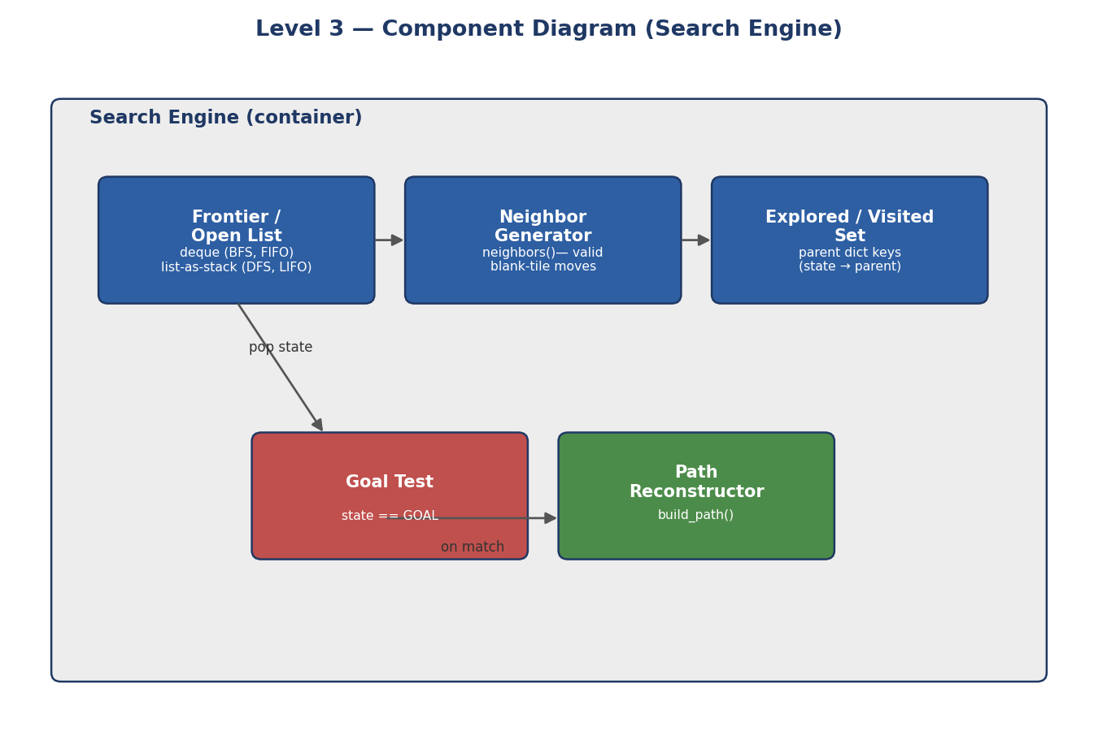
Fig. 3 — Component Diagram: inside the Search Engine container
The Search Engine is the most important container, so it is broken down further. The Frontier / Open List holds states waiting to be expanded — a deque for BFS (FIFO, so shallower states are expanded first) and a list used as a stack for DFS (LIFO, so one branch is followed deeply before backtracking). The Neighbor Generator (neighbors()) produces every valid board reached by sliding a tile into the blank space. The Explored / Visited Set is the parent dictionary, which both prevents revisiting a state and lets the final path be rebuilt. The Goal Test checks each popped state against GOAL, and the Path Reconstructor (build_path()) walks the parent pointers back to START once the goal is found.

5. Code Level Overview (Level 4)
- class — none; states are plain tuples of 9 ints, which keeps them hashable for the visited-set dictionary.
- def neighbors(state) — returns every board reachable by one blank-tile move.
- def bfs(start) — FIFO search; guarantees the shortest solution.
- def dfs(start) — LIFO search; finds a solution but not necessarily the shortest.
- def build_path(parent) — reconstructs the move sequence from GOAL back to START.
- def run_benchmark(name, function) — runs an algorithm 3 times and averages the timing.

6. Design Decisions
States are stored as immutable tuples (not lists) so they can be dictionary keys in the visited set — this makes membership checks O(1) instead of scanning a list. The same neighbors() function is reused by both bfs() and dfs() so the comparison in SLE-2 is fair: any performance difference comes from the search strategy (FIFO vs LIFO), not from different move-generation code. DFS reverses the neighbor order before pushing so that, if both algorithms expanded states in the same order, they would try moves in the same priority — isolating the frontier structure (queue vs stack) as the one real difference being measured.

7. AI Contribution Note
- AI tools used: ChatGPT (for the SLE-1/2 code and report) and Claude (for the SLE-3 C4 diagrams and this report).
- What AI helped with: drawing the four C4 levels from the existing bfs()/dfs()/neighbors()/build_path() code, structuring the containers and components, and drafting the written explanations.
- What I did myself: chose the 8-puzzle system to carry forward from SLE-2, checked that each diagram matches what my code actually does, and reviewed the design decisions so I can explain them.

8. Conclusion
Building the full C4 model showed that the same small program can be described at very different levels of detail: as one box talking to a user (Context), as six cooperating modules (Container), as the internal parts of a single module (Component), and finally as the actual functions (Code). Mapping my own bfs()/dfs() code onto these levels made it clearer why the Search Engine is the container worth zooming into — it is where the BFS vs DFS difference measured in SLE-2 actually lives, inside the Frontier component's queue-vs-stack choice.

