MINI TASK MANAGEMENT SYSTEM
High-Level Design Document
System context, architecture, major components, data, security, and deployment
Application type | Full-stack web application
Frontend | React, HTML, CSS, Bootstrap, Chart.js
Backend | Java, Spring Boot, Spring MVC, Hibernate
Database and email | MySQL and Java Mail Sender with Gmail SMTP

Prepared for project demonstration and technical review

Document map
01 Executive summary
02 Goals and scope
03 Actors and use cases
04 System architecture
05 Major components
06 Data architecture
07 Role and security model
08 Core workflows
09 API and integration overview
10 Deployment and operations
11 Quality attributes and risks
12 Roadmap and acceptance

1. Executive summary
The Mini Task Management System is a browser-based application for capturing, assigning, tracking, and completing team tickets. It uses a React frontend, a Spring Boot REST backend, Hibernate-based persistence, MySQL storage, and Gmail SMTP for real assignment notifications.
Architecture decision: The system is intentionally implemented as a modular monolith. One backend application contains separate controller, service, repository, entity, and email modules. This keeps the project achievable within one week while preserving clear separation of responsibilities.

The delivered application meets the original functional scope and adds stricter role behavior: admins manage team work, regular users manage only their assigned workflow, and ticket status advances through Open, In Progress, and Complete.

2. Goals and scope

2.1 Primary goals
- Provide user registration and login with Admin and User roles.
- Allow ticket creation, assignment, search, detailed viewing, prioritization, and status tracking.
- Provide a graphical dashboard using live backend counts.
- Send a real email when a ticket is assigned.
- Keep the implementation understandable and demonstrable as a Java training project.

2.2 In scope
Area | Included capability
Identity | Registration, login, current-user session in browser storage
Tickets | Create, list, details, update, delete, search, priority, due date, assignment
Workflow | Open → In Progress → Complete
Administration | View users and delete regular users with safeguards
Reporting | Total, status, and priority counts with charts
Notification | Gmail SMTP assignment email

2.3 Out of scope for the current version
- Attachments and comments
- Projects/workspaces beyond one team
- Real-time collaboration
- Calendar or Kanban views
- Production-grade token authentication and deployment automation

3. Actors and use cases
Actor | Primary use cases | Restrictions
Admin | View all work; create and assign; edit/delete tickets; manage users; view dashboard | Cannot delete self or another admin; cannot delete a user with assigned tickets
User | Register/login; create self-assigned ticket; view/search own tickets; view details; advance status | Cannot assign others, full-edit tickets, delete tickets, or access the user directory

3.1 Key user journeys
1. A person registers and signs in.
2. An admin creates a ticket and selects an assignee, or a user creates a self-assigned ticket.
3. The system stores the ticket and attempts to email the assignee.
4. The assignee opens the ticket details and moves it to In Progress and then Complete.
5. The dashboard reflects the new status and priority totals.

4. System architecture
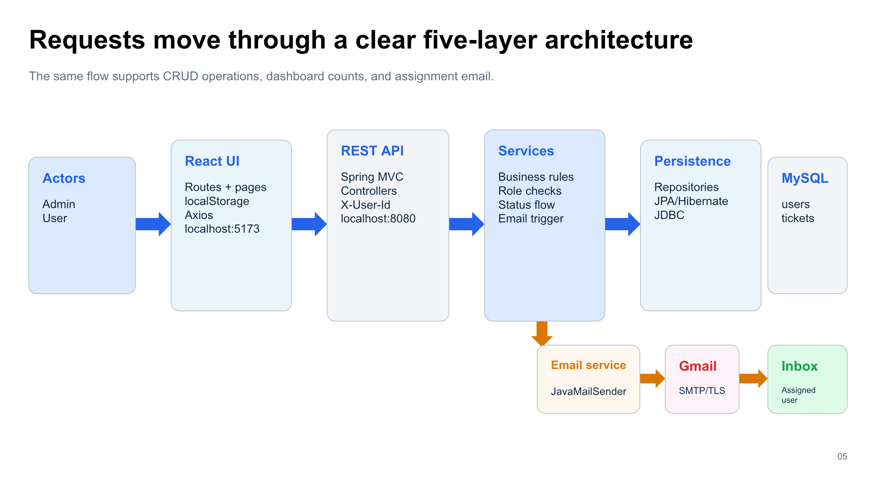
Figure 1. End-to-end architecture and data flow

4.1 Architectural style
The browser and server are separate applications in one repository. The React single-page application communicates with the Spring Boot server over HTTP/JSON. The server follows a layered architecture: REST controllers receive requests, services enforce rules, repositories perform persistence operations, and Hibernate translates entity operations into SQL.

4.2 External integration
JavaMailSender connects to Gmail SMTP over TLS on port 587. When ticket creation succeeds and an assignee exists, EmailService sends a SimpleMailMessage to the email stored on the User record. Email errors are caught so the ticket remains saved.

5. Major components
Component | Responsibility | Technology
React SPA | Pages, forms, routing, client session, role-aware controls, API calls | React, React Router, Axios, Bootstrap/CSS
Dashboard | Summary cards and charts based on live counts | Chart.js, react-chartjs-2
REST layer | Maps HTTP requests and JSON payloads to services | Spring MVC controllers
Business layer | Role checks, assignment, status flow, deletion safeguards, email trigger | Spring services
Persistence | CRUD, scoped search, counts, entity mapping | Spring Data JPA, Hibernate
Database | Durable storage for users and tickets | MySQL
Email integration | Assignment notification delivery | Java Mail Sender, Gmail SMTP

6. Data architecture
Entity | Key fields | Purpose
User | id, name, email, password, role | Identity, login lookup, authorization role, ticket assignee contact
Ticket | id, title, description, priority, status, dueDate, assignedUserId | Work item and its current assignment/workflow state

Logical relationship: Ticket.assignedUserId refers to User.id. It is stored as a Long rather than a JPA @ManyToOne association, so the service layer validates the assignee and prevents deleting a user who still owns tickets.

7. Role and security model
The frontend stores the current user object in localStorage. Axios copies its ID into the X-User-Id request header. Backend services reload that user and enforce role and ownership rules before performing protected operations.
Development limitation: SecurityConfig currently permits all HTTP routes and disables CSRF. The X-User-Id header identifies the actor but is not tamper-proof authentication. Passwords are not hashed, and registration currently allows choosing ADMIN. These choices are acceptable only for the local training/demo environment.

Operation | Admin | User
List tickets | All tickets | Assigned tickets only
Create ticket | Assign any valid user | Forced to self
View details | Any ticket | Assigned ticket only
Full update/delete | Allowed | Denied
Advance status | Allowed | Assigned ticket only
List/delete users | Allowed with safeguards | Denied

8. Core workflows

8.1 Ticket creation and email
1. React submits POST /api/tickets with JSON and X-User-Id.
2. TicketService loads the actor and applies admin assignment or user self-assignment.
3. The requested status is validated; invalid status becomes Open.
4. TicketRepository saves the entity through Hibernate.
5. The assignee is loaded and EmailService attempts Gmail delivery.
6. The API returns the saved ticket regardless of a caught email failure.

8.2 Ticket progress
The allowed status set is Open, In Progress, and Complete. The dedicated PATCH endpoint accepts only In Progress or Complete. The service permits an admin or the currently assigned user to make the change.

8.3 User deletion
DELETE /api/users/{id} is admin-only. It rejects self-deletion, rejects deleting an ADMIN account, returns Not Found for an unknown target, and returns Conflict if the target still owns tickets.

9. API and integration overview
Resource | Endpoints | Consumers
Users | register, login, list, delete by ID | Login/Register/Users pages; Ticket assignment list
Tickets | create, list, details, update, status patch, delete, search | Tickets, TicketForm, TicketDetails pages
Dashboard | aggregate counts | Dashboard cards and charts
SMTP | Gmail host:587 with STARTTLS | EmailService during assignment

10. Deployment and operations
Process | Default address | Start command
Frontend development server | http://localhost:5173 | npm run dev (or pnpm dev)
Backend API server | http://localhost:8080 | ./mvnw spring-boot:run or IntelliJ Run
MySQL | localhost:3306 / task_management_db | Start local MySQL service

- Database credentials and Gmail App Password must be provided securely.
- The frontend base URL currently points directly to http://localhost:8080/api.
- Hibernate ddl-auto=update maintains tables for development.
- The backend and frontend build independently but are versioned in one repository.

11. Quality attributes and risks
Attribute | Current design | Risk / response
Usability | Simple ClickUp-inspired responsive interface | Keep workflows small and labels explicit
Maintainability | Layered packages and small entities | Add DTOs and tests as scope grows
Reliability | Email failure does not roll back a saved ticket | Add logging/retry for production
Security | Service role checks using actor ID header | Replace with authenticated principal and JWT/session
Data integrity | Service validates assignee and deletion | Add database foreign key and migrations
Performance | Simple repository counts and lists | Add pagination/indexes for larger datasets

12. Roadmap and acceptance

12.1 Recommended hardening
- Use Spring Security authentication with BCrypt and JWT or server sessions.
- Remove public ADMIN registration and create admins through controlled provisioning.
- Move secrets to environment variables and rotate any exposed credentials.
- Introduce DTO validation, global exception handling, Flyway migrations, structured logging, and API documentation.
- Add controller/service unit tests, integration tests, frontend tests, pagination, and audit history.

12.2 Acceptance summary
Status: The application implements the original project requirements, plus ticket detail navigation, stricter Admin/User behavior, ticket progress controls, and safeguarded admin-only user deletion.

