MINI TASK MANAGEMENT SYSTEM
Low-Level Design Document
Detailed frontend, backend, API, persistence, workflow, configuration, and test specification
Application type | Full-stack web application
Frontend | React, HTML, CSS, Bootstrap, Chart.js
Backend | Java, Spring Boot, Spring MVC, Hibernate
Database and email | MySQL and Java Mail Sender with Gmail SMTP

Prepared for project demonstration and technical review

Document map
01 Implementation conventions
02 Source structure
03 Domain model
04 Repository design
05 Service design
06 REST controller design
07 Frontend routes and components
08 Client API integration
09 Business rules and state model
10 Detailed request flows
11 Database design
12 Error handling
13 Configuration
14 Testing specification
15 Security notes
16 Appendix: payload examples

1. Implementation conventions
Concern | Convention
Backend base package | com.project.taskmanagement
Backend layers | controller → service → dao → modal/entity → MySQL
Frontend entry | src/main.jsx renders App.jsx
Frontend routing | BrowserRouter with protected nested AppLayout routes
API format | JSON over HTTP at http://localhost:8080/api
Actor context | X-User-Id request header added by Axios interceptor
Status values | Open, In Progress, Complete
Priority values | Low, Medium, High

Naming note: The current project uses package names dao for repositories and modal for JPA entities. The documentation preserves those implemented names even though entity/model would be more conventional.

2. Source structure

2.1 Backend classes
Package | Classes
config | SecurityConfig
controller | UserController, TicketController, DashboardController
service | UserService, TicketService, EmailService
dao | UserRepository, TicketRepository
modal | User, Ticket
root | TaskManagementSystemApplication

2.2 Frontend modules
Folder | Modules
components | AppLayout.jsx, ProtectedRoute.jsx
pages | Login, Register, Dashboard, Tickets, TicketDetails, TicketForm, Users
services | api.js Axios instance and actor-header interceptor
root | main.jsx, App.jsx, App.css, index.css

3. Domain model

3.1 User entity
Field | Java type | Persistence / JSON behavior
id | Long | @Id, IDENTITY auto-generation
name | String | Stored and returned
email | String | Stored, returned, used by findByEmail
password | String | Stored; @JsonProperty WRITE_ONLY prevents response serialization
role | String | Expected ADMIN or USER

3.2 Ticket entity
Field | Java type | Meaning
id | Long | Primary key, IDENTITY
title | String | Searchable ticket title
description | String | Detailed work description
priority | String | Low, Medium, or High
status | String | Open, In Progress, or Complete
dueDate | LocalDate | Optional target date in ISO format
assignedUserId | Long | Logical reference to users.id; optional for admin-created tickets

3.3 Entity relationship
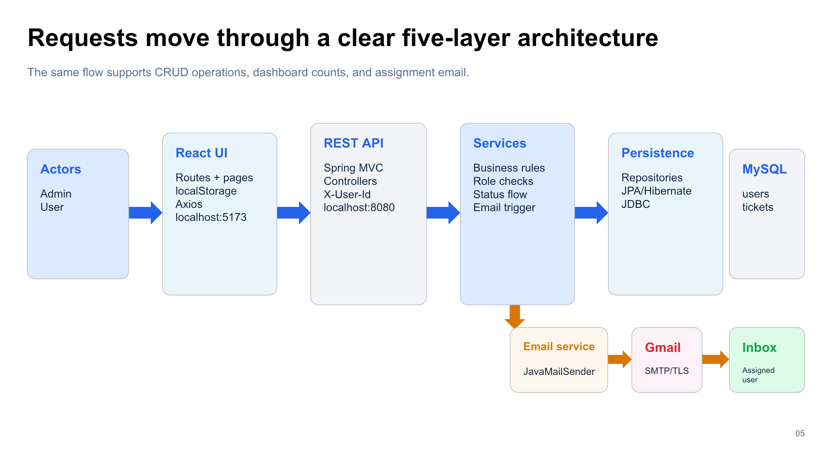
Figure 1. End-to-end architecture and data flow
The architecture figure includes the persistence relationship. At the database level, tickets.assigned_user_id logically points to users.id. The Java model does not declare @ManyToOne, so no JPA object navigation or automatic foreign key is created by the entity mapping.

4. Repository design
Repository method | Generated behavior | Used by
UserRepository.findByEmail(email) | Exact email lookup | Registration duplicate check and login
findAll / findById / save / delete | JpaRepository CRUD | User and ticket services
TicketRepository.findByTitleContainingIgnoreCase(title) | Global case-insensitive title search | Admin search
findByAssignedUserId(userId) | Tickets for one assignee | User list and deletion safeguard
findByTitleContainingIgnoreCaseAndAssignedUserId(...) | Scoped title search | Regular-user search
countByStatus(status) | Aggregate by workflow status | Dashboard
countByPriority(priority) | Aggregate by priority | Dashboard

Spring Data derives SQL from method names. JpaRepository supplies the remaining CRUD and count operations without custom SQL.

5. Service design

5.1 UserService
Method | Detailed behavior
registerUser(User) | Calls findByEmail. Returns null for duplicates; otherwise saves the user.
loginUser(email, password) | Loads by email and compares the stored password; returns the user or null.
getAllUsers(actorId) | Requires a valid actor and ADMIN role, then returns all users.
deleteUser(actorId, userId) | Requires ADMIN actor; rejects self, ADMIN target, unknown target, or target with tickets; then deletes.

5.2 TicketService shared helpers
Helper | Behavior
requireUser(id) | 401 if ID is null or no matching user exists
requireTicket(id) | 404 if the ticket does not exist
isAdmin(user) | Case-insensitive comparison with ADMIN
requireAdmin(user) | 403 when the actor is not an admin
sendAssignmentEmail(ticket) | Loads assignee; sends email; catches and prints mail errors

5.3 TicketService operation rules
Method | Authorization | Processing
createTicket | Authenticated actor | User is forced to self-assignment. Admin assignee is validated. Invalid status becomes Open. Save then email.
getTicketsForUser | Authenticated actor | Admin receives findAll; user receives findByAssignedUserId.
getTicketById | Admin or assignee | Returns Optional; 403 if another user requests the ticket.
updateTicket | Admin only | Copies title, description, priority, due date, assignment, and valid status; saves.
updateTicketStatus | Admin or assignee | Accepts only In Progress or Complete; rejects Open and unknown values.
deleteTicketById | Admin only | Deletes through repository.
searchTicketsByTitle | Authenticated actor | Admin global search; user scoped search.
count methods | No actor parameter | Return total, status, or priority counts.

5.4 EmailService
sendTicketAssignedEmail(toEmail, ticketTitle) creates a SimpleMailMessage, sets subject Assigned Ticket, builds a short text body, and calls JavaMailSender.send(message). SMTP host, port, sender username, app password, authentication, and STARTTLS are supplied by Spring properties.

6. REST controller design
Method and path | Header / body | Service call | Expected result
POST /api/users/register | User JSON | registerUser | User JSON or null duplicate
POST /api/users/login | email/password JSON | loginUser | User JSON or null failure
GET /api/users | X-User-Id | getAllUsers | Admin user list
DELETE /api/users/{id} | X-User-Id | deleteUser | Success text
POST /api/tickets | X-User-Id + Ticket JSON | createTicket | Saved Ticket JSON
GET /api/tickets | X-User-Id | getTicketsForUser | Role-scoped list
GET /api/tickets/{id} | X-User-Id | getTicketById | Optional ticket
PUT /api/tickets/{id} | X-User-Id + Ticket JSON | updateTicket | Updated Ticket JSON
PATCH /api/tickets/{id}/status | X-User-Id + status JSON | updateTicketStatus | Updated Ticket JSON
DELETE /api/tickets/{id} | X-User-Id | deleteTicketById | Success text
GET /api/tickets/search | X-User-Id + title query | searchTicketsByTitle | Role-scoped matches
GET /api/dashboard | None | count methods | Seven count values

7. Frontend routes and components
Route | Component | Access and behavior
/login | Login | Public; saves returned user in localStorage and redirects to dashboard
/register | Register | Public; submits name/email/password/role
/dashboard | Dashboard | Protected; loads cards and Chart.js status/priority charts
/tickets | Tickets | Protected; admin sees all, user sees own; search/filter/status actions
/tickets/new | TicketForm | Protected; admin selects assignee; user is self-assigned
/tickets/:id | TicketDetails | Protected and backend-scoped; details plus workflow actions
/tickets/:id/edit | TicketForm | Frontend redirects non-admin; backend also enforces admin
/users | Users | Navigation is admin-only; backend requires admin; delete regular users

7.1 Shared components
Component | Responsibility
ProtectedRoute | Checks for currentUser in localStorage and redirects unauthenticated visitors to /login.
AppLayout | Renders the sidebar, top bar, role-aware navigation, nested page outlet, and logout.
api.js | Creates the Axios instance, sets baseURL, uses JSON, and injects X-User-Id.

8. Client API integration
1. A successful login stores the returned user object as localStorage.currentUser.
2. Every Axios request parses currentUser and adds X-User-Id when an ID exists.
3. Components call relative endpoints such as /tickets or /dashboard.
4. Promises update React state, which immediately refreshes lists, details, cards, and charts.
5. Errors are converted into simple notices appropriate for the page.
Frontend defense in depth: The UI hides or redirects disallowed actions, but the backend service remains the authoritative permission check. A user cannot gain admin behavior merely by editing React controls.

9. Business rules and state model
Rule ID | Rule
BR-01 | A duplicate email registration returns no new user.
BR-02 | A regular user-created ticket is always assigned to that user.
BR-03 | An admin may assign a ticket only to an existing user.
BR-04 | Allowed statuses are Open, In Progress, and Complete.
BR-05 | PATCH status may move only to In Progress or Complete.
BR-06 | A regular user may view/search/advance only assigned tickets.
BR-07 | Only admins may full-edit or delete tickets.
BR-08 | Only admins may list or delete users.
BR-09 | An admin cannot delete self or any ADMIN target.
BR-10 | A user owning tickets must be reassigned or have tickets deleted before account deletion.

10. Detailed request flows

10.1 Login
1. Login form posts email and password.
2. UserController passes values to UserService.
3. UserRepository finds by email.
4. Service compares password and returns User or null.
5. Frontend stores a successful response and routes to /dashboard.

10.2 Create ticket
1. TicketForm builds JSON and converts assignedUserId to a number.
2. Axios attaches actor ID.
3. TicketController calls TicketService.
4. Service enforces assignment and status rules.
5. Repository/Hibernate inserts the ticket.
6. EmailService attempts assignment notification.
7. Frontend returns to the ticket list.

10.3 View details and advance status
1. Clicking a ticket title routes to /tickets/{id}.
2. TicketDetails calls GET /tickets/{id}.
3. Service checks admin or assignee access.
4. Page renders description, priority, status, due date, and assignee.
5. Start Ticket or Mark Complete calls PATCH /tickets/{id}/status.
6. Returned ticket replaces local component state.

10.4 Delete user
1. Admin clicks Delete User and confirms.
2. Frontend sends DELETE /users/{id}.
3. Service validates actor and target.
4. Service queries assigned tickets.
5. Deletion proceeds only when all safeguards pass.
6. Frontend removes the user card from state.

11. Database design
Table | Column | Suggested SQL type | Constraints / notes
users | id | BIGINT | Primary key, auto increment
users | name | VARCHAR(255) | Required by UI
users | email | VARCHAR(255) | Application-level duplicate check; add UNIQUE in production
users | password | VARCHAR(255) | Plain in current demo; store BCrypt hash in production
users | role | VARCHAR(255) | ADMIN or USER
tickets | id | BIGINT | Primary key, auto increment
tickets | title | VARCHAR(255) | Search field
tickets | description | VARCHAR(255) | Current default mapping; TEXT recommended for long content
tickets | priority | VARCHAR(255) | Low, Medium, High
tickets | status | VARCHAR(255) | Open, In Progress, Complete
tickets | due_date | DATE | Optional
tickets | assigned_user_id | BIGINT | Logical User ID; add FK/index in production

12. Error handling
HTTP status | Trigger in current services | Frontend behavior
400 Bad Request | Unsupported status or attempt to patch status back to Open | Shows update failure notice
401 Unauthorized | Missing actor ID or actor user not found | Request fails; login/session should be restored
403 Forbidden | Wrong role, ownership violation, self/admin deletion attempt | Shows permission-specific or generic notice
404 Not Found | Ticket or user target not found | Shows load/delete failure
409 Conflict | Target user still owns tickets | Displays reassign/delete-tickets instruction
200 with null | Duplicate registration or failed login | Pages show duplicate or incorrect-credentials message

ResponseStatusException supplies backend error responses. The project does not yet contain a global @ControllerAdvice response format, so the frontend reads message or detail when available and otherwise falls back to page-specific text.

13. Configuration
Property group | Purpose | Safe documentation value
spring.datasource.url | MySQL JDBC connection | jdbc:mysql://localhost:3306/task_management_db
spring.datasource.username/password | Database authentication | <environment-provided secret>
spring.jpa.hibernate.ddl-auto | Schema behavior | update (development only)
spring.jpa.show-sql | SQL console output | true (development)
spring.mail.host/port | SMTP endpoint | smtp.gmail.com / 587
spring.mail.username/password | Gmail sender and App Password | <environment-provided secret>
mail.smtp.auth/starttls | Authenticated encrypted SMTP | true / true
Axios baseURL | Frontend API origin | http://localhost:8080/api

Secret handling: Never place real database passwords or Gmail App Passwords in documentation or Git. Rotate credentials that were previously shared or committed, and load them through environment variables for any non-demo environment.

14. Testing specification
Test ID | Scenario | Expected result
T-01 | Register new user | User saved; password omitted from response
T-02 | Register duplicate email | No duplicate; frontend shows message
T-03 | Login valid/invalid | Valid returns user; invalid returns null
T-04 | User creates ticket for another ID | Backend overwrites assignment to actor
T-05 | Admin creates assigned ticket | Ticket saved; email attempted
T-06 | User requests another user ticket | 403 Forbidden
T-07 | User full-edits/deletes ticket | 403 Forbidden
T-08 | Assignee advances workflow | Open → In Progress → Complete
T-09 | Search as admin/user | Global vs assignee-scoped results
T-10 | Delete self/admin user | 403 Forbidden
T-11 | Delete user with tickets | 409 Conflict
T-12 | Dashboard request | Seven count fields and charts render
T-13 | Frontend build | Vite production build succeeds
T-14 | Backend test | Spring context test succeeds

15. Security notes
Current choice | Impact | Production replacement
localStorage user + X-User-Id | Header can be changed by a client | Authenticated principal from Spring Security/JWT or session
permitAll and CSRF disabled | No framework-level endpoint authentication | SecurityFilterChain with explicit public/protected routes
Plain password comparison | Unsafe password storage | BCryptPasswordEncoder and credential DTOs
Public role selection | A registrant can request ADMIN | Force USER on public registration; provision admins separately
Secrets in properties | Risk of repository leakage | Environment variables / secret manager
Global dashboard counts | Users can view team-wide totals | Scope dashboard queries by actor if privacy is required

Service-layer authorization is still valuable and should remain after production authentication is added. The authenticated principal should replace the raw actor ID header, while the same ownership and role rules continue to protect operations.

16. Appendix: payload examples

16.1 Register user
POST /api/users/register: { "name": "Aayam", "email": "user@example.com", "password": "<secret>", "role": "USER" }

16.2 Create ticket
POST /api/tickets: { "title": "Fix login page", "description": "Correct validation issue", "priority": "High", "status": "Open", "dueDate": "2026-07-24", "assignedUserId": 2 }

16.3 Update status
PATCH /api/tickets/8/status: { "status": "In Progress" }

16.4 Dashboard response shape
GET /api/dashboard: { "totalTickets": 0, "openTickets": 0, "inProgressTickets": 0, "completeTickets": 0, "lowPriorityTickets": 0, "mediumPriorityTickets": 0, "highPriorityTickets": 0 }

The zero values above describe the response shape only; actual values are calculated from the current database.

