UNIVERSITY MANAGEMENT SYSTEM
A Web-Based Campus Administration & Academic Platform

A Project Report
Submitted in partial fulfilment of the requirements for the degree of
Bachelor of Technology / Master of Computer Applications

Developed using Python (Django Framework)

Submitted by: ____________________
Guided by: ____________________
Department of Computer Science & Engineering
Academic Year 2025–2026

Declaration
I hereby declare that the project work entitled “University Management System” submitted for the award of the degree is a record of original work carried out by me. I further declare that the material contained in this report has not been submitted, either in part or in full, for the award of any other degree or diploma. The application, its source code, database design, and documentation presented here were designed and implemented by me under the guidance of my project supervisor.

Place: ____________________
Date: ____________________
Signature of the Candidate: ____________________

Certificate
This is to certify that the project report entitled “University Management System” is a bonafide record of the project work carried out by the candidate in partial fulfilment of the requirements for the award of the degree. The project was carried out under my supervision and has reached the standard fulfilling the requirements of the regulations relating to the degree.

Project Guide: ____________________
Head of Department: ____________________
External Examiner: ____________________

Acknowledgement
I take this opportunity to express my profound gratitude and deep regard to my project guide for their exemplary guidance, monitoring, and constant encouragement throughout the course of this project. I also extend my sincere thanks to the Head of the Department and all the faculty members for providing the necessary infrastructure and a stimulating academic environment. Finally, I am thankful to my family and friends for their continuous support and motivation, without which this project would not have been possible.

Abstract
The University Management System (UMS) is a comprehensive, web-based platform designed to digitise and streamline the day-to-day academic and administrative operations of a modern university. Traditional campus management relies heavily on manual paperwork, disconnected spreadsheets, and siloed records that are error-prone, time-consuming, and difficult to audit. UMS addresses these problems by unifying admissions, student and faculty records, course catalogues, enrollment, day-wise attendance, assignments, examinations, results, fee management, notices, and campus events into a single, role-aware application.
The system implements strict Role-Based Access Control (RBAC) that provides three distinct, colour-themed portals — Administrator, Faculty, and Student — each tailored to the responsibilities of that role. It further embeds a lightweight, offline Artificial Intelligence layer (requiring no external API keys) that offers a rule-based assistant chatbot, student performance prediction, at-risk-student detection, and study recommendations. Built on the Django framework with a responsive Bootstrap 5 front end and Chart.js visualisations, the platform is secure, scalable, and mobile-friendly. This report documents the complete software engineering lifecycle of the project — requirement analysis, feasibility study, system design (architecture, ER, DFD, use-case, class, and sequence diagrams), implementation, testing, and results.

Table of Contents
- 1. Introduction
- 2. System Analysis
- 3. System Requirements Specification
- 4. System Design
- 5. Database Design & Data Dictionary
- 6. Implementation
- 7. Testing
- 8. Results & Screenshots
- 9. Conclusion & Future Scope
- 10. References
- 11. Appendix

1. Introduction

1.1 Overview
A university is a complex organisation that manages thousands of students, hundreds of faculty members, dozens of departments and programs, and a continuous flow of academic and financial transactions. Managing this volume of information manually is inefficient and unreliable. The University Management System is an integrated software solution that automates these processes and provides each stakeholder with a purpose-built interface.

1.2 Problem Statement
Existing manual and semi-digital approaches suffer from several drawbacks:
- Student and faculty records are scattered across registers and spreadsheets.
- Attendance is recorded on paper and is difficult to analyse day-wise.
- Assignment distribution, submission, and grading lack a unified workflow.
- Fee collection and outstanding balances are hard to track in real time.
- There is no single dashboard offering analytics or early warning signals.
- Notices and events are communicated informally and inconsistently.

1.3 Objectives
- To design a centralised database for all academic and administrative data.
- To provide secure, role-based portals for Admin, Faculty, and Student users.
- To automate enrollment, day-wise attendance, assignments, exams, and results.
- To manage fee invoices and payments with live collection analytics.
- To embed offline AI features (assistant, prediction, at-risk detection).
- To deliver a modern, responsive, and visually distinct user experience.

1.4 Scope
The scope of UMS covers the complete academic administration cycle: creating and maintaining departments, programs, courses, students, and faculty; enrolling students into courses; recording and reporting attendance on a per-day basis; publishing, submitting, and grading assignments; scheduling exams and recording results; raising fee invoices and recording payments; and broadcasting notices and events. The system also provides AI-assisted insights and analytics dashboards. It is a web application accessible from any modern browser on desktop or mobile.

1.5 Organisation of the Report
Chapter 2 analyses the existing and proposed systems and presents the feasibility study. Chapter 3 details the functional and non-functional requirements. Chapter 4 describes the system design with all supporting diagrams. Chapter 5 documents the database and data dictionary. Chapter 6 discusses implementation. Chapter 7 covers testing. Chapter 8 shows results. Chapter 9 concludes with future enhancements.

1.6 Background & Motivation
Educational institutions are growing rapidly in both size and complexity. As student and faculty populations expand, the volume of academic and administrative data grows correspondingly, and the shortcomings of manual processes become increasingly costly. Staff spend disproportionate amounts of time on repetitive record-keeping, students struggle to obtain timely information about their academic standing, and management lacks the consolidated view required for informed decision-making. The motivation behind this project is to demonstrate that a single, well-designed web application can replace this patchwork of manual processes with an integrated, reliable, and pleasant-to-use system, while also showcasing modern software-engineering practices such as role-based design, reusable components, and offline artificial intelligence.

1.7 Project Timeline
The project was executed over the phases summarised below.
Phase | Activities | Deliverable
Requirement Analysis | Study of existing processes and needs | SRS document
System Design | Architecture, ER, DFD, UML diagrams | Design document
Database Design | Schema, normalization, data dictionary | Database schema
Implementation | Coding of all modules and UI | Working application
Testing | Unit, integration, system testing | Test report
Deployment & Docs | Seed data, README, project report | Deliverable package

1.8 Expected Outcomes
- A fully functional, role-aware university management web application.
- A centralised, normalised database preserving data integrity.
- Automated attendance, assessment, and fee workflows.
- Offline AI insights that require no paid external services.
- A responsive, modern, and accessible user interface.

2. System Analysis

2.1 Existing System
In most institutions academic administration is handled through a combination of physical registers, standalone spreadsheets, and isolated legacy tools. These systems do not communicate with one another, resulting in duplicated data entry, inconsistencies, and considerable manual effort. Reporting is retrospective and labour-intensive, and there is no mechanism to proactively identify students who are falling behind.

2.2 Limitations of the Existing System
- High probability of human error during manual data entry.
- No real-time visibility into attendance, fees, or performance.
- Poor data security and no fine-grained access control.
- Difficulty in generating consolidated reports and analytics.
- No support for remote or mobile access.

2.3 Proposed System
The proposed University Management System eliminates these limitations by providing a single, database-backed web application. All stakeholders interact with the same consistent data through secure, role-specific portals. Data is entered once and reused everywhere; analytics and AI insights are generated automatically; and the responsive interface works across devices.

2.4 Advantages of the Proposed System
- Centralised, consistent, and secure data storage.
- Role-Based Access Control ensuring users only see what they should.
- Automated, day-wise attendance with registers and analytics.
- End-to-end assignment and examination workflows.
- Real-time fee collection tracking and payment recording.
- Built-in AI insights with no dependency on paid external APIs.
- Modern, responsive, and role-themed user interface.

2.5 Feasibility Study

2.5.1 Technical Feasibility
The system is built entirely on mature, open-source technologies — Python, Django, SQLite/PostgreSQL, Bootstrap, and Chart.js. These tools are well-documented, widely supported, and require only commodity hardware, making the project technically feasible.

2.5.2 Economic Feasibility
Because the entire stack is free and open-source and the AI features run locally without paid API subscriptions, the development and operational cost is minimal. The system can be hosted on inexpensive cloud instances, making it economically viable for institutions of any size.

2.5.3 Operational Feasibility
The interface is intuitive and role-specific, requiring minimal training. Seeded demo data and clear navigation ensure that administrators, faculty, and students can adopt the system with little friction.

2.6 Modules of the System
- Authentication & Role Management module.
- Student Management module.
- Faculty Management module.
- Department & Program module.
- Course & Enrollment module.
- Attendance module (day-wise).
- Assignment & Submission module.
- Examination & Result module.
- Fee & Payment module.
- Notice & Event module.
- AI Insights & Assistant module.
- Analytics Dashboard module.

2.7 Software Development Life Cycle Model
The project followed an iterative and incremental development model. The core data model and authentication were built first, followed by successive iterations that added the academic, attendance, assignment, examination, fee, and AI modules. Each iteration was independently testable, which allowed early feedback and continuous refinement of both functionality and user interface. This approach reduced risk and ensured that a working system was available at the end of every cycle.

2.8 Stakeholders
Stakeholder | Interest in the System
Administrator | Full control of institutional data, analytics, and configuration.
Faculty | Managing courses, attendance, assignments, and grading.
Student | Accessing courses, attendance, results, fees, and AI guidance.
Management | Consolidated dashboards and institution-wide insights.
IT / Support | Maintenance, backups, and user administration.

2.9 Risk Analysis
Risk | Impact | Mitigation
Data loss | High | Regular database backups and migrations under version control.
Unauthorised access | High | Server-side RBAC, hashed passwords, CSRF protection.
Scope creep | Medium | Iterative development with prioritised backlog.
Performance under load | Medium | Indexed queries and swappable PostgreSQL backend.
Browser incompatibility | Low | Standards-based Bootstrap 5 responsive UI.

2.10 Cost Estimation
Because the entire technology stack is open-source and the AI features run locally, the only recurring cost is modest cloud hosting. The indicative cost breakdown is shown below.
Item | Nature | Indicative Cost
Development tools | One-time | Free (open-source)
Framework & libraries | One-time | Free (open-source)
AI capabilities | Recurring | Free (offline, no API)
Cloud hosting | Recurring | Low (commodity instance)
Maintenance | Recurring | Minimal (modular codebase)

2.11 Comparison with Existing Approaches
The table below contrasts the proposed system with the manual and generic spreadsheet-based approaches commonly used today.
Criterion | Manual / Registers | Spreadsheets | Proposed UMS
Centralised data | No | Partial | Yes
Role-based access | No | No | Yes
Day-wise attendance analytics | No | Limited | Yes
Assignment workflow | No | No | Yes
Fee tracking | Manual | Manual | Automated
Real-time dashboards | No | No | Yes
AI insights | No | No | Yes (offline)
Remote / mobile access | No | Limited | Yes

3. System Requirements Specification

3.1 Functional Requirements

3.1.1 Administrator
The administrator is the super-user of the system and has unrestricted control over every module. The administrator shall be able to:
- Create, read, update, and delete students, faculty, departments, programs, and courses.
- Enroll or remove students from courses and manage the course roster.
- Create and manage assignments, exams, events, and fee invoices.
- Record fee payments and monitor collection analytics.
- Publish and delete campus-wide notices.
- View institution-wide dashboards and AI at-risk detection.

3.1.2 Faculty
Faculty members are responsible for teaching and assessment. A faculty user shall be able to:
- View assigned courses and enrolled students.
- Mark and edit day-wise attendance and view the attendance register.
- Create, edit, and delete assignments for their courses.
- Grade student submissions and provide feedback.
- Publish notices to students and view class performance insights.

3.1.3 Student
Students are the primary consumers of academic information. A student user shall be able to:
- Self-register and log in to a personalised portal.
- View enrolled courses, day-wise attendance, results, and fees.
- Submit and resubmit assignments before the due date.
- Receive AI study recommendations and grade predictions.
- View notices and campus events.

3.2 Non-Functional Requirements
Attribute | Requirement
Security | Password hashing, CSRF protection, RBAC on every view.
Performance | Typical page response under 300 ms on demo data.
Usability | Responsive, role-themed, icon-rich Bootstrap 5 UI.
Reliability | Data integrity via ORM constraints & unique keys.
Portability | Runs on Windows, Linux, and macOS with Python 3.11+.
Maintainability | Modular apps, reusable templates, clear separation.
Scalability | Swappable database backend (SQLite → PostgreSQL).

3.3 Hardware Requirements
Component | Minimum | Recommended
Processor | Dual-core 2.0 GHz | Quad-core 2.5 GHz+
RAM | 4 GB | 8 GB+
Storage | 500 MB free | 2 GB free
Display | 1366 × 768 | 1920 × 1080

3.4 Software Requirements
Software | Version / Detail
Operating System | Windows 10/11, Linux, or macOS
Language | Python 3.11 or higher
Framework | Django 6.x
Database | SQLite (development) / PostgreSQL (production)
Front End | HTML5, CSS3, Bootstrap 5.3, Chart.js 4, Font Awesome 6
Browser | Chrome, Edge, Firefox, or Safari (latest)
Image Library | Pillow

3.5 Use Case Specifications
The table below specifies the principal use cases, including the primary actor and the essential pre- and post-conditions for each.
ID | Use Case | Actor | Pre-condition | Post-condition
UC-01 | Login | All | Valid account exists | Session created, role dashboard shown
UC-02 | Sign Up | Student | Unique username | Student account created
UC-03 | Add Student | Admin | Logged in as admin | Student + user persisted
UC-04 | Add Faculty | Admin | Logged in as admin | Faculty + user persisted
UC-05 | Manage Course | Admin | Department exists | Course created / updated
UC-06 | Enroll Student | Admin | Student & course exist | Enrollment created
UC-07 | Mark Attendance | Faculty | Owns course, roster exists | Attendance saved for date
UC-08 | View Register | Faculty | Attendance recorded | Matrix + % displayed
UC-09 | Create Assignment | Faculty | Owns course | Assignment published
UC-10 | Submit Assignment | Student | Enrolled, before due date | Submission recorded
UC-11 | Grade Submission | Faculty | Submission exists | Marks + feedback saved
UC-12 | Record Payment | Admin | Invoice exists | Balance reduced
UC-13 | Publish Notice | Admin/Faculty | Logged in | Notice visible to audience
UC-14 | View Results | Student | Results published | Results displayed
UC-15 | AI Insights | All | Sufficient data | Prediction / advice shown

3.6 Requirement Traceability Matrix
The matrix below traces each key requirement to the module that implements it and the test case that verifies it, ensuring complete coverage.
Req. | Description | Module | Test Case
R1 | Authenticate and route by role | Authentication | TC-01..04
R2 | Student can view notices | Communication | TC-05
R3 | Admin manages students | Student Mgmt | TC-07..09
R4 | Admin manages faculty | Faculty Mgmt | TC-10
R5 | Admin manages courses & roster | Course & Enroll | TC-11..13
R6 | Day-wise attendance | Attendance | TC-14..17
R7 | Assignment workflow | Assignment | TC-18..20
R8 | Examinations | Examination | TC-21
R9 | Fees & payments | Fees | TC-22, 23
R10 | Departments & programs | Dept & Program | TC-24, 25
R11 | Events management | Notices & Events | TC-26
R12 | Access control enforcement | Authentication | TC-27
R13 | AI insights & assistant | AI Insights | TC-28, 29
R14 | Public site & responsiveness | Analytics/UI | TC-30, 31

4. System Design

4.1 Design Approach
UMS follows Django’s Model–Template–View (MTV) architecture, a variant of the classic Model–View–Controller pattern. Models define the data and business rules, Views contain the application logic and enforce access control, and Templates render the role-themed presentation layer. This separation of concerns yields a clean, maintainable, and testable codebase.

4.2 System Architecture
The application is organised into three logical tiers — the client (browser) tier, the application (Django) tier, and the data (database) tier — as shown below.

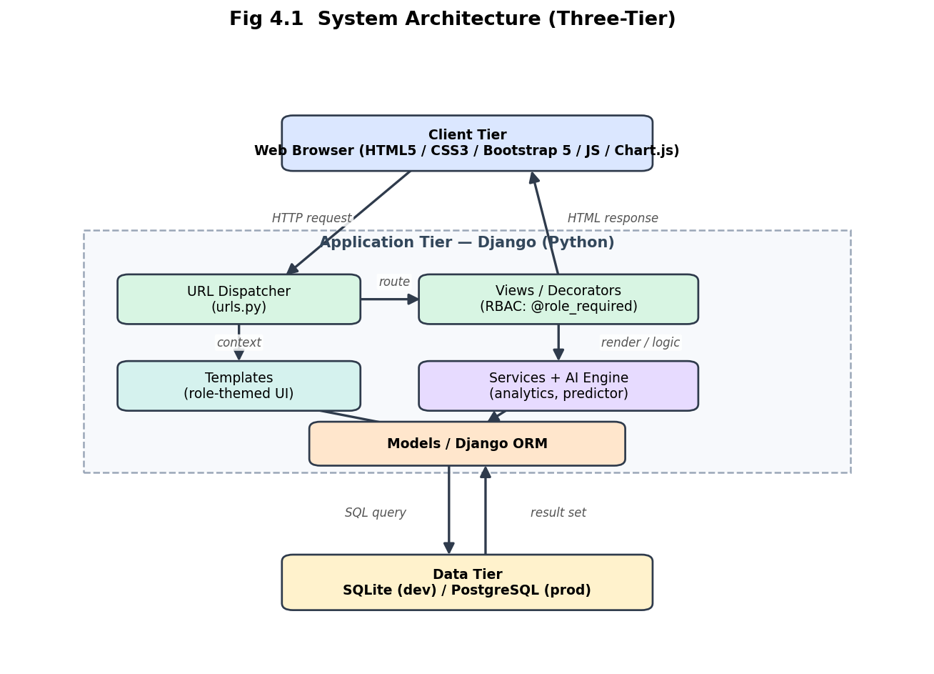
Fig 4.1 System Architecture (Three-Tier)

4.3 Use Case Diagram
The use case diagram identifies the three actors and the functions each can perform within the system boundary.

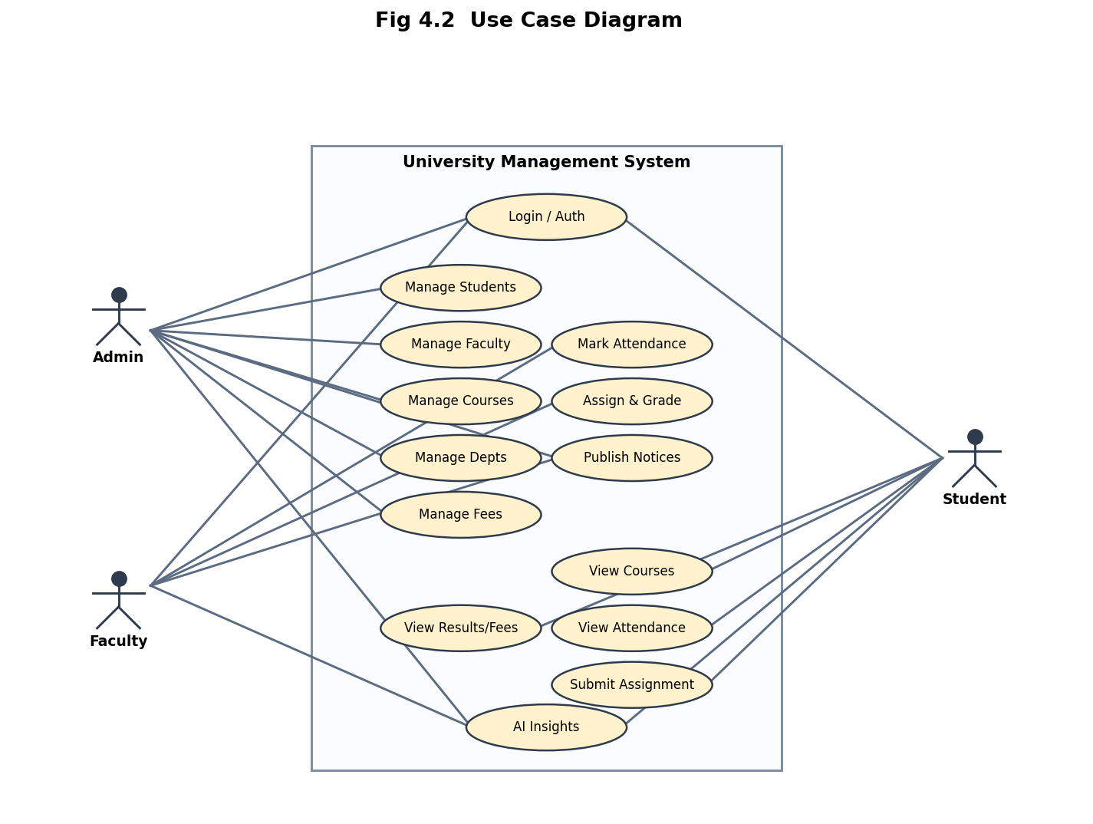
Fig 4.2 Use Case Diagram

4.4 Data Flow Diagrams
The context-level (Level 0) DFD depicts the system as a single process exchanging data with the three external actors.

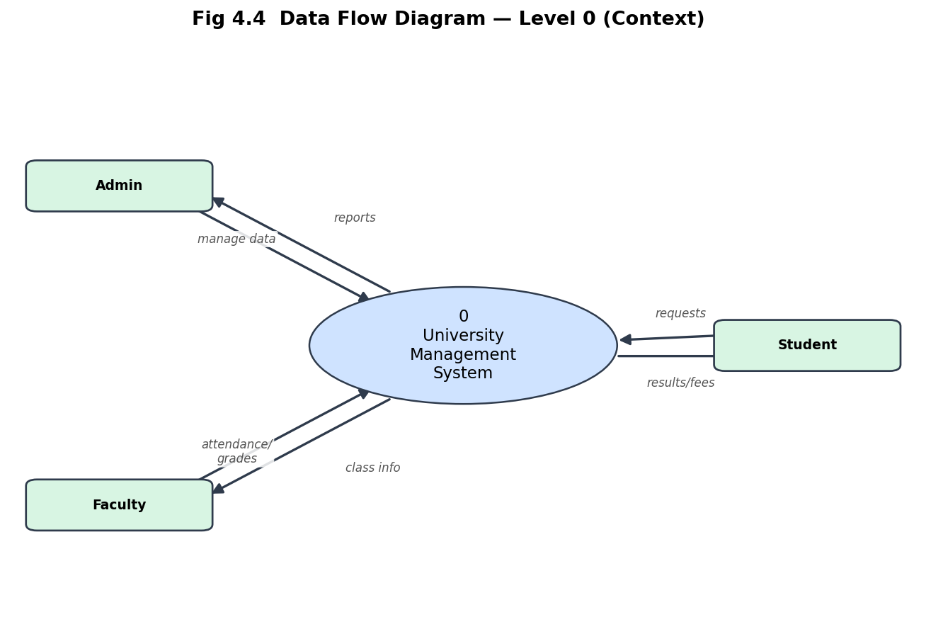
Fig 4.4 DFD Level 0 (Context)
The Level 1 DFD decomposes the system into its principal processes and data stores.

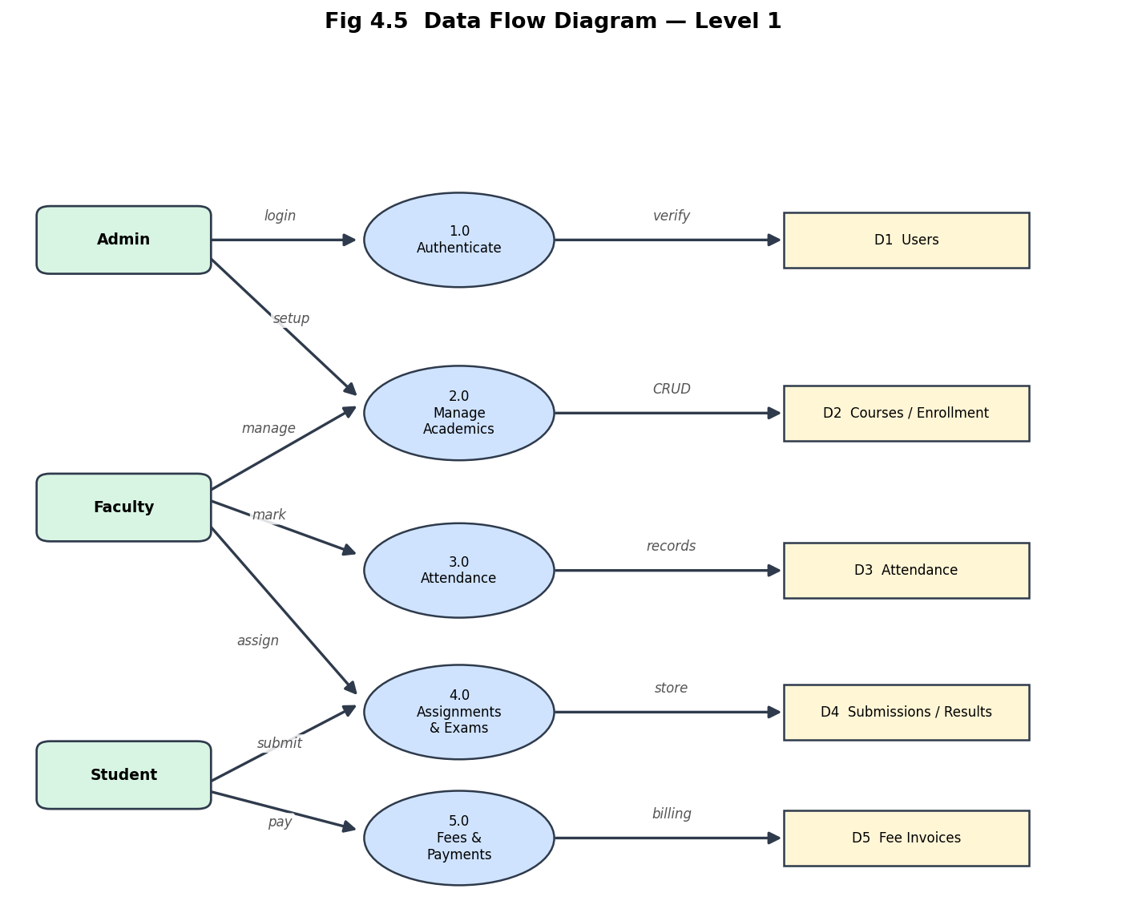
Fig 4.5 DFD Level 1

4.5 Entity-Relationship Diagram
The ER diagram models the entities and the relationships between them. Each arrow points from the entity that holds a foreign key toward the referenced parent entity.

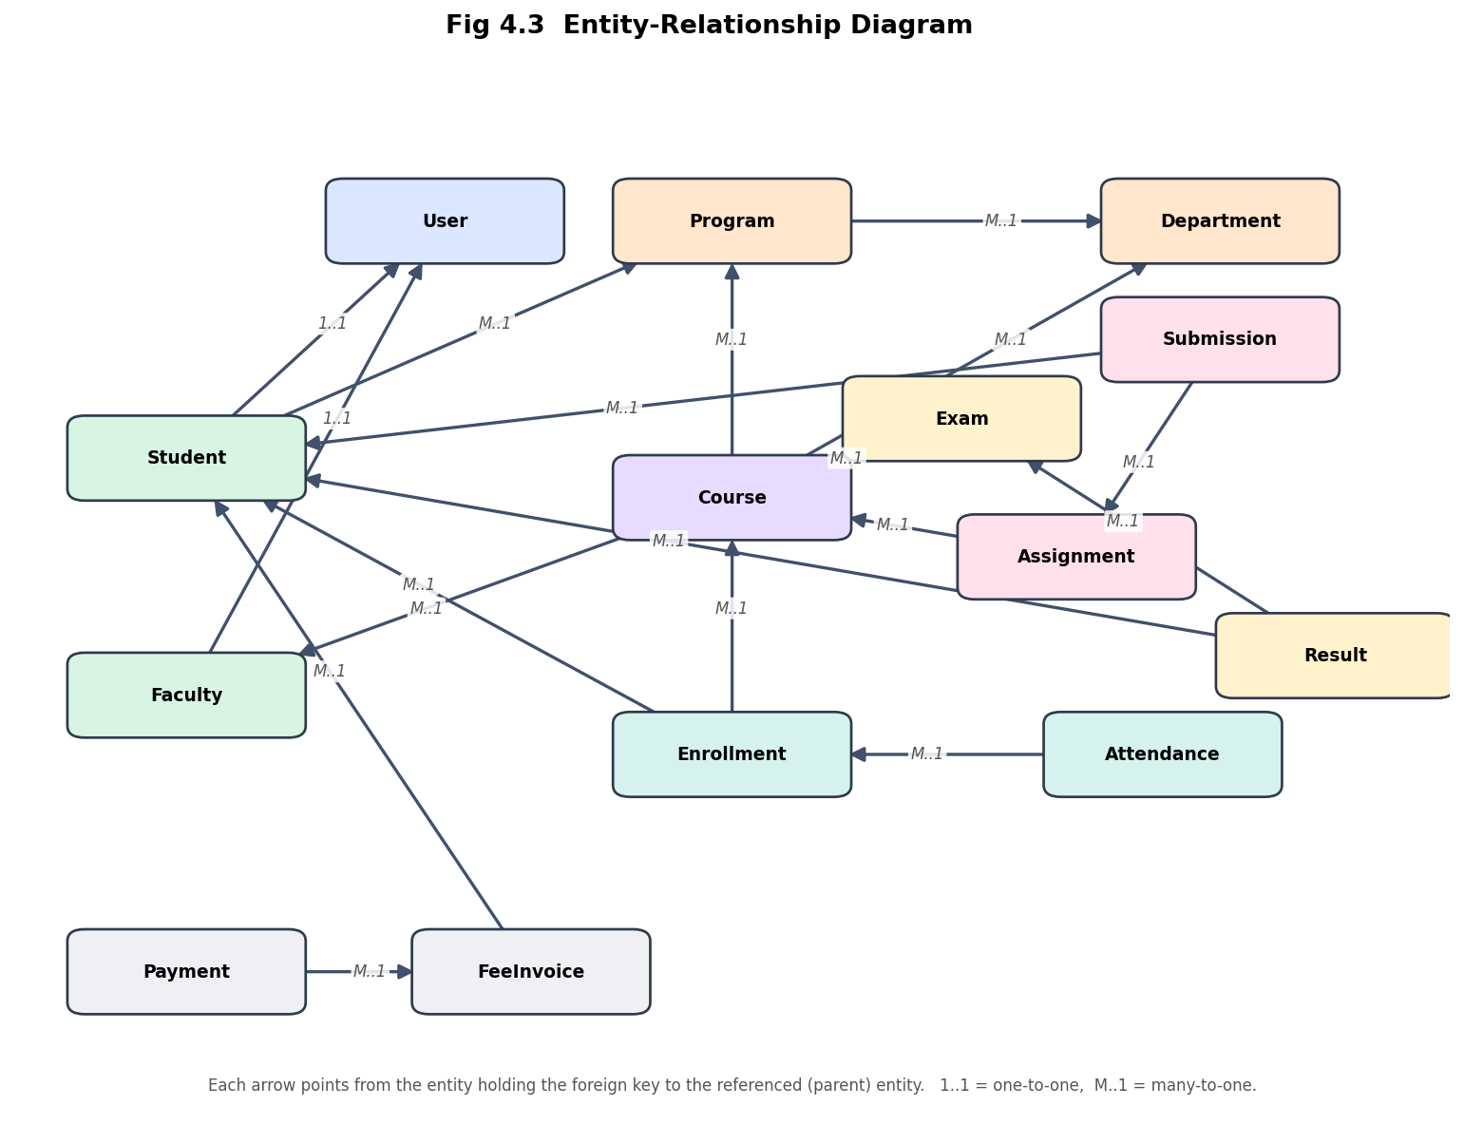
Fig 4.3 Entity-Relationship Diagram

4.6 Class Diagram
The class diagram shows the principal domain classes, their key attributes, and their associations, including the inheritance of the custom User model from Django’s AbstractUser.

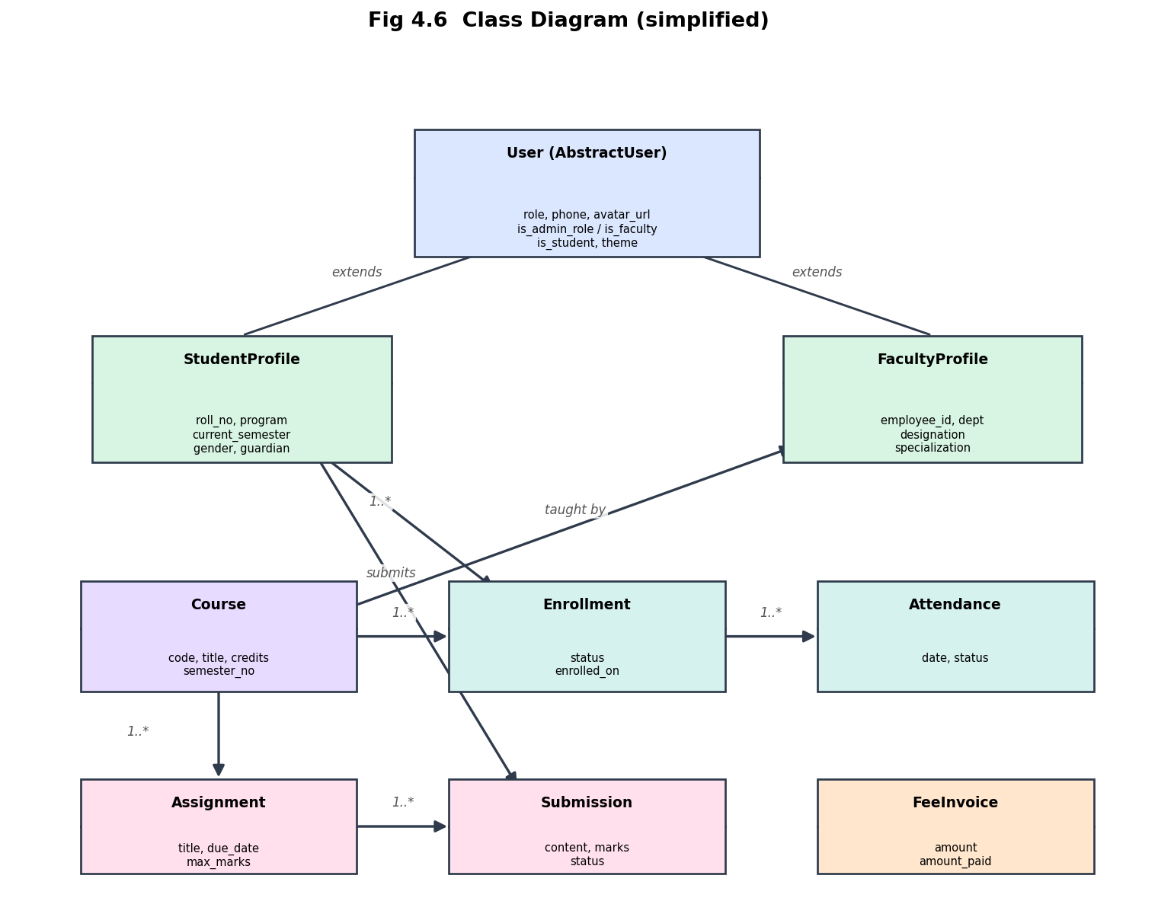
Fig 4.6 Class Diagram

4.7 Sequence Diagrams
The following sequence diagram illustrates the login and role-based redirection flow.

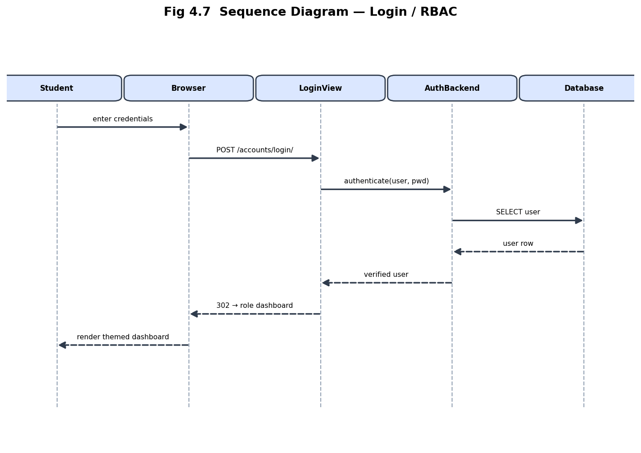
Fig 4.7 Sequence Diagram — Login / RBAC
The next sequence diagram illustrates how a faculty member marks day-wise attendance.

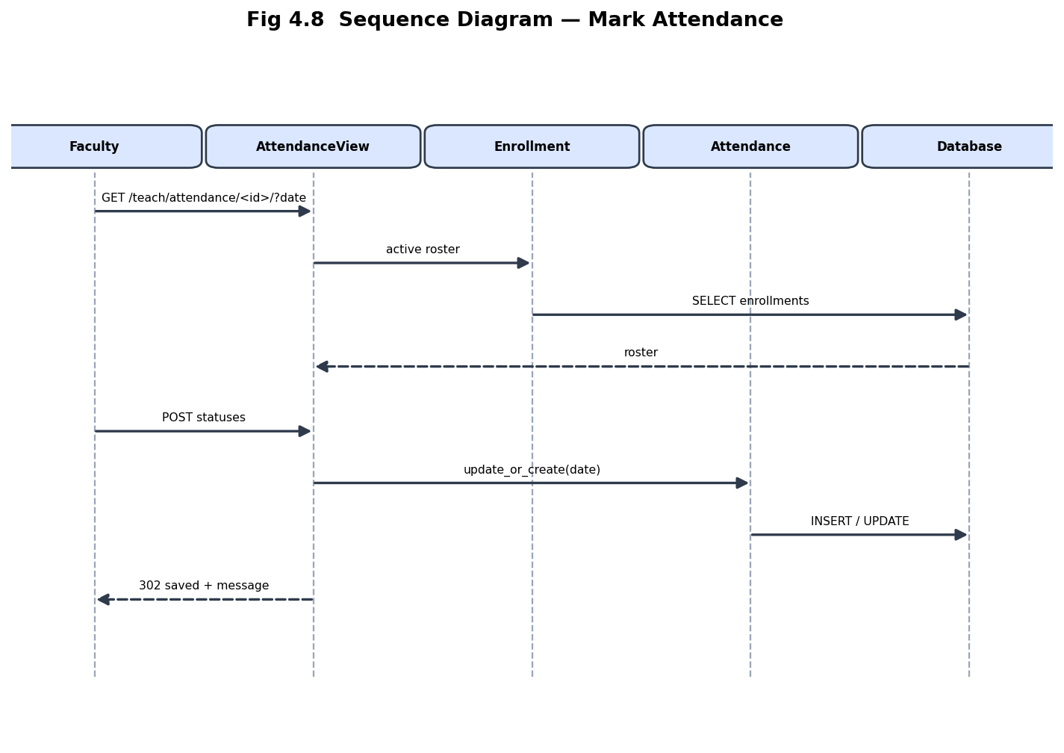
Fig 4.8 Sequence Diagram — Mark Attendance

4.8 Activity Diagram
The activity diagram below captures the end-to-end assignment workflow, including the decision on whether the submission window is still open.

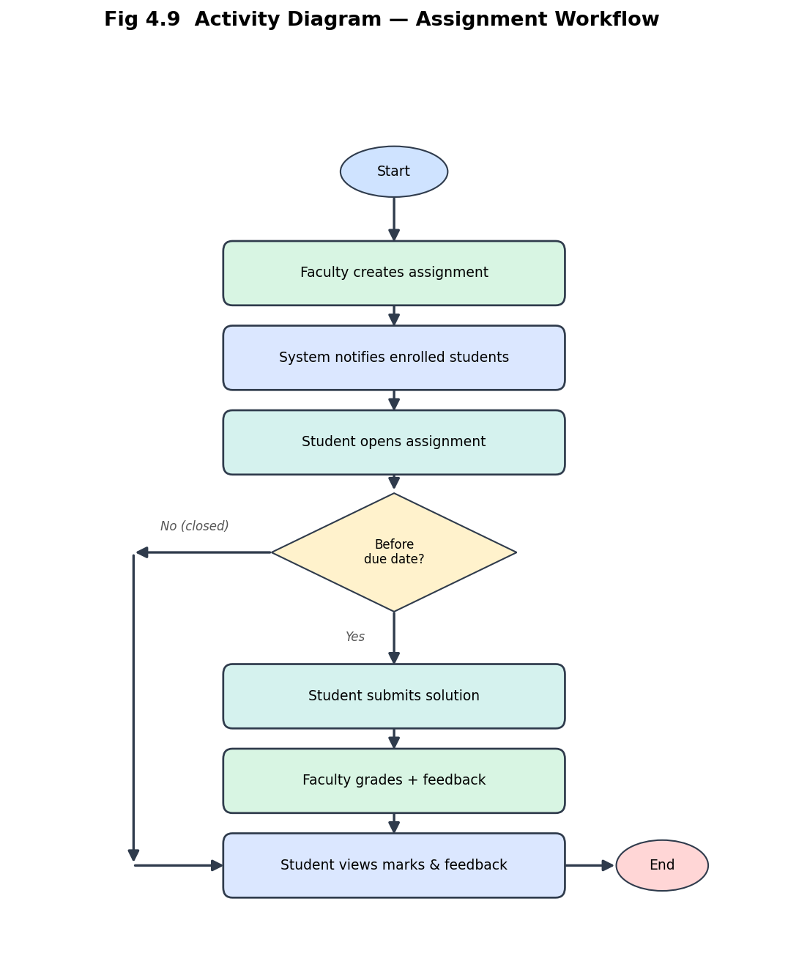
Fig 4.9 Activity Diagram — Assignment Workflow

4.9 Detailed Module Design
The system is decomposed into loosely coupled modules that communicate through the shared data layer. The design of each principal module is described below.

4.9.1 Authentication & RBAC Module
This module manages the complete authentication lifecycle — login, logout, and student self sign-up — and enforces authorisation. A custom User model extends Django’s AbstractUser with a role field. After successful authentication the user is redirected to the dashboard corresponding to their role, and every subsequent view is protected by the @role_required decorator, guaranteeing that users can access only the functionality permitted to them.

4.9.2 Academic Structure Module
Departments, programs, and courses form the academic backbone of the institution. Departments group programs; programs define degrees offered by a department; and courses belong to a department and are optionally linked to a program and an assigned faculty member. This hierarchy is fully manageable by the administrator.

4.9.3 Enrollment & Attendance Module
Students are enrolled into courses through Enrollment records. Attendance is then captured per enrollment on a per-day basis using an update-or-create strategy keyed on the (enrollment, date) pair, which guarantees exactly one record per student per class day. The attendance register aggregates these records into a matrix and computes attendance percentages automatically.

4.9.4 Assessment Module
Assignments and examinations constitute the assessment subsystem. Faculty create assignments with due dates and maximum marks; students submit before the deadline; and faculty grade the submissions and provide feedback. Examinations record per-student results, which flow into the analytics and AI layers.

4.9.5 Finance Module
The finance module raises fee invoices for students and records payments against them. All monetary calculations use fixed-point decimal arithmetic to avoid rounding errors, and the outstanding balance is derived as the difference between the billed amount and the total amount paid.

4.9.6 Communication Module
Notices and events keep the campus informed. Notices support audience targeting and pinning, while events carry a category, venue, and date. All authenticated users can read notices; only administrators and faculty may publish them.

4.9.7 AI & Analytics Module
The analytics module renders role-specific dashboards using Chart.js, while the AI module derives insights — performance prediction, at-risk detection, and study recommendations — from attendance, assignment, and examination data using a transparent, rule-based model that runs entirely offline.

5. Database Design & Data Dictionary
The database is designed in third normal form to eliminate redundancy and preserve referential integrity. The following data dictionary documents every table (Django model), its fields, data types, and constraints.

5.1 User
Field | Type | Constraint / Note
id | AutoField | Primary Key
username | CharField(150) | Unique, required
password | CharField | Hashed (PBKDF2)
first_name / last_name | CharField(150) | Optional
email | EmailField | Login/contact
role | CharField(10) | ADMIN / FACULTY / STUDENT
phone | CharField(20) | Default 0000
avatar_url | URLField | Optional

5.2 StudentProfile
Field | Type | Constraint / Note
id | AutoField | Primary Key
user_id | OneToOne(User) | FK, unique
roll_no | CharField(20) | Unique
program_id | FK(Program) | Nullable
current_semester | PositiveSmallInt | Default 1
gender | CharField(1) | M / F / O
admission_date | DateField | Nullable
address | CharField(255) | Optional
guardian_name | CharField(120) | Optional

5.3 FacultyProfile
Field | Type | Constraint / Note
id | AutoField | Primary Key
user_id | OneToOne(User) | FK, unique
employee_id | CharField(20) | Unique
department_id | FK(Department) | Nullable
designation | CharField(80) | e.g. Professor
specialization | CharField(120) | Optional
joining_date | DateField | Nullable

5.4 Department
Field | Type | Constraint / Note
id | AutoField | Primary Key
name | CharField(120) | Unique
code | CharField(10) | Unique
description | TextField | Optional
icon | CharField(40) | Font Awesome icon
color | CharField(20) | Theme colour
image_url | URLField | Optional

5.5 Program
Field | Type | Constraint / Note
id | AutoField | Primary Key
name | CharField(120) | Required
code | CharField(15) | Unique
department_id | FK(Department) | Cascade
level | CharField(3) | UG / PG / PHD
duration_years | PositiveSmallInt | Default 4
total_seats | PositiveInt | Default 120

5.6 Course
Field | Type | Constraint / Note
id | AutoField | Primary Key
code | CharField(15) | Unique
title | CharField(150) | Required
department_id | FK(Department) | Cascade
program_id | FK(Program) | Nullable
faculty_id | FK(FacultyProfile) | Nullable
credits | PositiveSmallInt | Default 4
semester_no | PositiveSmallInt | Default 1
description | TextField | Optional

5.7 Enrollment
Field | Type | Constraint / Note
id | AutoField | Primary Key
student_id | FK(StudentProfile) | Cascade
course_id | FK(Course) | Cascade
term_id | FK(AcademicTerm) | Nullable
enrolled_on | DateField | Default today
status | CharField(10) | ACTIVE/COMPLETED/DROPPED
(student, course) | Unique Together | No duplicate enroll

5.8 Attendance
Field | Type | Constraint / Note
id | AutoField | Primary Key
enrollment_id | FK(Enrollment) | Cascade
date | DateField | Class date
status | CharField(1) | P / A / L
(enrollment, date) | Unique Together | One record per day

5.9 Assignment
Field | Type | Constraint / Note
id | AutoField | Primary Key
course_id | FK(Course) | Cascade
title | CharField(150) | Required
description | TextField | Optional
max_marks | PositiveSmallInt | Default 100
assigned_on | DateField | Default today
due_date | DateField | Required

5.10 Submission
Field | Type | Constraint / Note
id | AutoField | Primary Key
assignment_id | FK(Assignment) | Cascade
student_id | FK(StudentProfile) | Cascade
content | TextField | Answer / link
submitted_on | DateTimeField | Nullable
marks | PositiveSmallInt | Nullable
feedback | CharField(255) | Optional
status | CharField(10) | PENDING/SUBMITTED/GRADED

5.11 Exam
Field | Type | Constraint / Note
id | AutoField | Primary Key
course_id | FK(Course) | Cascade
term_id | FK(AcademicTerm) | Nullable
name | CharField(80) | e.g. Mid Term
date | DateField | Exam date
max_marks | PositiveSmallInt | Default 100

5.12 Result
Field | Type | Constraint / Note
id | AutoField | Primary Key
exam_id | FK(Exam) | Cascade
student_id | FK(StudentProfile) | Cascade
marks_obtained | DecimalField(5,2) | Score
(exam, student) | Unique Together | One result each

5.13 FeeInvoice
Field | Type | Constraint / Note
id | AutoField | Primary Key
student_id | FK(StudentProfile) | Cascade
term_id | FK(AcademicTerm) | Nullable
title | CharField(120) | e.g. Tuition Fee
amount | DecimalField(10,2) | Billed amount
amount_paid | DecimalField(10,2) | Paid so far
due_date | DateField | Required

5.14 Payment
Field | Type | Constraint / Note
id | AutoField | Primary Key
invoice_id | FK(FeeInvoice) | Cascade
amount | DecimalField(10,2) | Paid amount
paid_on | DateField | Default today
method | CharField(30) | Online / Front-desk
reference | CharField(40) | Transaction ref

5.15 Event
Field | Type | Constraint / Note
id | AutoField | Primary Key
title | CharField(150) | Required
description | TextField | Optional
category | CharField(40) | e.g. Campus
location | CharField(120) | Venue
date | DateField | Event date
icon / image_url | Char / URL | Presentation

5.16 Notice
Field | Type | Constraint / Note
id | AutoField | Primary Key
title | CharField(150) | Required
body | TextField | Required
audience | CharField(10) | ALL/STUDENT/FACULTY/ADMIN
is_pinned | BooleanField | Pin to top
created_by_id | FK(User) | Nullable
created_at | DateTimeField | Timestamp

5.17 Normalization
The schema is normalised up to the Third Normal Form (3NF). In the First Normal Form all attributes are atomic and there are no repeating groups. In the Second Normal Form every non-key attribute is fully functionally dependent on the whole primary key — for example, attendance is stored against an (enrollment, date) pair rather than being duplicated across student and course. In the Third Normal Form there are no transitive dependencies; look-up information such as department, program, and faculty is factored into separate tables and referenced through foreign keys. This design minimises redundancy, prevents update anomalies, and preserves referential integrity across the entire database.

5.18 Referential Integrity & Constraints
Referential integrity is enforced through foreign-key constraints with appropriate on-delete behaviour. Unique constraints (for example, on username, roll number, course code, and the (enrollment, date) and (exam, student) pairs) prevent duplicate records, while not-null and choice constraints validate the domain of each field at the database level in addition to the form level.

5.19 Sample Seeded Data Volume
To make dashboards, charts, and reports meaningful during demonstrations, the seed command populates a realistic, privacy-safe dataset. Indicative volumes are shown below.
Entity | Approx. Records | Purpose
Departments | 6 | Academic structure
Programs | 10 | Degrees offered
Courses | 30+ | Course catalogue
Faculty | 15+ | Teaching staff
Students | 120+ | Learner population
Enrollments | 400+ | Course registrations
Attendance | 3000+ | Day-wise records
Assignments / Submissions | 60+ / 300+ | Assessment data
Exams / Results | 30+ / 400+ | Examination data
Fee Invoices / Payments | 120+ / 200+ | Finance data

6. Implementation

6.1 Technology Stack
Layer | Technology
Back-end framework | Django (Python)
Database | SQLite (dev) / PostgreSQL (prod)
Front-end | HTML5, CSS3, Bootstrap 5.3
Charts | Chart.js 4
Icons & Fonts | Font Awesome 6, Bootstrap Icons, Google Fonts (Poppins)
AI layer | Custom rule-based Python (no external API)
Image handling | Pillow, ui-avatars.com, picsum.photos

6.1.1 Justification of Technology Choices
Django was selected as the core framework because it provides a mature, batteries-included environment with a powerful ORM, a robust authentication system, built-in security protections, and an excellent template engine — dramatically reducing the amount of boilerplate required to build a secure, data-driven application. Python offers readability and a vast ecosystem, which made it straightforward to implement the offline AI logic without additional services. Bootstrap 5 delivers a responsive, professional interface out of the box, while Chart.js provides lightweight, attractive data visualisations. SQLite keeps the development setup friction-free, and because Django abstracts the database layer, the same code migrates to PostgreSQL for production with only a configuration change.

6.2 Project Structure
The project is split into two Django apps — accounts (authentication, users, profiles) and university (all academic domain models and views) — with a shared config package for settings and URL routing, a templates directory for the role-themed UI, and a static directory for CSS/JS/images.

6.3 Role-Based Access Control
Access control is enforced by a custom decorator, @role_required, applied to each view. It checks the authenticated user’s role against the roles permitted for that view and raises a 403 (Forbidden) or redirects otherwise. Notices are readable by all authenticated users, while publishing is restricted to Admin and Faculty. The code below shows the core of the decorator:
def role_required(*roles):
def decorator(view):
@wraps(view)
@login_required
def _wrapped(request, *args, **kwargs):
u = request.user
if u.is_superuser or u.role in roles:
return view(request, *args, **kwargs)
raise PermissionDenied
return _wrapped
return decorator

6.4 AI Performance Prediction (offline)
The AI module predicts a student’s likely performance using a transparent weighted model that combines attendance percentage, average assignment score, and average exam result. Students falling below configurable thresholds are flagged as at-risk, and tailored study recommendations are generated — all without any external API call, guaranteeing zero cost and full data privacy.
A simplified form of the scoring logic is shown below:
score = (0.35 * attendance_pct
+ 0.30 * avg_assignment_pct
+ 0.35 * avg_exam_pct)
if score < 45: band = 'At Risk'
elif score < 65: band = 'Needs Improvement'
else: band = 'On Track'

6.5 Module-wise Implementation Details
Each functional module is realised as a coherent set of models, forms, views, and templates. The table below summarises the principal responsibilities of every module.
Module | Key Responsibilities
Authentication | Login, logout, self sign-up, role-based redirection, RBAC decorators.
Student Mgmt | CRUD for students with linked user accounts and profiles.
Faculty Mgmt | CRUD for faculty, department assignment, designations.
Dept & Program | Maintain departments and academic programs.
Course & Enroll | Course catalogue, faculty allocation, roster management.
Attendance | Day-wise marking, editing, register matrix, percentages.
Assignment | Create, edit, delete, submit, and grade with feedback.
Examination | Schedule exams and record per-student results.
Fees | Raise invoices, record payments, track balances and analytics.
Notices & Events | Publish and manage campus communications.
AI Insights | Prediction, at-risk detection, recommendations, assistant.
Analytics | Role dashboards with Chart.js visualisations.
The presentation layer reuses two generic templates — form_page.html for all create and edit operations and confirm_delete.html for all deletions — driven by Django ModelForms. This dramatically reduces duplication and guarantees a consistent look and feel across every administrative screen.

6.6 User Interface Theming
A context processor injects the current user’s role theme into every template. CSS custom properties defined on the :root element are overridden per role, producing three visually distinct portals — a purple administrative theme, a teal faculty theme, and a blue student theme — while the public website uses a maroon campus theme. This delivers a strong sense of identity for each type of user without duplicating templates.

6.7 Data Privacy in Demo Data
To allow the system to be demonstrated publicly, the seed command generates privacy-safe synthetic data: e-mail addresses use the example.com domain and phone numbers are masked, ensuring that no real personal information is ever exposed.

6.8 Key Implementation Highlights
- Custom User model extending AbstractUser with a role field and theme property.
- Context processor injects the role theme into every template for dynamic colours.
- Day-wise attendance uses update_or_create keyed on (enrollment, date).
- Fee payments use Decimal arithmetic to avoid floating-point errors.
- A management command (seed_demo) populates privacy-safe demo data.
- Reusable form_page and confirm_delete templates power all admin CRUD.

6.9 Coding Standards & Best Practices
The codebase adheres to the PEP 8 style guide for Python and follows Django’s recommended project conventions. Business logic is kept in models and dedicated service functions rather than in templates; views remain thin and focused on request handling and access control; and templates are limited to presentation. Meaningful names, small functions, and the reuse of generic form and delete views keep the code readable and maintainable.

6.10 Security Measures
- Passwords are never stored in plain text; Django hashes them with PBKDF2.
- Cross-Site Request Forgery (CSRF) tokens protect every state-changing form.
- Role-Based Access Control is enforced server-side on every protected view.
- The ORM parameterises all queries, preventing SQL injection.
- Template auto-escaping mitigates Cross-Site Scripting (XSS).
- Sessions are invalidated on logout and sensitive routes require authentication.
- DEBUG is disabled and ALLOWED_HOSTS is restricted in production settings.

6.11 Deployment Architecture
For development the application runs on Django’s built-in server backed by SQLite. In production it is deployed behind a WSGI/ASGI server such as Gunicorn, fronted by a reverse proxy (Nginx) that also serves the collected static files, and backed by a PostgreSQL database. Environment variables supply the secret key, database credentials, and allowed hosts, and the same code base runs unchanged across environments thanks to Django’s configurable settings.

6.12 AI Engine Implementation
The AI engine is deliberately transparent and dependency-free. Rather than relying on an opaque external service, it computes a weighted performance index from three signals — attendance, assignment average, and examination average — and maps the result onto an interpretable band. This keeps the logic explainable to students and faculty and incurs no cost or privacy risk. A representative implementation is shown below.
def predict_performance(attendance_pct, assign_pct, exam_pct):
score = (0.35 * attendance_pct
+ 0.30 * assign_pct
+ 0.35 * exam_pct)
if score < 45:
band, advice = 'At Risk', 'Meet mentor; prioritise weak subjects.'
elif score < 65:
band, advice = 'Needs Improvement', 'Increase practice and revision.'
else:
band, advice = 'On Track', 'Maintain consistency; attempt advanced work.'
return {'score': round(score, 1), 'band': band, 'advice': advice}
The at-risk detector applies the same index across the cohort and surfaces students whose score falls below the risk threshold, enabling faculty and administrators to intervene early. The assistant chatbot uses keyword matching over a curated knowledge base to answer frequently asked academic questions instantly.

6.13 Challenges Faced and Resolutions
Several engineering challenges arose during development; the principal ones and their resolutions are summarised below.
Challenge | Resolution
Distinct look for each role without duplicating templates | A context processor injects a per-role theme via CSS variables.
Ensuring one attendance record per student per day | update_or_create keyed on the (enrollment, date) unique pair.
Monetary rounding errors in fee calculations | All amounts use Python Decimal fixed-point arithmetic.
Consistent, low-boilerplate CRUD across many entities | Generic form_page and confirm_delete templates driven by ModelForms.
Meaningful analytics on a fresh install | A privacy-safe seed command populates realistic demo data.
AI insights without paid APIs or privacy risk | A transparent, offline rule-based scoring model.
Addressing these challenges improved both the robustness of the system and the quality of the developer experience, and each solution is reusable in future modules.

7. Testing

7.1 Testing Methodology
The application was validated using a combination of unit testing (Django’s test client), integration testing of complete workflows, and manual/exploratory testing across roles and devices. Every view was checked for correct HTTP status, correct template rendering, and correct enforcement of access control.

7.2 Test Cases
ID | Test Case | Expected Result | Status
TC-01 | Valid admin login | Redirect to admin dashboard | Pass
TC-02 | Valid faculty login | Redirect to faculty dashboard | Pass
TC-03 | Valid student login | Redirect to student dashboard | Pass
TC-04 | Invalid credentials | Error message, no login | Pass
TC-05 | Student opens /notices/ | Notices shown (no 403) | Pass
TC-06 | Student tries to publish notice | Blocked (not allowed) | Pass
TC-07 | Admin adds new student | Student + user created | Pass
TC-08 | Admin edits student | Changes persisted | Pass
TC-09 | Admin deletes student | Student removed | Pass
TC-10 | Admin adds faculty | Faculty + user created | Pass
TC-11 | Admin adds course | Course created | Pass
TC-12 | Admin enrolls student in course | Enrollment created | Pass
TC-13 | Remove enrollment | Student removed from roster | Pass
TC-14 | Faculty marks attendance today | Records saved | Pass
TC-15 | Faculty marks attendance past date | Records saved for date | Pass
TC-16 | View attendance register | Day-wise matrix shown | Pass
TC-17 | Student views day-wise log | Per-date status listed | Pass
TC-18 | Faculty creates assignment | Assignment created | Pass
TC-19 | Student submits assignment | Submission recorded | Pass
TC-20 | Faculty grades submission | Marks + feedback saved | Pass
TC-21 | Admin creates exam | Exam created | Pass
TC-22 | Record fee payment | Balance reduced correctly | Pass
TC-23 | Payment exceeding balance | Capped at balance | Pass
TC-24 | Admin creates department | Department created | Pass
TC-25 | Admin creates program | Program created | Pass
TC-26 | Admin creates event | Event created | Pass
TC-27 | Faculty accesses admin CRUD | Forbidden (403) | Pass
TC-28 | AI insights (student) | Prediction rendered | Pass
TC-29 | AI assistant reply | Rule-based JSON reply | Pass
TC-30 | Public homepage loads | Renders 200 OK | Pass
TC-31 | Responsive layout on mobile | Adapts correctly | Pass
TC-32 | Logout | Session cleared, redirect home | Pass

7.3 Types of Testing Performed
Unit testing validated individual functions and model methods in isolation, such as the attendance-percentage calculation and the fee-balance derivation. Integration testing verified that modules cooperate correctly — for example, that enrolling a student then marking attendance produces the expected register. System testing exercised complete end-to-end workflows for each role. Regression testing re-ran the suite after every change to ensure existing behaviour was preserved. Security testing confirmed that access control could not be bypassed, and usability testing checked the interface on desktop, tablet, and mobile form factors.

7.4 Sample Test Snippet
The following illustrative test confirms that a student is blocked from publishing a notice while still being able to read the notice list:
def test_student_cannot_publish_notice(self):
self.client.force_login(self.student)
resp = self.client.get('/notices/')
self.assertEqual(resp.status_code, 200) # can read
resp = self.client.post('/notices/', {'title': 'x', 'body': 'y'})
self.assertIn(resp.status_code, (403, 302)) # cannot publish

7.5 Test Environment
Parameter | Value
Operating System | Windows 11 (also verified on Linux)
Python | 3.11+
Framework | Django 6.x
Database | SQLite (development)
Browsers | Chrome, Edge, Firefox (latest)
Devices | Desktop, tablet, and mobile viewports
Test tool | Django test client (unittest)

7.6 Test Summary
All 32 documented test cases passed across the unit, integration, system, regression, security, and usability categories. The system correctly enforces role-based access, maintains data integrity, and behaves as expected across supported browsers and screen sizes.

8. Results & Screenshots
The completed system delivers a polished public website and three distinct, role-themed portals. The public landing page is shown below.

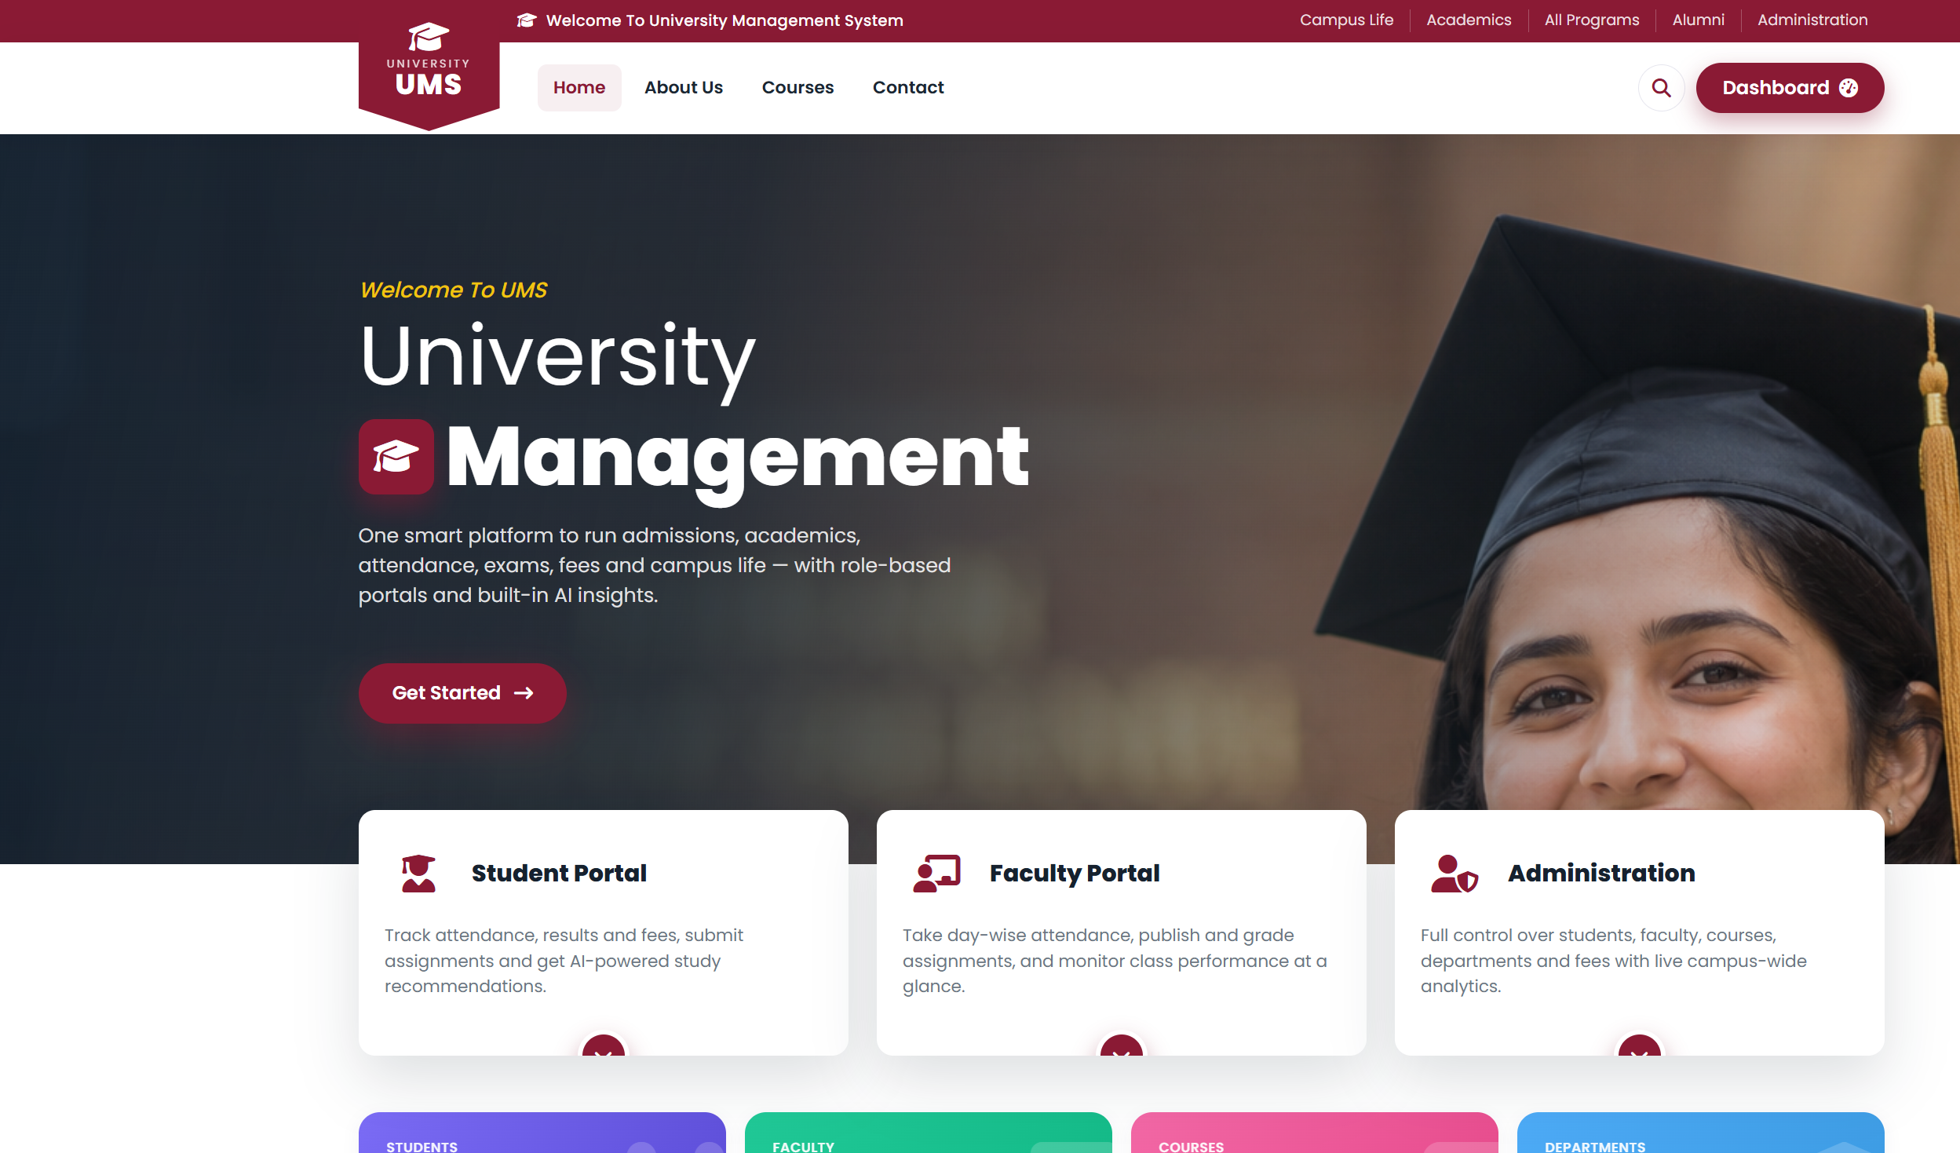
Fig 8.1 Public Home Page (maroon campus theme)
The hero section features a professionally styled banner, clear calls to action, and three portal cards linking students, faculty, and administrators to their respective dashboards. Each authenticated portal is colour-themed (purple for Admin, teal for Faculty, blue for Student) and presents role-appropriate statistics, Chart.js visualisations, and quick actions.

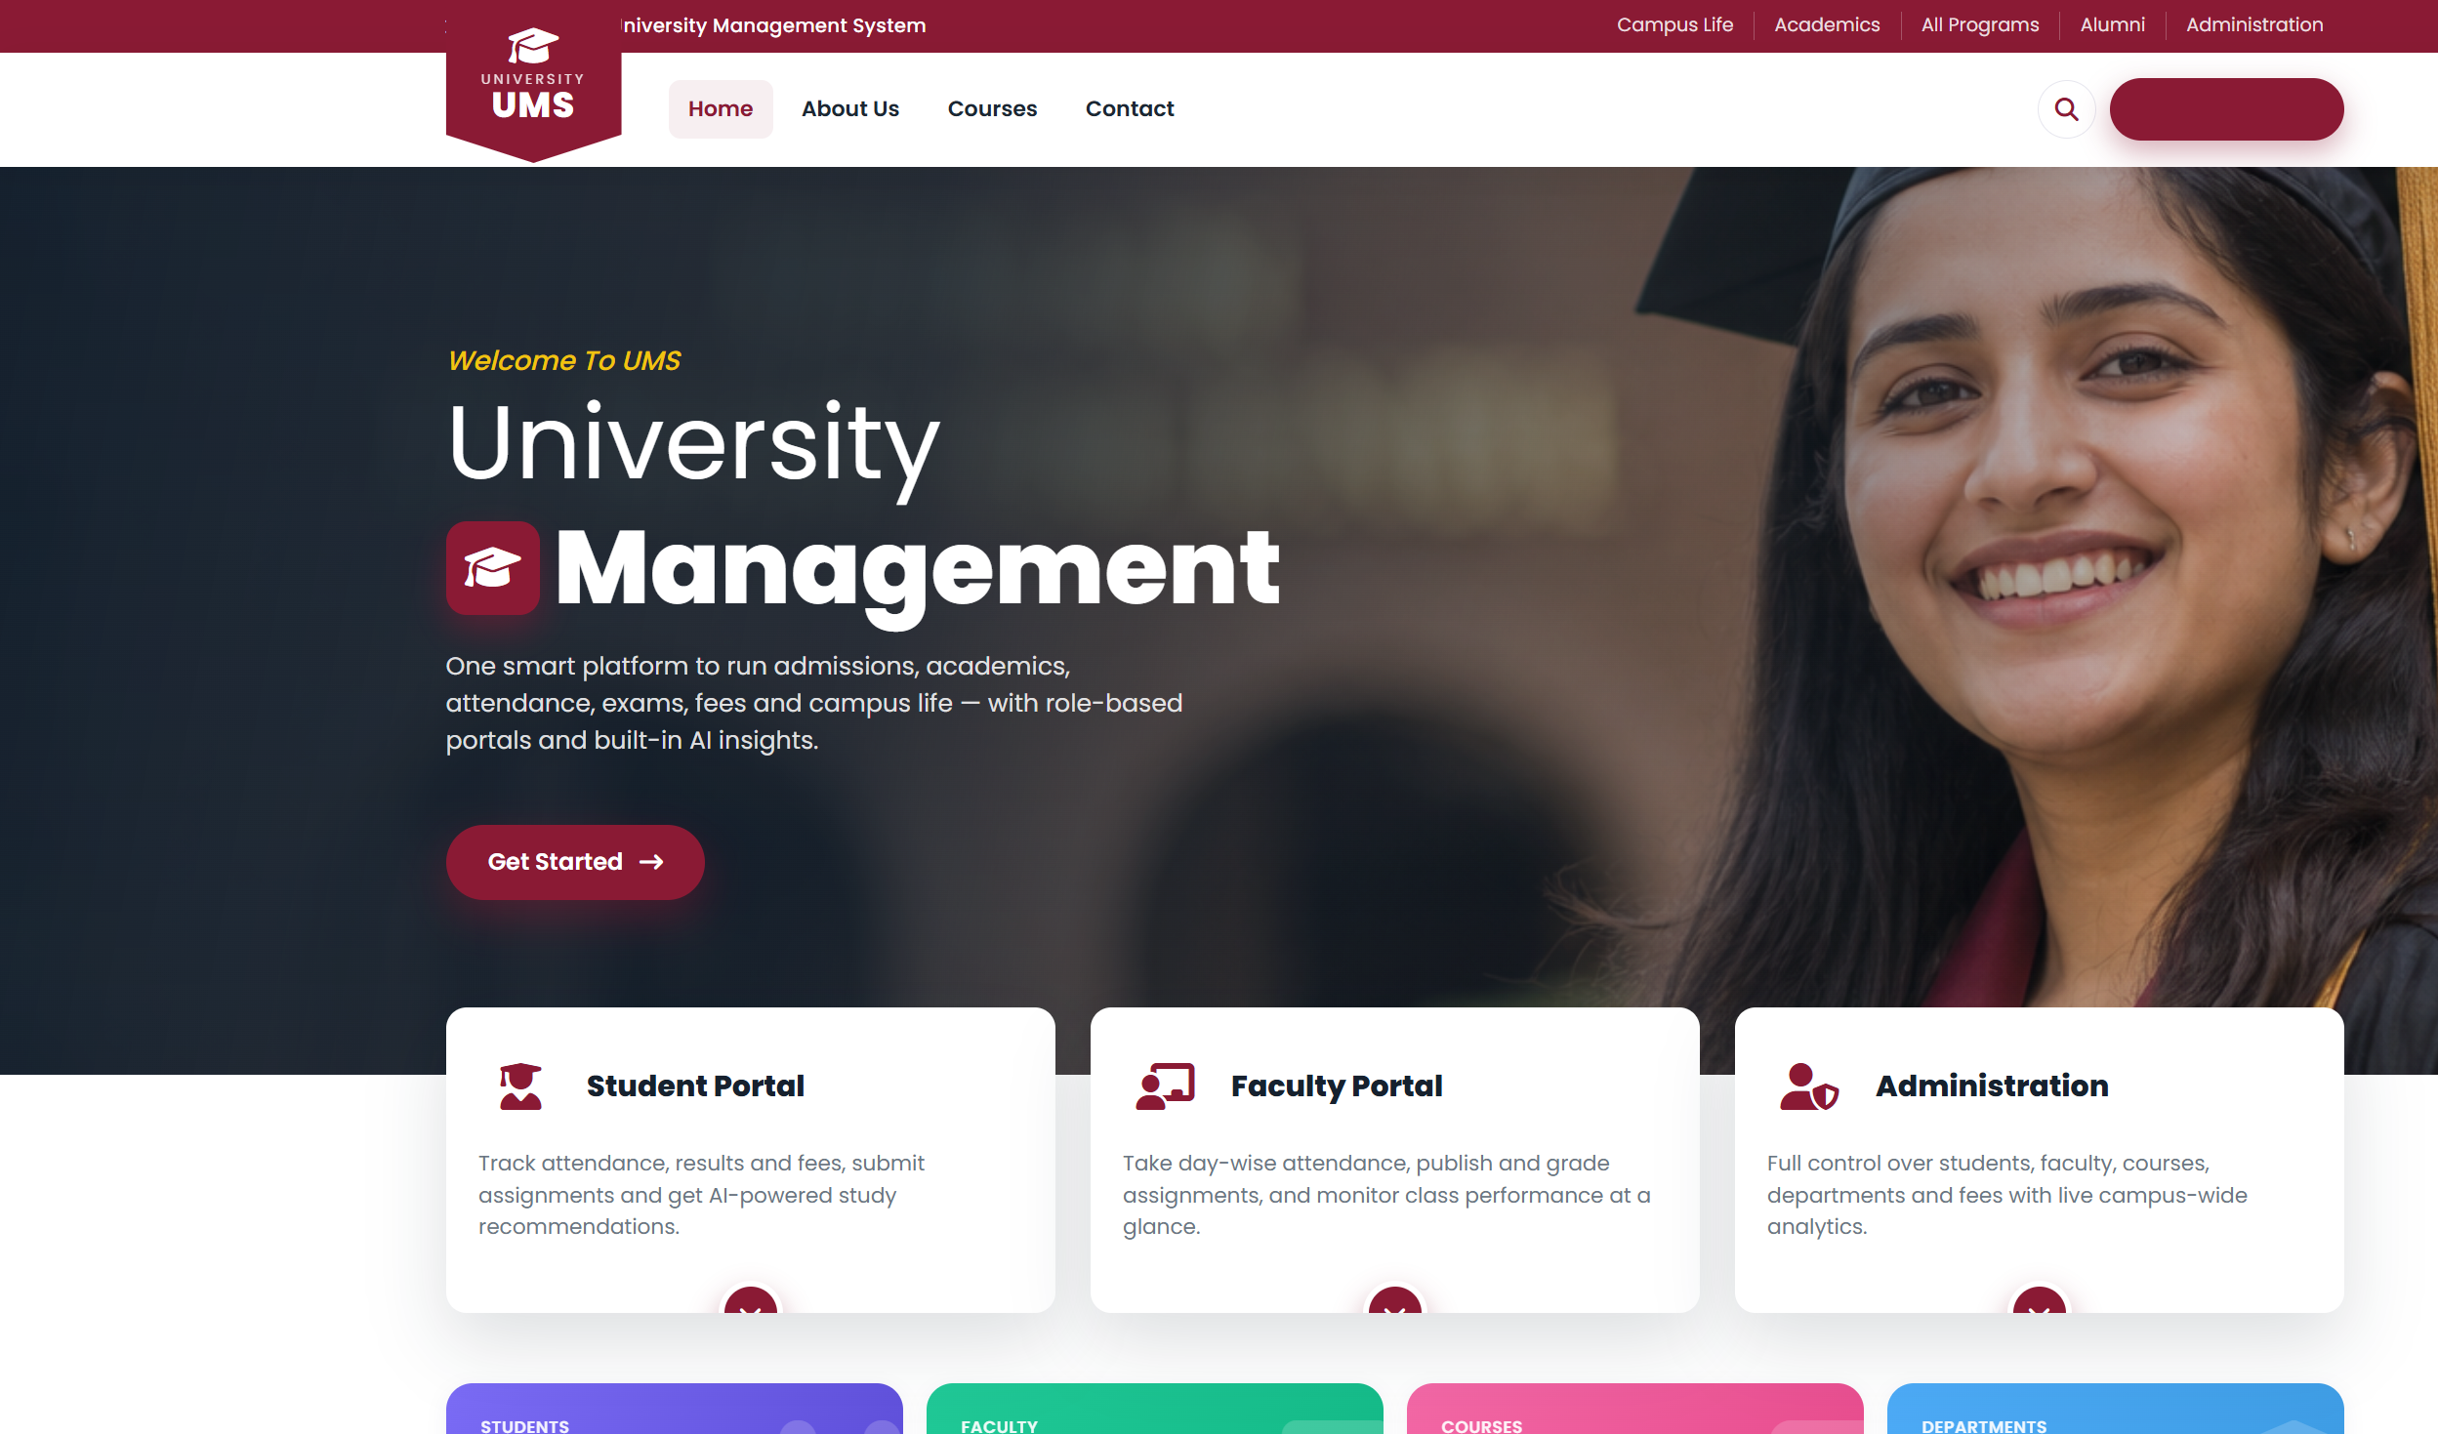
Fig 8.2 Home Page Hero & Portal Cards

8.1 Administrator Portal
The administrator portal is presented in a distinctive purple theme. Its dashboard summarises institution-wide statistics — total students, faculty, courses, and departments — alongside Chart.js visualisations for enrollment trends and fee collection. From here the administrator can create, edit, and delete every entity in the system, manage course rosters, publish notices and events, raise fee invoices, and review AI at-risk detection across all students.

8.2 Faculty Portal
The faculty portal uses a teal theme focused on teaching activities. Faculty members see the courses they teach, mark day-wise attendance, view an attendance register matrix, create and grade assignments, schedule exams, and monitor class performance through concise analytics.

8.3 Student Portal
The student portal adopts a friendly blue theme. Students view their enrolled courses, a day-wise attendance log with percentages, assignment deadlines and submissions, examination results, and fee status. The AI panel offers grade predictions and personalised study recommendations, while an assistant answers common academic queries.

8.4 Responsiveness
Because the interface is built on Bootstrap 5’s responsive grid, every page adapts gracefully from large desktop monitors down to tablets and mobile phones, with a collapsible navigation menu and fluid card layouts.

8.5 Navigation Map
Each portal exposes a focused set of menu items appropriate to the role, as summarised below.
Portal | Primary Menu Items
Admin | Dashboard, Students, Faculty, Departments, Courses, Fees, Events, Notices, AI Insights
Faculty | Dashboard, My Courses, Attendance, Assignments, Exams, Notices
Student | Dashboard, My Courses, Attendance, Assignments, Results, Fees, Notices, AI Guidance
Public | Home, About Us, Courses, Contact, Login, Sign Up
This role-appropriate navigation keeps each interface uncluttered and ensures users are presented only with the functionality relevant to them, reinforcing both usability and the security model.

9. Conclusion & Future Scope

9.1 Conclusion
The University Management System successfully digitises the core academic and administrative operations of a university within a single, secure, and user-friendly platform. By implementing role-based portals, day-wise attendance, complete assignment and examination workflows, fee management, and offline AI insights, the project demonstrates a practical, end-to-end software engineering solution. The modular Django architecture ensures the system is maintainable and readily extensible.

9.2 Advantages Achieved
- Single source of truth for all academic and administrative data.
- Strong, server-side role-based security on every operation.
- Automated, day-wise attendance with instant analytics.
- Complete assignment and examination lifecycles.
- Real-time fee tracking with accurate decimal arithmetic.
- Zero-cost, privacy-preserving AI insights.
- Modern, responsive, and role-themed interface.

9.3 Limitations
- The current AI model is rule-based rather than trained on historical data.
- Online payment gateway integration is not yet included.
- Timetable scheduling and library/hostel modules are planned but not built.
- Notifications are in-app only; email/SMS channels are future work.

9.4 Learning Outcomes
Developing this system provided practical experience across the full software engineering lifecycle: gathering and specifying requirements, designing a normalised relational schema, applying the Model-Template-View pattern, implementing secure role-based access control, building a responsive and themed user interface, embedding explainable offline AI, and validating the result through systematic testing. It reinforced the value of modular design, reusable components, and clear documentation in producing maintainable software.

9.5 Future Scope
- Native mobile applications for Android and iOS.
- Real-time notifications via email, SMS, and push channels.
- Online fee payment gateway integration.
- Timetable and classroom-allocation scheduling module.
- Library, hostel, and transport management modules.
- Advanced machine-learning models for performance prediction.
- Multi-language (i18n) support and accessibility enhancements.
- REST/GraphQL API for third-party integrations.

10. References
- Django Software Foundation, “Django Documentation”, https://docs.djangoproject.com/
- Python Software Foundation, “Python 3 Documentation”, https://docs.python.org/3/
- Bootstrap Team, “Bootstrap 5 Documentation”, https://getbootstrap.com/
- Chart.js, “Chart.js Documentation”, https://www.chartjs.org/docs/
- Font Awesome, “Icon Library”, https://fontawesome.com/
- R. S. Pressman, “Software Engineering: A Practitioner’s Approach”, McGraw-Hill.
- E. Gamma et al., “Design Patterns: Elements of Reusable OO Software”, Addison-Wesley.
- A. Silberschatz et al., “Database System Concepts”, McGraw-Hill.

11. Appendix

11.1 Demo Credentials
Role | Username | Password
Administrator | admin | demo1234
Faculty | prof.rao | demo1234
Student | stu.aarav | demo1234

11.2 Setup Commands
python -m venv venv
venv\Scripts\activate (Windows)
source venv/bin/activate (macOS/Linux)
pip install -r requirements.txt
python manage.py migrate
python manage.py seed_demo
python manage.py runserver

11.3 Module Summary
The complete source code is organised into the accounts and university Django apps. The accounts app defines the custom User model and Student/Faculty profiles, while the university app contains the academic domain models, the role-based views, the AI engine, analytics services, and the seed-data management command. This modular layout keeps authentication concerns separate from academic logic and makes the system straightforward to extend.

11.4 Sample Source Code

11.4.1 Custom User Model & Roles (accounts/models.py)
class Role(models.TextChoices):
ADMIN = "ADMIN", "Administrator"
FACULTY = "FACULTY", "Faculty"
STUDENT = "STUDENT", "Student"
class User(AbstractUser):
role = models.CharField(max_length=10, choices=Role.choices,
default=Role.STUDENT)
phone = models.CharField(max_length=20, blank=True, default="0000")
avatar_url = models.URLField(blank=True)
@property
def theme(self):
return ROLE_THEMES.get(self.role, ROLE_THEMES[Role.STUDENT])
@property
def is_admin_role(self):
return self.role == Role.ADMIN

11.4.2 Student Profile (accounts/models.py)
class StudentProfile(models.Model):
GENDER = [("M", "Male"), ("F", "Female"), ("O", "Other")]
user = models.OneToOneField(User, on_delete=models.CASCADE,
related_name="student_profile")
roll_no = models.CharField(max_length=20, unique=True)
program = models.ForeignKey("university.Program",
on_delete=models.SET_NULL, null=True, blank=True,
related_name="students")
current_semester = models.PositiveSmallIntegerField(default=1)
gender = models.CharField(max_length=1, choices=GENDER, default="O")

11.4.3 Course Model (university/models.py)
class Course(models.Model):
code = models.CharField(max_length=15, unique=True)
title = models.CharField(max_length=150)
department = models.ForeignKey(Department, on_delete=models.CASCADE,
related_name="courses")
faculty = models.ForeignKey("accounts.FacultyProfile",
on_delete=models.SET_NULL, null=True, blank=True,
related_name="courses")
credits = models.PositiveSmallIntegerField(default=4)
@property
def enrolled_count(self):
return self.enrollments.filter(status=Enrollment.ACTIVE).count()

11.4.4 Day-wise Attendance View (university/views.py)
@role_required(Role.ADMIN, Role.FACULTY)
def faculty_attendance(request, pk):
course = get_object_or_404(Course, pk=pk)
day = parse_date(request.GET.get('date', '')) or timezone.localdate()
roster = course.enrollments.filter(status=Enrollment.ACTIVE)
if request.method == 'POST':
for e in roster:
status = request.POST.get(f'status_{e.id}', 'A')
Attendance.objects.update_or_create(
enrollment=e, date=day, defaults={'status': status})
messages.success(request, 'Attendance saved.')
return redirect(request.path + f'?date={day}')
return render(request, 'dashboard/faculty_attendance.html',
{'course': course, 'roster': roster, 'day': day})

11.4.5 Role-Based Access Decorator (accounts/decorators.py)
def role_required(*roles):
def decorator(view):
@wraps(view)
@login_required
def _wrapped(request, *args, **kwargs):
u = request.user
if u.is_superuser or u.role in roles:
return view(request, *args, **kwargs)
raise PermissionDenied
return _wrapped
return decorator

11.4.6 Theme Context Processor (accounts/context_processors.py)
def role_theme(request):
# Inject the current user's role theme into every template so the
# UI colours change per role without duplicating templates.
user = getattr(request, 'user', None)
if user and user.is_authenticated:
return {'theme': user.theme}
return {'theme': None}

11.4.7 URL Routing (university/urls.py, excerpt)
urlpatterns = [
path('', views.home, name='home'),
path('dashboard/', views.dashboard, name='dashboard'),
path('students/', views.admin_students, name='admin_students'),
path('students/new/', views.student_create, name='student_create'),
path('students/<int:pk>/edit/', views.student_edit, name='student_edit'),
path('students/<int:pk>/delete/', views.student_delete,
name='student_delete'),
path('teach/attendance/<int:pk>/', views.faculty_attendance,
name='faculty_attendance'),
path('notices/', views.notices, name='notices'),
]

11.5 Project Directory Structure
UniversityManagementSystem/
├── config/ # settings, root URLs, WSGI/ASGI
├── accounts/ # custom User, roles, profiles, auth
│ ├── models.py
│ ├── views.py
│ ├── decorators.py
│ └── context_processors.py
├── university/ # academic domain
│ ├── models.py # Department, Course, Attendance, ...
│ ├── forms.py # ModelForms for CRUD
│ ├── views.py # role-based views + AI/analytics
│ ├── urls.py
│ └── management/commands/seed_demo.py
├── templates/ # role-themed HTML templates
│ ├── base_public.html
│ ├── base_dashboard.html
│ └── dashboard/ ...
├── static/ # CSS, JS, images
├── docs/screenshots/ # README/report screenshots
├── report/ # this project report
├── requirements.txt
├── manage.py
└── README.md

11.6 Frequently Asked Questions
Q1. Does the AI functionality require an internet connection or API key?
No. All AI features run locally using a transparent rule-based model, so there is no external dependency, no cost, and no privacy risk.
Q2. Can the system scale beyond the demo dataset?
Yes. Because Django abstracts the database, the SQLite backend used for development can be replaced with PostgreSQL for production simply by changing the configuration.
Q3. How is data privacy ensured in the demo?
The seed command generates synthetic data using the example.com domain and masked phone numbers, so no real personal information is exposed.
Q4. How are the three portals kept visually distinct?
A context processor injects a per-role theme, and CSS custom properties override the colour scheme for each role without duplicating any templates.
Q5. What prevents a student from accessing administrative functions?
Every protected view is guarded by the @role_required decorator, which enforces authorisation on the server, independently of what the browser displays.

11.7 Glossary
Term | Meaning
RBAC | Role-Based Access Control
ORM | Object-Relational Mapping
MTV | Model-Template-View (Django's architecture)
ER | Entity-Relationship
DFD | Data Flow Diagram
CSRF | Cross-Site Request Forgery
XSS | Cross-Site Scripting
3NF | Third Normal Form
CRUD | Create, Read, Update, Delete
UAT | User Acceptance Testing

