
Affiliated to University of Mumbai 2026 – 2027

PRACTICAL JOURNAL OF
CLOUD COMPUTING

SUBJECT GUIDE
MAHESH K.
(Asst. Professor)

SUBMITTED BY:
Shruti Gupta
ROLL NO: 264450

SUBMITTED IN PARTIAL FULFILLMENT OF THE
REQUIREMENTS

FOR QUALIFYING M. Sc.IT PART I
(SEMESTER I EXAMINATION)

CERTIFICATE OF APPROVAL

This is to certify that Ms. Shruti gupta student of “Master of Science (Information Technology)” of “Thakur College of Science and Commerce”. Roll No. 264450 has successfully completed and submitted the Practical & Assignment entitled “Cloud Computing” in the partial fulfilment as per the syllabus defined by the University of Mumbai in the academic year 2026 2027.

It is further certified that the student has completed all the required phases of the practical & assignment.

_________________________ ________________________
PROFESSOR INCHARGE HEAD OF DEPARTMENT

_________________________ ________________________
INTERNAL EXAMINER EXTERNAL EXAMINER

INDEX
No. | PRACTICALS | DATE | SIGN
1 | Practical 1- (A) A client server-based program using TCP to find if the number entered is prime.  (B) A client server TCP based chatting application.
2 | Practical 2 – (A) A client server-based program using UDP to find if the number entered is even or odd.  (B) A program to implement simple calculator operations like addition, subtraction, multiplication and division.
3 | Practical 3 - Multicast Socket example.
4 | Practical 4 - RMI based application program to display current date and time.
5 | Practical 5 - Implement Xen virtualization and manage with Xen Center.
6 | Practical 6 - Implement virtualization using VMWare ESXi Server and managing with vCenter.
7 | Practical 7 - Implement server cluster with Windows Server 2012.
8 | Practical 8 - Implement virtualization using Hyper-V.
9 | Practical 9 - Implement IaaS with Eucalyptus
10 | Practical 10 - Implement OpenNebula

PRACTICAL 1
- AIM: A client server-based program using TCP to find if the number entered is prime.
CODE:
- tcpServerPrime.java :
import java.net.*;
import java.io.*;

class tcpServerPrime {
public static void main(String args[]) {
try {
ServerSocket ss = new ServerSocket(8001);
System.out.println("Server Started..............");

Socket s = ss.accept();

DataInputStream in =
new DataInputStream(s.getInputStream());

int x = in.readInt();

DataOutputStream otc =
new DataOutputStream(s.getOutputStream());

int y = x / 2;
boolean prime = true;

if (x <= 1) {
prime = false;
} else {
for (int i = 2; i <= y; i++) {
if (x % i == 0) {
prime = false;
break;
}
}
}

if (prime) {
otc.writeUTF(x + " is Prime");
} else {
otc.writeUTF(x + " is not Prime");
}

in.close();
otc.close();
s.close();
ss.close();
} catch (Exception e) {
System.out.println(e.toString());
}
}
}
- tcpClientPrime.java :
import java.net.*;
import java.io.*;

class tcpClientPrime {
public static void main(String args[]) {
try {
Socket cs = new Socket("localhost", 8001);

BufferedReader infu = new BufferedReader(
new InputStreamReader(System.in));

System.out.println("Enter a number : ");
int a = Integer.parseInt(infu.readLine());

DataOutputStream out =
new DataOutputStream(cs.getOutputStream());

out.writeInt(a);

DataInputStream in =
new DataInputStream(cs.getInputStream());

System.out.println(in.readUTF());

in.close();
out.close();
cs.close();
} catch (Exception e) {
System.out.println(e.toString());
}
}
}

Output:

D:\M.SC.IT> javac tcpServerPrime.java
D:\M.SC.IT>java tcpServerPrime
Server Started...............
D:\M.SC.IT>javac tcpServerPrime.java
D:\M.SC.IT>java tcpServerPrime
Server Started............

D:\M.SC.IT>javac tcpClientPrime.java
D:\M.SC.IT>java tcpClientPrime
Enter a number:
7
7 is Prime
D:\M.SC.IT>javac tcpClientPrime.java
D:\M.SC.IT>java tcpClientPrime
Enter a number :
8
8 is not Prime

B)AIM : A client server TCP based chatting application.
1. ChatServer.java
import java.net.*;
import java.io.*;

class ChatServer {
public static void main(String args[]) {
try {
ServerSocket ss = new ServerSocket(8000);
System.out.println("Waiting for client to connect..");

Socket s = ss.accept();

BufferedReader br = new BufferedReader(
new InputStreamReader(System.in));

DataOutputStream out =
new DataOutputStream(s.getOutputStream());

DataInputStream in =
new DataInputStream(s.getInputStream());

String receive, send;

while ((receive = in.readLine()) != null) {
if (receive.equals("STOP"))
break;

System.out.println("Client Says : " + receive);
System.out.print("Server Says : ");

send = br.readLine();
out.writeBytes(send + "\n");

if (send.equals("STOP"))
break;
}

br.close();
in.close();
out.close();
s.close();
ss.close();
} catch (Exception e) {
e.printStackTrace();
}
}
}
- ChatClient.java
import java.net.*;
import java.io.*;

class ChatClient {
public static void main(String args[]) {
try {
Socket s = new Socket("localhost", 8000);

BufferedReader br = new BufferedReader(
new InputStreamReader(System.in));

DataOutputStream out =
new DataOutputStream(s.getOutputStream());

DataInputStream in =
new DataInputStream(s.getInputStream());

String msg;

System.out.println("To stop chatting with server type STOP");
System.out.print("Client Says: ");

while ((msg = br.readLine()) != null) {
out.writeBytes(msg + "\n");

if (msg.equals("STOP"))
break;

System.out.println("Server Says : " + in.readLine());
System.out.print("Client Says : ");
}

br.close();
in.close();
out.close();
s.close();
} catch (Exception e) {
e.printStackTrace();
}
}
}

Output:
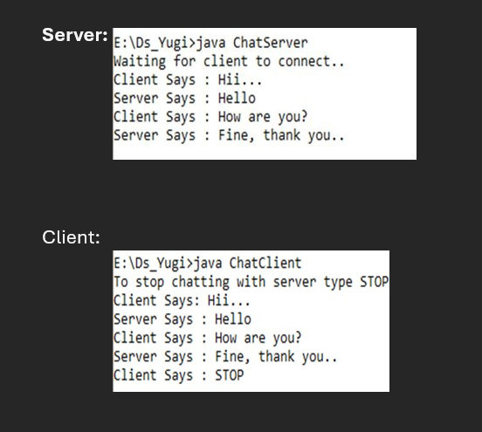

Practical 2
A) AIM : A client server-based program using UDP to find if the number entered is even or odd.
CODE :
- udpServerEO.java
/* Program which finds whether the entered number is even or odd */

import java.io.*;
import java.net.*;

public class udpServerEO {
public static void main(String args[]) {
try {
DatagramSocket ds = new DatagramSocket(2000);

byte b[] = new byte[1024];
DatagramPacket dp = new DatagramPacket(b, b.length);

ds.receive(dp);

String str = new String(
dp.getData(), 0, dp.getLength());

System.out.println(str);

int a = Integer.parseInt(str);
String s;

if (a % 2 == 0)
s = "Number is even";
else
s = "Number is odd";

byte b1[] = s.getBytes();

DatagramPacket dp1 = new DatagramPacket(
b1, b1.length,
dp.getAddress(), dp.getPort());

ds.send(dp1);
ds.close();
} catch (Exception e) {
e.printStackTrace();
}
}
}
- udpClientEO.java
/* Program which finds whether the entered number is even or odd */

import java.io.*;
import java.net.*;

public class udpClientEO {
public static void main(String args[]) {
try {
DatagramSocket ds = new DatagramSocket(1000);

BufferedReader br = new BufferedReader(
new InputStreamReader(System.in));

System.out.println("Enter a number : ");
String num = br.readLine();

byte b[] = num.getBytes();

DatagramPacket dp = new DatagramPacket(
b, b.length,
InetAddress.getLocalHost(), 2000);

ds.send(dp);

byte b1[] = new byte[1024];

DatagramPacket dp1 = new DatagramPacket(
b1, b1.length);

ds.receive(dp1);

String str = new String(
dp1.getData(), 0, dp1.getLength());

System.out.println(str);

br.close();
ds.close();
} catch (Exception e) {
e.printStackTrace();
}
}
}

OUTPUT :
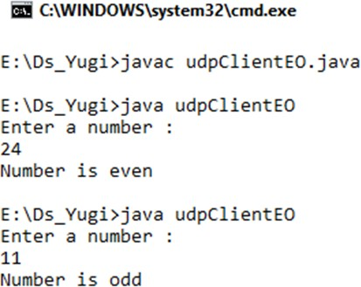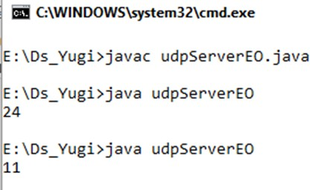

(B)AIM : A program to implement simple calculator operations like addition, subtraction, multiplication and division.
CODE :
- RPCServer.java
import java.util.*;
import java.net.*;

class RPCServer {
DatagramSocket ds;
DatagramPacket dp;
String str, methodName, result;
int val1, val2;

RPCServer() {
try {
ds = new DatagramSocket(1200);
byte b[] = new byte[4096];

while (true) {
dp = new DatagramPacket(b, b.length);
ds.receive(dp);

str = new String(
dp.getData(), 0, dp.getLength());

if (str.equalsIgnoreCase("q")) {
break;
}

StringTokenizer st = new StringTokenizer(str, " ");

methodName = st.nextToken();
val1 = Integer.parseInt(st.nextToken());
val2 = Integer.parseInt(st.nextToken());

System.out.println(str);

if (methodName.equalsIgnoreCase("add")) {
result = "" + add(val1, val2);
} else if (methodName.equalsIgnoreCase("sub")) {
result = "" + sub(val1, val2);
} else if (methodName.equalsIgnoreCase("mul")) {
result = "" + mul(val1, val2);
} else if (methodName.equalsIgnoreCase("div")) {
if (val2 != 0) {
result = "" + div(val1, val2);
} else {
result = "Division by zero is not allowed";
}
} else {
result = "Invalid method name";
}

byte b1[] = result.getBytes();

DatagramPacket dp1 = new DatagramPacket(
b1, b1.length,
dp.getAddress(), 1300);

System.out.println("Result : " + result + "\n");

ds.send(dp1);
}

ds.close();
} catch (Exception e) {
e.printStackTrace();
}
}

public int add(int val1, int val2) {
return val1 + val2;
}

public int sub(int val1, int val2) {
return val1 - val2;
}

public int mul(int val1, int val2) {
return val1 * val2;
}

public int div(int val1, int val2) {
return val1 / val2;
}

public static void main(String args[]) {
new RPCServer();
}
}
- RPCClient.java
import java.io.*;
import java.net.*;

class RPCClient {
RPCClient() {
try {
InetAddress ia = InetAddress.getLocalHost();

DatagramSocket ds = new DatagramSocket();
DatagramSocket ds1 = new DatagramSocket(1300);

System.out.println("\nRPC Client\n");
System.out.println(
"Enter method name and parameters like: add 3 4");
System.out.println("Type q to quit.\n");

BufferedReader br = new BufferedReader(
new InputStreamReader(System.in));

while (true) {
String str = br.readLine();

if (str.equalsIgnoreCase("q")) {
byte b[] = str.getBytes();
DatagramPacket dp = new DatagramPacket(
b, b.length, ia, 1200);
ds.send(dp);
break;
}

byte b[] = str.getBytes();

DatagramPacket dp = new DatagramPacket(
b, b.length, ia, 1200);

ds.send(dp);

byte b1[] = new byte[4096];
DatagramPacket dp1 = new DatagramPacket(
b1, b1.length);

ds1.receive(dp1);

String s = new String(
dp1.getData(), 0, dp1.getLength());

System.out.println("\nResult = " + s + "\n");
}

ds.close();
ds1.close();
} catch (Exception e) {
e.printStackTrace();
}
}

public static void main(String args[]) {
new RPCClient();
}
}

OUTPUT :
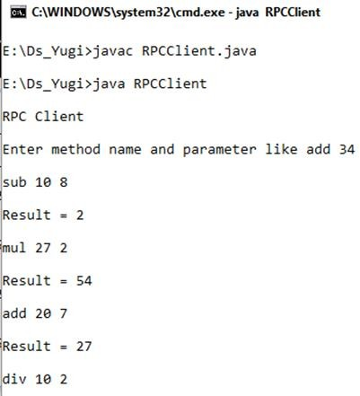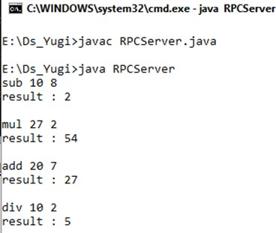

Practical 3
AIM : Multicast Socket example.
CODE :
- BroadcastServer.java
import java.net.*;
import java.io.*;
import java.util.*;

public class BroadcastServer {
public static final int PORT = 1234;

public static void main(String args[]) throws Exception {
MulticastSocket socket;
DatagramPacket packet;
InetAddress address;

// Set the multicast address
address = InetAddress.getByName("239.1.2.3");
socket = new MulticastSocket();

// Join the multicast group
socket.joinGroup(address);

byte[] data;

for (;;) {
Thread.sleep(10000);

System.out.println("Sending");

String str = "This is Neha Calling......................";
data = str.getBytes();

packet = new DatagramPacket(
data, data.length, address, PORT);

// Send the packet
socket.send(packet);
}
}
}
- BroadcastClient.java
import java.net.*;
import java.io.*;

public class BroadcastClient {
public static final int PORT = 1234;

public static void main(String args[]) throws Exception {
MulticastSocket socket;
DatagramPacket packet;
InetAddress address;

// Set the multicast address
address = InetAddress.getByName("239.1.2.3");
socket = new MulticastSocket(PORT);

// Join the multicast group
socket.joinGroup(address);

byte[] data = new byte[1024];

packet = new DatagramPacket(data, data.length);

for (;;) {
// Receive the packets
socket.receive(packet);

String str = new String(
packet.getData(),
0,
packet.getLength());

System.out.println(
"Message received from "
+ packet.getAddress());

System.out.println("Message is : " + str);
}
}
}

OUTPUT :
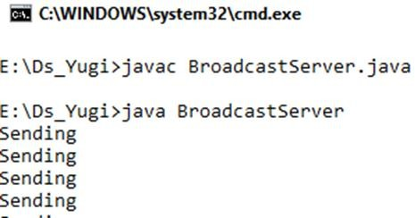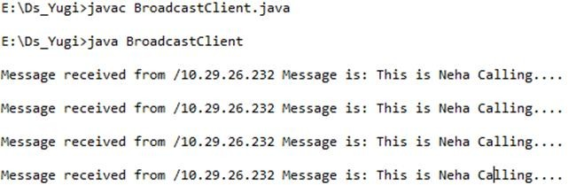

Practical 4
AIM : RMI based application program to display current date and time.
CODE :
- InterDate.java
import java.rmi.*;

public interface InterDate extends Remote {
public String display() throws Exception;
}
- ServerDate.java
import java.rmi.*;
import java.rmi.server.*;
import java.util.*;

public class ServerDate extends UnicastRemoteObject
implements InterDate {

public ServerDate() throws Exception {
super();
}

public String display() throws Exception {
String str = "";
Date d = new Date();
str = d.toString();
return str;
}

public static void main(String args[]) throws Exception {
ServerDate s1 = new ServerDate();

Naming.rebind("DS", s1);

System.out.println(
"Object registered................................................");
}
}
- ClientDate.java
import java.rmi.*;
import java.io.*;

public class ClientDate {
public static void main(String args[]) throws Exception {
String s1;

InterDate h1 = (InterDate) Naming.lookup("rmi://localhost/DS");

s1 = h1.display();

System.out.println(s1);
}
}

OUTPUT :
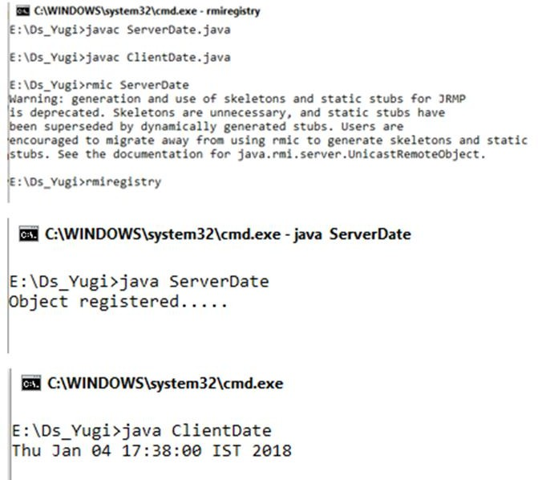

Practical 5
AIM : Implement Xen virtualization and manage with Xen Center.
    - Install XenServer in VMware Workstation and select Guest operating system as Linux.
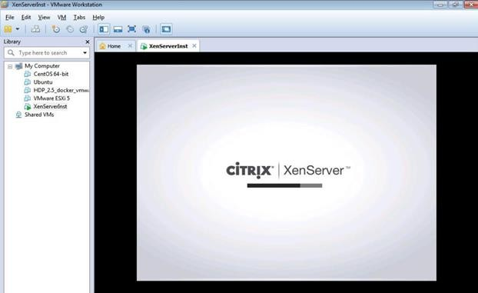
Note IP Address – “ 192.168.124.137” ping it from command prompt.
    - Now Install Citrix App if not installed
    - Now Open Citrix XenCenter – and Click and Add Server.
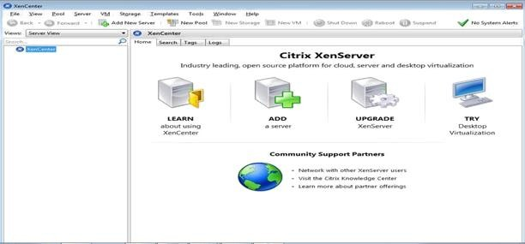
    - Fill IP address copied from Installation and User name as “root” and Password as “root123” which we had given during installation and Click on Add.
    - Then click on Ok
    - Now Click on New Storage
    - Select Window File Sharing (CIFS) and click on next
    - Uncheck Auto generate option Click on Next.
    - Provide the path of shared windows XP image and enter local pc credential , click on Finish
    - Click on New VM – and Windows XP SP3
    - Select ISO file and click on next –
    - Click on Next –
    - Uncheck – Start the new VM and click on create now
    - Now Right click on Windows XP and Start -
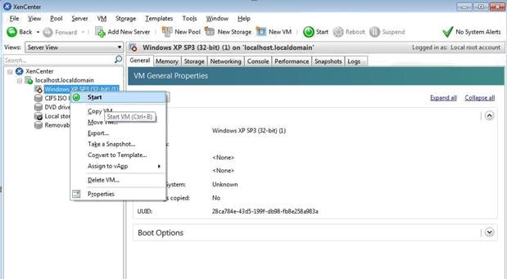
Installation is successful and virtual node has been created if we get below Welcome screen of Windows XP machine.
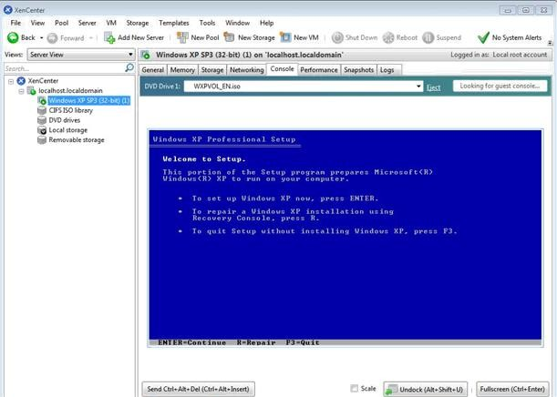 PRACTICAL 6
AIM : Implement virtualization using VMWare ESXi Server and managing with vCenter.
Steps:
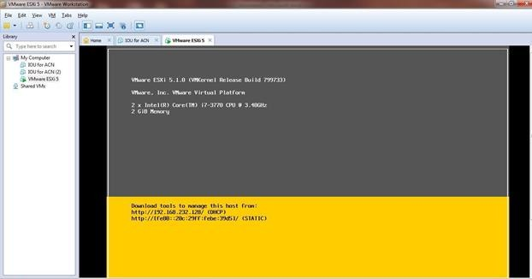
Install ESXi iso in VMWare workstation.

Install VMware vSphere Client
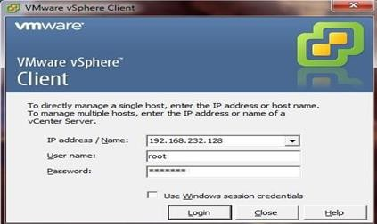

In vSphere create new Virtual Machine. Install Windows XP iso file and open it.
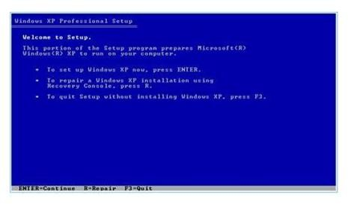

Practical 7
AIM : Implement server cluster with Windows Server 2012.
Requirements: • Two Windows Server 2012 machines (Node1, Node2) in the same domain • One shared storage (iSCSI target) visible to both nodes • Static IP addresses on all machines
Step 1 : Open Server Manager → Add Roles and Features → Features → select Failover Clustering → Install (on both nodes).
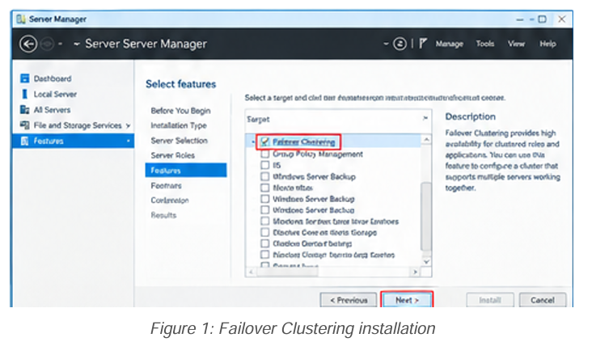
Step 2 : Create an iSCSI virtual disk and connect both nodes to it using iSCSI Initiator. Bring the disk online and format it (on Node1).
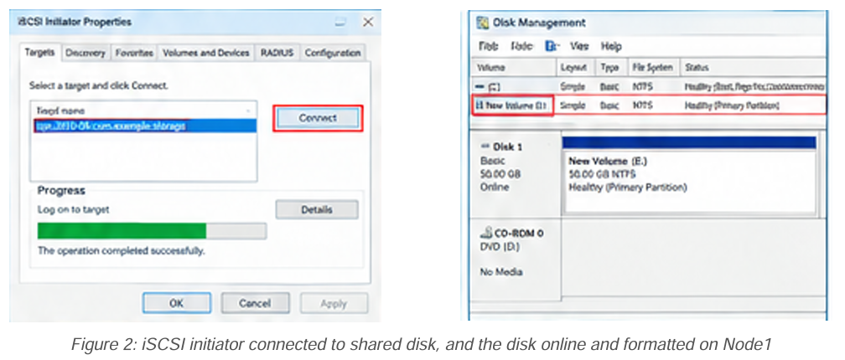
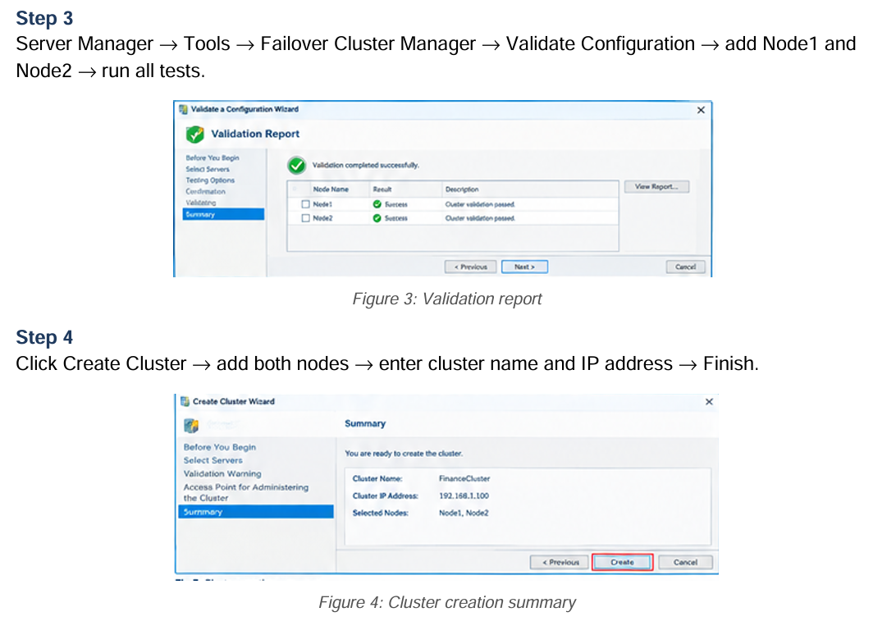
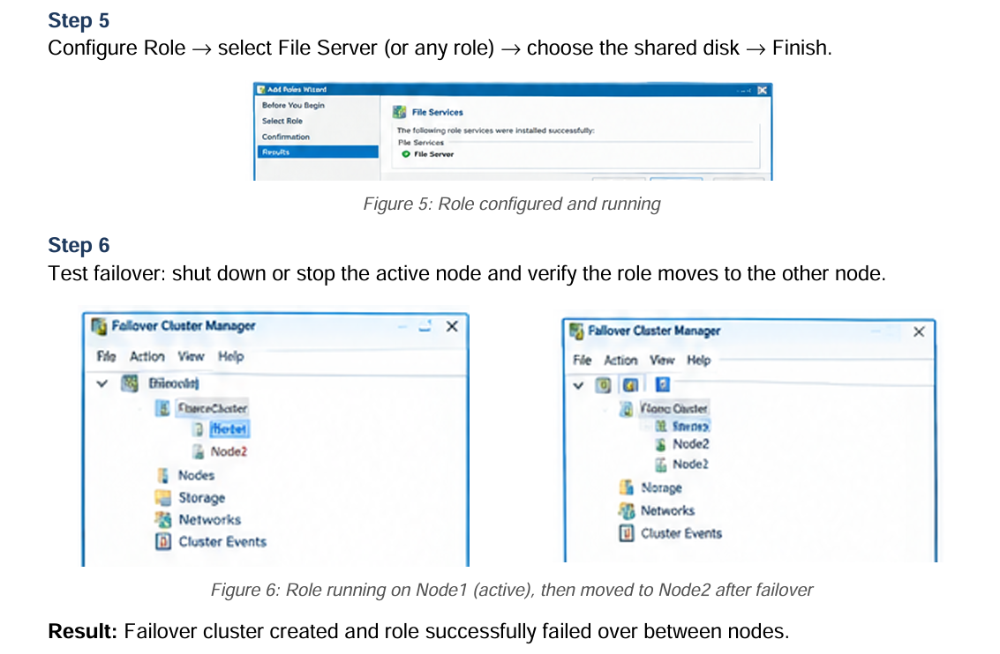

Practical 8
AIM : Implement virtualization using Hyper-V.
First we have to uninstall vmware software if already installed on computer because the VMware Workstation installer does not support running on a Hyper-V virtual machine. after uninstalling vmware we can proceed to next step go to control panel and click on uninstall a program.
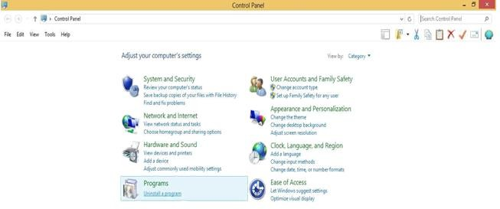
Click on Turn windows features on or off.
Now in windows features check on Hyper-V option.
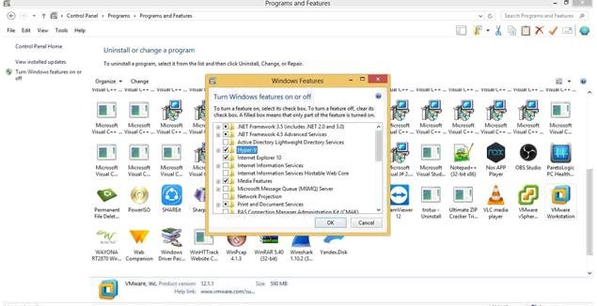

After Restart Search for hyper-v manager in search box and click on that.

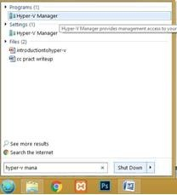
for creating virtual machine first we have to create virtual switch click on virtual switch manager option.
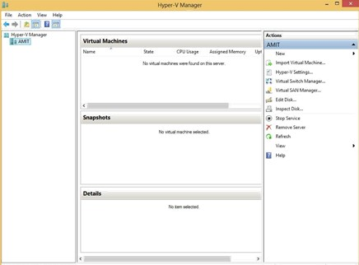

Select External as a connection type and then click on create virtual switch. Create new Virtual switch and install windows XP .iso

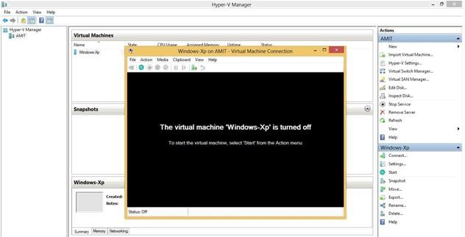

and virtual machine will start.
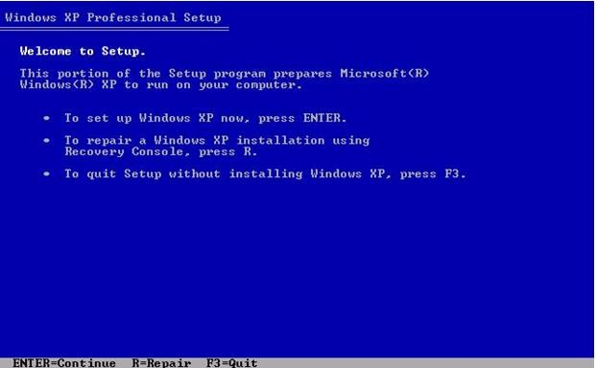

PRACTICAL 9
AIM : Implement IaaS with Eucalyptus
Requirements:
• Clean CentOS/RHEL machine with virtualization enabled
• Static IP and internet access
• Free IP range for instances
Step 1 : Prepare the machine: set static IP, disable conflicting services, and update the system.
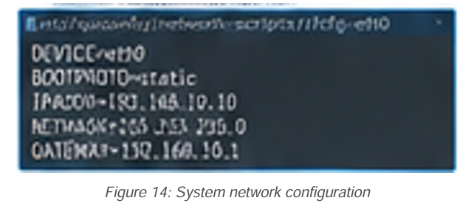

Step 2 : Run the Eucalyptus FastStart installer and answer the prompts (network mode, IP range).
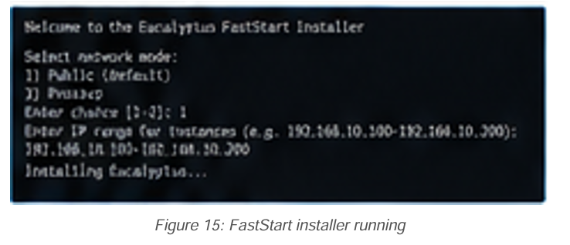

Step 3 : Wait for installation to finish and note the console URL and login details.
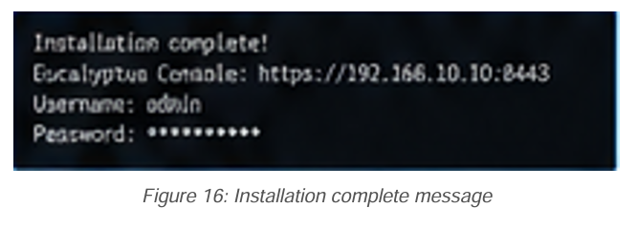
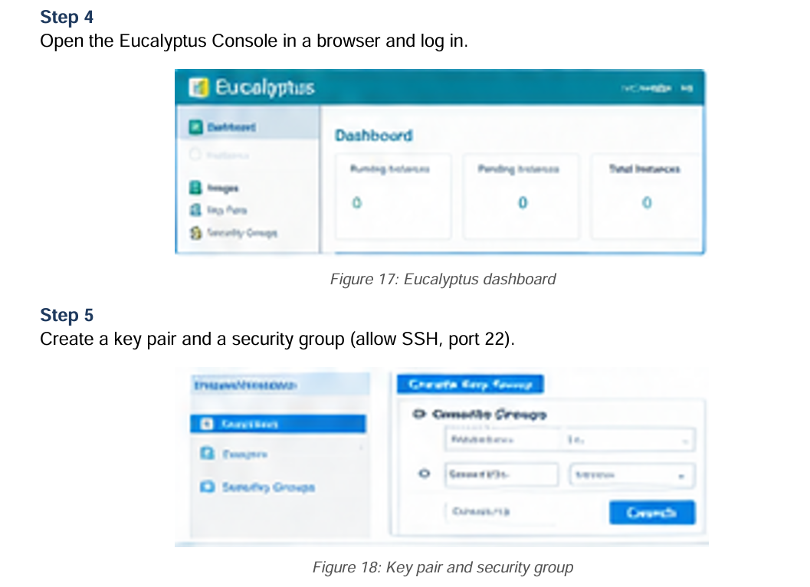

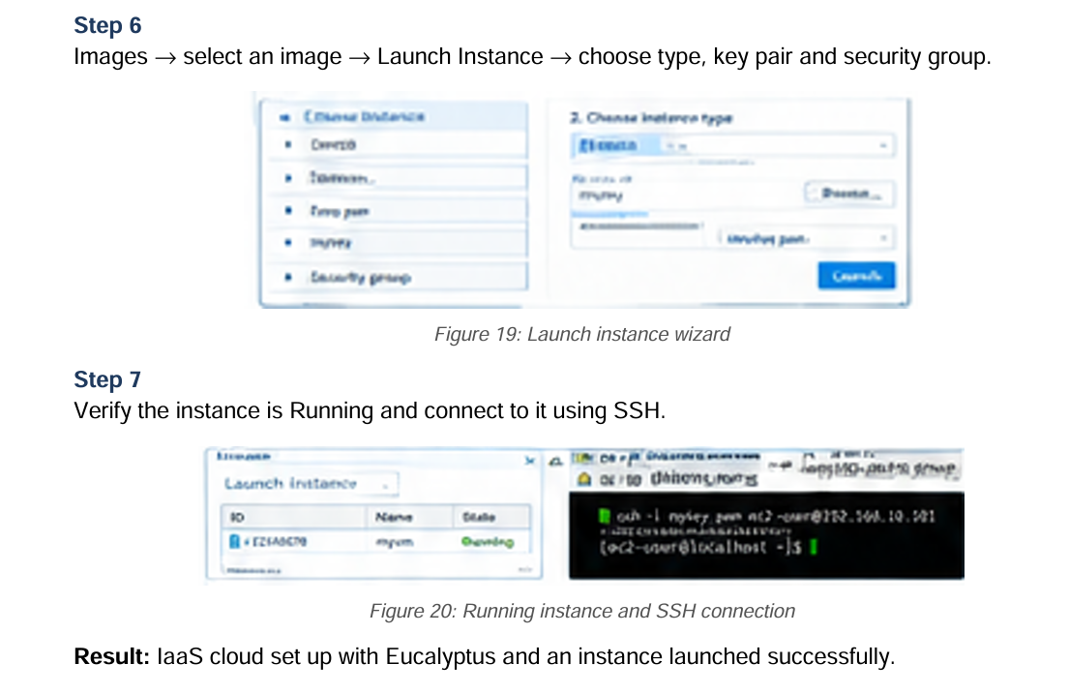

PRACTICAL 10
AIM : Implement OpenNebula
STEP 1: Update the system and note the IP address.
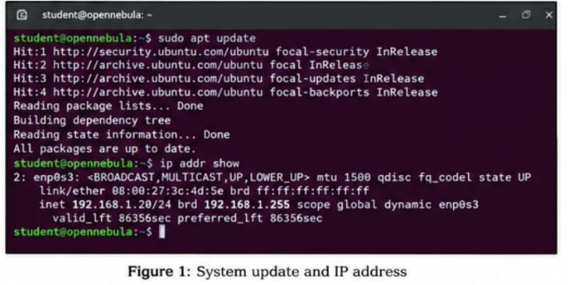

STEP 2 : Download and run the miniONE installer.
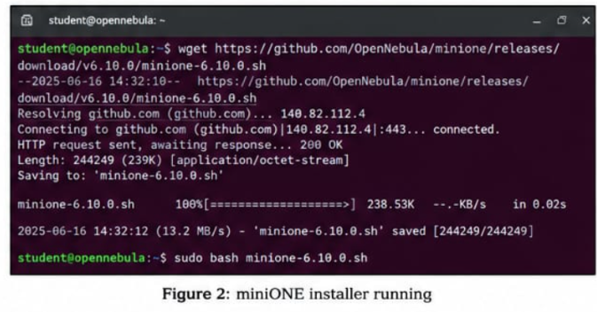

STEP 3 : Wait for installation to finish and note the Sunstone URL , username(oneadmin) and password.
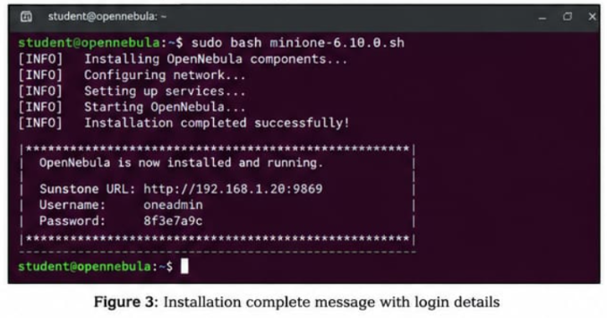

STEP 4 :
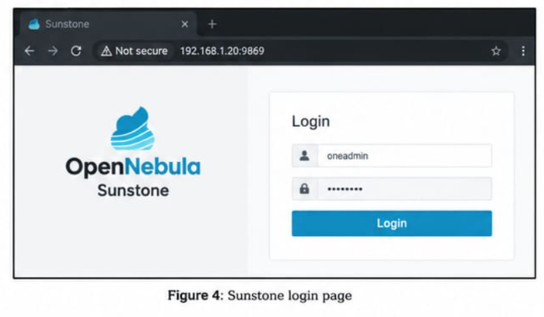

STEP 5 : Infrastrusture -> Hosts(showing the available hosts)



