DATABASE SYSTEMS LABORATORY WORK - 1
Part 1: Task 1.1
Relation A: Employee
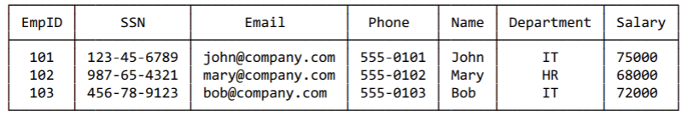
- 6 different superkeys: EmpId, SSN, Email, (EmpId, Name), (SSN, Email).
- all candidate keys: EmpId, SSN, Email, Phone.
- Primary key: EmpId
EmpId is the ideal choice for a primary key because it is a surrogate numerical identifier. Unlike options like SSN, it does not contain sensitive personal data and provides immutability, as it is issued once and never changes over time.
4)Under the current setup, no, they cannot. Each employee in the provided data has a unique phone number, meaning the Phone column uniquely identifies each row and qualifies as a candidate key.
Relation B: Course Registration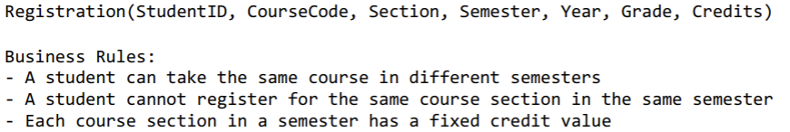
1)Minimum attributes for the primary key: StudentId, CourseCode, Section, Semester, Year
2)StudentID:Uniquely identifies which student is registering for the course.
CourseCode and Section: Specify the exact course and class section the student attends.
Semester and Year: Necessary because the business rules state that a student can take.The same course in different semesters. Without both attributes, the database would prevent a student from retaking a course non -unique records.
Summary: Removing any single attribute from this 5-column composite key breaks the business rules or creates non-unique records.
- Additional Candidate Keys:There are no additional candidate keys in this table because the Grade and Credits attributes are not unique and depend on the registration record itself.
Task 1.2
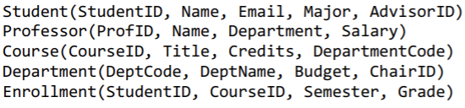
- Student – Professor
Foreign Key: Student.AdvisorID references Professor.ProfID
Links a student to their assigned faculty advisor.
- Department – Professor
Foreign Key: Department.ChairID references Professor.ProfID
Links an academic department to the professor serving as department chair.
- Course – Department
Foreign Key: Course.DepartmentCode references Department.DeptCode
Connects a course to the department that offers it.
- Enrollment – Student
Foreign Key: Enrollment.StudentID references Student.StudentID
Identifies which student is enrolled in a class.
- Enrollment – Course
Foreign Key: Enrollment.CourseID references Course.CourseID
Identifies which course the student is taking.

Part 2: ER DIAGRAM COSTRUCTION
Task 2.1 Hospital Management System
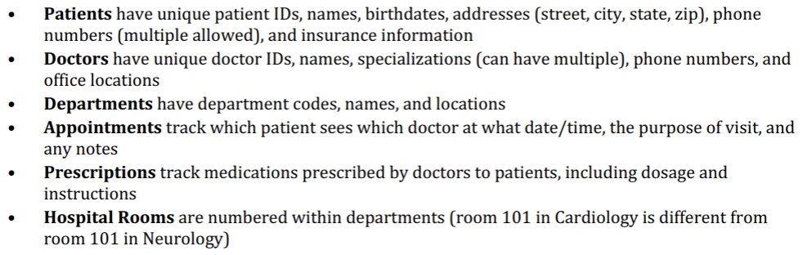
- Entity Classification:
Strong Entities: Patient, Doctor, Department.
Weak Entity: Room (depends on Department for unique identification).
Associative Entities: Appointment, Prescription (bridge M:N relationships between Patient and Doctor).
- Attribute Classification:
Patient: PatientID (Key), Name (Simple), Birthdate (Simple), Address (Composite: Street, City, State, Zip), Phone (Multi-valued), Insurance (Simple).
Doctor: DoctorID (Key), Name (Simple), Specialization (Multi-valued), Phone (Simple), OfficeLocation (Simple).
Department: DeptCode (Key), Name (Simple), Location (Simple).
Room: RoomNumber (Partial Key).
Appointment: DateTime (Simple), Purpose (Simple), Notes (Simple).
Prescription: Medication (Simple), Dosage (Simple), Instructions (Simple).

- Relationships and Cardinalities:
Department contains Room: $1:N$ (One department has many rooms).
Doctor belongs to Department: $N:1$ (Many doctors work in one department).
Patient schedules Appointment with Doctor: $M:N$ (A patient can have many appointments with many doctors).
Doctor prescribes Prescription to Patient: $M:N$ (A doctor can give multiple prescriptions to multiple patients).
4)
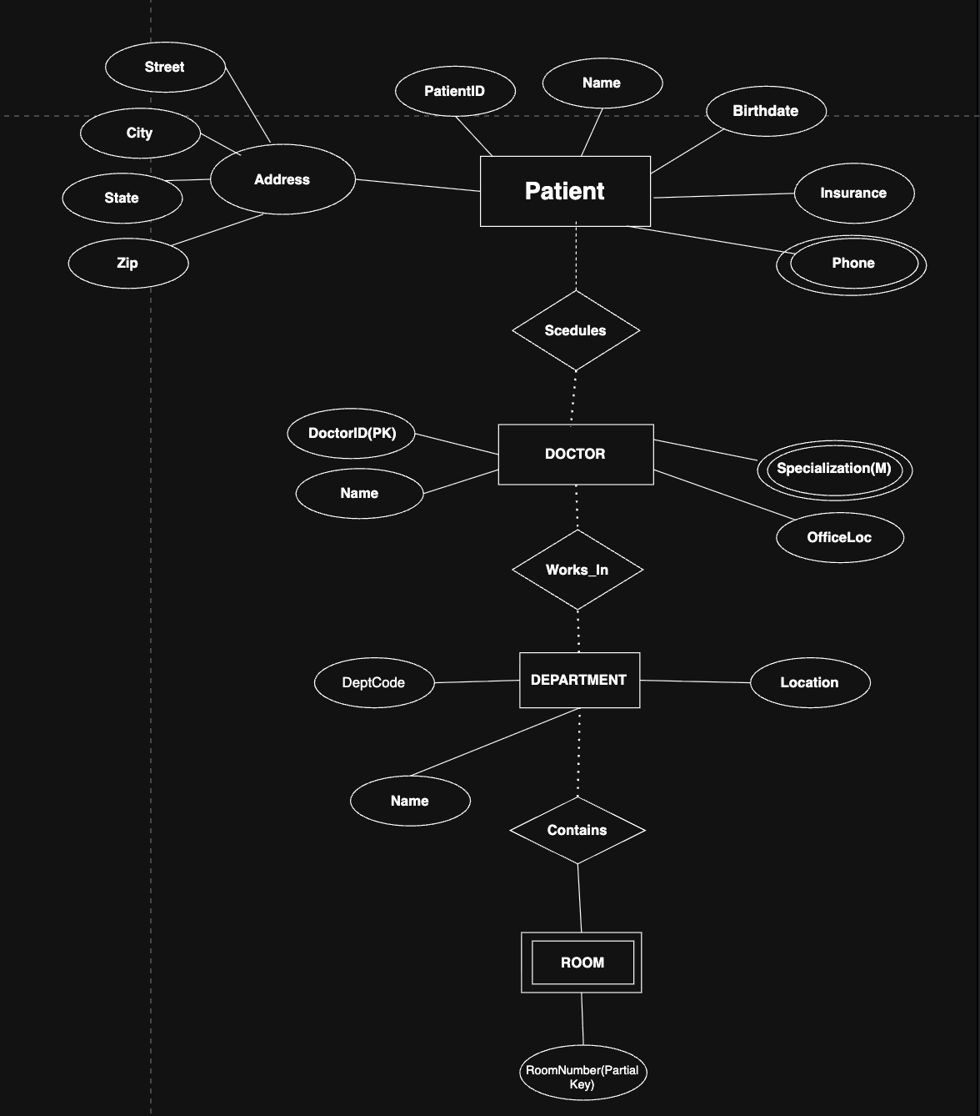
5)
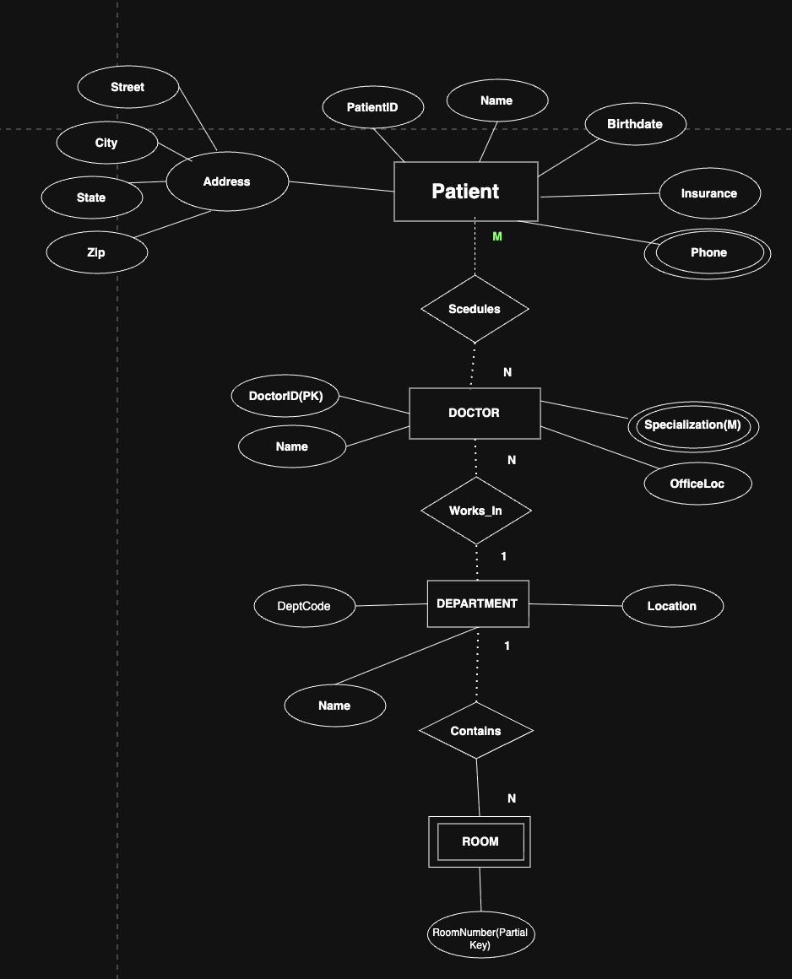

Task 2.2 E-commerce Platform
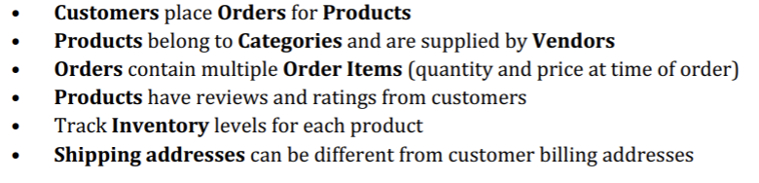
- Entities & Classifications
Strong Entities:
Customer (PK: CustomerID) Product (PK: ProductID) Category (PK: CategoryID)
Weak Entities / Sub-entities:
OrderItem (dependent on Order, PK: OrderID + orderItemID)
Associative / Transaction Entities:
Order (PK: OrderID) Payment (PK: PaymentID)
- Attribute Classifications
Customer:
CustomerID (Simple, Key)
Name (Simple)
Email (Simple, Unique)
ShippingAddress (Composite: Street, City, State, Zip)
Product:
ProductID (Simple, Key)
Name (Simple)
Price (Simple)
StockQuantity (Simple)
Category:
CategoryID (Simple, Key)
CategoryName (Simple)
Description (Simple)
Order:
OrderID (Simple, Key)
OrderDate (Simple)
Status (Simple)
TotalAmount (Derived)
OrderItem:
Quantity (Simple)
UnitPrice (Simple)
Payment:
PaymentID (Simple, Key)
PaymentDate (Simple)
PaymentMethod (Simple)
Amount (Simple)
- Relationships & Cardinalities
Customer places Order: $1:N$
A single customer can place multiple orders, but each order belongs to exactly one customer.
Order contains OrderItem: $1:N$ (Identifying / Weak Relationship)
An order contains one or more line items (OrderItem).
Product included in OrderItem: $1:N$
A product can appear in multiple order line items across different orders.
Category contains Product: $1:N$
A category can contain multiple products, while each product belongs to one primary category.
Order paid via Payment: $1:1$
Each order is processed with a single payment transaction.
4)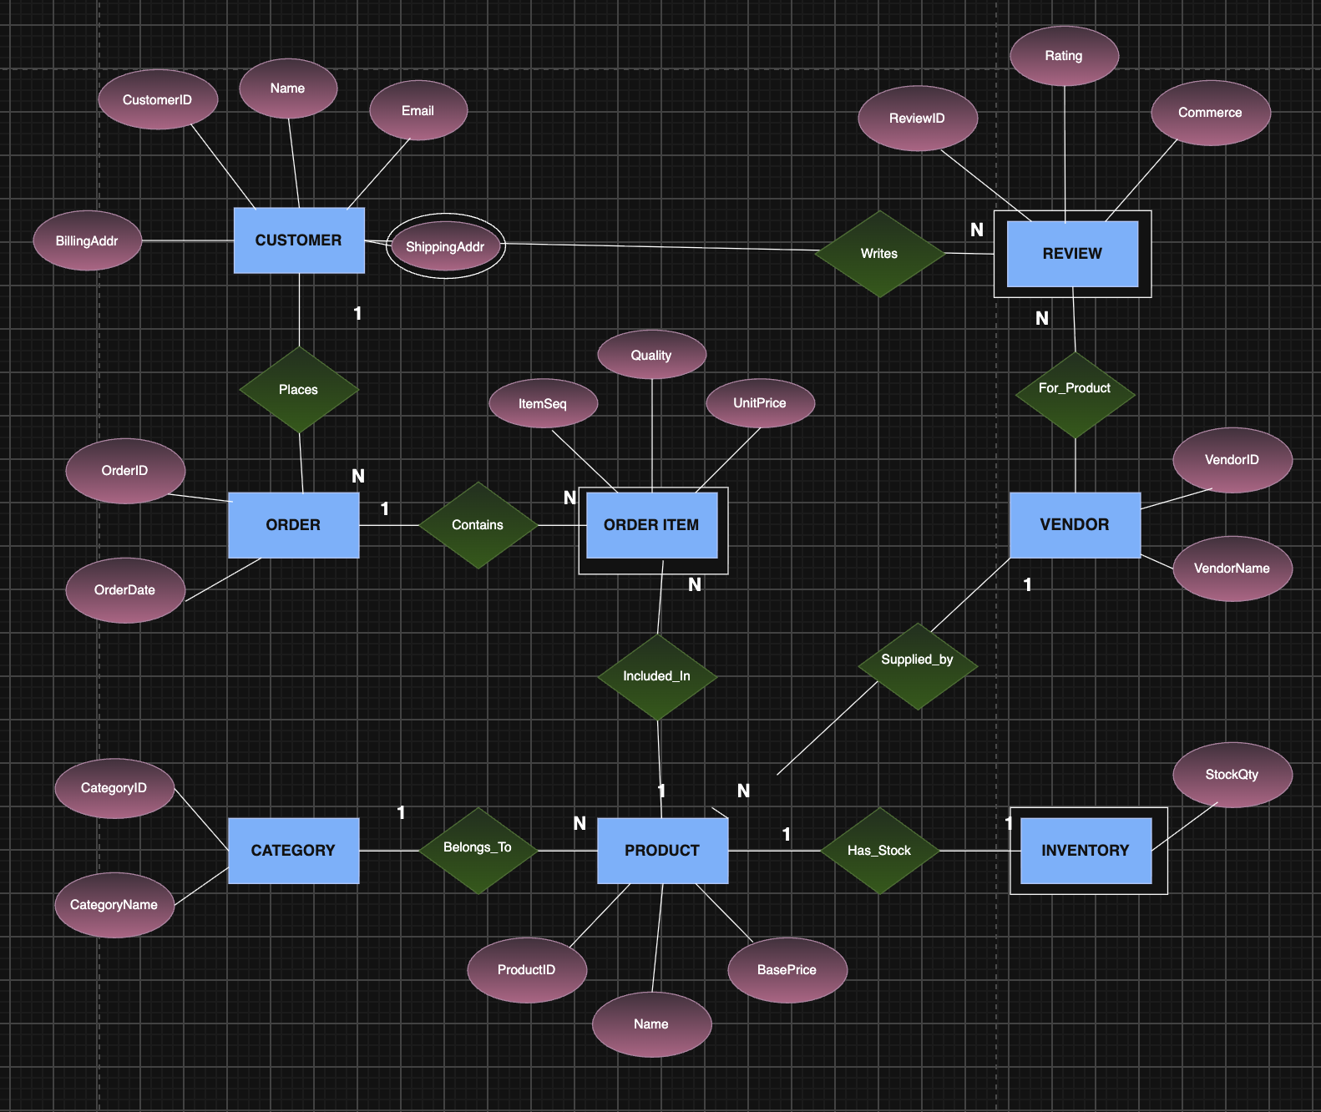
1) Entities and Attributes
Customer: CustomerID (PK), Name, Email, Phone
Address: addressid (PK), Street, City, State, Zip
Order: orderid (PK), orderdate, Status, totalamount
Order_item: orderitemid (PK), Quantity
Product: productid (PK), Name, Description, currentprice
Category: categoryid (PK), categoryname
Vendor: vendorid (PK), vendorname, contactinfo
Inventory: inventoryid (PK), stockquantity, reorderlevel
Review: reviewid (PK), Rating, Comment, reviewdate

2) Weak Entity and Justification
Weak Entity: ORDER_ITEM
Justification: An ORDER_ITEM cannot exist independently without a parent ORDER. It does not possess a primary key of its own (it relies on a composite key made of OrderID + ProductID, or a partial discriminator like LineNumber). If the parent ORDER is deleted from the database, all corresponding ORDER_ITEM records lose their context and must be deleted (identifying dependency).
3)Many-to-Many Relationship That Needs Attributes
Relationship: The $M:N$ relationship between ORDER and PRODUCT (resolved via the associative entity ORDER_ITEM).
Attributes Needed:
Quantity: Stores how many units of the product were purchased in that specific order.
PriceAtTimeOfOrder (or UnitPrice): Stores the actual price of the product when the order was placed. This is critical because the current price in the PRODUCT table may change over time, but the historical purchase price in the order must remain fixed.

PART 4: NORMALIZATION WORKSHOP

Task 4.1: Denormalized Table Analysis
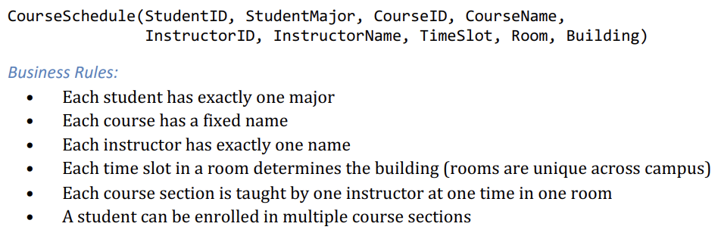
1) Identify Functional Dependencies (FDs)
StudentID $→$ StudentName, StudentMajor
ProjectID $→$ ProjectTitle, ProjectType, SupervisorID
SupervisorID $→$ SupervisorName, SupervisorDept
(StudentID, ProjectID) $→$ Role, HoursWorked, StartDate, EndDate

2) Identify Problems
Redundancy: StudentName and StudentMajor repeat for every project a student joins. ProjectTitle and Supervisor info repeat for every student working on the same project.
Update Anomaly: If a supervisor changes departments, every row where they supervise a project must be updated.
Insert Anomaly: You cannot add a new student who hasn't been assigned to a project yet because ProjectID is part of the primary key (PK cannot be NULL).
Delete Anomaly: If the only student working on a project leaves, deleting that row deletes all project and supervisor information.

3) Apply 1NF
1NF Violations: None (assuming all attributes contain atomic/single values and no repeating groups).
Fix: Ensure all attributes are atomic. Primary Key for StudentProject is composite: (StudentID, ProjectID)

4) Apply 2NF
Primary Key: (StudentID, ProjectID)
Partial Dependencies:
StudentID $→$ StudentName, StudentMajor
ProjectID $→$ ProjectTitle, ProjectType, SupervisorID, SupervisorName, SupervisorDept
2NF Decomposition:
Student (StudentID [PK], StudentName, StudentMajor)
Project (ProjectID [PK], ProjectTitle, ProjectType, SupervisorID, SupervisorName, SupervisorDept)
StudentProjectAssignment (StudentID [FK], ProjectID [FK], Role, HoursWorked, StartDate, EndDate)
PK: (StudentID, ProjectID)

5) Apply 3NF
Transitive Dependency: In the Project table: SupervisorID $→$ SupervisorName, SupervisorDept.
Final 3NF Decomposition:
Student (StudentID [PK], StudentName, StudentMajor)
Supervisor (SupervisorID [PK], SupervisorName, SupervisorDept)
Project (ProjectID [PK], ProjectTitle, ProjectType, SupervisorID [FK])
StudentProjectAssignment (StudentID [FK], ProjectID [FK], Role, HoursWorked, StartDate, EndDate)
PK: (StudentID, ProjectID)

TASK 4.2: ADVANCED NORMALIZATION

1) Determine the Primary Key
Primary Key: (StudentID, TimeSlot)

2) List All Functional Dependencies
StudentID $→$ StudentMajor
CourseID $→$ CourseName
InstructorID $→$ InstructorName
Room $→$ Building
(Room, TimeSlot) $→$ CourseID, InstructorID
(CourseID, TimeSlot) $→$ Room, InstructorID
(InstructorID, TimeSlot) $→$ Room

3. Check if in BCNF
Not in BCNF because left sides of functional dependencies like StudentID or Room are not candidate keys.

4. Decompose to BCNF
Student (StudentID [PK], StudentMajor)
Course (CourseID [PK], CourseName)
Instructor (InstructorID [PK], InstructorName)
RoomLocation (Room [PK], Building)
Section (SectionID [PK], CourseID [FK], InstructorID [FK], TimeSlot, Room [FK])
Enrollment (StudentID [FK], SectionID [FK])
PK: (StudentID, SectionID)

5. Explain Potential Loss of Information / Dependencies
Decomposing into BCNF guarantees lossless join, so no data is lost. However, there is a dependency preservation issue: cross-table constraint (Room, TimeSlot) determining a unique section requires checking multiple tables (Sectionand RoomLocation).

PART 5: DESIGN CHALLENGE
Task 5.1 PlantUML ER Diagram Code

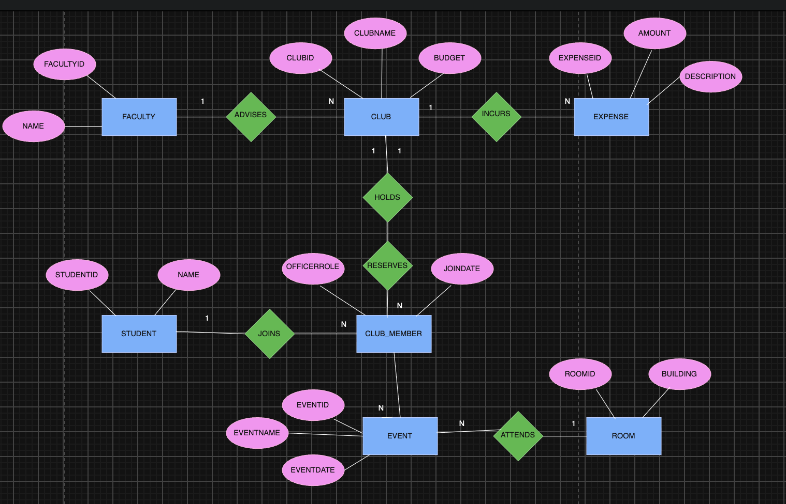

2) Normalized Relational Schema (3NF)
Student (StudentID [PK], StudentName, Email)
FacultyAdvisor (FacultyID [PK], FacultyName, Department)
Club (ClubID [PK], ClubName, Budget, FacultyID [FK])
ClubMember (StudentID [FK], ClubID [FK], OfficerRole, JoinDate)
PK: (StudentID, ClubID)
Room (RoomID [PK], Building, Capacity)
Event (EventID [PK], EventName, EventDate, ClubID [FK], RoomID [FK])
EventAttendance (StudentID [FK], EventID [FK], CheckInTime)
PK: (StudentID, EventID)
Expense (ExpenseID [PK], Amount, Description, ExpenseDate, ClubID [FK])

3) Design Decision
Decision: We merged the officer role into the ClubMember table using an OfficerRole attribute instead of making a separate Officer entity.
Justification: Every officer is fundamentally a club member. Storing OfficerRole directly in ClubMember simplifies the schema, avoids redundant joins, and makes it easy to update a student’s status when their role changes.

4) Example Supported Queries
"Find all students who currently hold officer positions in the Computer Science Club."
"List all upcoming events for next week with their assigned rooms and organizing clubs."
"Calculate the remaining balance for a club by deducting its total logged expenses from the allocated budget."

