Automation Framework And Report
By Ayesha Riaz

Application Tested:
OrangeHRM Demo Website
https://opensource-demo.orangehrmlive.com/

Project Description:
Focused on creating Automation Framework
The following tasks were performed:
- Organized automation scripts using a proper framework structure.
- Automated functional test cases and recorded execution results.
- Captured screenshots and prepared automation documentation.

Test Automation Framework & Reporting Report

Project Overview :
This project was created to organize Selenium WebDriver automation scripts into a simple automation framework.
The OrangeHRM Demo application was tested using Selenium with Python to automate basic functional test cases.

Automation Framework Structure
The project was organized into separate folders for better management:
- TestScripts: Contains automation scripts.
- Screenshots: Stores execution screenshots.
- TestData: Contains testing data.
- Reports: Stores final reports.
- Utilities: Contains reusable functions.

Test Scripts Organization
The automation scripts were separated from other project files to improve maintainability.
The following scripts were created:
- orangehrm_login.py
Used for automating login functionality and verifying successful login.
- failure_test.py
Used for testing failed login scenarios and capturing screenshots automatically.

Test Data
The test data was separated from automation scripts to make future updates easier.
Test data includes:
- Application: OrangeHRM Demo Website
- Username: Admin
- Password: admin123
- Employee information used for form submission testing

Reusable Functions
Reusable methods were created to reduce code repetition and improve script maintenance.
Common functions include:
- Opening website URLs
- Entering text into fields
- Clicking buttons
These functions can be reused in multiple automation scripts.

Automation Excecution Result

ScriptID | TestModule | ExecutionResult | Screenshot | Remarks
TC_001 | Login Test | Pass | Login_Failure.png (Failure Test Screenshot) | Login functionality verified successfully
TC_002 | Employee Form Submission | Pass | AddEmployeeForm.png | Employee form submitted successfully
TC_003 | Employee Save Verification | Pass | EmployeeSaved.png | Employee record saved successfully
TC_004 | Logout Test | Pass | No Screenshot | User logged out successfully
TC_005 | Failure Screenshot Test | Pass | Login_Failure.png | Screenshot captured automatically on test failure

Automation Execution Summary
Total Scripts Executed | Passed | Failed | Execution Status
5 | 5 | 0 | Completed Successfully

Automation Observations and Limitations
During the automation testing process, the following observations and limitations were identified:
- Selenium WebDriver successfully automated repetitive functional test cases and reduced manual testing effort.
- Automation scripts require maintenance if the application's user interface or element locators are changed.
- Test execution depends on browser configuration and proper WebDriver setup.
- Network issues may affect the execution of automation scripts.
- Captcha and some security-related features are difficult to automate using Selenium.

Source Code Screenshots
The following screenshots were captured from the automation project:

Automation Framework Folder structure:
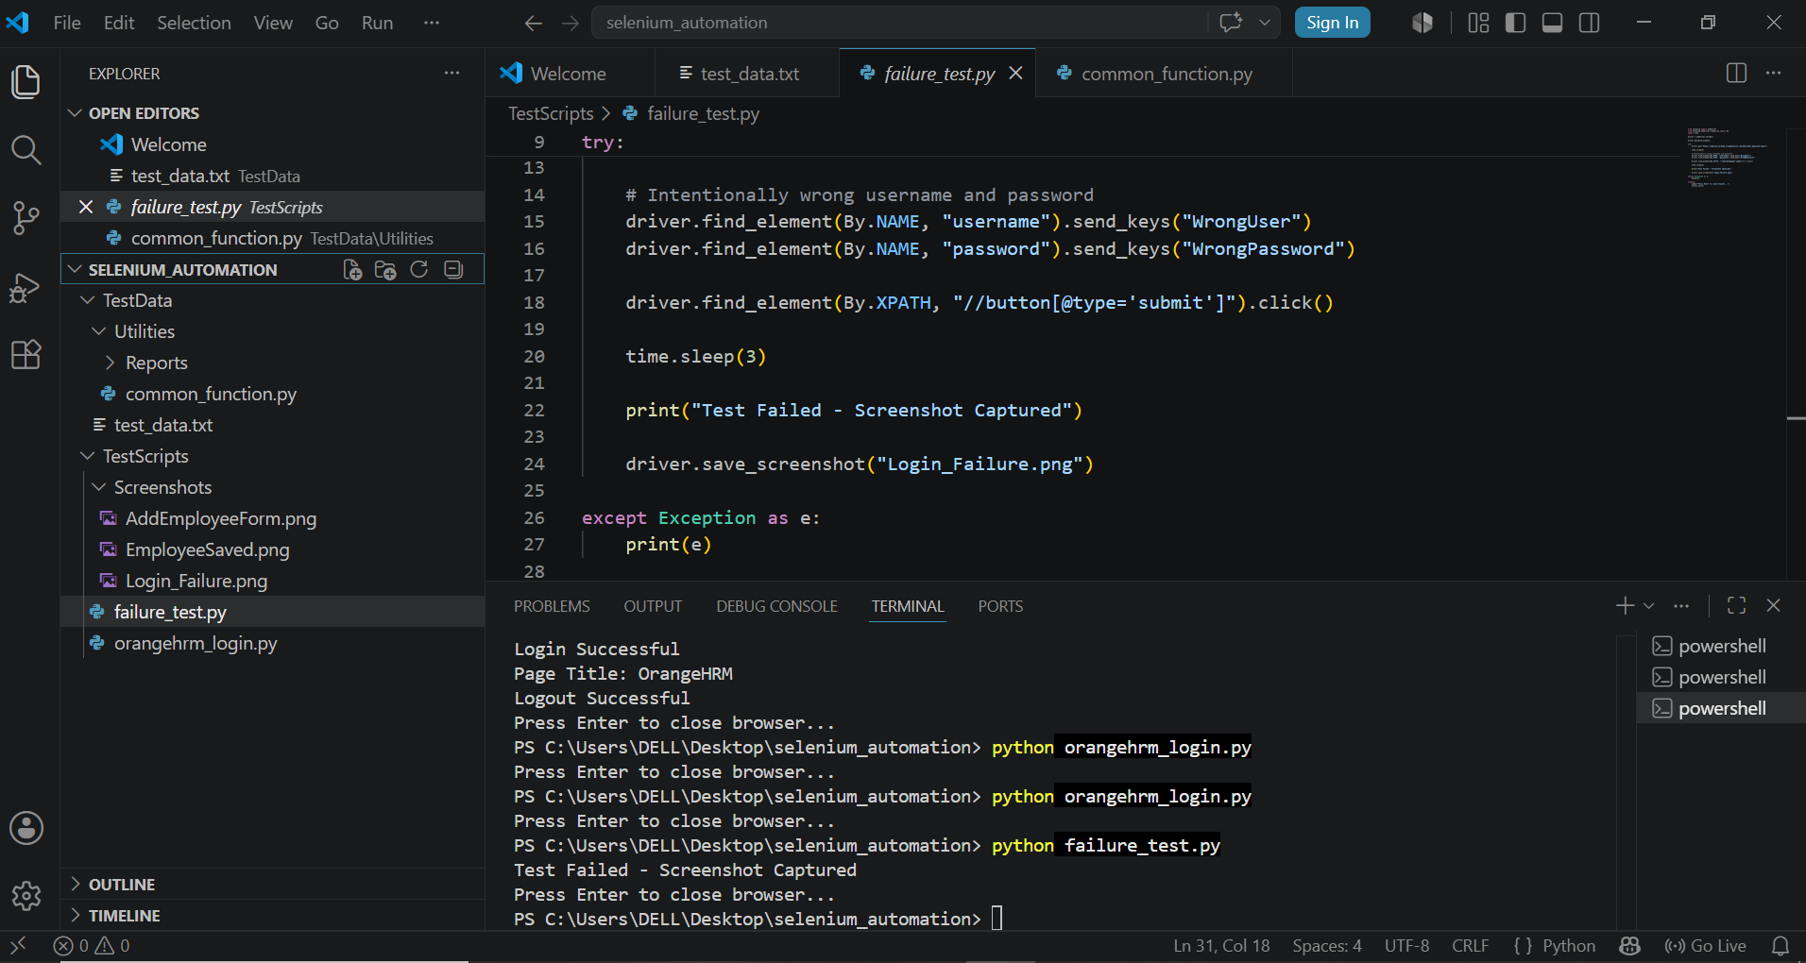

Reusable Functions Implementation
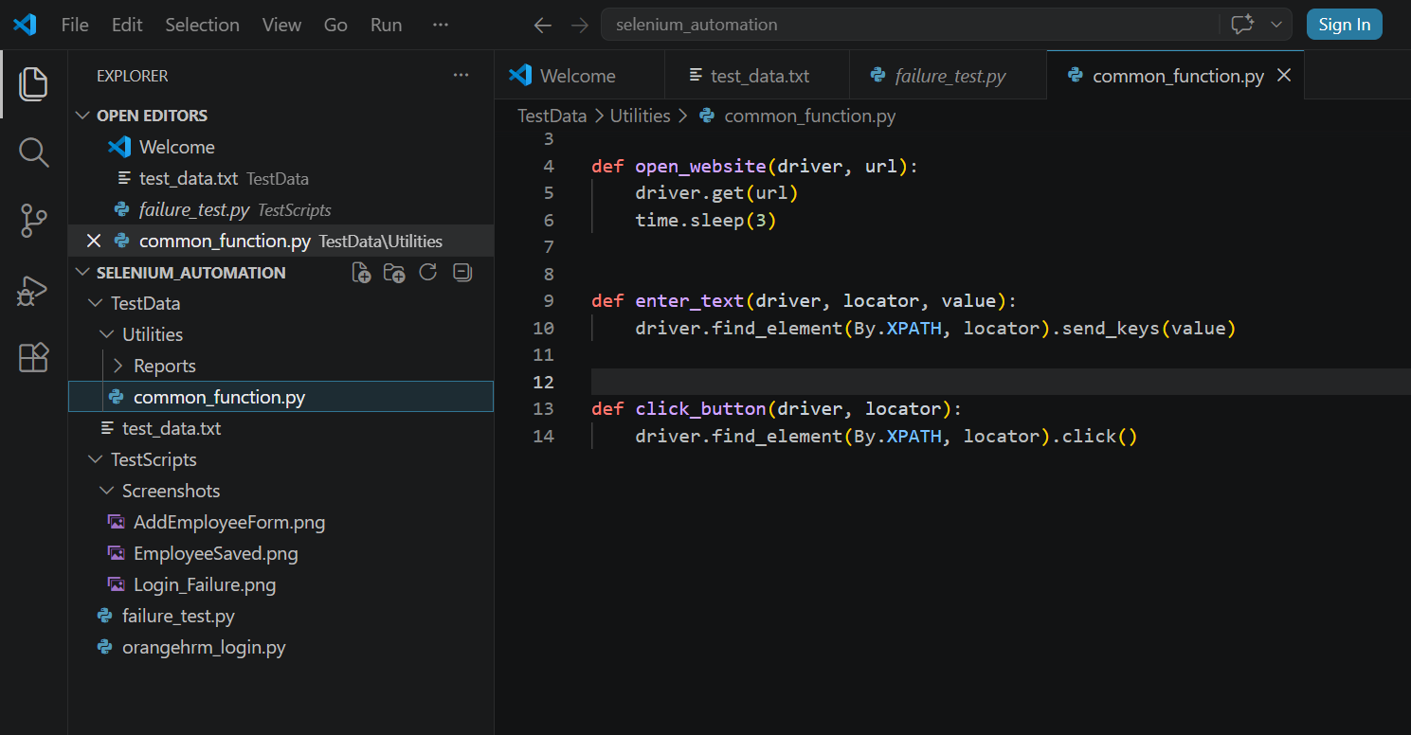
Test Script Code:
