Crop Disease Detection and Diagnosis System

|  |  |  |
| --- | --- | --- |
|  |  | |
| **Aayush Singh**  *Department of Computer Engineering* | **Deepanshu Sonparote**  *Department of Computer Engineering* | **Nitish Talekar**  *Department of Computer Engineering* |
| *Rajiv Gandhi Institute of Technology*  ***aayushipsingh@gmail.com*** | *Rajiv Gandhi Institute of Technology*  ***deepanshusonparote@gmail.com*** | *Rajiv Gandhi Institute of Technology*  ***nitishtalekar.nt503@gmail.com*** |

|  |  |  |
| --- | --- | --- |
|  | **Dilip S. Kale**  *Asst. Professor*  *Department of Computer Engineering*  *Rajiv Gandhi Institute of Technology* |  |

***Abstract* - The crop agriculture industry faces the economic losses due to the pest infections, bacterial or viral contagions, the farmers lose nearly 10-20% of the total profit on an average annually in India. This paper proposes a solution to the agricultural problem, which involves crop disease recognition by using machine learning and deep learning techniques. In this paper, the study sets out to classify cotton crop images into classes, whether the crop is infected by a disease or not. Also, we endeavour applications that give the farmer readily available means to identify the diseases on their crop and take appropriate damage control actions. The dataset used to train the model was user created (mobile capture images with high-resolution camera) from various crop farms. Cotton crops, of different varieties, containing three types of diseases, namely Rust, Mosaic Virus, Woolyaphids and Healthy plants are taken as classification ideals. The trained models have provided a performance reaching a 79.53% success rate in identifying the corresponding cotton plant disease. The model used in the study delivers significant accuracies of classification on the dataset used by employing Dense Neural Network techniques. The model is a very useful advisory or early warning tool for the farmers for identification of diseases in the early stage so that immediate action can be taken.**

***Keywords – Crop Disease Detection, Cotton plant leaf, Dense Neural Network, Image processing*.**

I. Introduction

Agriculture is the primary occupation in India. Crops are part and parcel of the agricultural industry. Nowadays, a tremendous loss in the quality and quantity of crop yield is observed, subject to various diseases in the plant. Crop Plant disease classification is a critical step, which can be useful in early detection of pest, insects, disease control, increase in productivity, among other examples. Farmers recognize disease manually with foregoing symptoms of plants, and with experts, whereas the actual diseases are hard to distinguish with naked eye, and it is time-consuming to predict whether the crop is healthy or not. Cotton is one of the major agricultural crops in India and it has a dominant impact on the overall Indian agriculture sector. Cotton plant leaf disease diagnosis is very difficult through simple observation. Due to complexity even experienced agronomists and plant pathologists often fail to successfully diagnose specific diseases and are consequently led to mistaken conclusions and treatments.

Our study helps to predict crop diseases in cotton plants by processing the images of the crop. For this, Image Processing techniques are used for fast, accurate and appropriate classification of diseases. Symptoms of diseases in cotton predominantly come out on leaves of plants. The existence of an automated system for the detection and diagnosis of plant diseases would offer a support system to the agronomist who is performing such diagnosis through observation of the leaves of infected plants.

The existing techniques for disease detection have utilized various image processing methods followed by varied classification techniques. Crop Yield Forecasting has been an area of interest for producers, agricultural-related organizations. Timely and accurate crop yield forecasts are essential for crop production. The proposed system uses an artificial neural network to classify the health of a cotton leaf plant.

The flow diagram of the proposed system given in Fig. 1. consists of steps used to acquire the desired output.

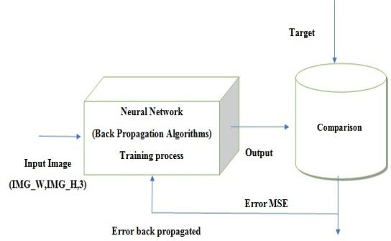

*Fig 1. Flow Diagram of Proposed System*

II. Methodology

*A. Input images*

For this initial process images of high resolution (4160 x 3120) are taken from datasets as input by setting IMG_W, IMG_H with 3 channels (RGB), for better visibility. The images are foremost pre-processed into a 4160 x 3120, RGB format with pixel values ranging from 0 to 255. The feature normalization used in the study is the min-max normalization. It is the ratio of the difference between the instance's feature value and the minimum value of a feature in the instance to the difference between the maximum and minimum values of features in the instance.

*B. Dataset*

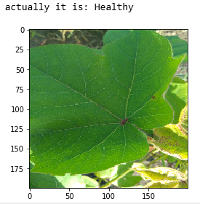 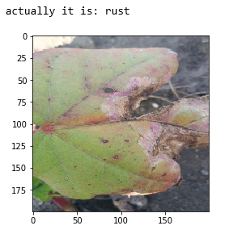

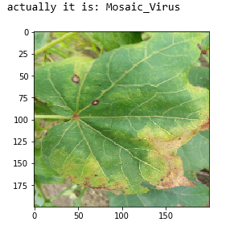 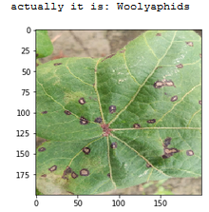

*Fig 2. Dataset Examples and their labels*

The dataset contains a total of 1676 images. This is constituted by 411 healthy plants images, 360 having the Mosaic virus, 431 plants being infected by Rust and 474 samples of plants having Woolly aphids. Table 2 shows the composition of dataset of leaf images with class name and the number of plant leaf samples.

|  |  |
| --- | --- |
| **Image Class** | **Number of Samples** |
| Healthy | 411 |
| Mosaic virus | 360 |
| Rust | 431 |
| Woolly aphids | 474 |
| Total | 1676 |

*Table 2. Amount of data samples per class*

*C. Feature Extraction*

The DNN classifier used is fed with features (pixels of image instances). DNN classifier has 5 hidden units with 100 nodes each and a 6th hidden unit with 50 nodes. The images are pre-processed through resizing. The images with given height, width and channels are fed to the DNN. ReLU (Rectified Linear Unit) activation function was used.

*D. Training and Testing*

The tensorflow framework is used for training and testing. The model which is employed is the DNN Classifier. The DNN Classifier which is created has a seven-layer neural network. The activation function, ReLU is used for each of the hidden layers and the SoftMax function used in the last layer. Gradient descent optimizer is used for optimization. The dataset is divided into a train test split of 70%-30%. Results are compared from the network and backpropogation is done based on errors.

E. *Web Application*

The web application is developed using Flask framework in python, wherein the user can upload crop leaf image. The DNN model used at the backend predicts the crop disease and displays it on the application. Along with disease detection, the application also provides information on precautionary measures that can be used on the given instance.

III. Literature Review

Crop Yield Forecasting has been an area of interest for producers, agricultural-related organizations. Timely and accurate crop yield forecasts are essential for crop production. The existing techniques for disease detection have utilized various image processing methods followed by various classification techniques. However, some unconventional approaches have led to classification of diseases using unconventional factors. Chopda et al. [1] proposes a system which can predict the cotton crop diseases using decision tree with the help of the parameters like temperature, soil moisture, etc. based on the previous year data and through sensors. However, these data might not be fully dependable to predict or classify diseases.

Image classification and regression techniques play a very important role because they allow identifying, grouping, and organizing from a standardized system. We apply an algorithm for image segmentation technique on data for automatic detection and classification of plant leaf diseases. In [2], Kamble defines the application of texture analysis for detecting plant diseases with the help of different image processing technique. Further with the use of Decision-Making Module, the disease is classified. Singh and Misra [8] suggest different disease classification techniques that can be used for plant leaf disease detection and an algorithm for image segmentation, the advantage of using this method is that the plant diseases can be identified at an early stage or the initial stage.

Deep learning is a set of learning methods attempting to model data with complex architectures combining multiple non-linear transformations. The element of deep learning is the neural networks that are combined to form the deep neural networks. These techniques have enabled significant progress in the fields of image processing and image classification. Kulkarni [3] formulates an application of Deep Convolutional Neural Network to identify and classify crop disease on images, testing it on five classes of crops and three types of diseases for each class. Mique Jr, Eusebio L [4] proposed an application that will help farmers in detecting rice insect pests and diseases using Convolutional Neural Network (CNN) and image processing. The searching and comparison of captured images to a stack of rice pest images was implemented using a model based on CNN. Collected images were pre-processed and were used in training the model.

There exist several types of architectures for neural networks:

1. The multilayer perceptions, that are the oldest and simplest ones,
2. The Convolutional Neural Networks (CNN), particularly adapted for image processing
3. The recurrent neural networks and dense neural network (DNN) used for sequential data such as text or times series.

A different approach is taken by Petrellis [6] where mobile phone application for plant disease diagnosis is presented which is based on the detection of the disease signature that is expressed as a number of rules that concern the color, the shape of the spots and historical weather data among other factors..

VI. Discussions and Results

The study was set out to classify if the crop is infected by a disease or is healthy. Fig 3. shows the Graphs of execution each hidden layer with a fraction of zero values (0-5 hidden layers)

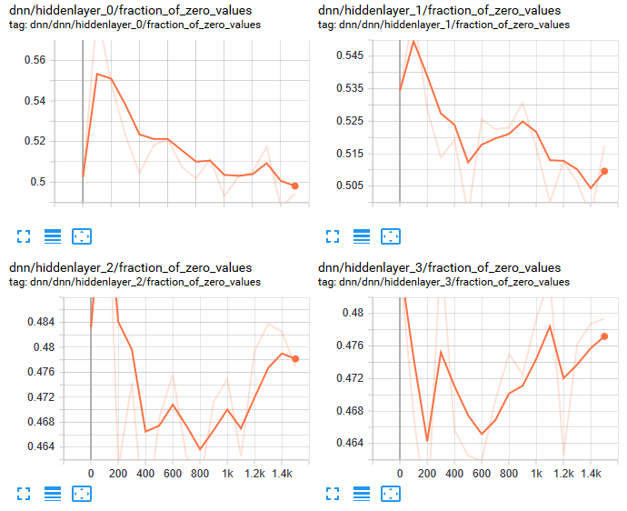

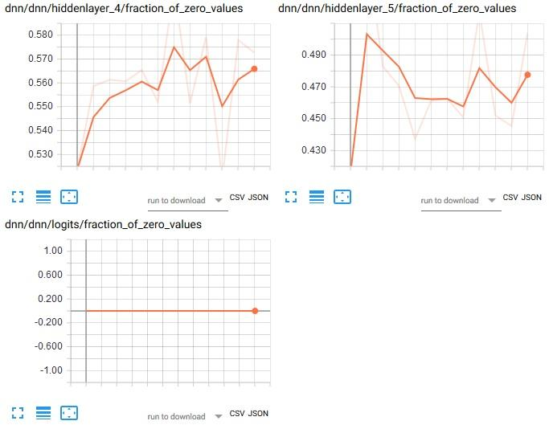

*Fig 3. Execution of different hidden layer with fraction of zero values.*

ReLu activation function is used for training the model. Fig. 4 shows the accuracy obtained using the ReLu activation function.

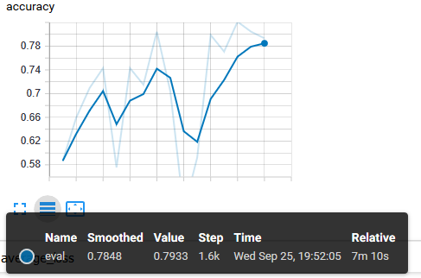

*Fig 4. Shows Line Plot of accuracy using Rectified Linear Activation function*

The training of the model produces a 79.53% accuracy as shown in Fig. 4. The average loss suffered during training period is displayed in Fig 5.

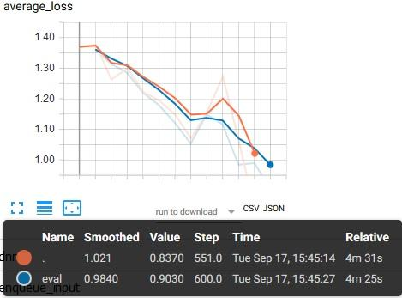

*Fig 5. Line Plot of average loss during training period*

Gradient descent algorithm is used as an optimization function to converge to the optimized classes quicker. The number of true values predicted correctly are represented as T, several false values predicted correctly are represented as F. The error was calculated using the error function mentioned.

$$Error = \left(\frac{F}{F+T}\right)* 100$$

The web application is developed with a simple GUI that helps the user identify crop disease by uploading the plant leaf image. Fig. 6 shows the user interface of the Web application. Fig.7 displays the working of the application and the produced output from the trained DNN model.

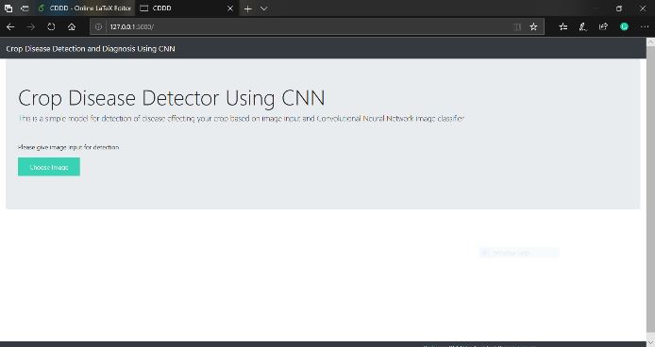

*Fig 6. Web Application interface*

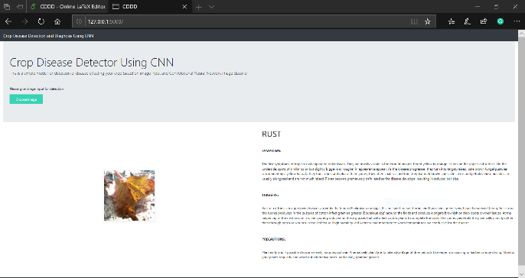

*Fig 6. Web Application output after upload*

VII. Conclusions and Future scope

In this paper, we have considered the cotton crop as it is the most important cash crop in India. Normally Rust, Mosaic virus and Wollyaphids are the hazardous diseases that the cotton crop suffers from in our country. Here, we consider a Dense Neural Network for crop disease recognition using leaf images for classification. There are several methods in computer vision for plant disease detection and classification process, but still, this research field is lacking. At present, there are no commercial solutions available in the market dealing with plant disease recognition based on the leaf images. We use a new approach of deep learning which automatically classifies and detect crop diseases from leaf images.

The data set of size 1676 images is collected from my farm with different diseases. The crop leaf images are considered for the training and testing purpose of the network. Initially, with the use of Gradient Descent and Back-Propagation algorithm classification are performed and it gives the prediction of diseases with 79.53% efficiency.

Furthermore, Convolution Neural Network (CNN) can be used for better classification accuracy. The main aim is to detect the crop leaf diseases from the database and train the images in such a way that the trained model gives the solution to farmers. The proposed model can recognize 11 different types of plant diseases. Here we consider plant stream and affected area by the disease boundaries, colour variation, size and shape of plant leaves.

The future work of this project is to develop a complete system consisting of server-side components containing a trained model and an application for smart mobile devices with features such as displaying recognized diseases in plants, based on leaf images captured by the mobile phone camera. This application will serve as an aid to farmers, enabling fast and efficient recognition of plant diseases and facilitating the decision-making process when it comes to the use of chemical pesticides.

References

1. Chopda, J., Raveshiya, H., Nakum, S. and Nakrani, V., 2018, January. Cotton Crop Disease Detection using Decision Tree Classifier. In 2018 International Conference on Smart City and Emerging Technology (ICSCET) (pp. 1-5). IEEE.
2. Kamble, J.K., 2018, February. Plant Disease Detector. In 2018 International Conference On Advances in Communication and Computing Technology (ICACCT) (pp. 97-101). IEEE.
3. Kulkarni, O., 2018, August. Crop Disease Detection Using Deep Learning. In 2018 Fourth International Conference on Computing Communication Control and Automation (ICCUBEA) (pp. 1-4). IEEE.
4. Mique Jr, E.L. and Palaoag, T.D., 2018, April. Rice Pest and Disease Detection Using Convolutional Neural Network. In Proceedings of the 2018 International Conference on Information Science and System (pp. 147-151). ACM.
5. Padol, P.B. and Yadav, A.A., 2016, June. SVM classifier based grape leaf disease detection. In 2016 Conference on advances in signal processing (CASP) (pp. 175-179). IEEE.
6. Petrellis, N., 2017, September. Mobile Application for Plant Disease Classification Based on Symptom Signatures. In Proceedings of the 21st Pan-Hellenic Conference on Informatics (p. 1). ACM.
7. Zeng, W., Li, M., Zhang, J., Chen, L., Fang, S. and Wang, J., 2018, October. High-Order Residual Convolutional Neural Network for Robust Crop Disease Recognition. In Proceedings of the 2nd International Conference on Computer Science and Application Engineering (p. 101). ACM.
8. Singh, V. and Misra, A.K., 2015, March. Detection of unhealthy region of plant leaves using image processing and genetic algorithm. In 2015 International Conference on Advances in Computer Engineering and Applications (pp. 1028-1032). IEEE.
9. Sardogan, M., Tuncer, A. and Ozen, Y., 2018, September. Plant leaf disease detection and classification based on CNN with LVQ algorithm. In 2018 3rd International Conference on Computer Science and Engineering (UBMK) (pp. 382-385). IEEE.