**Block diagram**

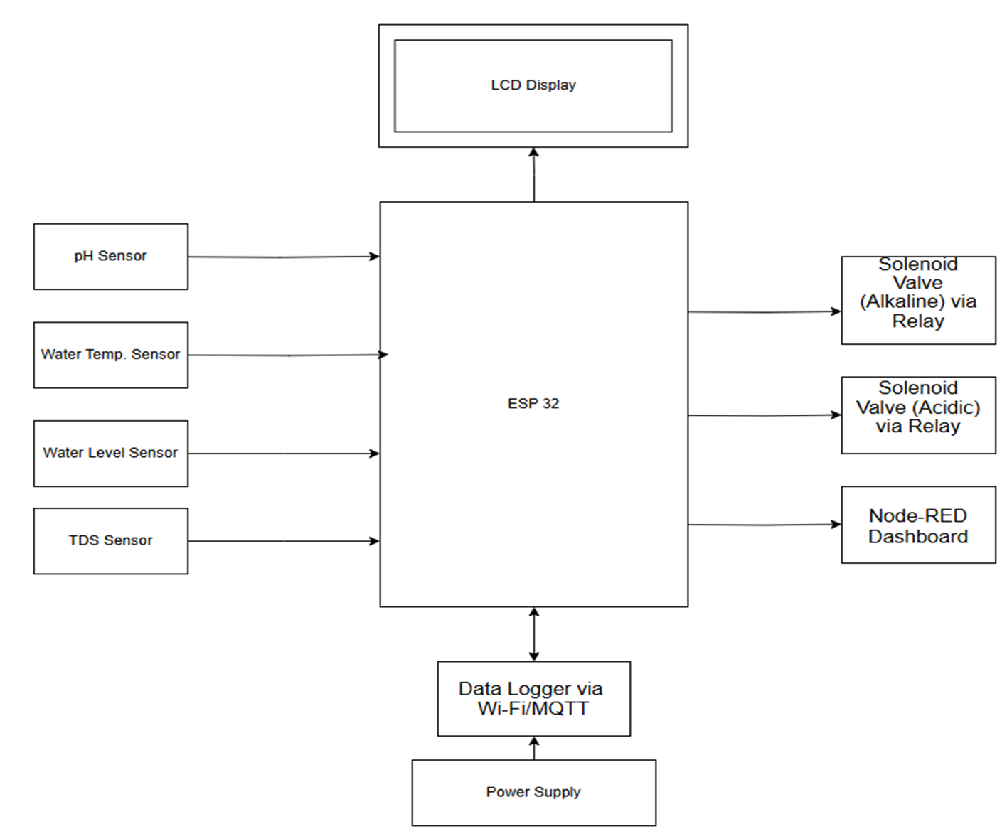

**Figure ‎1: Block Diagram for IoT and Actuators of Hydroponic system**

The system's functionality is represented by the block diagram below in Figure 1:

**1. Sensors**

* + Various sensors are used to monitor critical environmental and nutrient conditions:
    - pH Sensor: Tracks the acidity or alkalinity of the solution.
    - Water Temperature Sensor: Monitors the water's temperature for optimal plant growth.
    - Water Level Sensor: Detects the water level in the reservoir tank to prevent it from running dry.
    - TDS Sensor: Measure the nutrient concentration in water.
    - LCD: Output all sensor data.

**2. Microcontroller**

* + Acts as the central processing unit of the system. It collects data from all sensors and makes decisions based on predefined conditions.
  + Controls solenoid valves through relay modules to regulate pH levels.
  + Publishes sensor readings over Wi-Fi using the MQTT protocol for remote data logging.

**3. Actuators**

* + Solenoid Valve (Acidic) + Relay Driver: Dispenses acidic solution into the water tank when the pH level is too high.
  + Solenoid Valve (Alkaline) + Relay Driver: Dispenses alkaline solution into the water tank when the pH level is too low.

**4. Data Logger (via Wi-Fi/MQTT)**

* + Transmits sensor data to an external logging system or database using MQTT over Wi-Fi
  + Enables historical data tracking for analysis and troubleshooting.

**5. Node-RED Dashboard**

* + A graphical interface built using Node-RED displays real-time sensor values and system status.
  + Allows remote user access and system interaction via a web browser.

**6. Power Supply**

* + Provides the necessary energy to operate the microcontroller, sensors, and actuators.

### Summary:

This system integrates essential environmental and nutrient sensors with an ESP32 microcontroller to automate hydroponic water quality management. It controls pH levels using solenoid valves driven by relays and monitors nutrient strength with a TDS sensor. Real-time data is logged wirelessly via MQTT and visualized through a Node-RED dashboard, providing a smart, automated, and remotely accessible hydroponic farming solution.

**Context Diagram**

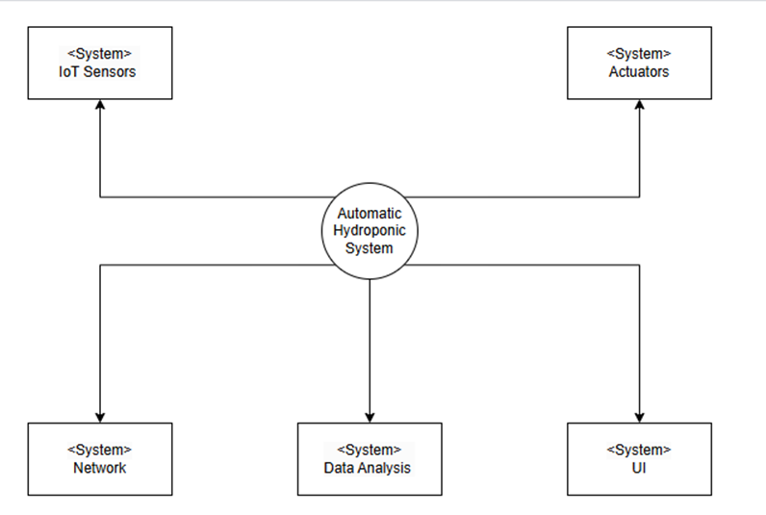

| **Figure ‎2: context diagram shows the structure of an Automatic Hydroponic System** |
| --- |

This context diagram in Figure 2 shows the structure of an Automatic Hydroponic System and how its different parts work together to create an efficient hydroponic farming setup. The central system connects and controls all the components, ensuring they communicate and function properly.

**1. IoT Sensors**

* + These sensors measure important factors like pH, temperature, tds, and water level in the hydroponic system. They send real-time data to the main system for monitoring.

**2. Actuators**

* + Actuators are devices that adjust things like pH level. Based on the sensor data, the system tells the actuators what to do to maintain the best conditions for plant growth.

**3. Network**

* + The network ensures that the sensors, actuators, and the main system are all connected and can share information without interruptions.

**4. Data Analysis**

* + This part analyzes the data from the sensors and figures out what actions need to be taken. For example, if the pH is too high, it will recommend adjustments to fix it automatically.

**5. User Interface (UI)**

* + The UI allows users to see the system’s data and control it remotely. It shows things like sensor readings and system performance while also letting users make changes if needed.

### How It All Works:

The Automatic Hydroponic System uses these components to create a smart, automated farming setup. The sensors collect data, the system analyses it, and the actuators make the necessary adjustments. The network keeps everything connected, and the UI makes it easy for users to interact with the system. This setup helps reduce manual work, improve efficiency, and ensures plants grow in the best conditions possible year-round.

**Flowchart Diagram**

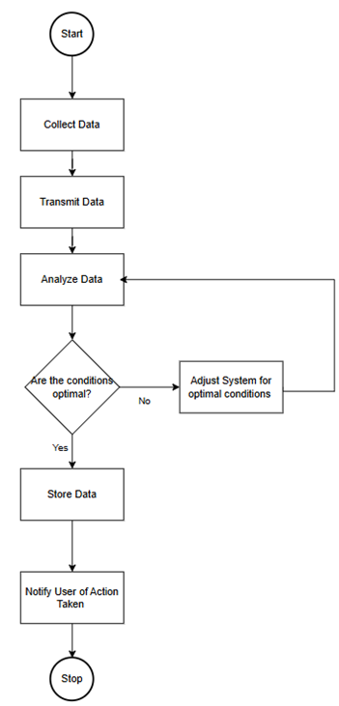

| **Figure ‎3:** Activity Diagram of an Automatic Hydroponic System. |
| --- |

The **Automatic Hydroponic System** is designed to automate the monitoring and management of essential parameters required for optimal plant growth in a hydroponic setup. The system integrates sensors, actuators, and IoT features to ensure that the hydroponic environment remains within desired conditions.

**Key Functions**

1. **Data Collection**:
   * Sensors continuously monitor parameters such as pH, nutrient levels, water temperature, and water level.
   * Data is captured in real-time to ensure accurate decision-making.
2. **Data Transmission**:
   * Collected data is transmitted to a microcontroller or central processing unit for further analysis.
   * Wireless communication can be utilized to send data to a cloud server for remote monitoring.
3. **Data Analysis**:
   * The system compares the collected data against predefined optimal thresholds for each parameter.
   * A decision is made whether the conditions are optimal or require adjustments.
4. **Condition Adjustment**:
   * If conditions deviate from optimal ranges, the system activates the necessary actuators:
     + **Solenoid Valve (Acidic) + Relay Driver**: Dispenses acidic solution into the water tank when the pH level is too high.
     + **Solenoid Valve (Alkaline) + Relay Driver**: Dispenses alkaline solution into the water tank when the pH level is too low.
   * The system loops back to re-analyse the updated conditions.
5. **Data Storage and Notification**:
   * Data is stored locally or in the cloud for tracking system performance and historical analysis.
   * The user is notified of the system's status, including any adjustments made or alerts triggered.

**Workflow Description**

1. The system starts by **collecting data** from various sensors.
2. The data is **transmitted** to the processing unit for analysis.
3. The system **analyses** the data to check whether conditions are within optimal ranges.
   * If **optimal**, the system **stores the data** and **notifies the user** of the status.
   * If **not optimal**, the system **adjusts parameters** by activating relevant actuators.
4. After adjustments, the system loops back to re-analyse the conditions, ensuring a continuous feedback cycle.

**Benefits of the System**

* Ensures optimal growing conditions for plants, improving growth rates and yields.
* Reduces manual labour by automating monitoring and adjustments.
* Provides real-time data and notifications, enhancing user control and decision-making.