1.Soru

index.html:

<!DOCTYPE html>

<html>

<head>

<title>1.soru</title>

</head>

<body>

<script src="script.js"></script>

</body>

</html>

script.js:

let a = 2;

let b = 3;

let c = 2;

console.log(a == b);

Çıktısı:

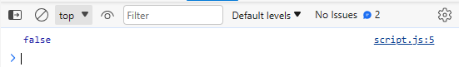

2.soru:

index.html:

<!DOCTYPE html>

<html>

<head>

<title>2.soru</title>

</head>

<body>

<script src="script.js"></script>

</body>

</html>

script.js:

let a = 2;

let b = 3;

let c = 2;

console.log(a == c);

Çıktısı:

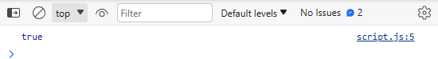

3.Soru:

index.html:

<!DOCTYPE html>

<html>

<head>

<title>3.soru</title>

</head>

<body>

<script src="script.js"></script>

</body>

</html>

script.js:

console.log(typeof "John Doe");

console.log(typeof 3.14);

console.log(typeof true);

console.log(typeof 234567890123456789012345678901234567890n);

console.log(typeof undefined);

console.log(typeof null);

console.log(typeof Symbol('symbol'));

Çıktısı:

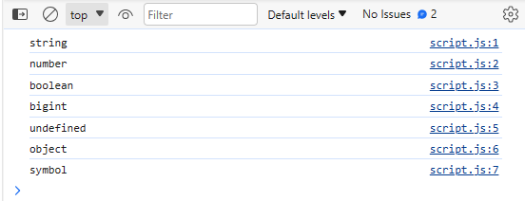

4.Soru:

index.html:

<!DOCTYPE html>

<html>

<head>

<title>4.soru</title>

</head>

<body>

<script src="script.js"></script>

</body>

</html>

script.js:

let x = 2;

let y = "2";

console.log(x == y);

console.log(x === y);

Çıktısı:

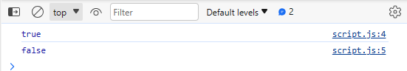

5.Soru:

index.html:

<!DOCTYPE html>

<html>

<head>

<title>5.soru</title>

</head>

<body>

<script src="script.js"></script>

</body>

</html>

script.js:

let x = 3;

let y = "3";

console.log(x + y);

Çıktısı:

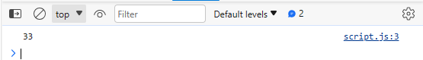

6.Soru:

index.html:

<!DOCTYPE html>

<html>

<head>

<title>6.soru</title>

</head>

<body>

<script src="script.js"></script>

</body>

</html>

script.js:

let x = 24;

let y = "Hello";

console.log(x + y);

Çıktısı:

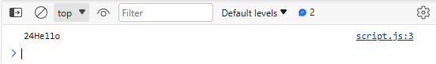

7.Soru:

index.html:

<!DOCTYPE html>

<html>

<head>

<title>7.soru</title>

</head>

<body>

<script src="script.js"></script>

</body>

</html>

script.js:

let name = "Vivek";

let surname = " Bisht";

console.log(name + surname);

Çıktısı:

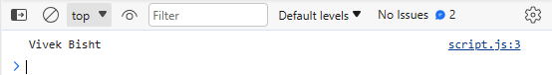

8.Soru:

index.html:

<!DOCTYPE html>

<html>

<head>

<title>8.soru</title>

</head>

<body>

<script src="script.js"></script>

</body>

</html>

script.js:

let x = 3;

let y = "3";

console.log(x - y);

Çıktısı:

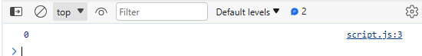

9.Soru:

index.html:

<!DOCTYPE html>

<html>

<head>

<title>9.soru</title>

</head>

<body>

<script src="script.js"></script>

</body>

</html>

script.js:

let x = 0;

let y = 23;

if (x) { console.log(x) }

if (y) { console.log(y) }

Çıktısı:

(ilk kod bir şey yazdırmaz çünkü x=0 )

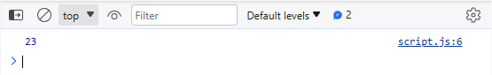

10.Soru:

index.html:

<!DOCTYPE html>

<html>

<head>

<title>10.soru</title>

</head>

<body>

<script src="script.js"></script>

</body>

</html>

script.js:

console.log(isNaN("Hello"));

console.log(isNaN(345));

console.log(isNaN('1'));

console.log(isNaN(true));

console.log(isNaN(false));

console.log(isNaN(undefined));

Çıktısı:

