MIRA
System Documentation
Consolidated, current-state reference — covers all six pipeline phases, the desktop app, and bilingual voice reporting.

1. What MIRA Is
MIRA is a local, offline-first facial health observation tool. A person takes a photo through a desktop app; the pipeline detects the face, extracts specific regions (eyes, skin, lips, mouth), scores each region against a set of tunable thresholds, and turns those scores into plain-language findings. Those findings are written out as four kinds of report — a raw metrics file, a clinical-style doctor report, a friendly user report, and a spoken-language script — available in English or Hindi. Every session is saved to a per-patient folder so the same person's readings can be compared over time.
This document covers the system as it exists today. It intentionally does not repeat the constant-by-constant threshold tables (see thresholds_documentation.docx) or the feature-export schema (see feature_vector_export_docs.docx) — both of those remain the authoritative reference for their topics. A separate MIRA_System_Audit.docx covers test results, the fairness audit, and what's still open.

1.1 Pipeline at a glance
Phase | Module(s) | What it does
Phase 1 | phase1_face_understanding/ | Detects the face and landmarks; computes symmetry, head alignment, and swelling indicators.
Phase 2 | phase2_region_extraction/ | Extracts eye, skin (forehead/cheeks/nose), lip, and mouth regions as pixel masks.
Phase 3 | phase3_feature_analysis/ | Scores each region (redness, texture, dryness, asymmetry, etc.) against thresholds.py.
Phase 4 | phase4_observation_engine/ | Converts scores into severity-labelled findings (mild / moderate / notable) and an overall verdict.
Phase 5 | phase5_report/ | Generates the metrics / doctor / user / TTS reports, in English or Hindi.
Phase 6 | phase6_feature_vector/ | Flattens every session into one row of a growing, ML-ready CSV dataset.
App layer | mira_app.py, history_window.py, trend_window.py | Desktop GUI: registration, capture, results, per-patient history, and trend charts.
Voice | piper_tts.py + Piper (external) | Local text-to-speech via the Piper engine, using bundled English and Hindi voice models.

2. Phase 1 — Face Detection & Landmarks
Face and landmark detection runs on MediaPipe's 468-point face mesh. Every downstream region (Phase 2) and geometry score (symmetry, head alignment, swelling) is derived from these landmark positions — nothing past this phase looks at raw pixels without going through a landmark-defined region first.
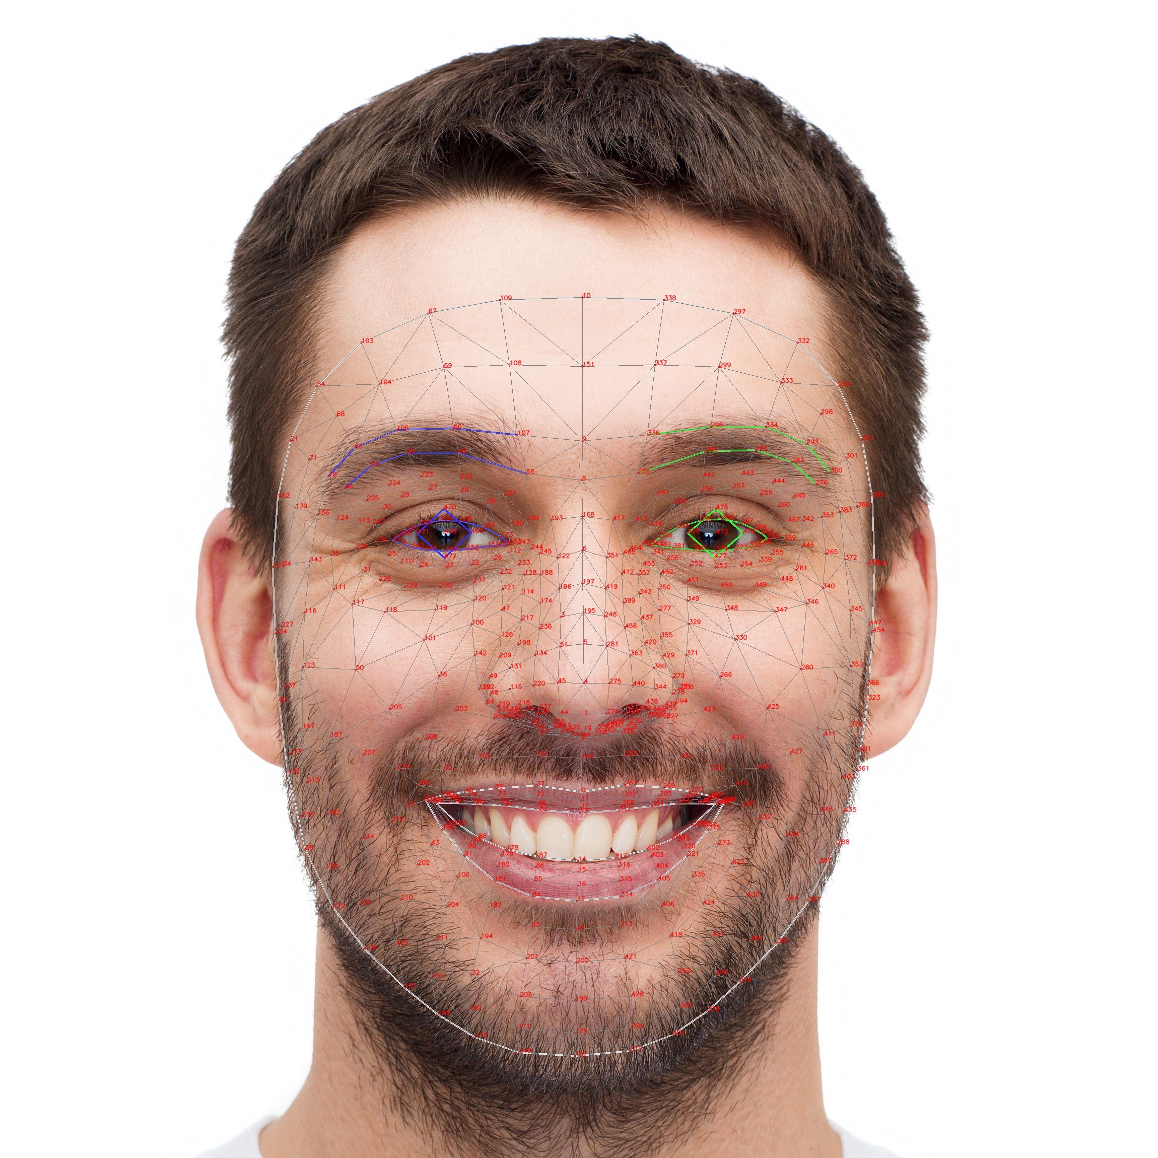
Figure 1. The 468-point MediaPipe face mesh MIRA's landmark detection is built on. Colored overlays mark the eye and eyebrow contours used by later phases.

Bug found & fixed — cheek points swapped
An earlier version of the region logic assigned the left- and right-cheek landmark sets to the wrong side of the face. Caught during live testing (a real photo produced a mirrored cheek-redness reading), and fixed by correcting the landmark index mapping.

Known limitations
- Detection assumes a single, mostly front-facing subject — not validated for multiple faces in one frame or extreme head angles.
- No liveness/spoof check — a photo of a photo would be processed the same as a live capture.

3. Phase 2 — Region Extraction
Turns landmark points into filled pixel masks for each region of interest, so Phase 3 can compute pixel-level statistics (color, texture, variance) only within the relevant area of the face.

Regions
- 6 direct regions — MediaPipe already defines a landmark connection group for these: left eye, right eye, left eyebrow, right eyebrow, lips, and the mouth interior.
- 4 derived regions — no MediaPipe group exists, so these are built from surrounding landmarks with percentile-based fallbacks: forehead, left cheek, right cheek, and chin/jaw.

Known issues
- Forehead region can be partly occluded by hair/fringe — affects downstream texture and redness readings for that region specifically; flagged, not yet corrected for.
- Cheek region can overlap the eye bounding box on some face shapes, which needs a tighter mask boundary.

4. Phase 3 — Feature Analysis
Computes the actual numeric scores. Every score follows the same shape: a raw pixel/landmark measurement is normalized against constants in thresholds.py into a 0–100 score.

Eyes
- Openness ratio (EAR) — the standard eye-aspect-ratio calculation (vertical eye landmark distances over horizontal).
- Redness score — relative red-channel dominance within the eye region.
- Dark circle score — reference luminance minus the mean luminance of the under-eye area.
- Puffiness score — pixel-intensity variance in the upper eye region.

Skin (forehead, both cheeks, nose)
- Redness score — same relative red-channel method as eye redness.
- Texture irregularity — variance of a Laplacian edge-detector pass over the region.
- Acne score / spot count — a Gaussian-blur pass estimates local skin variation to flag likely spots.
- Low-light flag — raised when the region's mean masked luminance falls below a threshold, so low-confidence readings are marked rather than reported as if clean.

Lips
- Dryness score — the same Laplacian-variance texture method used for skin.
- Color consistency — 100 minus the average per-channel standard deviation across lip pixels.
- Pallor score — inverse of mean HSV saturation across lip pixels.

Smile / mouth
- Mouth aspect ratio (MAR) — mouth width divided by mouth height.
- Corner asymmetry — vertical difference between the two mouth corners.
- Curvature score — how far the mouth corners sit above or below the midline.

Face
- Swelling score — ratio of cheek-point distance to eye-corner distance.

Bugs found during live testing
- Polygon edge artifact — nose texture and lip dryness both scored a flat 100/100 on certain captures; traced to the region polygon including a thin sliver of background pixels at the edge.
- Mouth aspect ratio 100/100 collision — a closed-mouth fallback path returned the same score as a genuinely wide-open mouth; fixed by separating the two cases explicitly.
- Forehead redness 57.7 — an oddly specific mid-range score traced to hair occlusion reducing the effective sample area rather than a real skin-redness signal; the low-light/occlusion flagging above was added partly in response to this.

5. Phase 4 — Observation Engine
Converts the Phase 3 numeric scores into severity-labelled findings (mild / moderate / notable) using the SeverityBand cut points defined in thresholds.py, then rolls every section's findings into one overall verdict.
- Face — one verdict each for symmetry, head tilt, proportion, and swelling.
- Eyes — dark circles, redness, and puffiness checked separately per eye.
- Skin — acne/spot count, texture, and redness checked separately per region (forehead, left cheek, right cheek, nose).
- Lips — dryness (also lighting-gated), color evenness, and pallor.
- Mouth shape — corner asymmetry and curvature, kept separate from the smile-detection use case.
- Overall — collects every finding across all sections, counts how many fall in each severity band, and produces the single spoken_label used in reports (“you're doing great” through “a few things stood out”).

6. Phase 5 — Report Generation
Every session produces four outputs from the same underlying Phase 1/3/4 results:
Report | What it is
Metrics Report | A flat JSON dump of every raw Phase 1 + Phase 3 score, for QA and downstream tooling — not meant for a person to read directly.
Doctor Report | A clinical PDF: full raw scores, per-metric severity, and the low-light/occlusion flags, formatted for a healthcare professional.
User Report | A friendly PDF for the person who submitted the photo — plain-language findings, no raw numbers.
TTS Report | A plain-text script, structured for a voice pipeline (greeting → section-by-section findings → closing), available in English or Hindi.

6.1 Hindi localization
The Hindi path (phase5_report/hindi_translation.py) is not a generic translator — it's a purpose-built, layered system for the fixed, template-driven vocabulary the TTS report is built from:
- Layer 1 — scaffold phrases: hand-translated fixed text (greeting, section intros, closings, the medical disclaimer).
- Layer 2 — connectors: the linking words used to string multiple findings together in one section.
- Layer 3 — dates: only the month name is localized; digits stay Latin, matching normal spoken/written Hindi convention.
- Layer 4 — structural templates: re-parses whole finding sentences and rebuilds them in correct Hindi word order (region → पर → finding), with gender-agreeing severity words, instead of swapping words in place inside English syntax.
- Layer 5 — word/phrase dictionary: fallback substitution for whatever vocabulary isn't covered by a structural template.
- Layer 6 — a scoped cleanup pass that collapses an accidental repeated noun, without touching genuine Hindi reduplication.
Bug fixed: a finding like “uneven skin texture” previously produced a doubled “त्वचा त्वचा”, because both the category word and the finding phrase were translated independently. Layer 4 fixes this by not re-translating the leading category word, since the section intro already establishes the topic.
Known limitation: Layer 5's word-substitution fallback means a genuinely novel finding sentence outside the template catalog can still come out as a Hindi/English mix rather than fluent Hindi. This degrades gracefully — nothing is dropped or garbled — but is not yet fully covered.

6.2 Voice synthesis (Piper TTS)
piper_tts.py wraps the local Piper binary. Three voice models are bundled: en_US-lessac-medium (verified, has a confirmed test.wav output), en_US-amy-medium, and hi_IN-priyamvada-medium, each with its matching .onnx.json config. An unavailable binary or missing model path degrades gracefully (TTSResult(success=False, source="unavailable")) rather than raising an error.
Integration gap: Piper itself is proven working standalone (lessac voice, verified test.wav). The desktop app's pipeline currently writes the TTS script as text only (tts_report_*.txt) — it does not yet call piper_tts.py automatically to produce the audio file as part of a normal session. Wiring that call in is the remaining step to make spoken reports work end-to-end from the GUI, not a synthesis problem.

7. Phase 6 — Feature Vector Export
Flattens Phase 1 + Phase 3 (and optionally Phase 4 confidence) into one flat, all-numeric CSV row per capture — the bridge from per-session analysis objects to an ML-ready training dataset. Full schema, column list, and design rationale are documented separately in feature_vector_export_docs.docx; the short version:
- 36 feature columns (identity, face geometry, eyes, skin, lips, mouth) plus one trailing metadata column (overall_confidence), kept separate since it's derived from the same scores rather than an independent signal.
- Missing regions are stored as empty cells, never zero-filled, so a missing capture can't be mistaken for a real “no signs” reading.
- Column order is fixed regardless of which regions were detected in a given capture, so the CSV is directly usable as a training matrix.

8. Desktop Application
mira_app.py is a Tkinter desktop app that wires the whole pipeline together for an end user, running the analysis as a subprocess and rendering each stage as its own screen: registration → capture guidelines → running/progress → results → history → trends.

Registration
Captures name and a patient ID, validates and normalizes both, and maintains a simple JSON registry (database/registry.json) mapping each patient to their own folder. Each session under that folder gets photos/, reports/, and a per-patient dataset.csv.

History & trends
An earlier version of this feature used a separate SQLite-backed history/trend package that no longer exists in this codebase. History and trends are now both read directly from the same per-patient dataset.csv that Phase 6 already writes — no separate database, no duplicate storage. history_window.py shows each past session as a card (photo, headline scores, a placeholder audio control since TTS audio isn't auto-generated yet — see 6.2); trend_window.py aggregates the same session data to plot one metric over time, reporting plain direction of change (up / down / roughly stable) without asserting whether that direction is clinically good or bad.

Known limitation
All of the above is unit-tested at the data layer, but no human has yet run a full click-through of the live GUI — registration through to viewing a trend chart — to confirm it renders and behaves correctly end to end.

9. Where to look for more detail
Topic | Document
Every threshold constant, its basis (calibrated vs. asserted), and priority for revalidation | thresholds_documentation.docx
Full CSV schema, column list, and training-data notes | feature_vector_export_docs.docx
Test results, fairness audit, maturity assessment, and outstanding work | MIRA_System_Audit.docx

