1.What are the two values of the Boolean data type? How do you write them?

=> Python Boolean type is one of the built-in data types provided by Python, which represents one of the two values i.e. True or False. Generally, it is used to represent the truth values of the expressions. For example, 1==1 is True whereas 2<1 is False.

2. What are the three different types of Boolean operators?

=> The three different types of Boolean operators are AND, OR , NOT

1. **AND** [**narrows**](https://apus.libanswers.com/faq/49916)a search by telling the database that **ALL keywords used must be found** in an article in order for it to appear in your results list. Search for two or more concepts that interest you by combining descriptive keywords with AND.
2. **OR** [**broadens**](https://apus.libanswers.com/faq/49885)a search by telling the database that any**of the words it connects are acceptable**. This is particularly helpful when you are searching for **synonyms**, such as “death penalty” OR “capital punishment.”
3. **NOT** [**narrows**](https://apus.libanswers.com/faq/49916) your search by telling the database to **eliminate all terms that follow it** from your search results

3. Make a list of each Boolean operator's truth tables (i.e. every possible combination of Boolean values for the operator and what it evaluate).

=> 1.AND

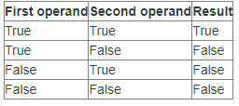

2.OR

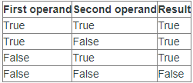

3.NOT

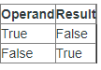

1. What are the values of the following expressions?

* (5 > 4) and (3 == 5)

=> False

* not (5 > 4) =>False
* (5 > 4) or (3 == 5) => True
* not ((5 > 4) or (3 == 5)) => False
* (True and True) and (True == False) => False
* (not False) or (not True) => True

1. What are the six comparison operators?

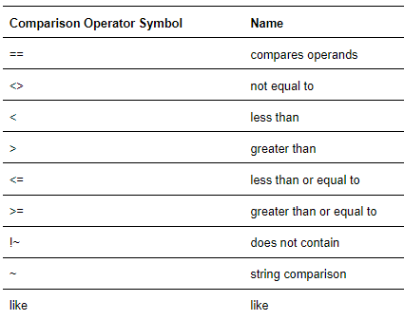

6. How do you tell the difference between the equal to and assignment operators? Describe a condition and when you would use one.

7. Identify the three blocks in this code:

spam = 0

if spam == 10:

print('eggs')

if spam > 5:

print('bacon')

else:

print('ham')

print('spam')

print('spam')

=> The three blocks are everything inside the if statement and the lines print('bacon') and print('ham').

spam = 0

if spam == 10:

print('eggs') # indent increased, block A

if spam > 5: # still block A

print('bacon') # still block A, indent increased, block B inside block A

else: # still block A, indent decreased, block B ended in line above

print('ham') # still block A, indent increased, block C inside block A

print('spam') # still block A, indent decreased, block C ended in line above

print('spam ’) # indent decreased, block A ended in line above

8. Write code that prints Hello if 1 is stored in spam, prints Howdy if 2 is stored in spam, and prints Greetings! if anything else is stored in spam.

=> spam = input()

if spam == 1:

print('Hello')

elif spam == 2:

print('Howdy')

else:

print('Greetings!')

9.If your programme is stuck in an endless loop, what keys you’ll press?

=> Press CTRL+C to stop a program stuck in an infinite loop.

10. How can you tell the difference between break and continue?

=> *The break statement will move the execution outside and just after a loop. The continue statement will move the execution to the start of the loop.

*whenever break statement executed then else block will not be executed whereas In continue ,all the time else block is executed.

11. In a for loop, what is the difference between range(10), range(0, 10), and range(0, 10, 1)?

=> The range(10) call ranges from 0 up to (but not including) 10 gives 10th output,

range(0, 10) explicitly tells the loop to start at 0, and

range(0, 10, 1) explicitly tells the loop to increase the variable by 1 on each iteration.

12. Write a short program that prints the numbers 1 to 10 using a for loop. Then write an equivalent pr ogram that prints the numbers 1 to 10 using a while loop.

=> FOR

**for** i **in** range(1, 11):

print(i)

1

2

3

4

5

6

7

8

9

10

WHILE

i **=** 1

**while** i **<=** 10:

print(i)

i **=** i **+** 1

1

2

3

4

5

6

7

8

9

10

13. If you had a function named bacon() inside a module named spam, how would you call it after importing spam?

=> This function can be called with spam.bacon().