1. Add the current date to the text file today.txt as a string.

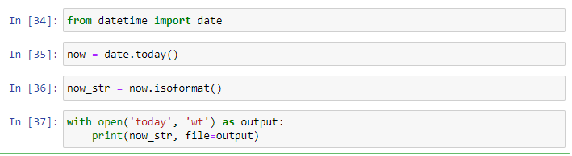

1. Read the text file today.txt into the string today_string

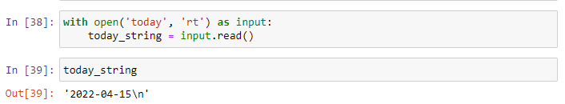

1. Parse the date from today_string.



datetime.strptime(today_string, fmt)

1. List the files in your current directory

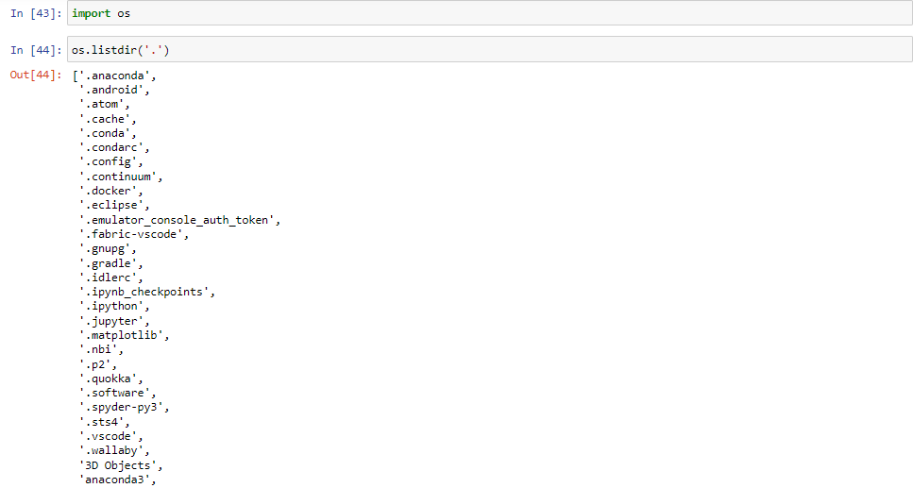

1. Create a list of all of the files in your parent directory (minimum five files should be available).



1. Use multiprocessing to create three separate processes. Make each one wait a random number of seconds between one and five, print the current time, and then exit.

import multiprocessing

def now(seconds): from datetime import datetime from time import sleep sleep(seconds) print('wait', seconds, 'seconds, time is', datetime.utcnow())

if **name** == '**main**': import random for n in range(3): seconds = random.random() proc = multiprocessing.Process(target=now, args=(seconds,)) proc.start()

1. Create a date object of your day of birth.

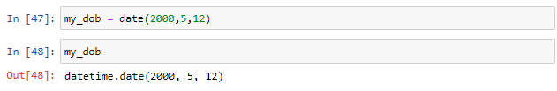

1. What day of the week was your day of birth?

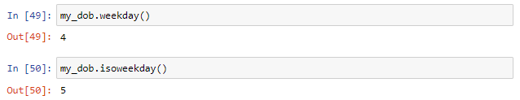

1. When will you be (or when were you) 10,000 days old?

