1. What is the result of the code, and explain?

>>> X = 'iNeuron'

>>> def func():

print(X)

>>> func()

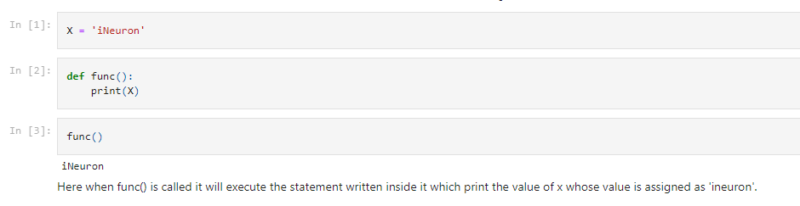

2. What is the result of the code, and explain?

>>> X = 'iNeuron'

>>> def func():

X = 'NI!'

>>> func()

>>> print(X)

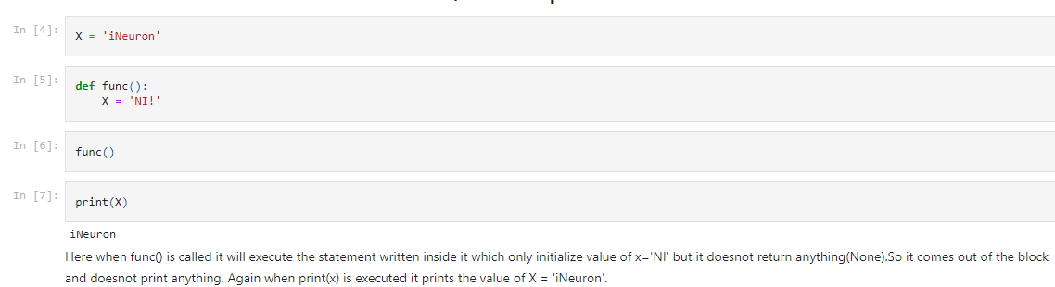

3. What does this code print, and why?

>>> X = 'iNeuron'

>>> def func():

X = 'NI'

print(X)

>>> func()

>>> print(X)

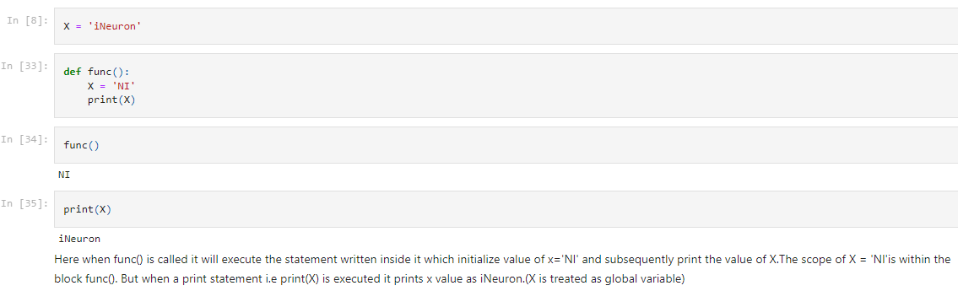

4. What output does this code produce? Why?

>>> X = 'iNeuron'

>>> def func():

global X

X = 'NI'

>>> func()

>>> print(X)

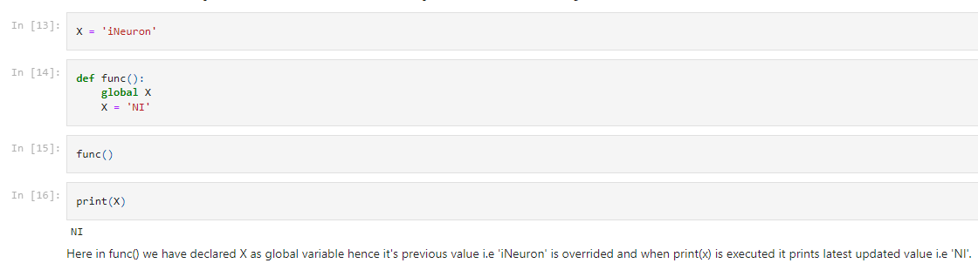

5. What about this code—what’s the output, and why?

>>> X = 'iNeuron'

>>> def func():

X = 'NI'

def nested():

print(X)

nested()

>>> func()

>>> X

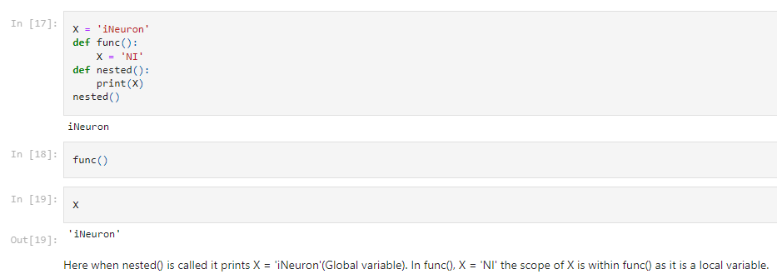

6. How about this code: what is its output in Python 3, and explain?

>>> def func():

X = 'NI'

def nested():

nonlocal X

X = 'Spam'

nested()

print(X)

>>> func()

