1. What is the result of the code, and why?

>>> def func(a, b=6, c=8):

print(a, b, c)

>>> func(1, 2)

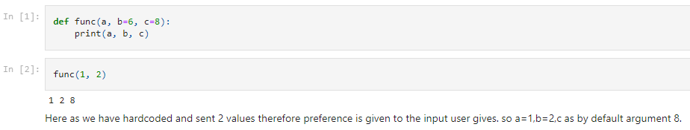

2. What is the result of this code, and why?

>>> def func(a, b, c=5):

print(a, b, c)

>>> func(1, c=3, b=2)

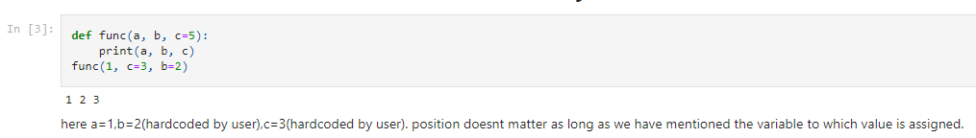

3. How about this code: what is its result, and why?

>>> def func(a, *pargs):

print(a, pargs)

>>> func(1, 2, 3)

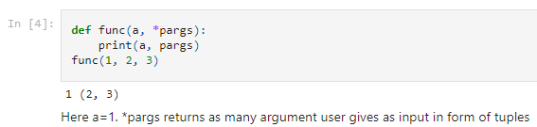

4. What does this code print, and why?

>>> def func(a, **kargs):

print(a, kargs)

>>> func(a=1, c=3, b=2)

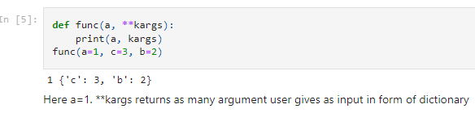

5. What gets printed by this, and explain?

>>> def func(a, b, c=8, d=5): print(a, b, c, d)

>>> func(1, *(5, 6))

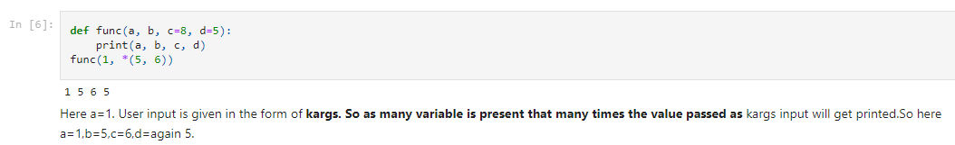

6. what is the result of this, and explain?

>>> def func(a, b, c): a = 2; b[0] = 'x'; c['a'] = 'y'

>>> l=1; m=[1]; n={'a':0}

>>> func(l, m, n)

>>> l, m, n

