1. What does an empty dictionary's code look like?

Just curly brackets: {}

1. What is the value of a dictionary value with the key 'foo' and the value 42?

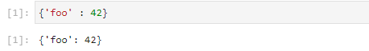

1. What is the most significant distinction between a dictionary and a list?

The items stored in a dictionary are unordered, while the items in a list are ordered.

1. What happens if you try to access spam['foo'] if spam is {'bar': 100}?

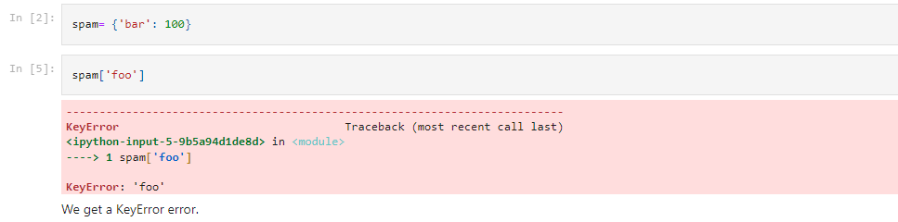

1. If a dictionary is stored in spam, what is the difference between the expressions 'cat' in spam and 'cat' in spam.keys()?

There is no difference. The in operator checks whether a value exists as a key in the dictionary.

1. If a dictionary is stored in spam, what is the difference between the expressions 'cat' in spam and 'cat' in spam.values()?

'cat' in spam checks whether there is a 'cat' key in the dictionary, while 'cat' in spam.values() checks whether there is a value 'cat' for one of the keys in spam.

7. What is a shortcut for the following code?

if 'color' not in spam:

spam['color'] = 'black'

if 'color' not in spam: spam['color'] = 'black'

spam.setdefault('color', 'black')

1. How do you "pretty print" dictionary values using which module and function?\

pprint.pprint()