Full Stack Development – Lab 2

Yoonhee Kim

101277278

Exercise 1.

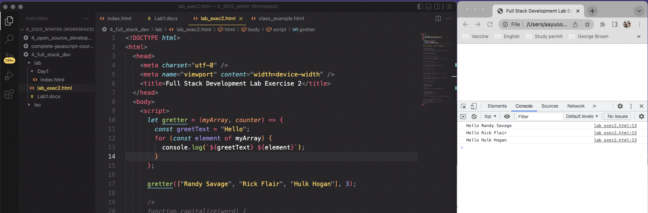

Exercise 2.

Exercise 3.

Exercise 4.

Exercise 5.

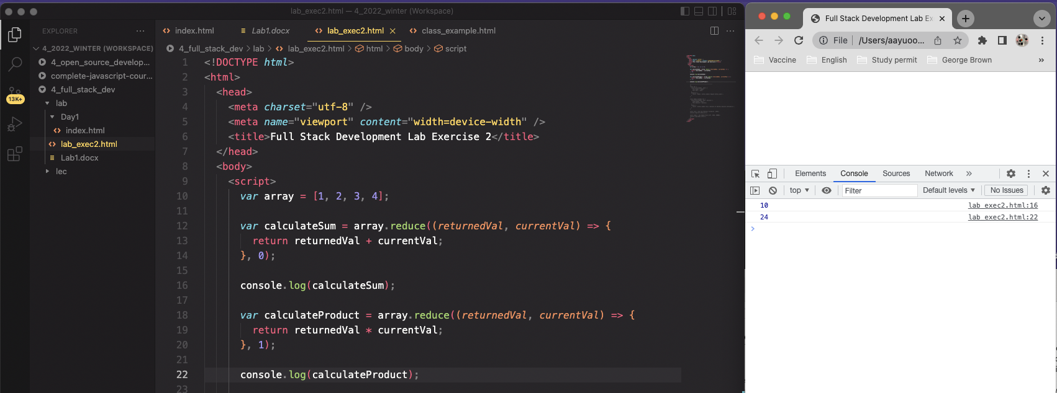

Exercise 6.

