List of window commands &

Their functions



Created by: Aayush Nihure

Student of BCS.IT (CS & NT)

Presented to: Er. Raj Sapkota

Head of the BCS.IT (CS & NT) Department

Name of college: Forbes College

Address: BNP-2, Chitwan

December 26, 2024

List of command and their functions:

1. appwiz.cpl: This command allows you to uninstall, change, or repair installed programs on your computer.

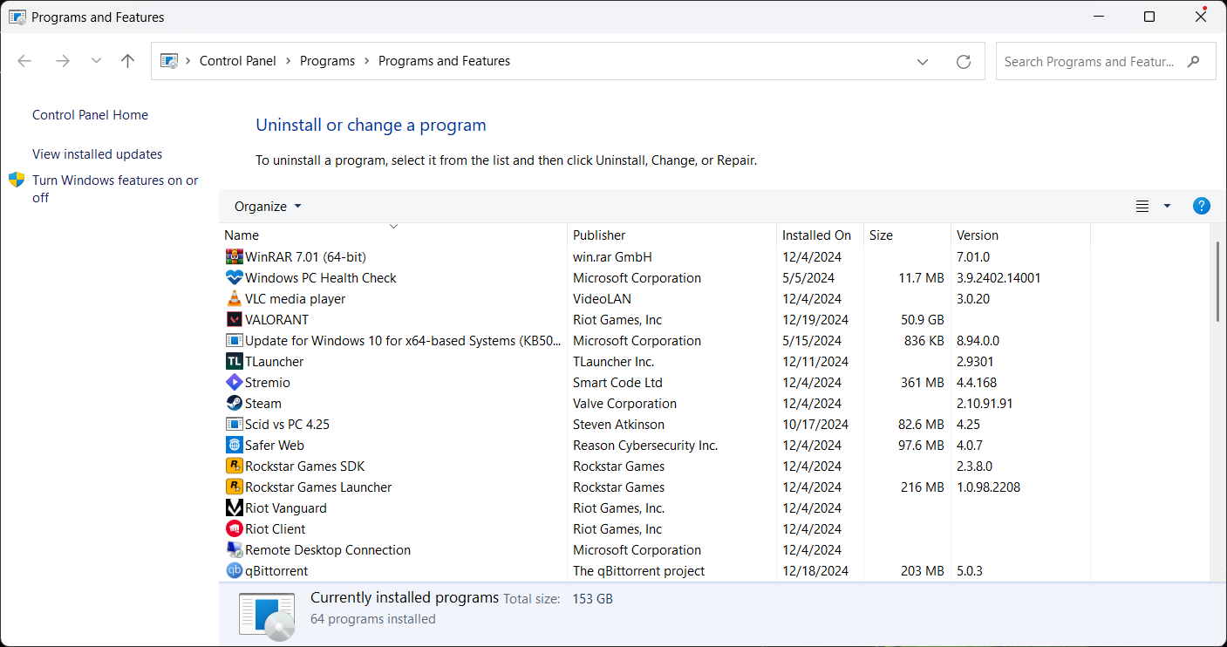

1. devmgmt.msc: This command offers a quick view of your hardware devices.

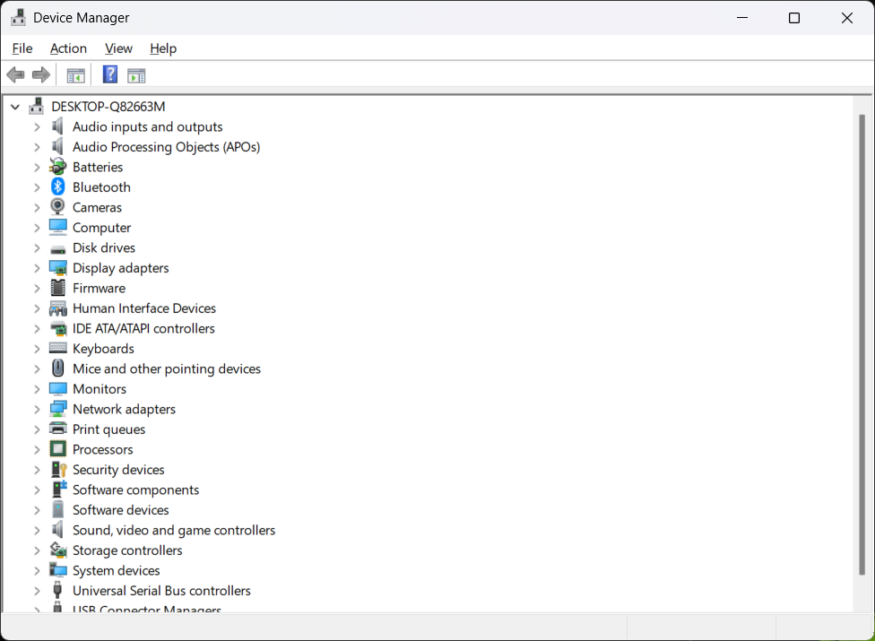

1. Diskmgmt.msc: This command allows user to create, delete or resize disk partitions.  
    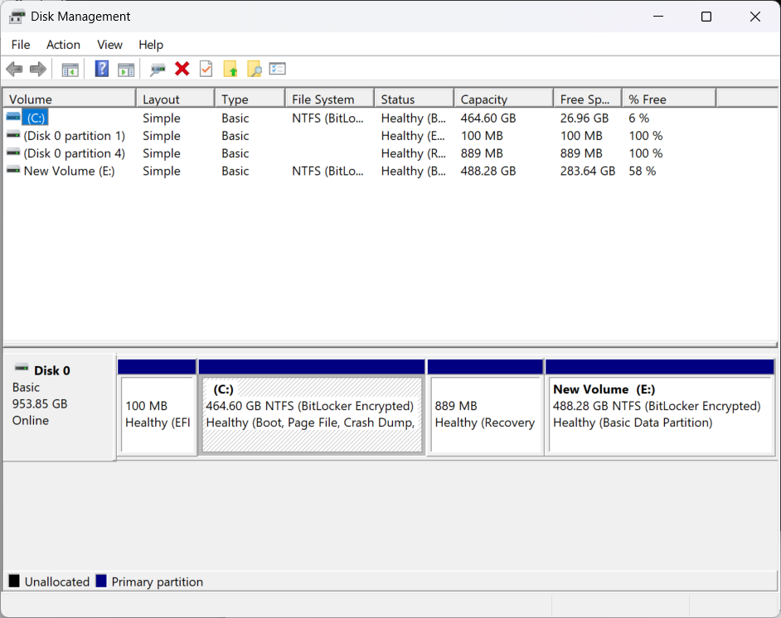
2. Winver: This command displays the version, edition, and Windows build number.

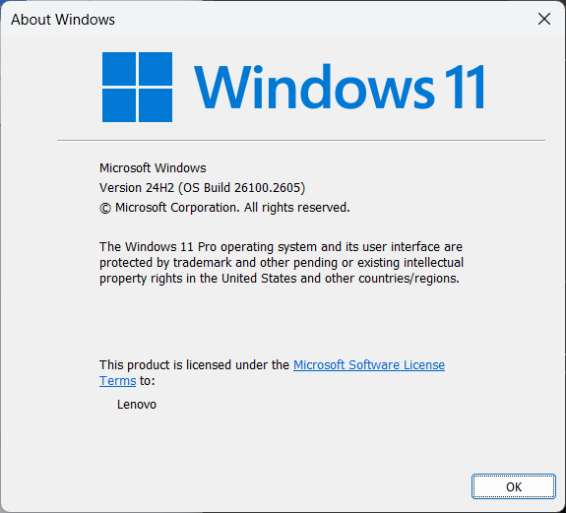

1. ncpa.cpl: This command opens a panel that empowers you to manage network connections and configure adapter settings.

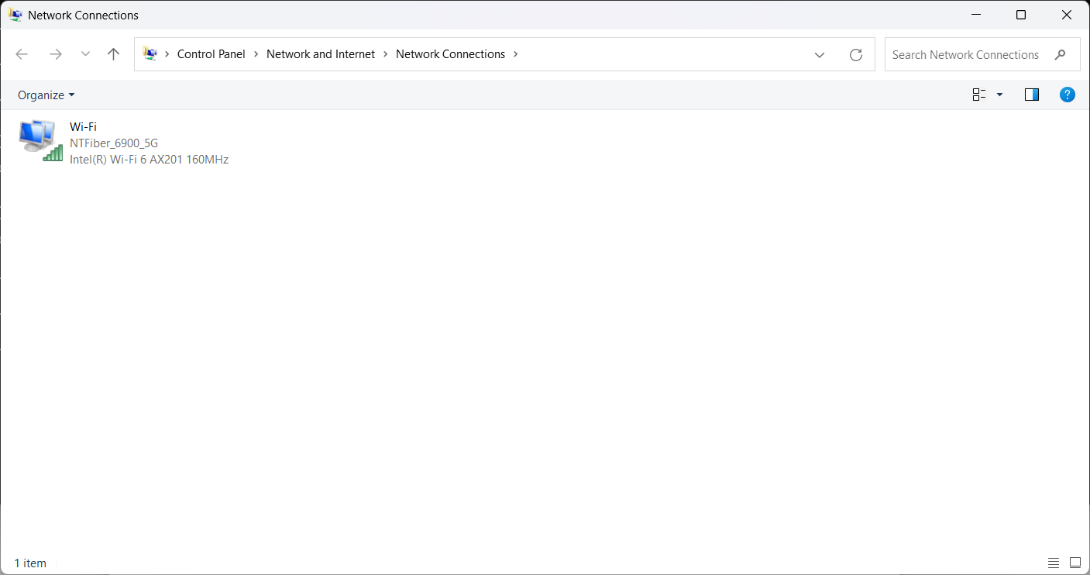

1. Control: This command opens the control panel, allowing access to various system settings.

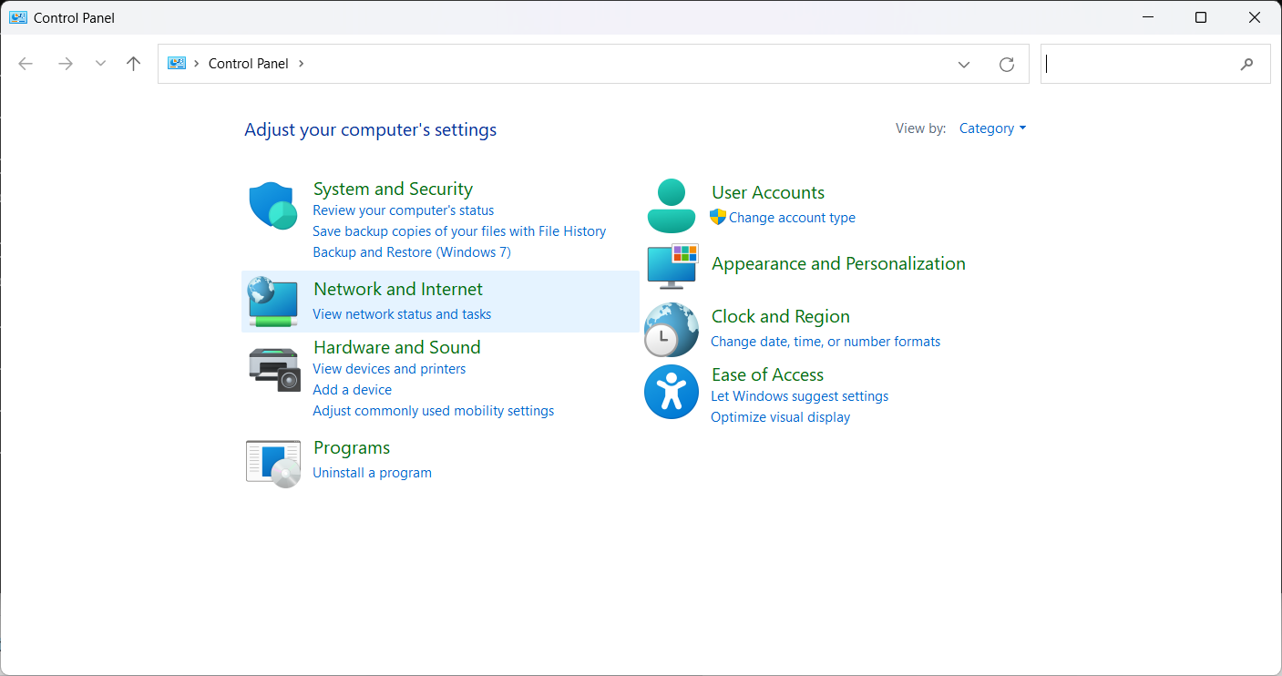

1. Cmd: This command opens the command-line interface, allowing you to execute commands and scripts.

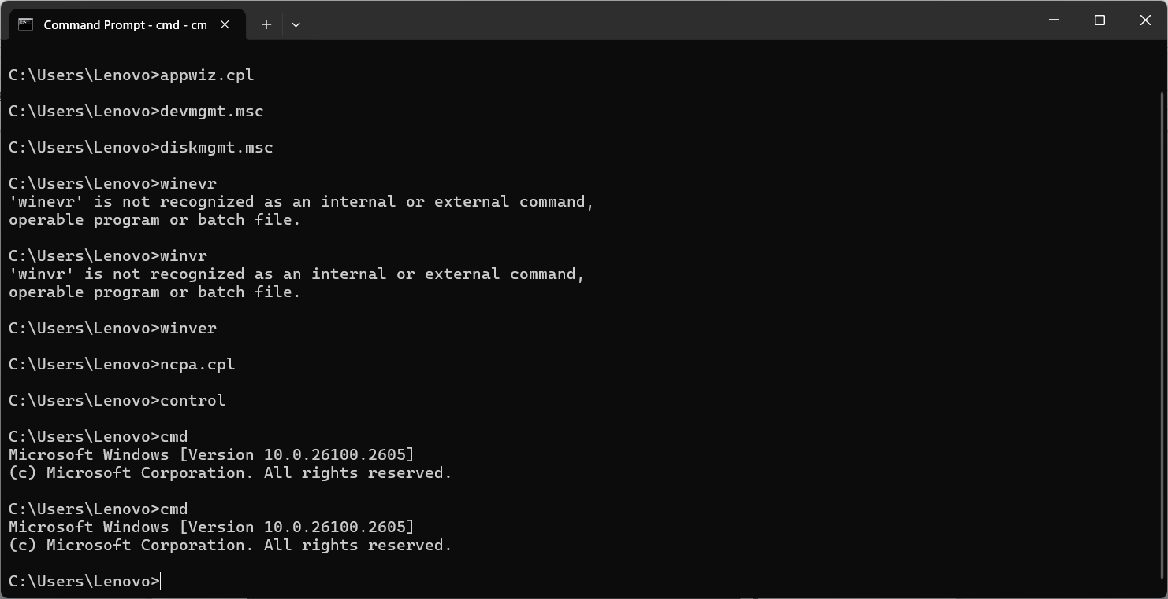

1. Lusrmgr.msc: This command displays the management options for local user accounts.

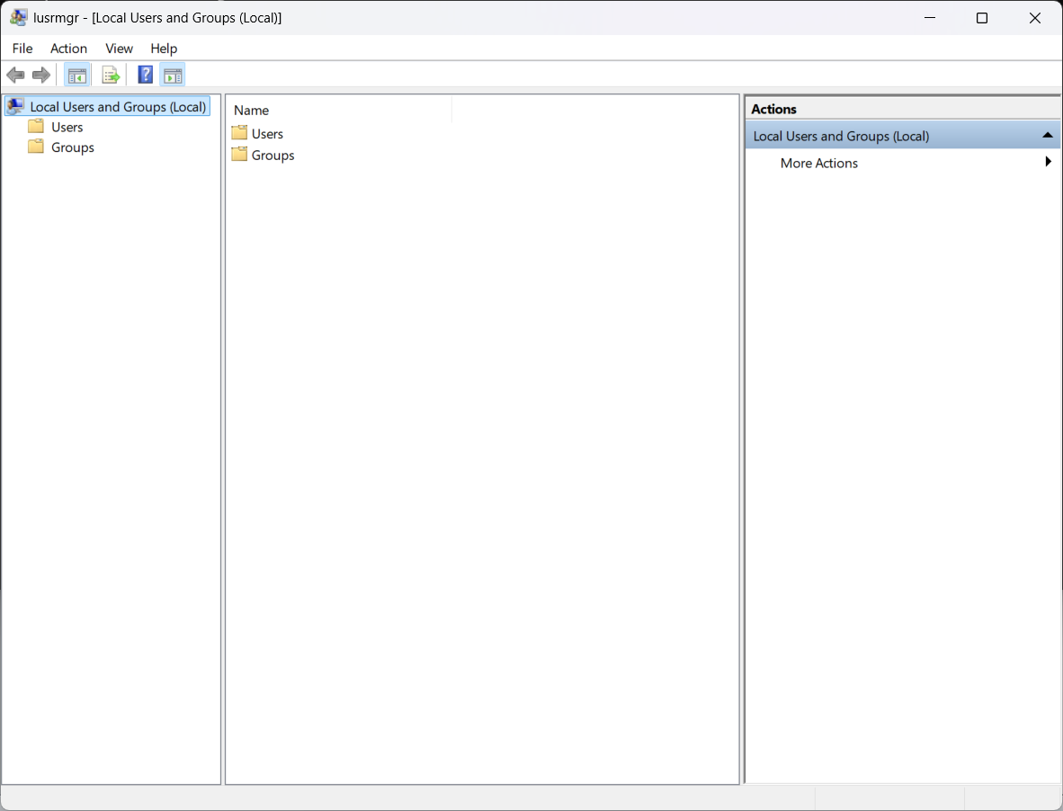

1. Msconfig: It opens the System Configuration tool, enabling management of startup and system settings.

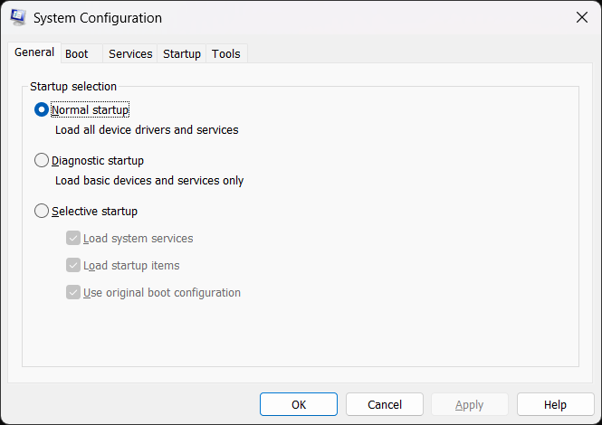

10. Taskmgr: It allows you to open the Task Manager program from within any directory on your computer.

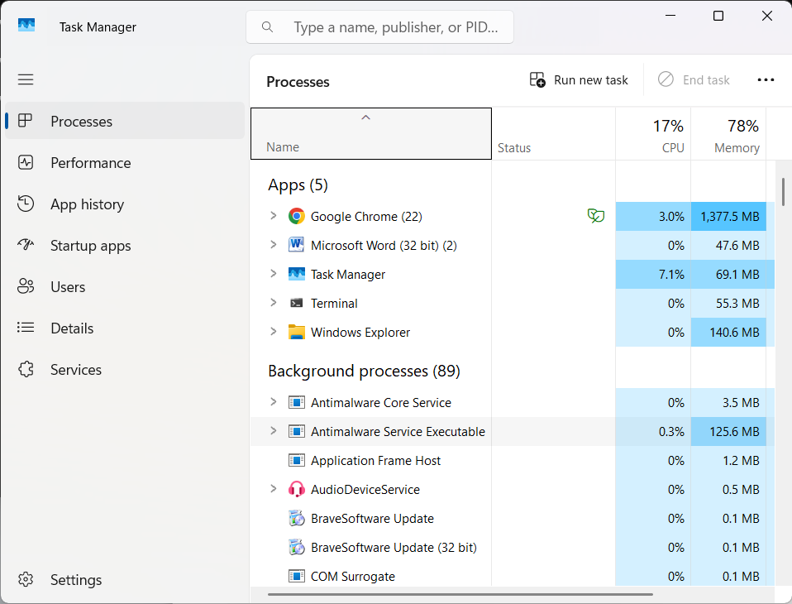

11. Services.msc: This command opens the Services Management Console for managing Windows services.

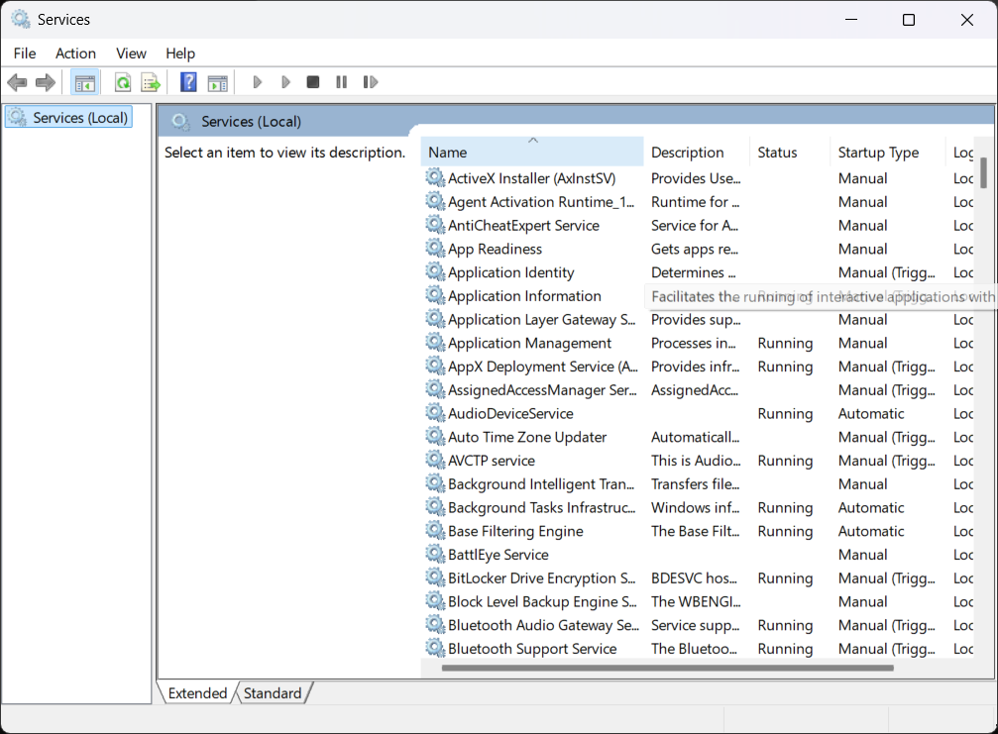

12. msinfo32: This command displays system information, including details about both the hardware and software.

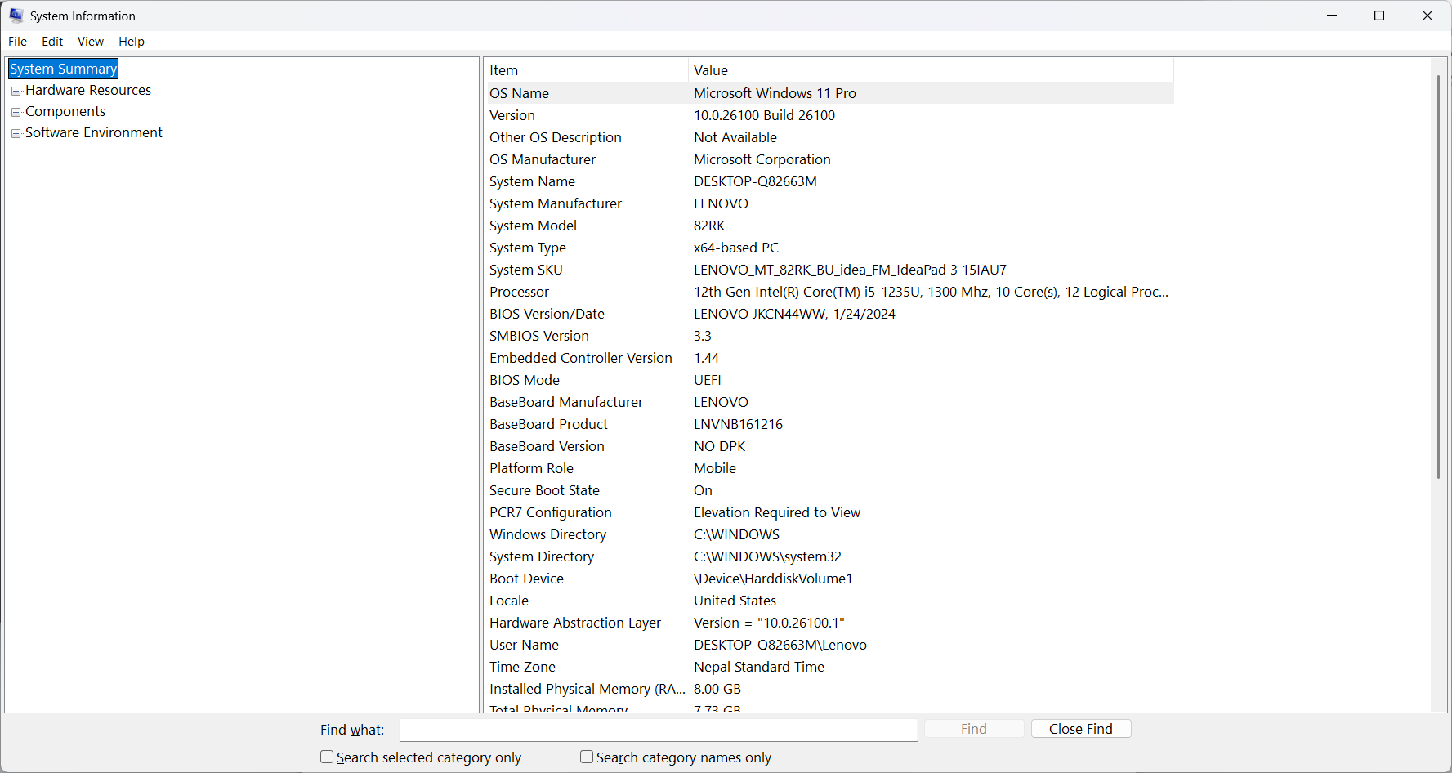

13. mrt: This command runs a tool to scan and remove malware from the system.

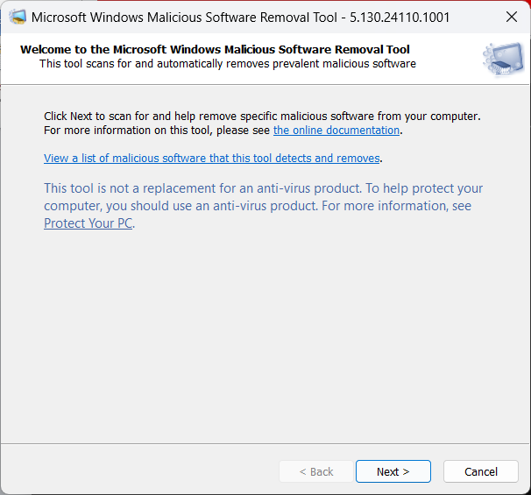

14. charmap: It open character map which lets you access All the characters in the font of your choice to easily use anywhere you like.

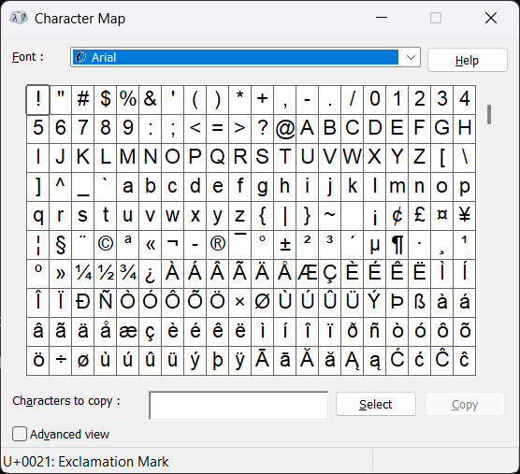

15. regedit: This command opens the Windows Registry Editor, allowing users to view and edit the system registry.

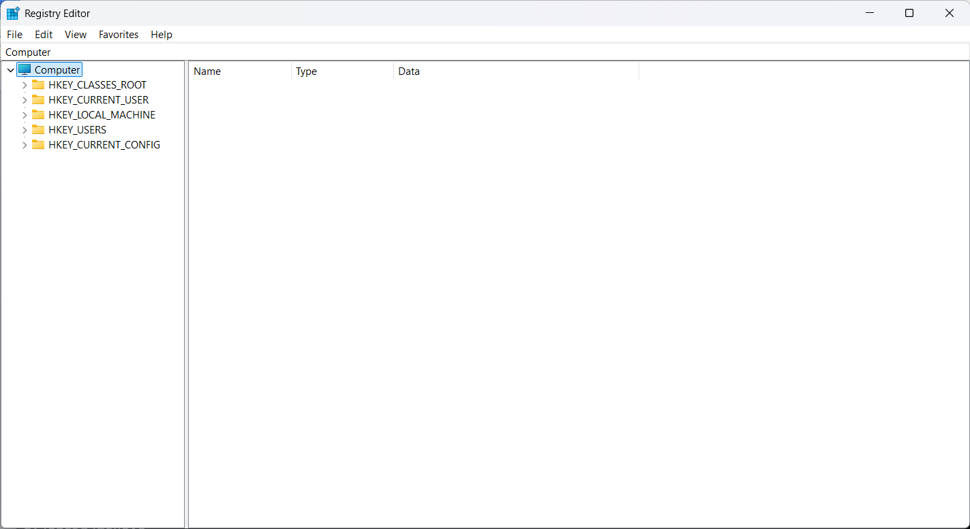

16. dxdiag: Use the tool to generate a dxdiag text report file, which has detailed information about your computer's graphics, sound, and other devices

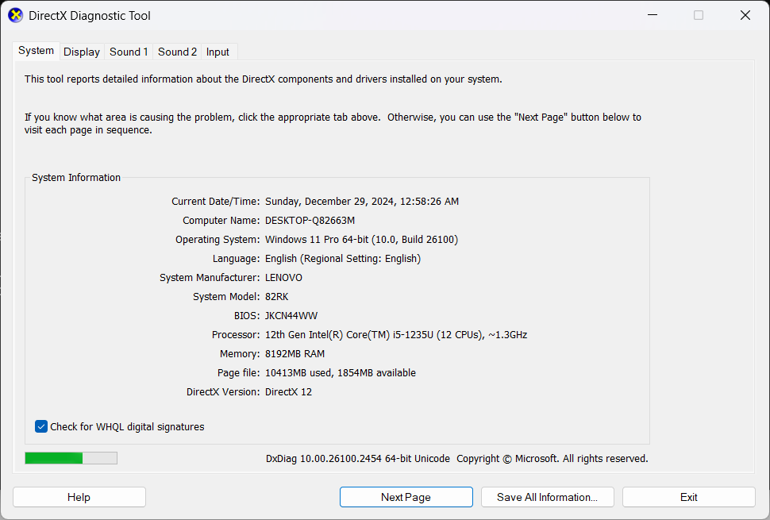

REFRENCES:

<https://serverspace.io/support/help/windows-run-commands-cheat-sheet/>