AQ1:
#include <iostream>
using namespace std;

void printArray(int arr[], int n) {
for(int i=0; i<n; i++) cout << arr[i] << " ";
cout << endl;
}

void selectionSort(int arr[], int n) {
for(int i=0; i<n-1; i++) {
int minIdx = i;
for(int j=i+1; j<n; j++) {
if(arr[j] < arr[minIdx])
minIdx = j;
}
int temp = arr[minIdx];
arr[minIdx] = arr[i];
arr[i] = temp;
}
}

void insertionSort(int arr[], int n) {
for(int i=1; i<n; i++) {
int key = arr[i];
int j = i-1;
while(j>=0 && arr[j] > key) {
arr[j+1] = arr[j];
j--;
}
arr[j+1] = key;
}
}

void bubbleSort(int arr[], int n) {
for(int i=0; i<n-1; i++) {
for(int j=0; j<n-i-1; j++) {
if(arr[j] > arr[j+1]) {
int temp = arr[j];
arr[j] = arr[j+1];
arr[j+1] = temp;
}
}
}
}

void merge(int arr[], int l, int m, int r) {
int n1 = m-l+1;
int n2 = r-m;
int a[n1], b[n2];
for(int i=0; i<n1; i++) a[i] = arr[l+i];
for(int i=0; i<n2; i++) b[i] = arr[m+1+i];
int i=0, j=0, k=l;
while(i<n1 && j<n2) {
if(a[i] <= b[j])
arr[k++] = a[i++];
else
arr[k++] = b[j++];
}
while(i<n1) arr[k++] = a[i++];
while(j<n2) arr[k++] = b[j++];
}

void mergeSort(int arr[], int l, int r) {
if(l < r) {
int m = (l+r)/2;
mergeSort(arr, l, m);
mergeSort(arr, m+1, r);
merge(arr, l, m, r);
}
}

int partitionQ(int arr[], int low, int high) {
int pivot = arr[high];
int i = low - 1;
for(int j=low; j<high; j++) {
if(arr[j] < pivot) {
i++;
int t = arr[i];
arr[i] = arr[j];
arr[j] = t;
}
}
int t = arr[i+1];
arr[i+1] = arr[high];
arr[high] = t;
return i+1;
}

void quickSort(int arr[], int low, int high) {
if(low < high) {
int p = partitionQ(arr, low, high);
quickSort(arr, low, p-1);
quickSort(arr, p+1, high);
}
}

void copyArray(int a[], int b[], int n) {
for(int i=0; i<n; i++) b[i] = a[i];
}

int main() {
int n;
cout << "Enter number of elements: ";
cin >> n;

int original[n];
cout << "Enter elements: ";
for(int i=0; i<n; i++) cin >> original[i];

int arr[n];

copyArray(original, arr, n);
selectionSort(arr, n);
cout << "Selection Sort: ";
printArray(arr, n);

copyArray(original, arr, n);
insertionSort(arr, n);
cout << "Insertion Sort: ";
printArray(arr, n);

copyArray(original, arr, n);
bubbleSort(arr, n);
cout << "Bubble Sort: ";
printArray(arr, n);

copyArray(original, arr, n);
mergeSort(arr, 0, n-1);
cout << "Merge Sort: ";
printArray(arr, n);

copyArray(original, arr, n);
quickSort(arr, 0, n-1);
cout << "Quick Sort: ";
printArray(arr, n);

return 0;
}

Output:
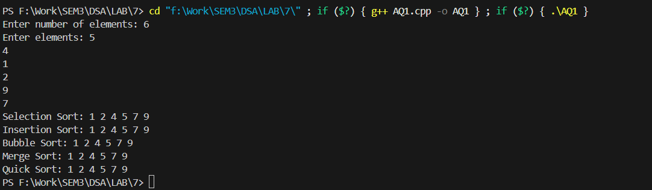
AQ2:
#include <iostream>
using namespace std;

void improvedSelectionSort(int arr[], int n) {
int left = 0, right = n - 1;

while(left < right) {
int minIdx = left, maxIdx = right;

for(int i = left; i <= right; i++) {
if(arr[i] < arr[minIdx]) minIdx = i;
if(arr[i] > arr[maxIdx]) maxIdx = i;
}

int t = arr[left];
arr[left] = arr[minIdx];
arr[minIdx] = t;

if(maxIdx == left) maxIdx = minIdx;

t = arr[right];
arr[right] = arr[maxIdx];
arr[maxIdx] = t;

left++;
right--;
}
}

int main() {
int n;
cout << "Enter number of elements: ";
cin >> n;
int arr[n];
cout << "Enter elements: ";
for(int i = 0; i < n; i++) cin >> arr[i];

improvedSelectionSort(arr, n);

for(int i = 0; i < n; i++) cout << arr[i] << " ";
return 0;
}

Output:
