1. Two Sum II - Input array is sorted  
   Given a sorted array of integers, return the indices of the two numbers such that they add up to a specific target.  
     
   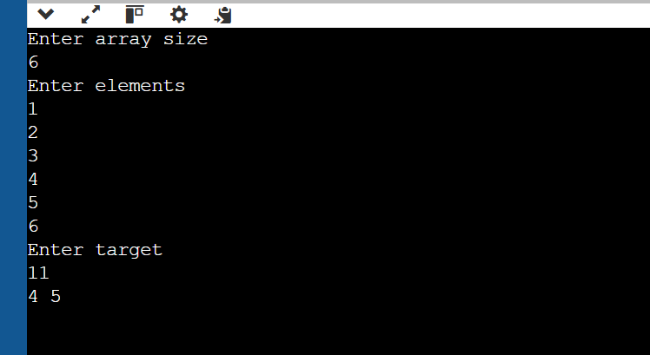

6. Remove Nth Node From End of List

Given a linked list, remove the nth node from the end and return its head.

9. Rearrange a no to find min possible no in o(n) and constant space.

for eg input   
1. 324 -> output 234  
2. 50221 – 01225

