Q. Created Database and selected database

create database asessment;

use asessment;



1. Create the tables below in the database. Use foreign keys and primary keys as required.
   1. Create a table called as student with the following columns student_id, first_name, last_name ,birthdate , department_id ,address_id .

create table student(

student_id int,

first_name varchar(30),

last_name varchar(30),

birthdate date,

department_id int,

address_id int

);



* 1. Create Address table with following columns address_id , street_address, city, State,

postal_code

create table address(

address_id int,

street_address varchar(100),

city varchar(30),

state varchar(30),

postal_code int

);



* 1. Create department table department_id, department name. Make sure you are using the right data type against all the columns.

create table department(

department_id int,

department_name varchar(50)

);



1. Use Sample data from sampledata.txt to insert data into the database

insert into student values(1,'john','doe','1995-04-15',1,1),

(2,'jane','smith','1967-07-22',2,2),

(3,'alice','johnson','1994-11-30',3,3),

(4,'michael','brown','1997-02-19',4,4),

(5,'sophia','davis','1998-01-05',5,5),

(6,'daniel','wilson','1995-06-10',6,6),

(7,'olivia','martinez','1995-11-25',1,7),

(8,'ethan','miler','1995-03-30',2,8);

insert into address values

(1,'123 elm st','springfield','IL',62701),

(2,'456 oak st','decatur','IL',62521),

(3,'789 pine st','champaign','IL',61820),

(4,'102 birch rd','peoria','IL',61602),

(5,'205 cedar ave','chicago','IL',60601),

(6,'310 maple dr','urbana','IL',61801),

(7,'415 oak blvd','champaign','IL',61821),

(8,'520 pine rd','carbondale','IL',62901);

insert into department values

(1,'computer science'),

(2,'mechanical engineering'),

(3,'electrical engineering'),

(4,'civil engineering'),

(5,'matchematics'),(6,'biology');

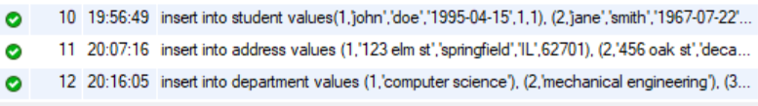

1. Write a query to find the total number of students.

select count(student_id) from student;

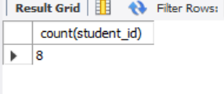

1. Write a query to find which department john belongs to.

select s.first_name, s.last_name, d.department_name

from student s

join department d on s.department_id = d.department_id

where s.first_name = 'john';

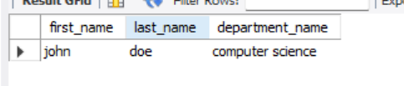

1. List All Departments with Their Number of Students (Including Departments with No Students)

select d.department_name, count(s.student_id) as student_count

from department d

left join student s on d.department_id = s.department_id

group by d.department_name;

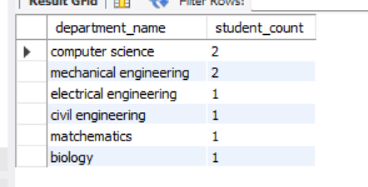

1. Select all students with their department and address.

select

s.student_id, s.first_name, s.last_name, d.department_name, a.street_address, a.city, a.state, a.postal_code

from student s

join department d on s.department_id = d.department_id

join address a on s.address_id = a.address_id;

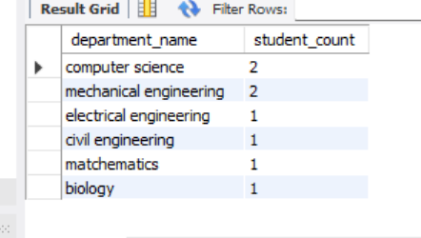

1. Find all students who are in the 'Computer Science' department

select

s.student_id,

s.first_name,

s.last_name,

d.department_name

from student s

join department d on s.department_id = d.department_id

where d.department_name = 'computer science';

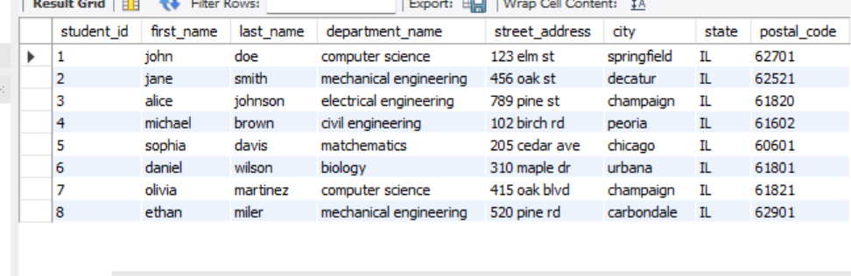

1. Update Jane’s city name to New York.

update address

set city = 'New York'

where address_id = (

select s.address_id

from student s

where s.first_name = 'jane'

);

1. Delete a student from the student table.

delete from student

where student_id = 8;

1. Select all students with their department and address in New York.

select

s.student_id,

s.first_name,

s.last_name,

d.department_name,

a.street_address,

a.city,

a.state,

a.postal_code

from student s

join department d on s.department_id = d.department_id

join address a on s.address_id = a.address_id

where a.city = 'New York';

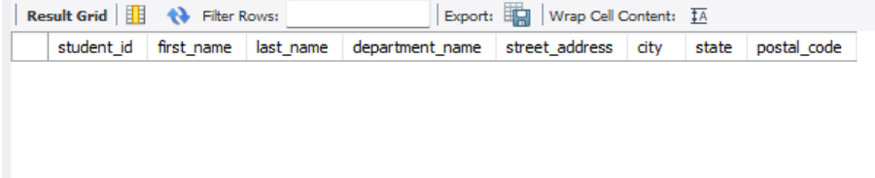

1. Count how many students are in each department

select

d.department_name,

count(s.student_id) as student_count

from department d

left join student s on d.department_id = s.department_id

group by d.department_name;

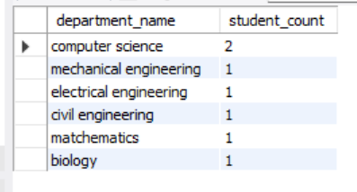

1. Find students who live in 'Springfield'

select

s.student_id,

s.first_name,

s.last_name,

a.city

from student s

join address a on s.address_id = a.address_id

where a.city = 'springfield';

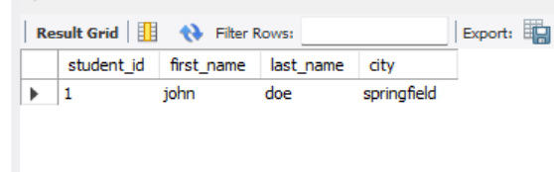

1. Select students whose birthday falls in February

select

student_id,

first_name,

last_name,

birthdate

from student

where month(birthdate) = 2;

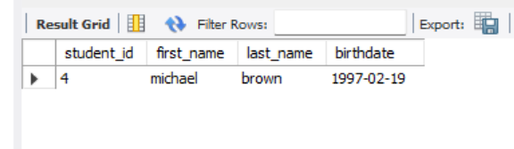

1. Get the department and address details for a specific student, example john

select

s.first_name,

s.last_name,

d.department_name,

a.street_address,

a.city,

a.state,

a.postal_code

from student s

join department d on s.department_id = d.department_id

join address a on s.address_id = a.address_id

where s.first_name = 'john';

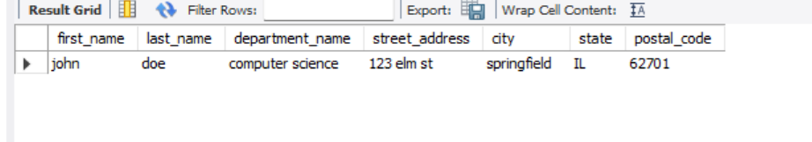

1. Find all students who are born within 1995 to 1998

select

student_id,

first_name,

last_name,

birthdate

from student

where year(birthdate) BETWEEN 1995 AND 1998;

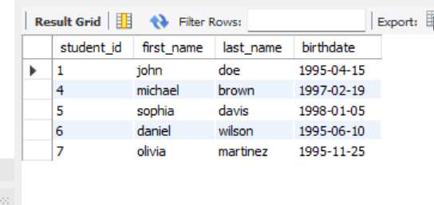

1. List all students and their corresponding department names, sorted by department

select

s.student_id,

s.first_name,

s.last_name,

d.department_name

from student s

join department d on s.department_id = d.department_id

order by d.department_name;

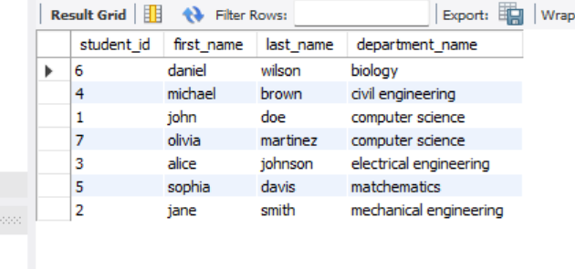

1. Find the number of students in each department who are living in 'Champaign'

select

d.department_name,

count(s.student_id) as student_count

from student s

join department d on s.department_id = d.department_id

join address a on s.address_id = a.address_id

where a.city = 'champaign'

group by d.department_name;

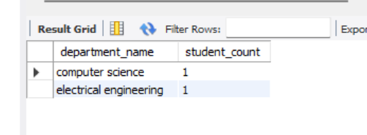

1. Retrieve the names of students who live on 'Pine' street

select

s.first_name,

s.last_name,

a.street_address

from student s

join address a on s.address_id = a.address_id

where a.street_address like '%Pine%';

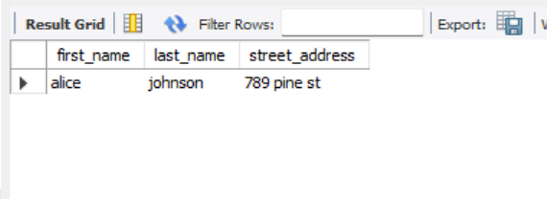

1. Update the department of a student with student_id = 6 to 'Mechanical Engineering'

update student

set department_id = (

select department_id

from department

where department_name = 'mechanical engineering'

)

where student_id = 6;

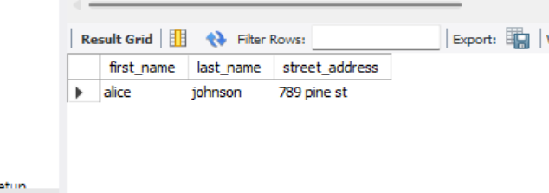

1. Find the student(s) who live in the city 'Chicago' and are in the 'Mathematics' department

select

s.student_id,

s.first_name,

s.last_name,

d.department_name,

a.city

from student s

join department d on s.department_id = d.department_id

join address a on s.address_id = a.address_id

where a.city = 'chicago'

and d.department_name = 'mathematics';

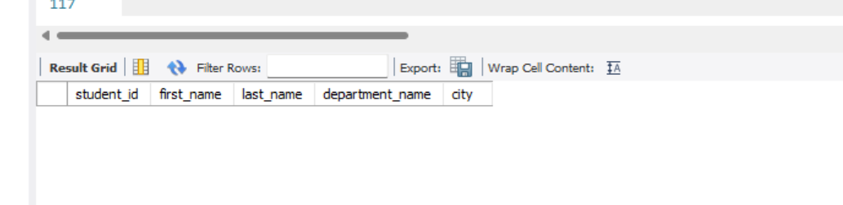

1. List all students who have an address in 'Urbana' or 'Peoria'

select

s.student_id,

s.first_name,

s.last_name,

a.city

from student s

join address a on s.address_id = a.address_id

where a.city in ('urbana', 'peoria');

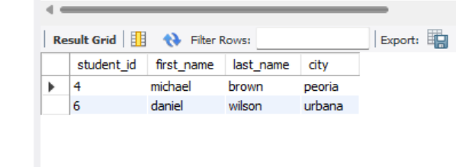

1. Find the student with the highest student_id

select

student_id,

first_name,

last_name

from student

order by student_id desc

limit 1;

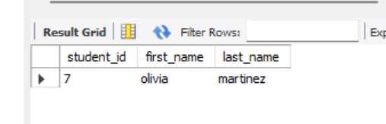

1. Find all students who are not in the 'Computer Science' department

select

s.student_id,

s.first_name,

s.last_name,

d.department_name

from student s

join department d on s.department_id = d.department_id

where d.department_name <> 'computer science';

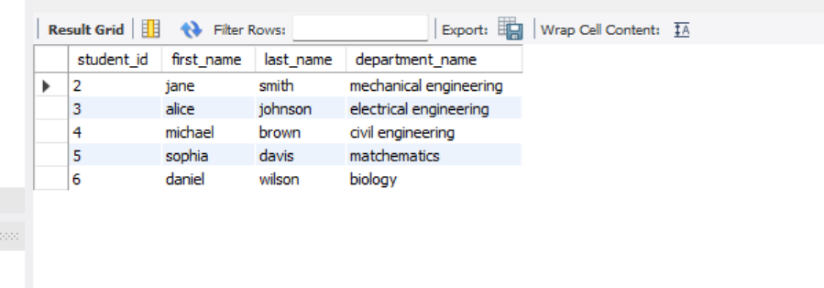

1. Count the total number of addresses in the 'Champaign' city

select

count(*) as total_addresses

from address

where city = 'champaign';

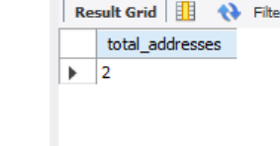

1. Find the name of the student who lives at '520 Pine Rd'

select

s.first_name,

s.last_name,

a.street_address

from student s

join address a on s.address_id = a.address_id

where a.street_address = '520 Pine Rd';

1. Get the average age of students in the 'Electrical Engineering' department

select

d.department_name,

avg(timestampdiff(year, s.birthdate, curdate())) as average_age

from student s

join department d on s.department_id = d.department_id

where d.department_name = 'electrical engineering';

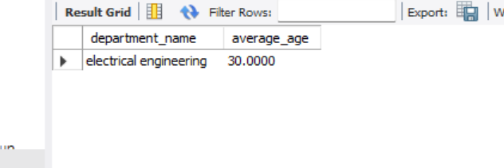

1. List the students, their department, and the city where they live, but only for those in departments starting with 'M'

select

s.student_id,

s.first_name,

s.last_name,

d.department_name,

a.city

from student s

join department d on s.department_id = d.department_id

join address a on s.address_id = a.address_id

where d.department_name like 'm%';

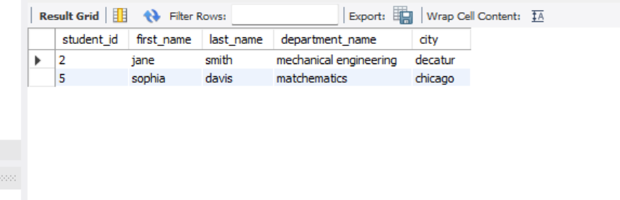

1. Delete a student from the 'Mechanical Engineering' department

delete from student

where department_id = (

select department_id

from department

where department_name = 'mechanical engineering'

)

limit 1;



1. Retrieve All Orders with Their Customer Details and Current Status

SELECT

o.order_id,

o.order_date,

o.total_amount,

CONCAT(c.first_name, ' ', c.last_name) AS customer_name,

c.email,

c.phone_number,

s.status_name AS current_status

FROM

order_schema.orders o

JOIN

order_schema.customer c ON o.customer_id = c.customer_id

JOIN

order_schema.status s ON o.status_id = s.status_id

ORDER BY

o.order_date DESC;

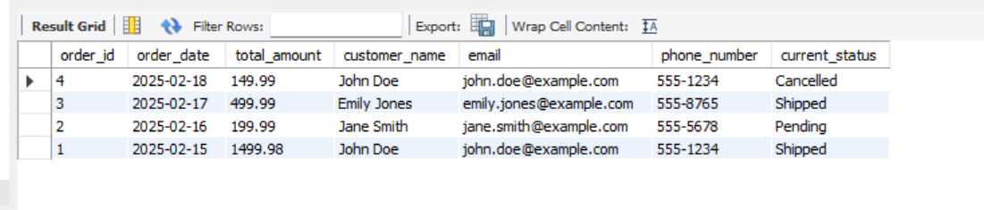

1. Get the Total Value of Orders for a Given Customer in a Specific Time Period

SELECT CONCAT(c.first_name, ' ', c.last_name) AS customer_name,SUM(o.total_amount) AS total_order_value

FROM order_schema.orders o

JOIN order_schema.customer c ON o.customer_id = c.customer_id

WHERE o.customer_id = 1 AND o.order_date BETWEEN '2025-02-15' AND '2025-02-18'

GROUP BY customer_name;

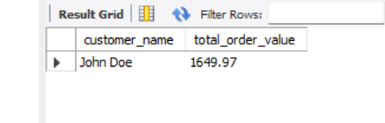

1. Find the Most Expensive Order by Customer

SELECT CONCAT(c.first_name, ' ', c.last_name) AS customer_name,o.order_id,o.total_amount

FROM order_schema.orders o

JOIN order_schema.customer c ON o.customer_id = c.customer_id

ORDER BY o.total_amount DESC

LIMIT 1;

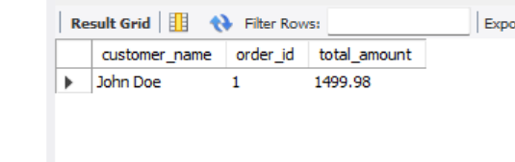

1. Find the Total Revenue for Each Product Based on Orders

SELECT p.product_name,SUM(oi.quantity * oi.price) AS total_revenue

FROM order_schema.order_items oi

JOIN order_schema.product p ON oi.product_id = p.product_id

GROUP BY p.product_name

ORDER BY total_revenue DESC;

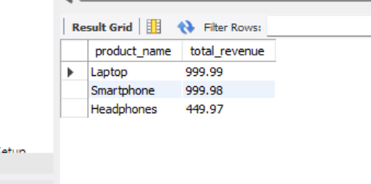

1. Write a query to retrieve the order ID, customer ID, and the total amount of each order. If the total amount is null, display '0.00' instead.

SELECT o.order_id,o.customer_id,COALESCE(o.total_amount, 0.00) AS total_amount

FROM order_schema.orders o;

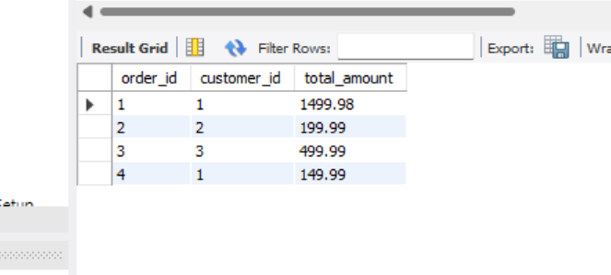

1. Retrieve the Order History of a Specific Customer Along with Product Details

SELECT o.order_id,o.order_date,p.product_name,oi.quantity,oi.price,oh.status_change_date,oh.status_description

FROM order_schema.orders o

JOIN order_schema.order_items oi ON o.order_id = oi.order_id

JOIN order_schema.product p ON oi.product_id = p.product_id

JOIN order_schema.order_history oh ON o.order_id = oh.order_id

WHERE o.customer_id = 1

ORDER BY o.order_id, oh.status_change_date;

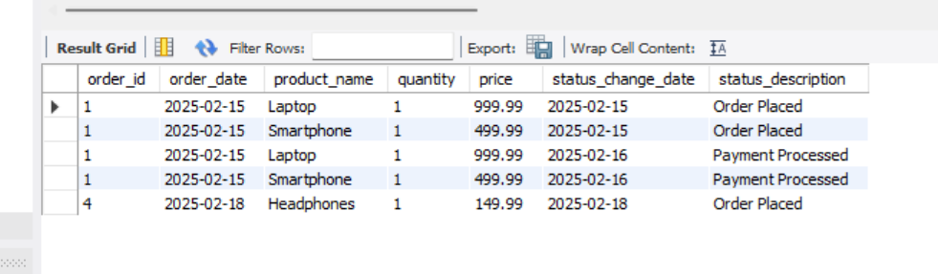

1. Get the Average Order Value Per Customer in the Last 30 Days.

select o.customer_id, avg(o.total_amount) as average_order_value

from order_schema.orders o

where o.order_date >= date_sub(current_date, interval 30 day)

group by o.customer_id;

1. Get the Top 5 Products with the Highest Number of Orders.

select p.product_name,count(distinct oi.order_id) as number_of_orders

from order_schema.order_items oi

join order_schema.product p on oi.product_id = p.product_id

group by p.product_name

order by number_of_orders desc

limit 5;

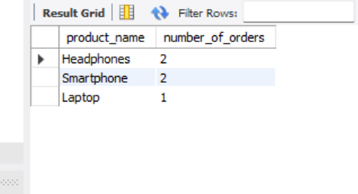

1. Get the Customers Who Have Not Placed Any Orders in the Last 60 Days

select c.customer_id, concat(c.first_name, ' ', c.last_name) as customer_name

from order_schema.customer c

left join order_schema.orders o on c.customer_id = o.customer_id and o.order_date >= current_date - 60

where o.order_id is null;

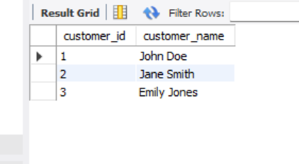

1. List the Orders with Products Ordered More Than Once, Sorted by Order Date

select o.order_id, o.order_date, p.product_name, oi.quantity

from order_schema.orders o

join order_schema.order_items oi on o.order_id = oi.order_id

join order_schema.product p on oi.product_id = p.product_id

where oi.quantity > 1

order by o.order_date;

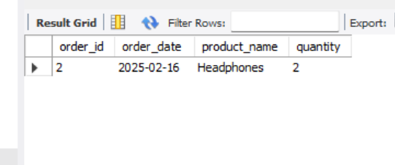

1. Retrieve the Number of Orders and Total Revenue for Each Status

select s.status_name, count(o.order_id) as number_of_orders, coalesce(sum(o.total_amount), 0) as total_revenue

from order_schema.status s

left join order_schema.orders o on s.status_id = o.status_id

group by s.status_name;

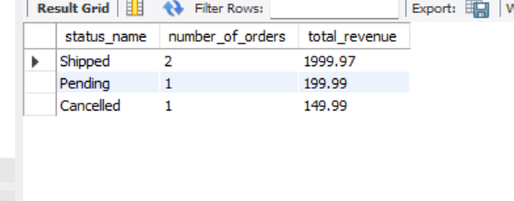

1. Find Customers Who Have Ordered More Than a Specific Product (e.g., "Laptop")

select distinct c.customer_id, concat(c.first_name, ' ', c.last_name) as customer_name

from order_schema.customer c

join order_schema.orders o on c.customer_id = o.customer_id

join order_schema.order_items oi on o.order_id = oi.order_id

join order_schema.product p on oi.product_id = p.product_id

where p.product_name = 'Laptop' and oi.quantity > 1;

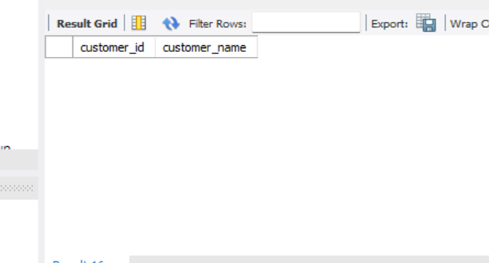

1. Find the Products That Have Never Been Ordered

select p.product_id, p.product_name

from order_schema.product p

left join order_schema.order_items oi on p.product_id = oi.product_id

where oi.order_item_id is null;

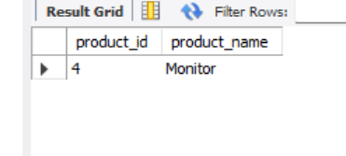

1. Get the Total Quantity of Products Ordered in the Last 7 Days

select sum(oi.quantity) as total_quantity_ordered

from order_schema.order_items oi

join order_schema.orders o on oi.order_id = o.order_id

where o.order_date >= current_date - 7;

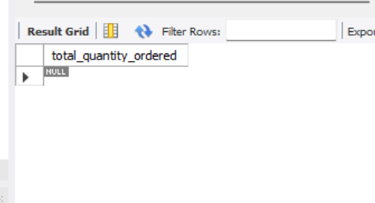

1. Create a view named product_details that includes all columns from the product table.

create view order_schema.product_details as

select * from order_schema.product;

1. Create a view named order_summary that includes the order_id, customer_id, order_date, total_amount, and status_name (from the status table) for each order.

create view order_schema.order_summary as

select o.order_id, o.customer_id, o.order_date, o.total_amount, s.status_name

from order_schema.orders o

join order_schema.status s on o.status_id = s.status_id;