LUMBINI CITY COLLEGE
(Affiliated to Tribhuvan University)
Drivertole, Tilottama - 4, Rupandehi


Final Year Project Proposal on
Automated Multi-Branch Enterprise Network with Secure WAN and Monitoring

Submitted To
Lumbini City College
Tilottama -4, Drivertole

In partial fulfillment of the requirement for the Bachelor Degree in Computer Science
and
Information Technology

Submitted By:
Aayush Chapagain
Sanchhep Raj Shrestha

Under the Supervision of
Mr. Kamal Sirish

Table of Contents

Chapter 1. Introduction 1
Chapter 2. Problem Statement 2
Chapter 3. Objectives 3
3.1 Scope and Limitations of the Project 3
3.1.1 Scope 3
3.1.2 Limitations 4
Chapter 4. Methodology 5
4.1 Requirement Identification 5
4.2 Study of Existing System / Literature Review 5
4.3 Requirement Analysis 5
4.4 Feasibility Study 6
4.4.1 Technical Feasibility 6
4.4.2 Operational Feasibility 6
4.4.3 Economic Feasibility 6
4.5 Schedule (Gantt Chart) 6
4.6 Proposed Network Architecture 7
4.6.1 Working Mechanism of the Proposed Network 8
4.6.2 Description of Algorithms 9
4.7. Tools and Technologies Used 9
4.7.1. Network Design and Emulation Tools 10
4.7.2. Networking Protocols and Technologies 10
4.7.3. Automation Tools 11
4.7.4. Monitoring and Logging Tools 11
4.7.5. Database and Backend Tools 11
4.7.6. Testing and Validation Tools 11
4.7.7. Documentation Tools 12
Chapter 5. Expected Outcome 13
References 14

Chapter 1. Introduction

In the modern digital era, enterprise organizations rely heavily on robust, secure, and scalable network infrastructures to support business operations, remote connectivity, cloud services, and data-driven decision-making [14]. As organizations expand geographically, multi-branch network architectures have become a necessity rather than a choice. These distributed environments introduce challenges related to availability, security, management complexity, and operational efficiency [3].

Traditional network deployments that depend on manual configuration and limited monitoring are increasingly insufficient in meeting current demands. Network automation, centralized monitoring, and data-driven management have emerged as critical components of next-generation enterprise networks [14]. Technologies such as dynamic routing protocols, secure WAN connectivity, high-availability mechanisms, and automation using scripting languages are now widely adopted across industries worldwide [12].

This project proposes the design and implementation of an Automated Multi-Branch Enterprise Network that integrates secure WAN connectivity, real-time monitoring, and database-backed automation. The project will be implemented and validated in PNetLab, a professional network emulation platform widely used for training, research, and enterprise-level network testing. The proposed system reflects international industry standards and best practices, making it suitable for real-world enterprise deployment.

Chapter 2. Problem Statement

Most organizations with multiple locations face a series of common and interconnected network-related problems that disrupt their daily operations. These begin with manual configuration challenges, where setting up and maintaining devices like routers and switches at each site often requires physical visits or reliance on less technical staff, leading to errors and network downtime. This is compounded by significant security concerns, as sensitive data traveling between branches and headquarters over the internet can be intercepted without proper protection. Furthermore, IT teams suffer from limited network visibility, leaving them unable to monitor branch activity proactively and forcing them to rely on user reports for troubleshooting, which is slow and inefficient. These issues are exacerbated by inconsistent configurations across locations, which create uneven security postures and performance, alongside significant support challenges. Finally, the entire infrastructure is difficult to scale, as adding a new branch becomes a major, expertise-intensive project that hinders organizational growth. Collectively, these practical problems lead to serious business impacts, including lost productivity, heightened risk of data breaches, and escalating IT support costs.

Chapter 3. Objectives

The primary objective of this project is to design and implement an automated, secure, and scalable multi-branch enterprise network that aligns with contemporary enterprise networking standards. The specific objectives of the project are as follows:

- Design a scalable and highly available multi-branch network.
- Implement secure WAN connectivity with centralized monitoring.
- Automate network configuration and management.

3.1 Scope and Limitations of the Project

3.1.1 Scope
The scope of this project encompasses the design and implementation of an automated, secure, and manageable multi-branch enterprise network within a simulated environment. This includes the use of a network emulation platform to create a hierarchical network architecture consisting of a central headquarters and several branch offices interconnected via secure Wide Area Network links [7]. The project will implement standard security mechanisms to ensure the confidentiality and integrity of data transmitted between sites. To ensure reliability and efficient data flow, the design will incorporate dynamic routing protocols and redundancy mechanisms for high availability. A core component is the use of Python-based automation to handle device configuration and management across all locations, thereby enforcing consistency and reducing manual effort [1]. Furthermore, the system will feature centralized monitoring, logging, and alerting to provide comprehensive network visibility [10]. A centralized database will be integrated to store device inventory, configuration backups, and monitoring data for analysis. Finally, the entire proposed network will undergo rigorous testing to validate its functionality, performance, security, and failover capabilities within the simulated environment.

3.1.2 Limitations
The project is subject to several defined limitations. Primarily, the network will be built and tested entirely within an emulated software environment and will not involve deployment on physical hardware. The scale of the model is constrained to a small-to-medium enterprise, and it does not aim to represent the complexity of large-scale carrier or global enterprise networks. While fundamental security configurations will be implemented and validated, the scope does not extend to advanced security assessments such as penetration testing or in-depth threat modeling. The implemented alerting mechanisms will be limited to basic formats like dashboard alerts, system logs, and email notifications, excluding more advanced integrations such as SMS or third-party messaging platforms. Lastly, the project will not explore advanced modern technologies including SD-WAN, cloud-native networking solutions, or artificial intelligence-based network analytics.

Chapter 4. Methodology

4.1 Requirement Identification
The project requirements are identified based on enterprise networking standards, industry practices, and real-world organizational needs. The system must support secure inter-branch communication, centralized management, automation, and monitoring. Both functional and non-functional requirements such as scalability, reliability, and security are considered [6].

4.2 Study of Existing System / Literature Review
A comprehensive literature review is conducted on enterprise network design models, including hierarchical network architecture, secure WAN technologies, and network automation frameworks. Existing systems often rely on manual configuration and decentralized monitoring, leading to inefficiencies and operational risks. Industry standards such as Cisco Enterprise Architecture, OSPF routing, IPsec VPNs, SNMP-based monitoring, and database-backed management systems are studied to guide the proposed solution [3].

4.3 Requirement Analysis
Based on the requirement study, the following key requirements are analyzed:

- Support for multiple branch locations with centralized control
- Secure communication over public networks
- Dynamic routing and automatic failover
- Automation of repetitive configuration tasks
- Real-time monitoring and historical performance analysis
- Centralized storage of configurations and logs

4.4 Feasibility Study
Following feasibility are to be considered before implementing the project:

4.4.1 Technical Feasibility
The project is technically feasible as all required technologies such as routing protocols, VPNs, automation tools, monitoring systems, and databases are well-established and supported within PNetLab. Virtual routers, switches, and security devices can be emulated accurately to represent enterprise environments [5].

4.4.2 Operational Feasibility
The proposed system simplifies network operations through automation and centralized monitoring. Network administrators can manage multiple branches efficiently with reduced manual effort, making the system operationally feasible for enterprise adoption [3].

4.4.3 Economic Feasibility
By using network emulation tools and open-source technologies, the project minimizes hardware and licensing costs. Automation reduces long-term operational expenses by decreasing manual configuration time and reducing network downtime.

4.5 Schedule (Gantt Chart)
The project is planned to be completed over a defined academic period with the following phases:

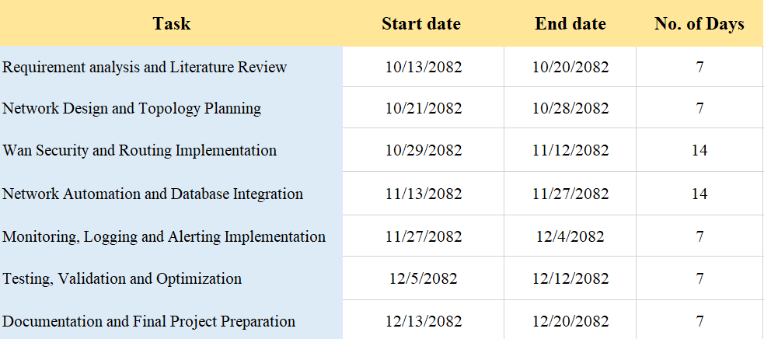
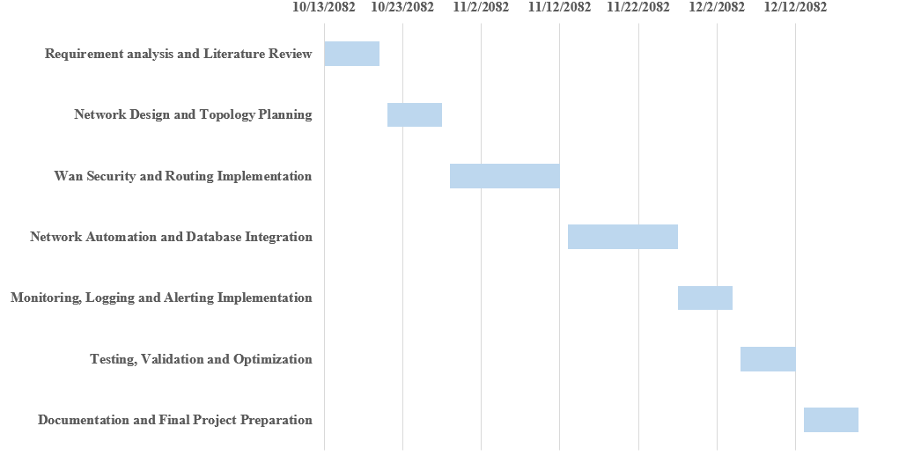
Fig 4.1: Gantt Chart

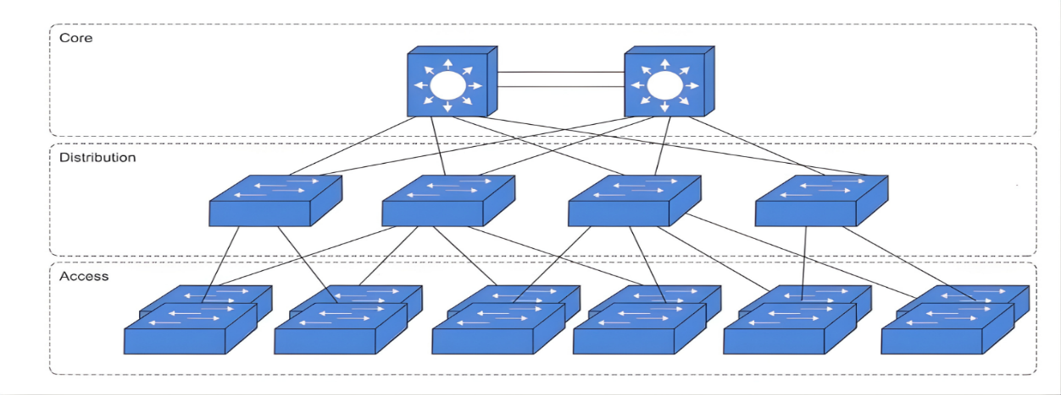
4.6 Proposed Network Architecture

Fig 4.2.: Logical Three-Tier Network Architecture

The proposed network follows a three-tier hierarchical architecture consisting of core, distribution, and access layers implemented at each branch location. The core layer provides high-speed backbone connectivity between network segments and sites, the distribution layer performs routing and policy enforcement, and the access layer connects end-user devices. This standardized design improves scalability, fault isolation, and simplifies management across the multi-branch enterprise environment [6].

4.6.1 Working Mechanism of the Proposed Network

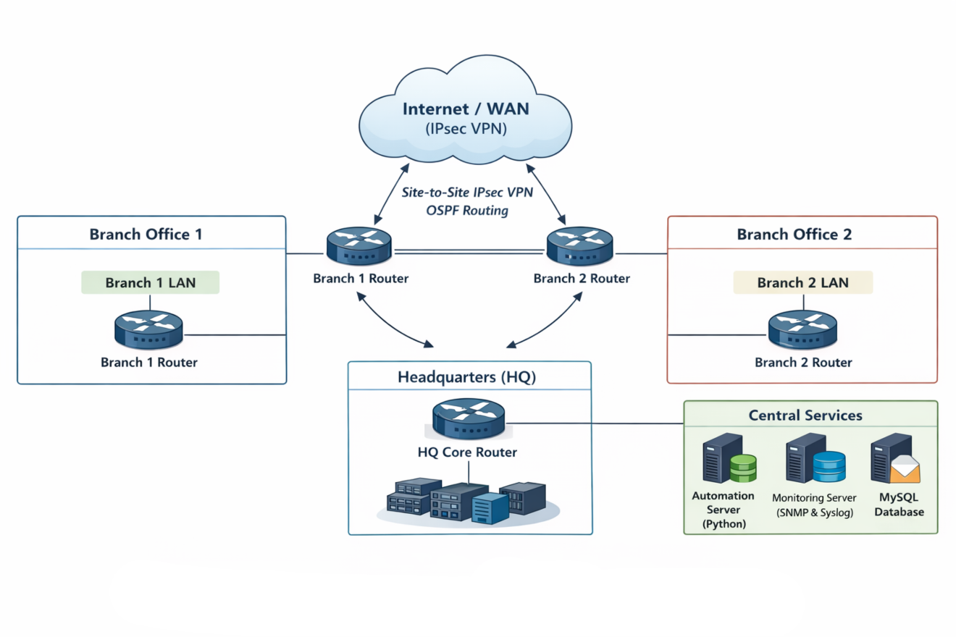

Figure 4.3: Working Mechanism

- Branch networks connect securely to the headquarters via encrypted WAN tunnels
- Dynamic routing ensures optimal path selection and redundancy
- Automation scripts deploy and manage configurations across devices
- Monitoring systems collect and analyze performance metrics
- A centralized database stores configurations, logs, and inventory data

4.6.2 Description of Algorithms

- OSPF Shortest Path First (SPF) Algorithm: Uses Dijkstra’s algorithm to compute the shortest path tree for dynamic routing and fast convergence.

- Redundancy and Failover Detection Algorithm: Utilizes link-state hello timers and routing table recalculation to enable automatic failover during link or node failure.

- Python-Based Configuration Automation Algorithm: Implements programmatic device access (SSH/CLI APIs) to push, verify, and maintain consistent configurations.

- Threshold-Based Monitoring and Alerting Algorithm: Continuously analyzes SNMP/syslog data and triggers alerts when predefined performance thresholds are exceeded.

4.7. Tools and Technologies Used
The following tools and technologies will be used for the design, implementation, automation, monitoring, and validation of the proposed enterprise network:

4.7.1. Network Design and Emulation Tools

- PNetLab – Enterprise network emulation platform used to simulate multi-branch network topology.
- Cisco IOS / IOS-XE Images – Used for routing, switching, WAN, and security configurations.
- Virtual Switches and Routers – Emulated core, distribution, access, and branch devices.
- Linux Server – A virtual Linux-based server deployed within the network to support centralized services such as network monitoring, logging, database management, automation scripts, and email-based alerting mechanisms.

4.7.2. Networking Protocols and Technologies

- OSPF (Open Shortest Path First) – Dynamic interior gateway routing protocol used for efficient inter-branch route exchange and fast convergence.
- IPsec VPN – Provides secure WAN connectivity between headquarters and branch offices over public networks using encryption and authentication.
- VLAN and IEEE 802.1Q – Enables logical network segmentation and VLAN trunking to improve security, scalability, and traffic management.
- HSRP / VRRP – First-hop redundancy protocols used to ensure gateway availability and seamless failover in case of device failure.
- Access Control Lists (ACLs) – Implements traffic filtering policies to control network access and enforce security rules.
- Network Address Translation (NAT/PAT) – Allows internal private IP addressing while enabling secure communication with external networks.
- DHCP (Dynamic Host Configuration Protocol) – Automatically assigns IP addresses and network configuration parameters to hosts across the enterprise.
- SNMP (Simple Network Management Protocol) – Used for centralized network monitoring, performance tracking, and fault detection.
- Syslog – Provides centralized logging of network events, errors, and security alerts for analysis and troubleshooting.
- ICMP – Supports network diagnostics, reachability testing, and fault identification.
- SSH (Secure Shell) – Enables secure remote management and administration of network devices.
- STP / RSTP (Spanning Tree Protocol) – Prevents switching loops and ensures Layer-2 network stability.

4.7.3. Automation Tools

- Python – Core scripting language for network automation.
- Netmiko – Python libraries for SSH-based device configuration.
- REST APIs / CLI Automation – For configuration deployment and verification.

4.7.4. Monitoring and Logging Tools

- SNMP – Device health and performance monitoring.
- Syslog Server – Centralized log collection and analysis.
- Custom Python Monitoring Scripts – Threshold detection and alert triggering.
- Email (SMTP) Alerting – Notification of critical network events.

4.7.5. Database and Backend Tools

- MySQL– Centralized database for:
- Device inventory
- Configuration records
- Logs and monitoring data
- Python Database Connectors – For automation and data storage integration.

4.7.6. Testing and Validation Tools

- Ping, Traceroute – Used to verify end-to-end connectivity, latency, and routing paths between headquarters and branch networks.
- Wireshark – Used for packet capture and deep packet inspection to validate routing protocols, VPN encapsulation, and security mechanisms.
- Cisco IOS Diagnostic Commands (e.g., show ip route, show ip ospf neighbor) – Used to verify routing tables, routing protocol states, and VPN tunnel status.
- SNMP Monitoring Tools – Used to validate device reachability, interface status, and performance metrics such as CPU and bandwidth utilization.
- Log Analysis Tools (Syslog Server) – Used to collect and analyze system logs, security events, and fault messages from network devices.

4.7.7. Documentation Tools

- Microsoft Word – Used for the preparation of the project proposal, technical documentation, and final report in compliance with academic formatting and IEEE documentation standards.
- Draw.io – Used for designing and illustrating logical and physical network topology diagrams, including hierarchical enterprise architecture and inter-branch connectivity.
- Git and GitHub – Git is used to track version changes of network configurations, automation scripts, and documentation. GitHub is used to store the repository centrally, enabling collaboration, backup, and change history management.

Chapter 5. Expected Outcome

The successful completion of this project is expected to result in a fully functional, automated, and secure multi-branch enterprise network that follows industry-standard enterprise network design principles. The network will provide reliable and encrypted WAN connectivity between headquarters and branch locations, ensuring secure data transmission over public networks. The implementation of dynamic routing protocols and redundancy mechanisms will enable high availability and fast failover in the event of link or device failures. Python-based network automation will reduce manual configuration tasks, improve operational efficiency, and ensure consistent configurations across all network devices. Centralized network monitoring, logging, and alerting will enhance network visibility and support proactive fault detection and troubleshooting. Furthermore, database integration will facilitate efficient management of network device inventory, configuration records, and operational logs. Overall, the project will demonstrate a scalable, resilient, and automation-driven enterprise network suitable for real-world network deployment.

References

[1] | Foundation, Python Software, "Python Documentation," 2023. [Online]. Available: https://www.python.org.
[2] | PNetLab, "Professional Network Emulator," 2023. [Online]. Available: https://pnetlab.com.
[3] | Cisco Systems, Enterprise Network Design Guide, San Jose, CA: Cisco Press, 2022.
[4] | J. Clemm, Network Management Fundamentals, Indianapolis, IN: Cisco Press, 2007.
[5] | D. Kim and M. Solomon, Fundamentals of Information Systems Security, Burlington, MA: Jones & Bartlett Learning, 2019.
[6] | T. A. Limoncelli, C. J. Hogan and S. R. Chalup, The Practice of System and Network Administration, Boston, MA: Addison-Wesley, 2016.
[7] | M. Fowler, Patterns of Enterprise Application Architecture, Boston, MA: Addison-Wesley, 2003.
[8] | S. Kent and K. Seo, "Security Architecture for the Internet Protocol," Internet Engineering Task Force (IETF), 2005.
[9] | J. T. Moy, "OSPF Version 2," Internet Engineering Task Force (IETF), 1998.
[10] | J. Case, M. Fedor, M. Schoffstall and J. Davin, "Simple Network Management Protocol (SNMP)," Internet Engineering Task Force (IETF), 1990.
[11] | Cisco Systems, "IPsec Virtual Private Networks Configuration Guide," 2021. [Online]. Available: https://www.cisco.com/.
[12] | Cisco Systems, "Cisco SAFE: Secure Network Architecture," 2020. [Online]. Available: https://www.cisco.com/.
[13] | D. J. Wetherall and A. S. Tanenbaum, Computer Networks, Boston, MA: Pearson Education, 2011.
[14] | S. Punitha, "AI – Driven Networking: Pioneering the Future of Communication and Data Systems," 2025. [Online]. Available: https://aarambhquill.in/wp-content/uploads/2025/05/ACS042509-Punitha.pdf.

