SQL Like Operator

OBJECTIVES

* To know about the SQL like operators.

OVERVIEW

1. SQL like operator:

SQL LIKE operator is used with the WHERE clause to search for a specified pattern in a column. LIKE operator finds and returns the rows that fit in the given pattern.

Syntax:

SELECT column1, column2, ...

FROM table_name

WHERE columnN LIKE pattern;

1. LIKE Operator Wild Cards:

Wild cards are used with the LIKE operator to search for specific patterns in strings. Wild card characters substitute one or more characters in the string. There are four wildcard characters in SQL:

1. % (Percent): Represents zero or more characters.
2. _ (Underscore): Represents a single character.
3. [] (Square Brackets): Represents any single character within brackets.
4. -(Hyphen): Specify a range of characters inside brackets.
5. Wild Cards Example:

The below table shows some examples on how wild card can be written and what do they mean:

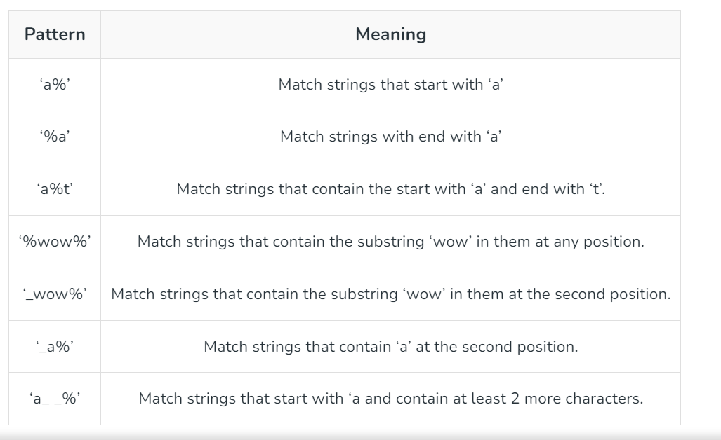

1. SQL IN clause :

The IN command allows you to specify multiple values in a WHERE clause.

The IN operator is a shorthand for multiple OR conditions.

Syntax:

SELECT column_name(s)

FROM table_name

WHERE column_name IN (value1, value2, ...);

1. BETWEEN clause:

The BETWEEN command is used to select values within a given range. The values can be numbers, text, or dates.

The BETWEEN command is inclusive: begin and end values are included.

Syntax:

SELECT column_name(s)

FROM table_name

WHERE column_name BETWEEN value1 AND value2;

LAB WORK

1. Create Database library_db and table books and insert data into the books.

Query:

CREATE DATABASE libarary_db;

CREATE TABLE books(

id int NOT NULL PRIMARY KEY,

title varchar(50),

author varchar(50),

year_published varchar(50)

);

OUTPUT:

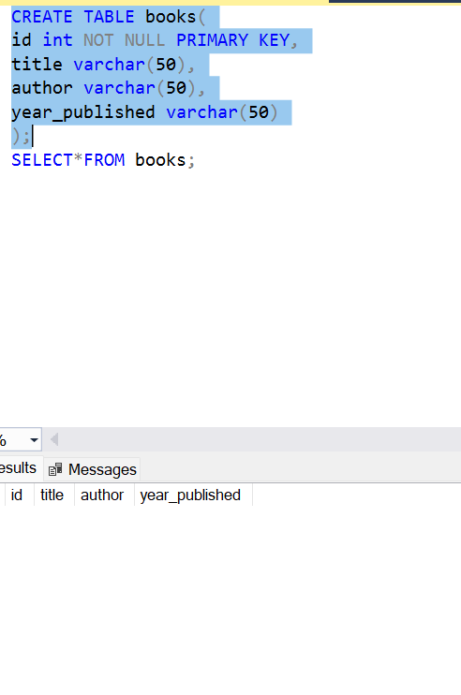

1. Insert data into the books.

Query:

INSERT INTO books Values

(1,'Muna Madan','Laxmi Parsad',1925),

(2,'Ramayan','Valmiki',1960),

(3,'Sumer Love','Subin Bhattarai',1949),

(4,'EK Sarko Maya','Bibek Ojha',1951),

(5,'China Harayako Manchhe','Hari Bansha Acharya',1813),

(6,'Shiris Ko Phool','Parijat',2005);

OUTPUT

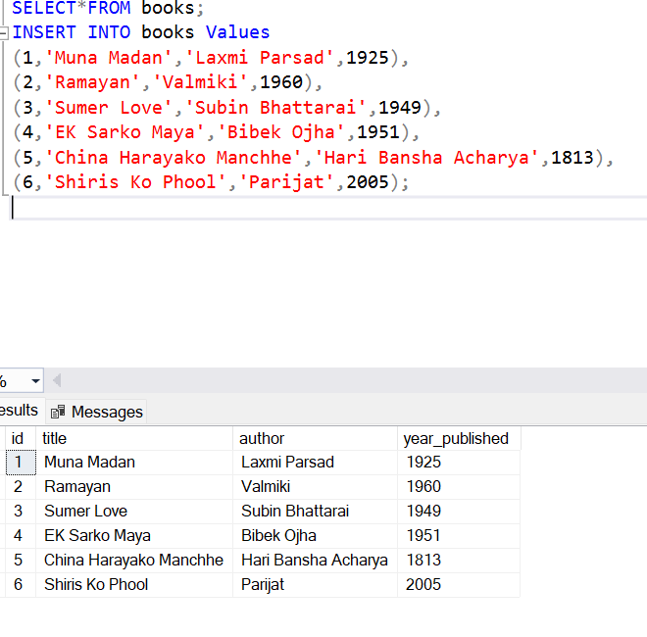

1. Find all the books with titles that start with the letter “E”.

Query:

SELECT title FROM books WHERE title LIKE 'E%';

OUTPUT:

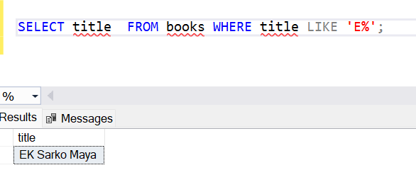

1. Find all the books whose author contains the substring “Ojha”;

Query:

SELECT * FROM books WHERE author LIKE '%ojh%';

OUTPUT:

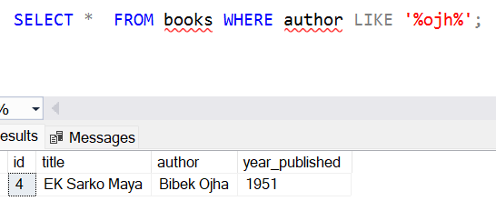

1. Find all books published between the year 2005 &2024.

Query:

SELECT * FROM books

WHERE year_published BETWEEN 2005 AND 2024;

OUTPUT:

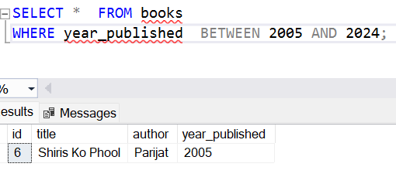

1. Find all books written by ‘laxmi parsad’, ‘valmiki’, ‘Subin Bhattrai’.

Query:

SELECT * FROM books

WHERE author IN('laxmi parsad', 'valmiki', 'Subin Bhattarai');

OUTPUT:

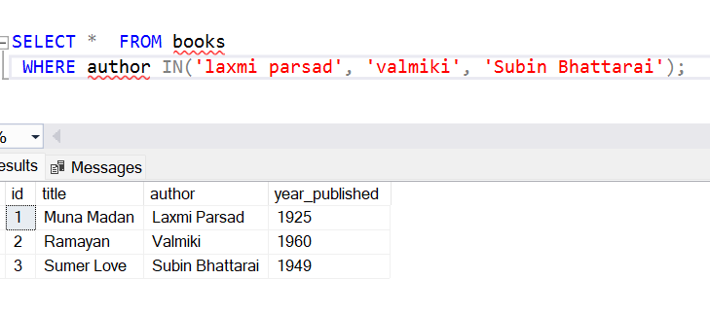

1. Find the books published in the year 2005 and 1813.

Query:

SELECT * FROM books

WHERE year_published IN('2005', '1813');

OUTPUT:

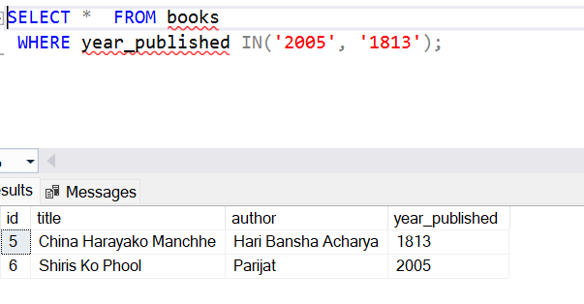

1. Find all the books starting with ‘S’ and published Between 1800 to 2005.

Query:

SELECT * FROM books

where title like 'S%' AND year_published BETWEEN 1800 AND 2005;

OUTPUT:

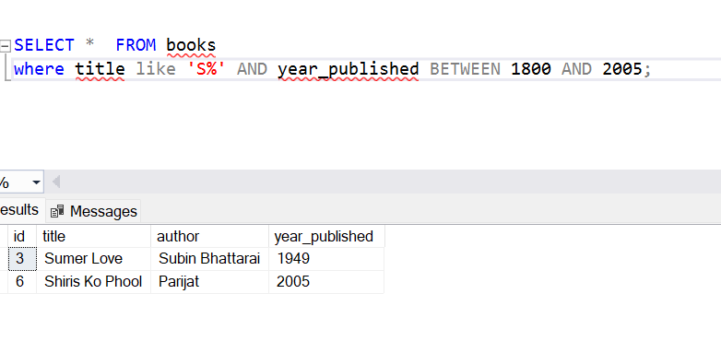

CONCLUSION:

In this lab session we were learned about the SQl like operator ,SQL IN clause ,BETWEEN clause. The LIKE operator allows pattern matching, making it easier to search for partial matches. The IN clause simplifies filtering by checking if a value matches any value in a list. The BETWEEN clause efficiently retrieves data within a specified range.