Document Intelligence System
Explanation Document
Assignment 1 • AI & Data Engineering
A rule-based (no-LLM) system that answers plain-English questions about PDF, Excel, and CSV files.
Prepared by Aayush
October 2026

Contents
Contents
1. What I Built and the Problem It Solves
2. What the System Does — Main Features
3. Tech Stack, Libraries, and Tools
4. How to Run the Project Locally
Setup
Ask a one-off question
Interactive mode (file stays loaded)
Run the tests
5. How It Works — Architecture
6. Sample Inputs, Outputs, and Screenshots
6.1 Summary (PDF)
6.2 Filter by value (CSV)
6.3 Filter by number (CSV)
6.4 Sorting (CSV)
6.5 Count with a domain phrase (Excel)
6.6 Search (Excel)
6.7 Aggregation, grouped (CSV)
6.8 Analytics (CSV)
7. Design Decisions
8. Assumptions
9. Known Limitations
10. What I Would Improve Next

1. What I Built and the Problem It Solves
Organisations deal with large volumes of documents every day — spreadsheets of records, PDF reports, CSV exports. Getting a specific answer out of them usually means opening the file and searching manually. I built a Document Intelligence System that lets a person hand over a file and simply ask a question in plain English.
The system reads the file, corrects spelling or grammar mistakes in the question, works out what the user is trying to do, runs that operation against the file, and returns a clean, structured answer. The same query logic works whether the file is a spreadsheet or a PDF.
In short: upload a file + ask a question → get a structured, relevant insight back.

2. What the System Does — Main Features
- File parsing: reads CSV, TSV, Excel (.xlsx/.xls/.xlsm) and PDF files.
- Spell & grammar correction: fixes the query before processing — e.g. “summrize this docment” → “Summarize this document”.
- Intent detection: classifies the query into one of seven intents — Summary, Search, Filter, Count, Aggregation, Sorting, Analytics.
- Query execution: returns accurate results, including value-aware filters (“from Mumbai” knows Mumbai is a City) and grouped aggregation (“total salary by department”).
- Structured output: every response shows file type, original query, corrected query, detected intent (with a confidence score) and the result.
- Multi-document support: one query pipeline, two backends — pandas for tables, text logic for PDFs.
- Confidence & fallback: low-confidence intents are flagged and default to the most forgiving operation instead of failing.

3. Tech Stack, Libraries, and Tools
Area | Choice | Why
Language | Python 3.12 | Strong data-handling ecosystem
Tabular data | pandas | Filtering, grouping, sorting out of the box
Excel | openpyxl (via pandas) | Reads modern Excel files
PDF | pypdf | Pure-Python text extraction
Fuzzy matching | RapidFuzz | Fast edit-distance for spell-fix + column resolution
Sample PDF | reportlab | Generates a demo report
Tests | pytest | 21 unit + end-to-end tests
No database is used — the file itself is the data source, loaded into memory per session. There are no external APIs and no LLM; all natural-language processing is rule-based and edit-distance based, so it runs fully offline.

4. How to Run the Project Locally

Setup
pip install -r requirements.txt # install dependencies
python samples/make_samples.py # generate sample documents

Ask a one-off question
python -m docintel.cli samples/employees.csv "list all employees from Mumbai"

Interactive mode (file stays loaded)
python -m docintel.cli samples/expenses.csv

Run the tests
python -m pytest -q # -> 21 passed

5. How It Works — Architecture
Every query flows through the same four-stage pipeline, each stage a separate module with one job:
parse -> correct -> detect intent -> execute
- Parse (parsers.py): turns any supported file into one common shape — a pandas table (CSV/Excel) or a text string (PDF). Everything downstream branches on this shape, not the file extension, which is what makes multi-document support fall out naturally.
- Correct (corrector.py): checks each word against a vocabulary built from command words plus the file’s own column names, using RapidFuzz edit distance. Real terms like GPA or Mumbai are never mis-corrected; a similarity threshold stops confident-but-wrong fixes.
- Detect intent (intent.py): each intent owns a set of weighted regex signals; the highest total wins and the margin over the runner-up becomes a confidence score. Specific phrases (“top 5”) outweigh generic ones (“find”).
- Execute (executor.py): runs the chosen intent on the table (pandas) or text. A generalised condition parser extracts a (column, operator, value) triple from free text, resolves columns fuzzily, and infers a column from its value when needed.
pipeline.py wires the four stages together and packages the five required output fields; cli.py formats the result for the terminal.

6. Sample Inputs, Outputs, and Screenshots
The screenshots below are real runs of the system. Note that several queries contain deliberate typos (“employes”, “expences”, “docment”) which the corrector fixes automatically.

6.1 Summary (PDF)
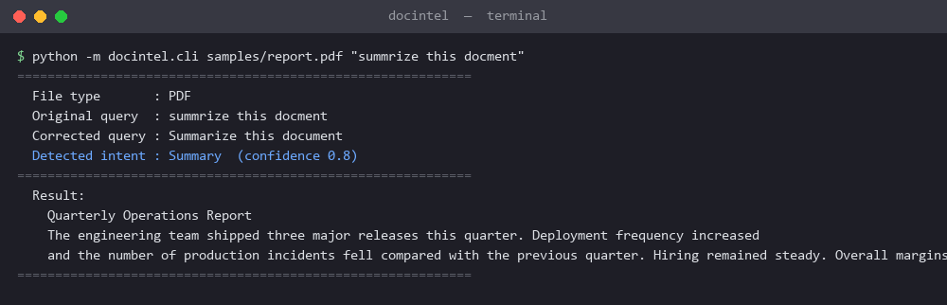
An extractive summary of a PDF report; the query “summrize this docment” is auto-corrected.

6.2 Filter by value (CSV)
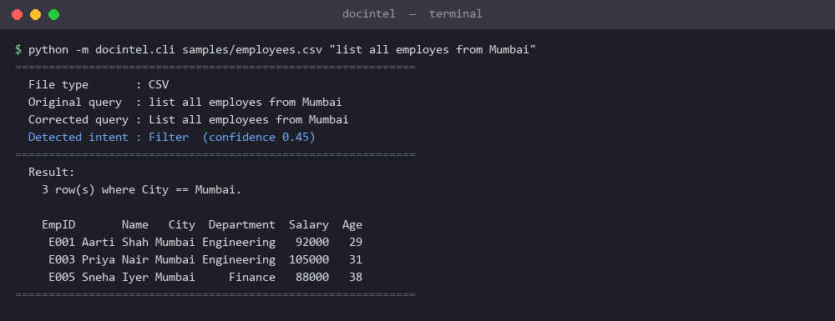
“from Mumbai” names only the value — the system infers that it belongs to the City column.

6.3 Filter by number (CSV)
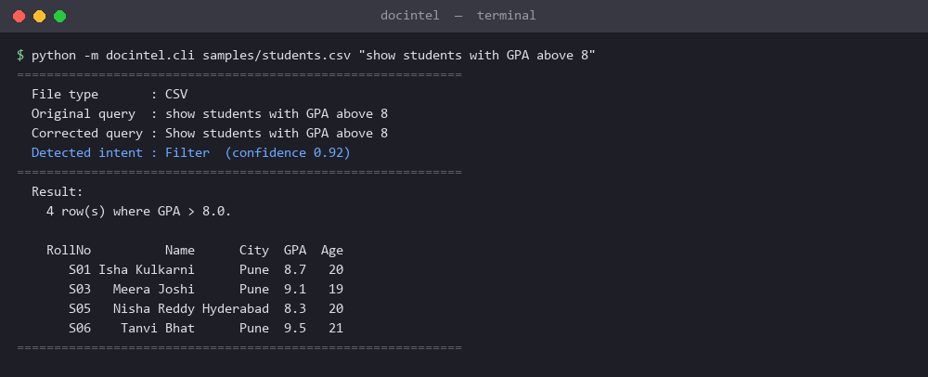
Students with GPA above 8, detected with high confidence.

6.4 Sorting (CSV)
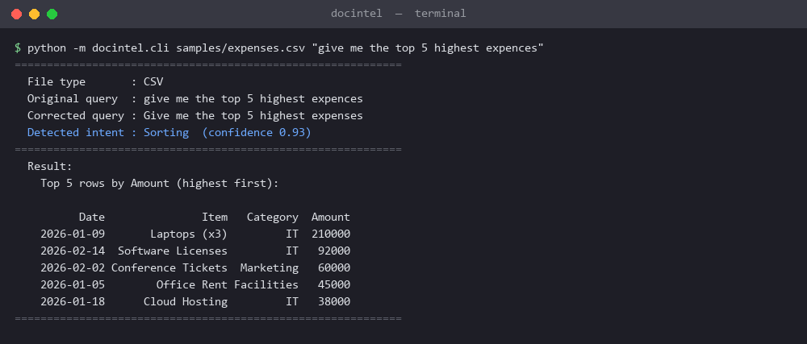
Top 5 highest expenses, sorted by the Amount column.

6.5 Count with a domain phrase (Excel)
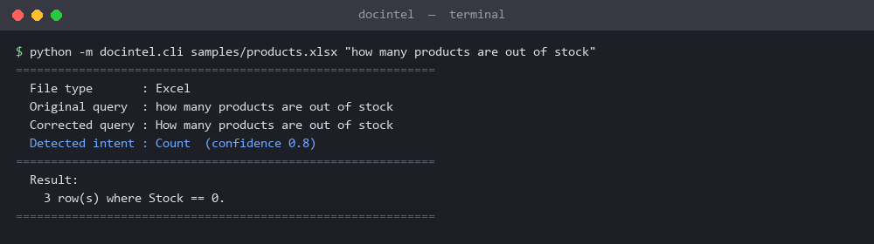
“out of stock” is mapped to the condition Stock == 0.

6.6 Search (Excel)
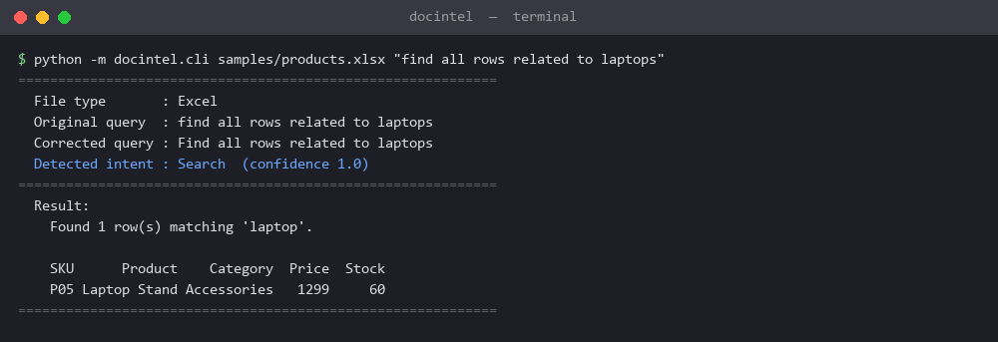
“laptops” (plural) still finds “Laptop Stand” via a singular retry.

6.7 Aggregation, grouped (CSV)
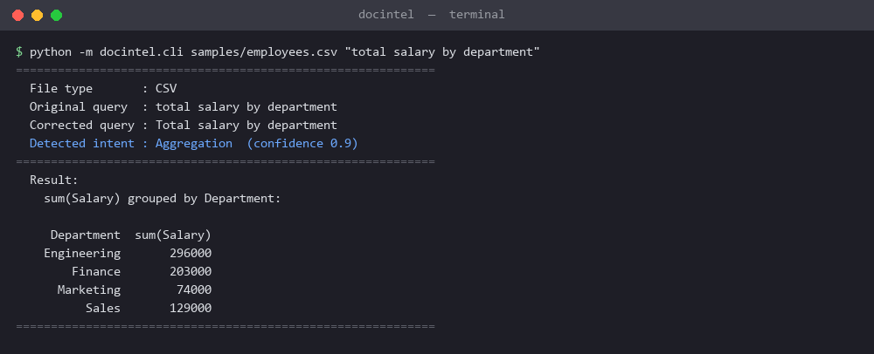
Total salary grouped by department.

6.8 Analytics (CSV)
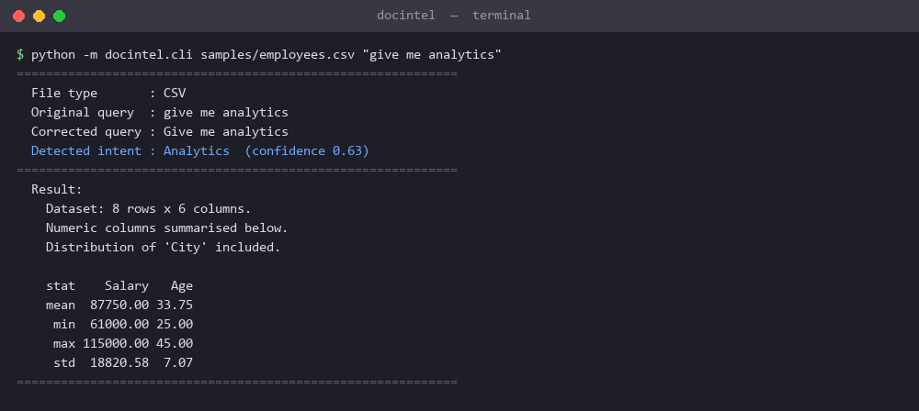
Dataset overview with numeric statistics and a category distribution.

7. Design Decisions
- Four-stage pipeline. Separate, narrowly-scoped modules make each stage independently testable and swappable.
- A normalised Document. Parsers return the same shape regardless of file type, so downstream code branches on document kind, not extension.
- Document-aware spell correction. Seeding the vocabulary with the file’s column names prevents real terms from being wrongly corrected.
- Weighted intent rules. Scoring instead of keyword matching lets overlapping queries route correctly and yields a confidence value for free.
- Generalised condition parsing. One parser handles “above 5000”, “from Mumbai”, and “GPA above 8” without hardcoding.
- Extensibility by design. New file type = one parser + one line; new intent = one rule set + one handler; new domain phrase = one line.

8. Assumptions
- The first row of a spreadsheet is the header; the first sheet is the one read (other sheet names are kept in metadata).
- A column is treated as numeric if at least 60% of its values parse as numbers — tolerant of a few stray text cells.
- When a numeric comparison names no column (“above 5000”), the main numeric column is assumed to be the target.
- PDFs are text-based; scanned or image-only PDFs would need OCR, which is not included.

9. Known Limitations
- One condition per query. “salary above 90000 and city Mumbai” applies only the first condition.
- PDF tables are read as flowing text, not reconstructed into a grid, so numeric aggregation over a PDF table is not supported.
- Summarisation is extractive (it selects representative existing sentences), not abstractive.
- The common-word dictionary is small, so a very unusual misspelling may be left uncorrected rather than mis-corrected — a deliberate safe-failure choice.

10. What I Would Improve Next
- Multi-condition filters (A and B, A or B) with a small expression parser.
- Proper PDF table extraction (e.g. pdfplumber) to unlock aggregation on PDFs.
- A thin web UI (Streamlit/Flask) with drag-and-drop upload over the same pipeline.
- Optional semantic search using TF-IDF / embeddings for “related to” queries that miss synonyms.
- Date-aware filtering (“expenses in February”, “last 30 days”).

