GitHub Insights Dashboard
API Insights Dashboard — Explanation Document
Assignment 2 • Web Development & Data Engineering
Live GitHub metrics with saved, prioritised observations backed by SQL.
Prepared by Aayush
October 2026

Contents
Contents
1. What I Built and the Problem It Solves
2. What the System Does — Main Features
3. Tech Stack, Libraries, Database, APIs, and Tools
4. How to Run the Project Locally
Setup & start
Optional: raise the GitHub rate limit
Run the tests
5. How It Works — Architecture
Database schema (insights table)
6. Sample Inputs, Outputs, and Screenshots
6.1 The dashboard
6.2 Saving an insight
6.3 Saved-insights view
6.4 Filtering saved insights
6.5 Graceful error state
7. Design Decisions
8. Assumptions
9. Known Limitations
10. What I Would Improve Next

1. What I Built and the Problem It Solves
Raw API data is rarely useful on its own — a GitHub account’s repository list is dozens of JSON objects with no shape or story. I built an API Insights Dashboard that fetches live data from the GitHub REST API, turns it into a clean dashboard a non-technical person can read at a glance, and lets the user save observations (a note plus a priority) against any repository to a SQL database for later review.
In one line: fetch live GitHub data → understand it as metrics and trends → save and manage your own insights on top of it.

2. What the System Does — Main Features
- Live data fetching: with three honest UI states — a loading spinner, a graceful error message, and a manual Refresh button.
- A real dashboard, not a data dump: KPI tiles (repos, stars, forks, open issues, average stars), a derived-insight banner, a top-repos bar chart, a language-distribution doughnut, and a filterable repository table.
- Save insights to SQL: write a note and pick a priority (High / Medium / Low) on any repo; stored in SQLite.
- Saved-insights view: a dedicated tab showing item name, note, priority, and timestamp.
- Full CRUD: Create and Read (required) plus Update and Delete (bonus).
- Filter & search: saved insights by priority, free text, and sort order.
- Graceful API failure handling: unknown accounts, rate limits, timeouts and outages each produce a specific, friendly message — never a broken screen.

3. Tech Stack, Libraries, Database, APIs, and Tools
Area | Choice | Why
Backend | Python + Flask | Lightweight; quick to expose a clean JSON API
Database | SQLite (sqlite3) | Zero-config SQL, ideal for a single-file app
External API | GitHub REST API | Free, no key needed, rich structured data
HTTP client | requests | Robust server-side fetching with timeouts
Frontend | Vanilla JS + Chart.js | No build step; Chart.js for clean visuals
Tests | pytest | 10 tests across DB, transform, and HTTP layers
The GitHub call is proxied server-side rather than from the browser. That gives one place to shape the data and compute derived metrics, uniform error handling, and the option to keep a GITHUB_TOKEN secret on the server.

4. How to Run the Project Locally

Setup & start
pip install -r requirements.txt # Flask, requests, pytest
python app.py # http://127.0.0.1:5000
Open the URL, type a GitHub username or organisation (e.g. vercel, facebook) and press Load.

Optional: raise the GitHub rate limit
$env:GITHUB_TOKEN = "ghp_your_token"; python app.py # PowerShell

Run the tests
python -m pytest -q # -> 10 passed

5. How It Works — Architecture
Browser (dashboard) ---> Flask ---> GitHub API (live metrics)
| |
+------------------+---> SQLite (insights) (saved observations)
- app.py — Flask routes. /api/github/<account> fetches repos, drops forks, aggregates totals, computes derived insights, and returns dashboard-ready JSON. /api/insights is a small CRUD API.
- db.py — a framework-free SQLite layer. Every query is parameterised; ORDER BY is whitelisted, never interpolated.
- schema.sql — the insights table plus two indexes.
- static/ — the single-page dashboard (index.html, style.css, app.js) with two tabs and a shared create/edit modal.

Database schema (insights table)
Column | Type | Notes
id | INTEGER PK | autoincrement
source | TEXT | defaults to 'github'; lets a future API reuse the table
item_name | TEXT | e.g. facebook/react
item_url | TEXT | link back to the item
note | TEXT | the observation
priority | TEXT | High / Medium / Low (CHECK-constrained)
created_at | TEXT | ISO-8601 UTC
updated_at | TEXT | set on edit

6. Sample Inputs, Outputs, and Screenshots
Input: the GitHub account vercel. Output: 98 repositories aggregated into 517,187 total stars, 84,524 forks, 11,888 open issues, ~5,277 average stars per repo, TypeScript as the primary language across 10 languages, and vercel/next.js as the most-starred repo.

6.1 The dashboard
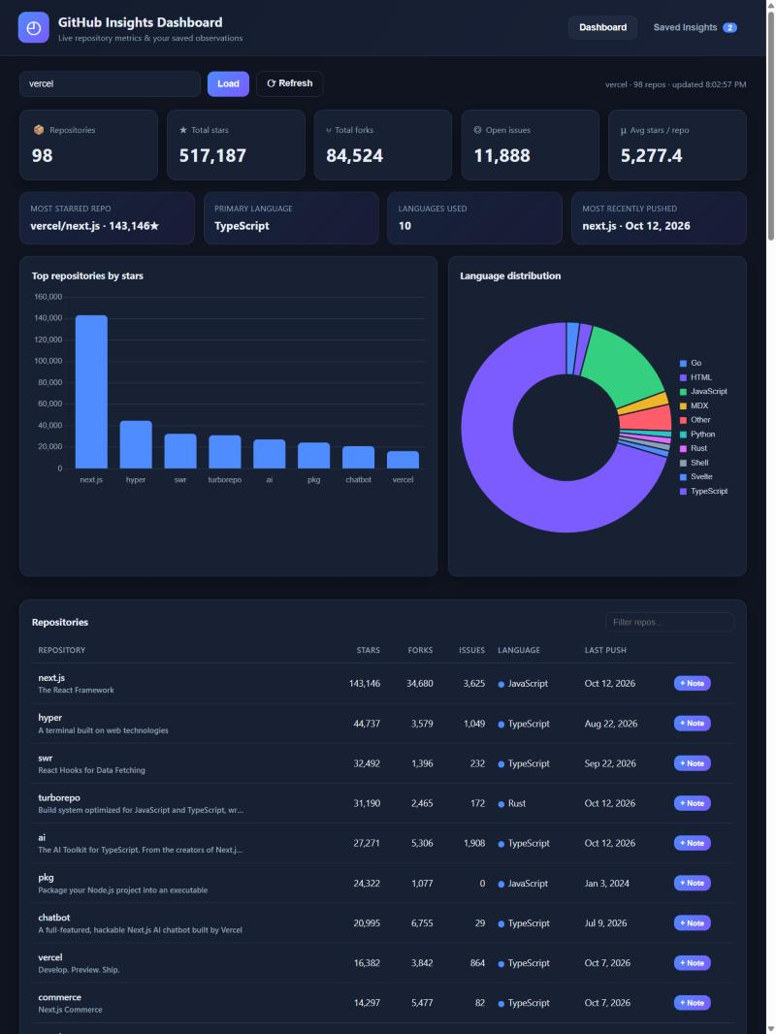
Live metrics, a derived-insight banner, two charts, and a filterable repository table.

6.2 Saving an insight
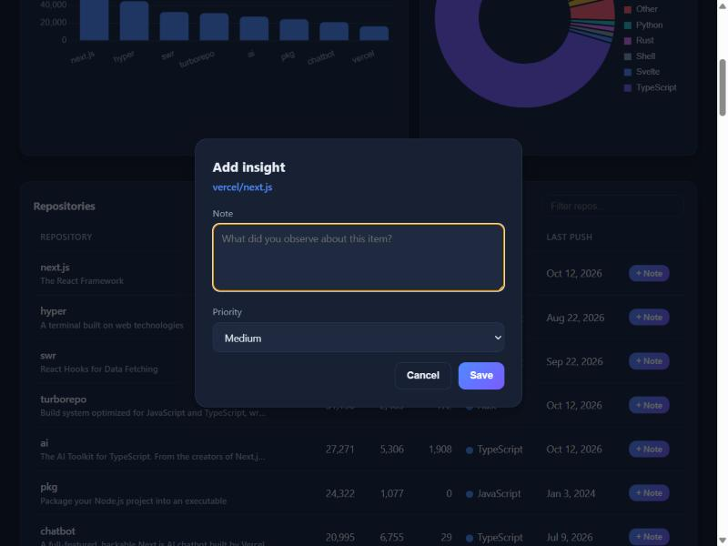
A note and a priority are attached to a repository and written to SQLite.

6.3 Saved-insights view
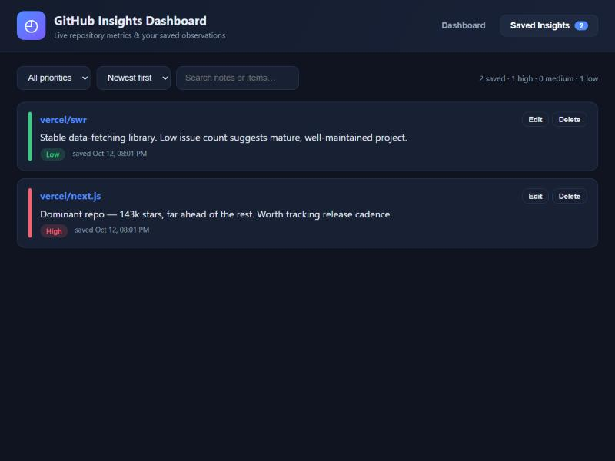
Item name, note, colour-coded priority, and timestamp, each with Edit and Delete.

6.4 Filtering saved insights
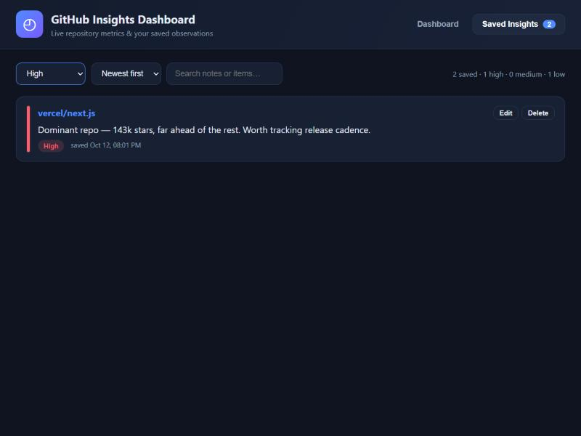
Filtering the saved list to High-priority items only.

6.5 Graceful error state
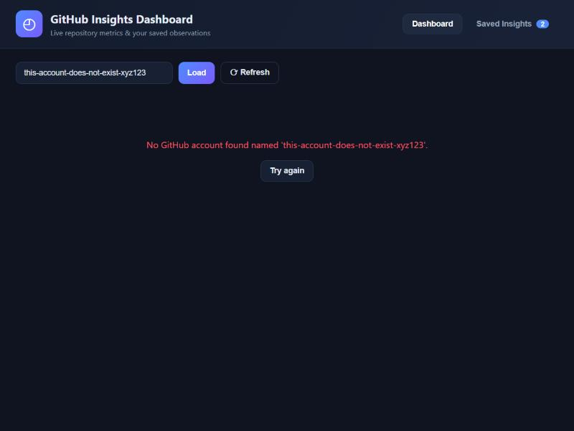
An unknown account produces a friendly message and a retry button, not a broken screen.

7. Design Decisions
- Server-side API proxy + transform. the browser never sees raw GitHub JSON; it receives exactly the metrics it renders.
- Derived metrics over raw fields. averages, rankings, and a language breakdown answer “what does this account look like?”
- An extensible single-table schema. a source column and generic item_name / item_url mean a second API could reuse the same table without a migration.
- Safety in the data layer. parameterised queries everywhere; priority is CHECK-constrained in SQL and validated in Python; ORDER BY is whitelisted.
- Honest UI states. loading, error, and empty states are first-class, so the app never looks broken.

8. Assumptions
- Public repositories are the subject; forks are excluded so metrics reflect the account’s own work.
- The GitHub pushed_at timestamp represents “recent activity”.
- Up to 100 repositories are fetched (one API page) — enough for the metrics without pagination.
- Unauthenticated use is assumed (60 requests/hour); a GITHUB_TOKEN raises this to 5000.

9. Known Limitations
- No pagination beyond the first 100 repos, so very large accounts are partially summarised.
- Rate limits can be hit without a token after several refreshes.
- Insights are free text and not linked to a live snapshot of the metric, so a note won’t auto-update if stars change.
- Single user / no auth — saved insights are shared, not per-account.

10. What I Would Improve Next
- Paginate and cache GitHub responses (per account, for a few minutes).
- Store a metric snapshot alongside each insight so values can be tracked over time.
- Add a second data source (weather or movies) to exercise the schema’s source column.
- User accounts so insights are private and per-user.
- A trend view (stars over time) using the GitHub stats endpoints.

