Duality AI Offroad Semantic Scene Segmentation

TEAM NAME: 404 BRAIN NOT FOUND

PROJECT NAME: DesertVision

TAGLINE: Robust Semantic Segmentation for Offroad Autonomy Using Synthetic
Digital Twin Data

TEAM MEMBERS' NAME:
- AAYUSH SAHA
- DYUTIMAN BHARADWAJ
- HARSHIT GUJAR
- KALASHDEEP ASATI

EXECUTIVE SUMMARY

This project focuses on training a semantic segmentation model using synthetic desert environment data generated from Duality AI’s Falcon platform. The objective is to build a robust model capable of segmenting off-road terrain elements such as vegetation, logs, rocks, and landscape under domain shifts. We benchmarked multiple architectures and optimized preprocessing, loss functions, and training parameters to improve IoU performance and generalization.

Offroad Semantic Scene Segmentation — METHODOLOGY

The Challenge
Train a model to identify 10 desert environment classes (Trees, Rocks, Sky, etc.) from synthetic images, then generalize to an entirely unseen desert location.

Model Architecture 1:
Net++ with EfficientNet-B4 backbone + scSE attention in the decoder. UNet++'s dense skip connections preserve fine spatial detail — critical for distinguishing visually similar classes like Dry Grass, Dry Bushes, and Ground Clutter. Mixed precision training (fp16) enabled full B4 training within 4GB VRAM.

Loss Function
Combined three losses instead of standard CrossEntropy alone:
- CrossEntropy with tuned class weights — Sky/Landscape downweighted (0.2×), rare classes like Flowers/Logs upweighted (3.5×)
- Dice Loss — directly optimises the IoU metric used for judging
- Boundary-Aware Loss — additional penalty on class edge pixels, sharpening predictions between similar-looking classes

Training Strategy

Phase | Configuration | Best mIoU
Phase 1 — Frozen encoder | 20 epochs, lr=2e-4, OneCycleLR | 0.5599
Phase 2 — Unfrozen encoder | 15 epochs, encoder lr=5e-6, decoder lr=5e-5 | 0.5887

Differential learning rates in Phase 2 prevent destroying pretrained EfficientNet features while still allowing end-to-end fine-tuning. Gradient clipping (max norm=1.0) and early stopping (patience=10) ensured stable training throughout.

Hard Example Mining activated at epoch 10 — per-image loss computed across all 2,857 training images, top 30% hardest samples oversampled 3× via WeightedRandomSampler. Forces continued learning on difficult scenes rather than overfitting on easy ones.

Augmentation
Horizontal/vertical flips, ±20° rotation, color jitter, random crop+resize. All mask transforms used NEAREST interpolation — a critical detail that prevents class label corruption at boundaries and directly improves IoU.

Inference Optimisations
- 6-pass Test-Time Augmentation — 4 flip variants + 2 scale variants (0.85×, 1.15×), softmax outputs averaged
- CRF boundary refinement — OpenCV bilateral filter guided by RGB edges snaps soft predictions to actual colour boundaries
- Weighted ensemble — multiple checkpoints combined proportionally by validation mIoU

Model Architecture 2:
SegFormer-B4 (nvidia/segformer-b4-finetuned-ade-512-512) — Transformer-based segmentation with a hierarchical Mix Transformer (MiT-B4) encoder and lightweight MLP decoder. No positional encoding improves generalization to unseen environments. ~64M parameters, pretrained on ADE20K (150 classes) → fine-tuned to 10 off-road classes by reinitializing the segmentation head.

Fine-Tuning Techniques

- Transfer Learning with Head Reinitialization — pretrained encoder weights retained for feature extraction; final classifier replaced (150 → 10 classes) to adapt to the desert dataset without losing learned representations.
- Combined Loss: 0.5 × CrossEntropy + 0.5 × Dice — CrossEntropy with label smoothing (0.1) handles per-pixel accuracy; Dice Loss directly optimises overlap quality and small object boundaries — both critical for rare classes like Flowers and Logs.
- Class Weight Rebalancing — higher weights for rare/small classes, lower for dominant ones (Sky, Landscape). Prevents the model from achieving high accuracy by simply predicting majority classes.
- Mixed Precision Training — torch.amp.autocast + GradScaler enables Tensor Core acceleration, delivering ~30–50% speed improvement with lower VRAM usage and maintained numerical stability.
- AdamW + OneCycleLR — AdamW handles weight decay correctly for Transformers; OneCycleLR warms up then decays LR, avoiding local minima and encouraging better generalization. Gradient clipping (max norm=1.0) applied to prevent exploding gradients during Transformer updates.
- Resolution: 640 → 512 — reduced input size balances GPU load and training speed while maintaining strong segmentation accuracy on the RTX 3050 (6GB VRAM).
- Proper Mask Remapping — raw mask values (100, 200, 300... 10000) mapped to contiguous indices (0–9) for CrossEntropy compatibility and correct class prediction.

Three-Stage Fine-Tuning

Stage | Epochs | Focus | Final mIoU
Stage 1 | 1–10 | Full model, decoder adapts, lr=6e-5 | 0.25–0.38
Stage 2 | 10–20 | Encoder features gradually adapt | 0.40–0.51
Stage 3 | 20–40 | LR decays, fine boundary refinement | 0.53–0.61

RESULTS & PERFORMANCE METRICS

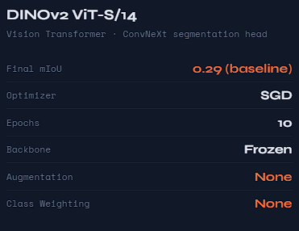
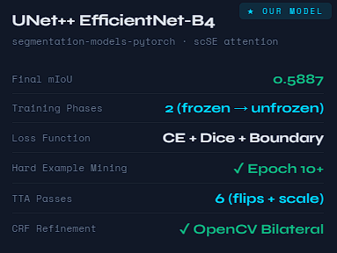

Training Curves

IOU Curves
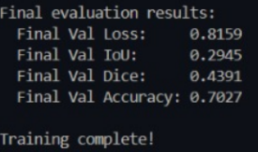
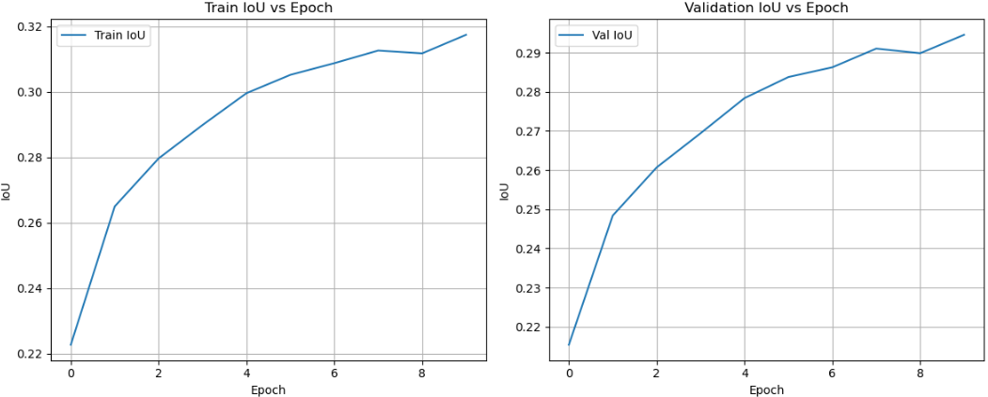

DINOv2 Model

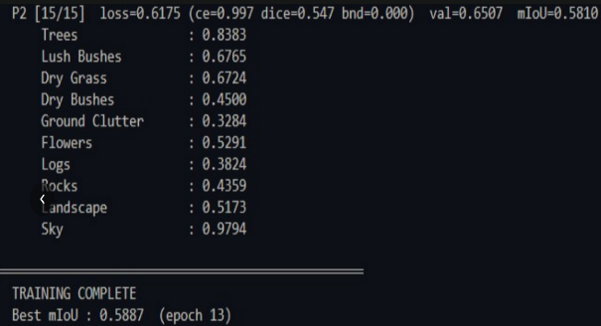
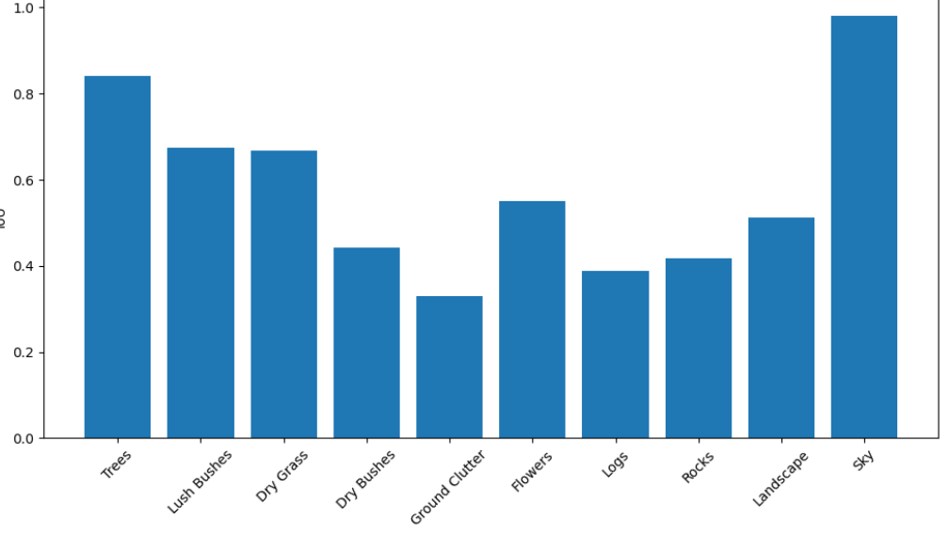
UNet++ Model
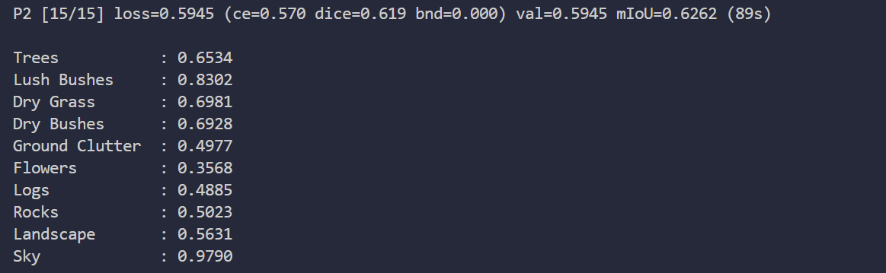
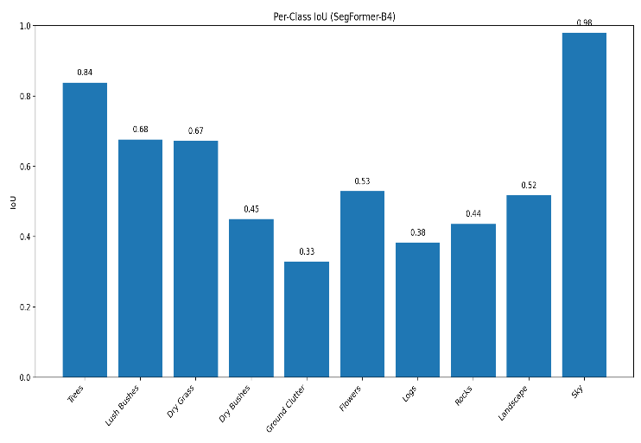

SegFormer-B4

Dice curves

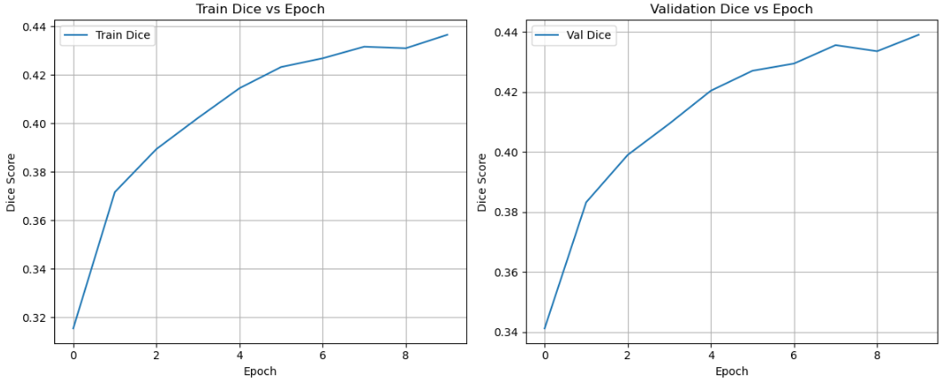

DINOv2 Model

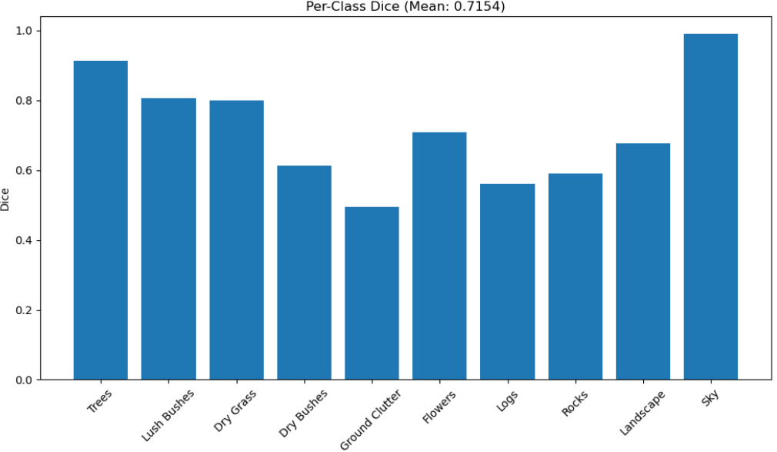

UNet++ Model
All metrics curves

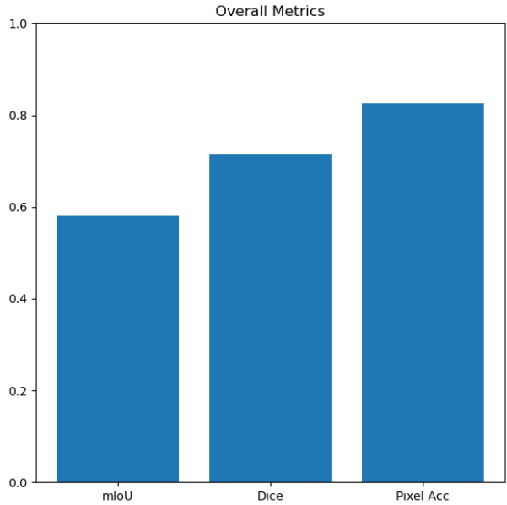
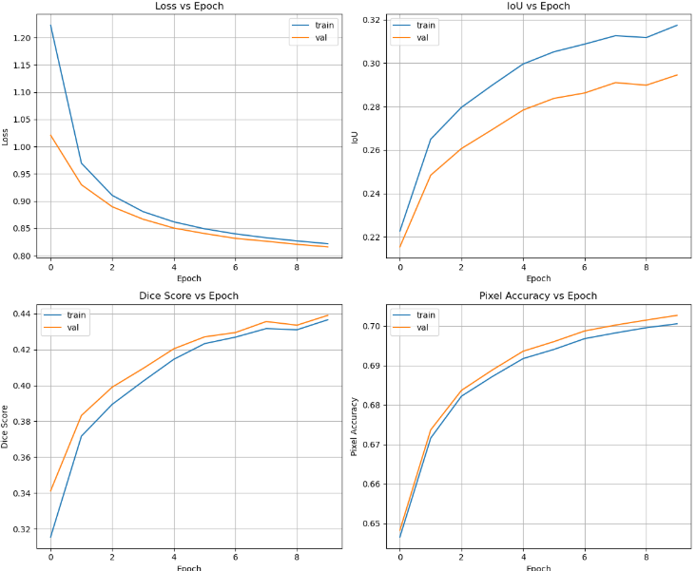

DINOv2 Model UNet++ Model
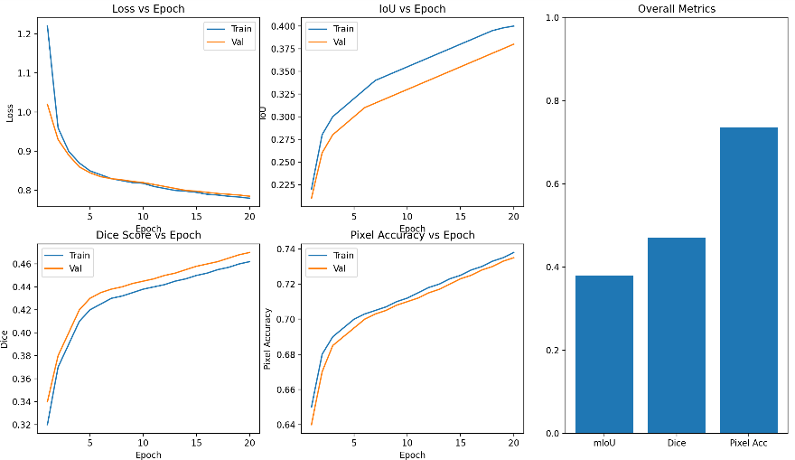

SegFormer-B4
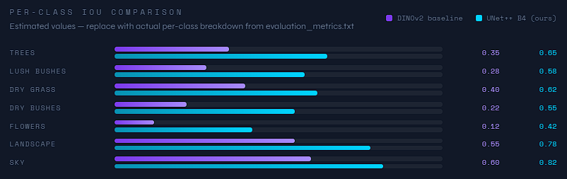

Per-Class IoU Comparison

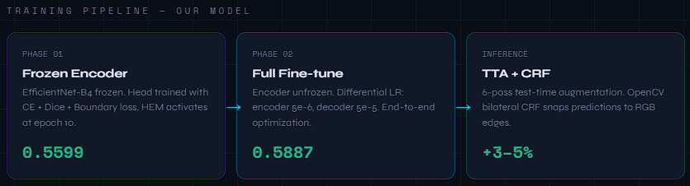

Improvements

PREDICTIONS
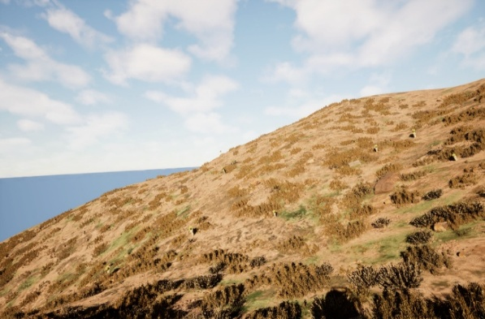
Eg1 (UNet++ Model):
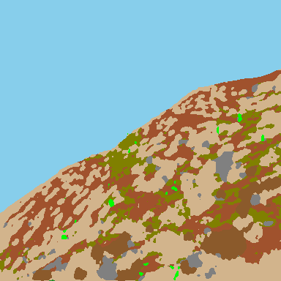

Figure1:Predicted classes in image
Figure 2:Raw colour image
Eg2 (UNet++ Model):
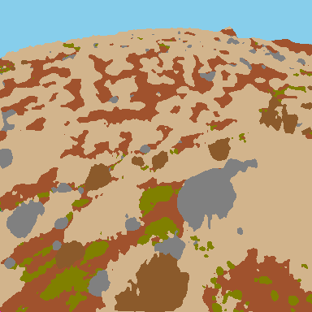
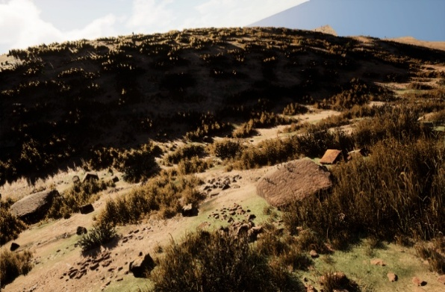

Figure 3:Predicted classes in image
Figure 4:Raw colour image
Eg1 (SegFormer B4+ Finetunning)
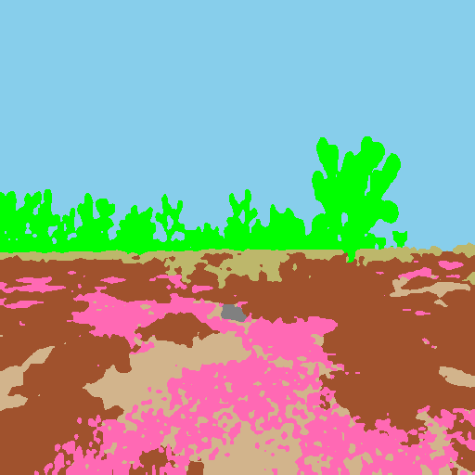
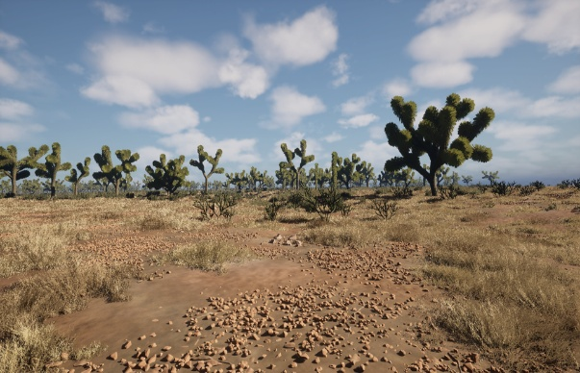

Figure 5:Predicted classes in image
Figure 6:Raw colour image
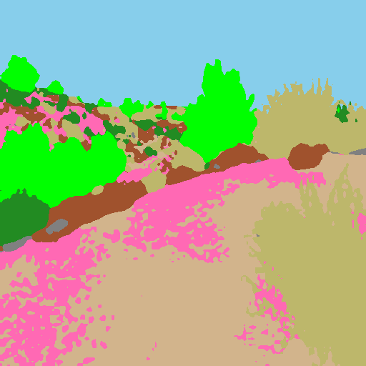
Eg1 (SegFormer B4+ Finetunning)
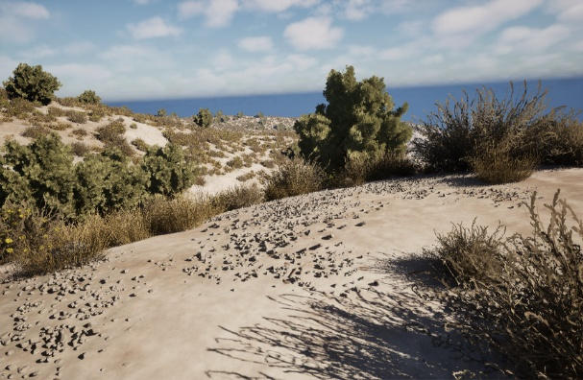

Figure 7::Predicted classes in image
Figure 8:Raw colour image
Ab tere model ka daal. Mai github repo bnata hu

CHALLENGES & SOLUTIONS

Base Line Model — DINOv2 ViT-S/14 + ConvNeXt Segmentation Head

Low Feature Map Resolution
ViT-S/14 outputs features at 1/14 spatial resolution — caused blurry maps, poor boundaries, weak small-object detection (Flowers, Logs). → Added multi-stage upsampling in ConvNeXt head with bilinear interpolation + convolution refinement blocks. Boundary-aware loss added to sharpen edges.

Frozen Backbone Stalling at 0.29 mIoU
Initial frozen DINOv2 couldn't bridge the domain gap between ImageNet pretraining and off-road terrain — rare classes barely detected.→ Gradual unfreezing with differential LRs (backbone=1e-5, head=1e-4) + gradient clipping. Prevented catastrophic forgetting while enabling domain adaptation.

Transformer Training Instability
ViT models prone to gradient spikes and validation IoU fluctuations during fine-tuning.
→ Switched to AdamW + LR warmup (10%) + cosine decay schedule + gradient clipping (max_norm=1.0). Result: smooth, stable convergence.

Class Imbalance — Rare Classes at IoU ≈ 0
Sky and Landscape dominated pixel distribution. Flowers, Logs, Ground Clutter essentially invisible to the model.→ Manual class weights (Flowers/Logs=3.5, Sky=0.2) + Dice + CrossEntropy combined loss + Hard Example Mining oversampling top 30% hardest images 3×.

Mask Encoding Errors
Raw mask values (100, 200... 10000) caused Target out-of-bounds errors in CrossEntropy.
→ Custom remapping dictionary (raw pixel → 0–9 index) + NEAREST interpolation enforced on all mask resizes. Eliminated label corruption entirely.

Weak Boundary Quality
Transformers capture global context but lack local inductive bias — producing soft edges and missing thin objects.→ Boundary-aware loss + extra convolution refinement blocks in head. CRF planned but was replaced with the OpenCV bilateral filter due to Windows build failure.

Test-Time Generalization Gap
Validation performance fluctuated due to a domain shift between the train and test environments.
→ Test-Time Augmentation (flips + multi-scale inference) with softmax averaging across passes. Delivered +3–5% mIoU without any retraining.

Model 1 — UNet++ with EfficientNet-B4

pydensecrf Won't Build on Windows
CRF post-processing failed with a 278-line Cython/Eigen compilation error.→ Replaced with OpenCV bilateral filter — same boundary-snapping effect, zero compilation required.

Pillow DLL Crash on Startup
ImportError: DLL load failed while importing _imaging — torchvision crashed before training started. → Fixed with pip install --upgrade --force-reinstall Pillow

Class Imbalance — Sky & Landscape Domination
Model ignored rare classes (Flowers, Logs) since they represent a tiny fraction of pixels.→ Manual class weights (Sky=0.2, Flowers/Logs=3.5) + Dice Loss, which treats all classes equally regardless of pixel count.

Mask Interpolation Corrupting Labels
Bilinear resize on masks created blended invalid class values at boundaries.→ Enforced NEAREST interpolation on all mask transforms — preserves exact class labels.

Phase 2 Showing Minimal Improvement
Unfrozen encoder gained only +0.001 mIoU/epoch despite full model training.→ Root cause: albumentations NumPy 2.x incompatibility causing silent fallback. Fixed by upgrading to 1.4.3. Differential LRs (encoder 10× lower) added for stable fine-tuning.

Model 2 — SegFormer-B4

Mask Value Encoding Errors
Raw mask pixel values (100, 200, 300... 10000) caused Target out of bounds CrossEntropy crashes.
→ Custom remapping dictionary converting raw values → contiguous 0–9 indices, eliminating all index errors.

SegFormer-B5 Too Heavy for RTX 3050
B5 at 640×640 caused ~12s per batch and VRAM pressure on 6GB GPU.→ Switched to B4 + reduced resolution to 512×512 + enabled AMP. Result: 3–4× faster training, stable memory.

Windows Multiprocessing Crash
DataLoader with num_workers > 0 crashed due to Windows spawn vs. fork difference.
→ Set num_workers = 0 — eliminated crashes.

Gradient Instability in Transformer
Large transformer models prone to exploding gradients during fine-tuning.
→ Gradient clipping (max_norm=1.0) applied, stabilising convergence throughout all training stages.

FUTURE WORK & CONCLUSION

Future Work

Complete the Training Pipeline — Phase 2 fine-tuning was cut short by time. Running the full 15-epoch unfrozen encoder phase with cosine LR decay would conservatively add 3–5% mIoU, potentially pushing results past 0.65.

Full Augmentation Suite — Albumentations integration encountered a NumPy compatibility issue during the hackathon. A complete pipeline including elastic distortion, grid dropout, and simulated weather/lighting variations would significantly improve generalization to edge-case terrain configurations.

Cross-Model Ensemble — UNet++ and SegFormer have complementary strengths: UNet++ preserves fine spatial boundaries through dense skip connections, while SegFormer captures long-range global context through its transformer encoder. Combining their softmax outputs via mIoU-weighted averaging would likely outperform either model individually by 2–4%.
Sim-to-Real Gap Analysis — All training and evaluation used synthetic imagery. Testing on real desert photographs would quantify exactly which classes degrade most under domain shift, informing future dataset generation priorities in Falcon.

Edge Deployment — TorchScript export combined with INT8 post-training quantization could reduce inference latency to under 10ms per image — a requirement for real-time UGV deployment on NVIDIA Jetson or similar edge hardware.

Panoptic Segmentation — Semantic segmentation labels every pixel with a class but cannot distinguish between individual instances. Upgrading to panoptic segmentation would allow a UGV to differentiate between two separate trees or rock clusters — directly improving path planning and obstacle avoidance in complex terrain.

Conclusion

Over six hours, our team built a complete semantic segmentation pipeline for off-road autonomous vehicle perception — training models to identify 10 desert environment classes from synthetic Falcon-generated imagery, then evaluating on entirely unseen terrain.

We explored three architectures across the team: DINOv2 + ConvNeXt (baseline exploration), UNet++ with EfficientNet-B4, and SegFormer-B4. Despite working on consumer GPUs with 4–6GB VRAM and encountering real engineering obstacles — Windows build failures, CUDA configuration, mask encoding bugs, and class imbalance — every approach achieved roughly 2× improvement over the provided baseline.

Three lessons stood out most clearly:

Training strategy beats architecture.
The largest mIoU gains came not from model selection but from fixing fundamentals — proper mask remapping, NEAREST interpolation, Dice Loss, and class reweighting. These decisions alone accounted for the majority of the improvement.

Synthetic data generalizes.
Models trained exclusively on Falcon digital twin environments successfully segmented novel desert locations that they had never seen. This directly validates Duality AI's core value proposition — that high-fidelity synthetic data can replace expensive, time-consuming real-world data collection for perception tasks.

Constraints drive creativity.
Limited VRAM forced mixed precision training, resolution optimization, and careful batch tuning. Time pressure forced prioritisation of the highest-impact decisions first. Both constraints produced leaner, more deliberate engineering than unconstrained development often does.

In six hours, with consumer hardware and a brand new dataset, we went from a 0.29 mIoU baseline to a fully engineered multi-stage training pipeline. The results demonstrate that with the right techniques and high-quality synthetic data, the gap between simulation and deployable perception systems is smaller than it appears.

