REPORT
A
B
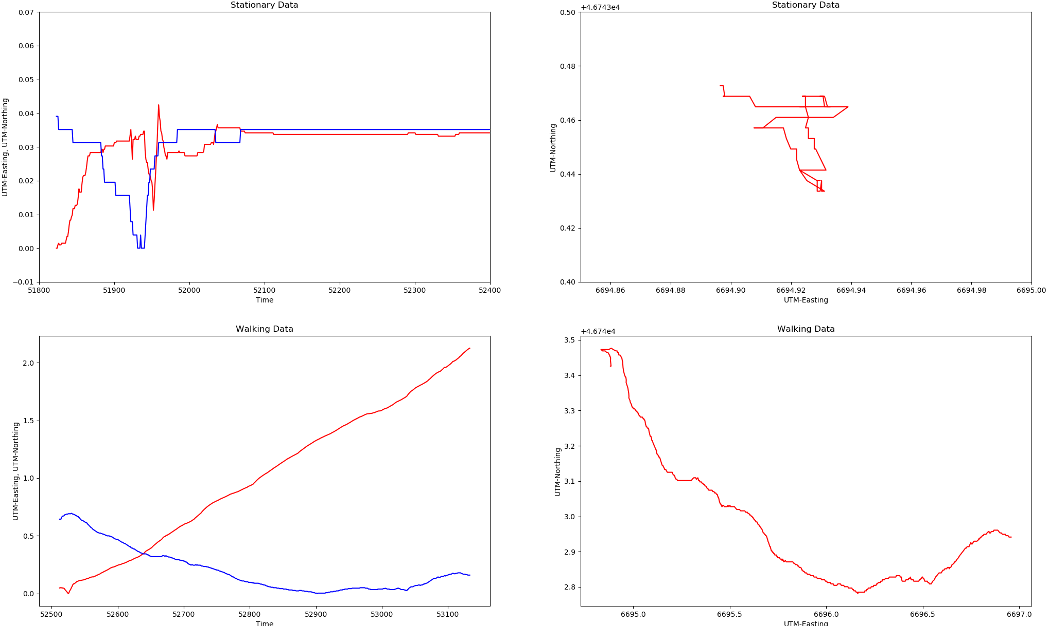
C
D
--- UTM-Easting
--- UTM-Northing
--- UTM-Easting
--- UTM-Northing
Fig. 1

In the above figure, Fig.1, four graphs are plotted ,
“A” for Stationary Data that plots UTM-Easting & UTM-Northing co-ordinates versus Time,
“B” for Stationary Data that plots UTM-Northing co-ordinates versus UTM-Easting co-ordinates,
“C” for Walking Data that plots UTM-Easting & UTM-Northing co-ordinates versus Time,
“D” for Walking Data that plots UTM-Northing co-ordinates versus UTM-Easting co-ordinates.

For plot A, ideally, the GPS puck should transmit a constant value for the utm-easting and utm-northing as the puck is stationary. During the initial time graph, we can observe high fluctuations of the utm co-ordinates which says that the GPS puck transmits an error signal initially. Looking at the graph we can say that the error component is exceedingly small within the range of 0.0 to 0.04. As the time progresses,the puck then readjusts the error component minimizes the error and transmits the precise value and the signal remains constant throughout.

For plot B, the graph should ideally plot a single value as the puck is stationary but due to the error signal transmitted by the gps puck, we get a some error values in the graph. The error component witnessed here ranges between 46743.42 to 46743.48 for UTM-Northing and between 6694.89 to 6694.94 for UTM-Easting.

Note:-For A plot and C plot, both UTM co-ordinates value has been scaled down for analysis purpose
Therefore, by analysing the stationary data, we can conclude that gps puck does transmit an error signal initially but then eliminates the error over time and provides an accurate value. The error signal could be caused because of the sudden noise generated from the surrounding for instance the sun rays or acoustic noise affecting the signal i.e. being received by the GPS puck. The error generated is very minute and we can eliminate the signal either by applying a hardware filter or a software filter while reading the data digitally.

For the walking data, the C graph plots easting and northing data versus time. Here we can see that the range for easting co-ordinates changes by 2 units denoting movements from the East whereas the northing co-ordinates did not change as much as the easting co-ordinates with respect to time. It has change marginally by 0.75 units. From this we can infer that the puck was moved more latitudinally than longitudinally.

The D graph which is plotted as UTM-Northing versus UTM-Easting, shows us that with respect to the movements made latitudinally how much was the puck moved longitudinally. From the graph, we can say that puck was moved longitudinally by a very small amount whereas it made major changes latitudinally.

