**OTT**

**#4WEEK 4APP CHALLENGE**

**3RD APP**

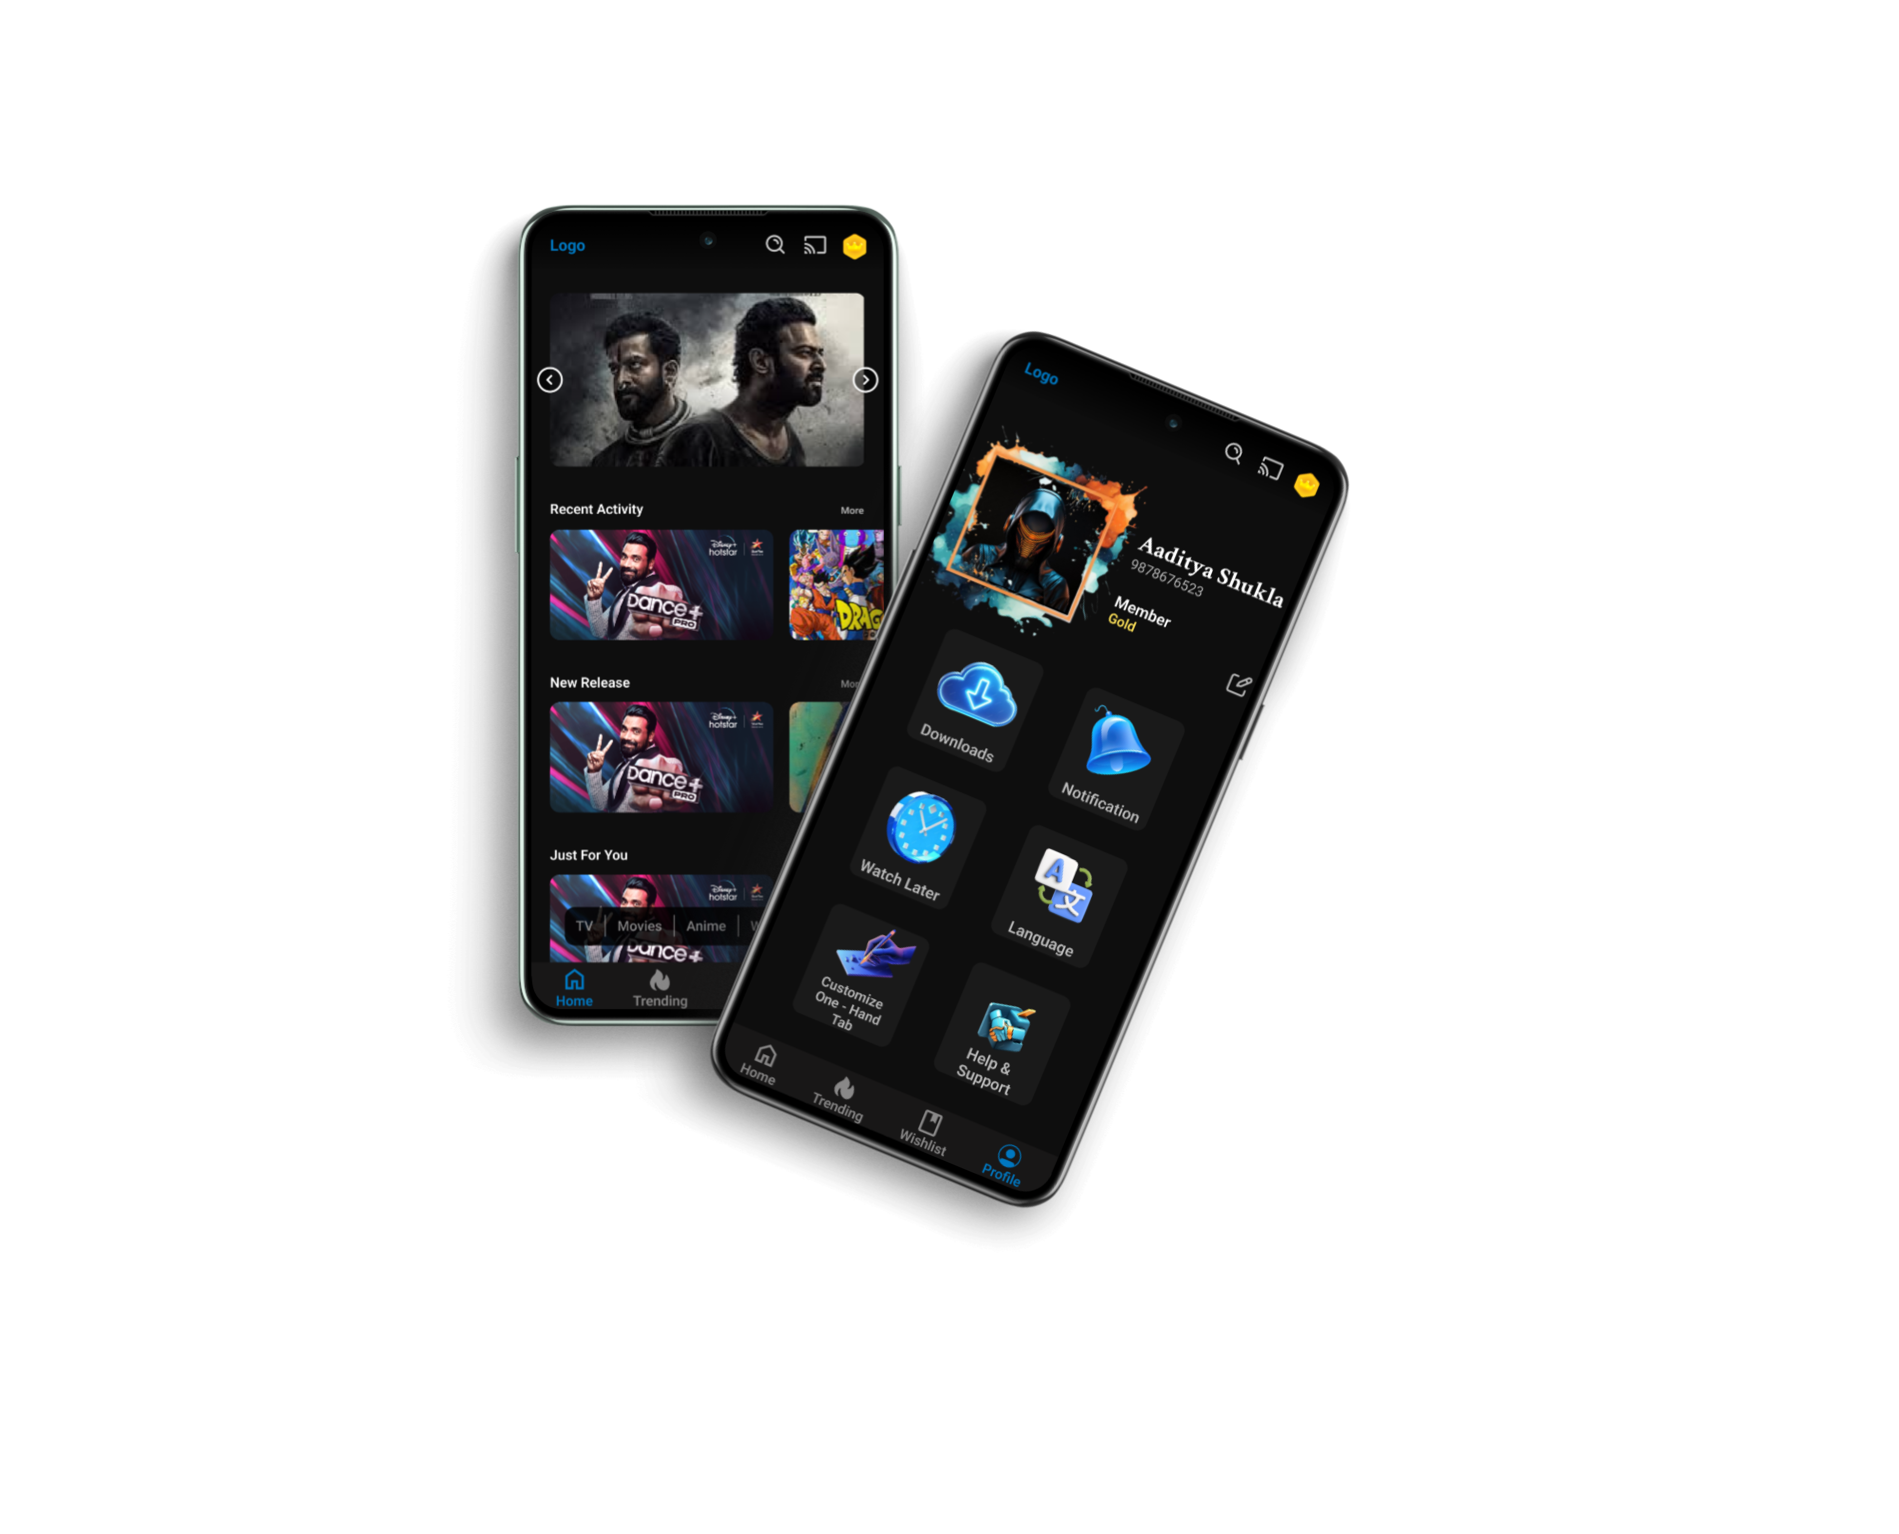

**ANDROID VIEW**

**LINK**

<https://www.figma.com/proto/hYGSMXi1El2jceoXIl7yIU/app-practice-2?page-id=839%3A1415&type=design&node-id=839-1617&viewport=-153%2C-143%2C0.21&t=EMOhuY5uIlJDMGdM-1&scaling=scale-down&starting-point-node-id=981%3A742&mode=design>

In this app i focused on one hand accessibility so pls operate it with single hand

Only profile page have loading animation which normally any app have

You can tap on dragon ball image in recent activity tab

In one hand bar anime option is working

More option of anime slide is working

Please click on r button(pc/laptop) or reset button for mobile if initially animation is not loaded