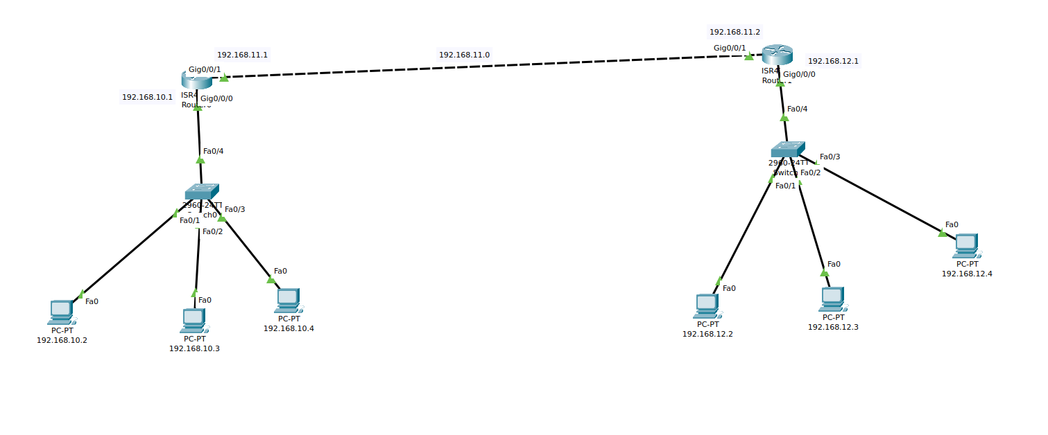
Figure : Static Routing for 2 Routers

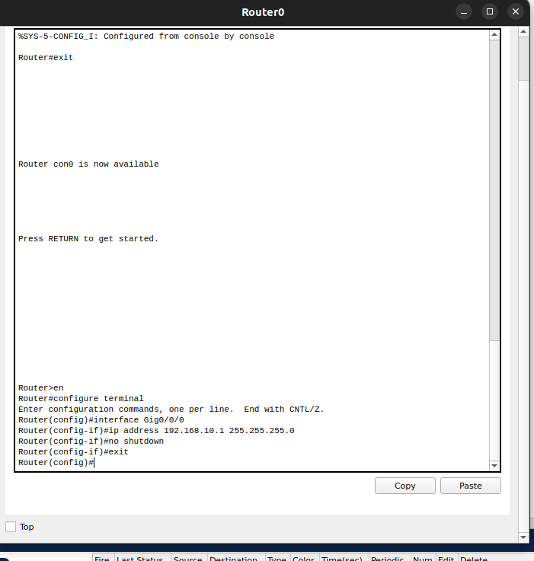
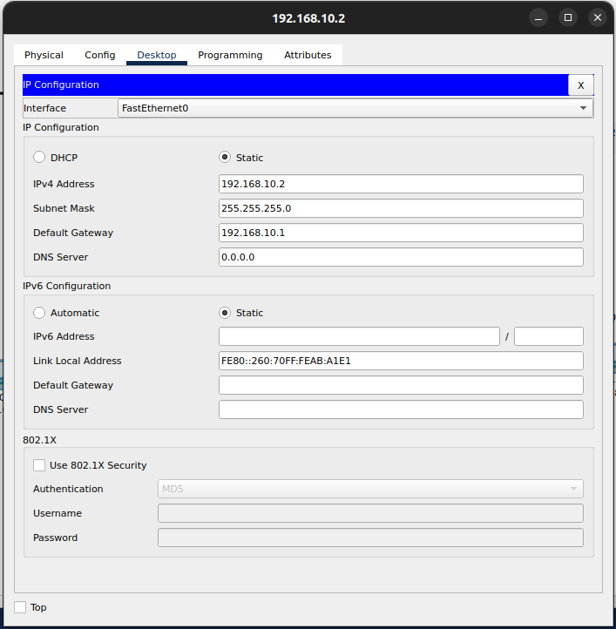

Figure : PC static ip configuration Figure : Configuring the interface
of router 0

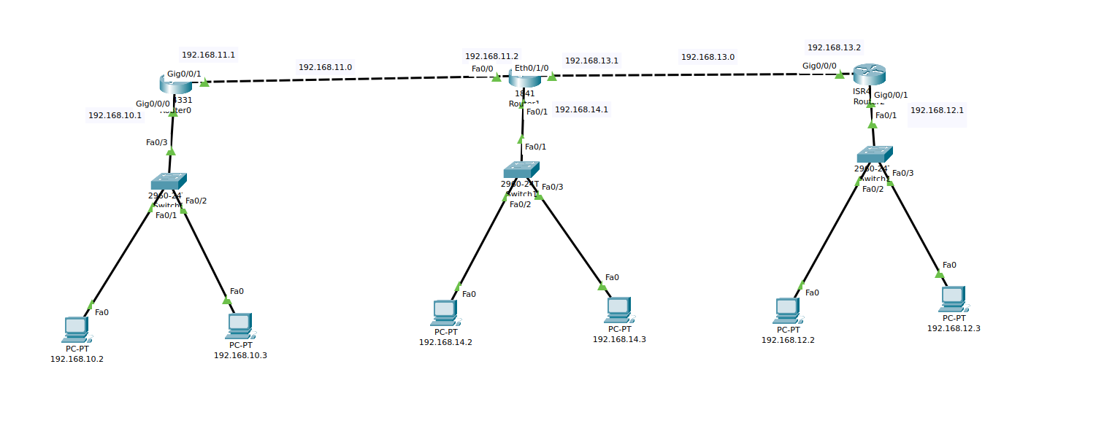
Figure : Static Routing for 3 Routers

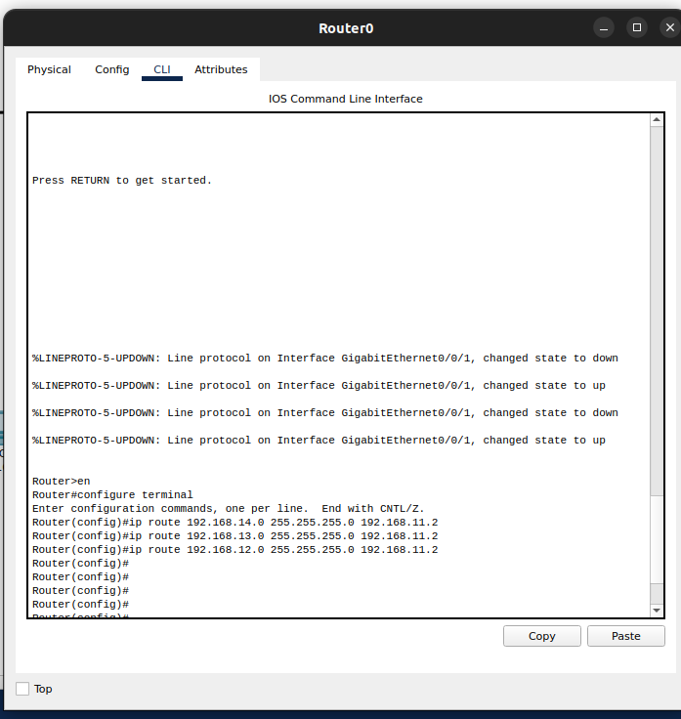
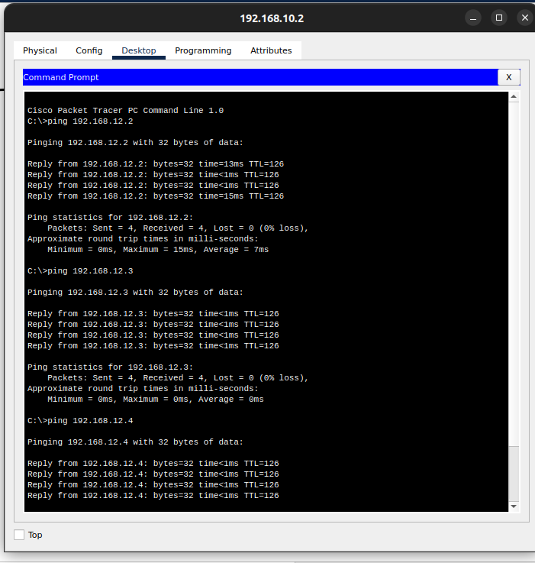

Figure : Static routing syntax for Figure : Connection Verify using Ping Router 0

