**Find the names and addresses of all employees**

select emp.first_name, emp.last_name, addr.address

from employee emp

left join addr

on emp.addr_id = addr.addr_id;

employee.first_name, employee.last_name, addr.address employee ⟕ employee.addr_id = addr.addr_id addr

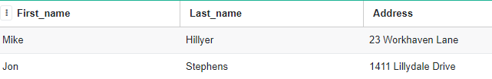

**Find the sum of transaction amounts of each employee in the year 2020**

select emp.first_name, emp.last_name, sum(trans.amount)

from employee emp

left join payment trans

on emp.employee_id = trans.employee_id

WHERE strftime('%Y',trans.payment_date) == '2020'

group by emp.first_name, emp.last_name;

γ employee.first_name, employee.last_nameemployee.first_name, employee.last_name, sum(amount) σ year(payment.payment_date) == 2005 (employee ⟕ employee.employee_id = payment.employee_id payment)

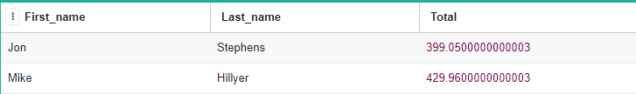

**Find all movies along with the number of actors listed in that movie, where the number of listed actors is > 7**

select mv.title, count(*) number_of_actors

from movie mv

inner join movie_actor mv_act

on mv.movie_id = mv_act.movie_id

group by mv.title having count(*) > 7

order by number_of_actors desc;

τnum_actors desc (σ num_actors > 7 (γ movie.title σmovie.title, num_actors<- count(*) (movie ⟕movie.movie_id = movie_actor.movie_id movie_actor)))

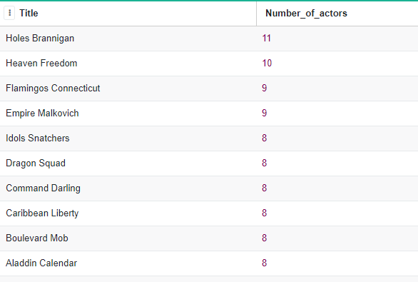

**Find the highest paying customers, i.e. customers who have spent more than $125. Display their name along with the total amount paid**

select cust.first_name, cust.last_name, sum(trans.amount) 'Total Amount Paid'

from payment trans

join buyer cust

on trans.buyer_id = cust.buyer_id

group by cust.first_name, cust.last_name HAVING SUM(trans.amount) > 125

order by sum(trans.amount) DESC;

τ Amount desc (σ Amount > 125 γ buyer.first_name, buyer.last_name σbuyer.first_name, buyer.last_name, Amount <- sum(payment.amount) (payment ⟕ payment.buyer_id = buyer.buyer_id buyer))

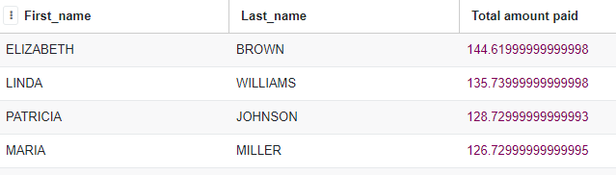

**Find all action movies**

select movie_id, title

from movie

where movie_id in (

select movie_id

from movie_category

where category_id in (

select category_id

from category

where name = 'Action'

)

);

ρ M (movie) ; ρ MC (movie_category) ; ρ A (category)

π M.movie_id, M.title σ C.name = ‘Action’ ^ C.category_id = MC.category_id ^ MC.movie_id = M.movie_id ’ (M x MC x C)

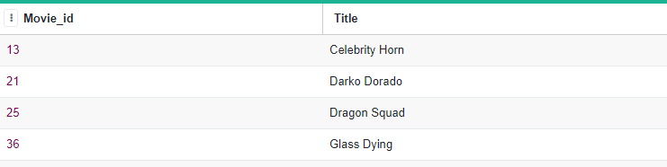

**Find First name and last name of the actors in the movie ‘Deer Virginian’**

select first_name, last_name

from actor

where actor_id in (

select actor_id

from movie_actor

where movie_id in (

select movie_id from movie where lower(title) = lower('Deer Virginian')

)

);

ρ M (movie) ; ρ MA (movie_actor) ; ρ A (actor)

π A.first_name, A.last_name σ M.title = ‘Deer Virginian’ ^ M.movie_id = MA.movie_id ^ MA.actor_id = A.actor_id ’ (M x MA x A)

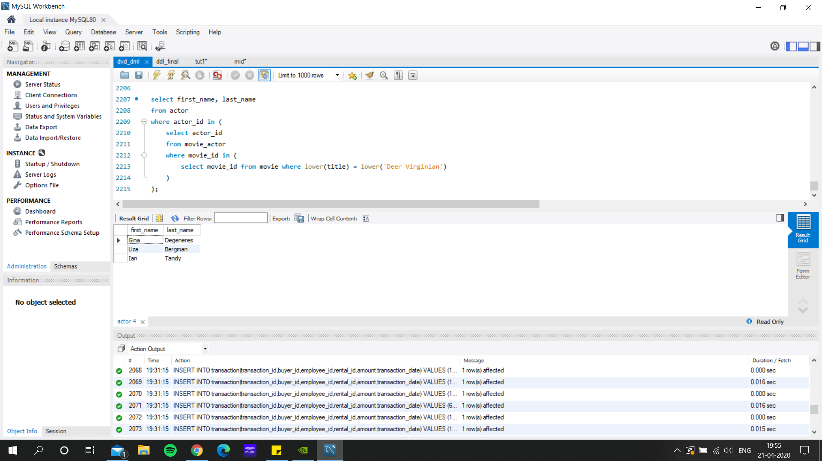

**Find the movie title and its release year having the actor “Alec Wayne”**

select title, release_year

from movie

where movie_id in (

select movie_id

from movie_actor

where actor_id in (

select actor_id

from actor

where lower(first_name) = lower('Alec') and lower(last_name) = lower('Wayne')

)

);

ρ M (movie) ; ρ MA (movie_actor)

π M.title, M.release_year σ M.movie_id = MA.movie_id ^ MA.first_name = ‘Alec’ ^MA.last_name = ‘Wayne’ (M x MA)

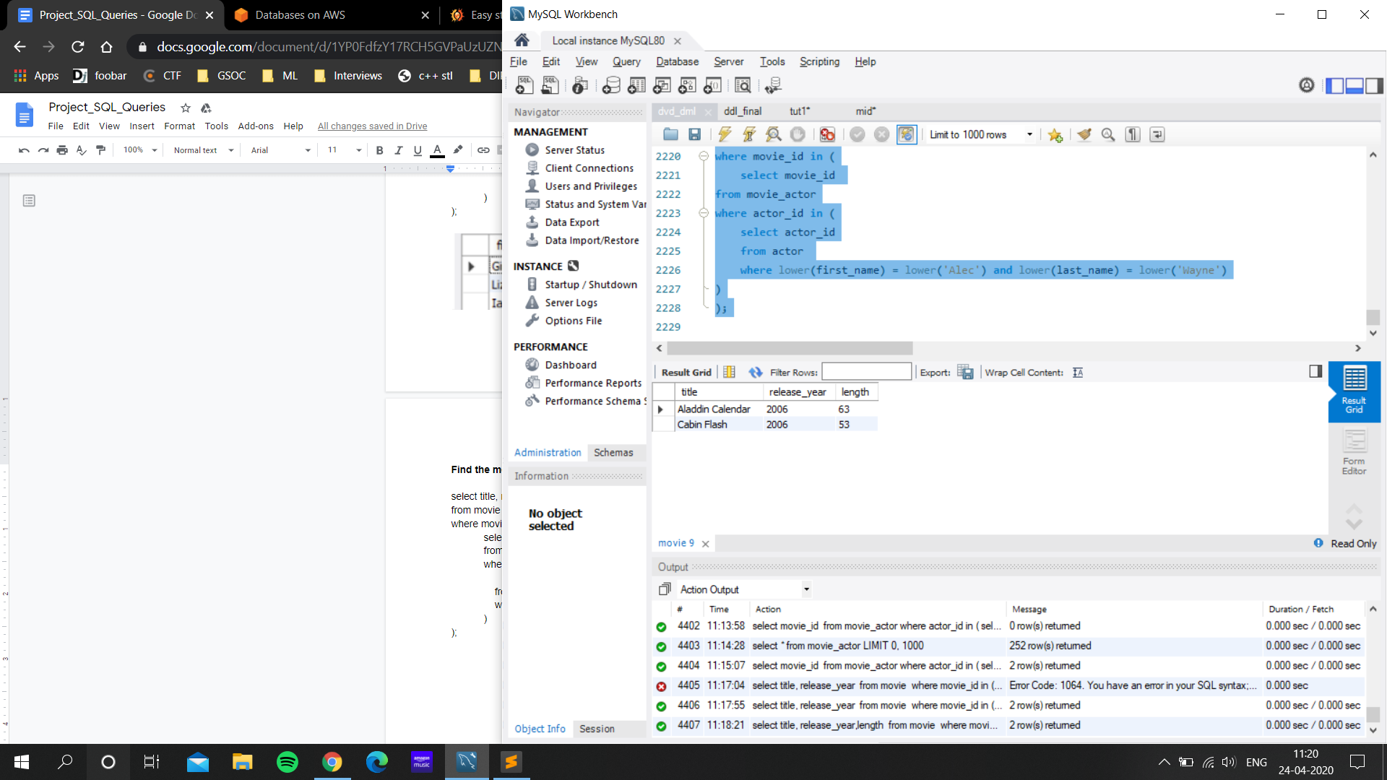

**Find the movie having length lesser than 60 mins i.e. 1 hour and view them in decreasing order.**

select title,length

from movie

Where length<60

order by length desc;

τ length desc π title, length σ length < 60 movie

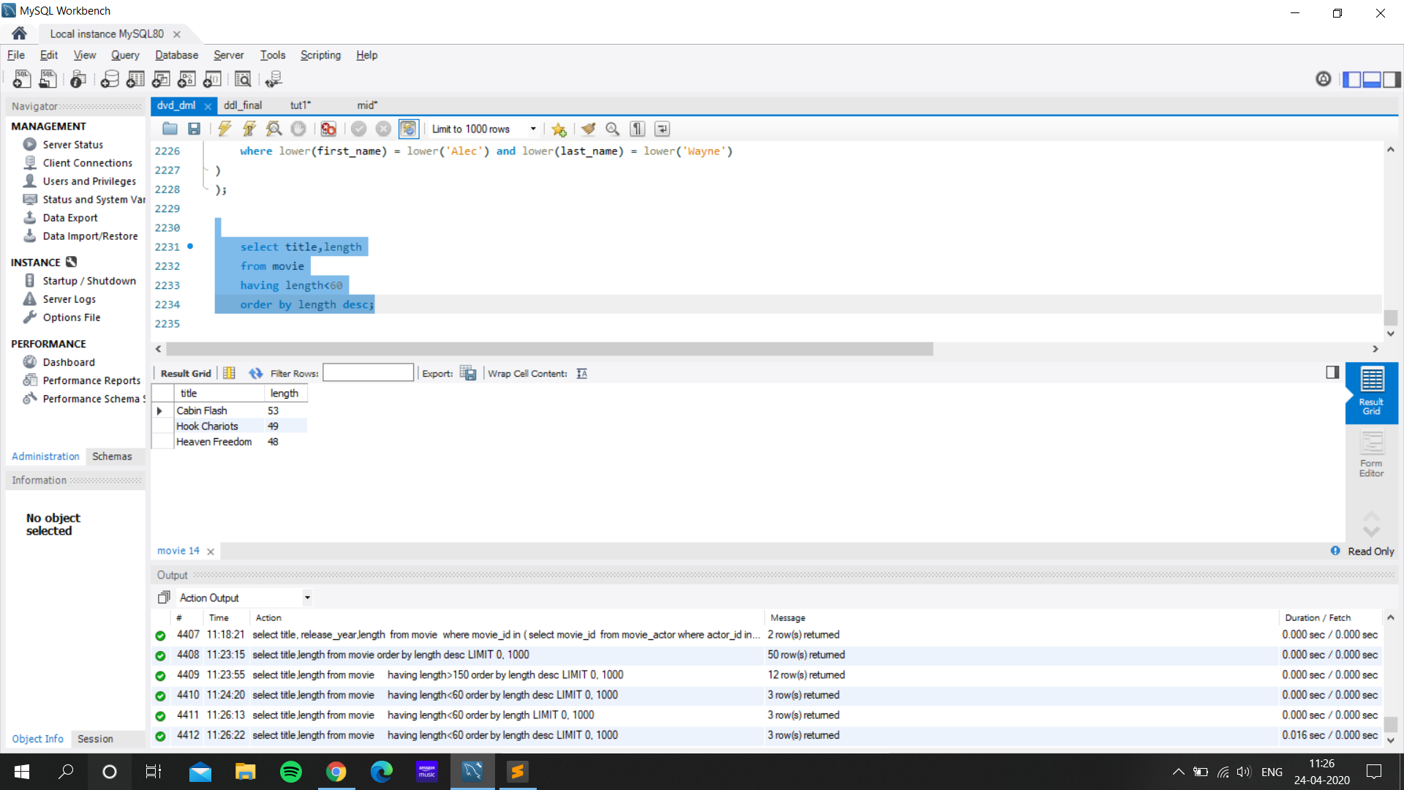

**Find the first name, last name, and emails of the customers who bought movies on 24-05-2005**

select first_name,last_name,email

from buyer

where buyer_id in (

select buyer_id

from rental

where date(rental_date) = "2005-05-24"

);

ρ B1 (buyer) ; ρ R (Rental)

π B1.first_name, B1.last_name, B1.email σ R.buyer_id = B1.buyer_id ^ date(R.rental_date) = ‘2005-05-24’ (B1 x R)

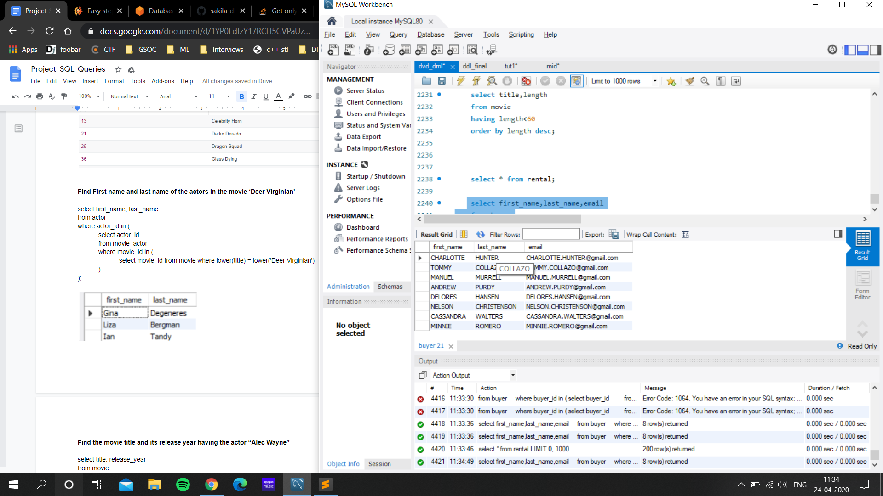

**Find the name of movies and number of times it has been rented till date**

select mv.title, count(*) rented_times

from movie mv

inner join rental r

on mv.movie_id = r.movie_id

group by r.movie_id having count(*) >0

order by rented_times desc;

τ rented desc (σ rented > 0 γ movie.titleσ movie.title, rented <- count (*) (movie ⨝movie.movie_id = rental.movie_id rental))

**Find movies with the same category of a person**

select * from movie where movie_id in (

select movie_id from movie_category where category_id in (

select category_id from movie_category where movie_id in(

select movie_id

from rental

where buyer_id in(

select buyer_id from buyer where lower(email)= lower('MARIA.MILLER@gmail.com')

))

)

);

ρ B1 (buyer) ; ρ R (Rental) ; ρ M (movie) ; ρ MC (movie_category)

π M.title (σ B1.email = ‘maria.miller@gmail.com’ ^ B1.buyer_id = R.buyer_id ^ R.movie_id = MC.movie_id ^ MC.movie_id = M.movie_id (B1 x R x M x MC)

**-- a query to find all orders of user id 1**

select title, movie_id from movie where movie_id in(

select movie_id from rental where buyer_id = 1

);

**-- a query to find all active orders for user id1**

select movie_id, title, return_date from movie, rental where movie.id = rental.id and buyr.id = 1 and return_date>today;

**Display each movie name with its category name**

select mov.title, cat.name from movie mov left join movie_category mcat on mov.movie_id = mcat.movie_id left join category cat on mcat.category_id = cat.category_id;

---------------------------- FOR ML DEMO QUERIES (Don’t change)----------------------------------

select mov.title, cat.name from movie mov left join movie_category mcat on mov.movie_id = mcat.movie_id left join category cat on mcat.category_id = cat.category_id;

select * from buyer;

select title from movie where movie_id in

(select movie_id

from rental

where buyer_id in(

select buyer_id from buyer where lower(email)= lower('MARIA.MILLER@gmail.com')

)

);

select * from rental;