**WHOLE FOODS RMS MANAGEMENT(CEM)**

**Experience**

1. About this document
   1. Purpose

This document specifies the reports and dashboards that will be delivered on the Whole Foods platform as part of bespoke use cases to support RMS initiative.

The bespoke content is marked as “Custom Reports” in the table below:

|  |  |  |  |
| --- | --- | --- | --- |
| **Case** | **Use Case Title** | **Phase** | **Type** |
| 1 | Current Month Transactions | 1 | Revenue |
| 2 | Current Month Returns | 1 | Revenue |
| 3 | Current Month Profits | 1 | Revenue |
| 4 | Product Brand Wise Transactions,Profits,Margin,ReturnRate% | 1 | Revenue |
| 5 | Weekly Revenue Trending | 1 | Budget |
| 6 | Revenue vs Target | 1 | Budget |
| 7 | States Revenue | 1 | Budget |
| 8 | Performance Indicators |  |  |

* 1. Document scope

The scope of this document is limited to the front end reports and dashboards in terms of

* Use case description
* Requirements covered
* KPIs
* Object and time levels
* Functionality (e.g. drill-downs, filters)
* Layout
* Data sources
* Report availability
  1. Audience

The main target Audience are the following:

* Consumer Enterprise Management(CEM)
* Global Marketing Team(GMT)
* Enterprise Business Unit
* Technology and OperationsCommon concepts
  1. KPI names and units

The following conventions shall be used in KPI names:

* KPI names are presented with first character of each word capitalized except for prepositions, e.g.
  + Total Transactions

The following conventions shall be used in KPI units

* KPI unit is shown in parenthesis after the KPI name, e.g.
  + Margin (%)
  + Revenue (Decimals)
  1. KPI value presentation

The following conventions shall be used in presenting KPI values:

* Percentage KPIs are shown with a precision of 2 decimal points
* Duration KPIs are shown with a precision of 0 decimal points
* Average KPIs are shown with a precision of 2 decimal points
* Count KPIs (attempts, nr. of Project Codes, ...) are shown with a precision of 0 decimal points and a thousand separator, e.g.
  + 1,450,000
  1. Colour palette

For Profits use Green Color Scheme,For Returns,Loss Show Red and For Transactions use Blue Color Scheme

* 1. Filtering

Each use case would be filtered based on filter options defined in this document and developed as part of the use case GUI.

1.Apply Year to All the Sheets

2.Store Country Slicer to All Sheets

* 1. Data

The Data is Available in the Form of the CSV Files initially and do the following cleaning.

Using **WholeFoods**  csv files

* Name the table "**Customers**", and make sure that headers have been promoted
* Confirm that data types are accurate (**Note:** "*customer_id*" should be whole numbers, and both "*customer_acct_num*" and "*customer_postal_code*" should be text)
* Add a new column named "*full_name"*to merge the the "*first_name"* and "*last_name"* columns, separated by a space
* Create a new column named "*birth_year"*to extract the year from the "*birthdate"*column, and format as text
* Create a **conditional column**named "*has_children"*which equals "**N**" if "*total_children"* = 0, otherwise "**Y**"
* Name the table "**Products**" and make sure that headers have been promoted
* Confirm that data types are accurate (**Note:** "*product_id*" should be whole numbers, "*product_sku*" should be text), "*product_retail_price*" and "*product_cost*" should be decimal numbers)
* Use the statistics tools to return the number of distinct product brands, followed by distinct product names
  + ***Spot check:****You should see****111****brands and****1,560****product names*
* Add a calculated column named "*discount_price*", equal to 90% of the original retail price
  + Format as a fixed decimal number, and then use the rounding tool to round to 2 digits
* Select "*product_brand*" and use the **Group By** option to calculate the average retail price by brand, and name the new column "*Avg Retail Price*"
  + ***Spot check:****You should see an average retail price of****$2.18****for Washington products, and****$2.21****for Green Ribbon*
* Delete the last applied step to return the table to its pre-grouped state
* Replace "*null*" values with zeros in both the "*recyclable*" and "*low-fat*" columns
* Name the table "**Stores**" and make sure that headers have been promoted
* Confirm that data types are accurate (**Note:** "*store_id*" and "*region_id*" should be whole numbers)
* Add a calculated column named "*full_address*", by merging "*store_city*", "*store_state*", and "*store_country*", separated by a comma and space (***hint:****use a custom separator*)
* Add a calculated column named "*area_code*", by extracting the characters before the dash ("-") in the "*store_phone*" field
* Name the table "**Regions**" and make sure that headers have been promoted
* Confirm that data types are accurate (**Note:** "*region_id*" should be whole numbers)
* Name the table "**Calendar**" and make sure that headers have been promoted
* Use the date tools in the query editor to add the following columns:
  + *Start of Week (starting Sunday*
  + *Name of Day*
  + *Start of Month*
  + *Name of Month*
  + *Quarter of Year*
  + *Year*
* Name the table "**Return_Data**" and make sure that headers have been promoted
* Confirm that data types are accurate (all ID columns and *quantity* should be whole numbers)

**Using WholeFoods_Transactions_1997** and **WholeFoods_Transactions_1998** csv files

* Connect to the folder path, and choose "Edit" (*vs. Combine and Edit*)
* Click the "*Content*" column header (double arrow icon) to combine the files, then remove the "*Source.Name*" column
* Name the table "**Transaction_Data**", and confirm that headers have been promoted
* Confirm that data types are accurate (all ID columns and *quantity* should be whole numbers)
  + ***Spot check:****You should see data from 1/1/1997 through 12/30/1998 in the "transaction_date" column*

**9)** With the exception of the two data tables, disable "*Include in Report Refresh*", then **Close & Apply**

* Confirm that all 7 tables are now accessible within both the **RELATIONSHIPS** view and the **DATA** view

**10)** Save your .pbix file (*i.e. "****WholeFoods_Report****"*)

***Solution screenshot (for reference):***

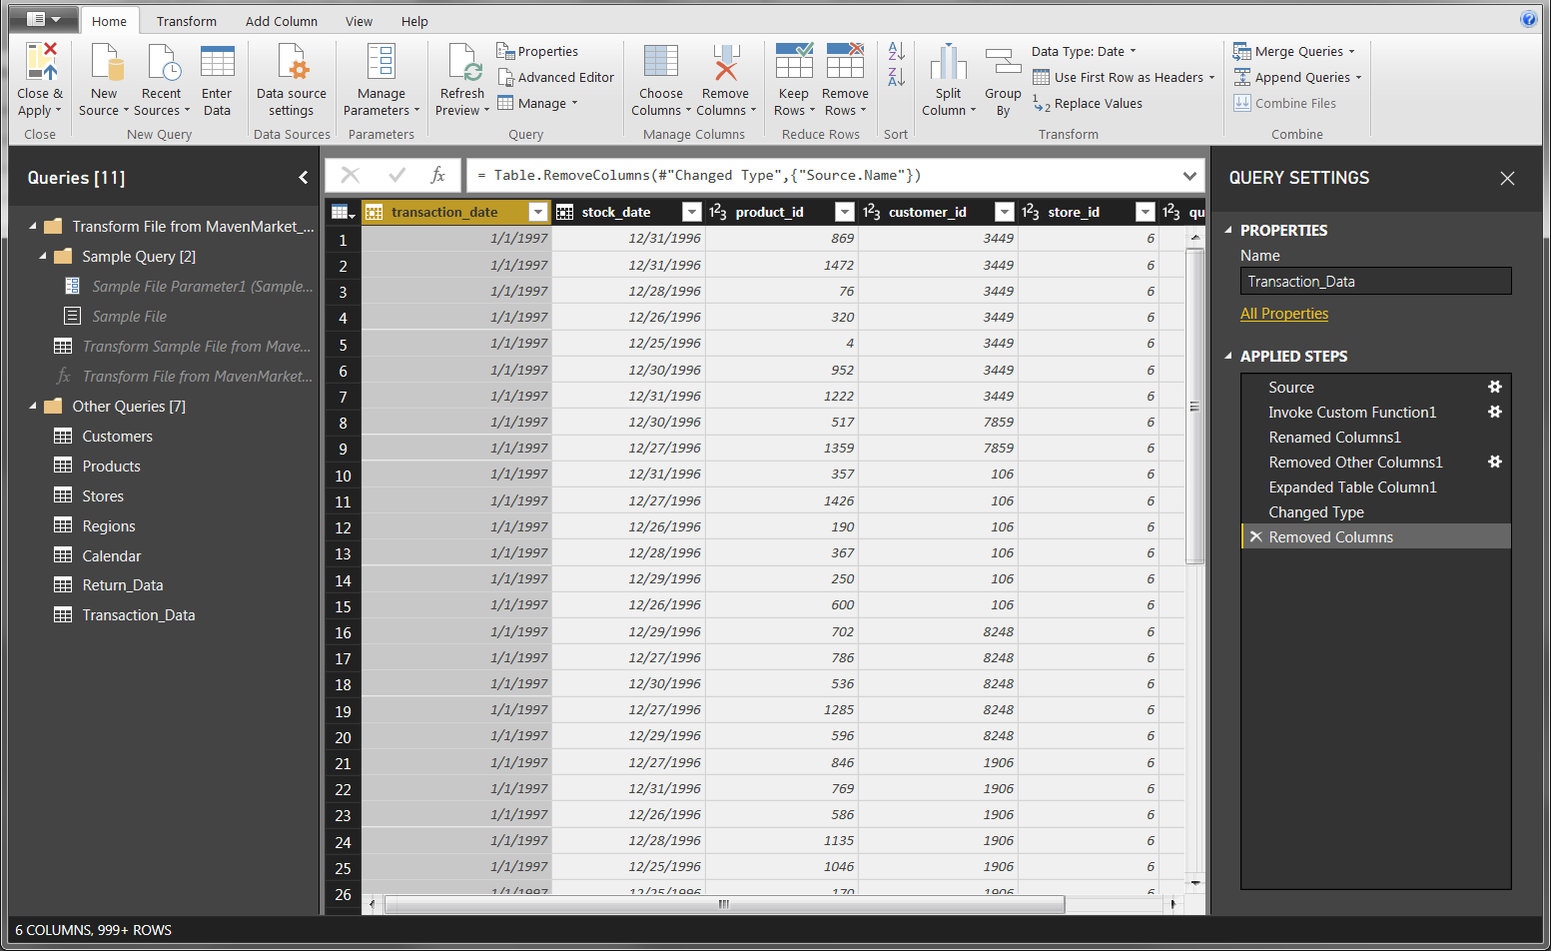

* 1. Modelling the Data:-

After Performing the Data Cleaning,Model the data as Following.

Creating the Data Model

**1)** In the **RELATIONSHIPS** view, arrange your tables with the lookup tables above the data tables

* Connect **Transaction_Data** to **Customers**, **Products**, and **Stores** using valid primary/foreign keys
* Connect **Transaction_Data** to **Calendar** using both date fields, with an inactive "stock_date" relationship
* Connect **Return_Data** to **Products**, **Calendar**, and **Stores** using valid primary/foreign keys
* Connect **Stores** to **Regions** as a "snowflake" schema

**2)** Confirm the following:

* All relationships follow **one-to-many** cardinality, with primary keys (1) on the lookup side and foreign keys (*) on the data side
* Filters are all **one-way** (no two-way filters)
* Filter context flows "**downstream**" from lookup tables to data tables
* Data tables are connected via **shared lookup tables** (not directly to each other)

**3)** Hide all **foreign keys** in both data tables from Report View, as well as "region_id" from the **Stores** table

**4)** In the **DATA** view, complete the following:

* Update all date fields (across all tables) to the "**M/d/yyyy**" format using the formatting tools in the **Modeling** tab
* Update "product_retail_price", "product_cost", and "discount_price" to **Currency ($ English)** format
* In the **Customers**table, categorize "customer_city" as **City**, "customer_postal_code" as **Postal Code**, and "customer_country" as **Country/Region**
* In the **Stores**table, categorize "store_city" as **City**, "store_state" as **State or Province**, "store_country" as **Country/Region**, and "full_address" as **Address**

**5)** Save your .pbix file

**Solution screenshot (for reference):**

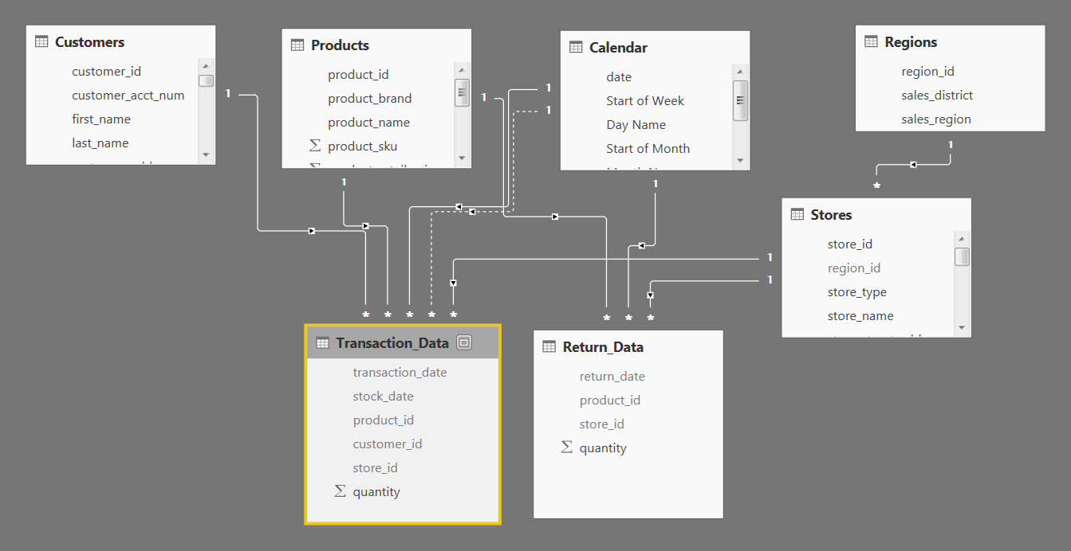

* 1. Analyzing the Data:-

Using the DAX Analyze the data in the following way.

Analyzing the data using DAX Measures

**1)** In the **DATA** view, add the following **calculated columns**:

* In the **Calendar** table, add a column named "**Weekend**"
  + Equals "***Y***" for Saturdays or Sundays (otherwise "**N**")
* In the **Calendar** table, add a column named "***End of Month***"
  + Returns the last date of the current month for each row
* In the **Customers** table, add a column named "***Current Age***"
  + Calculates current customer ages using the "birthdate" column and the TODAY() function
* In the **Customers** table, add a column named "**Priority**"
  + Equals "***High***" for customers who own homes and have Golden membership cards (otherwise "**Standard**")
* In the **Customers** table, add a column named "**Short_Country**"
  + Returns the first three characters of the customer country, and converts to all uppercase
* In the **Customers** table, add a column named "**House Number**"
  + Extracts all characters/numbers before the first space in the "customer_address" column (***hint:*** use SEARCH)
* In the **Products** table, add a column named "***Price_Tier***"
  + Equals "**High**" if the retail price is >**$3**, "**Mid**" if the retail price is >**$1**, and "**Low**" otherwise
* In the **Stores** table, add a column named "**Years_Since_Remodel**"
  + Calculates the number of years between the current date (TODAY()) and the last remodel date

**2)** In the **REPORT** view, add the following **measures**(Assign to tables as you see fit, and use a matrix to match the "***spot check***" values)

* Create new measures named "**Quantity Sold**" and "**Quantity Returned**" to calculate the sum of quantity from each data table
  + ***Spot check:*** You should see total Quantity Sold = ***833,489*** and total Quantity Returned = ***8,289***
* Create new measures named "**Total Transactions**" and "**Total Returns**" to calculate the count of rows from each data table
  + ***Spot check:*** You should see ***269,720*** transactions and ***7,087*** returns
* Create a new measure named "**Return Rate**" to calculate the ratio of quantity returned to quantity sold (format as %)
  + ***Spot check:*** You should see an overall return rate of **0.99%**
* Create a new measure named "**Weekend Transactions**" to calculate transactions on weekends
  + ***Spot check:*** You should see ***76,608*** total weekend transactions
* Create a new measure named "**% Weekend Transactions**" to calculate weekend transactions as a percentage of total transactions (format as %)
  + ***Spot check:*** You should see ***28.4%***weekend transactions
* Create new measures named "**All Transactions**" and "**All Returns**" to calculate grand total transactions and returns (regardless of filter context)
  + ***Spot check:*** You should see ***269,720*** transactions and ***7,087*** returns across all rows (test with product_brand on rows)
* Create a new measure to calculate "**Total Revenue**" based on transaction quantity and product retail price, and format as $ (***hint:*** you'll need an iterator)
  + ***Spot check:*** You should see a total revenue of ***$1,764,546***
* Create a new measure to calculate "**Total Cost**" based on transaction quantity and product cost, and format as $ (***hint:*** you'll need an iterator)
  + ***Spot check:*** You should see a total cost of ***$711,728***
* Create a new measure named "**Total Profit**" to calculate total revenue minus total cost, and format as $
  + ***Spot check:*** You should see a total profit of ***$1,052,819***
* Create a new measure to calculate "**Profit Margin**" by dividing total profit by total revenue calculate total revenue (format as %)
  + ***Spot check:*** You should see an overall profit margin of ***59.67%***
* Create a new measure named "**Unique Products**" to calculate the number of unique product names in the **Products** table
  + ***Spot check:*** You should see ***1,560*** unique products
* Create a new measure named "**YTD Revenue**" to calculate year-to-date total revenue, and format as $
  + ***Spot check:*** Create a matrix with "***Start of Month***" on rows; you should see ***$872,924*** in YTD Revenue in September 1998
* Create a new measure named "**60-Day Revenue**" to calculate a running revenue total over a 60-day period, and format as $
  + ***Spot check:*** Create a matrix with "***date***" on rows; you should see ***$97,570*** in 60-Day Revenue on 4/14/1997
* Create new measures named  "**Last Month Transactions**", "**Last Month Revenue**", "**Last Month Profit**", and "**Last Month Returns**"
  + ***Spot check:*** Create a matrix with "***Start of Month***" on rows to confirm accuracy
* Create a new measure named "**Revenue Target**" based on a 5% lift over the previous month revenue, and format as $
  + ***Spot check:*** You should see a Revenue Target of ***$99,223*** in March 1998

1.11 Visualizing the Data:-

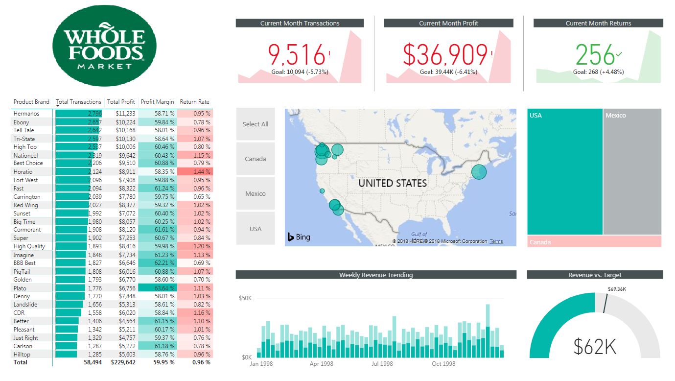

**1)** Rename the tab "**Topline Performance**" and insert the logo

**2)** Insert a **Matrix** visual to show **Total Transactions**, **Total Profit**, **Profit Margin**, and **Return Rate** by **Product_Brand**(on rows)

* Add conditional formatting to show **data bars** on the Total Transactions column, and **color scales** on Profit Margin (White to Green) and Return Rate (White to Red)
* Add a visual level**Top N** filter to only show the top 30 product brands, then sort descending by Total Transactions

**3)**Add a **KPI Card** to show **Total Transactions**, with **Start of Month** as the trend axis and **Last Month Transactions** as the target goal

* Update the title to "**Current Month Transactions**", and format as you see fit
* Create two more copies: one for **Total Profit**(vs. Last month Profit) and one for **Total Returns** (vs. Last Month Returns)
  + Make sure to update titles, and change the Returns chart to color coding to "Low is Good"

**4)**Add a **Map** visual to show **Total Transactions** by store city

* Add a slicer for store country
  + Under the "selection controls" menu in the formatting pane, activate the "**Show Select All**" option
  + **Pro Tip:** Change the orientation in the "General" formatting menu to**horizontal** and resize to create a vertical stack (rather than a list)

**5)** Next to the map, add a **Treemap** visual to break down **Total Transactions** by store country

* Pull in **store_state** and **store_city**beneath **store_country** in the "Group" field to enable drill-up and drill-down functionality

**6)** Beneath the map, add a **Column Chart** to show **Total Revenue** by week, and format as you see fit

* Add a **report level filter** to only show data for 1998
* Update the title to "**Weekly Revenue Trending**"

**7)** In the lower right, add a **Gauge Chart** to show **Total Revenue**against**Revenue Target**(as either "target value" or "maximum value")

* Add a visual level **Top N** filter to show the latest **Start of Month**
* Remove data labels, and update the title to "**Revenue vs. Target**"

**8)**Select the Matrix and activate the  **Edit interactions** option to prevent the Treemap from filtering

**9)** Select "USA" in the country slicer, and drill down to select "Portland" in the Treemap

* Add a new bookmark named "**Portland 1000 Sales**"
* Add a new report page, named "**Notes**"
* Insert a text box and write something along the lines of "**Portland hits 1,000 sales in December**"
* Add a button (your choice) and use the "**Action**" properties to link it to the bookmark you created
* Test the bookmark by CTRL-clicking the button
* Find 2-3 additional insights from the Topline Performance tab and add new bookmarks and notes linking back
  1. SIT.

Perform the System Integration before publishing into the Service by connecting to the Oracle.

After SIT add a new report to display the last Refresh time.

* 1. Publishing into Server

Publish to the Service and Perform Unit Testing,Restrict the Data to GMT,CEM Users and then Migrate to QA Environment and from their to LIVE .