**C Array**

An array is defined as the collection of similar type of data items stored at contiguous memory locations. Arrays are the derived data type in C programming language which can store the primitive type of data such as int, char, double, float, etc. It also has the capability to store the collection of derived data types, such as pointers, structure, etc. The array is the simplest data structure where each data element can be randomly accessed by using its index number.

#### Advantage of C Array

**1) Code Optimization**: Less code to the access the data.

**2) Ease of traversing**: By using the for loop, we can retrieve the elements of an array easily.

**3) Ease of sorting**: To sort the elements of the array, we need a few lines of code only.

**4) Random Access**: We can access any element randomly using the array.

#### Disadvantage of C Array

**1) Fixed Size**: Whatever size, we define at the time of declaration of the array, we can't exceed the limit. So, it doesn't grow the size dynamically like LinkedList which we will learn later.

## Declaration of C Array

We can declare an array in the c language in the following way.

1. data_type array_name[array_size];

Now, let us see the example to declare the array.

1. int marks[5];

## Initialization of C Array

The simplest way to initialize an array is by using the index of each element. We can initialize each element of the array by using the index. Consider the following example.

1. marks[0]=80;//initialization of array
2. marks[1]=60;
3. marks[2]=70;
4. marks[3]=85;
5. marks[4]=75;

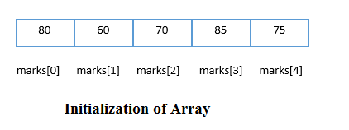

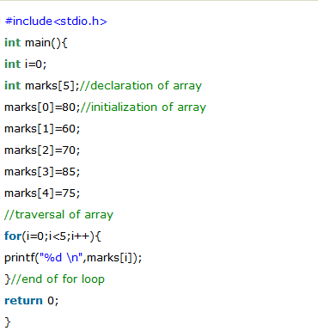

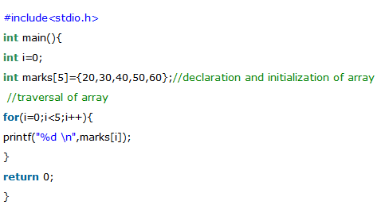

# Two Dimensional Array in C

The two-dimensional array can be defined as an array of arrays. The 2D array is organized as matrices which can be represented as the collection of rows and columns. However, 2D arrays are created to implement a relational database lookalike data structure. It provides ease of holding the bulk of data at once which can be passed to any number of functions wherever required.

## Declaration of two dimensional Array in C

The syntax to declare the 2D array is given below.

1. data_type array_name[rows][columns];
2. int twodimen[4][3];

Here, 4 is the number of rows, and 3 is the number of columns.

## Initialization of 2D Array in C

In the 1D array, we don't need to specify the size of the array if the declaration and initialization are being done simultaneously. However, this will not work with 2D arrays. We will have to define at least the second dimension of the array. The two-dimensional array can be declared and defined in the following way.

1. int arr[4][3]={{1,2,3},{2,3,4},{3,4,5},{4,5,6}};

