## A Real-Time Example

Let's take a real-time example to find out how @Output and EventEmitter can be more useful. Consider that **AppComponent** is rendering a list of products in a tabular form as shown in the image below:

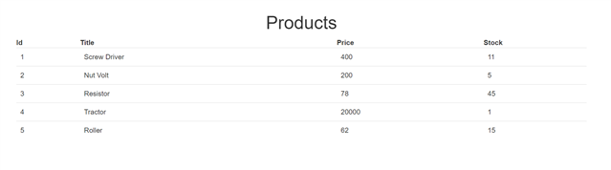

Angular Front-End App

To create the product table above, we have a very simple **AppComponent** class with only one function: to return a list of products.

export class AppComponent implements OnInit {

products = [];

title = 'Products';

ngOnInit() {

this.products = this.getProducts();

}

getProducts() {

return [

{ 'id': '1', 'title': 'Screw Driver', 'price': 400, 'stock': 11 },

{ 'id': '2', 'title': 'Nut Volt', 'price': 200, 'stock': 5 },

{ 'id': '3', 'title': 'Resistor', 'price': 78, 'stock': 45 },

{ 'id': '4', 'title': 'Tractor', 'price': 20000, 'stock': 1 },

{ 'id': '5', 'title': 'Roller', 'price': 62, 'stock': 15 },

];

}

}

In the ngOnInit lifecycle hook, we are calling the getPrdoducts() function and assigning the returned data to the products variable so it can be used in the template. There, we are using the *ngFor directive to iterate through the array and display the products. See the code below:

<div class="container">

<br />

<h1 class="text-center">{{title}}</h1>

<table class="table">

<thead>

<th>Id</th>

<th>Title</th>

<th>Price</th>

<th>Stock</th>

</thead>

<tbody>

<tr *ngFor="let p of products">

<td>{{p.id}}</td>

<td>{{p.title}}</td>

<td>{{p.price}}</td>

<td>{{p.stock}}</td>

</tr>

</tbody>

</table>

</div>

With this code, products are rendered in a table as shown in the image below:

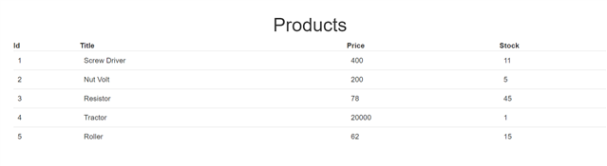

Now let's say we want to add a new column with a button and input box as shown in the image below:

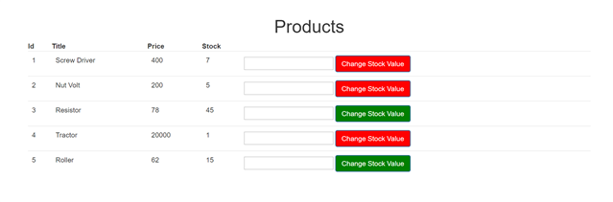

Angular Front-End

Our requirements are as follows:

1. If the value of **stock** is more than 10 then the button color should be green.
2. If the value of **stock** is less than 10 then the button color should be red.
3. The user can enter a number in the input box, which will be added to that particular stock value.
4. The color of the button should be updated on the basis of the changed value of the product stock.

To achieve this, let us create a new child component called **StockStatusComponent**. Essentially, in the template of **StockStatusCompontent**, there is one button and one numeric input box. In **StockStatusCompontent**:

1. We need to read the value of **stock** passed from **AppComponnet**. For this, we need to use @Input
2. We need to emit an event so that a function in **AppComponent** can be called on the click of the **StockStatusComponent** For this, we need to use @Output and EventEmitter.

Consider the code below:

#### ****stockstatus.component.ts****

import { Component, Input, EventEmitter, Output, OnChanges } from '@angular/core';

@Component({

selector: 'app-stock-status',

template: `<input type='number' [(ngModel)]='updatedstockvalue'/> <button class='btn btn-primary'

[style.background]='color'

(click)="stockValueChanged()">Change Stock Value</button> `

})

export class StockStatusComponent implements OnChanges {

@Input() stock: number;

@Input() productId: number;

@Output() stockValueChange = new EventEmitter();

color = '';

updatedstockvalue: number;

stockValueChanged() {

this.stockValueChange.emit({ id: this.productId, updatdstockvalue: this.updatedstockvalue });

this.updatedstockvalue = null;

}

ngOnChanges() {

if (this.stock > 10) {

this.color = 'green';

} else {

this.color = 'red';

}

}

}

Let's explore the above class line by line.

1. In the first line, we are importing everything that's required: @Input, @Output, etc.
2. In the template, there is one numeric input box which is bound to the **updatedStockValue** property using **[(ngModel)].** We need to pass this value with an event to the **AppComponent**.
3. In the template, there is one button. On the click event of the button, an event is emitted to the **AppComponent**.
4. We need to set the color of the button on the basis of the value of product stock. So, we must use property binding to set the background of the button. The value of the color property is updated in the class.
5. We are creating two @Input() decorated properties - **stock** and **productId** - because the value of these two properties will be passed from **AppComponent**.
6. We are creating an event called **stockValueChange**. This event will be emitted to **AppComponent** on the click of the button.
7. In the **stockValueChanged** function, we are emitting the **stockValueChange** event and also passing the product id to be updated and the value to be added to the product stock value.
8. We are updating the value of the color property in the ngOnChanges() lifecycle hook because each time the stock value gets updated in the **AppComponent**, the value of the color property should be updated.

Here we are using the @Input decorator to read data from **AppComponent** class, which happens to be the parent class in this case. So to pass data from the parent component class to the child component class, use the @Input decorator.

In addition, we are using @Output with **EventEmitter** to emit an event to **AppComponent**. So to emit an event from the child component class to the parent component class, use **EventEmitter** with the @Output() decorator.

Therefore, **StockStatusComponent** is using both @Input and @Output to read data from **AppComponent** and emit an event to **AppComponent**.

### ****Modify AppComponent to Use StockStatusComponent****

Let us first modify the template. In the template, add a new table column. Inside the column, the <app-stock-status> component is used.

<div class="container">

<br />

<h1 class="text-center">{{title}}</h1>

<table class="table">

<thead>

<th>Id</th>

<th>Title</th>

<th>Price</th>

<th>Stock</th>

</thead>

<tbody>

<tr *ngFor="let p of products">

<td>{{p.id}}</td>

<td>{{p.title}}</td>

<td>{{p.price}}</td>

<td>{{p.stock}}</td>

<td><app-stock-status [productId]='p.id' [stock]='p.stock' (stockValueChange)='changeStockValue($event)'></app-stock-status></td>

</tr>

</tbody>

</table>

</div>

We are passing the value to **productId** and **stock** using property binding (remember, these two properties are decorated with @Input() in **StockStatusComponent**) and using event binding to handle the **stockValueChange** event (remember, this event is decorated with @Output() in **StockStatusComponent**).

productToUpdate: any;

changeStockValue(p) {

this.productToUpdate = this.products.find(this.findProducts, [p.id]);

this.productToUpdate.stock = this.productToUpdate.stock + p.updatdstockvalue;

}

findProducts(p) {

return p.id === this[0];

}

In the function, we are using the JavaScript **Array.prototype.find** method to find a product with a matched **productId** and then updating the stock count of the matched product. When you run the application, you'll get the following output:

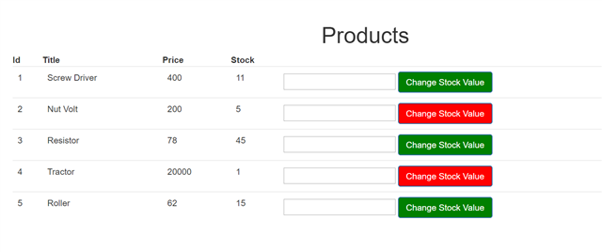

Angular Front-End

When you enter a number in the numeric box and click on the button, you perform a task in the child component that updates the operation value in the parent component. Also, on the basis of the parent component value, the style is being changed in the child component. All this is possible using Angular @Input,  @Output, and EventEmitter.

In summary:

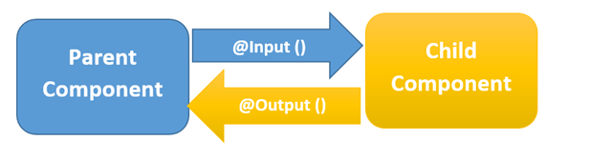

Angular EventEmitter