**HTML <video> Tag**

### Example

Play a video:

<video width="320" height="240" controls>  
  <source src="movie.mp4" type="video/mp4">  
  <source src="movie.ogg" type="video/ogg">  
  Your browser does not support the video tag.  
</video>

## Definition and Usage

The <video> tag specifies video, such as a movie clip or other video streams.

Currently, there are 3 supported video formats for the <video> element: MP4, WebM, and Ogg:

|  |  |  |  |
| --- | --- | --- | --- |
| **Browser** | **MP4** | **WebM** | **Ogg** |
| Internet Explorer | YES | NO | NO |
| Chrome | YES | YES | YES |
| Firefox | YES from Firefox 21 from Firefox 30 for Linux | YES | YES |
| Safari | YES | NO | NO |
| Opera | YES From Opera 25 | YES | YES |

* MP4 = MPEG 4 files with H264 video codec and AAC audio codec
* WebM = WebM files with VP8 video codec and Vorbis audio codec
* Ogg = Ogg files with Theora video codec and Vorbis audio codec

### MIME Types for Video Formats

|  |  |
| --- | --- |
| **Format** | **MIME-type** |
| MP4 | video/mp4 |
| WebM | video/webm |
| Ogg | video/ogg |

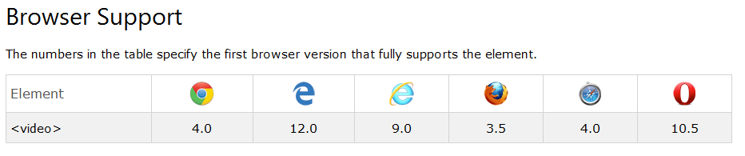

## Optional Attributes

= New in HTML5.

|  |  |  |
| --- | --- | --- |
| **Attribute** | **Value** | **Description** |
| [autoplay](http://www.w3schools.com/tags/att_video_autoplay.asp) | autoplay | Specifies that the video will start playing as soon as it is ready |
| [controls](http://www.w3schools.com/tags/att_video_controls.asp) | controls | Specifies that video controls should be displayed (such as a play/pause button etc). |
| [height](http://www.w3schools.com/tags/att_video_height.asp) | *pixels* | Sets the height of the video player |
| [loop](http://www.w3schools.com/tags/att_video_loop.asp) | loop | Specifies that the video will start over again, every time it is finished |
| [muted](http://www.w3schools.com/tags/att_video_muted.asp) | muted | Specifies that the audio output of the video should be muted |
| [poster](http://www.w3schools.com/tags/att_video_poster.asp) | URL | Specifies an image to be shown while the video is downloading, or until the user hits the play button |
| [preload](http://www.w3schools.com/tags/att_video_preload.asp) | auto metadata none | Specifies if and how the author thinks the video should be loaded when the page loads |
| [src](http://www.w3schools.com/tags/att_video_src.asp) | *URL* | Specifies the URL of the video file |
| [width](http://www.w3schools.com/tags/att_video_width.asp) | *pixels* | Sets the width of the video player |

# HTML <video> poster Attribute

### Example

A video player with a poster image:

<video controls poster="/images/w3html5.gif">  
  <source src="movie.mp4" type="video/mp4">  
  <source src="movie.ogg" type="video/ogg">  
  Your browser does not support the video tag.  
</video>

## Definition and Usage

The poster attribute specifies an image to be shown while the video is downloading, or until the user hits the play button. If this is not included, the first frame of the video will be used instead.