**HTML <track> Tag**

### Example

A video with two subtitle tracks:

<video width="320" height="240" controls>  
  <source src="forrest_gump.mp4" type="video/mp4">  
  <source src="forrest_gump.ogg" type="video/ogg">  
  <track src="subtitles_en.vtt" kind="subtitles" srclang="en" label="English">  
  <track src="subtitles_no.vtt" kind="subtitles" srclang="no" label="Norwegian">  
</video>

## Definition and Usage

The <track> tag specifies text tracks for media elements (<audio> and <video>).

This element is used to specify subtitles, caption files or other files containing text, that should be visible when the media is playing.

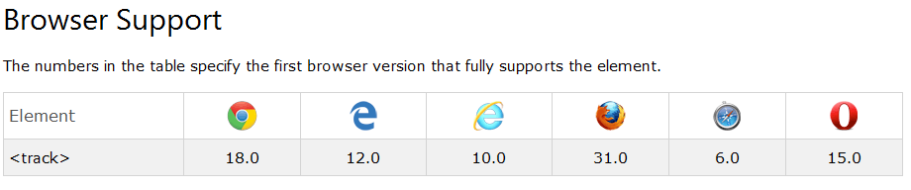

## Optional Attributes

= New in HTML5.

|  |  |  |
| --- | --- | --- |
| **Attribute** | **Value** | **Description** |
| [default](http://www.w3schools.com/tags/att_track_default.asp) | default | Specifies that the track is to be enabled if the user's preferences do not indicate that another track would be more appropriate |
| [kind](http://www.w3schools.com/tags/att_track_kind.asp) | captions chapters descriptions metadata subtitles | Specifies the kind of text track |
| [label](http://www.w3schools.com/tags/att_track_label.asp) | text | Specifies the title of the text track |
| [src](http://www.w3schools.com/tags/att_track_src.asp) | URL | Required. Specifies the URL of the track file |
| [srclang](http://www.w3schools.com/tags/att_track_srclang.asp) | *language_code* | Specifies the language of the track text data (required if kind="subtitles") |

# HTML <track> default Attribute

### Example

A video with two subtitle tracks. "English" subtitle is the default:

<video width="320" height="240" controls>  
  <source src="forrest_gump.mp4" type="video/mp4">  
  <source src="forrest_gump.ogg" type="video/ogg">  
  <track src="subtitles_en.vtt" kind="subtitles" srclang="en" label="English" default>  
  <track src="subtitles_no.vtt" kind="subtitles" srclang="no" label="Norwegian">  
</video>

# HTML <track> kind Attribute

The kind attribute specifies the kind of text track.

### Example

A video with two subtitle tracks:

<video width="320" height="240" controls>  
  <source src="forrest_gump.mp4" type="video/mp4">  
  <source src="forrest_gump.ogg" type="video/ogg">  
  <track src="subtitles_en.vtt" kind="subtitles" srclang="en" label="English">  
  <track src="subtitles_no.vtt" kind="subtitles" srclang="no" label="Norwegian">  
</video>

# HTML <track> label Attribute

The label attribute specifies the title of the text track.

The title of the text track is used by the browser when listing available text tracks

# HTML <track> srclang Attribute

The srclang attribute specifies the language of the track text data.

This attribute is required if kind="subtitles".

**Tip:** To view all available language codes, go to our [Language code reference](http://www.w3schools.com/tags/ref_language_codes.asp).