Use Case Diagram:

This use Case Diagram is the graphic description of the interactions among the elements of Covid Related System. It represents the methodology used in system analysis to identify, clarify, and organize the system requirement of Covid Related System.

The main actors of Covid Related System in this Use Case Diagram are: Patient/Family member, Staff, Health Administrator who perform the different type of use cases such as to Find Nearest Hospital, to Confirm Beds, to View Patient Status Report, to Update Status report, to Approve Hospital, To Admit Patient and To Discharge Patient.

Major elements of the UML Use Case Diagram of Covid Related System are shown on the picture below:

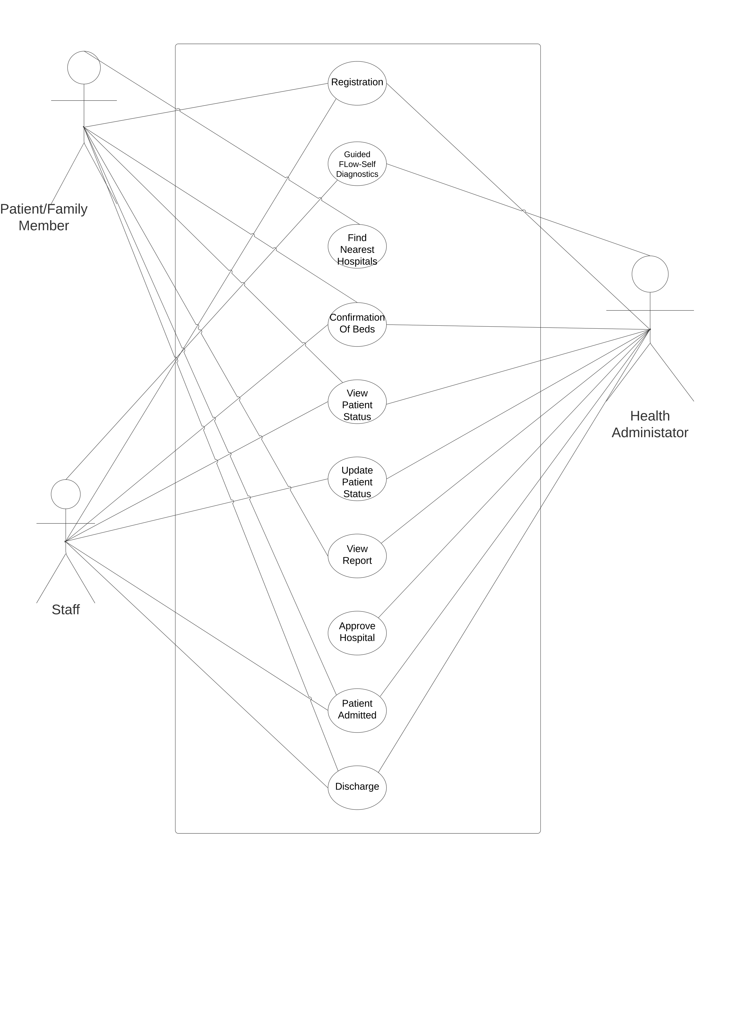

Sequence Diagram:

The Sequence Diagram depicts interaction

Between objects in a sequential order i.e. the

Order in which these interactions take place. It

Represents individual use case:

1. Login Sequence Diagram

1. Registration Sequence Diagram

1. Hospital Management Sequence Diagram:

1. Patient Management Sequence Diagram:

1. Hospitalization Sequence Diagram:

Activity Diagram:

The Class Diagram shows the dynamic aspect of

The system. It is basically a flowchart to represent

The flow from one activity to another activity. The

Activity can be described as an operation of the

System. The control flow is drawn from one Operation to another. Different users and roles are Depicted by swim lanes*.*

1. State Chart Diagram:

