A

PROJECT REPORT ON

***Health-card***

**By**

**Aayush Dakwala(CE-20)(18CEUOD015)**

**Tanuj Doshi(CE031)(18CEUOD008)**

**Bhavik Mojidra(CE071)(18CEUBD001)**

**B.Tech CE Semester – VI**

**Subject: System Design Practice**

**Guided By:**

Prof.Pandav K Patel

Assistant Professor

Dept. of Comp. Engg.



**Faculty of Technology**

**Department of Computer Engineering**

**Dharmsinh Desai University,Nadiad**



**Faculty of Technology**

**Department of Computer Engineering**

**Dharmsinh Desai University,Nadiad**

**CERTIFICATE**

This is to certify that the practical / term work carried out in the subject of

**System Design Practice** and recorded in this journal is the

bonafide work of

**Aayush Dakwala(CE-20)(18CEUOD015)**

**Tanuj Doshi(CE031)(18CEUOD008)**

**Bhavik Mojidra(CE071)(18CEUBD001)**

of B.Tech semester **VI** in the branch of **Computer Engineering**

during the academic year **2019-2020.**

|  |  |  |
| --- | --- | --- |
|  |  |  |

Prof. pandav k patel Dr.C.K.Bhensdadia

Assistant Professor, Head,

Dept. of Computer. Engg., Dept. of Computer. Engg.,

Faculty of Technology Faculty of Technology

Dharmsinh Desai University, Nadiad Dharmsinh Desai University, Nadiad

**Content**

1. Abstract………………………………………………………………….....4
2. Introduction………………………………………………………………..5
3. Software Requirement Specification…………………..........6
4. Design ………………………………………………………………………9
5. Implementation Details……………………………………………….16
6. Testing and Validations……………………………………………….18
7. Screen-Shots…………………………………………………………….19
8. Conclusion……………………………………………………………….22
9. Limitations and Future Extension…………………………………23
10. Bibliography………………………………………………………………24

**Abstract**

We have Aadhar card, pan card, Voter id, driving licence like identity proofs for our day to day transactions, but we have major missing that is our health card, which manages our day to day health history like disease, allergy etc. And same card is used everywhere in private and public hospitals and clinics, medical store, laboratory to track your health-related data.

A big responsibility to maintain health related data can be resolved by the help of this system. because of this system user does not have to standing at queue of hospitals to take new case every time. User just need to carry his/her health card.

**Introduction**

**2.1 Brief Introduction**

* Purpose: -

The purpose of the Health card is to provide an easy, responsive web interface for the patient who want to store health related data online

* Scope: -

Health card System provides information of the Patient all medical related data, and lets the government use that data and get all statistic analysis of patient health data area wise .

* Objectives: -

Health card System aims The application reduces lot of work load for government and can be helpful to all patient.

**2.2 Tools/Technologies used**

**Technology: -** HTML 5

CSS3

BOOTSTRAP 4

ANGULAR CLI

NODE

TYPESCRIPT

MONGODB

**Platform: -** Google chrome, Mozilla Firefox

**Tools: -** Visual Studio Code, Mongo DB Compass

**3 SOFTWARE REQUIREMENT SPECIFICATION**

**3.1 Types of Users:**

1.Doctor

2. Laboratorian

3. patient

**3.2 Functional Requirement: -**

**R.1 Doctor:**

R.1.1 Registration

Description: - If Doctor Wants To Register To Health-card system he/she can register by giving valid proofs.

Input: - Doctors Details like licence number, email, licence expiration date etc

output: - sign in page

R.1.2 Login

Description: - Doctor can login to system by giving valid email id and password.

Input: - doctor credential

output: - home page

R.1.3 View Previous health reports

Description: Doc tor shall check health reports and health statistics of the patient.

Input: User Selection

Output: Displays Selected Health report and statistics

R.1.4 Write a Prescription

Description: Doctor shall write a Prescription of a medicine for the required treatment.

Input: Prescription

Output: Generation of a Prescription

**R.2 Laboratorian**

R.2.1 Login: -

Description: Laboratorian Login to the system by entering valid email id and password

input: Laboratorian credential

output: home page

R.2.2 Add Lab Report: -

Description: Laboratorian Can add lab report of respective patient

input: - Report Selection

output: - Prompts whether reports added or not

R.2.3 Search Report

Description: Laboratorian can search reports by patient name or date

input: search input

output: search related data

**R.3 Patient:**

R.3.1 Register: -

Description: Patient can register itself by giving valid data.

input: patient basic details including blood group of patient

output: sign in page

R.3.2: -view and download health card

Description: patient can view as well as download his/her health card

input: - patient login credential

output: downloaded health card in pdf format

R.3. View Prescriptions

Description: Patient can view Prescription written by Doctor

Input: User Selection

Output: Display selected prescription

**3.3 Other non-functional requirement**

**1)performance: -**

Performance The system must be interactive and the delays involved must be less. So, in every action-response of the system, there are no immediate delays. In case of opening App components, of popping error messages and saying the settings or sessions there is delay much below 3 seconds.

**2)safety: -**

User details should be securely to be the server. The main security concern is for user account hence proper login mechanism should be used to avoid hacking.

**3)Reliability: -**

As the system provide the right tools for discussion, problem solving it must be made sure that the system is reliable in its operations and for securing the sensitive details.

**4)Database: -**

System requires to access users data fast to maintain the performance

**4 Design**

**4.1 Use case Diagram**

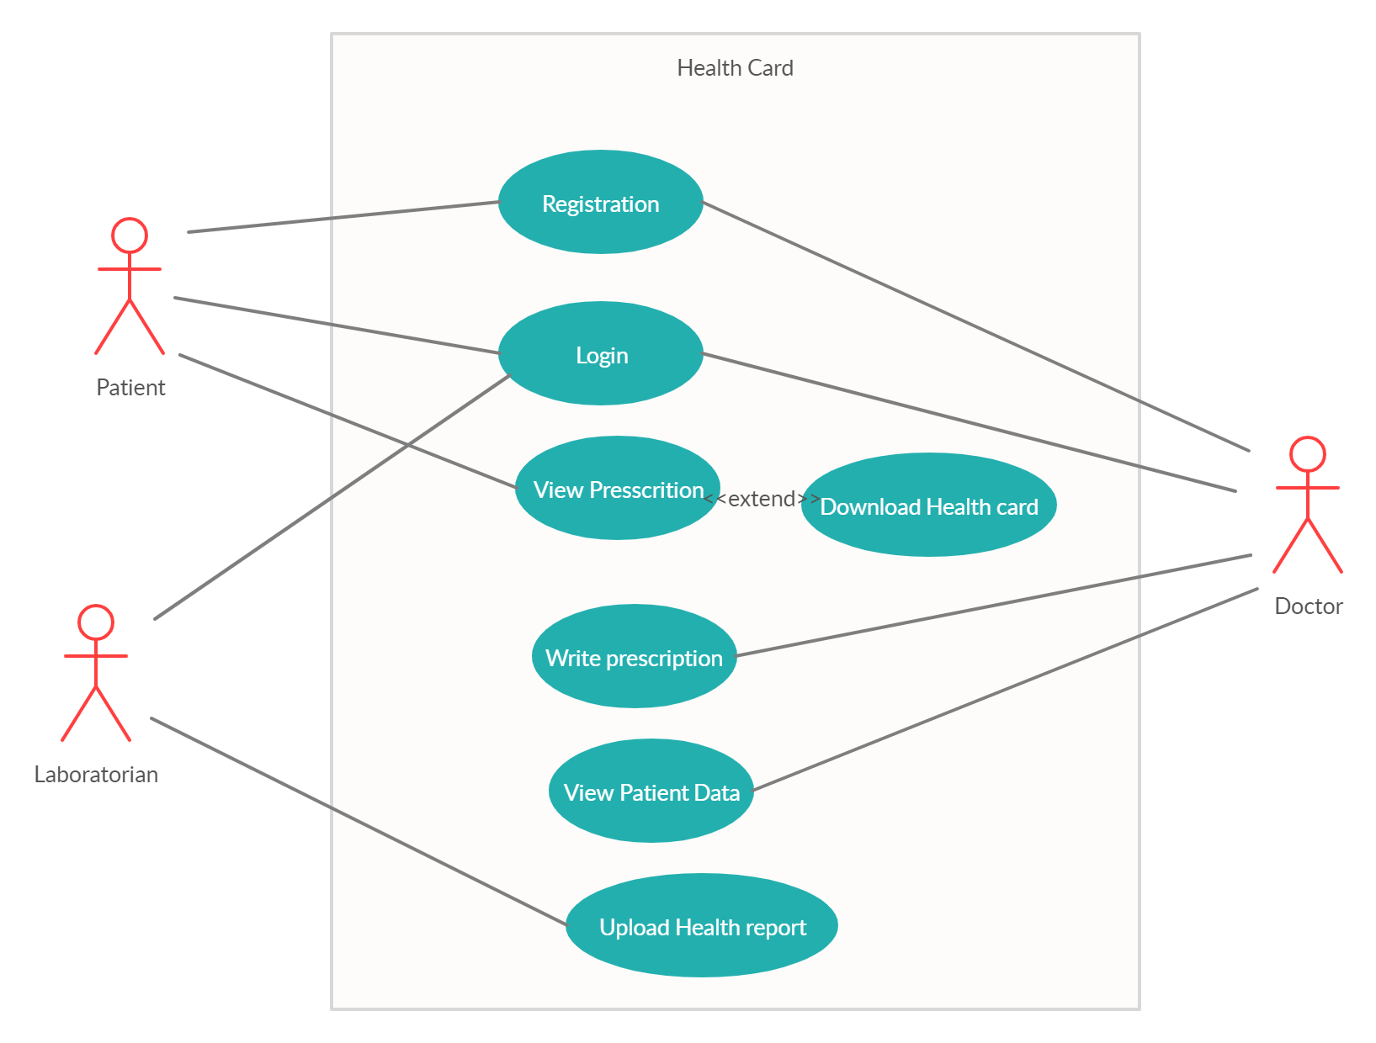

**4.2 Class Diagram**

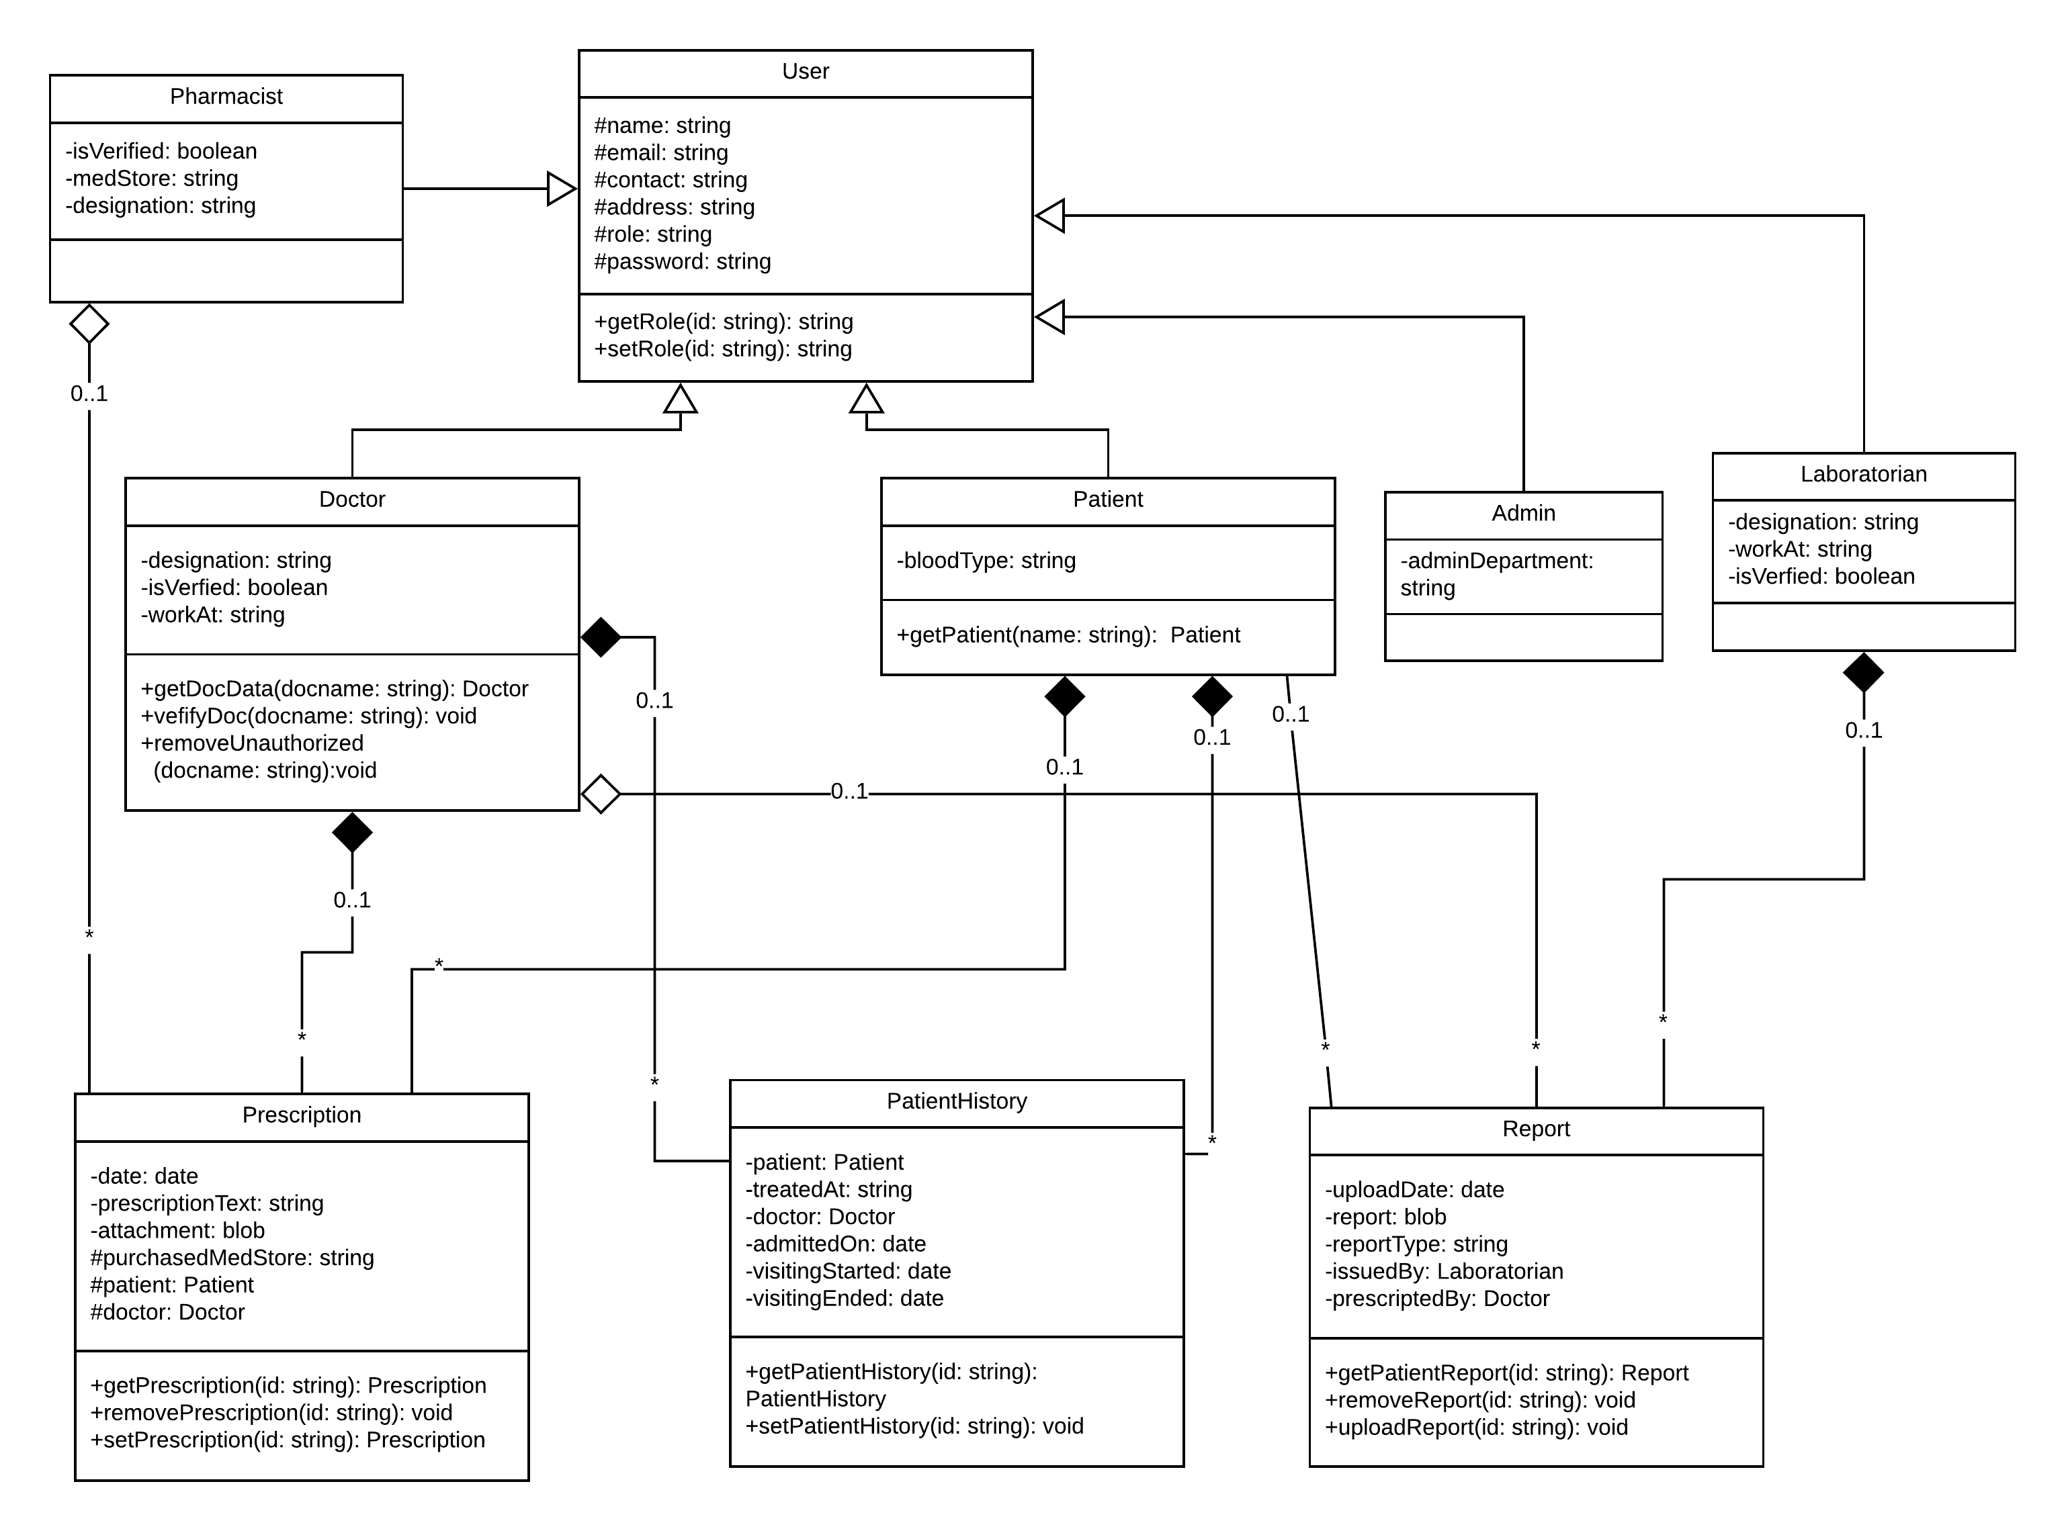

**4.3 Sequence Diagram**

**1)**

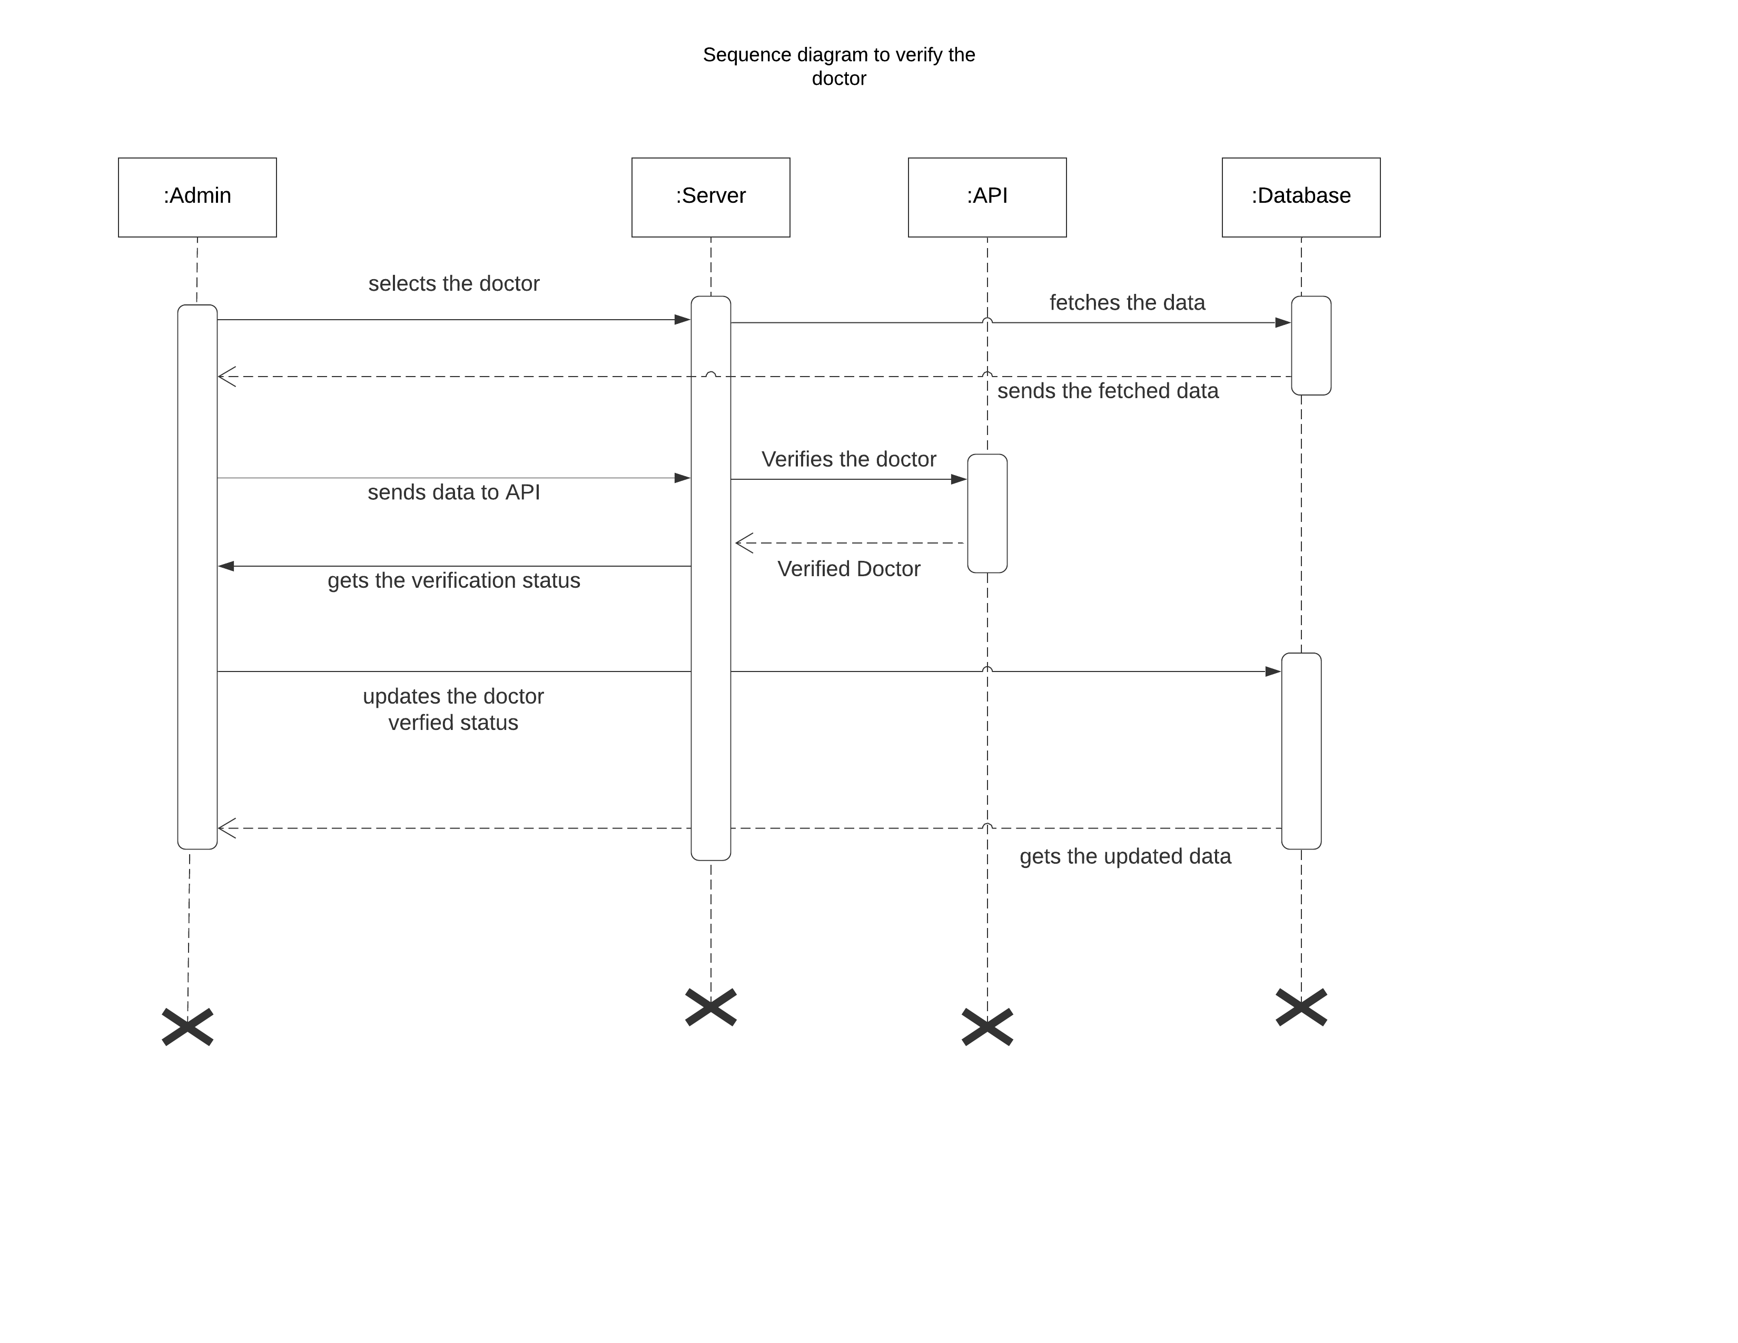

**2)**

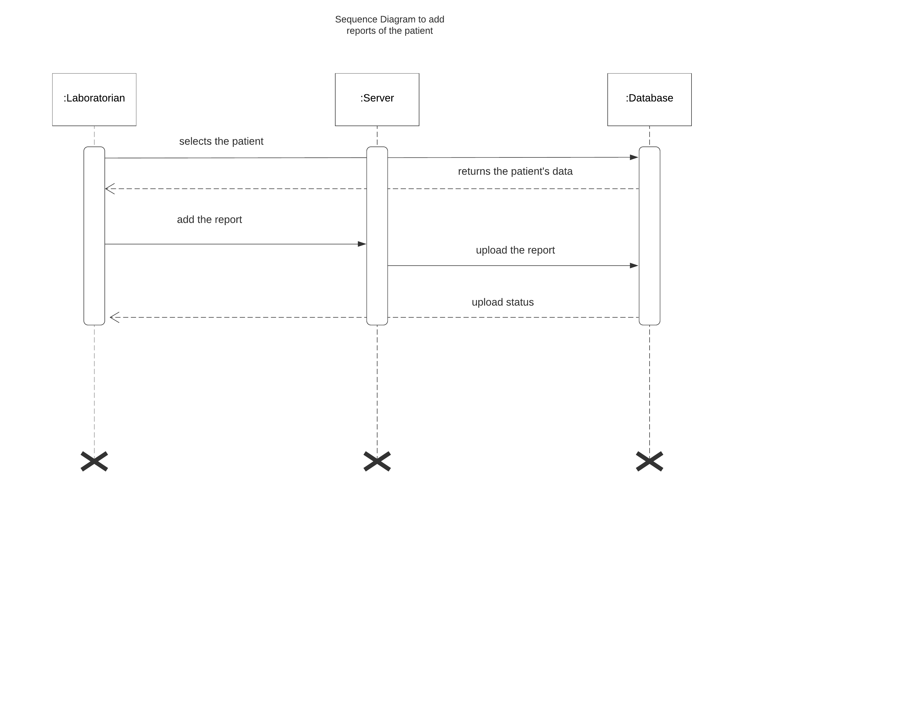

**4.4 Activity Diagram**

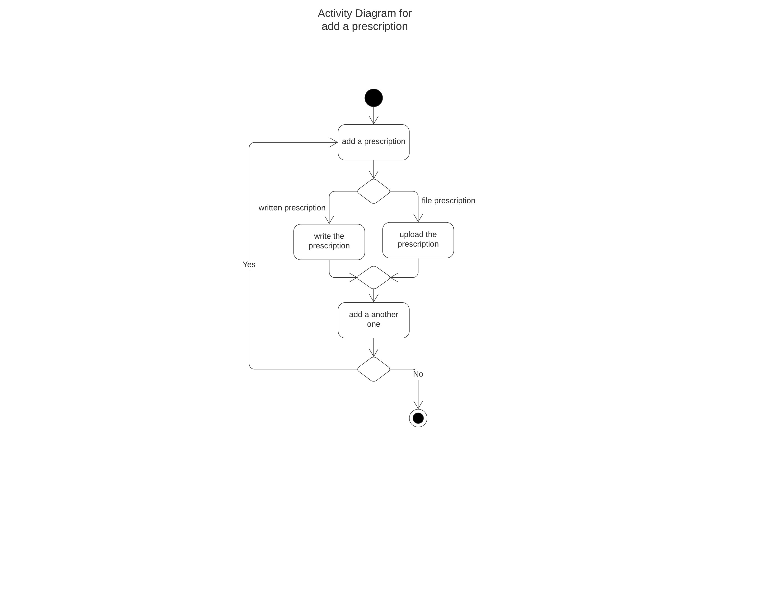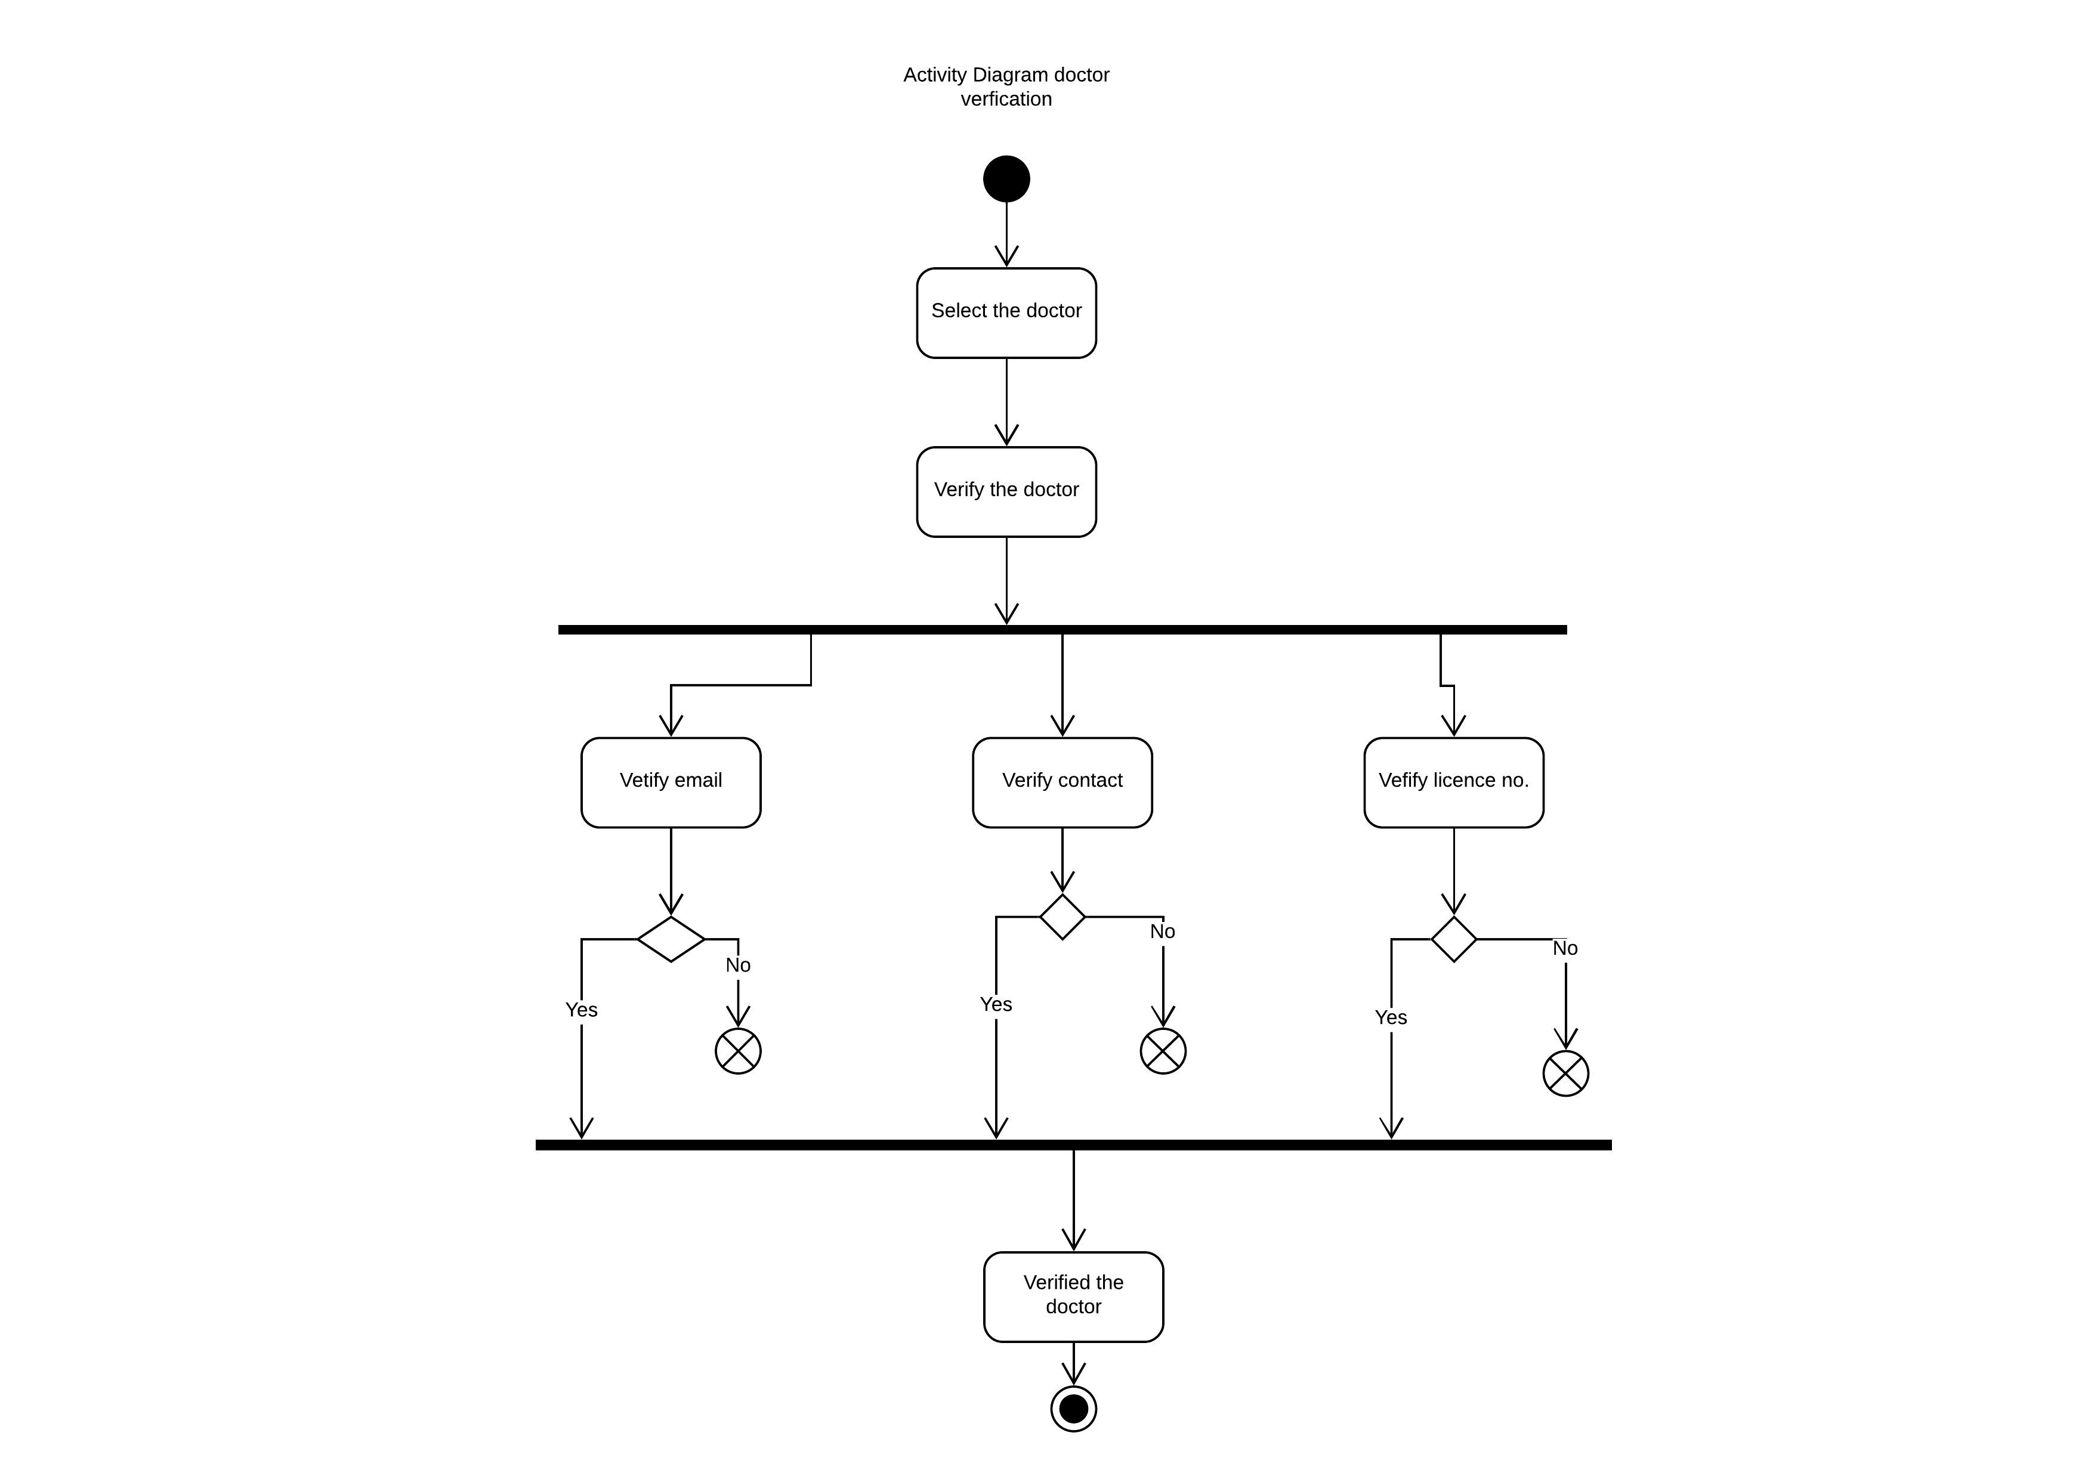

**4.4 E-R Diagram**

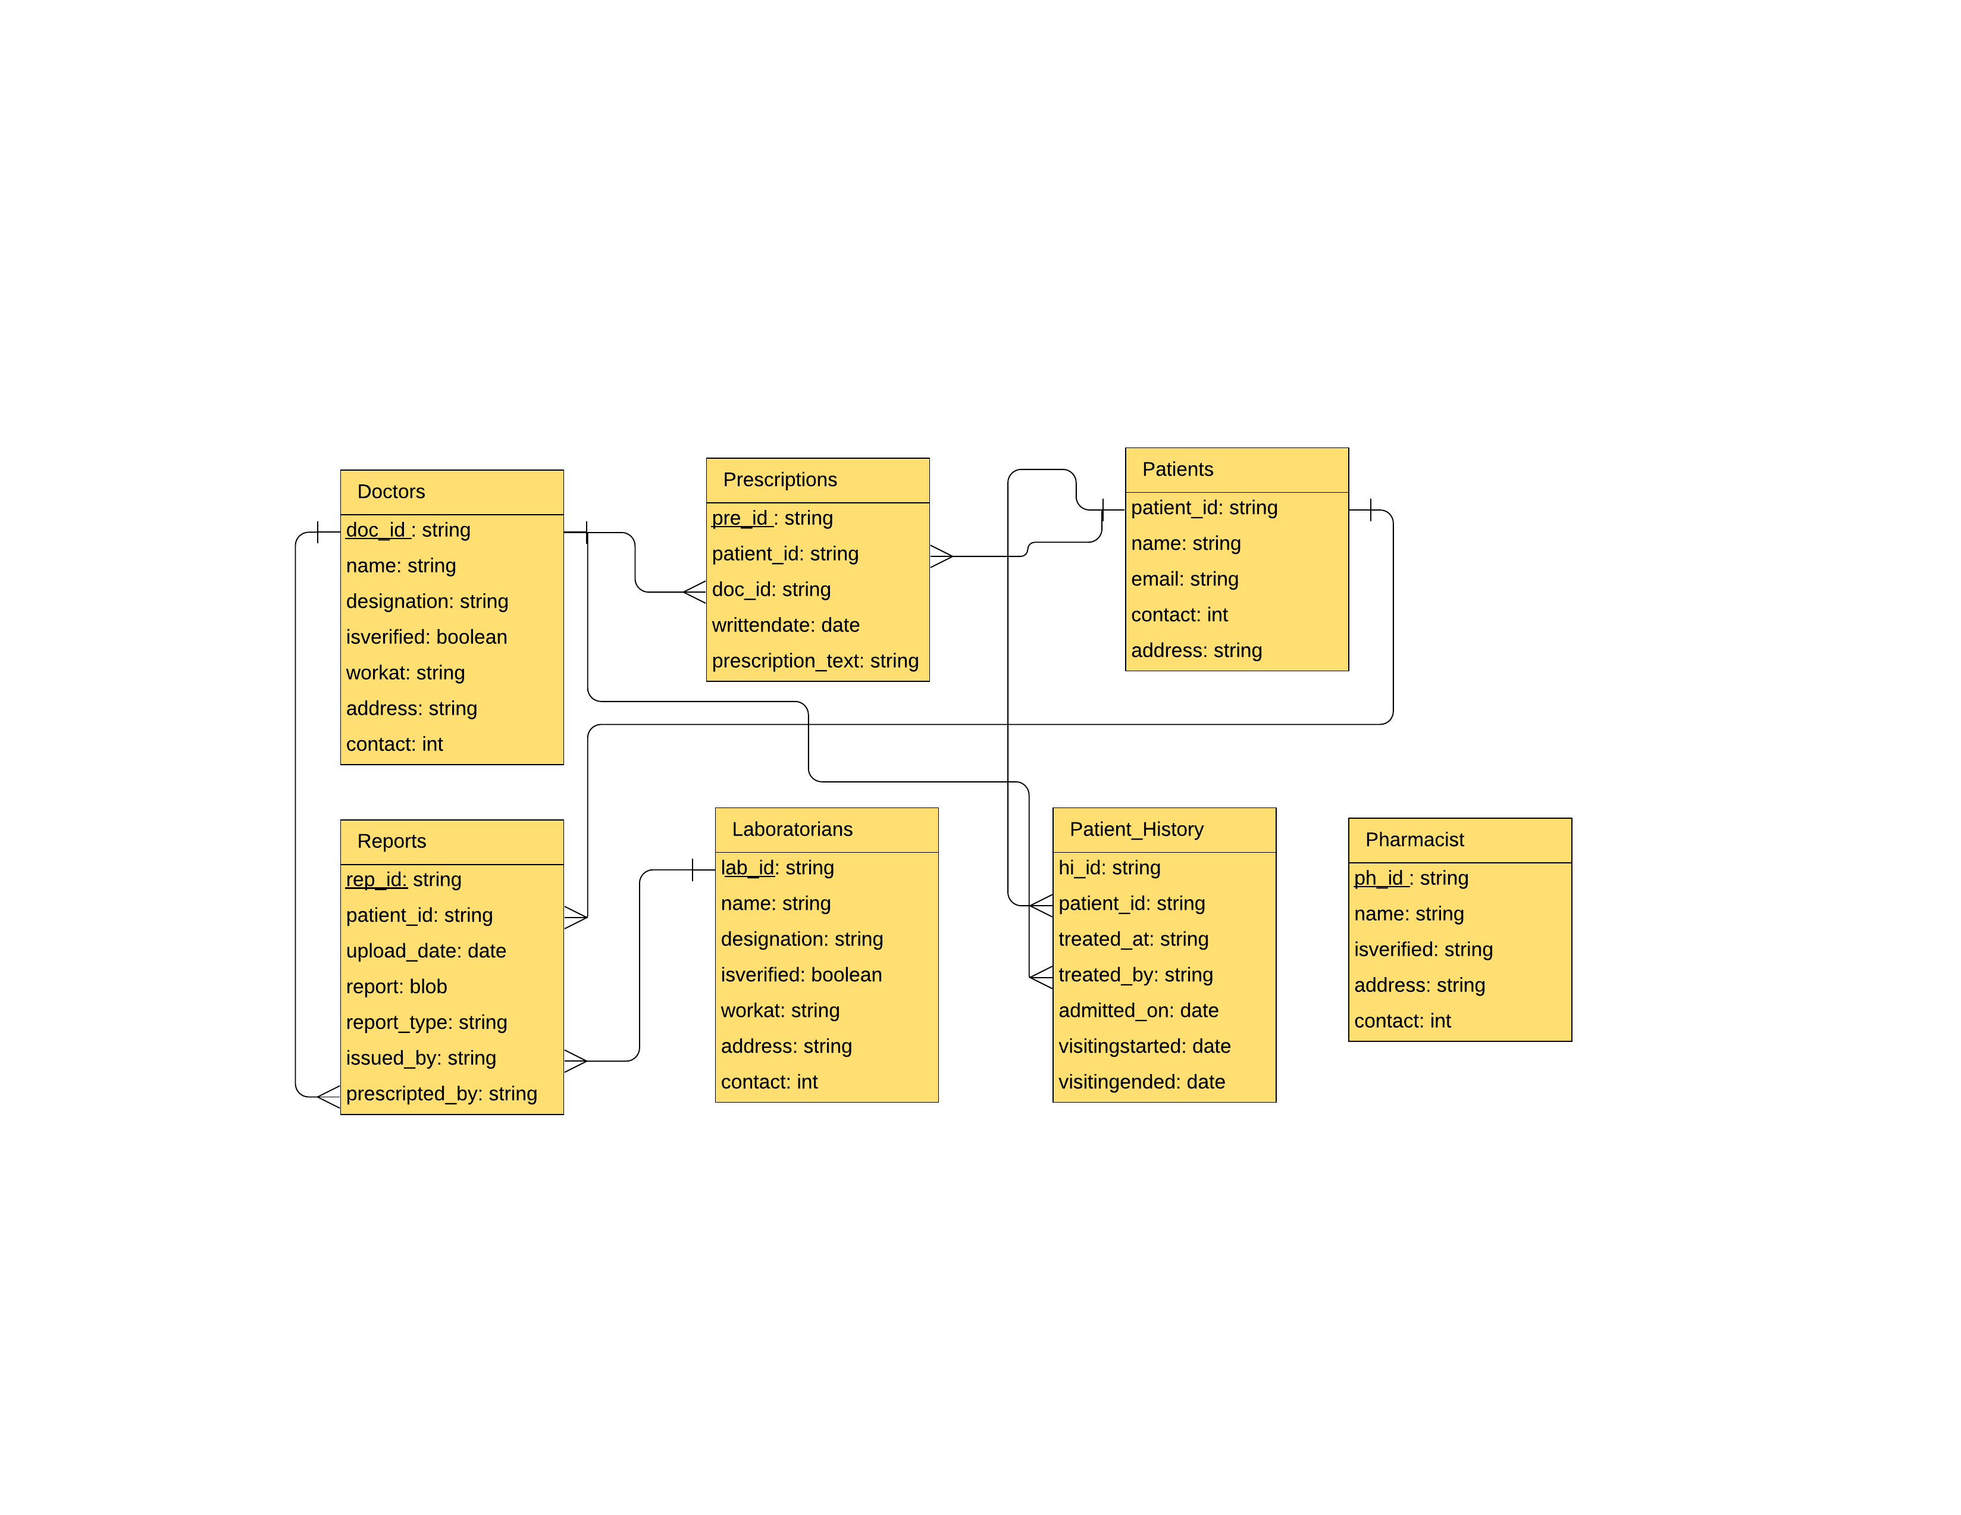

**4.5 Data Dictionary Table**

|  |  |  |  |  |
| --- | --- | --- | --- | --- |
| **1) Doctors** | | | | |
| **Field Name** | **Data Type** | **PK/Fk** | **Referenced Table** | **Description** |
| Doctor_id | Number | PK |  |  |
| Name | Number |  |  |  |
| designation | Varchar2 |  |  |  |
| isvarified | Boolean |  |  |  |
| Work-at | Varchar2 |  |  |  |
| address | Varchar2 |  |  |  |
| Contact | Number |  |  |  |

|  |  |  |  |  |
| --- | --- | --- | --- | --- |
| **2)users** | | | | |
| **Field Name** | **Data Type** | **PK/Fk** | **Referenced Table** | **Description** |
| user_id | Number | PK |  |  |
| Name | Varchar2 |  |  |  |
| Email | Varchar2 |  |  |  |
| Contact | Number |  |  |  |
| Address | Varchar2 |  |  |  |

|  |  |  |  |  |
| --- | --- | --- | --- | --- |
| **3)Reports** | | | | |
| **Field Name** | **Data Type** | **PK/Fk** | **Referenced Table** | **Description** |
| Rep_id | Number | PK |  |  |
| user_id | Number | FK | user |  |
| Upload_date | date |  |  |  |
| Report | blob |  |  |  |
| Report_type | Varchar2 |  |  |  |
| Issued_by | Varchar2 |  |  |  |
| Prescripted_by | Varchar2 |  |  |  |

|  |  |  |  |  |
| --- | --- | --- | --- | --- |
| **4)prescription** | | | | |
| **Field Name** | **Data Type** | **PK/Fk** | **Referenced Table** | **Description** |
| Prescription_id | Number | PK |  |  |
| user_id | Number | FK | user |  |
| Doc_id | Varchar2 |  |  |  |
| Written_date | date |  |  |  |
| Prescripton_type | Varchar2 |  |  |  |

|  |  |  |  |  |
| --- | --- | --- | --- | --- |
| **5)prescription_details** | | | | |
| **Field Name** | **Data Type** | **PK/Fk** | **Referenced Table** | **Description** |
| Prescription_detail_id | Number | PK |  |  |
| Prescription_id | Number | FK | prescription |  |
| Drug_name | Varchar2 |  |  |  |
| Drug_duration | Varchar2 |  |  |  |
| Morning | Boolean |  |  |  |
| Afternoon | Boolean |  |  |  |
| Evening | boolean |  |  |  |
| After/before meal | Boolean |  |  |  |

|  |  |  |  |  |
| --- | --- | --- | --- | --- |
| **6)Laboratorians** | | | | |
| **Field Name** | **Data Type** | **PK/Fk** | **Referenced Table** | **Description** |
| Lab_id | Number | PK |  |  |
| Name | Varchar2 |  |  |  |
| Designation | Varchar2 |  |  |  |
| isVarified | Boolean |  |  |  |
| Workat | Varcahr2 |  |  |  |
| Address | Varchar2 |  |  |  |
| Contact_no | Number |  |  |  |

**5.Implemantation Details**

**5.1 Modules Description**

* Registration Module**:**

This Module is used to store user data to the database and enables the user to login to the system if he /she is authorized. All the fields in this module contain require fields. user can also navigate to login page if he/she has already registered.

* Login Module:

This Module takes user credential and then verifies with registered user, if user is nor registered the invalid credential is shown else if they match with database and then login user.

* Upload report Module:

This module only accessed by authenticated laboratian. It is users upload report page, in which lab report of individual patient has been uploaded.

* Prescription Module:

This Module is accessed only by authenticated doctors, in which doctors can add prescription of particular patient by entering valid details of patient.

* View prescription Module:

In this module patient can view prescription or his/her history which is main goal of project to manage that. Patient can view his/her prescription with all details

**5.2 Function prototype**

**1)Register User: -**

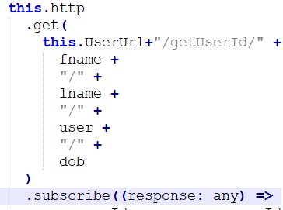

**2)Login**

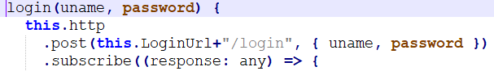

**3)Setting Session: -**



**4)Authentication: -**

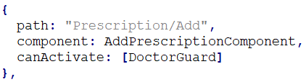

**6 Testing**

**6.1 Testing Method:**

We have Performed Black box testing For the testing purpose

**6.2 Test Cases:**

For Registration:

Password and confirm password must be same

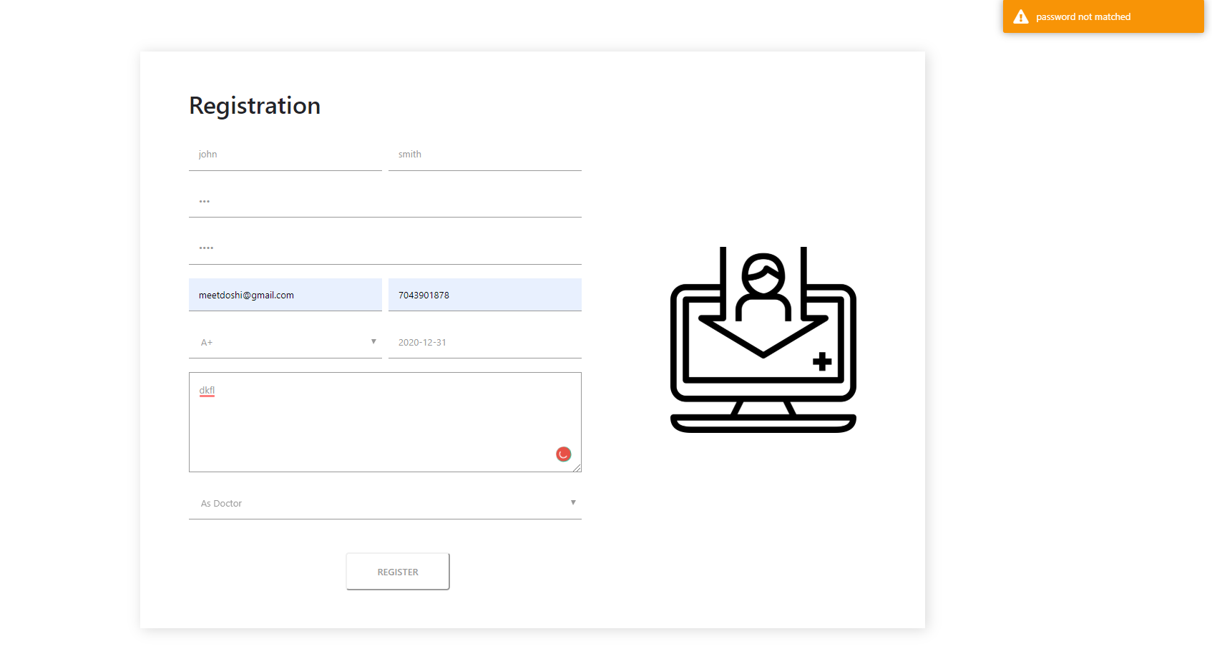

Login:

If credentials Are Invalid Error Message will be shown

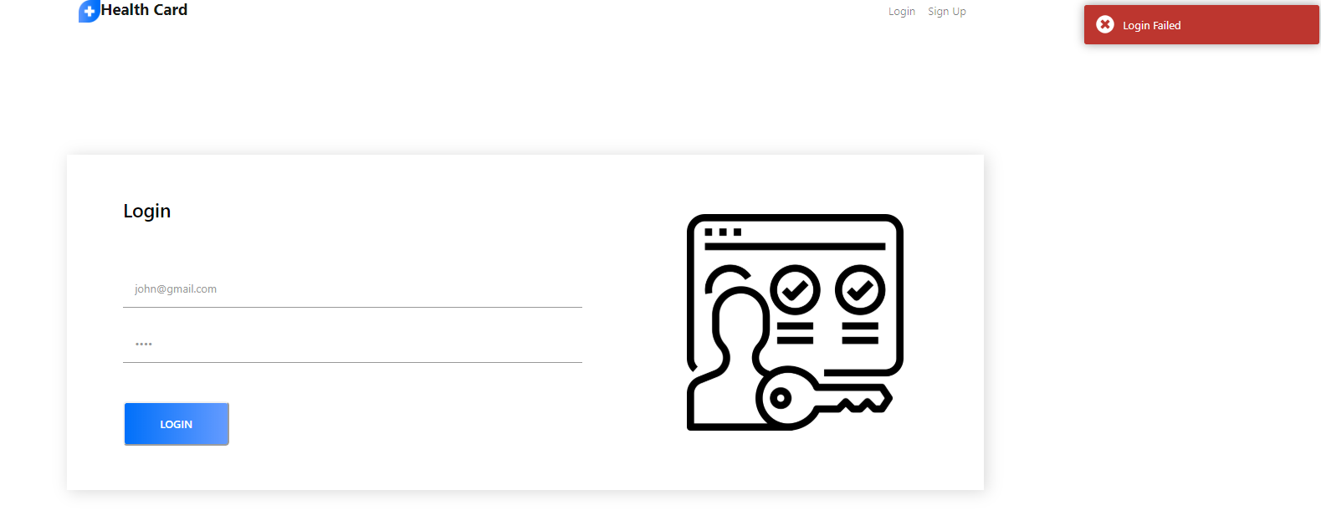

**7 Screenshots**

1)Doctor Registration

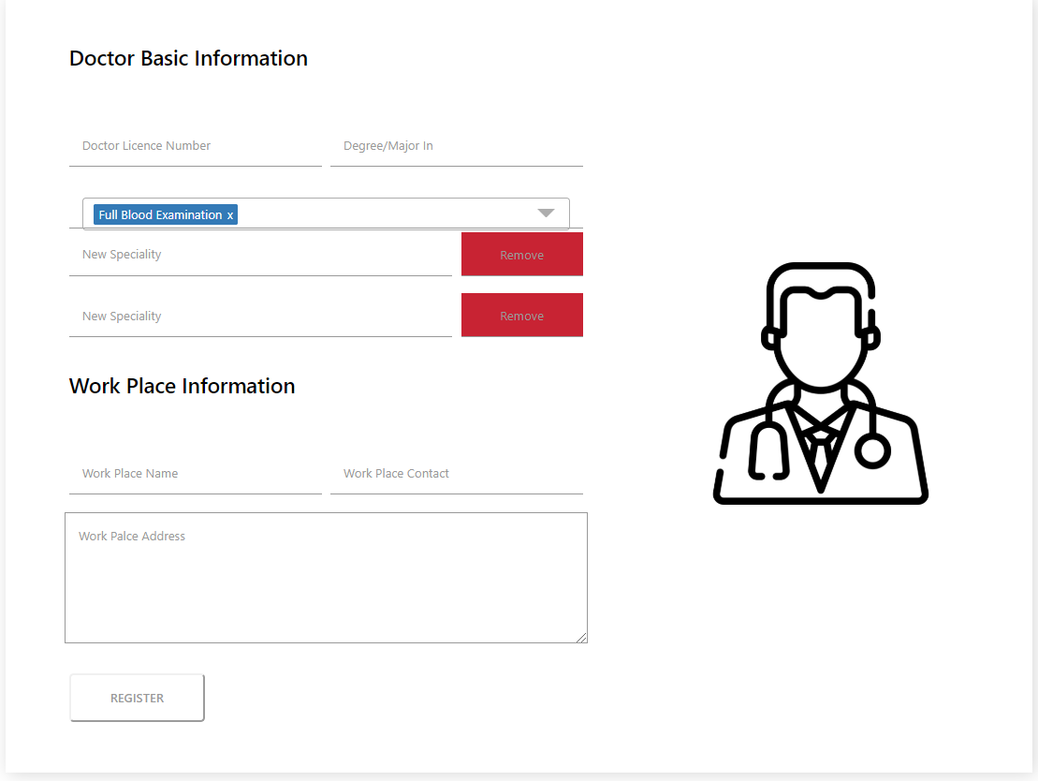

2)Add new Diagnosis

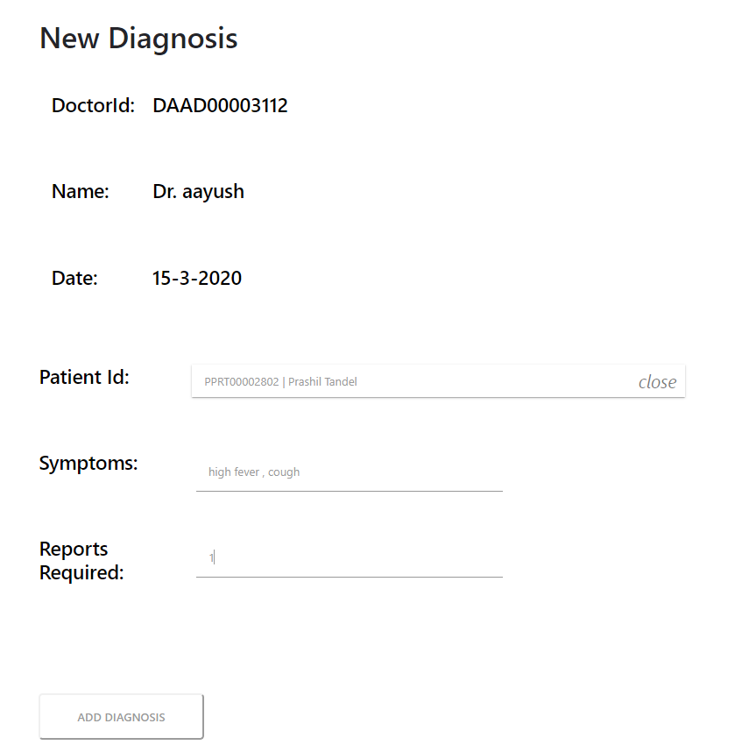

3)Add prescription

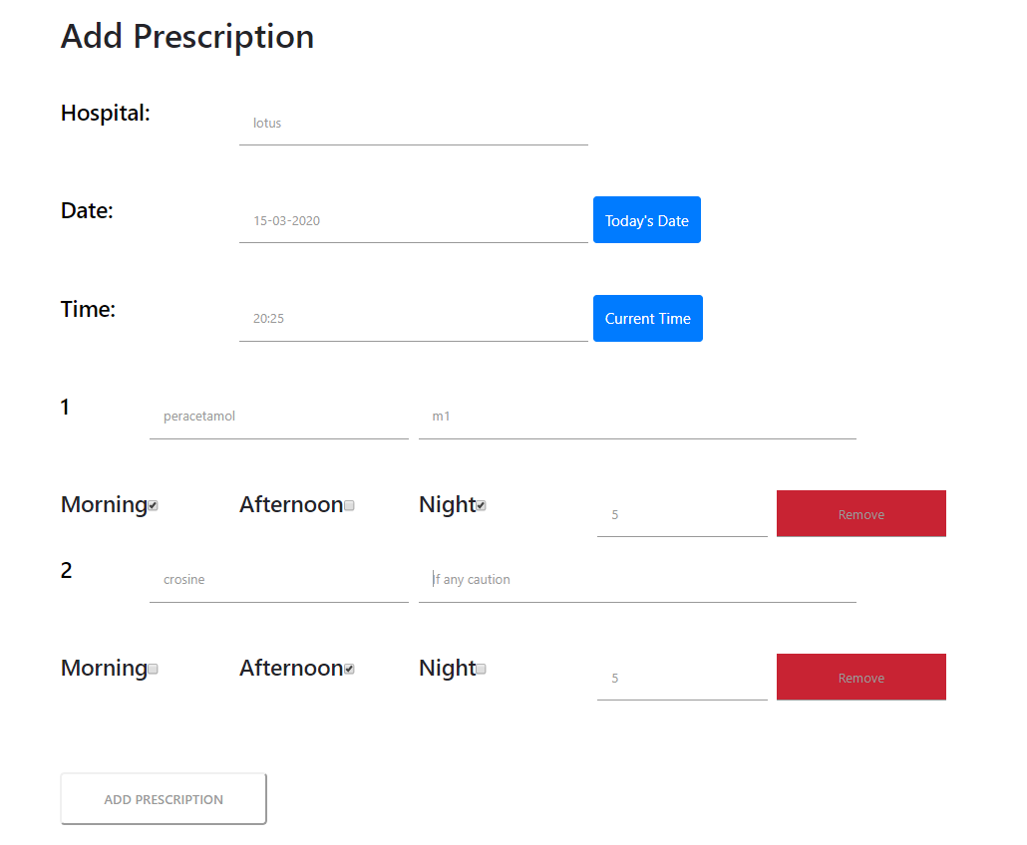

4)Upload Report

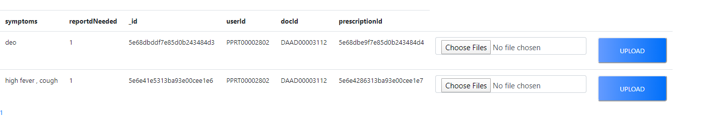

5)Patient Health card:

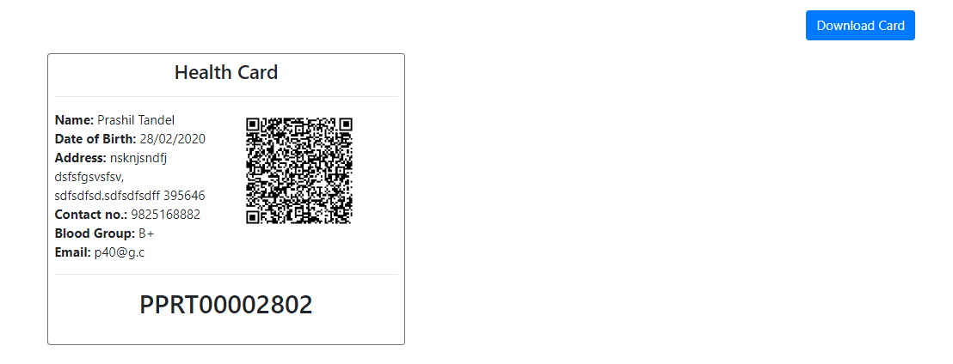

6)patient view prescription:

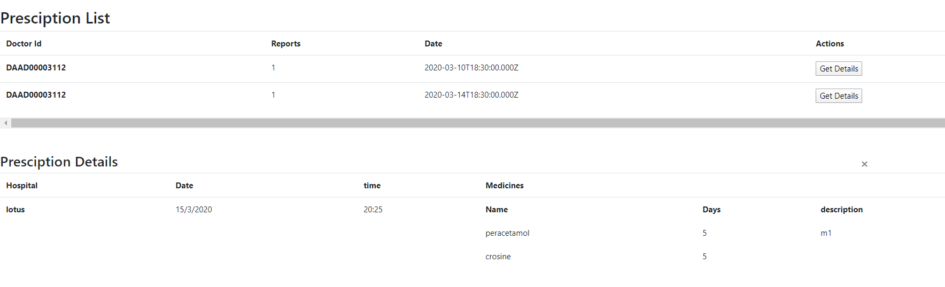

**Conclusion**

The functionality implemented in the system was done after understanding all the system modules according to requirements.

Functionality that are successfully implemented in the system are:

* Patient/Doctor/Lab Registration
* Login
* Session management
* Upload lab reports and searching
* Add diagnosis
* View / download health card
* View prescription of patients
* Log out

After the implementation and coding of system , comprehensive testing was performed on the system to determine the loopholes and possible flaws in the system

**Limitations and Future Enhancements**

* **Limitations**
  + Every time when doctor add prescription, he/she needs to add drug name
  + Not verified doctors are also allowed to use system
* **Functionality not implemented**
  + Laboratorian cannot view uploaded reports
  + User cannot change his profile name once Registered
* **Future Extension**
  + Making module of medical shop owner
  + By gathering all health data train, a model and analysis of allergies area wise
  + Registration of patient via Aadhar card

**Bibliography**

* **Websites:-**

1.<https://www.w3schools.com>–For Html,CSS,Bootstrap,XML,Javascript.

2 <https://mongoosejs.com/> - For mongoose database

3.<https://angular.io> –For Understanding Angular.

4.<https://stackoverflow.com> –For Solving problems.

* **Useful Links**

1. <https://nodejs.org/en/> ‐For download and setup of NodeJS.
2. <https://fonts.google.com> –For getting fonts families.

3 <https://www.tutorialspoint.com/index.htm>