University of Mumbai


A PROJECT REPORT ON

“Esanjeevani-2.0 : A Secure Telemedicine Platform for Remote Clinical Consultation”
SUBMITTED BY

Amreliya Mohinuddin(Roll No: 03) Aayush Bharda (Roll No: 10)
Krish Darji(Roll No: 22)

GUIDED BY

Prof : Devanand Bathe

DEPARTMENT OF ARTIFICIAL INTELLIGENCE & DATA SCIENCE

K. J. SOMAIYA INSTITUTE OF TECHNOLOGY SION (E), MUMBAI 400022


Academic Year-2025-26

K. J. SOMAIYA INSTITUTE OF TECHNOLOGY SION (E), MUMBAI 400022
UNIVERSITY OF MUMBAI CERTIFICATE
This is to certify that the project titled has been partially completed under our supervision and guidance, by the following students:

Amreliya Mohinuddin(Roll No: 03) Aayush Bharda (Roll No: 10)
Krish Darji(Roll No: 22)

In the partial fulfillment of semester VII in the Department of Artificial Intelligence & Data Science as prescribed by the University of Mumbai during the academic year 2023-2024. The said work has been assessed and is found to be satisfactory.

( Prof : Devanand Bathe ) (External Examiner Name and Sign)

Prof. Dr. Milind Nemade College Seal Dr. Vivek Sunnapwar
(Head of Department) (Principal KJSIT)

PROJECT APPROVAL

This project report entitled “Esanjeevani-2.0 : A Secure Telemedicine Platform for Remote Clinical Consultation” by Amreliya Mohinuddin , Aayush Bharda and Krish Darji is approved for the semester VI in B.Tech degree of Artificial Intelligence & Data Science.

Examiners

1.

2.

Supervisors

1.

2.

Date:

Place:

ACKNOWLEDGEMENT

We would like to thank our project guide Prof. Devanand Bathe, for their immense guidance, support and encouragement throughout the project 'E-Sanjeevani 2.0: AI-Powered Intelligent Telemedicine Platform'. With their suggestions and guidance, we were able to understand the problem and take the right path for the project.

We would also like to thank the department of Artificial intelligence and Data science, K. J. Somaiya institute of technology, for giving us the opportunity and providing us with all the necessary resources for working on this project. We thank our head of department and all the teachers for their assistance and their support to develop an environment conducive to learning.

We would also like to express our gratitude to our team mates for their coordination, contribution and support through out the project. We have gained so much by working on this project as it was a great learning experience for enhancing our problem solving skills and technical knowledge in artificial intelligence and full stack development.

We also extend our thanks to all our friends and peers who had discussion with us and had given us ideas, for this project.

Lastly, we would like to thank our family members for their constant support and encouragement which helped us successfully complete the project.

It has been a learning experience to be a part of this project and it has given us a real-world application of the various concepts we have learned till date.

ABSTRACT

Telemedicine has become an important way to deliver healthcare services remotely, particularly in India, where access to quality healthcare can be limited by geography and infrastructure. Platforms like eSanjeevani allow patients to consult doctors online; however, they still encounter several challenges. These include long waiting times, a lack of prioritization for emergencies, and poor doctor allocation.

The current first-come-first-serve method does not distinguish between minor and serious conditions. This can result in delays in providing timely medical care to patients who need it. Furthermore, without an effective pre-screening process, doctors' workloads increase, as even simple cases require in-person consultations.

To tackle these problems, this project proposes “E-Sanjeevani 2.0,” an AI-driven telemedicine platform aimed at improving the efficiency and accessibility of remote healthcare. The system includes an AI-based symptom checker that collects important information from patients, followed by a machine-learning triage system that assigns an urgency score to each case.

Based on this urgency level, the system decides whether a case can be managed with basic guidance or if it needs a doctor's consultation. For cases that require medical attention, an intelligent doctor-patient matching system assigns the best doctor based on their specialization and availability. The platform also offers real-time video consultations and keeps patient records for future reference.

The proposed system aims to cut down waiting times, make better use of resources, and improve the overall patient experience. By combining artificial intelligence with modern web technologies, this project offers a scalable and efficient solution for next-generation telemedicine.

CONTENTS

Sr. No. | Title | Page No.
1. | Introduction | 7
2. | Literature Survey  - Comparative Survey of Existing system  - Limitation of the Existing system or research gap | 9
3. | Proposed System  - Problem Statement and Objective.  - Methodology (your approach to solve the problem).  - Analysis/Framework/ Algorithm.  - Details of Hardware & Software.  - Design details.  - Implementation Plan up to next semester. | 12
4. | Expected Results | 25
5. | Conclusion | 28
6. | Future Scope | 29
7. | References | 30

LIST OF FIGURES

Figure No. | Title | Page No.
3.1 | System Flow diagram | 15
4.1 | User Login and Authentication Module | 25
4.2 | AI Symptom Triage Chatbot Interface | 25
4.3 | Patient Consultation History Dashboard | 26
4.4 | Doctor Dashboard Overview | 26
4.5 | Doctor Schedule and Availability Management | 27
4.6 | Doctor Patient Management Module | 27

INTRODUCTION

In many parts of India, especially in semi-urban and rural areas where access to medical services and specialists is limited, healthcare accessibility remains a critical concern. Telemedicine provides a convenient solution by connecting patients with doctors virtually using various digital mediums. Various government schemes, such as eSanjeevani, have actively encouraged the adoption of telemedicine, enabling access to online consultations for a large population.

In the current systems, however, some shortcomings are encountered which hinder the efficiency of telemedicine:

- First-come-first-serve model: It does not prioritize the severity of the patient's symptoms. As a result, patients with critical conditions may have to wait longer for immediate medical assistance while healthy patients with non-serious symptoms take up appointment slots.
- Ineffective pre-screening: Patients proceed directly to doctors without prior examination. This further increases the burden on the available healthcare professionals and makes the process ineffective.
- Lack of effective doctor-patient matching system: A suitable doctor-patient matching system is not incorporated. Doctors are arbitrarily assigned patients without much consideration to their specialized medical expertise or conditions. This leads to ineffective consultations and requires more follow-ups.

The integration of AI in healthcare has been recognized for its potential to improve various aspects, from diagnosis to resource allocation and decision-making. Techniques like Natural Language Processing (NLP) could be used to analyze patient symptoms, while machine learning could classify the urgency level of the patient, and deep learning could aid in preliminary diagnosis of certain conditions by analyzing medical images.

The proposed system, E-Sanjeevani 2.0, aims to enhance the current telemedicine framework by integrating AI aspects such as symptom analysis, triage classification, and an intelligent doctor-patient matching system.

Using AI and modern web technologies, the proposed platform aims to reduce waiting times and increase consultation efficiency by providing a better and more streamlined user experience to both patients and doctors.

LITERATURE SURVEY

The current pace of advancements in telemedicine and Artificial Intelligence (AI) has profoundly reshaped the face of the modern healthcare delivery systems. Research studies have indeed tried to assess the roles and applications of AI technologies in telemedicine for accurate diagnosis, effective management of patients and readily accessible healthcare services.

The review on Telehealth and AI by El-Sherif et al. (2022) [1] analyzes the different application areas of these technologies during the COVID-19 pandemic. The authors have given an insight into the use of AI based diagnostic tools, Telehealth platforms, and cloud-based healthcare systems in enabling doctor-patient remote consultations. AI techniques has an utmost importance of their roles in predictive capabilities of diseases, managing the patients and effective communication between the doctor and the patient, however on the other hand; many drawbacks such as internet dependent application of telehealth systems, security and privacy of medical data, and the lack of integrated framework of Telehealth have been also noted down by the authors.

Jenko et al. (2025) [2] carried out a research in the field of reliable, secure and safe AI systems. It elaborates on the usage of Predictive analytics and ML algorithms along with the Healthcare data sets that improve diagnostic abilities of the healthcare professionals and systems. Although, there is great deal of discussion about ethics that AI system should adhere to while its development such as bias, fairness and transparency; it is yet complicated to implement such system in the practical environment due to regulated health guidelines and the absence of integrated framework.

In the domain of the NLP, the need of extraction of useful and relevant clinical information is important. Rocha et al. (2023) [3] conducted a study on the usage of the NLP techniques to extract clinical information from patient's medical records. The research shows that different techniques such as Named Entity Recognition (NER), text classification etc. Can be useful for identifying the required information and the symptoms, however a lot more improvements need to be made in order to resolve limitations such as dependence on specific language and variety of unstructured data forms, along with the need for preprocessing.

Similarly, Mikoajewska and Masiak (2025) [4] evaluated the usage of Deep Learning techniques in NLP for medical applications. Transformer based approaches like BERT and GPT have been employed for analyzing the patient's medical record for accurate predictions and health risk assessment. These models are advanced as they can understand context and are able to do prediction of illness at early stage. However, they require extensive computational resources and there are issues related to the data privacy of the medical records and their implementation for real time use.

Resource management is one of the vital features of telehealth system, an approach using Reinforcement learning based AI is proposed by Saini et al. (2025) [5] for better patient scheduling and doctor allocation. They introduce a Q-learning based algorithm which will help in efficient queue and resource management. Although, the model is useful for telehealth systems, but it has certain implementation issues and parameter tuning is difficult, making it challenging to adopt in real time systems.

Finally, Smith et al. (2024) [6] carried out a research on factors that influence the adoption of telehealth services. The main issues highlighted are the patient's lack of digital literacy, reliance on internet access and inability to carry out physical examination on patients remotely. They stress on user-friendly design and effective communication systems as being important elements to enhance patient interaction and clinical outcomes.

As can be seen, while AI could immensely improve the capabilities of Telehealth through its automating and predictive abilities in decision making; however the existing models are focusing more on specific parts rather than a whole integrated Telehealth and AI system.

Research Gap:
AI and telemedicine have been widely studied but a comprehensive platform which involves AI driven symptom diagnosis, classification for triage, smart matching of doctor and patient with real-time consultation has not been designed. A lot of current platforms are hypothetical or are focused on limited function and most of these systems are not real-time and scalable. In addition, most current telemedicine platforms do not give the priority to the patient based on the urgency, and the

resources are not efficiently utilized. Most current telemedicine systems do not focus on easy to use UI and multiple languages which would be a major issue for a country like India. While the literature deals with security and privacy in telemedicine systems, real-time applications usually lack the implementation.

An integrated AI-powered telemedicine platform that involves smart triage, intelligent doctor and patient matching, and real-time communication along with user friendly UI needs to be designed which can improve healthcare. The following system aims to fulfill this gap.

- PROPOSED SYSTEM

The proposed system is an AI-driven telemedicine platform developed to improve the efficiency and accessibility of remote healthcare services. Traditional healthcare systems often face issues such as long waiting times, improper patient-doctor matching, delayed diagnosis, and limited access to medical consultation, especially in remote areas. To address these challenges, the system introduces an intelligent digital healthcare solution that combines artificial intelligence, symptom analysis, and real-time consultation into a single integrated platform. The main objective is to provide faster preliminary diagnosis, priority-based patient handling, and seamless doctor consultation through an online environment.

The system begins with patient registration and login, followed by symptom submission through an AI-powered chatbot interface. The chatbot collects patient symptoms, medical history, and basic health details using natural language interaction. The AI engine then performs symptom analysis using Natural Language Processing (NLP) and severity detection algorithms to classify the case into Low, Medium, or High priority levels. Based on this classification, patients may receive self-care suggestions, be assigned to an appropriate doctor, or be flagged for urgent medical attention. Verified doctors can access patient details through the doctor dashboard, review AI-generated triage reports, and conduct secure video consultations for diagnosis, prescription, and treatment. This smart and automated approach improves healthcare delivery, reduces consultation delays, and creates a more reliable telemedicine ecosystem.

3 (a). PROBLEM STATEMENT AND OBJECTIVES

Problem Statement:
Telemedicine platforms have emerged as an integral component of our modern healthcare systems enabling both patients and doctors to connect remotely. However, there are a number of challenges that affect even existing systems like eSanjeevani. One of the most significant drawbacks is the use of a first-come first-serve approach to booking appointments, which ignores urgency of patient's medical conditions and hence critically ill patients can face significant delays to consult a doctor and have to wait behind patients with trivial health concerns.

Another aspect which needs immediate attention is the lack of an intelligent pre-screening mechanism in the current telemedicine systems. Currently patients consult doctors directly without any prior medical evaluation, leading to high work-load for doctors and inefficient utilization of limited resources. A significant amount of time and effort could be saved if minor problems are dealt with basic guidance.

In addition to this, the present systems don't utilize an efficient doctors patient mapping system and patients are simply matched with whichever doctor is available without matching with their specialization, and last but not least limited use of Artificial Intelligence and lack of decision-support tools severely compromises the ability of these systems to deliver speedier, precise healthcare.

Objectives:
This project primarily focuses on the creation of an AI enabled telemedicine platform to tackle the drawbacks of the existing systems and to facilitate it with an intelligent automation and decision making. The goal of the developed system is to enhance the experience of both the patient and the doctors. The project's objectives include:
- To develop an AI powered system for symptom analysis, gather and analyze the data given by the patient to perform a preliminary diagnosis
- To implement a triage system to score the patients based on their symptoms and urgency

- To create an intelligent matching system between the patient and the doctor on the basis of the patient's requirement and doctor's availability to optimize consultations
- To reduce the time for patients waiting by smartly handling queues using intelligent system
- To provide a real-time video consultation for an efficient doctor-patient interaction
- To develop an easy and interactive interface that is user-friendly and simple to use by patients/doctors
- To create a flexible and robust system to deal with multiple users simultaneously.
The implementation of this project will contribute in increasing the efficiency of telemedicine. It will significantly decrease the waiting time, optimize resource utilization and thereby improve the quality of healthcare delivered. The system utilizes an Artificial Intelligence embedded system that is interfaced with the modern web development framework and helps in dealing with the shortcomings of the current systems in a practical and effective way.

3.(b) METHODOLOGY

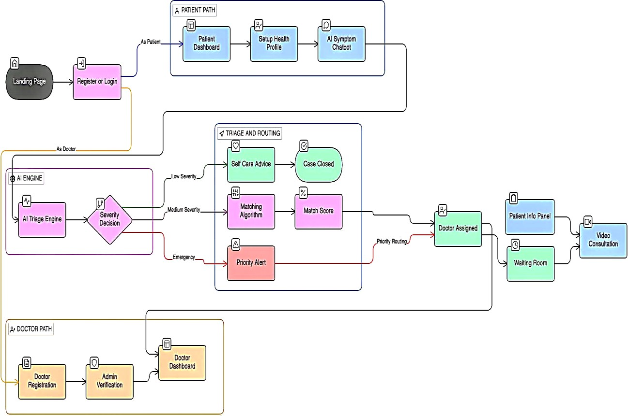

The architecture consists of five integrated modules that facilitate a structured, scalable, and patient-centric healthcare ecosystem.

Patient Path
The workflow begins at the Landing Page, where users interact with the Register or Login module. Based on the authenticated credentials, the system branches into the Patient Path or Doctor Path. For patients, the journey involves three primary stages:
    - Patient Dashboard: The central hub where users manage their profile and previous records.
    - Setup Health Profile: A prerequisite module where medical history and personal health data are digitized.
    - AI Symptom Chatbot: An NLP-driven interface that collects real-time symptoms. As shown in the diagram, this serves as the gateway to the AI Engine.

AI Engine
The AI Engine acts as the intelligence layer, processing data through a sequential decision-making process:
    - AI Triage Engine: Analyzes raw symptoms from the chatbot against medical databases and historical data.
    - Severity Decision (Decision Node): This diamond-shaped logic gate classifies the case into one of three distinct streams: Low Severity, Medium Severity, or Emergency.

Triage and Routing System
This module acts as the traffic controller, directing the patient based on the AI Engine's output:
    - Low Severity (Green Path): Routes the user to Self-Care Advice. If the automated guidance is sufficient, the workflow concludes at Case Closed, bypassing the need for a doctor.
    - Medium Severity (Purple Path): Triggers the Matching Algorithm. This identifies the best-suited physician, resulting in a calculated Match Score before proceeding to doctor assignment.
    - Emergency (Red Path): Activates a Priority Alert. This bypasses standard matching wait times through Priority Routing to ensure immediate medical intervention.

Doctor Path
Doctors follow a separate onboarding and management track:
    - Doctor Registration & Admin Verification: A secure entry point where credentials and licenses are validated by administrators.
    - Doctor Dashboard: Once verified, doctors gain access to their workspace, which is directly linked to the Doctor Assigned module to receive incoming consultations.

Doctor Assignment and Video Consultation
The final phase of the system integrates the patient and doctor streams:
    - Doctor Assigned: The point of convergence where a specific doctor is linked to a patient case (via either the Match Score or Priority Routing).
    - Pre-Consultation Preparation: The system simultaneously prepares two components:

    - Patient Info Panel: Provides the doctor with AI-generated summaries and medical history.
    - Waiting Room: A virtual space where the patient remains until the doctor initiates the session.
    - Video Consultation: The culminating module where real-time diagnosis and treatment occur via a secure video link.

3(c) ANALYSIS / FRAMEWORK / ALGORITHM

The suggested system works on layered architecture and it has following layers: User interaction layer, AI processing layer and service execution layer. Through the help of these layers the request of patient is handled efficiently.

The user interaction layer has following things like patient dashboard, chatbot interface and doctor dashboard. The patient will inform about their symptom with the help of AI chatbot whereas doctor can see the detail of patients and their request through the doctor dashboard.

The AI processing layer has the major functionality where the classification is done by using triage engine and decision making components. Triage engine will analyze the symptom given by the patient and allocate an urgency level to the patient as per the predefined rule or using machine learning techniques. We will divide the patients into 3 classes:
- Low Severity
- Medium Severity
- Emergency

For low severity patient, system will provide some tips on how they can get better themselves at home by themselves and they do not have to meet a doctor.

For Medium and High severity patients, we will go for the doctor matching stage.
The doctor is matched based on a multi-factor scoring algorithm. The system will check certain conditions and calculate a matching score between the patient and doctors and allocate a doctor who got maximum matching score. Following is the formula used for calculation:

Matching Score = 0.40 Urgency + 0.25 Specialty Match + 0.20 Availability + 0.10 Language Preference + 0.05 Patient History

So that patients will get best doctor instead of some random patient.

In emergency condition, normal queue is skipped, doctor are directly mapped and patient's call is prioritized, to minimize the risk involved.

The service execution layer is part of consultation and communication where a real-time video call is set up between the patient and doctor once the doctor is matched with the patient. The doctor will be given summarized information of the patient by AI engine that would help the doctor to get faster decisions.

This frame work is a mix of rule-based logic and decision making that will provide better speed and quality for telemedicine services.

DETAILS OF HARDWARE & SOFTWARE

The developed system uses modern web technologies and AI tools for development. The system is of light weight and can be developed and tested on any modern computers without much infrastructural facilities.

Hardware Requirements:
The development and execution of the system require a standard personal computer or laptop with the following specifications:
      - Processor: Minimum Intel i5 / Ryzen 5 or equivalent
      - RAM: Minimum 8 GB (16 GB recommended for smoother performance)
      - Storage: At least 10–20 GB free space
      - Internet Connection: Required for API communication and real-time video consultation
For training machine learning models, a system with GPU support is beneficial but not mandatory, as cloud-based platforms such as Google Colab can be used.

Software Requirements:
The system is developed using the following software technologies:
- Frontend : The user interface is built using React.js, along with HTML, CSS, and JavaScript. This provides a responsive and user-friendly interface for both patients and doctors.
- Backend : The backend is developed using Node.js and Express.js, which handle API requests, user authentication, and system logic.
- Artificial Intelligence / Machine Learning : Python is used for implementing AI and ML components. Libraries such as Scikit-learn are used for building the triage model, while PyTorch or TensorFlow can be used for image-based analysis.
- Database : MongoDB is used to store user data, medical records, and consultation details in a flexible and scalable manner.
- API Integration : FastAPI is used to integrate machine learning models with the backend

system, allowing efficient communication between the AI module and the main application.
- Real-Time Communication : WebRTC technology is used to enable video consultation between patients and doctors. Socket-based communication can be used for real-time updates such as queue status.
- Development Tools : The project is developed using tools such as Visual Studio Code for coding, Git and GitHub for version control, and Postman for API testing.

The combination of these hardware and software components ensures that the system is scalable, efficient, and suitable for real-world telemedicine applications.

DESIGN DETAILS

To provide a maintainable and scalable system the designed system will have a layered and modular approach. The design has been broadly categorized into two user interfaces- Patient Interface and Doctor Interface, and an integrated AI processing module.

Patient Interface :
The patient interface will be a simple, user-friendly interface to facilitate basic data input, interaction with the system, and a communication channel to a doctor if required. Upon logging in, the patient will be asked to enter and set up the one-time health profile that has basic details about the medical condition, such as the patient's age, sex, current condition, etc. This would help in the accurate diagnosis with the AI component of the system.
The patient would interact with the AI Chat bot by entering the symptoms of the disease, which would be given in natural language, but step-by-step instructions will be provided, so as to ensure a smooth input, even for an inexperienced user. Based on the system's decision, either a suggestion of self care or a reference to a doctor would be given to the patient. The interface will have a display of the waiting queue and the video consultation screen and previous consultation records.

Doctor Interface :
The doctor interface will be an interactive, yet functional interface to allow efficient interaction with patients. Doctors will be required to first register with the system, and only then will they be allowed access after an admin verification process. After the authentication, doctors can access the doctors dashboard that has a pending list of patients who have been referred by the system and each has a summary of symptoms identified by the AI component. The doctor would also be able to view the details of the patient and also join the video call and prescribe through this interface. This ensures minimum interaction time for the doctor and faster turnaround of patients.

AI Processing Module :
The AI processing module forms the back end of the system, and is responsible for analysis of symptoms, triage and decisions. It will process inputs and decide the level of priority of patients

and also identify the appropriate route of action for the patient. It will operate as an independent module and will interact through APIs.

System Architecture :
The overall architecture of the system will be a hybrid system where the front end is developed in React.js, while the backend will be handled by Node.js and Express.js and the AI components will be handled by separate Python based services and all communication between modules will be through APIs to establish smooth interaction and data flow between all components. The separation of the system design is aimed at making the system easy to extend at any given point of time.

3(f) IMPLEMENTATION PLAN (Implementation Plan up to next semester)

Activity | Jan | Feb | Mar | Apr | May | Jun | July | Aug | Sep | Oct | Nov | Dec
Research & Problem Understanding | ✔ | ✔
Literature Survey | ✔ | ✔ | ✔
Dataset Collection & Analysis |  | ✔ | ✔ | ✔
Basic Frontend UI Development |  |  | ✔
Backend Setup (APIs & Database) |  |  | ✔ | ✔
Basic AI Model (Triage) | ` |  |  | ✔ | ✔
Integration of AI with Backend APIs |  |  |  |  | ✔ | ✔
AI Model Improvement & Optimization |  |  |  |  |  | ✔ | ✔ | ✔
Doctor-Patient Matching System  Implementation |  |  |  |  |  | ✔ | ✔ | ✔
Video Consultation Feature Development |  |  |  |  |  |  | ✔ | ✔ | ✔
Complete Frontend  Development (Patient + Doctor Dashboard) |  |  |  | ✔ | ✔ | ✔ | ✔ | ✔ | ✔
System Integration (Frontend + Backend +  AI) |  |  |  |  | ✔ | ✔ | ✔ | ✔ | ✔
Testing & Debugging |  |  |  |  |  |  |  |  | ✔ | ✔
Final Deployment & Documentation |  |  |  |  |  |  |  |  |  |  | ✔ | ✔

EXPECTED RESULTS
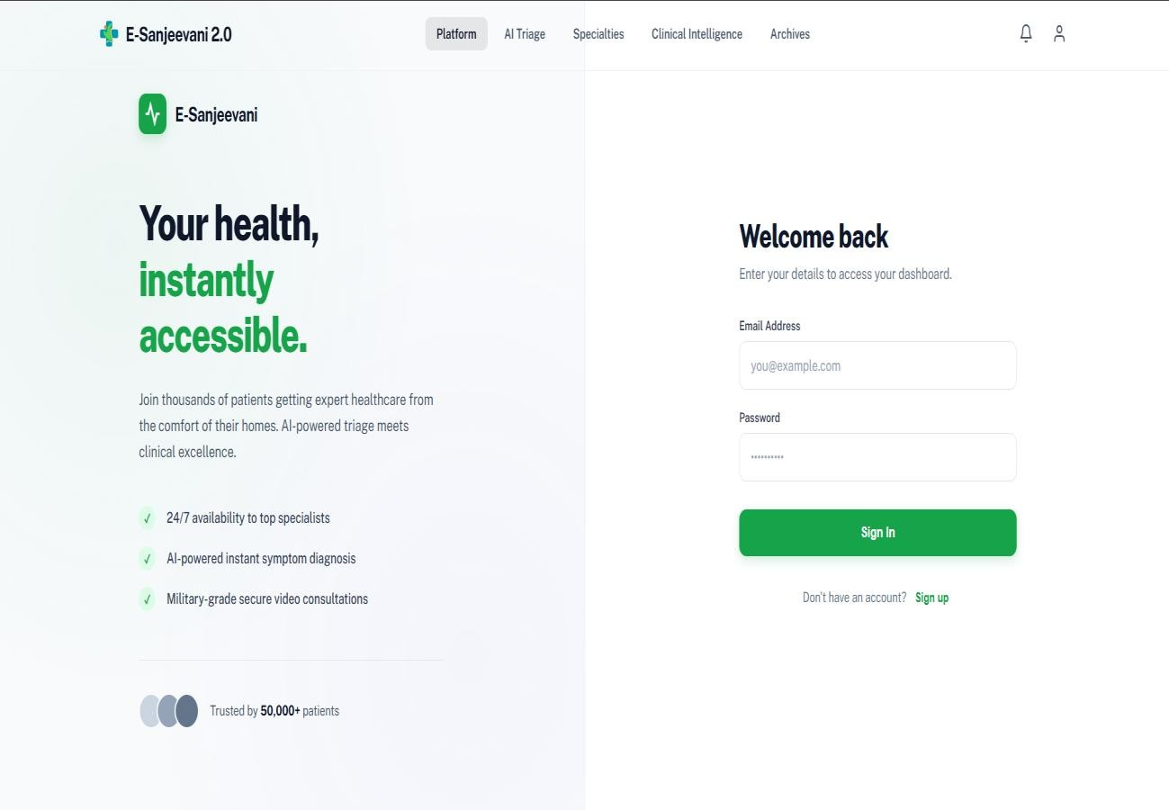
(Fig: 4.1 User Login and Authentication Module)

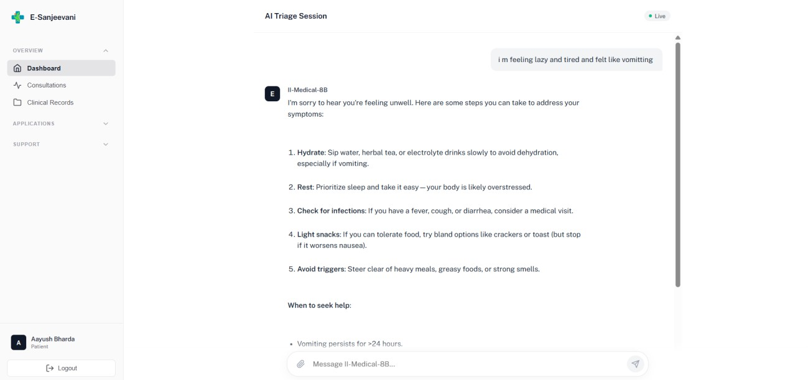
(Fig : 4.2 AI Symptom Triage Chatbot Interface)

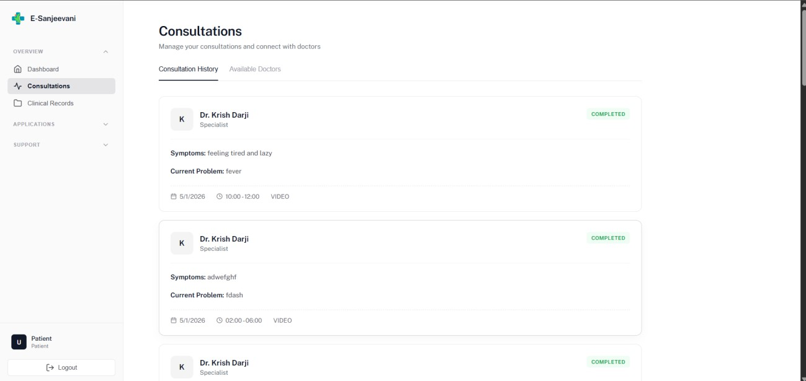

(Fig: 4.3 Patient Consultation History Dashboard)

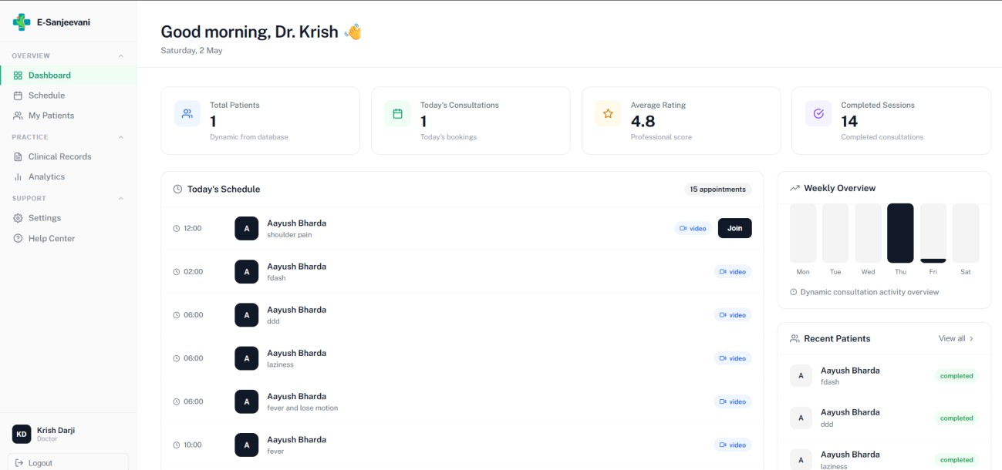
(Fig: 4.4 Doctor Dashboard Overview)

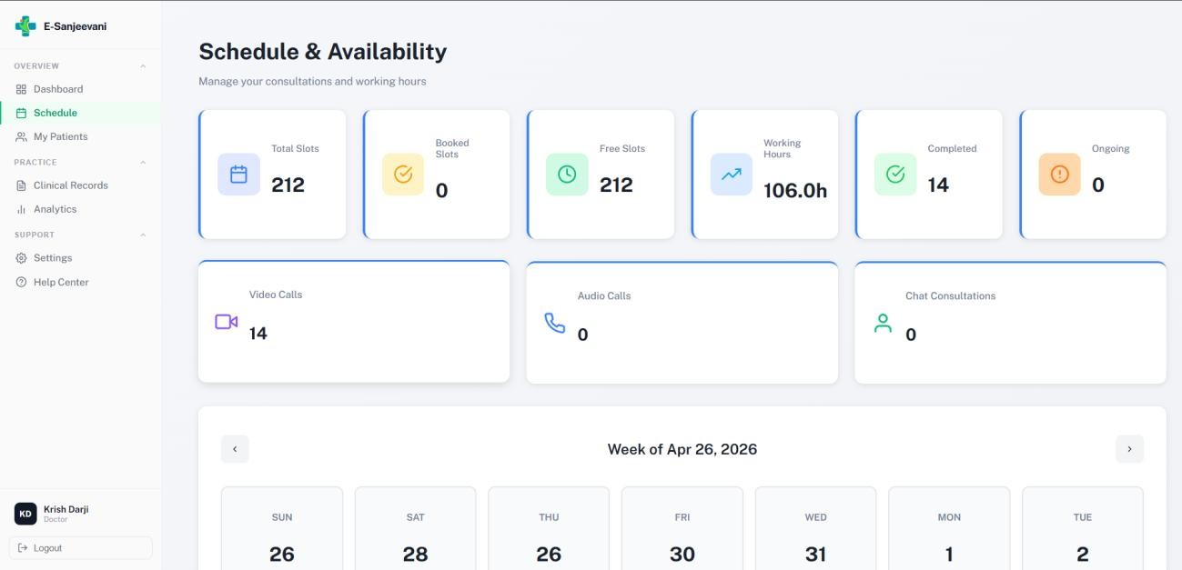
(Fig: 4.5 Doctor Schedule and Availability Management)

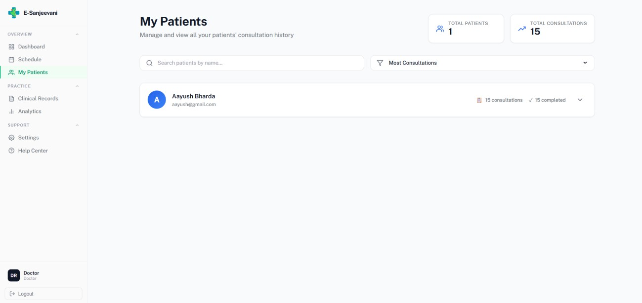
(Fig: 4.6 Doctor Patient Management Module)

CONCLUSION

The system that is proposed above, E-Sanjeevani 2.0, shows a better mechanism for telemedicine service that rectifies the shortcomings of all the current systems that have been discussed. Current systems are based on a first-come first-served basis which inefficiently handles requests from patients and it has severe consequences on the criticality of patients and they need a more efficient mechanism. An effective intelligent pre-screening of the patient as well as an effective doctors-patients matching mechanism are not present in the current systems.

Therefore the system presented above utilizes artificial intelligence and latest web technologies for a more methodical service. The proposed system uses an AI-based symptom checker and triage which help in making an early assessment of patients’ conditions and classifying the patients based on their critical condition for earlier attention. With the proposed mechanism, unnecessary patients are refused from seeing doctor, thus helping in minimizing time wastage for non-critical cases and at the same time catering to the critical patients earlier than expected. A smart doctor-patients matching mechanism allows for effective communication between doctor and patient by allocating doctors according to their speciality based on patients' needs and an real time video consultation between doctor and patient makes the communication seamless. This system seeks to lower the waiting time for patients and improve utilization of resources and quality of experience for the users. This shows the impact of artificial intelligence and decision making in telemedicine and suggests a way of creating effective and scalable healthcare system.

FUTURE SCOPE

The proposed system provides a strong foundation for an AI-powered telemedicine platform; however, several enhancements can be implemented in the future to improve its capabilities and real-world applicability.

- The system can be enhanced by implementing voice-based interaction and multilingual support to improve accessibility for diverse users
- Integration with Electronic Health Records (EHR) and government healthcare systems can provide better continuity of patient care
- The platform can be extended to support wearable devices and IoT-based health monitoring for real-time health tracking
- Advanced analytics dashboards can be developed to provide insights for doctors and healthcare administrators
- Security can be further strengthened by implementing advanced encryption techniques and healthcare data compliance standards
- The system can be expanded into mobile applications to increase accessibility and user reach
- Continuous improvements can be made to the AI chatbot to enhance conversational capabilities and user experience

Overall, the future scope of the system focuses on improving intelligence, accessibility, scalability, and integration with real-world healthcare ecosystems.

REFERENCES

- D. M. El-Sherif, M. Abouzid, M. T. Elzarif, A. A. Ahmed, A. Albakri, and M. M. Alshehri, “Telehealth and Artificial Intelligence: Insights into Healthcare during the COVID-19 Pandemic,” Healthcare, vol. 10, no. 2, p. 385, 2022.

- S. Jenko, E. Papadopoulou, V. Kumar, S. S. Overman, K. Krepelkova, J. Wilson, E. L. Dunbar,
C. Spice, and T. Exarchos, “Artificial Intelligence in Healthcare: How to Develop and Implement Safe, Ethical and Trustworthy AI Systems,” AI, vol. 6, no. 6, p. 116, 2025.

- N. C. da Rocha, A. M. P. Barbosa, Y. O. Schnr, J. Machado-Rugolo, L. G. M. de Andrade, J.
E. Corrente, and L. V. A. Silveira, “Natural Language Processing to Extract Information from Medical Records,” Data, vol. 8, no. 1, p. 11, 2023.

- E. Mikołajewska and J. Masiak, “Deep Learning Approaches to Natural Language Processing for Digital Twins of Patients in Psychiatry and Neurological Rehabilitation,” Electronics, vol. 14, no. 10, 2025.

- B. Saini, D. Singh, K. C. Sharma, and D. K. Saini, “AI-Enhanced Telemedicine: Resource Optimization Using Reinforcement Learning,” Scientific Reports, 2025.

- A. Smith and B. Johnson, “Telemedicine Adoption: Barriers, Facilitators, and Clinical Outcomes,” Telemedicine and e-Health, vol. 30, no. 7, 2024.

